Design thinking presentation

Lewis Ensor
2317067

Contemporary Challenges
(BMSS4009/C)

The slides listed are the ones that I had designed before they got redesigned.

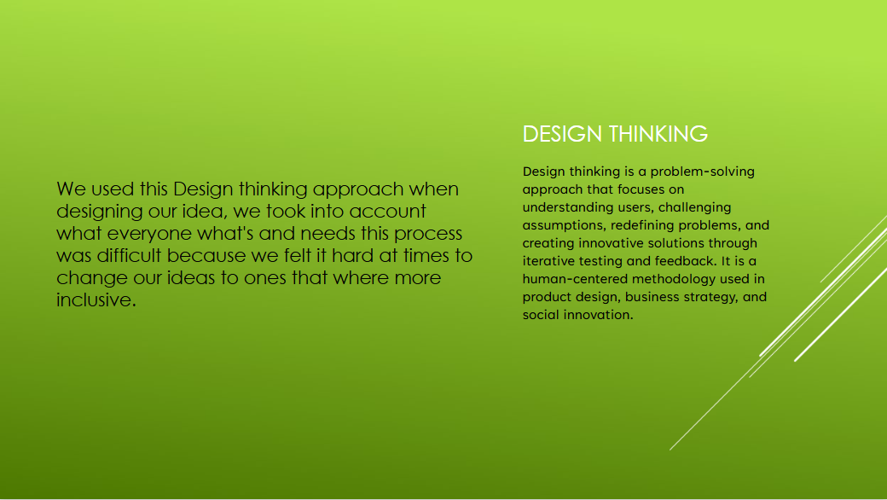
Information that's on the slide was found by me.

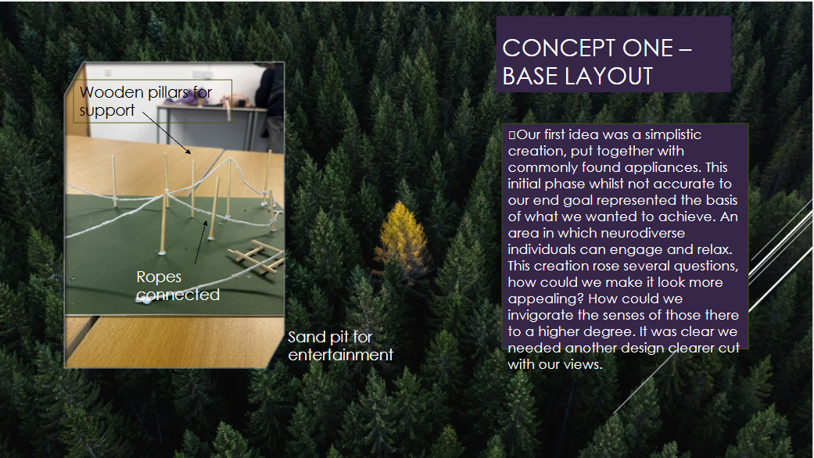
The prototype was built by me as well as the photo and information on the slide is from the script that I made.

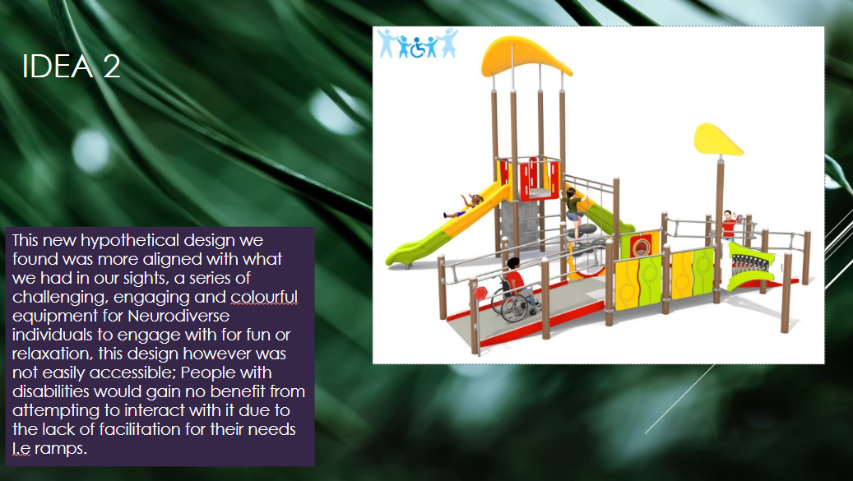
The photo was found by me and the information on the slide is from the script

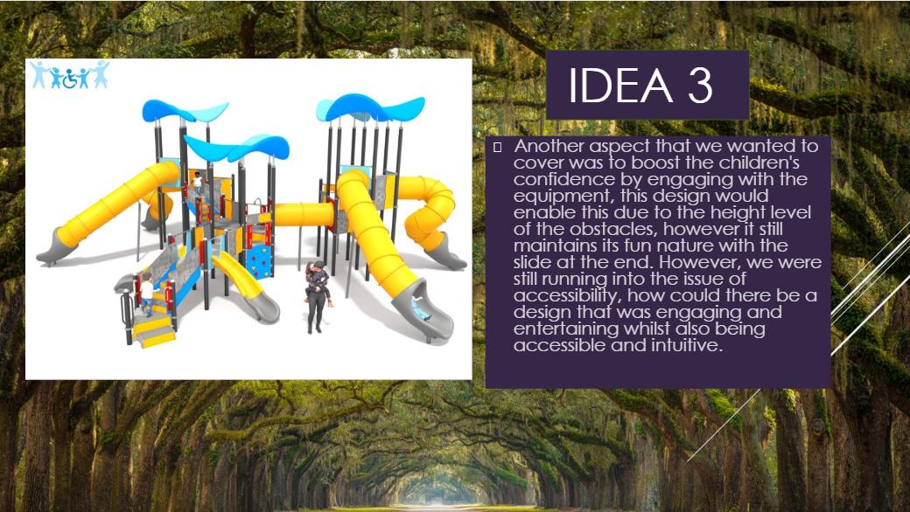
The photo was found by me and the information on the slide is from the script.

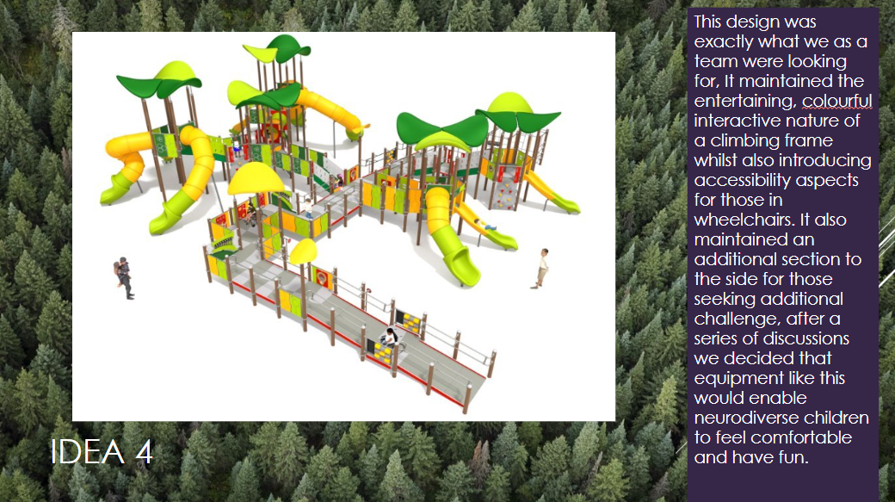
The photo was found by me and the information on the slide is from the script.

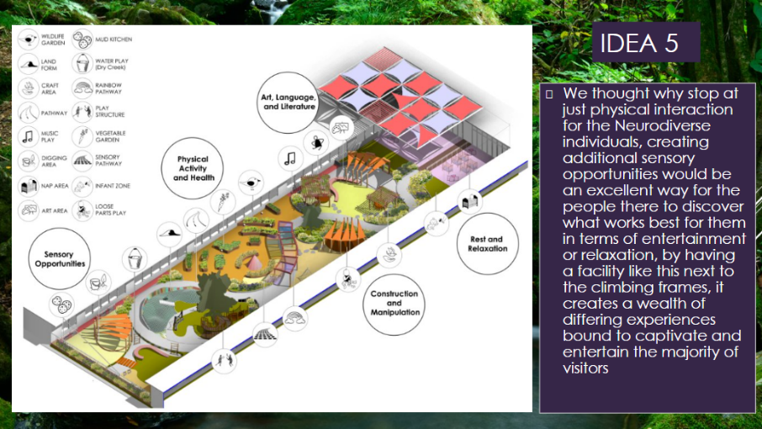
The photo was found by me and the information on the slide is from the script.

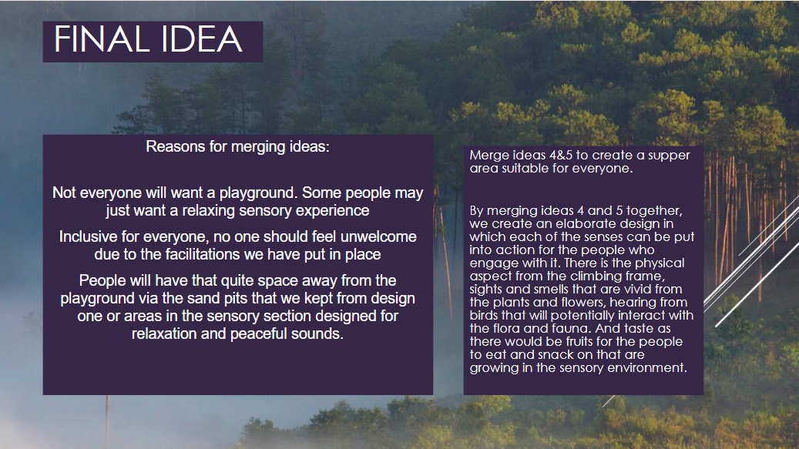
The information is from the script and the idea of merging ideas came from me.

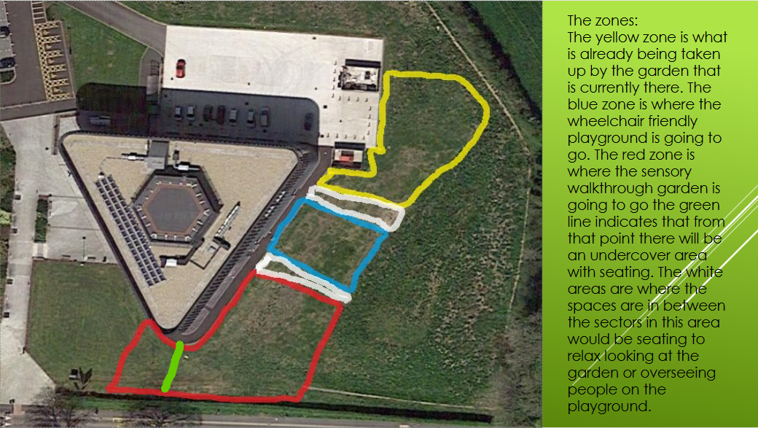
Picture and writing both came from me.

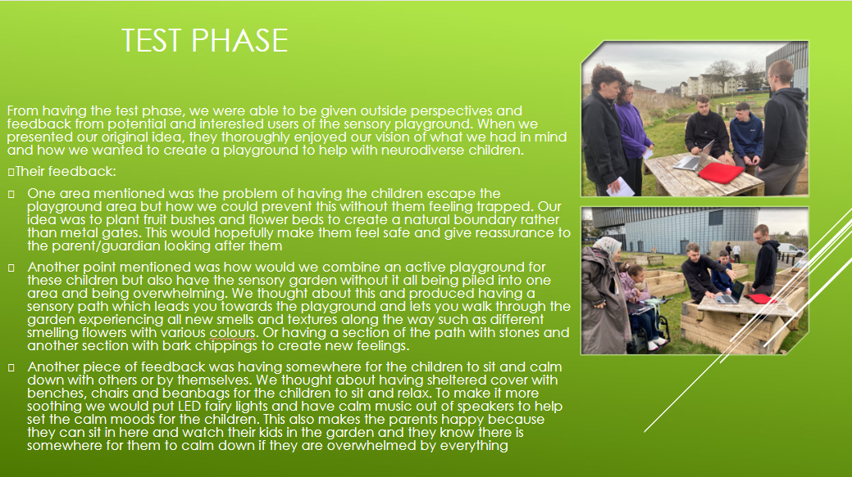
Pictures were found by me.

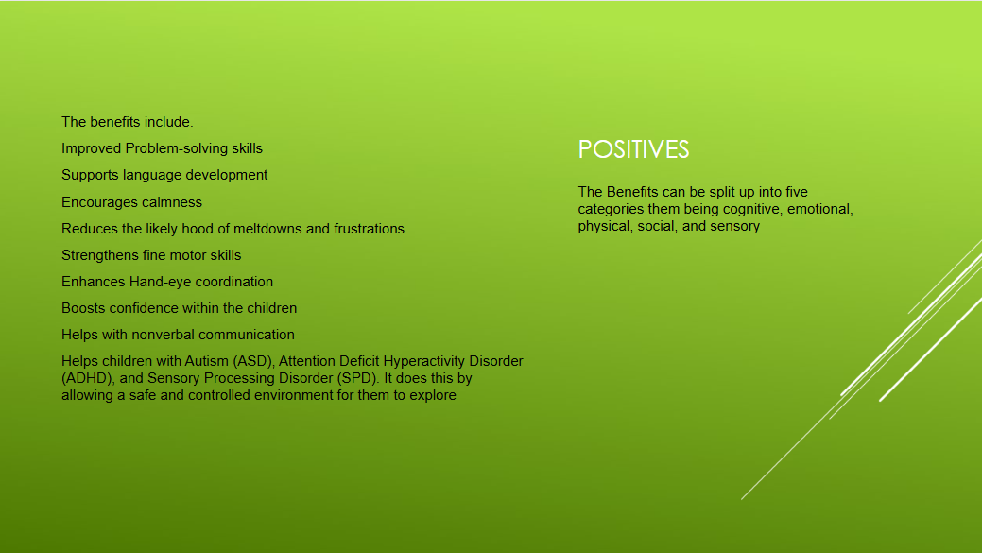
All benefits were found by me.

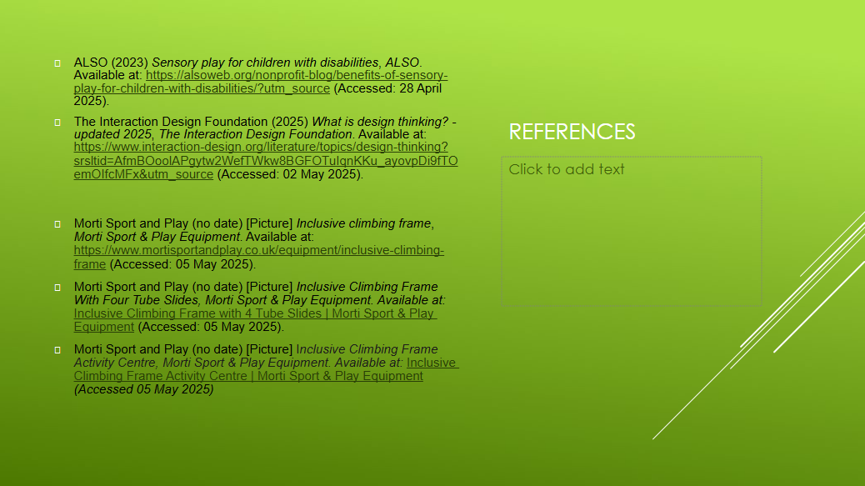
References all found by me.

All the script was written by me despite it not being used. I have put names above who was going to read what.

Slide: Title Slide – “Progression of Sensory Playground”
Speaker: Liam
Hi everyone, thank you for being here. Today, we’re presenting our project titled ‘Progression of Sensory Playground.’ We’re Liam, Lucas, and Lewis, and this project addresses contemporary challenges through inclusive design.

Slide: Design Thinking
Speaker: Liam
We used the design thinking process as our foundation. It’s a human centered approach that focuses on solving problems by deeply understanding the users in our case, children with diverse needs.
One challenge we faced was adapting our original ideas to be more inclusive, but this process helped us grow in flexibility and empathy.

Slide: Early Ideas (Ideas 1-5)
Speaker: Lewis
“During our brainstorming phase, we explored several ideas. Each one focused on different ways to make the play area more inclusive and engaging.
From physical playground features to calming spaces, we aimed to address a range of needs. These five ideas laid the groundwork for our final concept.”
Idea 1: this was our first idea where we showed the class our idea where we received critical constructive feedback that we used to come up with our other ideas.
Idea 2: this idea we fixed some of the issues that were brought to our attention but soon realised that it wouldn’t be suitable for what we needed.
Idea 3: this one is fairly similar to idea 2 just on a bigger scale it just wasn’t aligning with what our vision is. with it still having some of the issues we saw in the second one
Idea 4: here is where we felt we struck gold with an accessible for all climbing frame with features for everyone to enjoy including an accessible slide, and multiple things to do on the access ramps to keep people entertained.
Idea 5: we decided to make a nature walk through with a sensory path where there would be plants that have a strong smell, digging area, water play area, picnic area and the rear, and sensory games and objects along the path
Slide: Final Idea – Merging Ideas 4 & 5
Speaker: Lewis
“Ultimately, we decided to merge Ideas 4 and 5 to create a balanced and inclusive space.
Not everyone is interested in an active playground, so we also designed a quiet area for relaxation. This allows everyone whether they want to play, relax, or simply observe to feel welcomed and included.

Slide: The Zones
Speaker: Lucas
“Here’s a breakdown of the physical layout:
- The yellow zone is the existing garden.
- The blue zone is the wheelchair-accessible playground.
- The red zone is the sensory walkthrough garden.
- The white areas are open spaces with additional seating, offering a good view of both the garden and the playground.
This layout ensures a flow of movement and accessibility for all users.”

Slide: Test Phase
Speaker: Lucas
“During our test phase, we gathered feedback and considered how people would actually use and respond to the space. The feedback we received was very helpful it helped us realise that we were on the right track with our final idea. We refined the design based on what we learned, ensuring that both sensory and physical needs were met.”
Slide: Positives / Benefits
Speaker: Liam
“Our design supports a wide range of developmental needs
(Read what’s on the PowerPoint)
Teamwork & Contemporary challenges slide
Speaker Lewis
Traditional playgrounds often fail to meet the needs of children with disabilities or sensory processing challenges. Our project is centered on designing a space where all children regardless of ability feel welcomed, engaged, and safe.
We feel we also addressed the growing awareness around neurodiversity. Many children experience the world differently due to conditions like autism or ADHD. A sensory playground creates a supportive environment through tactile panels, calming colours, and safe spaces for decompression all tailored to diverse sensory needs.
Finally, our project tackles a major health issue: the decline in outdoor play. With screen time and sedentary habits on the rise, children need more opportunities to move, socialise, and explore. Sensory playgrounds encourage physical activity while also supporting mental and emotional well-being.
In summary, this project represents more than a playground it’s a step toward more inclusive, thoughtful, and health-focused community spaces.

Closing Statement
Speaker: Lucas
our aim was to create an inclusive space that supports all children’s needs emotionally, physically, and socially.(Give thanks and answer questions.)

