Knowledge management assignment
Date: 12/07/2019
Student number: 1705024
Student name: Lubna Dababneh

Table of Contents
1 Executive summary 3
2 Introduction 3
3 FINDINGS 3
3.1 introduction to organization. 3
3.1.1 Job at Amazon. 3
3.1.2 Location of Amazon 4
3.1.3 Profile of staff: 4
3.1.4 SWOT analysis to Amazon 5
3.1.5 What is KM system? 5
3.1.6 Strength in KM system in Amazon 6
3.1.7 Weakness in KM system in Amazon 6
3.1.8 Opportunity KM system. 6
3.1.9 Threat in KM amazon 6
3.1.10 Background of Burberry fashion store and main activity 6
3.1.11 Jobs in Blueberry 7
3.1.12 The Role working in Burberry 7
3.1.13 Location of Burberry. 8
3.1.14 SWOT analysis to KM systemin Burberry company. 8
3.2 Critical evaluation in amazon. 9
3.2.1 Applying Knowledge. 10
3.2.2 Evaluating Knowledge. 10
4 Conclusion 11
5 Recommendation 11
6 References 12
7 Appendices. 13

1 Executive summary
This report concern in Knowledge management system (KMS), and it`s importance in any organisation. the researcher concern in two different organization, Amazon, and Burberry fashion store.
The researcher mentions the main activities in both organisation as location of the knowledge management, in addition, SWOT analysis.
researcher realized the importance of critical evaluation in Amazon company. This report concern in value chain in Amazon, this give a chance to the researcher to understand if Amazon doing right way in using KMS, by studying mission vision, knowledge sharing, applying knowledge then evaluation. Then there is a conclusion, this part concerns the positive point in Amazon. As Amazon is the successful company in the world because it`s applied KMS in good way. The negative point Amazon neglect the employees and talented people that will impact negatively in the company, researcher identify where is the gap between positive and negative to improve it in future. Recommendation. Amazon must concern in employees to motivate them, use communicate tool to make them happier, more loyalty.

2 Introduction
There are different kinds of organization in market, these organizations might be IT company, food company, clothing company or banks… etc. in this report will mention the background in each companies, the activities, the numbers of employees. In addition, SWOT analysis of KM system. The second task will mention the evaluation of KM System.
This report will concern in KM in Amazon company and Burberry fashion company.
Task 2, the report will mention the critical Evaluation of KM in one company, the researcher concerned in Amazon organization. And how Amazon applied different theorist in knowledge. In addition, this report concern in value chain.
Task3, conclusion of the Amazon organization, then recommendation.

According to (Schenider,2019) mention the history and background of Amazon organization.
Amazon is a fortune 500 e commerce company based in Seattle; it has the distinction of being one of the large companies to sell goods over the internet.
Jeff Benzos was founded Amazon in 1994, An American multinational technology company.
Amazon started out as online bookstore and then quickly diversified by adding other items including DVD’s, music, video’s, clothing, food hundreds kind of soup (amazon.jobs, 2019).

3 FINDINGS

3.1 introduction to organization.

3.1.1 Job at Amazon.
Early 2017, Amazon has nearly 269,000employees worldwide, it is known for its technological innovation and boasts that it`s engineers handle complex challenges in large scale computing, software, technological programs. Amazon concern in engineers to use interface experts work with small teams throughout the company to build an e- commerce platform that's used by customers, sellers, and external developers.
Amazon company had an IT department, has a massive responsibility and enormous system. That extremely reliable.

3.1.2 Location of Amazon
Amazon organization is multinational company, the main found it in Seattle U.S.A as well as can find in North America, Latin America, Europe, France and middle east.
In addition, Amazon can find in UK as well as in Swansea (Al-Qurmoshi Institute of Business Management, 2019). According to Dr. Mahanta (2013) mention location of KMS might be on several level. Might be individual, personal keep information private on notebook, group/ community or external activities that surrounding of the organization and information can be sorted from employees, government bodies and competitors.
Possessing factual and theoretical knowledge.
- Finding accessing information.
- Ability to apply information
- Communication skills and motivation.

Skills sets required for Knowledge workers like basic skills to use verbal, write and calculate and operate basic application.

3.1.3 Profile of staff:
According to Dishman (2016) mention the employees in Amazon are qualified and many of staffers from nearby university of Washington in Seattle. 38% employees hold bachelor’s degrees, more than half 57% know Java language, and 45%are skilled in software department, and less quarter21% are knowledgeable in web services (What eligibility is required to get a job in Amazon?, 2019).
- Software Development Engineers.
The software manager must have B. Technology, B.E degree in computer science and engineering or the reverent from prestigious institute.
+3 years of experiences in design and development of data driven.
+3 years of one or more core programming language (Java).
+ 2 years of using modern Java script framework. In addition, the employees can work well with the teams and respecting all ideas with others, and excellent communication verbal and writing.

Roles of software Development managers in Amazon:

1-Write a high – quality offence test able code in Java, and other objects – oriented languages.
2-Build highly available secure, disrupted systems in microwave and computer.
3- Collaborate with some of the best engineer’s industry to work on some complex challenges in large scale comp.
4- Contribute to planning, design implementation and process improvement as a manager of scrum team. (it means group of people or workers work together to achieve main goals) (Sec.gov, 2019).
Pogramme manager in Amazon the basic qualification is:
- Bachelor’s degree in business, and Technology and communication.
- +5 years’ work experience, managing – functional Programs.
- Demonstrated success in program and project management.
- Ability to work independently and autonomously.
- High level in communication skills with innate attention to details.
- Strong standing in IT management and process.

Roles of program managers:
Manager had a big responsibility to collaborate with stakeholders across Global IT, to develop the process and provide the highest level of IT customers services.
In addition, Ensour customers satisfaction and try to improve IT services.
The programmer’s manager in Amazon have be alerted to develop and create the strategy about business, products and operational challenges.

Senior Human Recourses:
Human resources are crucial in any organization, the roles are:
- HR may car about all team members so, they can care about our customers as well.
- HR Concern to build strong relationship with everyone inside and outside the organization, thus, that will impact positively to our company.
- HR concern in motivation tools and motivate all the employees to achieve the main goals. By allow the team to have decision, discus and share the ideas

Qualification (Hubspot.com, 2019):
- a bachelor’s degree or equivalent
- have a significant human resources experiences at management level, ideally with a high volume fast paced and customer focused environment.
- Have ability to motivate and positively influence others.
- Have ability to develop effective working relationships with colleagues

3.1.4 SWOT analysis to Amazon
Swot analysis is the strength, weakness, opportunity and threat, is a farm work for identify the internal and external factors, that impact on the viability to project or products (SearchCIO, 2019). The SWOT analysis to KM system in Amazon.

3.1.5 What is KM system?
KM is any kind of IT system that store and retrieves Knowledge to improve understanding, collaboration, the process.
KM system coexist with in organization or teams as well as KM used for customers and users (Hubspot.com, 2019).
Amazon used KM principles and practise to add efficiency value for their customers in different way.
- One portal. The customers can buy everything’s through the same portal, food, books, books… etc.
This give comfort for users and allowing less anxiety, by this way give a chance to customers to explore new areas in the site with new products.
- Consistent presentation. Amazon display all the information to the products from the first stage of the products to the reviews, this method is unique. Because Amazon believed by this way give a chance to customers to have more information about the products.
- Amazon used artificial intelligent voice recognition technology to provide customers support for simple request.

3.1.6 Strength in KM system in Amazon
This way help Amazon to expand more, Amazon depend on online purchases to create more customers, and make customers happier, more satisfaction, create good customer services, using KM system help the firm to learn from mistake that lead the firm to susses, in addition, give a chance to Amazon to develop and innovate.

3.1.7 Weakness in KM system in Amazon
Amazon does not treat the employees well, that impact to the employees, they will leave the job, that will impact negatively to the company, will loss the expert in KM system. Might be the system will be hacked and all the privets information will be lost like ID information, or bank details. Waste of time and more expenses, when the customers see the items in website not be the same, that lead customers will return it. The technology problem, if it happens that will impact negatively to the System. Using KM System can be expensive.

3.1.8 Opportunity KM system.
Opportunity is external elements, that will impact to the Amazon. New technology that is improve rapidly, that will impact positively to improve the KM system as well increase the numbers of customers. Amazon is multinational company, that will give a chance to share information in different people, different culture.as between UK and China.

3.1.9 Threat in KM amazon
New rules, regulation and policies by the government, impact negatively, as new rule in UK, after Brexit, UK will leave EU, that make huge number of worker to leave the job, include the talented people, more acquisitions, e-commerce companies can increase the company capacity and reduce compaction level.
People have more information and they can hike the programme

3.1.10 Background of Burberry fashion store and main activity
It is British fashion brand, founded by Thomas Burberry in 1856, Burberry group specialised in design, manufacturing and marketing of top- of the rang of clothes and accessories. In (1914- 1918) during the first world Burberry provided apparel equipment to the army forces, designed to the military (Hubspot.com, 2019) (Marketscreener.com, 2019).

3.1.11 Jobs in Blueberry
One of the main jobs in Burberry is retails pace and events designers – Beauty.

The Role working in Burberry
1. Working to develop market leading beauty and fragrance concepts in marketing requirement and support the senior manager designer to establish beauty and fragrance.
2.Communicate with the designers to give different ideas and cross functional collaboration and external team like hand drawing.
3.Provide creative input on spirit and mood.

Qualification needed to work for Burberry:
- BA, BS design degrees
- Organized and clear communicator.
- CAD drawing experience.
- Luxury industry experience.
- Social media coordinator.
- Social media coordinator will be integrated with social media team and wider digital marketing team.

Further qualifications include.
- Master’s degree in media
- Senior chain manager, part of supply chain and is a strategic role, any company must have excellent team which offers a unique opportunity to play in shaping the future of the organization.
- As well as the role of the senior managers is a change leader to direct and drove the effective and efficient design and delivery of change.

There are many responsibilities in strategic leader
- Create structured change and managements plans covering change.
- Set out the change’s strategy and articulating (need for change).

Planning and executing.
- Set the change of Methodology
- Size and shape the team
- Understanding the barriers to change.

Team management.
- Organized the right recourse against the plan.
- Lead and manage resources cross discipline, coach and monitor the change team (Anon, 2019)
Further qualifications required include
- Expert in retail
- Expert in communication skills
- Experience in origination design
- Experience in team management and expert in management tools and technology.

3.1.13 Location of Burberry.
Burberry is in London, can find it in different countries in the world in Japan, China, Europe the most recent employees (10,417) is in May 2019. As well as location of Knowledge management in Burberry might be personal, group/ community. From external activities that is surrounding the company like government bodies and competitors (Daalderop, 2019)

Burberry used a technology and KM system in all branches of the company to get connected under single network and officials attend conferences through videos, tele conferences, this way saves the company travelling expenses.
Burberry used modern technology like voice mail, call waiting that help both the company and its customers to save valuable time and call charge. That lead the customers happier and feel more satisfied. That will increase the loyalty to the company. in addition, this way gives a change to customers to complaint during online purchases, that shows how the company caring attitude a ward is customers. as well as Burberry offers an e mail mini surveys to the customers to ask about their opinions like, dislike regarding specific products that help to achieve customers loyalty.
Burberry used online purchases discount membership; this way will attract customers to interest.

According to Milling (2015) Burberry boosting the revenue and sales by using digital and e – commerce, the company result shows 11% growth and £ 2.5 bn and retail sale growth of 14% (Alchetron.com, 2019).

3.1.14 SWOT analysis to KM systemin Burberry company.
Strength.
Using KM system will help company to expand. Concern customer services that lead to have more customers, feel happier and more satisfied.
On-line purchases with offering good discount that will impact positively to the company.
Amazon create Amazon. Com to give a chance to customers to buy what they want any time, where they are.
Weakness.
Might be the private information like ID information, or bank details are hacked or stolen, that will impact negatively to the reputation of the company.
Offers KM system to the customers is very expensive to the company.
Might be the technological system or program has a problem, that will make KM System will influence negatively and impact negatively to the company.
Amazon does not treat well to employees, that force them to leave the company, will impact negatively to the company.
Opportunity.
Burberry is international company, can find it in different countries so that will impact positively in KM system to share knowledge, work with different people different culture that help to share with new ideas and new knowledge.
Threat.
New polices and regulation that create new threat.
Brexit UK will leave EU, that will impact negatively to the company and most if the worker will leave the company.

3.2 Critical evaluation in amazon.
Amazon practise KM principle in different way:
One portal. One interface everything can buy from Amazon through the same portal as food, electronic, books, one-stop shopping. This portal give comfort for user and less anxiety, in addition, give a chance to customers to explore more and new products in one site. As well as Amazon did outstand by consistent presentation all the products from the first stage until the reviews and display all information of all products. Amazon realized to make customers more happier and satisfaction by make every page be easy to read and provide additional details in website, customer can click it and have more information of any item. Amazon offers to customers buying something can putting on hold, or requesting more information, that impact positively to Amazon company. Amazon believed feedback from customers is essential tool to make the company susses. Because the company values what a customer have say? And what the feedback provides from customers? this way feedback gives a benefit to the company to improve the products as well as give a chance to reader (shopper) to rate the reviews. Using KM system reducing calls to Amazon call centre, because this site tries to be friendly and comprehensive as possible to customers, to make customers more satisfied. KM system in Amazon offers a performance- centred that include if customer need to cancel or change any order, or change payment method, or retune item, all these is possible in Amazon (Learning Solutions Magazine, 2019). There are different thorites in KM system. One of them is Nonaka and Taken chi are believed to capture KM system in any organization have to use the element of the theory, first one is socialization to share information and communicate with other inside and outside the company.
Second element is Externalization. Try to develop the information more
Third element is combination, the person has learned by doing, the explicit knowledge become part of individual’s knowledge base and become as asset in the company, as well as Nonaka believed this asset will help to create a value for the company. fourth elements are internalisation categories for knowledge asset. Experiential assets, Tacit knowledge though common experience and skills have gotten it individual and love care, trust. Conceptual knowledge asset. Is Explicates know though as images, language, products concepts and design. Routine knowledge assets are Tactic routinized action and practise, like company culture and company routine. Systemic knowledge assets. Systemized is explicates knowledge las database, ID information, Bank details and documents. From our research in Amazon organization, Amazon used and apply conceptual knowledge asset by creating new design website is different and unique to attract more customers. as well as Amazon applied systemic knowledge by depend on online purchase as give customers extraordinary facilities as the client can change the payment method or can hold the item. By this way of purchase Amazon company must keep the privet information like bank details or Details. Amazon organisation one of the most successful company in the world and has billions of revenues every year, because Amazon considers and realized the importance of knowledge is an essential asset in any company theories (vdocuments.net, 2019).

Wig’s ‘theories
Wig’s believed to capture the knowledge you have to considers what is fact of the knowledge, there are 4 classification.
1-Factual knowledge, one of the most common type of knowledge and this kind of knowledge will describe.2- Conceptual knowledge refers to understanding the concept principle through reading and experience.
3-Expectational, is what considered the most likely happen.4- Methodological knowledge is a systematic theoretical it will comprise the theoretical analysis of the body methods and principle. From our research Amazon used conceptual knowledge, because Amazon concern in describe the item to customers.

Evaluation process is essential in any organization by evaluation make employees happier, as well as motivate them. First stage of evaluation is mission vision of Amazon organization. According to Farfan (2019) mention Amazon vision is to be earth’s most customer -centric to build a place where people can come, find and discover anything they might want to buy online (The Balance Small Business, 2019). Knowledge inventory is a kind of stock taking to identify and locate knowledge asset around the organization, this include explicit knowledge as documents, internet, database. Amazon depend on database by keep the privet information of customers like ID, bank details.as well as Amazon concern in internet because all purchased done via new technology and via web site. According to Leybovich (2016) Amazon deal with 4.5 million every day. Massive transaction through website and internet (Pmtips.net, 2019) (Anon, 2019). Amazon Available knowledge. from our research Amazon has a unique system to display all information of the items and products to customers, to make them happier and more satisfied, that will impact positively to Amazon. Amazon believed knowledge is power, because that Amazon offers app to describe all the product in different language as French, English, Arabic…. etc. Knowledge sharing. Most of the organization concern to Knowledge sharing. According to Andrew and (2018) mention Knowledge sharing is that process which enables the knowledge held in individuals or groups to be transferred to others in an organisation, so that will help to improve or create of new products, services and process. Our research conform Amazon has genius KM system, that help to share knowledge with others by display all the products and items in one page and website, to give a chance to customers to have enough information for any item, as well as Amazon receive feedback from the customers to improve in products and create new item and new services that will impact positively to the organisation (Learning Solutions Magazine, 2019).

Applying Knowledge.
Amazon apply Knowledge by create website call Amazon.com to help customers to purchase the items in easy way, saves your time, in addition, give a chance to customers to buy what they want in any time and in anywhere, by delivery in one day. Or delivery within hours, amazon add new and express delivery (Amazon.co.uk, 2019)

3.2.2 Evaluating Knowledge.
From our research and analysing value chain in Amazon organization. Amazon realized the importance of KM System, because that Amazon done a great work, make customers happier and more satisfied, that lead Amazon be a greatest and successful organization in the world. KM system in Amazon depend on new technology and IT skills, that make the purchase be easier, impact in good reputation and lead to increase the revenue. From the mission vision and main goals in Amazon to consider and focus in customers to make happier and satisfied, but Amazon neglect the employees who work inside the company, that impact negatively to the company. The reviews from the workers in Amazon announce very demand workplace with unreasonable demand at work, and other said Amazon had very hard training, that will impact the workers feel unhappy, for them to leave the job (Indeed.co.uk, 2019).

KM system is tools in an organisation use, to collect, analysis, store, distribute intellectual capital.so, KM Implication and include HRM. HRM can encourage Knowledge, share and re- use. HR and KM system are responsibility and duties together to reduce the contradiction of staff. In addition, KM practise in HRM to help the manager to take the right decision at the right time. Thus, HRM can implement or share any decision based on Knowledge of manager who play a key asset to HR unit in the company. The essential duties of HR, KM play effective role in decision making process. Because without Knowledge HRM will not function well in taking decision. Help to develop an open culture and emphasize the important sharing knowledge to a achieve the main goal and decision making. From our research in Amazon, this organization had a great work, great reputation, achieve the main goal and strategy, one of the most successful organization in the world, because KM is contributing with HR system, that lead to impact positively to the company. because HR manager can’t take the right decision without knowledge, as well as KM help HR manager to develop and open new path to achieve the main goal. That will impact positively to the company same in Amazon.

4 Conclusion
From our research and analysis, the value chain, the researcher considered Amazon doing a great job, positive way, Amazon use knowledge inventory which considered in locate knowledge asset around organization, this include explicit knowledge as internet, data base as well as Amazon used it.
Amazon used knowledge sharing, that help to improve their product and services. Amazon used this method. In addition, Amazon display all the products in website in one page to make it easier to customers and feel happier. Also, Amazon share knowledge with the feedback from customers, that give a benefit to Amazon to improve the product. Therefore, Amazon is the most successful organization in the world. Negative point in Amazon, from the mission statement, Amazon considered and force in customers and neglect the employees. hard work, herd training. Basic salary that will impact the company. that make employees to leave the company as well as the talented workers will leave the work. To make a solution, Amazon must to care more to the employees, by motivate them, give awards, more communication and give a chance to employees to share ideas. Definitely, that will impact positively to the workers in km system as well.

5 Recommendation
Amazon must to look after and more care to the employees to encourage them to stay in the company, by motivate them, give a reward, create healthy environment, this will give a chance to the worker to be more create, happier, feel more satisfied.

6 References
Al-Qurmoshi Institute of Business Management, H. (2019). Location of knowledge and rise of knowledge worker. [online] Slideshare.net. Available at: https://www.slideshare.net/GaurangaMohanta/location-of-knowledge-and-rise-of-knowledge-worker [Accessed 11 Jul. 2019].
Alchetron.com. (2019). [online] Available at: https://alchetron.com/cdn/141871955093602dd3f15-ad25-4946-a2e5-0e33749f387.pdf [Accessed 11 Jul. 2019].
Amazon.co.uk. (2019). Amazon.co.uk Help: Deliveries in the UK. [online] Available at: https://www.amazon.co.uk/gp/help/customer/display.html?nodeId=202016280. [Accessed 12 Jul. 2019].
amazon.jobs. (2019). Amazon's global career site. [online] Available at: https://www.amazon.jobs/en-gb/locations/?&continent=all&cache [Accessed 11 Jul. 2019].
Anon, (2019). [online] Available at: https://www.linkedin.com/jobs/view/senior-business-change-manager-supply-chain-excellence-at-burberry-1208017357/?originalSubdomain=uk [Accessed 11 Jul. 2019].
Daalderop, C. (2019). How Burberry Reinvented Its Employer Brand - Link Humans. [online] Link Humans. Available at: https://linkhumans.com/burberry/. [Accessed 11 Jul. 2019].
Docsity.com. (2019). Nonaka Seci Model-Knowledge Management-Lecture Slides - Docsity. [online] Available at: https://www.docsity.com/en/nonaka-seci-model-knowledge-management-lecture-slides/168778/. [Accessed 12 Jul. 2019].
Hubspot.com. (2019). Knowledge Management Systems: The Ultimate Guide. [online] Available at: https://www.hubspot.com/knowledge-management-systems [Accessed 11 Jul. 2019].
Indeed.co.uk. (2019). Working at Amazon.com: 2,898 Reviews | Indeed.co.uk. [online] Available at: https://www.indeed.co.uk/cmp/Amazon.com/reviews?start=20. [Accessed 12 Jul. 2019].
Learning Solutions Magazine. (2019). The Knowledge Management Genius of Amazon.com. [online] Available at: https://learningsolutionsmag.com/articles/1480/the-knowledge-management-genius-of-amazoncom [Accessed 12 Jul. 2019].
Marketscreener.com. (2019). BURBERRY GROUP : Shareholders Board Members Managers and Company Profile | GB0031743007 | MarketScreener. [online] Available at: https://www.marketscreener.com/BURBERRY-GROUP-98491/company/ [Accessed 11 Jul. 2019].
Pmtips.net. (2019). Knowledge Inventory. [online] Available at: https://pmtips.net/article/knowledge-inventory [Accessed 12 Jul. 2019].
SearchCIO. (2019). What is SWOT analysis (strengths, weaknesses, opportunities and threats analysis)? - Definition from WhatIs.com. [online] Available at: https://searchcio.techtarget.com/definition/SWOT-analysis-strengths-weaknesses-opportunities-and-threats-analysis [Accessed 11 Jul. 2019].
Sec.gov. (2019). [online] Available at: https://www.sec.gov/Archives/edgar/data/819118/000081911810000002/main.htm [Accessed 11 Jul. 2019].
The Balance Small Business. (2019). Why Amazon.com Continues to Be the Top Internet Retailing Company. [online] Available at: https://www.thebalancesmb.com/amazon-mission-statement-4068548 [Accessed 12 Jul. 2019].
vdocuments.net. (2019). Document - [PDF Document]. [online] Available at: https://vdocuments.net/5750a5ad1a28abcf0cb3bbf7.html [Accessed 12 Jul. 2019].
What eligibility is required to get a job in Amazon?. (2019). [online] Available at: https://www.quora.com/What-eligibility-is-required-to-get-a-job-in-Amazon [Accessed 11 Jul. 2019].

7 Appendices.
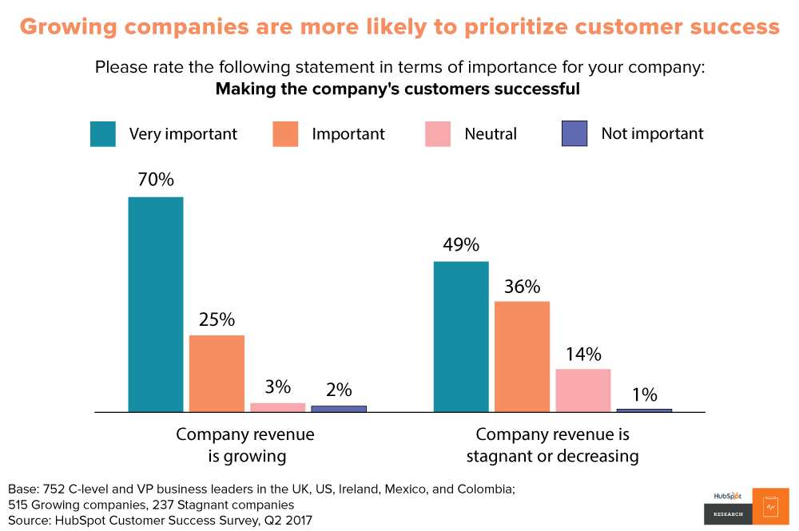

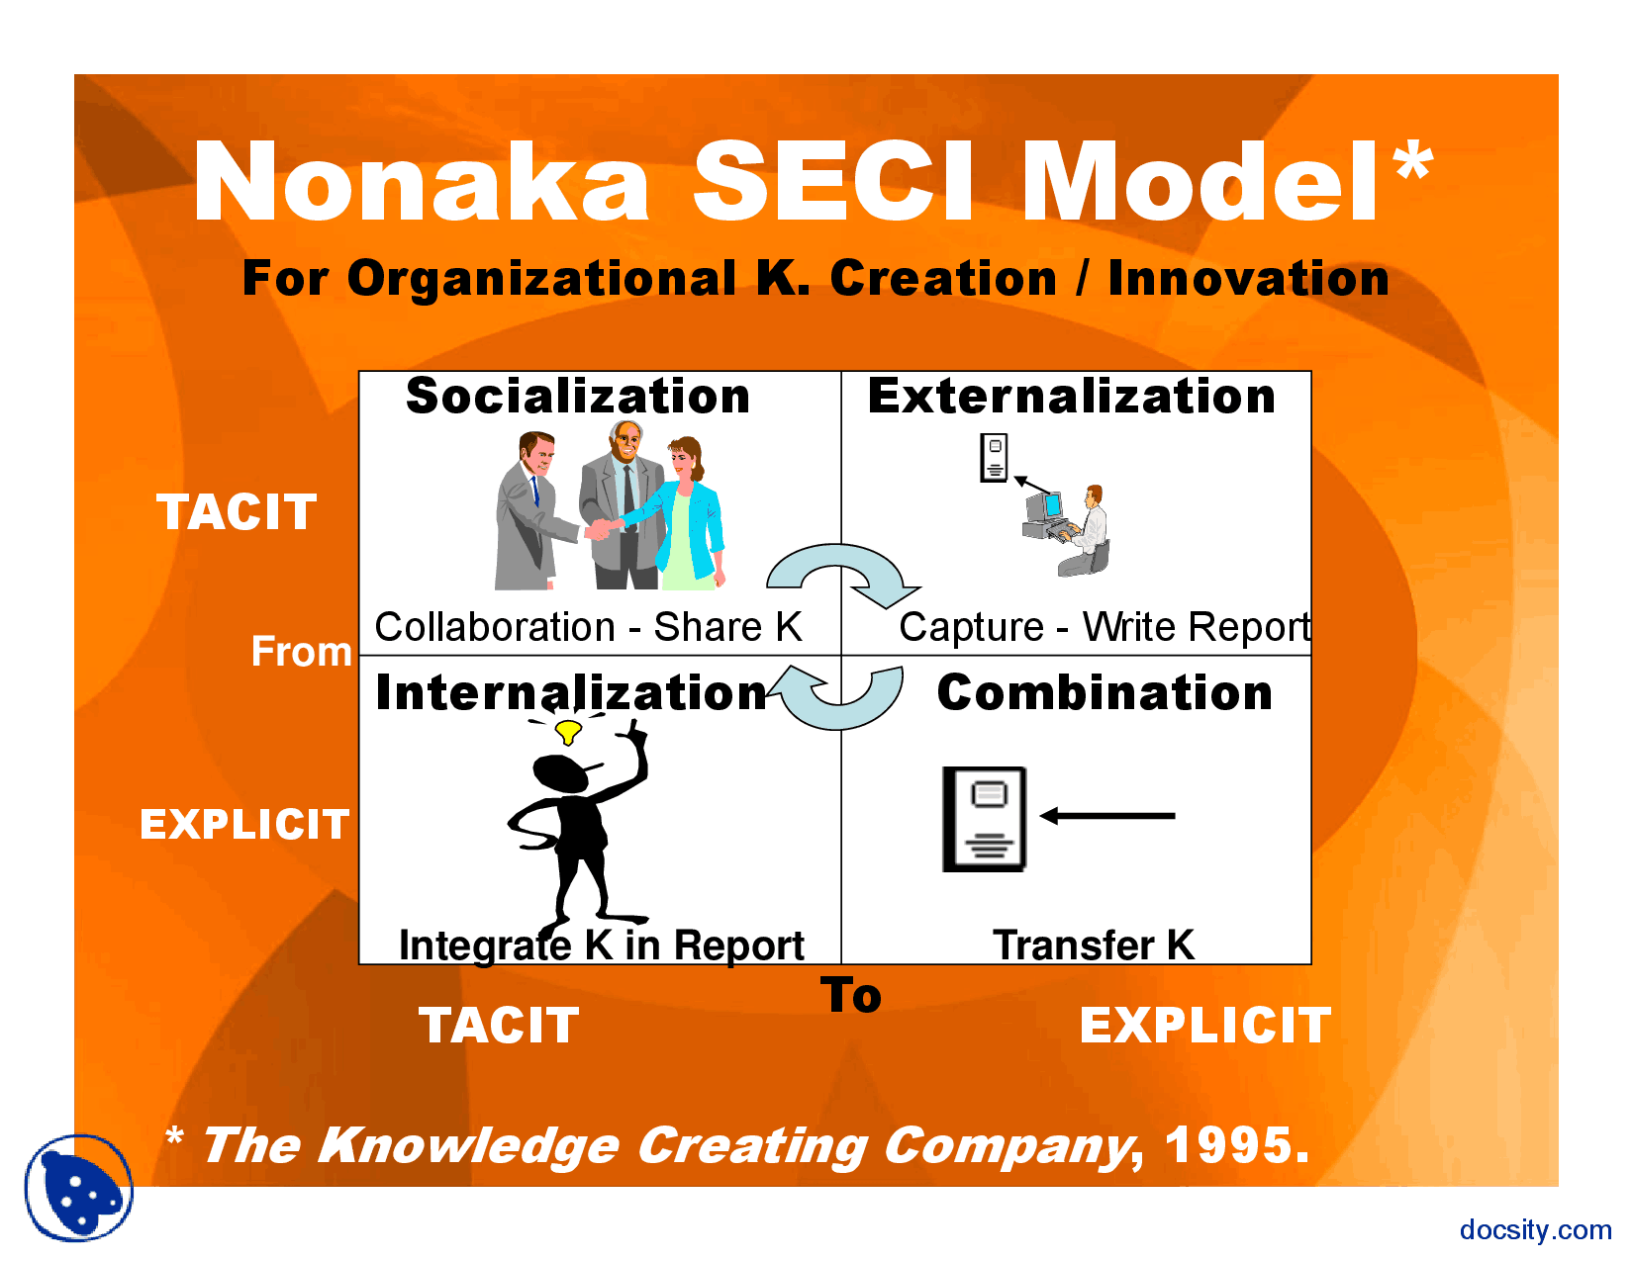
(Docsity.com, 2019)

