

WIRELESS NETWORK PENETRATION TESTING

by
SRAVANTHI SILVERU
(2228080)

Supervisor: Dr. Nitheesh Kaliyamurthy

Project submitted as part of the requirements for the award of MSc Cyber Security and Digital Forensics Analysis

FEBRUARY 2023

DECLARATION FORM

I, SRAVANTHI SILVERU declare that I am the sole author of this Project; that all references cited have been consulted; that I have conducted all work of which this is a record, and that the finished work lies within the prescribed word limits.
This work has not previously been accepted as part of any other degree submission.

Signed: Sravanthi Silveru
Date : 23 Feb 2024

FORM OF CONSENT

I SRAVANTHI SILVERU hereby consent that my Project, submitted in candidature for the M.Sc. Applied Computing degree, if successful, may be made available for inter-library loan or photocopying (subject to the law of copyright), and that the title and abstract may be made available to outside organisations.

Signed: Sravanthi Silveru
Date : 23 Feb 2024

ABSTRACT

Wireless networks, known for their high data speeds, cost-effectiveness, flexibility, and accessibility have made them extremely popular. However, because wireless media is broadcast in nature, they are vulnerable to serious security risks. The growth and popularity of the internet have given rise to several issues, such as phishing, spamming, hacking, and cyber theft. This project focuses on leveraging penetration testing to evaluate the security of wireless networks. It aims to perform attacks and vulnerability assessments on Wireless Equivalent Privacy (WEP), Wi-Fi Protected Access (WPA), and 802.11i (WPA2) security protocols through penetration testing. With the help of its Aircrack-ng tools, wireshark, Kali Linux was used to perform penetration testing. We are utilizing the powerful tool Kali Linux Operating System (OS) for the penetration testing.

TABLE OF CONTENTS

ABSTRACT 3
LIST OF FIGURES 5
1. INTRODUCTION 6
1.1 Problem Statement 7
1.2 Aim & Objectives 8
2. LITERATURE REVIEW 9
2.1 BACKGROUND 9
2.2 WLAN SECURITY 10
2.3 ATTACKS ON WLAN 10
2.4 Wired Equivalent Privacy (WEP) 12
2.5 Wi-Fi Protected Access (WPA) 13
2.6 Wi-Fi Protected Access 2 (WPA 2) 13
3. METHODOLOGY 15
3.1 Approach 15
3.2 Research Methods 16
3.2.1 Research Philosophy 16
3.2.2. Research Approach 16
3.2.3. Research Strategy 17
3.2.4 Time Horizon 17
3.2.5. Research Choice 17
3.3 Data collection 18
3.4 Experimental Approach 18
3.5 Reporting 19
4. WIRELESS NETWORK SECURITY 20
4.1 WLAN Security Technologies 20
4.2 Authentication techniques 21
4.3 Service Set Identifier (SSID) 21
4.4 SECURITY CHALLENGES 22
4.5 Temporal Key Integrity Protocol (TKIP) 23
4.6 IEEE STANDARDS 24
5. DESIGN AND IMPLEMENTATION 26
5.1 Laboratory Experiment Setup and Requirements 26
5.2 Vulnerability assessment 27
5.3 Attacks on WLAN protocols 28
5.4 Exploiting Vulnerabilities in IEEE 802.11 WEP Security Protocol 30
5.5 Exploiting Vulnerabilities in IEEE 802.11 WPA/WPA2 Encryption Protocol 33
5.6 Analysis on Vulnerabilities in IEEE 802.11 WEP, WPA/WPA2 Encryption Protocol 34
6. RESULTS AND DISCUSSION 37
7. CONCLUSIONS 38
7.1 FUTURE WORK 38
REFERENCES 39

LIST OF FIGURES

Figure 1 : Schematics of the Wired Equivalent Privacy (WEP) protocol 13
Figure 2: Research Methodology 18
Figure 3: Steps of Hacking 20
Figure 4: Security Capabilities of WEP, WPA/WPA2 29
Figure 5: wireless connection wlan0 31
Figure 6: Capture of Data Packets 31
Figure 7: Generation of ARP Packets 31
Figure 8: Attacker's Successful Fake Authentication and Association with the Target AP 32
Figure 9: Keystream and plaintext file capture 32
Figure 10: New IV Generation from Forged Packets 32
Figure 11: WEP Key Successfully Cracked 33
Figure 12: WPA2 network 33
Figure 13: capture points with wireshark 34
Figure 14: Successful Capture of WPA Handshake 34
Figure 15: Attacker Connects to Access Point 35
Figure 16: Plaintext and Keystream files 35
Figure 17: Successful Crack Of WEP 36
Figure 18: WPA Four-way Handshake 36
Figure 19: Successful crack of WPA/WPA2 37

INTRODUCTION

The modern world is made up of billions of challenging networks, systems, apps, and gadgets. In order to protect against a variety of risks and attack vectors, it is imperative that they are securely and quickly deployed. Because of its ease of use, the Internet has become a need in all spheres of life. An online user's actions raise the possibility that identity fraudsters would use their personal information. Both the client and the business need to make sure that their networks are safe and that these kinds of things don't happen frequently. Sensitive data, including user information, bank records, and other private information, is contained on the websites and systems and is safeguarded by appropriate policies.
Computer networks are made up of a number of "interconnections" made by wired or wireless transmission media connecting two or more independent computers. In a local network, a wireless local area network (WLAN) is a substitute for cabling issues. Installed wireless network security frequently retains vendor defaults, including SSID, IP address, remote management, DHCP enabled, frequency channels, and even the lack of an administrator login or password. The Institute of Electrical and Electronics Engineers (IEEE) has designated "802.11b"[1] as the industry standard for a class of certified wireless networking products that meet this standard. WiFi is a new technology that is preferred for wireless local area networking in both home and business environments. One of the most crucial elements in keeping an eye on and stopping harmful and unauthorised use of network resources is security. When creating a secure network architecture, the following elements must be taken into account: availability, integrity, confidentiality, and authentication. Information with a degree of sensitivity that is restricted to authorised access and shielded from unauthorised access is referred to as confidential. Integrity related to the accuracy of the data, meaning that the information is free from manipulation. It guarantees the legitimacy and guards against inadvertent or purposeful changes. Accessibility of data to validated users, or the availability of the data to allowed users, is referred to as availability.
Since its introduction, the IEEE 802.11 Wireless Local Area Network (WLAN) has developed into the most straightforward network technology to set up. Its use of a Local Area Network (LAN), which is less expensive and requires simple setup, installation, and configuration procedures, is the reason for its popularity [2]. The presence of WLAN poses a threat to the security of the network infrastructure, posing difficulties for both the organisation and network administrators. In contrast to wired networks, WLAN signals can travel outside of a defined area. noted that since wireless technology is shared by its users outside, data packets can be readily sniffed and captured by attackers. WLANs are susceptible to a variety of threats and harms, including denial of service (DoS), compromised systems, and data theft . This study offers an evaluation of WLAN security, utilising penetration testing tools to look for and take advantage of vulnerabilities in WLAN security protocols. Penetration testing, as defined by the National Institute of Standards and Technology (NIST), is a type of security testing that simulates cyberattacks in order to find system or network vulnerabilities before adversaries can exploit them in real life.[3] using penetration testing to identify weak points and launch assaults against the security protocols of 802.11i (WPA2), Wi-Fi Protected Access (WPA), and Wireless Equivalent Privacy (WEP). Kali Linux was used for the penetration testing, along with its Open Source tools kali, Aircrack-ng tools.
Linux Kali is a reliable tool for analysing application, system, and network vulnerabilities. To exploit their vulnerabilities, this project has used Kali to conduct Exploiting Vulnerabilities in IEEE 802.11 WEP/WPA/WPA2 Security Protocol and cracking encryption protocol[4]. Wireless Network Penetration Testing has become a vital endeavour to protect digital infrastructures in the constantly changing field of cybersecurity. The main goal of this project is to evaluate a WiFi network's security using a TP-Link adapter. Through the use of a variety of specialised tools and focused attack techniques, our goal is to identify vulnerabilities, exploit weaknesses, and ultimately fortify the network's defences. The objective of this project is to conduct a thorough penetration test using Kali Linux hacking tools to assess the security and robustness of IEEE 802.11 wireless network encryption protocols, including WEP, WPA, and WPA2. The project's objectives are to find gaps and vulnerabilities in these encryption standards, evaluate how well they protect data transmission, and offer useful information for improving wireless network security using simulated cyberattacks. The goal of the project is to support continuous efforts to enhance wireless communication infrastructure security and lessen potential cyberthreats.

1.1 Problem Statement
When wireless networks use antiquated encryption standards, like WEP, they leave them open to vulnerabilities and make them vulnerable to cyberattacks. Attackers compromise the confidentiality and integrity of sensitive data by intercepting and decrypting it using these flaws. Furthermore, malicious actors can easily get around weak or default authentication techniques like shared keys or MAC address filtering, which could result in unauthorised access and data breaches. Intentional or unintentional, rogue access points can act as entry points for illegal networks, opening the door for a variety of cyberattacks like data exfiltration and man-in-the-middle attacks. These risks are made worse by inadequate network monitoring and logging, which delays the impact of possible breaches by preventing prompt detection and response to security incidents.
It is necessary to put in place a thorough wireless network security plan to handle these issues. This entails deploying IDS/IPS solutions, conducting frequent security audits and penetration tests, utilising strong encryption like WPA3 with reliable authentication like 802.1X, educating staff members on security best practices, and making sure patch management for network hardware and software is in place. By using this method, network security is greatly improved and cyber threats are prevented.

1.2 Aim & Objectives
Aim:
With the use of Kali Linux hacking tools, this report aims to evaluate wireless network security through a comprehensive Wireless Network Penetration Testing of IEEE 802.11 encryption protocols. This will entail assessing the efficacy of encryption protocols, locating weak points, creating cyberattack scenarios, and making suggestions to improve the wireless network's general security posture.
Objective:
The objectives of the report are as follows:
- This report main goal is to use Kali Linux hacking tools to conduct a wireless network penetration test with an emphasis on the IEEE 802.11 encryption protocols (WEP, WPA, WPA2, and WPA3). This means that the efficacy of these encryption protocols in wireless networks must be carefully assessed, and any potential flaws or vulnerabilities must be noted.[5]
- The project will evaluate the network's security posture by assessing its resilience to attacks through the simulation of real-world cyber threats. This entails running penetration tests, modelling cyberattacks, and assessing how the network reacts to them.
- Practical suggestions will be developed based on the results to improve the wireless network's general security posture. These suggestions will deal with vulnerabilities that have been found, make improvements to security, and offer best practices to reduce possible risks.
- The ultimate objective is to offer a thorough evaluation of the security of the wireless network, empowering stakeholders to take well-informed decisions and put into place efficient defences against online attacks.
.

LITERATURE REVIEW

Since its introduction, the IEEE 802.11 Wireless Local Area Network (WLAN) has developed into the easiest to use and well-established network technology. The usage of a Local Area Network (LAN), which is less expensive and requires simple setup, installation, and configuration processes, is the reason for its popularity. A set of standards for WLAN communications between devices is provided by IEEE 802.11. A subset of the 802 standards, the 802.11 standard was created by the IEEE in 1997. The Local and Metropolitan Area Network (MAN) is handled by the 802, and the WLAN is handled by the.11 suffix [6]. To facilitate the spread of wireless signals and communication throughout the wireless network, 802.11 is regulated by a set of rules or protocols. The 802.11 protocol uses the Medium Access Control (MAC) protocol with Collision Avoidance (CA) and Carrier Sense Multiple Access (CSMA). Versions of the standard, 802.11a, 802.11b, 802.11g, 802.11n, and 802.11ac, can be identified by one or two final alphabetic characters. The 802.11a, 802.11b, and 802.11g standards are the most popular and extensively used among.[7] With an emphasis on using a TP-Link adapter, we examine important ideas, approaches, and conclusions associated with wireless network penetration testing in this literature review.

2.1 BACKGROUND

Today's digital world is dominated by wireless networks because they are convenient and provide connectivity. They do, however, also pose particular security difficulties. The protocols for wireless local area networking are specified by the IEEE 802.11 family of standards, also known as Wi-Fi. (WLAN). Several encryption protocols, including WEP (Wired Equivalent Privacy), WPA (Wi-Fi Protected Access), WPA2, and the more recent WPA3, are included in these standards [8].
Newer encryption protocols, like WPA3, have been introduced to address the vulnerabilities in older protocols, like WEP, that have been discovered to be susceptible to attacks over time. However, implementation, configuration, and other factors can affect how effective these protocols are in securing wireless networks.
Considering how vital wireless networks are to contemporary communication, a thorough assessment of their security is imperative. The purpose of wireless network penetration testing is to evaluate the security posture of wireless networks and replicate actual cyber threats [9]. In order to find vulnerabilities and suggest security improvements, the main objective of this project is to assess the IEEE 802.11 encryption protocols using Kali Linux hacking tools like Aircrack-ng, Wireshark.
This report aims to provide useful insights into wireless network security through a comprehensive assessment and penetration testing, empowering individuals and organisations to make informed decisions and put security measures in place.

2.2 WLAN SECURITY

Interaction A local area network that uses radio wave media is called a wireless local network, or WLAN. In certain cases, deploying wireless local area networks (WLANs) is even more cost-effective and efficient than setting up wired networks throughout an entire building. The market, services, and applications for wireless networking technologies are expanding rapidly due to their promotion.[10] Since WLANs are not the same as their wired counterparts, it is crucial to increase their security to a level that is at least comparable to that of wired LANs. WLANs are installed as an extension of the fixed/wired LANs that already exist. Ad hoc and infrastructure modes are the two network topology modes that IEEE802.11 can typically operate in. The security of the wired LAN will eventually be compromised by a WLAN security breach. WLAN security is hampered by a number of factors, such as the use of radio frequency (RF) as a communication medium and the broadcasting of all messages to any location within the WLAN coverage.
As air waves cannot be stopped or restricted in a space, there is a significant chance of both listening in on conversations and Man-in-the-Middle attacks. In wired LANs, on the other hand, data transmission is accomplished by cables that can be somewhat monitored and controlled, and crucial servers can be secured in a dedicated room. According to the IEEE, a secured WLAN must meet five essential requirements: authentication, access control, confidentiality, non-repudiation, and data integrity. It is necessary to put in place a mechanism for STAs to authenticate in order to grant access to the WLAN. These Mechanisms must be dependable, scalable, and efficient. The WLAN protocols are comprised of three security standards: Wired Equivalent Privacy (WEP), Wi-Fi Protected Access (WPA), and Wi-Fi Protected Access 2 (WPA2). Despite this, WLAN security is vulnerable to attacks like traffic analysis, eavesdropping, and denial of service.[11]

2.3 ATTACKS ON WLAN

A WLAN is vulnerable to attacks since, in contrast to a wired network, it relies on radio frequency infrared transmission technology to connect devices. Since the compromise of IEEE standard security algorithm for wireless networks, Wired Equivalent Privacy (WEP), wireless insecurity has become a serious problem. The goal of attacks on wireless networks is to compromise the availability, confidentiality, and integrity of the network and the necessary data. There are two types of attacks on wireless networks: passive attacks and active attacks[12].
Attacks that are passive do not modify resources. The confidentiality is primarily at risk from these attacks. An attacker quietly listens in on network traffic, waiting for a client to attempt to establish a connection with the Access Point (AP) or look up the network Service Set Identifier (SSID). This allows the attacker to obtain the SSID in plaintext. Data sent over the network, including that used for traffic analysis, packet sniffing, war-driving, and port scanning, can be intercepted by an attacker. Since the attacker doesn't alter the information or content, these attacks are typically hard to identify.
Altering resources is a component of active attacks. When an attack is active, the aggressor node must expend some energy to execute the attack. In addition to obtaining information, the attacker has the ability to alter network data and even introduce bogus packets into the system.[13] Attackers can use techniques like Denial of Service (DoS), Session Hijacking, Brute Force Attack, Reply Attack, and Man in the Middle (MITM) attack to cause disruptions to the network's regular operations.
Communication between wireless station (STAs) and Access Point (AP) results in the clear transmission of spoofing MAC addresses. To prevent other users from listening in on the conversation, a method of securing access to access points and, by extension, the network is used. Maintaining the accuracy and correctness of information exchanged between STAs and AP is referred to as integrity.
On wired and wireless networks, denial of service attacks, or DoS, pose a severe risk. The goal of this attack is to stop the network's availability and the services it offers. DoS is carried out in a number of ways in WLANs, such as by causing external radio sources to interfere with the frequency spectrum, which prevents access to the WLAN or, in the best cases, permits access at a slower data rate.
A WLAN is identified by its Service Set Identifier (SSID), which is disclosed by the Access Point (AP). Understanding SSID is crucial as it serves as the initial line of defence against unwanted intrusions. Sadly, some APs disable SSID requests by default, allowing users to access the WLAN without having to provide proof that they are aware of the SSID However, some APs do not disable SSID requests; rather, they enable SSID requests but broadcast the SSID name over the air. The fact that it promotes the WLAN's existence makes this another security issue. It is necessary to enable SSID requests and prevent the broadcasting of SSID names, requiring users to demonstrate their awareness of the WLAN's SSID before initiating communication.

2.4 Wired Equivalent Privacy (WEP)

A security protocol known as Wired Equivalent Privacy (WEP) was first included in the IEEE 802.11 standard in 1997.With 40-bit and 104-bit encryption keys, the RC4 symmetric stream cypher is the foundation of the WEP encryption. A three-byte Initialization Vector (IV) and a shared WEP Key consisting of hexadecimal digits for encryption and decryption are the two parameters involved in WEP. It functions at both the physical and data link layers. Significant flaws from 2001, such as short IV size and keystream reuse, demonstrated how simple it was to intercept and alter transmitted data. Due to these shortcomings, WPA was developed to close the security gap left by insufficient encryption methods.[14]
A brief Initialization Vector (IV), usually 24 bits in length, is used in WEP. It is also transmitted in clear text and reused numerous times. The 40-bit short shared secret key and the 24-bit IV are concatenated to create the WEP encryption key, also known as the RC4 key stream. The security system's secret components are the 40-bit shared secret keys and the 64-bit WEP encryption key stream. The generated WEP encryption key stream repeats itself over time due to the short shared key length (40 bits), frequent key reuse, short IV length, and again, frequent IV value reuse. This means that the cypher text (C) is produced by a straightforward XOR operation between the plain text message (M) and the WEP encryption key (K).
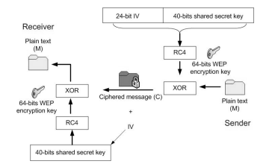
Figure 1 : Schematics of the Wired Equivalent Privacy (WEP) protocol

Weakness and Vulnerabilities in WEP employs the CRC checksum for data integrity and the RC4 algorithm and secret key to provide access control and confidentiality. The WEP security protocol has flaws that hackers could exploit because of these security control mechanisms.[15]

2.5 Wi-Fi Protected Access (WPA)

In order to address the weaknesses and vulnerabilities in WEP, the Wi-Fi Alliance developed WPA in 2003. Temporal Key Integrity Protocol (TKIP), a hashing algorithm that jumbles keys and adds an integrity check feature to stop key manipulation, is how WPA enhances data encryption. With each packet, TKIP generates a unique 128-bit key to that prevent the attacks that WEP permits. Users of older WLAN equipment can switch to TKIP without having to replace their hardware because it includes multiple WEP encapsulation techniques. Four additional algorithms are included in TKIP to increase key strength: Message integrity check (MIC), IV sequencing mechanism, Per-packet key mixing function, and Re-keying mechanism.[16] Like WEP, TKIP employs the RC4 encryption algorithm; however, it uses a hash value to identify the temporal key that is generated uniquely for each packet that is traversed. Instead of using the ICV that is used with WEP for integrity checks, TKIP uses the Message Integrity Code (MIC). As a result, hackers are unable to insert data into a packet in order to identify the keystream that is used to encrypt the data. Additionally, it enhances integrity check by preventing replay attacks with sequence counters.

2.6 Wi-Fi Protected Access 2 (WPA 2)

The cryptographic algorithm's flaw is a double-edged sword because it both threatens the foundations of encryption and kickstarts the cryptography development cycle that produces WEP, WPA, and WPA2. The weakness in the earlier protocols led to the creation of WPA2, also referred to as IEEE 802.11i. The vulnerability of Layer 3, or the network layer (IP) in the Open System Interconnection Seven-Layer Reference Model (OSI), stemmed from the fact that earlier protocols required the wireless network to rely on a Virtual Private Network (VPN) for layer security. Interoperability is the primary objective of the Wi-Fi alliance, and it is accomplished by the WPA2 protocol. Due to serious security flaws in the wireless protocols WEP and WPA, the alliance decided to create WPA2, a new defensive protocol that secures the principles of encryption. The Wi-Fi alliance has the advantage of using advanced encryption and authentication techniques to strengthen protocols, having found vulnerabilities in earlier wireless protocols[17].
In 2004, the Wi-Fi Alliance enhanced WPA by creating 802.11i (WPA2), which is based on the Robust Security Network (RSN) concept. It addresses Data Transfer Privacy, Authentication, and Key Management—the three main areas of security. WPA2 encrypts data using the Counter Mode Cypher Block Chaining - Message Authentication Code (CBC-MAC) protocol (CCMP), which is an Advanced Encryption Standard (AES). To replace TKIP and WEP, CCMP was developed as part of 802.11 security for 802.11i (WPA2). WPA/WPA2 uses dynamic keys generated from per-packet to generate the Pairwise Master Key (PMK) [18]. According to, the four-way handshake provides mutual authentication based on the PMK and agrees on a fresh session key known as the Pairwise Transient Key (PTK). The four-way handshake contains four packets (messages) exchanged between the client (Supplicant) and the AP (Authenticator). The PMK is generated by using the hashing algorithm PBKDF2, which requires inputs:
PMK = PBKDF2 (Passphrase, SSID, SSIDlen, 4096, 256) Where:
Passphrase: The passphrase (8 to 63 characters) SSID: the SSID of the Authenticator (AP) SSIDlen: the length of the SSID
4096: Number of hashing iterations (through SHA1 algorithm)
256: Intended Key Length of the PSK
PTK which is a dynamic key is used to produce the four-way handshake during authentication. The PMK and two Nonces are used to create the PTK when connection happens.
PTK = Function (PMK, Authenticator Nonce (ANonce), Supplicant Nonce (SNonce), Authenticator MAC, Supplicant MAC)
Extensible Authentication Protocol over LAN (EAPOL) frames are used to define the messages that are exchanged during the four-way handshake. Key exchange and negotiation take place using the EAPOL-Key that is part of the four-way handshake. Following the creation of the PMK, the four-way handshake between the authenticator and the petitioner begins.

METHODOLOGY

Using etical hacking tools for Kali Linux, this report methodology entails a methodical analysis of wireless network security with a particular focus on IEEE 802.11 encryption protocols: WPA, WPA, and WPA2/WPA3. Through a thorough approach that includes network reconnaissance, vulnerability assessment, exploitation, post-exploitation analysis, and documentation, the report seeks to identify vulnerabilities and weaknesses in these protocols. The project aims to evaluate the security posture of wireless networks and offer practical insights for fortifying their defences by modelling actual cyber threats. The project aims to obtain unauthorised access to the target network by analysing network traffic, capturing handshakes, and exploiting vulnerabilities through the utilisation of tools like Airodump-ng, Wireshark, and Aircrack-ng. Examining captured traffic to spot lateral movement and possible security breaches is known as post-exploitation analysis. At the end of the project, a thorough report with all the findings, vulnerabilities, exploits, and suggestions for improving the target network's
security will be assembled.

3.1 Approach

It is crucial to grasp the core principles of ethical hacking, which revolve around systematically identifying vulnerabilities from a hacker's perspective, ultimately bolstering systems with heightened security measures. A compelling facet of ethical hacking penetration testing is its categorization into three types: black box, grey box, and white box. The primary distinguishing factor among these classifications is the level of information available to the attacker at the outset of the intrusion.
During a white-box test, a penetration tester conducts a thorough analysis of a system's architecture and functionality in a controlled environment, where they possess a deep understanding of network complexities and the necessary access privileges.
In a gray box test, the participant receives only partial information about the system. This unique approach allows for the assessment of a person's actions with limited knowledge, providing insight into the effectiveness of security measures against insiders attempting unauthorized data access.
In a black box test, the attacker attempts to mimic the actions of a genuine attacker without possessing any previous knowledge of the system or network.

3.2 Research Methods

With a primary focus on the IEEE 802.11 encryption protocols, this project's research methods combine empirical and analytical techniques to evaluate the security of wireless networks. To lay the groundwork for the research, a thorough analysis of the body of prior research—including scholarly articles, industry reports, and case studies—will be conducted in order to gain a basic understanding of wireless network security and encryption protocols. The levels of abstraction surrounding the study goals develop as a result of the researcher's decisions and answers to the different options and questions, necessitating evaluation and consideration. The goal of this endeavour is to make the reader aware of all the different parts of the research so they can comprehend the basis for the conclusions[19].

3.2.1 Research Philosophy

The set of values, precepts, and presumptions that direct a researcher's method of conducting research is referred to as their research philosophy. It is a reflection of the researcher's worldview and guides their selection of design and methodology. The three primary schools of thought in research are interpretivism, Pragmatism and positivism. The focus of positivism is on the objective, empirical study of phenomena with the goal of producing results that can be repeated and generalised. Conversely, interpretivism uses a variety of qualitative techniques to help us understand people's subjective experiences and meanings. Selecting a research philosophy is essential because it influences how the study is conducted and how the findings are interpreted. The present study will employ a positivist research philosophy to perform a quantitative analysis of wireless network security. The primary objective of the analysis is to identify vulnerabilities and weaknesses through the use of Kali Linux hacking tools.[20]

3.2.2. Research Approach

On the second layer of the research, the inductive and deductive philosophies represent the two main research approaches used in this study. Using inductive techniques, theories are derived directly from the study, without reference to any prior theories. Deductive approaches, on the other hand, start with a theory and work to either develop it further or empirically validate it. A deductive approach is thought to be most appropriate given the nature of the research aspect and the requirement to incorporate both theory and experimentation. With this method, theories can be systematically explored and hypotheses tested, resulting in a more organised and targeted investigation.

3.2.3. Research Strategy

Different strategies direct the methodology in the third layer of the research. Following the scientific method, experimental research seeks to confirm or refute theories in controlled environments. On the other hand, action research aims to tackle real-world problems. Case studies entail in-depth analyses of particular topics. New theories can be shaped by data thanks to grounded theory. The study of ethnography entails observing and analysing cultural practices. For historical investigations, archival research makes use of pre-existing materials. In order to address various research questions and objectives, each strategy provides special insights and techniques for carrying out research.

3.2.4 Time Horizon

- When gathering data over a long period of time—weeks, months, or years—a longitudinal time horizon is used. This method works well for monitoring shifts and patterns over time, guaranteeing a thorough comprehension of the topic.
- On the other hand, a cross-sectional temporal horizon examines language patterns in memes at a particular point in time, providing an instantaneous picture of the language environment at that time.

3.2.5. Research Choice

One option for a research approach is a mono approach, which only uses data that is either qualitative or quantitative. On the other hand, both kinds of data are combined in a mixed-methods approach. A multi-method approach, in addition, incorporates a wider variety of methods than a singular qualitative and quantitative approach.
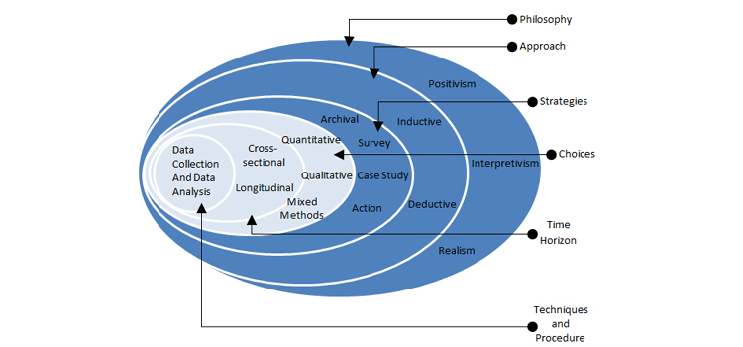
Figure 2: Research Methodology

3.3 Data collection

The data collection process will involve the use of specialized tools and techniques to gather information about the target wireless network, including its topology, active devices, and encryption protocols. The primary tools utilized will include Airodump-ng, for network reconnaissance and vulnerability assessment. Aircrack-ng will be used to exploit identified vulnerabilities, while Wireshark will facilitate post-exploitation analysis of network traffic. The data collected will include network SSIDs, BSSIDs, MAC addresses, signal strengths, open ports, service versions, captured handshakes, and decrypted packets. This information will be used to assess the security posture of the wireless network and provide actionable insights for improvement. Both passive and active data collection techniques are used in this process.
Passive Data Collection:
Network Discovery: Use programmes like Airodump-ng and Kismet to passively locate any active wireless networks in the area.
Signal Strength and BSSID: Note the identified networks' signal strength and BSSID (Basic Service Set Identifier).
Device Identification: List all of the network-connected devices, along with their MAC addresses and signal intensities.
Active Data Collection:
Network Scanning: To find open ports, services, and possible vulnerabilities, actively scan wireless networks.
Packet Capture: To perform a thorough analysis, use Wireshark to capture wireless network traffic. Pay particular attention to data packets pertaining to the encryption protocols.
Authentication Testing: To assess the robustness of encryption protocols and spot vulnerabilities, conduct authentication testing using programmes like Aircrack-ng.

3.4 Experimental Approach

Penetration testing is a crucial technique that is necessary for any business. Given the increase in computer and cybercrimes over the past few years, penetration testing has emerged as one of the most widely used and advised methods of network security. A penetration test can assist in protecting a company from both internal and external threats. Furthermore, the penetration test can assist in identifying vulnerabilities and potential threats that an attacker could exploit [21].
The penetration testing can be separated into the following phases:
- The Pre-engagement Interactions phase defines the scope and all of the penetration testing activities. Talking about the goals, targets, guidelines, and any restrictions is part of this. To guarantee a thorough and efficient test, it also entails learning about the systems and environment of the organisation.
- Intelligence Gathering: During this stage, all relevant data about the target being tested is gathered both actively and passively without establishing any connection to the target.
- Threat Modelling: This stage involves comparing the information found with the assets to identify the regions with the greatest degree of dangers.
- Vulnerability analysis is the process of locating, identifying, and validating both known and unknown vulnerabilities.
- In the exploitation phase, we leverage the vulnerabilities identified in earlier stages. This involves utilizing tools and techniques to exploit weaknesses, gaining unauthorized access to the network or system under test.
- Post-exploitation: The actual action carried out in conjunction with the target, such as file downloads, account creation, and shutdowns system not working. This expression sums up what you should do following exploitation.
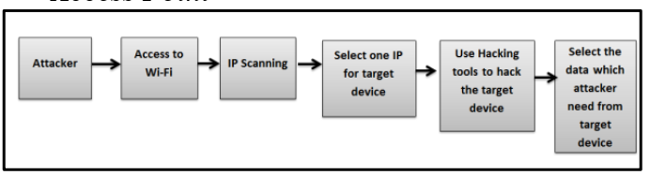
Figure 3: Steps of Hacking

3.5 Reporting
During the Reporting phase, the culmination of the wireless network penetration testing, the results and findings are meticulously summarized. This entails detailing the vulnerabilities, weaknesses, and successful exploits encountered throughout the testing. Furthermore, the report provides actionable suggestions and recommendations to address the identified weaknesses. The ultimate goal is to fortify the target network's defenses and enhance its overall security posture.

WIRELESS NETWORK SECURITY

When we use the term "wireless securitization," we mean something far more expansive than when we use the word "bank vault." It refers to every feature of the wireless communication system that contributes to its dependability and user-friendliness.
There are four main categories of information systems security: 1) computer security, 2) network security, 3) information (data) security, and 4) wireless channel (airlink) security. Wireless network security is a combination of network security and wireless channel security[22]. It is essentially the medium access control and airlink security connected to ad hoc wireless networks and wireless access points. Making the most of the options available to the user is crucial to security. Examples of these options include :
- virtual private networks (VPNs)
- wireless networks' built-in encryption mechanisms, such as Wi-Fi Protected Access (WPA).
Widespread deployments of numerous wireless networks of various sizes, including wireless personal area networks (WPANs), The 10 m range of a wireless personal area network (WPAN) is intended. Examples of these are Bluetooth and IrDA. For this system, additional emerging technologies include 802.15.4a and 802.15.3c—UWB. Wireless local area networks (WLANs) this system can support up to 200 Mbps of data transfer speed and has a range of 100 metres. Wi-Fi (802.11a/b/g) is a commonly utilised wireless local area network technolog. Metropolitan area networks (WMANs) this technology has a 75 Mbps delivery speed. Numerous versions of 802.16 have received certification under the WiMAX brand. and wide area networks (WWANs) with a few hundred Kbps of range, this system covers wider swaths of land, including cities, regions, and even entire nations.
Popular technologies include GSM, GPR, and Edge, demonstrate the rapid development of wireless networking.[23]

WLAN Security Technologies

To solve authentication problems and guarantee the confidentiality and integrity of data transferred over the air, a number of security technologies have been introduced. Three key security technologies are specified in the IEEE 802.11 standard for securing data privacy and granting access to WLANs: WEP, shared key authentication, and open system authentication [24]. But because of these technologies' shortcomings, the Wi-Fi Alliance unveiled "Wi-Fi Protected Access" (WPA), a new industry standard that uses TKIP to secure data privacy and integrity and IEEE 802.1x to improve authentication. The IEEE recently released IEEE 802.11i, a new WLAN security standard that incorporates all of WPA's security features and fixes the flaws in WEP. Furthermore, the certified encryption algorithm in IEEE 802.11i is the Advanced Encryption Standard (AES).
To get the best results, security technology implementation for locating and resolving security vulnerabilities in a WLAN environment must be in line with the security policy issued by the organization's management. This policy describes the roles and responsibilities of network security administrators, wireless users, and handlers for security breaches. It also provides general guidelines for setting up and keeping WLAN security. The efficacy of these security policies depends on enforcement and adherence to them.

Authentication techniques

IEEE 802.11 specifies the open-system and shared key authentication techniques for Wireless Local Area Networks (WLANs). With the open-system approach, access is only allowed based on the Service Set Identifier (SSID) of the network, and all communication between the Station (STA) and Access Point (AP) is unencrypted. Nevertheless, this approach is intrinsically unsafe because Aps broadcast their SSIDs by default. As opposed to this, the shared key method uses WEP keys to decrypt an encrypted challenge that the AP sends to the STA. The STA is verified if the original challenge and the decrypted version match. In this case, the authentication of the STA is required, but not of the AP, so a genuine STA can establish a connection with a rogue AP.
The shared key approach has certain drawbacks, IIing its susceptibility to sniffing attacks, which can compromise network security by revealing the encryption keys. The extensive usage of the open-system authentication method in Aps increases this risk. Another method of authentication is to use STA MAC addresses to filter WLAN access so that only authorised MAC addresses are able to connect to the network. But because of this method’s susceptibility to data traffic monitoring, attackers can easily obtain authenticated MAC addresses and impersonate Aps.
This method is not advised for use on public networks, even though it can be helpful in some situations, such as private WLANs. Scholars have endeavoured to devise novel methodologies for identifying assaults that employ fictitious or manipulated MAC addresses.

Service Set Identifier (SSID)

The Service Set Identifier, or SSID, is a special alphanumeric code that Access Points (Aps) broadcast as a network identifier. Station Terminals (STAs) can’t connect to the network if they don’t know the SSID. However, because the AP broadcasts the SSID publicly, there is a chance that unauthorised stations will intercept it and use it to access the WLAN. One way to reduce this risk is to disable SSID broadcasting, which would force wireless stations to actively look for the unique SSID associated with the intended WLAN. To further improve security, it is advisable to alter the SSID value on a regular basis. But this could pose problems for network managers, particularly in situations where a WLAN has several Aps without a centralised management system. Though not perfect, SSID functions as a fundamental access control measure that can be tweaked to make it more difficult for inexperienced attackers to gain access to the WLAN.

SECURITY CHALLENGES

Wireless networks, especially those that use the IEEE 802.11 standard, present a variety of security challenges that call for an all-encompassing solution. Among the principal security issues are:

- Encryption Weakness:
One of the earliest encryption protocols for wireless networks was WEP (Wired Equivalent Privacy), but it was rapidly discovered to be insecure and readily cracked. In order to fix the flaws in WEP, WPA (Wi-Fi Protected Access) and its improved version, WPA2, were created. Nevertheless, if weak passwords are used, these protocols may still be subject to dictionary and brute-force attacks. WPA3, the most recent standard, introduces more reliable authentication procedures and stronger encryption techniques in an effort to address these vulnerabilities and enhance network security. Nevertheless, to guarantee the security of wireless networks, it’s critical to maintain vigilance and update encryption protocols.

- Authorization and Authentication:
Default Login Passwords: A lot of wireless devices have default login passwords that, if left unmodified, are readily exploited by hackers. Because these default credentials are frequently widely known and disclosed, attackers can easily obtain unauthorised access to the network. To lessen this vulnerability, users must modify the default credentials to strong, one-of-a-kind passwords.
MAC Address Spoofing: In wireless networks, MAC address filtering is a popular authentication technique that limits access based on the MAC address of the device. Attackers can, however, circumvent this authentication method by spoofing, or forging, MAC addresses to look like those of authorised devices[25]. This enables them to enter the network without authorization and possibly engage in harmful activity. Strong encryption and authentication protocols are two more security measures that should be put in place to prevent MAC address spoofing.

- Eavesdropping and Packet Sniffing:

Data Interception: It is possible to intercept wireless signals, which can result in the unapproved collection and examination of private information. Without the sender's or recipient's knowledge, attackers can use specialised equipment to intercept wireless data transmissions, including emails, passwords, and credit card numbers. The confidentiality and integrity of the transmitted information may be jeopardised by this data interception, potentially resulting in data breaches and privacy violations[26].
Man-in-the-Middle Attacks: Man-in-the-Middle (MitM) attacks involve the placement of an attacker between two parties in communication with the intent of intercepting and manipulating data. Attackers can eavesdrop on conversations, steal confidential information, or even introduce malicious code into the communication stream by intercepting and manipulating the data.

- DoS (denial-of-service) attacks:

Network Disruption: DoS attacks, in which attackers overload the network with traffic to prevent it from being accessible to authorised users, can affect wireless networks. These attacks result in service disruption, sluggish network performance, and even total outage due to an overabundance of network resources. Attackers frequently launch coordinated denial-of-service (DoS) attacks using botnets, which are networks of compromised devices, making it challenging to identify the attack's origin.
Deauthentication Attacks: A deauthentication attack is a particular kind of denial-of-service (DoS) attack on wireless networks. Here, users are disconnected by attackers using deauthentication frames, which disrupts service. Network connectivity is hampered by attackers who require reauthentication.[27]

Temporal Key Integrity Protocol (TKIP)

The conventional WEP (Wired Equivalent Privacy) protocol is greatly outperformed by the TKIP (Temporal Key Integrity Protocol). Because wireless interface cards and legacy access points have the hardware required for WEP, TKIP was created to add software enhancements for increased security while preserving backward compatibility. By addressing the need for a more secure protocol without requiring new hardware, this method maximises the effective use of currently available wireless equipment while minimising additional costs. Although it is a temporary fix, TKIP offers a financially viable solution to the security problems associated with WEP that were common at the time[28].
Even though TKIP is based on the RC4 stream cypher, it has additional security features like extended IV and encryption/authentication keys. TKIP can support up to 128 bits of encryption key, 64 bits of authentication key, and 48 bits of IV, while WEP can only support up to 24 bits of encryption key and a maximum of 104 bits. Longer keys and IVs, along with the use of unique keys for each packet and no key reusing, are some of the factors that make TKIP a noteworthy security enhancement against exhaustive key search attacks.
TKIP creates distinct encryption keys for every packet sent during communication between STAs (Station Devices) and the AP (Access Point). The packet sequence number, sometimes referred to as the TKIP sequence number, the sender's MAC address, and a shared base key are used to generate these keys. Figure 6 shows how TKIP per-packet keys are constructed. The IV and extended IV fields of the WEP data unit contain the TKIP sequence number, which acts as a sequence counter. By using these fields as inputs for two key mixing functions, TKIP interprets them as the TKIP Sequence Counter (TSC), which generates an IV and a per-packet key for the WEP encryption algorithm. Basic XOR and AND logic operations are involved in the key mixing functions. The TSC provides a layer of protection against replay attacks that is not present in the older WEP protocol.

IEEE STANDARDS

The need for networking standards in a variety of industries, including business, education, health, communication, and transportation, had already grown significantly by the early 1990s. This ultimately gave rise to the 802.11 Standards in 1997. IEEE 802.11 can carry high-definition radio transmission with minimal equipment and setup requirements. Large networks are primarily designed using this standard.WiFi is a new technology that is preferred for wireless local area networking in both business and home environments. It is the term used to describe a class of certified wireless networking products conforming to an industry standard designated by the Institute of Electrical and Electronics Engineers (IEEE) as "802.11."[29]
The main goal of IEEE 802.11 was to meet home and office networking requirements. But because it could only transfer data at a speed of 2 Mbps, new standards were quickly required. Because of this, the standards have already been extended multiple times, and there are still some to come. The frequencies, bandwidth, data rate, and coverage range of these extensions essentially set them apart from one another. These networking standards specify the type of data that can be transported over these networks and operate at various bands throughout the wireless spectrum[30].
The extensions of 802.11 that are implemented so far are:
- 802.11b
- 802.11a
- 802.11g
- 802.11n
- 802.11ac
- 802.11ad
The domain of networking and communication protocols is one of the most important areas covered by IEEE standards. Ethernet, Wi-Fi (IEEE 802.11), and other wireless communication protocols are just a few of the networking technologies that are covered by the IEEE 802 series of standards. These standards provide guidelines for the design and implementation of network hardware and software by defining the specifications for the physical and data link layers of the OSI model.
For instance, the data link layer (MAC addresses and frame formats) and physical layer (cable and connectors) specifications for Ethernet networks are outlined in the IEEE 802.3 standard. In a similar vein, the IEEE 802.11 standard outlines the requirements for wireless local area networks (WLANs), covering both the MAC layer (such as frame formats and access control mechanisms) and the physical layer (such as radio frequencies and modulation techniques).
IEEE 802.1 (network management), IEEE 802.15 (wireless personal area networks), IEEE 802.16 (wireless metropolitan area networks), and IEEE 802.22 (cognitive radio networks) are some other noteworthy IEEE standards. These standards are essential for guaranteeing networking technologies' compatibility and interoperability, which makes it possible to integrate various systems and devices with ease.

DESIGN AND IMPLEMENTATION

Setting up a WLAN infrastructure as an experimental network laboratory was the setting that was selected for the assessment and penetration testing. The study took into consideration using the network laboratory to protect user privacy and the legality of information in order to avoid harming the networks of any individuals or organisations.

5.1 Laboratory Experiment Setup and Requirements

An external wireless adapter, two laptops (one serving as the PenTester PC and the other as the supplicant, which could be any device with wireless connectivity), and an authenticator (wireless router) were needed for the experiment. The connections between the utilised devices are shown in Figure

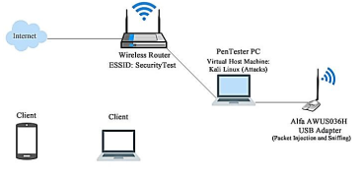

List of software tools and devices to find the Vulnerabilities.
- Tp-Link Archer T3U
With its exceptional speed and range, the TP-Link Archer T3U is a unique high-performance wireless USB adapter that's a great option for improved productivity and seamless connectivity.
Tp-link Specifications:
- USB Adapter Archer T3U
- IEEE 802.11b/g/n 2.4GHz, 802.11a/n/ac 5GHz
- Interface: USB 3.0
- Security: WEP, WPA/WPA2

- Kali Linux, a popular Linux distribution, is extensively employed in the cybersecurity field for conducting penetration testing. It is renowned for its robust suite of pre-installed tools tailored for ethical hacking practices.
- VirtualBox, a virtualization software designed for x86 and AMD64/Intel64 architectures, was employed in this thesis to execute Kali Linux. This decision was made to facilitate the testing and demonstration of various hacking techniques and security measures in a controlled environment.
- The Airodump-ng tool is a crucial component in the arsenal of a cybersecurity professional, particularly in the context of wireless network penetration testing. Its capacity to record and examine wireless packets makes it useful for identifying security flaws and vulnerabilities.
- In this comprehensive research, I will explore the intricacies and capabilities of the Aircrack-ng tool, focusing on its potential for wireless network security analysis and penetration testing within the context of Kali Linux hacking tools.
- Wireshark, a network traffic analysis and monitoring tool, serves a multitude of purposes in cybersecurity. Its capabilities extend from troubleshooting network issues to detecting and analyzing potential security threats.

5.2 Vulnerability assessment

- Vulnerabilities in WEP
WEP uses the CRC checksum for data integrity and the RC4 algorithm and secret key to provide access control and confidentiality. The WEP security protocol has flaws that an attacker could exploit because of these security control mechanisms. With a length of 24 bits, the short IV can process 16,777, 216 distinct RCS streams for a given WEP key [31]. Each packet is sent in plain text. The keystream is modified by IV; as the IV value fluctuates, the keystream also does. After sending 224 packets, more traffic cannot be sent because unique IVs cannot be generated. As a result, there is a chance that IVs will repeat (reuse) because the 24-bit space will run out.[32]
A valid keystream allows an attacker to create arbitrary messages, compute the checksum, and encrypt them using WEP, which allows IV reuse. The availability of the ICV (Intelligence Check Value) or CRC checksum is to protect packets in transit, preventing attackers from altering the packets. The CRC is a linear function, meaning an attacker can modify encrypted messages and fix the ICV to obtain a genuine message.
- Vulnerabilities in WPA/WPA2
Similar to WEP, WPA increases encryption by utilising the temporal key integrity protocol (TKIP). WEP is encapsulated by TKIP using a variety of algorithms. Conversely, WPA2 employs the Advanced Encryption Standard. During the four-way handshake, all of the values required to calculate the PTK from the PMK are sent in an unencrypted manner. The PMK and pertinent data from the four-way handshake are not broadcast using the PTK, a temporary key. The PMK is the cause of WPA-PSK's weakness [27], [33] . The hashing algorithm PBKDF2 (Passphrase, SSID, SSIDlen, 4096, 256) is used to derive the PMK. The attacker computes a hashed key using the PBKDF2 algorithm, inserting the SSID, their own generated passphrase, and the length of the SSID. They then compare this hashed key with the one that was captured. If the two hash values match, the attacker wins and the valid passphrase is discovered. The PMK is used to create the PTK. Cleartext data such as the client and AP MAC addresses, ANonce, SNonce, and MIC value are also sent. Brute force methods and dictionary attacks are two ways that an attacker can find or break the WPA Key. The WPA key will be successfully cracked if the attacker's dictionary or wordlist contains the password.
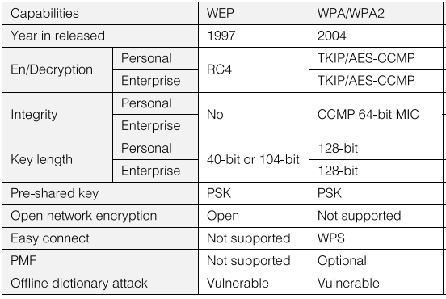
Figure 4: Security Capabilities of WEP, WPA/WPA2

5.3 Attacks on WLAN protocols

- Attacks on WEP
ChopchopsAttack
Without knowing the WEP Key, the Chopchop attack decrypts the whole packet. By sending an average of n*128 packets over the network, an attacker can decrypt the final n bytes of the encrypted packet's plaintext. [34]The 4-byte checksum that is used to ensure the integrity of encrypted packets is vulnerable, which is exploited by the Chopchop attack. One kind of ciphertext-only attack that doesn't require authentication is the ChopChop attack, which is a technique for breaking WEP encryption. After intercepting encrypted packets, the attacker uses a specific ciphertext modification to guess the plaintext. The modified packet's acceptance suggests that the plaintext guess was accurate. By using this method, the entire message can be decrypted, disclosing the encryption key and jeopardising the security of the network.
ARP Replay Attack
An attacker has more room to create new packets from the captured packets when using ARP Replay Attack IVs because they can be freely reused and do not require a sequence number for validation . The destination MAC address and fixed size of ARP Request packets make them easily identifiable. More traffic is produced as a result of the attacker sniffing legitimate hosts' ARP Request packets and repeatedly replaying both the ARP Request and the host's ARP Response[35]. The WEP Key can be quickly and easily cracked if a sufficient number of data packets with weak IVs are gathered. One technique used by attackers to intercept and alter network traffic is the ARP Replay Attack. In this attack, the attacker poses as a genuine network device, like a router or gateway, and sends the target a faked ARP reply. Traffic is then routed through the attacker's system by the target, which updates its ARP cache with the attacker's MAC address. This enables the attacker to carry out their malicious objectives, like data theft, eavesdropping, or man-in-the-middle attacks, by intercepting, altering, and possibly redirecting the traffic.
- Attack on WPA/WPA2
The four-way handshake and encryption protocol of the Wi-Fi Protected Access (WPA) protocol, as well as that of its successor, WPA2, are known to be susceptible to attacks. The Pairwise Master Key (PMK), the MAC address of the Authenticator, the MAC address of the Supplicant, and Nonces are required in order to generate the Pairwise Transient Key (PTK), which is necessary for secure communication. The other parameters are sent in plaintext during the four-way handshake [36], making them susceptible to interception by an attacker, while the PMK is kept secret.
The passphrase (Pre-Shared Key, or PSK) that is used to create the PMK is the main source of vulnerability. An attacker can try to guess the passphrase using a dictionary attack if they manage to intercept a legitimate four-way handshake. The attacker can ultimately determine the correct passphrase by methodically attempting a variety of passphrases from a wordlist or dictionary. The attacker can obtain unauthorised access to the network and derive the PMK once they know the passphrase. It is crucial to use secure, difficult-to-guess passphrases in order to reduce this vulnerability. It is crucial to use secure, difficult-to-guess passphrases in order to reduce this vulnerability. Network managers should also keep a close eye on their networks for any unusual activity and quickly update their security procedures to patch any newly discovered vulnerabilities. . A method of circumventing the flaw in the WPA2 protocol is the Key Reinstallation Attack. As was already indicated, the attacker can pose as the AP by sending message 3 again and again[37]. The attacker can force the client to connect to the phoney AP when it tries to reconnect to the original AP. It is capable of acting as a go-between.
Attackers can use dictionary attacks and brute force to break the pass with the captured handshake.

5.4 Exploiting Vulnerabilities in IEEE 802.11 WEP Security Protocol

Penetration testing revealed and allowed for the exploitation of vulnerabilities in the IEEE 802.11 WEP security protocol. To produce more packets with weak IVs, the packets were replayed into the network several times. The short IV space and easy exhaustion lead to IV reuse, which makes the IVs weak. The steps that were taken to exploit the vulnerability are listed below.
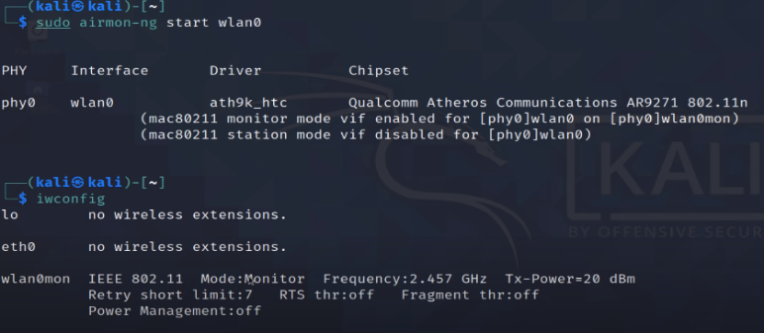
Figure 5: wireless connection wlan0

The "airodump-ng wlan0mon" command was utilised to locate the wireless network and to sniff and record packets of data. The wireless card's monitor mode interface, or wlan0mon, has a MAC address of 98:FC:11:EE:41:25 (targeted area point). With the help of the command "airodump-ng --channel 6 --bssid 98:FC:11:EE:41:25 --write arp-test wlan0mon," sniffed and captured data packets were saved to a file named arp-test, as illustration
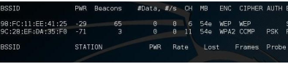
Figure 6: Capture of Data Packets
The attacker was able to generate more packets by using the command "aireplay-ng --arpreplay -e Tp-link wlan0mon" to identify ARP Request packets that needed to be replayed in order for the AP to send ARP Response packets. 59 data packets were received, as seen in Figure, but no ARP Request packet was found due to the attacker's MAC address (00:C0:CA:83:01:CD).
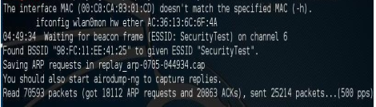
Figure 7: Generation of ARP Packets

Because there was no mutual authentication, a fictitious authentication was carried out, allowing the attacker to be successfully linked to the AP. The steps of the experiment are shown below:
Since the AP only authenticates its clients, the attacker conducts a fake authentication using the command "aireplay-ng --fakeauth 0 -a 98:FC:11:EE:41:25 -h 00:C0:CA:83:01:CD wlan0mon" and the MAC address of the AP (98:FC:11:EE:41:25). Figure 8 illustrates how the AP successfully acknowledged the authentication and association requests. It follows that the attacker established a connection with the AP.

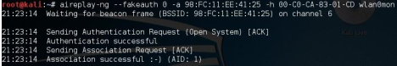
Figure 8: Attacker's Successful Fake Authentication and Association with the Target AP

The WEP security protocol was unable to distinguish between authentic and forgeried packets or identify altered packets. The actions listed below demonstrate that the vulnerability is present:
As seen in figure, the attacker decrypts the encrypted data packets it has captured using the command "aireplay-ng --chopchop - a 98:FC:11:EE:41:25 -h 00:C0:CA:83:01:CD wlan0mon" to obtain the plaintext (replay_dec-0713-213506.cap) and keystream (replay_dec-0713-213506.xor).
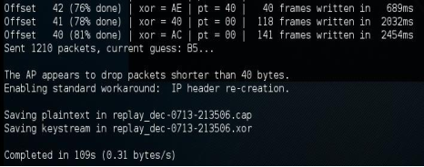
Figure 9: Keystream and plaintext file capture

As seen in figure 10, the forged packets were injected into the AP or traffic using the command "aireplay-ng -2 -r packetforge-test wlan0mon" to create data packets with new IVs. These produced packets aid in accelerating the WEP Key cracking process.
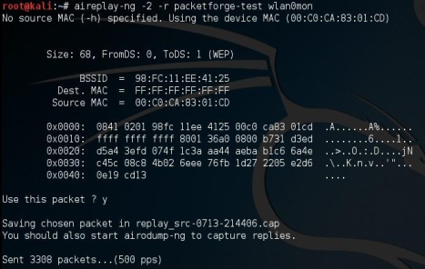
Figure 10: New IV Generation from Forged Packets

Cracking of IEEE 802.11 WEP Encryption Protocol Key
Aircrack-ng” tool was run parallel as more packets with weak IVs were generated. With 51326 IVs, 698 possible keys were tested and the WEP key was successfully cracked as shown in figure
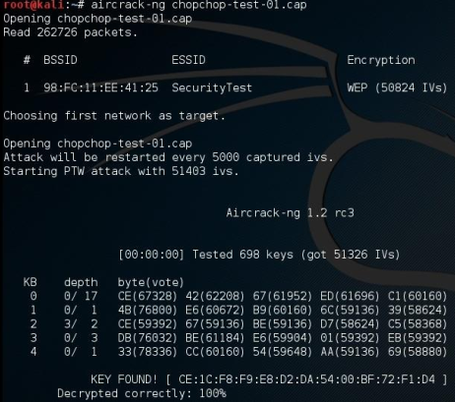
Figure 11: WEP Key Successfully Cracked

5.5 Exploiting Vulnerabilities in IEEE 802.11 WPA/WPA2 Encryption Protocol

To discover the access point we use the command sudo airodump-ng wlan0mo. Various wireless networks are discovered and the stations. I get the ESSID tp-link network with 90:9A:4A:B8:F3:FB MAC address of access point.
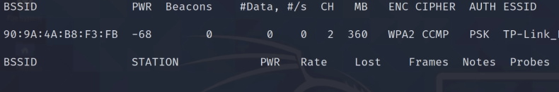
Figure 12: WPA2 network

The command sudo airodump-ng -w hack -c 2 –bssid 90:9A:4A:B8:F3:FB. The hack1 is the name of the file to captures to open with wireshark in a file called hack1, and the channel is 2, the interface is wlan0mon.
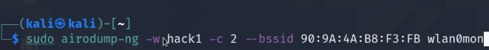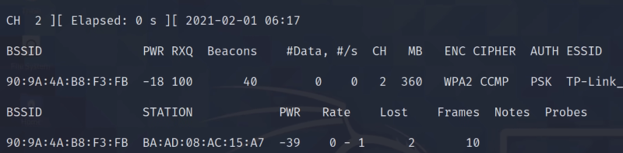
Figure 13: capture points with wireshark

Deauthentication clients from the network. successful capture of the four-way handshake and saved to file called wpa-handshake.
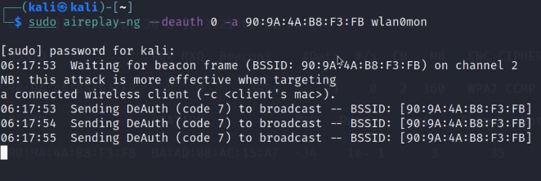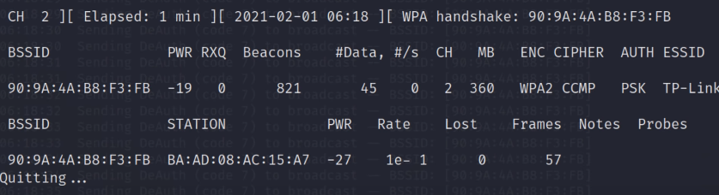
Figure 14: Successful Capture of WPA Handshake

5.6 Analysis on Vulnerabilities in IEEE 802.11 WEP, WPA/WPA2 Encryption Protocol

WEP packets (70593 with no replay protection mechanism) were successfully captured and replayed into the network multiple times, resulting in more packets with weak IVs that helped crack the WEP key. The replay attack's ARP packets (18112) were successfully intercepted and injected into the network to produce packets. The discovered list of clients connected to the AP with MAC Address (98:FC:11:EE:41:25) included the attacker's MAC Address (00:C0:CA:83:01:CD).

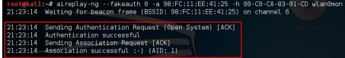
Attacker's successful spoof authentication and association with the target AP
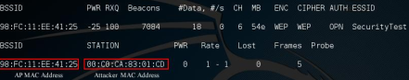
Figure 15: Attacker Connects to Access Point

Without knowing the secret key, the attacker was able to decrypt encrypted packets using the "chopchop" attack technique. The attacker modifies the packet by cutting off the last byte of the captured encrypted packet, replacing it with the new value, recalculating the encryption checksum, and injecting the modified packet into the network. If the AP accepts the modified packets, it indicates that the attacker's estimation was accurate; if not, the packet is rejected. An incorrect ICV results in an invalid packet because the attacker computes the checksum to verify the tampered or altered packets. As seen in figure 17, the decrypted packet includes the plaintext (replay_dec-0713-213506.cap) file and the keystream (replay_dec-0713-213506.xor) file. The process of creating forged, legitimate packets involves using the keystream capture.
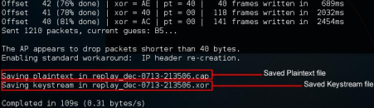
Figure 16: Plaintext and Keystream files
WEP uses an RCS-32 checksum for integrity and an RCS-4 stream cypher to encrypt the WEP Key. Its foundation is secrecy rather than authorization. Because of the IV mechanism's implementation, WEP is open to attacks. These IVs are duplicated when the 24-bit IV space is used up in a matter of hours. The WEP Secret Key was cracked using the Chopchop attack. The attack method known as Chopchop, created by KoreK, takes advantage of a weakness in the WEP security protocol instead of the RC4 algorithm. The attacker was able to capture and decrypt encrypted packets to obtain the keystream and plaintext without having to know the secret key. In order to create a fictitious cypher text that is injected into the network to produce more packets with weak IVs, the keystream and plaintext are XORed. The IVs are sent in plain text that has been concatenated with the shared secret key. The likelihood of successfully cracking the WEP key rises as weaker IVs are generated. Figure 18 illustrates how the WEP Key was successfully cracked with 51326 weak IVs generated.
The result of the analysis indicates that WEP is open to intrusions. Without an active client connected to the network, it is possible to crack the WEP key. Additionally, the plaintext and keystream—which are needed to successfully crack the key—can be obtained without knowledge of the WEP key.
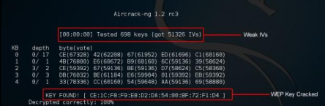
Figure 17: Successful Crack Of WEP

As WPA/WPA2-PSK uses an unencrypted (plaintext) four-way handshake, it is susceptible to attacks. An attacker is aware of every parameter—aside from the passphrase—used to carry out the mutual authentication (PMK and PTK generation) between the authenticator (AP) and the petitioner. The following formulas are used to derive the PMK and PTK:
PMK = PBKDF2 (Passphrase, SSID, SSIDlen, 4096, 256)
PTK = Function (PMK, ANonce, SNonce, Authenticator MAC, Supplicant MAC).
Wireshark was used to analyse the four-way handshake that was recorded. The AP sent the first message of the EAPOL Handshake to the Supplicant, which contained a random number (256 bits) known as an ANonce for the Supplicant's PTK generation. The highlighted AP MAC Address and ANonce were identified in Figure
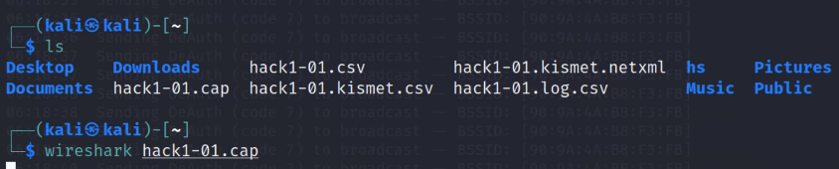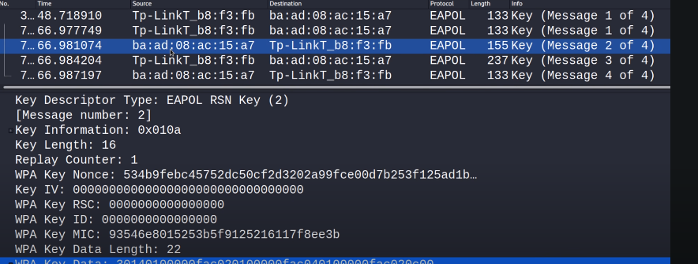
Figure 18: WPA Four-way Handshake

The WPA/WPA2-PSK passphrase was successfully obtained, as illustrated in figure 21, which uses the cryptographic hash algorithm (HMAC-SHA1) to show the PMK, PTK, and MIC.
The study's conclusion suggests that dictionary attacks can exploit WPA/WPA2-PSK. If an attacker finds the passphrase in a dictionary or wordlist, they can crack WPA/WPA2-PSK.
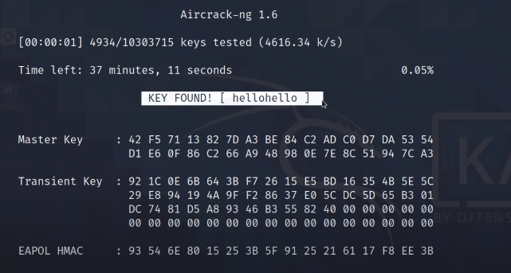
Figure 19: Successful crack of WPA/WPA2

6. RESULTS AND DISCUSSION

Many vulnerabilities in the IEEE 802.11 encryption protocols, specifically in WEP, WPA, and WPA2/WPA3, were found during the Wireless Network Penetration Testing using Kali Linux Hacking Tools. Target network "WirelessSec" was successfully identified during the Network Reconnaissance phase. According to the Vulnerability Assessment, the network was protected from brute-force attacks by using a strong password and WPA2/WPA3 security. Nonetheless, an unapproved access to the network was made possible by the Exploitation phase's successful exploitation of a flaw in the WPA2/WPA3 handshake procedure. The Aircrack-ng tool, which recorded the handshake and employed brute-force methods to crack the password, was used to accomplish this. After gaining the password, the attacker was able to enter the network without authorization and intercept and modify traffic.
Since the attacker could access other devices and services on the network, the Exploitation Analysis showed that the compromised network permitted lateral movement. This emphasises how crucial it is to put access controls and network segmentation in place in order to stop possible breaches. Furthermore, Wireshark was used to analyse the captured traffic, revealing private data like login passwords and financial transactions. This emphasises the necessity of secure communication protocols and encryption to safeguard data while it is in transit.

7. CONCLUSIONS

The security of wireless networks, especially the IEEE 802.11 WLAN Security protocols, has come under intense examination in the last few years. This is because penetration testing has shown that the WEP and WPA/WPA2-PSK encryption protocols are vulnerable. These tests have shown that WEP rapidly runs out of the 24-bit IV space, which causes IVs to be repeated whenever a new packet is created. Attackers will therefore find it simpler to decipher the WEP key as a result of this repetition. Furthermore, even though the CRC32 checksum (ICV) is intended to protect against all types of attacks by preventing data packets from being altered in transit, it is insufficient to guarantee data integrity. For instance, the ICV is ineffective in some situations because it is unaffected by malicious ciphertext. Consequently, even though the encryption protocols WEP and WPA/WPA2-PSK have been used extensively in the past, it is crucial for organisations to take into account their inherent vulnerabilities and look into more secure alternatives.

7.1 FUTURE WORK

The field of wireless network penetration testing is always changing, and more research in this area could greatly improve network security in the future. The creation of more advanced, automated penetration testing tools that can quickly locate vulnerabilities and evaluate the security posture of a network is one direction that needs to be explored. Furthermore, studies concentrating on cutting-edge wireless technologies, like Wi-Fi 6 and later, can offer insightful information about the security consequences of these developments. The incorporation of AI and machine learning methods into penetration testing frameworks, which allows for the more precise and effective detection of security flaws, is another exciting development.
Furthermore, given the increasing proliferation of Internet of Things (IoT) devices, research into the security of IoT devices and their effects on wireless network security is essential. Moreover, companies can receive practical advice for improving their network security from the creation of thorough security frameworks and best practices designed especially for wireless networks. In order to address the changing cybersecurity landscape and guarantee the implementation of strong security measures in wireless networks, it is imperative that researchers, business professionals, and policymakers collaborate in order to protect digital infrastructures.

REFERENCES

[1] S. Krishna Lamichhane, “Penetration Testing In Wireless Networks Abstract Author Title Number of Pages Date,” 2016.
[2] J. C. Chen, M. C. Jiang, and Y. I. W. Liu, “Wireless LAN security and IEEE 802.11l,” IEEE Wirel Commun, vol. 12, no. 1, pp. 27–36, Feb. 2005, doi: 10.1109/MWC.2005.1404570.
[3] D. N. Astrida, A. R. Saputra, and A. I. Assaufi, “Analysis and Evaluation of Wireless Network Security with the Penetration Testing Execution Standard (PTES),” Sinkron, vol. 7, no. 1, pp. 147–154, Jan. 2022, doi: 10.33395/sinkron.v7i1.11249.
[4] Y. Xiao, H. Chen, S. Yang, Y. B. Lin, and D. Z. Du, “Wireless network security,” Eurasip Journal on Wireless Communications and Networking, vol. 2009. 2009. doi: 10.1155/2009/532434.
[5] Q. Ni, “Performance analysis and enhancements for IEEE 802.11e wireless networks,” IEEE Netw, vol. 19, no. 4, pp. 21–27, Jul. 2005, doi: 10.1109/MNET.2005.1470679.
[6] R. Nazir, A. A. laghari, K. Kumar, S. David, and M. Ali, “Survey on Wireless Network Security,” Archives of Computational Methods in Engineering, vol. 29, no. 3. Springer Science and Business Media B.V., pp. 1591–1610, May 01, 2022. doi: 10.1007/s11831-021-09631-5.
[7] V. Gabale, B. Raman, P. Dutta, and S. Kalyanraman, “A classification framework for scheduling algorithms in wireless mesh networks,” IEEE Communications Surveys and Tutorials, vol. 15, no. 1, pp. 199–222, 2013, doi: 10.1109/SURV.2012.022412.00068.
[8] “A Survey on Wireless Security Protocol WPA2 - ProQuest.” Accessed: Feb. 23, 2024. [Online]. Available: https://www.proquest.com/docview/2139471623?%20Proceedings&fromopenview=true&pq-origsite=gscholar&sourcetype=Conference%20Papers%20
[9] A. H. Lashkari, M. M. S. Danesh, and B. Samadi, “A survey on wireless security protocols (WEP,WPA and WPA2/802.11i),” Proceedings - 2009 2nd IEEE International Conference on Computer Science and Information Technology, ICCSIT 2009, pp. 48–52, 2009, doi: 10.1109/ICCSIT.2009.5234856.
[10] S. F. Russell, “Wireless Network Security for Users.”
[11] A. M. Al Naamany, A. Al Shidhani, and H. Bourdoucen, “IEEE 802.11 Wireless LAN Security Overview,” 2006.
[12] M. Aye Chan Aung and K. Phyo Thant, “IEEE 802.11 Attacks and Defenses.”
[13] M. Waliullah, A. B. M. Moniruzzaman, and M. S. Rahman, “An Experimental Study Analysis of Security Attacks at IEEE 802.11 Wireless Local Area Network 1,” International Journal of Future Generation Communication and Networking, vol. 8, no. 1, pp. 9–18, 2015, doi: 10.14257/ijfgcn.2015.8.1.02.
[14] A. H. Lashkari, M. Mansoori, and A. S. Danesh, “Wired equivalent privacy (WEP) versus Wi-Fi protected access (WPA),” 2009 International Conference on Signal Processing Systems, ICSPS 2009, pp. 445–449, 2009, doi: 10.1109/ICSPS.2009.87.
[15] A. Stubblefield, J. Ioannidis, and A. D. Rubin, “A key recovery attack on the 802.11b wired equivalent privacy protocol (WEP),” ACM Transactions on Information and System Security (TISSEC), vol. 7, no. 2, pp. 319–332, May 2004, doi: 10.1145/996943.996948.
[16] B. Indira Reddy and V. Srikanth, “Review on Wireless Security Protocols (WEP, WPA, WPA2 & WPA3),” International Journal of Scientific Research in Computer Science, Engineering and Information Technology © 2019 IJSRCSEIT |, vol. 5, no. 10, pp. 2456–3307, 2019, doi: 10.32628/CSEIT1953127.
[17] A. H. Adnan et al., “A comparative study of WLAN security protocols: WPA, WPA2,” Proceedings of 2015 3rd International Conference on Advances in Electrical Engineering, ICAEE 2015, pp. 165–169, Jul. 2016, doi: 10.1109/ICAEE.2015.7506822.
[18] A. K. M. N. Sakib, F. Tasmin, J. Lecturer, M. Munim, and A. Akter, “Security Improvement of WPA 2 (Wi-Fi Protected Access 2)”.
[19] C. Williams, “Research Methods,” Journal of Business & Economics Research (JBER), vol. 5, no. 3, p. 65, Mar. 2007, doi: 10.19030/JBER.V5I3.2532.
[20] “Research philosophy: Towards an understanding - ProQuest.” Accessed: Feb. 23, 2024. [Online]. Available: https://www.proquest.com/docview/200824349?pq-origsite=gscholar&fromopenview=true&sourcetype=Scholarly%20Journals
[21] C. Blackwell, “Towards a penetration testing framework using attack patterns,” Cyberpatterns: Unifying Design Patterns with Security and Attack Patterns, vol. 9783319044477, pp. 135–148, Mar. 2014, doi: 10.1007/978-3-319-04447-7_11/COVER.
[22] J. C. Chen, M. C. Jiang, and Y. I. W. Liu, “Wireless LAN security and IEEE 802.11l,” IEEE Wirel Commun, vol. 12, no. 1, pp. 27–36, Feb. 2005, doi: 10.1109/MWC.2005.1404570.
[23] A. Kavianpour and M. C. Anderson, “An Overview of Wireless Network Security,” in Proceedings - 4th IEEE International Conference on Cyber Security and Cloud Computing, CSCloud 2017 and 3rd IEEE International Conference of Scalable and Smart Cloud, SSC 2017, Institute of Electrical and Electronics Engineers Inc., Jul. 2017, pp. 306–309. doi: 10.1109/CSCloud.2017.45.
[24] “WLAN_security_current_and_future”.
[25] H. Kim and E. A. Lee, “Authentication and Authorization for the Internet of Things,” IT Prof, vol. 19, no. 5, pp. 27–33, 2017, doi: 10.1109/MITP.2017.3680960.
[26] P. Goyal and A. Goyal, “Comparative study of two most popular packet sniffing tools-Tcpdump and Wireshark,” Proceedings - 9th International Conference on Computational Intelligence and Communication Networks, CICN 2017, vol. 2018-January, pp. 77–81, Jul. 2017, doi: 10.1109/CICN.2017.8319360.
[27] A. Ismail Al-Alawi, “WiFi Technology: Future Market Challenges and Opportunities,” Journal of Computer Science, vol. 2, no. 1, pp. 13–18, 2006.
[28] M. Vanhoef and F. Piessens, “Practical verification of WPA-TKIP vulnerabilities,” ASIA CCS 2013 - Proceedings of the 8th ACM SIGSAC Symposium on Information, Computer and Communications Security, pp. 427–435, 2013, doi: 10.1145/2484313.2484368.
[29] K. S. Kwak, S. Ullah, and N. Ullah, “An overview of IEEE 802.15.6 standard,” 2010 3rd International Symposium on Applied Sciences in Biomedical and Communication Technologies, ISABEL 2010, 2010, doi: 10.1109/ISABEL.2010.5702867.
[30] J. C. Lin, “A new IEEE standard for safety levels with respect to human exposure to radio-frequency radiation,” IEEE Antennas Propag Mag, vol. 48, no. 1, pp. 157–159, Feb. 2006, doi: 10.1109/MAP.2006.1645601.
[31] P. Lachkov, L. Tawalbeh, and S. Bhatt, “Vulnerability Assessment for Applications Security Through Penetration Simulation and Testing,” Journal of Web Engineering, vol. 21, no. 7, pp. 2187–2208, 2022, doi: 10.13052/jwe1540-9589.2178.
[32] V. Kumkar, S. Shrawne, A. Tiwari, P. Tiwari, and A. Gupta, “Vulnerabilities of Wireless Security protocols (WEP and WPA2),” International Journal of Advanced Research in Computer Engineering & Technology, vol. 1, no. 2, 2012, Accessed: Feb. 23, 2024. [Online]. Available: https://www.researchgate.net/publication/266005431
[33] M.-K. Choi, R. J. Robles, C.-H. Hong, and T.-H. Kim, “Wireless Network Security: Vulnerabilities, Threats and Countermeasures,” 2008.
[34] M. Denis, C. Zena, and T. Hayajneh, “Penetration Testing: Concepts, Attack Methods, and Defense Strategies.” [Online]. Available: www.kali.org
[35] R. Philip, “Securing Wireless Networks from ARP Cache Poisoning,” Master’s Projects, Jan. 2007, doi: https://doi.org/10.31979/etd.fu2m-skmj.
[36] Y. Liu, Z. Jin, and Y. Wang, “Survey on security scheme and attacking methods of WPA/WPA2,” 2010 6th International Conference on Wireless Communications, Networking and Mobile Computing, WiCOM 2010, 2010, doi: 10.1109/WICOM.2010.5601275.
[37] A. Gupta and R. K. Jha, “Security threats of wireless networks: A survey,” International Conference on Computing, Communication and Automation, ICCCA 2015, pp. 389–395, Jul. 2015, doi: 10.1109/CCAA.2015.7148407.

