

Name of the Student : Shahedabibi Shaikh
Student Id : 2223092
Module name : Strategic Management
Lecturer Name : Dr Hossein Shokri
Module Code : LCMB7003
Company Name : Marks & Spencer

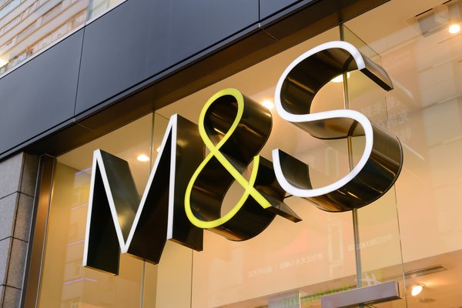

Table of Contents

Introduction...........................................................................................................01
Marks & Spencer Background..............................................................................01
M&S’s mission and objective...............................................................................01
Macro- Environment Analysis..............................................................................02
Pestle analysis.......................................................................................................02
Micro-Environment Analysis................................................................................04
Industry Life Cycle...............................................................................................05
Porter’s Industry Five Forces Analysis.................................................................05
Internal Analysis...................................................................................................07
M&S Strategic Resources and Capabilities Analysis...........................................07
Value Chain Analysis............................................................................................08
Primary Activities.................................................................................................08
Secondary Activities.............................................................................................09
VRIO Analysis of Distinctive Resources and Capabilities...................................10
SWOT Analysis....................................................................................................10
Strategies to Sustain Competitive Advantage.......................................................11
Growth Strategy....................................................................................................12
Green Strategy and CRS.......................................................................................14
Conclusion............................................................................................................15
References.............................................................................................................16

Introduction:
This strategic management assignment aims to critically analyse Marks & Spencer’s strategic orientation, also known as M&S, a multinational retailer with a long history dating back over a century. Analysis of the organization may be bolstered by identifying its SWOT strengths, weaknesses, threats and opportunities. The internal and external factors that have an impact on Marks & Spencer will be examined in this project. Additionally, the company’s existing strategic position and ideas on how to develop a competitive edge through strategic management decisions are provided (Dani, 2019). Marks & Spencer was recently crowned as the most reliable company throughout the UK due to its excellent reputation in these areas as well as for its innovative products and reasonable prices (Schleper et al., 2021). To generate value and maintain profitable growth, M&S is reorganizing on these principles.
Background of Marks & Spencer (M&S):
Marks & Spencer Group Ltd is headquartered in Paddington, London, as well as is a significant British international retailer. They offer affordable food, clothing, and household goods to millions of customers worldwide. The food business is famous for its high degree of innovation and outstanding quality. At M&S, over 64000 extraordinary people play a role in achieving change and great service (Marksandspencer.com, 2021). In 1884, Marks & Spencer was established. In the year 1884, Michael Marks, an immigrant, settled in the northern region of England and developed a thriving business out of booths in Leeds’s Kirkgate Marketplace. To further expand his firm, Michael partnered alongside Tom Spencer, an accountant at wholesalers Dewhirst (Amuna, Al Shobaki and Naser, 2017). With very limited finance and poor English, he established a successful organization using the slogan “DON’T ASK THE PRICE, IT’S A PENNY”. The corporation decided to buy directly from suppliers to provide customers with reasonably priced high-quality items.
Marks and Spencer reported its first loss in ninety-four years as a publicly traded firm in November 2020, with 7000 job layoffs, declining sales, and a pressing need to catch up on digital shopping (Akhtar, 2021). In 2021, they concentrated on reshaping M&S culture, enhancing the value and quality of its food items and clothing, reorganising its store estate, investing in e-commerce and technology, and partnering with online supermarkets. Ocado. Nowadays, M&S have a network of 1064 UK-owned and franchise stores (marksandspencer.com). In comparison to 2021–2022, statutory profit before tax was £475.7 million. Business rates relief in the United Kingdom climbed from £186.6 million in 2022-2023 to £59.8 million in the previous year, up from £186.6 million in 2022-2023 (Karwowski and Raulinajtys‐Grzybek, 2021).
Mission and objectives:
Marks & Spencer’s stated goal as an organization is “to provide high quality accessible to all consumers through the extensive variety and diversity of its products.” Their vision is to be the benchmark against which other brands are compared, with an emphasis on excellent value, outstanding service, innovation, and trust. (Marksandspencer.com, 2021)
Marks & Spencer’s resetting Plan has established a goal of being a carbon-neutral company throughout its whole value chain through 2039–40, 10 years ahead of the UK government’s target. Marks & Spencer PLC has committed to a 55 per cent reduction in emissions of greenhouse gases across both the first scope and second scope by the year 2030.
Macro-environment analysis:
Macroenvironment analysis is an essential instrument for organisations to understand external influences that can affect how they operate and their processes for making decisions. Kotler and Armstrong state, “The macro environment consists of several factors that affect the microenvironment such as demographic, economic, natural, technological, political and cultural forces.” (Kotler and Armstrong (n.d.). 12th ed.)
It is helpful to comprehend external elements through macro environment analysis to make wise strategic decisions. An organisation can foresee and prepare for future risks and uncertainty by monitoring the macro environment (Amuna, Al Shobaki and Naser, 2017). For instance, they must concentrate on income inequality and savings rates and understand consumer sentiment and the public’s growing environmental concern (Kotler and Kevin Lane Keller, 2009).
Pestle analysis:
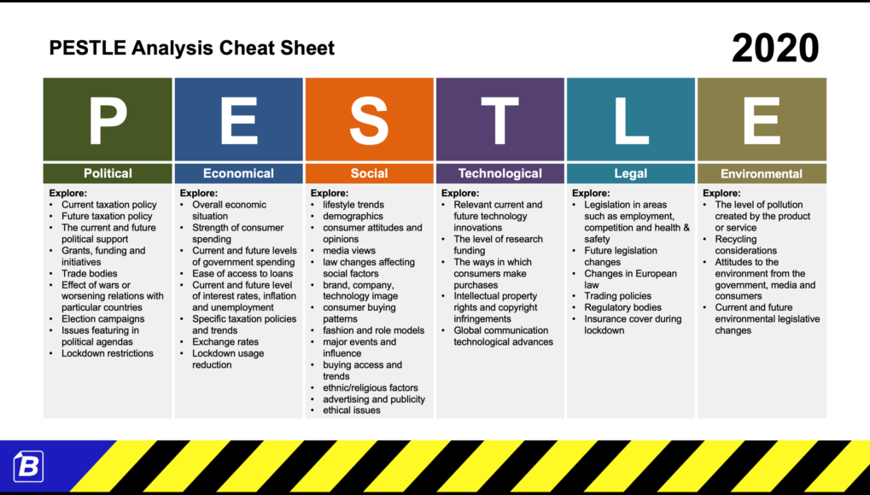

SOURCE: https://business-docs.co.uk/
One approach for classifying environmental elements into major categories is pestle analysis. Pestle analysis draws attention to six specific environmental factors: political, environmental, social, technological, legal, and economic. By looking at these elements, PESTLE analysis is a strategic tool that aids organisations in understanding the external environments of corporations (Dani, 2019). According to research Before evaluating strategic choices, it is important to fully comprehend how external environmental influences affect a firm’s industry (Parnell John A, 2017).
Factors affecting Marks & Spencer:
The effects of political factors on business activity include those of the government’s monetary, fiscal, international trade, and exchange rate policies (Rashain Perera, 2017). The consequences of Brexit may last for a long time. The company is impacted by the introduction of trade barriers plus the revision of labour legislation. Marks & Spencer reportedly plans to liquidate 11 stores in France because of difficulties sourcing perishable goods in the wake of Brexit, as reported by BBC News. Taxation and political security remain the two most significant factors (Karwowski and Raulinajtys‐Grzybek, 2021). Marks & Spencer’s revenues would suffer if taxes were raised since the firm would have to charge even more for its products. The new fair-trade strategy for M&S includes decreasing salt and fat content, utilizing recyclable packaging, and safeguarding animal well-being (Marks and Spencer, 2019).
When examining the economic environment, we consider capital costs, availability, and consumer demand. Analysing the nation’s statistics data offers insight into a wide range of variables, including inflation rates, consumer expenditure, unemployment rates, currency rates, etc (Jeffs, 2008). Economic factors assist an organization in forecasting the future by giving knowledge about past and present patterns. According to studies, this is because rising inflation causes prices to rise (Dani, 2019). Labour and energy prices are expected to rise, plus currency appreciation will increase M&S’ buying expenses. Conditions will likely worsen across all M&S markets in the financial year 2024,’’ M&S declared (James Davey, 2022).
The sociological aspect takes into account any market and community-related social events. These include things like social standards and customs, demographic shifts, health awareness and the desire for employment, climate change, and the like. These factors analyse the market’s social context, including such factors as demographics, cultural shifts, population statistics, and more (Rastogi, Nitank and Trivedi, 2016). The company has 35 Sparks collaborators spanning four categories, including young people and children’s health and wellness, social integration and environmental issues, wildlife, as well as animals, as stated in M&S’s sustainability assessment (Karwowski and Raulinajtys‐Grzybek, 2021). Marks & Spencer contributed almost £10 million to Sparks during September 2021, marking their billionth cent given to charity (Amuna, Al Shobaki and Naser, 2017).
Digital technology and automation can greatly impact business operations, consumer interactions, and efficiency. Companies that implement digital transformation can improve consumer experiences by streamlining operations (Mäkinen, S. J., and Seppänen, M., 2017). According to the data M&S has partnered up with RELEX Solutions to roll out an AI-powered platform across 1,050 UK and Irish food outlets and 13 centres of distribution. The technology provides accurate demand forecasting, ordering, and allocation, streamlines online delivery flow, and improves supply chain visibility, increasing efficiency and lowering store longevity wastage. (GlobalData, 2022).
The chancellor of the United Kingdom indicated in March 2021 that company taxes were going to increase from 19 per cent to 25 per cent in April 2023. Government revenue is expected to rise from GBP 11.9 billion ($16.5 billion) in fiscal years 2023 to 24 to GBP 17.2 billion ($23.9 billion) in fiscal years 2025 to 26 as corporate tax rates rise. However, this hike may ultimately deter investment (Marketline, 2023). An increase in business tax leads to M&S profitability being negatively affected as a larger portion of its earnings goes toward tax payments and this can reduce the company’s net income.
According to Tamara Ingram the Chair of the Environmental, Social & Governance Committee of M&S, “Plan A is a core to M&S delivering exceptional products and uploading trusted brands.’’ Plan A will guide performance against newly established targets, including the objectives of reducing carbon emissions by 2.1 million tonnes by 2025/26 and being a net zero business by 2040 (Marks & Spencer, 2023). M&S’s goals are to use 100% recycled polyester for the clothes by 2025/26, increase plant-based protein products by 2024/25, and use 100% edible surplus to reduce food wastage.
Micro-environment analysis:
The microenvironment is the company’s internal or closest environment in which it functions. Customers, suppliers, the general public, employees, shareholders, and rivals are the six primary components of microenvironment analysis. Marks & Spencer might be analysed using Porter’s five forces as the conceptual instrument and paradigm. Marks & Spencer’s attractiveness in the marketplace and competitive intensity may be gauged with the use of this instrument, which analyses the business’s profit and competitiveness levels. Competition from new stores is the primary cause (Dani, 2019). Although the retail sector is enticing, it is notoriously tough to get into. This is because of the market’s prevalence of formidable behemoths, such as Marks & Spencer, that make it difficult for upstarts to carve out a niche for themselves. However, the proliferation of low-cost manufacturers in the market represents a serious challenge to established players such as Marks & Spencer (Nyame-Asiamah and Ghulam, 2020). Large rivals like ASDA are thinking about entering the market with low-priced household goods, so there’s room for a low-priced economy as well (Rastogi, Nitank and Trivedi, 2016).
On the other hand, customers’ negotiating power is a major concern for all retailers, not just Marks & Spencer. There is another aspect associated with Porter’s Five Analysis that indicates intense competitiveness in this sector: the abundance of available alternatives in terms of suppliers (Karwowski and Raulinajtys‐Grzybek, 2021). Since there exists little to no product distinction, the sector is very competitive. Since there are plenty of substitute vendors in the marketplace, Marks & Spencer along with other retailers don’t have to worry about losing their negotiating power if one goes out of business.
Industry life cycle:
To some extent, M&S has reached the stage of maturity. The industry research presented so far shows that there is substantial rivalry from other shops and environmental issues throughout the United Kingdom, both of which hinder the business’s development. To ensure its continued success in the modern market, M&S must assess the efficacy of its present initiatives.
M&S has a well-defined business plan that makes good use of the company’s resources, including its money, distribution networks, expertise, and employees.
Paying attention to and meeting the demands of the client. Creating and developing a fashionable product (Schleper et al., 2021). Compliance with environmental and ethical standards in the procurement of goods and purchase
Marketing the goods in a way that complies with ethical standards (Rashain, 2017). Employee service and participation while M&S runs all of it according to their four guiding principles: inspiration, creativity, credibility, and connection.
Since consumers’ preferences in what they buy are always shifting, it might be difficult for M&S to keep up. According to the 2017 Mintel Report, “Consumers often switch retailers as they become more comfortable with and disenchanted with a particular store.” To sustain its position as a top high-street retailer, M&S must do a thorough examination of its external and internal business environments, finding both long-term and short-term patterns and developing a plan with defined goals and objectives.
Porter’s Five Forces:
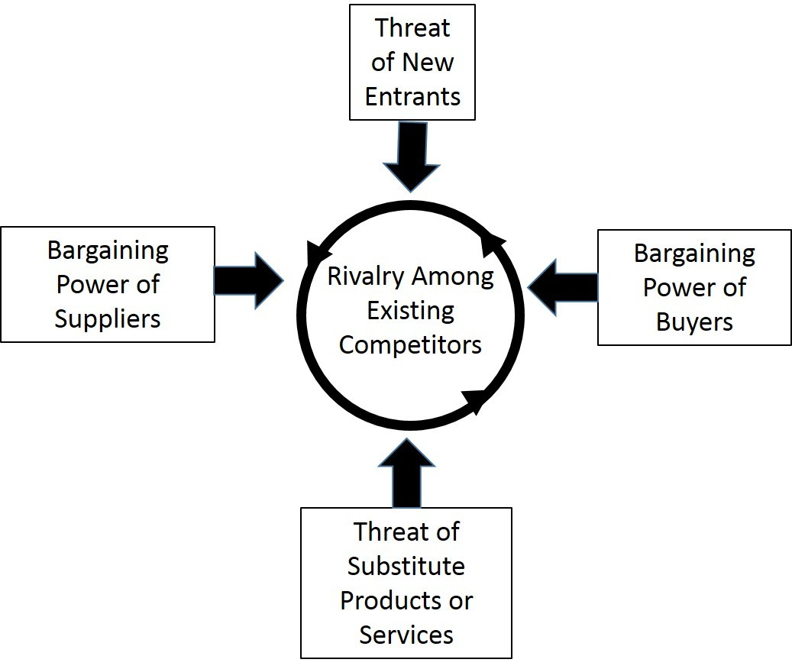
The UK’s top apparel shop M&S is tremendously successful. Mark & Spencer’s UK and worldwide retail competitiveness may be assessed using Porter’s five forces assessment (Porter, 1996). Figure 1 shows Porter’s five forces model examining M&S’s supplier strength, new entrant threats, buyer’s bargaining power, substitution threat, and intensity of competition in the retail sector.

Source: https://valuationmasterclass.com/

The threat of new entrants:
Newcomers face considerable entry barriers in this clothes retail business. Since M&S remains a significant clothes company with a strong brand. Thus, a new competitor struggles to compete with such massive financial expenditure and market dominance. M&S prioritizes product quality plus customers (Leavy and McKiernan, 2020). M&S has consumer loyalty, thus shattering this commitment and replicating M&S’s superior product variety with alternatives would be difficult for new competitors. A fresh entrant will also encounter the challenge of surviving in an established sector like the garment business without expertise and understanding.
Threats for substitute products:
M&S clothes may be bought elsewhere. Competitive stores might import items from abroad and sell them at cheaper prices over M&S and other high-quality brands (Porter, 1996). M&S must focus on developing and conducting research as well as innovation within an uncertain, unpredictable, complicated, and imprecise environment to maintain its brand relevant to evolving consumer needs while competing with the likes of John Lewis, Zara, H&M, etc (Amuna, Al Shobaki and Naser, 2017). Additionally, M&S’s competitive edge is constantly endangered since unique designs are simple to replicate and reproduce at low cost.
Suppliers bargaining power:
There are various reasons suppliers have little negotiating power. M&S is a major company with many customers; therefore, suppliers appreciate the competitive benefit of having these buyers. Owing to market volatility during the late 20th century, M&S had to outsource vendors abroad, many coming from developing nations (Porter, 1996). That eventually reduces supplier negotiating strength. M&S offers mostly their brands and does not use suppliers. (M&S, 2016). That competitive edge helps M&S maintain excellent supplier margins since they acquire raw materials rather than completed items.
Buyer bargaining power:
Buyers have several retail alternatives and cheap switching expenses. M&S must depend heavily on buyer norms and requirements. M&S may suffer from buyer price sensitivities, product range demand changes, and buyer dissatisfaction. M&S’s long-term policy of eliminating clothes offers and price reductions will strengthen shoppers’ bargaining power. (M&S, 2017). Additionally, other stores similarly prioritize buyer relationships, making it harder for M&S to maintain market share despite its fresh long-term approach.
Competitive rivalry:
H&M, Zara, and John Lewis compete with M&S in clothes retail. M&S is under pressure since it has begun to lose UK market share owing to intense competition. Marks & Spencer must change their corporate strategy to satisfy worldwide market demands and boost its marketing mix to survive tactical challenges and intense competition (Schleper et al., 2021). The business’s upper management must comprehend its external and internal environments while creating a strategic strategy. Its strategic strategy has made it a top UK retailer.
Internal Analysis:
By outlining the corporation’s financial performance, this analysis reveals the firm’s internal advantages and flaws. Analysis of the Financial Situation The economic indicators have shown not only how the business’s economic performance has changed over time, but also why it has increased or decreased.
The corporation operates a broad variety of shops around the United Kingdom and beyond. Over six hundred of the stores are located in the United Kingdom (M&S, 2019). It has a dominant market share and an impressive assortment of retail outlets. According to Matthew (2018), Marks & Spencer has been one of the leading clothes shops in the United Kingdom for many years. The company’s forté, then, is its well-established market reputation and its ability to serve its clients via brand positioning. The firm’s ability to develop its strength and spread its risk via a diverse portfolio is shown. It’s helping the business thrive and maintain a sizable slice of the overall market. M&S’s long-term ambition for sustainability includes being the industry leader in this space by 2025 (M&S, 2018).
The corporation’s performance has been deteriorating over time, as shown by all relevant metrics. Comparing the 2018 fiscal year’s performances to that of 2017, the company’s earnings fell by 5.4 per cent, its cash flow fell by 28.7 per cent, and its earnings per share fell by 8.6 per cent.
Resource and Capability Analysis:
When compared to rivals like Zara, H&M, and John Lewis, M&S is on par in terms of available resources. The greatest strategy to succeed and develop a firm in the face of competition is to manage your resources in the most strategic manner possible, according to the analysis. According to M&S (2017), the company’s economy, products & and channels, intellectual property, individuals, stakeholders, and biological resources are its most valuable assets.
M&S is dedicated to maintaining sound financial practices that will allow for optimal returns to its stockholders. Group sales were reported at £10.6bn by M&S (2017), with clothes contributing £3.8bn. M&S is confident that their long-term approach of forgoing marketing and price reductions will pay off in the long run, despite a 2.8 per cent decline compared to last year. Over the 2016/17 fiscal year, M&S improved its capital management procedures and generated substantial cash flow. As a result, M&S managed to pay down £ 203.6m in overall debt.
Products from M&S provide better value since the company uses high-quality materials. According to researchers, M&S pays close attention to the suppliers who offer the raw materials used to create the exceptional, one-of-a-kind items sold under the M&S label. More than three thousand different supplier bases are used by M&S. According to OpenLearn (n.d.), “lowest costs along with higher quality” may be achieved via efficient and tight supplier management. M&S (2017) promises to maintain a reliable and moral supply chain, make efficient use of Earth’s resources, be open about its practices, and work toward improving the quality of life for people and the planet. In addition, M&S abides by the Groceries Supplier Codes of Practice, which is essential for developing globally applicable strategies with ethical sourcing. Consequently, it is reasonable to infer that M&S remains safeguarded by a robust and pleased shareholder base, which gives them an edge over their rivals (Akhtar, 2021). M&S would feel more at ease decreasing huge expenditures after having previously invested in greater infrastructure necessary for sustained expansion in the business (Kotler et al., 2012). As a result, M&S is in a position to provide its consumers with reasonably priced, distinctive, and high-quality items thanks to its access to the aforementioned resources and competencies.
Value chain analysis:
A corporation’s competitive advantage over its rivals in a given industry may be identified via a value chain study. The subsequent value chain evaluation elucidates the processes through which M&S gains a competitive edge and generates profits for its investors.
Primary Activities
Inbound supply chain:
Marks & Spencer started a campaign to consolidate its warehouses. With the opening of its most recent Bradford warehouse, M&S consolidated its food vendors from 4 different locations into a single facility. Additionally, they will be constructing a second, brand-new warehouse near East Midlands to serve as an e-commerce centre and National Distribution headquarters. With this, it may exert more control over its supply chain (Jeffs, 2008). The business starts the development of its supply chain by selecting trustworthy vendors and high-quality manufacturers. Rapid restocking occurs as a result of careful inventory management.
Functionality:
Assembly and other manufacturing-related processes are implicit here. Smart packaging solutions, such as those used by M&S, help ensure that the food goods customers buy remain in pristine condition until they are finally consumed. Customer simplicity and lasting impressions of the brand are two further benefits of smart packaging. To meet the demands of their clientele, M&S created many product lines under the sub-brands of superior and highest quality (Parnell, 2017).
Outbound logistics:
M&S’s many distribution points provide users with a wide selection of convenient ordering and shipping methods. M&S’s next-day delivery choices were a nice perk for those who shopped with them online. Marks & Spencer has opted for the mainframe-based warehouse management platform Multi-User Warehouse Platform (MUWS). Shops and distribution centres get automatic updates on product availability and shipping details. The amount of output sent to shops is calculated in advance.
Sales and advertising:
M&S has a lot of very great sales. For instance, there was a sustained rise in interest in Dine In for £10. Increased consumer value and a leg up on the competition are both benefits of the marketing push. Newspapers plus magazine ads were also funded by the corporation (GlobalData, 2022).
M&S promotes its brands by emphasizing the uniqueness and, in particular, the “Britishness” of the products they sell. The corporation uses a wide variety of advertising methods, with an emphasis on more conventional media including billboards, newspapers, and television (Amuna, Al Shobaki and Naser, 2017).
Service:
M&S implemented personnel zoning throughout the Food Halls and added workers intending to preserve and improve customer service quality. M&S has designed a pretty comprehensive customer service strategy to ensure 100% satisfaction (Kotler et al., 2012). However, it has been rumoured that the employees in call centres are not provided with enough professional training or supervision.
Secondary Activities:
Purchasing:
The ratio of high-end quality to affordable costs is one that M&S has a history of establishing and maintaining (Schleper et al., 2021).
Management of Human Resources:
Everyone at M&S has received extensive training for their specific position. The outcomes of the semi-annual performance reviews are used to inform each employee’s strategy for professional growth. M&S has effective human resource management (Kotler and Kevin, 2009). Organizational excellence, staff development, and strong morale all contribute to giving one company an edge over its competitors. They must meet all criteria and do well in the interview (Sughra, 2020).
Progress in Technology:
This field addresses the vital issues of technical advancement, education, and information that must be addressed by most businesses today (Squire, 2020).
Firm Infrastructure:
Financial accounting, business strategy, etc. all fall under the umbrella of “preparation and control mechanisms.” Compared to other companies, M&S’s organizational structure is rather flat. Whenever the organization needs a decision, this framework can make one quickly. The company’s organizational structure was developed to provide winning tactics in the marketplace (Grewal, Motyka and Levy, 2018). This entails the responsibility of several sections of the business, including the accounting staff and the management’s information systems (MIS). The corporation’s infrastructure consists of all of its buildings, including its shops, warehouses, and headquarters. These are fundamental to every successful company.

VRIO Analysis of Distinctive Resources and Capabilities:
The VRIO study for M&S will examine if its internal capacities influence its competitive edge. With its strong reputation plus financial resources to combat external challenges, M&S represents a valuable brand. The company’s distribution method helps M&S access more consumers, its employees are committed and well-trained, and its interaction with clients is excellent. Despite M&S’s innovation, its items are common due to a vast number of replacements and easier design copying by rivals (Aranda, Martín and Santos, 2018). The corporation’s ease of imitation offers it a momentary edge, but its lack of novelty puts it at a competitive disadvantage.
Barney’s VRIO structure may help a corporation determine how to employ sustainable resources while determining its strategic capabilities (James, 2022). A corporation adopting VRIO architecture must leverage precious, unique, inimitable, and structured wealth to find strategic skills. Marks & Spencer’s VRIO model demonstrates:
Value
Marks & Spencer has employed a realistic value to gauge their competitive advantage.
Rareness
Marks & Spencer’s supply chain can attract affluent customers because of the excellent quality of the goods it transports (Szydlowska, 2020).
Inimitable
Due to the high standards set by Marks and Spencer, copycatting their business model is challenging at best.
Organization
By making the most of their present assets, businesses may improve their customer relationship management (CRM) and client service, which in turn allows them to get a deeper understanding of their current sales as well as make more educated decisions about their future.
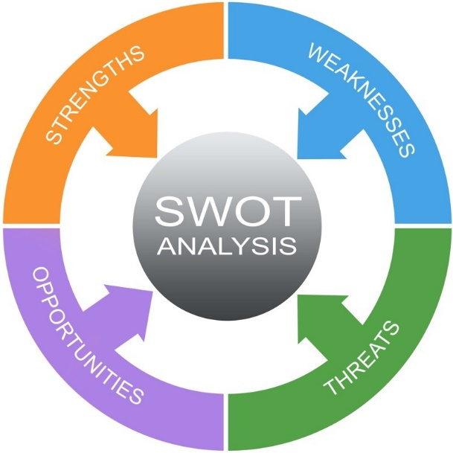
SWOT Analysis:
SOURCE: https://www.projectsmart.co.uk/
Strengths
- A sizable portion of the lucrative retail market share.
- A famous label that has been around for a century or more.
- Offering a large selection of goods, such as clothes for women and men as well as kids, as well as accessories for the house and body (Kotler et al., 2012).
- Provides several access points for customers, both physically and virtually.
Weaknesses
- Less emphasis on the youth market. Only 23 per cent of the clientele are younger than 35.
- Products from M&S are unable to distinguish themselves in the market since they are neither trendy nor affordable (Aranda, Martín and Santos, 2018).
- Insufficiently modern and lacking a cutting-edge e-commerce platform.
Opportunities
- Site updates that enhance the shopping, surfing, and purchasing processes for online customers
- Take part in e-commerce by selling items on sites such as eBay and Amazon, or by creating their e-commerce website (Wu and Li, 2019).
- Integrating big data systems to provide seamless service and tailored product suggestions and promotions is key to attracting tech-savvy millennials and Gen Zers.
Threats
- The average age of the current clientele is rising.
- Customers often experiment with cutting-edge styles (Ziyadin, Suieubayeva and Utegenova, 2020).
- The likes of Zara, H&M, and ASOS are light years beyond the competition when it comes to both technology and the newest styles (Wood and Butler, 2018).
- More and more people choose to purchase online rather than going to stores.
- The market for alternatives is growing.
- The apparel market is now in the decline phase of the good’s life cycle.

Strategies to sustain competitive advantage:
Accelerating omnichannel development:
Boosting online sales of clothing and home goods by using the existing retail and delivery network to provide clients with the same high level of service regardless of where they choose to make their purchases (Grewal, Motyka and Levy, 2018). And increasing demand for M&S items sold through Ocado Retail via first-rate service, industry-leading selection, and low prices.
Growing International Impact:
Using strategic relationships and the creation of a multi-platform online store to leverage the M&S brand and increase worldwide sales.
Cost reduction by reorganization:
By streamlining and simplifying digital, technology, and assistance centre operations, we will save £400 million in structural expenses over the next five years, lowering our cost to service, and increasing our margins (Kotler et al., 2012).
Building a culture of excellence:
An organization that is streamlined, quick, and customer-centric; one that values M&S goods above all else; and one that has the electronic acumen to make quick, educated business choices.
Increased shop turnover rate:
Over 100 additional Food shops will be built in growing regions to enable omnichannel shopping and store renewals and turnover will be sped up to improve productivity at the existing estate of about 180 full-line locations.
Introducing cutting-edge logistics:
Streamlining supply chains to save money and free up financial resources while enhancing product availability and client service. consumer environment that’s hard to resist Boosting omnichannel development via the development of a more interesting and interconnected customer experience (Akhtar, 2021). An improved and unified technological backbone supports the Sparks rewards scheme and its associated payment methods.
Allotting resources with restraint:
Investment-grade credit ratings and dividend payments may be secured via disciplined allocations of capital. We can buy an additional £225m of bonds due to maturity shortly since our liquidity plus balance sheet indicators are strong.
Their Family Matters Index indicated that to preserve these gatherings, people were willing to make sacrifices in other areas, with dining out is the first to go (Aranda, Martín and Santos, 2018). We upped our event ranges’ level of creativity in response, and we made sure their food was a terrific bargain compared to restaurants.
Growth strategies
Omni-channel model:
A “substantial” commitment to cutting-edge digital offerings complements the fresh and improved retail outposts. Shoppers can now use Scan and Shop straight from their M&S application on their smartphone to make in-store purchases, as well as digital clicking and collecting, which enables consumers to receive a shipment in a matter of seconds, is being extended to 130 shops.
According to the company’s most recent Christmas trade statement, the M&S application accounted for one-third of all online purchases, representing a 33 per cent increase during the holiday season. Customers who shop with M&S across several channels are worth eight times as much to the company, according to the retailer.
Sustainability:
By 2040, M&S aspires to become a net-zero company throughout its whole value chain, and it believes that its new locations will help it get there. It is investigating several options for producing electricity for its warehouses, such as the installation of solar photovoltaics across many promising locations (Grewal, Motyka and Levy, 2018). In addition, in collaboration with BP Pulse, they are installing ultra-fast charging networks for electric vehicles at around 70 M&S locations.
Market Penetrations:
Using cutting-edge techniques and methodologies while adapting to market shifts, M&S must expand its market share. The corporation is tasked with expanding its online purchasing platform into new areas and expanding sales in existing ones.
Products development:
When it comes to new product development, M&S’s approach doesn’t call for coming up with ground-breaking commercial items so much as it does for incorporating existing innovations into refined iterations of existing products (Akhtar, 2021). The corporation must, for instance, update its pattern and textile style in the garment industry. New food items that reflect the market’s need for multiculturalism are also necessary.
Employees:
Business Participation Groups are set up throughout the whole company to help employees communicate with the organization’s board (M&S, 2017). M&S, nevertheless, has realized the value of encouraging its staff to work together more to “make every opportunity unique for their customers.” The company should provide the means for its workers to make the consumer their priority.
Customers and community:
The most important stakeholder population to focus on and manage effectively is the customer base. For M&S to provide customers with what they desire, the company will need to investigate new and innovative methods of client feedback collection. M&S places a premium on making a difference in the world and making people’s lives better (Aranda, Martín and Santos, 2018). The community has a great deal of sway over the company but does not participate much in its operations. For this reason, M&S has to monitor its communities actively.
Marks & Spencer along with Vrutti have launched an environmental and social initiative to dispose of waste plastic in an environmentally responsible manner, to bolster the economic security of underprivileged populations in this manner. Eleven persons, of whom 78 per cent are women, from underprivileged backgrounds, were given the means to provide for themselves and their families of 45 individuals.
Green Strategy and CSR:
Marks & Spencer understands the importance of businesses being conscious of the communities and ecosystems in which they operate; as a response, M&S has developed initiatives to improve environmental conditions, public health, and educational opportunities. It is the practice of a company to recognise and actively address a big societal problem (Porter, 1985). The traditional idea of ethics is top-down, like a country’s laws. Established in 2004, Marks & Spencer’s “Ready for Work” CSR program sought to equip participants with fundamentals of business management to aid in the launch and expansion of participant-run businesses. The “Ready for Work” program has the same objectives as Marks & Spencer when it comes to CSR. Improving the standard of living and economic growth in the area.
Maintaining a healthy ecosystem. Maintaining a positive image in the community in which the organization operates. The company is dedicated to protecting the environment and does so via both internal efforts and financial support of external community efforts. Company initiatives have also included the construction of educational institutions, medical facilities, and charitable organizations as well as the provision of student fellowships. Business Activity on Homeless (for the homeless), Prince’s Trust (for the young jobless), One Parent Household and Parent-line Plus, as well as DisabledGo (for persons with disabilities) all benefit from the company’s charitable efforts. In 2021, M$S reported that 50% of the persons who had participated in the business’s educational initiative as pre-employments or internally sponsored learners had landed jobs with the public sector or the organization, demonstrating the effectiveness of M&S’s corporate social responsibility operations.
Effortless rebranding:
They simply renamed their CSR initiatives “Plan A” and updated their reporting to conform to GRI G3 requirements. Not only should retailers adapt their decor to the tastes of their customers in general, but they should also restrict their reliance on reports to do so (Aranda, Martín and Santos, 2018). The reports’ presentation and dissemination formats have been observed to be steadily evolving for the better.
Reducing Expenditures:
Stores that have been engineered to be more energy-efficient and environmentally friendly may save a significant amount of money. In addition to lowering the price of the product, outsourcing the production process may save money by reducing the number of personnel required to create the product.
Participation of Stakeholders:
When it comes to shareholder participation, M&S does several things, always keeping in mind how various stakeholders possess distinct needs and addressing those needs in different ways gives the company a solid foundation in the eyes of its stakeholders (Grewal, Motyka and Levy, 2018). If an employee ever has difficulty at work or in their personal life, they may always call the toll-free number provided by M&S.
Reporting and gauging progress:
The report on corporate social responsibility that M&S maintains is constantly updated to reflect the company’s current activities (Akhtar, 2021). Ernst and Young, an external auditor hired by the company, will evaluate current performance and track development toward future objectives. However, the method has to shift because of the incorporation of emissions from refrigeration as well as corporate travel, as well as the application of revised UK power conversion coefficients.
Aiming towards a future with no net emissions. Marks & Spencer has dedicated itself to lowering both its in-direct and direct effects upon the earth via emissions reduction while also adhering to its responsibilities to customer well-being and health. Emissions related to Scope 3 contribute to more than 97 per cent of Mark &Spencer’s carbon footprint, thus the company is adopting a ‘No Option B’ perspective regarding its sustainability option by aiming to attain net-zero carbon emissions spanning Scopes one, two, and three of the company’s operations by 2040 (Aranda, Martín and Santos, 2018). Mark & Spencer remains in an exceptional position to reduce emissions across its distribution network because of its focus on selling its private label items and its strong ties with its vendor partners. Using the 5.9 million metric tons of carbon emissions reported during the years 2016 and 2017 as a starting point, the corporation aims to lower its output by 34 per cent by 2025.
Conclusion:
According to a PESTEL study of M & S’s operating environment, it was determined that their economic climate poses serious risks owing to a decline in consumer income. M&S can take advantage of new openings made possible by the current technological climate. Positive signals were found in all but one of Porter’s five forces analysis. The last portion of the paper is the SWOT assessment that was prepared following the environmental study and the internal assessment. Marks & Spencer remains one of the foremost well-known merchants of glossaries, and for good reason: they know what their customers want. It’s been crucial to the administration of the support business. Marks & Spencer has put the competition in the UK and beyond to shame by providing customers with high-quality, uniform products at competitive prices. Marks & Spencer should create trendy clothing and then raise its advertising spending to establish a consumer perception of the company as an authority in the fashion industry. A company that wants to stay a step ahead of the competition and retain more customers must not only use intelligent designs but also comprehend when and why to use them. Before adopting a course of action, consider the likely results, both advantageous and unfavourable. Using strategies effectively not only aids in achieving competitive goals but also increases market share and profits for stakeholders.
In the opinion of Marks & Spencer, conducting a business environmental assessment is crucial because it helps a firm determine its external and internal strengths and shortcomings as well as the elements that have an impact on the corporation’s strategic objective and administration. Marks & Spencer continues to preserve its position as a market leader and expands its edge over competitors via the careful use of planning instruments and models. Because of this, the company’s plans are successful and tailored to the company’s needs, taking into account the business environment’s participants, culture, as well as hierarchy.
REFERENCES

- Akhtar, R., 2021. Introduction: Coronavirus, Environment and Human Behaviour. Coronavirus (COVID-19) Outbreaks, Environment and Human Behaviour: International Case Studies, pp.3-12.
- Amuna, Y.M.A., Al Shobaki, M.J. and Naser, S.S.A., 2017. Strategic environmental scanning: An approach for crises management. International Journal of Information Technology and Electrical Engineering, 6(3), pp.28-34.
- Aranda, E., Martín, V.J. and Santos, J., 2018. Competitive convergence in retailing. Economic research-Ekonomska istraživanja, 31(1), pp.206-227.
- Dani, S., 2019. Strategic supply chain management: creating competitive advantage and value through effective leadership. Kogan Page Publishers.
- Grewal, D., Motyka, S. and Levy, M., 2018. The evolution and future of retailing and retailing education. Journal of Marketing Education, 40(1), pp.85-93.
- GlobalData. (2022). Marks & Spencer – Digital Transformation Strategies. [online] Available at: https://www.globaldata.com/.
- Jeffs, C. (2008) Strategic Management (SAGE course companions). Sage Publications. https://web-s-ebscohost-com.ezproxy.uwtsd.ac.uk/
- James Davey (2022). Britain’s M&S warns of ‘gathering storm’ of higher costs and weak consumer. https://www.reuters.com/.
- Kotler, P., Armstrong, G., Ang, S.H., Leong, S.M., Tan, C.T. and Ho-Ming, O., 2012. Principles of marketing: an Asian perspective. Pearson/Prentice-Hall.
- Kotler, P. and Kevin Lane Keller (2009). Marketing Management. 13th ed. Upper Saddle River, N.J.: Pearson Prentice Hall.
- Karwowski, M. and Raulinajtys‐Grzybek, M., 2021. The application of corporate social responsibility (CSR) actions for mitigation of environmental, social, corporate governance (ESG) and reputational risk in integrated reports. Corporate Social Responsibility and Environmental Management, 28(4), pp.1270-1284.
- Leavy, B. and McKiernan, P., 2020. Strategic leadership: Governance and renewal. Bloomsbury Publishing.
- ‌Marks & Spencer. (2023). 2023 Annual Report. [online] Available at: https://corporate.marksandspencer.com/investors/our-performance-updates/2023-annual-report
- M&S (2023). Welcome to Marks & Spencer. [online] Marksandspencer.com. Available at: https://www.marksandspencer.com/.
- M&S (2021). Sustainability. [online] Sustainability. Available at: https://corporate.marksandspencer.com/sustainability.
- Marks and Spencer (2019). Home. [online] Home. Available at: https://corporate.marksandspencer.com/.
- Mäkinen, S. J., and Seppänen, M. (2017). The Role of Digitalization in Business Model Transformation. [online] Available at: https://www.ncbi.nlm.nih.gov/.
- Marketline. (2023). United Kingdom in - Depth Pestle Analysis. [online] Available at: https://advantage-marketline-com.ezproxy.uwtsd.ac.uk/.
- Nyame-Asiamah, F. and Ghulam, S., 2020. The relationship between CSR activity and sales growth in the UK retailing sector. Social Responsibility Journal, 16(3), pp.387-401.
- Porter, M., 1996. America’s green strategy. Business and the environment: a reader, 33, p.1072.
- Parnell John A (2017). Strategic management: theory and practice. 4th ed. https://librarysearch.uwtsd.ac.uk/
- Rashain Perera (2017). the pestle analysis. 2nd ed. https://books.google.co.uk/
- Rastogi, Nitank and Trivedi, Dr. M.K (2016). PESTLE TECHNIQUE – A TOOL TO IDENTIFY EXTERNAL RISKS IN CONSTRUCTION PROJECTS. International Research Journal of Engineering and Technology (IRJET), (2395-0056).
- Schleper, M.C., Gold, S., Trautrims, A. and Baldock, D., 2021. Pandemic-induced knowledge gaps in operations and supply chain management: COVID-19’s impacts on retailing. International Journal of Operations & Production Management, 41(3), pp.193-205.
- Squire, P., 2020. Selling transformed: develop the sales values that deliver competitive advantage. Kogan Page Publishers.
- Sughra, G., 2020. A Study Investigating Corporate Social Responsibility (CSR) and Financial Performance of Retail Industry in the UK (Doctoral dissertation, Cardiff Metropolitan University).
- Szydlowska, K., 2020. The future business strategy of Marks and Spencer. GRIN Verlag.
- Wood, Z. and Butler, S., 2018. Seven reasons why Marks & Spencer is in trouble. The Guardian. Available from: https://www. the guardian. com/business/2018/May/23/seven-reasons-why-marks-spencer-is-in-trouble [Accessed 27 May 2020].
- Wu, J.X. and Li, L., 2019. Sustainability initiatives in the fashion industry. In Fashion industry-An itinerary between feelings and technology. IntechOpen.
- Ziyadin, S., Suieubayeva, S. and Utegenova, A., 2020. Digital transformation in business. In Digital Age: Chances, Challenges and Future 7 (pp. 408-415). Springer International Publishing.

‌

‌

