- Evaluate the advantages and disadvantages of both a divisional structure and a matrix structure. Within the evaluation, you should include the reasons underpinning each structure. (AC 1.1)

Organisational structure is decided following the implementation of an Organisational strategy (Taylor, 2022). Taylor (2022) also defines it as ‘how individuals work within an organisation’. A divisional structure and matrix structure are two common organisational structures which outline how tasks are distributed and managed.

The decision for an organisation as to what structure to adopt depends on the needs and outcomes for the business. The divisional structure is more suited to larger scaled organisations such as a Local Authority which has various departments working on individual outcomes. A matrix structure is suited to smaller organisation that require flexibility and efficient utilisation of resources.

A divisional structure is when an organisation has separate individual departments, all responsible for a specific area. Each department works independently using its own resources, for example, Human Resources, IT and Finance (Mullins, 2019). Wyatt (2022) uses an example of General Electric company to demonstrate a divisional structure which has a lower layer of employees who work on project-based areas, then a level of functional departments including Legal and business development, with a CEO overseeing the entirety.

Advantages of divisional structure are departments will have accountability for their area; therefore, performance can be clearly assessed. Managers within each of the areas have autonomy over their decision making. There are usually specialists within their areas who can give their attention to the specific project.

There are some disadvantages to a divisional structure as divisions may start to compete for resources and some employees may feel their work is more important than another area within the organisation. Employees may also not understand the needs of co-workers, as areas work in isolation (Wyatt 2022).

A Matrix structure consists of dual reporting lines for employees and is a blend of divisional and functional structures. Matrix structures are more efficient within an organisation, allowing shared resources and flexibility within roles of employees, communication is also more fluid through the structure (Organ 2024). Matrix structures can cause confusion with employees due to dual reporting lines, power struggled between managers involved in the same area may cause conflict. Decision making can also be delayed to facilitate collaboration with all managers involved (Wyatt 2022)

Proctor & Gamble (P&G) is an example of company that has a matrix organisational structure to support the global operations and various product lines. For example, a product designer reports into a project manager for a specific task and an area manager for a geographical area (Proctor & Gamble, 2023).

- Analyse the extent to which the organisational strategy in your organisation (or an organisation with which you are familiar) helps to ensure products or services meet customers’ needs. (AC 1.2)

An organisations strategy is built around the objectives and how they are going to be achieved. There are two approaches to strategy which is a Planned Strategy and an Emergent Strategy. An emergent plan is based on the strategy developing as it proceeds, based on needs and circumstances (Taylor 2022). Pembrokeshire County Council develop a planned strategy in which the objectives are defined and agreed prior to the implementation.

Within the Human Resource department within Pembrokeshire County Council (PCC) our customers are employees of the Council. There is a Work Force plan that outlines the strategy within HR, how it is going to be achieved and the impact on the organisation.

The implementation of the SWITCH programme enables PCC to identify current talent in the workforce, therefore filling vacancies internally by matching employee’s ‘at risk’ to job specifications. This also helps mitigate internal redundancies by capitalising on natural turnover and making best use of existing staff resources (Pembrokeshire County Council 2023). An employee that may be medically discharged from his position within refuse due to a back issue, could have the skills suitable for an office-based position. The SWITCH programme enables PCC to carry out a skill scan on the employee and match then to a suitable role. This keeps the employee in work and utilises their skillset.

Leadership and succession planning is another focus of the workforce strategy. PPC have created in-house Management Development Programmes which looks to embed the culture, to ensure new behaviour standards are discussed and role modelled within all services (Pembrokeshire County Council, 2023). There are 4 levels to the Management programmes which includes Aspiring Managers, Introduction to Management, Emerging Leaders and Leadership Accreditation. By offering the 4 levels of programme allows all employees access to management training, the lowers levels suitable for an employee looking to progress. The higher levels are more suited to a an employee already within a managerial position who wishes to further develop their skills, it can also support the capability process. By investing in employees PCC seeks to equip all managers with the skills and tools to drive employee engagement, commitment, performance and retention.

PCC’s Mental Health Strategy was developed by a working group which consisted of various employees across the organisation with Human Resources having the majority of representation. Using the working group PCC was able to gather feedback from the employees to fulfil their needs. Since the Pandemic PCC has focussed efforts on supporting the Hybrid working culture by encouraging social and team building opportunities. Also ensuring management styles are suited to departments that are Hybrid working, are conducive. There is also a continued focus on maintaining the Silver Corporate Health Standard which was achieved in 2022.

Implementation of these aspects of the strategy will support the creation of a dynamic workforce, where employees feel valued and supported. This will also help retain employees within the organisation and enhanced the talent.

- Analyse the current impact of interest rates, inflation and one other external factor on your organisation (or one with which you are familiar). Identify organisational priorities arising from your analysis. (AC 1.3)

Increased interest rates have an impact on borrowing costs for Pembrokeshire County Council. This affects our ability to finance infrastructure such as schools and projects. Low interest rates can impact Local Authorities pension obligations as the future value of the pension could increase leading to pressure on budgets. Many Local authorities, including Pembrokeshire County Council have extensive amount of debts, higher interest rates can significantly impact the cost of the debt.

Inflation can also have an impact on the factors mentioned above. Inflation causes an increase in the cost of goods and services, higher expenses in all areas of the Authority. Also linked is the increase in employees’ wages to the rise in national minimum wage and cost of living wage. Together these can enforce areas to prioritise spending and put a strain on budgets (Martell 2024).

Local Governments need to be prepared for any emergencies that may be caused by environmental factors. Considering the allocation of resources and ensuring infrastructure is resilient. Recent Storm Darragh caused major disruption across the county in December, leaving many people without electricity and damage to infrastructure. Pembrokeshire County Council had to respond to the imminent needs of the county, working with alongside the National Grid, Welsh Water and many others to support people within the community.

The storm brought flooding to areas, damage to forestry and woodland along with many public access routes being obstructed by debris. Pembrokeshire County Council employees worked out of hours to support communities, adding additional unanticipated payroll costs. Many resources were required such as sandbags, equipment to cut down and remove trees blocking roads. Some of the tasks were outsourced to other companies due to the scale, Pembrokeshire County Council were then invoiced for these works.

From my analysis a high priority for Pembrokeshire County Council is identifying funding allocation from Welsh Government for financial year 25/26. It is anticipated there will be a shortly fall, urgency identifying the amount and devising a plan on where and how budget savings can be made. Also taking into consideration proposals from Unions for further pay increases of a significant amount.

Development of a Risk Management plan will enable PCC to plan for future environmental risks, such as natural disasters. This would include contingency planning, budget allocation and securing relevant insurances where applicable. A Robust PESTLE Analysis to help support and identify any new or imminent external factors and this to be reviewed on a regular basis.

- In February 2024, Peter Cheese, current CEO of CIPD stated, “AI is transforming jobs, careers and workplaces. People professionals have a key role to play in encouraging safe experimentation and rapid learning, so that we can reap the benefits and mitigate the risks.” Assess the extent that AI is, or could be, used in your organisation (or an organisation with which you are familiar) and assess how AI impacts work. (AC 1.4)

AI is becoming more integrated into the workplace, already present into many digital software’s used. The use of AI is growing rapidly, workplaces and workforces need to be prepared to reap the opportunities that it offers, along with dealing with challenges (CIPD 2025). HR professionals can consider how the implementation of AI for process and employee experience could enhance the employee lifecycle (Cockett 2023)

Pembrokeshire County Council use AI software to create Mandatory Training courses for employees, such as data protection and fire safety. These courses are thoroughly checked by a training adviser before uploading to the training platform. Although the checking of the content may seem time consuming, using AI generation is more efficient to the workforce.

AI is being adopted by schools to support lesson planning. It’s important for education professionals to engage with new technological advances that are starting to shape the educational system (Fakhr 2024). In the future, this could support the reduction of PPA time for teaching staff, providing budget saving opportunities for schools and higher efficiency during the teaching day.

The creation of Job adverts using AI Technology is more efficient, saving time for HR Professionals. The format and language used is consistent and avoids any use of bias language, making them more appealing and attractive to potential candidates. According to Frissen, et al (2022) biases and prejudice are present in job adverts, although subtle, it still discourages highly qualified applicants from minority groups from applying.

Job Descriptions are now generated using AI software, although this is a more efficient way it also supports consistency, ensuring the format and language used is the same for all, like job adverts it also removes biases, making them more inclusive. AI can also help identify key skills and qualifications for each role by analysing large amounts of data. However, consideration need to be given to the accuracy of the data. There are minimal disadvantages of using AI for Job Descriptions and Adverts (Deranity & Corbin 2022)

Within the contact centre at Pembrokeshire County Council the use of AI Chat Bots to support customers with simple basic questions and queries would help reduce the pressures on the contact centre team. This also would help enhance the customer experience as long wait times on the telephone can cause frustration. It enables the customer to have 24/7 support, all customers receive the same service however it is limited in understanding and support in complex queries (Adam, Wessel & Benlian 2020)

AI can cut the costs of hiring, improve workflows for employees, allowing best possible job allocation. It is widely used by companies such as Airbnb, Uber and amazon to manage, direct, recruit, evaluate and even terminate worker (Deranity & Corbin 2022)

AI can support the automation of monotonous tasks within an organisation, providing efficiency within the workforce. Conversely organisations need to consider the accuracy of any data used from AI, there are Data Privacy concerns as sensitive information could be inputted into AI software could lead to risks of misuse or breaches (Masry & Chapman 2023)

- Explain Charles Handy’s model of organisational culture and explain David Rock’s SCARF theory. (AC 2.1)

Charles Handy’s motivational theory consists of 4 different columns which identifies 4 distinct types of organisational cultures. These are Power, Role, Task and Person (HR Courses online, 2024)

Power culture refers to the decisions within the organisations sit with very few. Responsilbities can be delegated but the control of resources stays at the top of the hierarchical structure. This culture is usually within smaller organisations with a CEO. It enables quick decision making, however is dependent on good decision making. This culture does not value job security. Culture is described a web, each time the leader makes a decision it impacts a area, or multiple areas of the organisation (Francis, 2024)

Role culture has a small group of senior managers which is support by ‘pillars’ of the workforce. Employees have specific roles linked to their strengths and specialities which enables accountability for their own work. This culture values job security over power and growth within the organisation.

Task culture is team focussed who have common interests and specialisations. Senior managers hold the responsibility and then allocates roles and responsibilities. It is represented as a net, there are points where the team come together. Team leaders have responsibilities however this can cause competition which is counterproductive (Francis,2024)

Person Culture is a rare culture of an organisation which focusses on the person ambitions over the objectives of the organisation. High degree of autonomy within the organisation, however not many organisations are able to function in this way.

According to Cacciattolo (2014) handy argues that if an employee is successful in one culture, they may not be in another. Similar with organisations, an organisation may be successful adopting a type of culture, however a similar approach may not be right for another.

David Rock SCARF Model consist of 5 areas that guide human behaviour. SCARF stands for the following:

- Status- how important an individual feels to others
- Certainty – predicting the future
- Autonomy – having a feeling of control over situations
- Relatedness – Feeling safe with others
- Fairness – their perception of fair exchanges between people.

The model is designed to enhance human interactions with others by addressing he 5 key social factors that influence behaviour (Mullins & McClean 2019)

- Assess how employee selection or employee development impacts organisational culture and behaviour in your organisation (or one with which you are familiar). (AC 2.2)

Employee development impacts significantly on employee behaviour and organisational culture. According to Nami Nasution et el (2018) research shows that if organisation has transparent, fair and objective career development this helps strengthen the organisational culture by monitoring the implementation of firm values.

Stage 4 of the employee lifecycle focuses on employee development and the importance of growth and progression within a team and developing new opportunities. Providing the right conditions for professional development will increase employee engagement and staff retention (Finn 2024)

In a Local Authority staff retention remain high with long serving employees. However, this can negatively impact on culture as these employees are more resistant to change and culture remains as ‘always done it that way’. This creates stagnation within the workforce where innovation and new ideas are suppressed, preventing the organisation from evolving. Having effective change management process to support managers implementing change would help reduce the resistance from employees (Yılmaz and Kılıçoğlu, 2013).

Some new employees may not feel welcomed into the team due to resistant employees; this in itself would change the team dynamics. Toxic culture and breeding negativity between current and new employees can have a detrimental impact on organisational culture.

It is important that Continuous Professional Development (CPD) filters from Senior management through to the lower-level employees. If CPD is not valued at senior level, then it is unlikely to be a focus for lower-level management to support their employees. This can cause employees who value growth and development to leave the organisation.

- An organisation is planning a change relating to hybrid working. Many employees moved to home working during the Covid-19 pandemic. Whilst this approach worked well at the time, the organisation now wants all employees to work at least two days a week on site. Explain how Kotter’s approach to managing change could be used to successfully implement this change. (AC 2.3)

Kotter’s 8 step model outlines the process to implementing change within an organisation to make it successful.
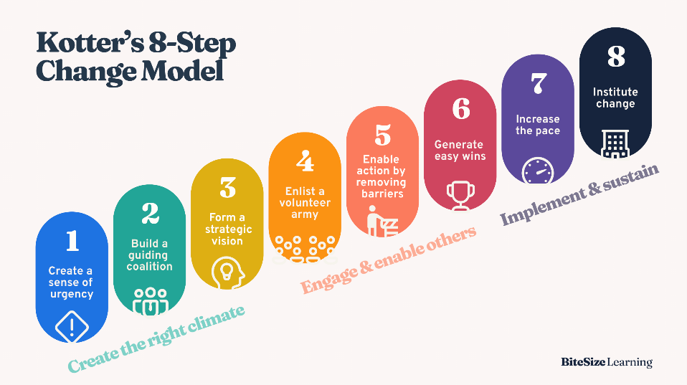
Figure 2 – A diagram of John Kotters 8 step Change Model (Parsons, 2024)

At the first stage the organisation needs to explain the reasons why the employees need to return to the workplace at least two days a week. Also highlighting the benefits of this in the initial stages will help get employees on board.

Building a coalition team within the organisation to help support implementation, ensuring the right people for the job and using expertise. For this organisation it would consist of senior management with the support of Human Resources.

The organisation needs to form a strategic vision and initiatives, incorporating the values of the organisation at every point. The change needs to be in line with the strategic vision and imbed core values at every stage, if this does not happen the employees with not have the connection (Laig & Abecejo, 2021)

Enlisting a volunteer army. The organisation should develop a working group to start delivery information and promoting the change to the employees in a positive way. They must ensure the group fully understands the change to ensure correct and consistent information is given. There is also opportunity for employees to feedback their view on returning to the workplace, which the group can feedback into the coalition team for consideration.

Enable action by removing barriers. At this point the organisation should have a good understand of feedback given and any potential barriers. If barriers are identified as significant then the organisation may need to return to Step 1 of model. Feedback can help overcome barriers however, the organisation needs to be mindful of any barriers identified. They also need to consider the impact the barrier may have if they continue with the change process. For example, the office space may no longer have enough desk space to accommodate all employees, the organisation may need to introduce ‘hot desking’ and employees may need to the work place on different days. (Laig & Abecejo, 2021)

Generate easy wins. The coalition team and volunteer army and communicate out any positive outcomes already identified and in place. If the organisation is unable to identify any short-term wins, then consideration need to be given as to whether to continue with the change.

Increase the pace. The organisation needs to ensure sustained acceleration to return the workforce back into the office 2 days a week. At this point potentially trial periods of attending the office could be implemented for some staff, with feedback give from the experience. Employees will start getting on board and adapting to the change being implemented.

Institute Change. At the point the change will be embedded within the organisation and integrate into the organisational culture. Leaders will need to ensure they continue the support for the employees to maintain momentum. (Laig & Abecejo, 2021). At this step all employees will be attending site at least 2 days per week.

To implement this change using this model successfully it’s advised not to miss a step, as each step is built on the work completed on the previous one. Missing a step can impact the implementation of the change and in some instances advised to start the process again.

- Using the Kubler-Ross change curve, discuss how change is experienced. (AC 2.4)
Kubler-Ross’s change management model consists of 7 stages. These are:
- Shock – Usually employees’ initial reaction once they are informed of the change.
- Denial – Some employee may be in denial about the change, feeling numb.
- Anger – Employees may show signs of anger and frustration towards themselves and/or others. Expressing resistance to it.
- Bargaining – Trying to avoid the change by negotiating. Discussing the ‘what ifs’ and ‘if only’ situations.
- Depression – Feeling sad and coming to realisation of the change being implemented
- Acceptance. – Accepting the change and then implications. This does not always mean the agree however have started to move forward.
- Integration – Implementation of the change
It’s important for organisations and HR professional to understand the change curve to help identify where employees are on the change curve and to help best support them. All employees react differently to the change and will experience different stages at different times, some may not experience some of the stages at all. For example, an employee may begin in the denial stage when first informed of an organisational change, then attempt to avoid the change being implemented and then accepting the change.
Taylor (2023) states that poorly managed change can lead to large resistance from groups. It is highly important for everyone affected by the change to be consulted at opportunity to give feedback, this way they are more likely to embrace change. Ensuring adequate training and development to enable staff to feel more prepared for the change. An employee’s resistance to change is created in organisational change process (Chavan 2022)

- The CIPD’s Health and wellbeing at work survey 2023 found the percentage of organisations that have a standalone wellbeing strategy has risen from 40% in 2018 to 53% in 2023. Although the percentage has increased, this means that 47% of organisations do not have a standalone wellbeing strategy. Assess the importance of wellbeing at work and assess how good work could impact wellbeing. (AC 2.5)

Wellbeing at work is crucial for both the employees and the organisation. An organisation as a duty of care to look after the health, safety and welfare of all employees and it has become an important part of People Practice roles (Taylor, 2022)

CIPD’s health and wellbeing survey 2023 highlights the highest sickness absence rate in a decade, with an average of 7.8 days taken per employee. This impacts the efficiency of an organisation and also has a significant cost. The organisation will be paying sick pay to the employee that is absent along with employing someone to cover the position if the employee is off long term. Short term absence is not as costly but still impact the organisation in terms of efficiency, an employee being absent may causes delay and additional workloads on to other employees.

76% of organisations who completed the survey reported absence related stress, with heavy workloads being the common cause, along with mental health being the most common cause for long term absence (Sinclair, 2023)

Investing in employee well-being will boost employee engagement in the workforce. Employees will feel valued and supported leading to an increase in retention of staff.

According Young (2024) CIPD defines good work as enabling employees a work-life balance and offering opportunities to develop. Providing a supportive environment ensuring employees are fairly rewarded and give employees a choice to help shape their working lives. CIPD’S Good Work Index 2024 identifies conflict within the work place as being experienced by a quarter of the respondents to the survey. Conflict in the workplace can negatively impact all aspects of work for an employee. Encouraging openness within the organisation enables employees to feel heard and express their views. An investment in management training for senior leaders would be beneficial to enable them to feel empowered to deal with conflict effectively.

As an employer there is also a legal obligation under Health and Safety legislation to protect employees from stress at work by completing a Stress Risk Assessment. Any issues that are highlighted in the risk assessment must be acted on (Suff, 2024)

- Provide a brief overview of the employee lifecycle and discuss people practice roles at the recruitment, development and separation stages of the lifecycle. (AC 3.1)

It is important for HR Professionals to be aware and understand the employee lifecycle and how is impacts on the workforce at each stage. The employee lifecycle shows the different stages an employee goes through from being recruited into an organisation until they leave.
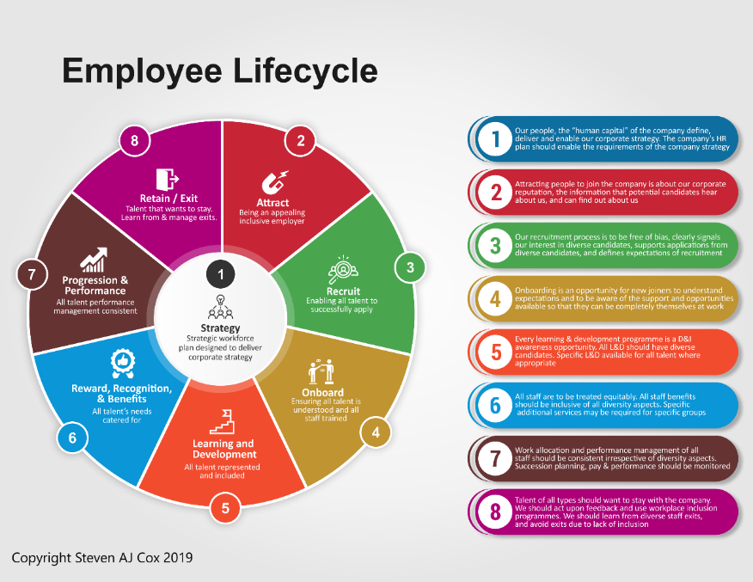
Figure 1 – A diagram explaining the stages of the employee lifecycle (Cox, 2024)

The employee life cycle (Taylor, 2022) is made-up of eight stages which are linked to attraction. Raising the awareness of the organisation to employees through creating a positive brand and reputation to appeal to top talent.

Recruitment - Through workforce planning managers can identify vacancies and the number of vacancies. Job evaluation may take place to analysis and agree the job description along with the salary. Job descriptions are key at this stage to outline the roles and responsibilities and appealing to potential candidates. The advertisement of the position is also key to ensure you are appealing to the appropriate applicants. This can be done internally, through word of mouth, organisations website and recruitment agencies. Use of social media to advertise vacancies has increased in recent years using platforms such as LinkedIn. The Onboarding stage will help to ensure new employees have an induction process which helps them to understand their roles and responsibilities.

It is important to have a link between managers and people involved in organisational and employee development. Creating career pathways for all areas within an organisation will give the employees an understanding of their professional development and how they can progress. The Learning and Development Teams create mandatory training courses, along with courses to enable employees to develop their skills, such as leadership and coaching courses. People Practice roles can development an effective Performance Review workflow which encourages a two-way conversation with employees and managers to discuss their development and their aspirations. When looking at the retention phase, through effective employee development this should help to keep employees engaged. Being able to offer benefits packages, career development opportunities and being part of a positive workforce and environment, will help to keep top talent within the business.

The Separation stage is about being able to deal with employees who potentially leave the business. This can be broken down into voluntary separation, link to retirement, development and career opportunities in another business, personal life changes. or involuntary separation, linked to redundancy, performance related dismissal or disciplinary actions (Taylor, 2022). This needs to be a professional, equal and respectful process. Armstrong and Taylor (2023) highlight the critical importance of having a professional exit process and CIPD (2022) emphasise the legal and ethical considerations when an employee separates from the organisation. Some examples of this ruling linked to adherence to employment laws, notice periods and contractual obligations as well as ensuring that administrative procedures are followed such as final payroll processing or returning company assets.

Finally, the retain/exit phase. Being able to effectively support employees that want to develop within the business through providing continuous opportunities. If there are people looking to exit the business, this process is learned from and organisational practises are improved to improve employee retention. Companies implement exit interviews to be able to obtain positive and constructive feedback from employees. Some former employees who have had a good experience can become advocates for your organisation and be able to spread positive comments to future potential employees. CIPD (2022) highlight the strategic importance for an organisation being able to understand why employees leave the organisation being able to capture this information and turn into useful data to make improvements. Armstrong & Taylor (2023) also suggests that this is a crucial stage to ensure that an organisation is learning from this process and improving their talent management.

- Analyse how people practice supports organisational strategy through vertical integration and how people practice supports wider people strategies through horizontal integration. (AC 3.2)

People practices play a fundamental role in supporting an organisation’s strategy through the implementation of vertical and horizontal integration. Vertical integration ensures that the strategy within the organisation cascades from top management all the way through to its operational staff. This involves ensuring alignment with an organisation’s goals, communication and practices to support the strategy and its implementation from the top down (Armstrong, 2019)

Some of the key areas of vertical integration begin with clear communication. It’s important within a business that the strategic goals and objectives are clearly communicated effectively through the organisation. People practice support this by creating the induction process, training and support as well as ensuring discussions in team meetings. The creation and ongoing development of policies and procedures and also embed this. Ensuring Training and development supports the employees in fulfilling and meeting the strategic aims. This also linked into performance management, ensuring the process supports individual performance goals that align with the organisational objectives.

Workforce planning is also an important part of vertical integration, ensuring that the right people are in the right roles, and the right time to achieve the goals. Leadership development is also crucial, ensuring leaders can drive change and align it to the organisational strategy, using this as a base for their decision-making.

Horizontal integration focuses on aligning the strategies across different functions and departments within the organisation (Armstrong, 2019). To support horizontal integration there is a need to work cross-functionally and collaboratively between departments. By promoting effective collaboration between departments, you can ensure that relevant departments roles and functions align. People practices need to consistency across all policies and procedures for departments will ensure alignment to the strategy. There also needs to be a focus on culture within the workforce as a strong organisational culture promotes alignment of the strategic goals.

People practices ensure that recruitment and training opportunities align with development opportunities for employees, fostering a collaborative and consistent work environment regardless of the area within the organisation.

- An organisation is planning to introduce a four-day working week. Discuss the processes the people function could use to consult and engage with managers and employees to understand their needs when moving from a five-day to four-day working week. (AC 3.3)

The people practice function of an organisation should always be consulted and involved when significant change is happening, to ensure policy and process is followed along with any legal requirements. There should be a framework in place to support and guide managers in the change process. Complete a stakeholder analysis to identify who might be impacted by the change. This includes a wide range of stakeholders, including employees from different roles and departments, as well as various levels of the organisation.

Consider potential interests, how it might concern them, and their levels of influence on the idea of a four-day working week. By doing this, you will be able to determine levels of interest and suitability and develop communication strategies to target specific groups, addressing their individual needs and concerns.

The survey would enable quantitative data on employees’ expectations, concerns, and suggestions regarding the change. This is an effective consultation and engagement method, as it can reach many employees. It is also an efficient way to obtain opinions and track common themes within the responses. Implementing focus groups to facilitate small group discussions with employees and managers from a range of backgrounds to understand their perspectives in more detail.
You will also need monitoring in place, such as key performance indicators (KPIs), to track the impact of a four-day working week once it has been fully implemented. This could include analysing productivity, employee morale, and improvements in work-life balance. Monitoring KPIs provides objective data, allowing you to assess the success of implementation and identify areas for improvement in a timely manner.
It is important to conduct regular reviews of the implementation, consistently obtaining feedback and analysing key performance indicator data. This will allow for real-time adjustments, ensuring that any problems are addressed efficiently while maintaining the needs of employees, the organisation, and other key stakeholders.
Some informal methods can also be used, such as casual conversations and encouraging managers and HR staff to engage in informal chats with employees about the changes.
This could take place throughout the workplace via ad hoc one-to-one meetings, providing valuable insights into employees’ concerns and allowing them to raise issues in a less formal setting, reducing pressure. In combination with an open-door policy, this will encourage employees to come forward and speak to HR or management with their thoughts and questions. This approach ensures that employees feel they can openly communicate and be heard in both informal and formal ways.
The People function can also support managers with strategic workforce planning, understanding the impact of the change on the staff and realigning the strategy if required. HR can advise following a change model such as Kotter’s 8 steps of Change or Lewin’s Change model (Roberts, 2024)

The function of people professionals is to support the process of change and the managers implementing – being ‘backstage support’ for the leaders. The overall communication should translate the vision to the employee which will ultimately be decided by the people professionals. People Professional should also advocate the change and ensure the vision of the leader is clear and remove any obstacles (Roberts 2024

Bibliography
Adam, M., Wessel, M. and Benlian, A. (2020) ‘AI-based Chatbots in customer service and their effects on user compliance’, Electronic Markets, 31(2), pp. 427–445. doi:10.1007/s12525-020-00414-7.
Armstrong, M. and Brown, D. (2019) Strategic Human Resource Management: Back to the future? . rep. Institute for Employment Studies.
Finn, B. (2024) The employee life cycle in 2025: A complete guide, People Managing People. Available at: https://peoplemanagingpeople.com/articles/the-employee-life-cycle/#what-is-the-employee-life-cycle (Accessed: 22 January 2025).
Cacciattolo, K. (2014) Understanding Organisational Cultures, 2. doi:10.19044/esj.
Chavan, S. and Bhattacharya, S. (2022) ‘Study of employees’ behaviour during organizational change: Effects of Business Theatre on Kübler-Ross Model’, CARDIOMETRY, (22), pp. 237–243. doi:10.18137/cardiometry.2022.22.237243.
CIPD (2025) Briefing: AI in focus: Role of people professionals, regulation and the CIPD, CIPD. Available at: https://www.cipd.org/uk/policy-and-insights/thought-leadership/insight/ai-people-professionals-cipd/ (Accessed: 19 January 2025).
Cockett, J. (2023) Employers moving to investigate, implement and invest in Generative AI, CIPD - Employers moving to investigate, implement and invest in generative AI . Available at: https://www.cipd.org/uk/policy-and-insights/thought-leadership/insight/employers-generative-ai/ (Accessed: 19 January 2025).
Cox, S.A. (2024) The employee lifecycle for Equity Diversity and Inclusion, Steven AJ Cox. Available at: https://www.stevenajcox.com/diversity-and-inclusion-employee-lifecycle/ (Accessed: 21 January 2025).

Deranty, J.-P. and Corbin, T. (2022) ‘Artificial Intelligence and work: A critical review of recent research from the Social Sciences’, AI &amp; SOCIETY, 39(2), pp. 675–691. doi:10.1007/s00146-022-01496-x.
Fakhar, H. et al. (2024) ‘Towards a new artificial intelligence-based framework for teachers’ Online Continuous Professional Development Programs: Systematic Review’, International Journal of Advanced Computer Science and Applications, 15(4). doi:10.14569/ijacsa.2024.0150450.
Finn, B. (2024) The employee life cycle in 2025: A complete guide, People Managing People. Available at: https://peoplemanagingpeople.com/articles/the-employee-life-cycle/#what-is-the-employee-life-cycle (Accessed: 22 January 2025).
Francis, A. (2024) Charles Handy’s model of organizational culture, MBA Knowledge Base. Available at: https://www.mbaknol.com/management-principles/charles-handys-model-of-organizational-culture/ (Accessed: 02 February 2025).
Frissen, R., Adebayo, K.J. and Nanda, R. (2022) ‘A machine learning approach to recognize bias and discrimination in job advertisements’, AI &amp; SOCIETY, 38(2), pp. 1025–1038. doi:10.1007/s00146-022-01574-0.
HR Courses online (2024) What is: Charles Handy Model of Organisational Culture. 29th August 2024. Available at: https://www.youtube.com/watch?v=pF1cfEt8JWQ (Accessed: 2nd February 2025).
Jordan, D. (2024) UK interest rates held as Bank of England says economy doing worse, BBC News. Available at: https://www.bbc.co.uk/news/articles/cd75yq1zlzqo (Accessed: 19 January 2025).
Laig, R.B. and Abocejo, F.T. (2021) ‘Change management process in a mining company: Kotter’s 8-step change model’, Journal of Management, Economics, and Industrial Organization, 5, pp. 31–50. doi:10.31039/jomeino.2021.5.3.3.
Martell, C.R. (2024) ‘The impact of inflation on Local Government Fiscal Health’, Journal of Public Budgeting, Accounting &amp; Financial Management, 36(2), pp. 234–252. doi:10.1108/jpbafm-09-2023-0171.
Masry and Chapman, C. (2023) 7 disadvantages of using AI at work, Explore Walling. Available at: https://explore.walling.app/7-disadvantages-of-using-ai-at-work/ (Accessed: 19 January 2025).
Mullins, L.J. and McLean, J.E. (2019) Organisational behaviour in the Workplace. 12th edn. Harlow, England: Pearson Education Limited.
Nami Nasution, F., Mariatin, E. and Zahreni, S. (2018) ‘The influence of Career Development and organizational culture on employee performance’, International Journal of Scientific Research and Management, 6(01). doi:10.18535/ijsrm/v6i1.el09.
Organ, C. (2024) 7 organizational structure types (with examples), Forbes. Edited by C. Botteroff. Available at: https://www.forbes.com/advisor/business/organizational-structure/ (Accessed: 14 January 2025).
Parsons, G. (2024) Kotter’s 8-step change model: Frameworks explained [with diagram], BiteSize Learning. Available at: https://www.bitesizelearning.co.uk/resources/kotters-8-step-change-model (Accessed: 22 January 2025).
Pembrokeshire County Council (2024) Maternity and Family Friendly Policy. Pembrokeshire County Council. Unpublished.
Pembrokeshire County Council (2023) Future Workforce Plan. Pembrokeshire County Council. Unpublished.
Procter and Gamble (2023) P&G Corporate Structure, P&G corporate structure. Available at: https://us.pg.com/structure-and-governance/corporate-structure/ (Accessed: 19 January 2025).
Roberts, A. (2024) Change management: A guide for people professionals, CIPD. Available at: https://www.cipd.org/uk/knowledge/guides/change-management/ (Accessed: 24 January 2025).
Sinclair, A. (2023) Health and Wellbeing at Work . rep. CIPD. Available at: https://www.cipd.org/globalassets/media/knowledge/knowledge-hub/reports/2023-pdfs/8436-health-and-wellbeing-report-2023.pdf (Accessed: 22 January 2025).
Suff, R. (2024) Stress in the workplace: Factsheets, CIPD. Available at: https://www.cipd.org/uk/knowledge/factsheets/stress-factsheet/#the-uk-legal-position (Accessed: 23 January 2025).
TAYLOR, S.W., CAROL (2022) Studying Human Resource Management A Guide to the study, context and practice of hr. 3rd edn. S.l.: KOGAN PAGE.
Wyatt, A. (2022) Company organizational structure: Functional vs. divisional vs. matrix vs. flat, Status.net. Available at: https://status.net/articles/company-organizational-structure-functional-divisional-matrix-flat/ (Accessed: 14 January 2025).
Yılmaz, D. and Kılıçoğlu, G. (2013) Resistance to change and ways of reducing resistance in educational organizations, European Journal of Research on Education - ISSN: 2147-6284. Available at: https://journaldatabase.info/journal/issn2147-6284 (Accessed: 02 February 2025).
Young, J. (2024) CIPD Good Work Index 2024: Summary report. London: Chartered Institute of Personnel and Development. Available at: https://www.cipd.org/globalassets/media/knowledge/knowledge-hub/reports/2024-pdfs/8625-good-work-index-2024-summary-report-web.pdf (Accessed: 22 January 2025).

