Operating System
Module Name: Computer Architecture
Module Code: ACCA 4022
Student Name: Alina Mateta
Student ID: 2511187
Lecturer Name: Dr. Md Shantanu Islam

Submission date:17/03/2026

Contents
Introduction 4
Key functions of general Operating Systems 4
Task Management: 4
Application/Program Management: 5
File/Directory Management: 6
Device Management: 7
Security Management: 8
Use of Windows OS CLI commands 9
Example 1: 9
Example 2: 10
Example 3: 11
Example 4: 12
Example 5: 13
Example 6: 13
Example 7: 14
Example 8: 15
Example 9: 16
Example 10: 16
Use of Linux OS CLI commands 17
Example 1: 17
Example 2: 18
Example 3: 19
Example 4: 20
Example 5: 20
Example 6: 21
Example 7: 21
Example 8: 22
Example 9: 22
Example 10: 23
Use of Windows OS scripts 23
Example 1: 23
Example 2: 24
Use of Linux OS scripts 25
Example 1: 25
Example 2: 26
Conclusion 28
References 28
Appendices 30

Introduction
In this coursework, I will examine the Microsoft Windows operating system. I will explain the purpose of the Windows Task Manager, the role of file and directory management, and how to locate and use Device Manager in Windows. The functionality of Windows Security Management will also be analysed. Furthermore, I will demonstrate interaction with Windows through Batch scripting language. Several commands will be examined, including DIR, MKDIR, CD, RD, ECHO, TASKLIST, SYSTEMINFO, IPCONFIG, PING, and TRACERT. Subsequently, I will investigate the Linux operating system operating within the Bash shell, review key commands such as SU, PWD, LS, TOUCH, CAT, and ECHO, and study script usage.

Key functions of general Operating Systems
An operating system is software that manages computer resources and acts as an interface between hardware and applications. In 1987, Microsoft and IBM released OS/2 for Intel processors, which had significant memory limitations and lacked a graphical interface. Due to high memory costs and usability constraints, Microsoft later introduced Windows. The name Windows sometimes reflected the release year and sometimes a sequential version number [1].

Task Management:
An operating system provides task management functionality that enables efficient control over running processes and system resources. This functionality allows the system to shift focus to the active window, switch between tasks in real time, and manage transitions between execution and waiting states. In Microsoft Windows, the Task Manager is a key system utility that gives users insight into active applications, background processes, CPU usage, memory consumption, and system performance. It also allows users to terminate unresponsive programs and monitor startup behaviour. The Task Manager can be quickly accessed using the keyboard shortcut Ctrl + Shift + Esc, ensuring immediate control over system operations [2].
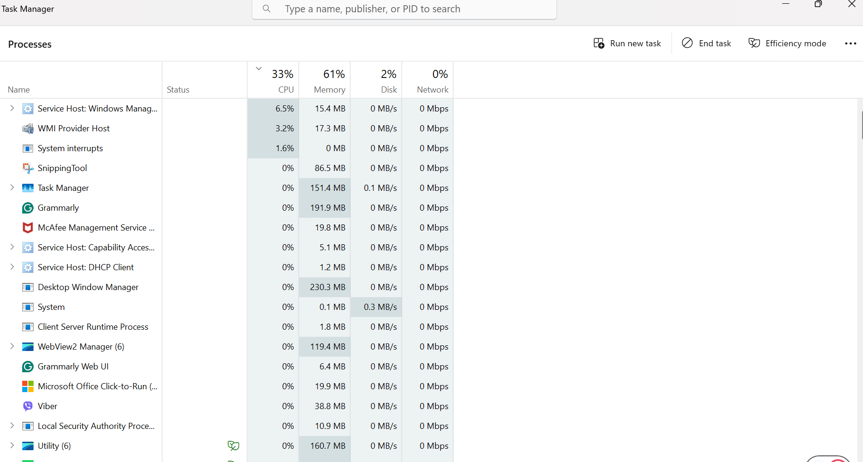
Figure 1: Task manager

Application/Program Management:
Application Program Management in Windows represents a structured approach to controlling the execution and behaviour of software within the operating system. This management process includes installing, configuring, monitoring, and terminating applications to maintain system stability and performance. Windows provides administrative mechanisms that regulate how programs interact with system resources, including processor time, memory allocation, and background execution. Effective Application Program Management also involves controlling startup processes, managing application permissions, and ensuring that inactive or unresponsive programs do not negatively affect overall system operation. Through these mechanisms, the operating system supports efficient resource utilisation and enables consistent, reliable performance in both personal and enterprise computing environments [3].
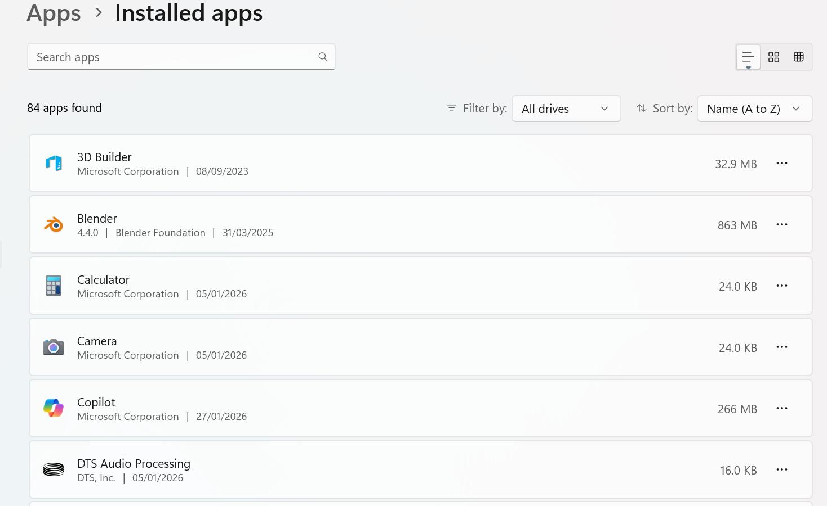
Figure 2: Program manager

File/Directory Management:
File and directory management is the process of controlling data storage, as well as the systematic organisation and maintenance of digital content within an operating system, on a computer, or on a memory card. File storage is commonly classified into three categories: fixed, removable, and network-based storage. This approach supports multimedia projects by enabling efficient management of large volumes of interactive resources. In addition, it ensures the accessibility, structured organisation, and security of digital assets, while preserving data integrity through regular backup procedures. The operating system applies a hierarchical directory structure, in which files are stored within folders according to logical data grouping principles [4].

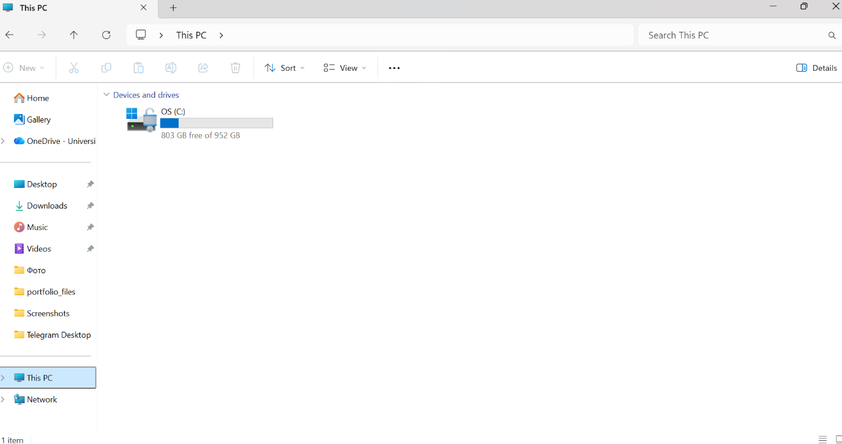
Figure 3: Directory manager

Device Management:
Device Management is a core operating system component that enables the identification, configuration, monitoring, and control of hardware devices connected to a computer. To open the Device Management interface, a user can select the Start menu, access system settings, and choose the Devices option, or alternatively press Win+X and select Device Manager from the context menu. The interface allows users to select specific devices, such as a mouse, keyboard, speakers, printer, scanner, digital camera, or headphones. Through this manager, device parameters, notifications, and connection status can be configured, ensuring efficient and reliable interaction between the operating system and connected hardware [5].
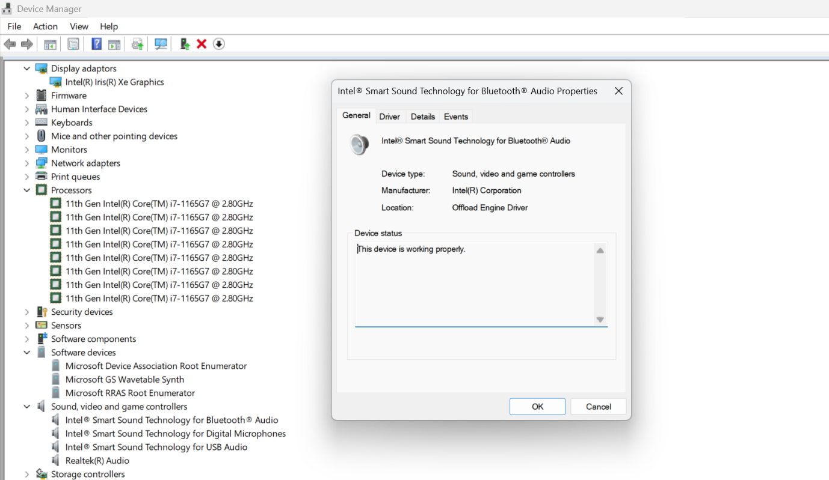
Figure 4: Divice manager

Security Management:
Security management in Windows operating systems is based on the systematic control of access, resources, and system behaviour in order to protect data and maintain system integrity. Windows implements security through user authentication, access control models, and permission management for files, processes, and network resources. Administrative tools such as security policies, account management, and
auditing mechanisms allow system administrators to enforce consistent protection rules across devices. Built-in components, including Windows Defender and the Windows Firewall, support proactive threat detection and network security. These mechanisms reflect general operating system security principles, where protection is achieved through controlled privileges, monitoring, and policy-based management [6].

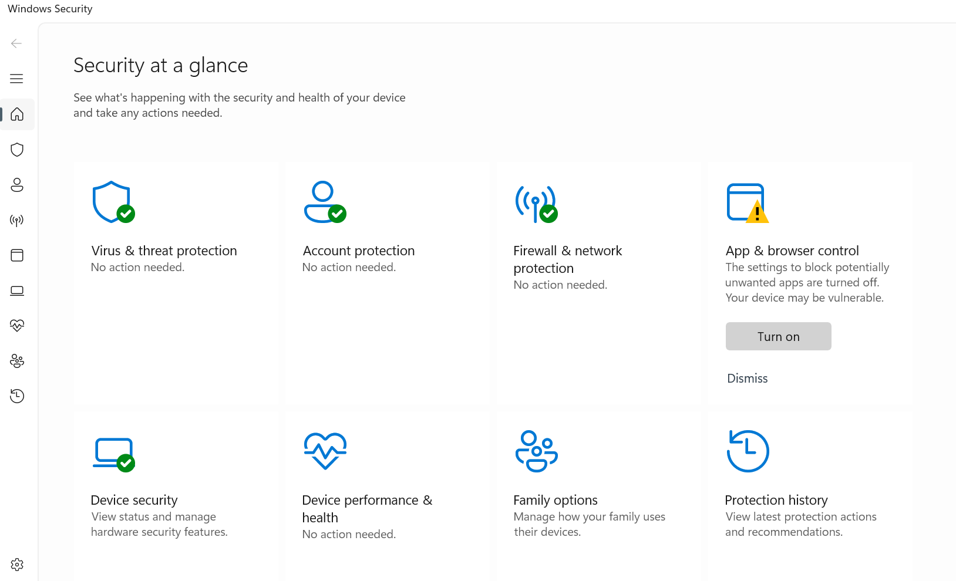
Figure 5: Security manager

Use of Windows OS CLI commands
To access the Command Prompt, open the Start menu, select All Programs, then Accessories. Configuration options are available via the icon in the top-left corner under Properties, allowing adjustments to colour, font, and screen buffer size, which ranges from 300 to 999 [7].

Example 1:
In the illustrated example, the dir command is used to display the contents of a specified directory, including a list of files, their extensions, the date and time of last modification, as well as any subdirectories contained within that directory.
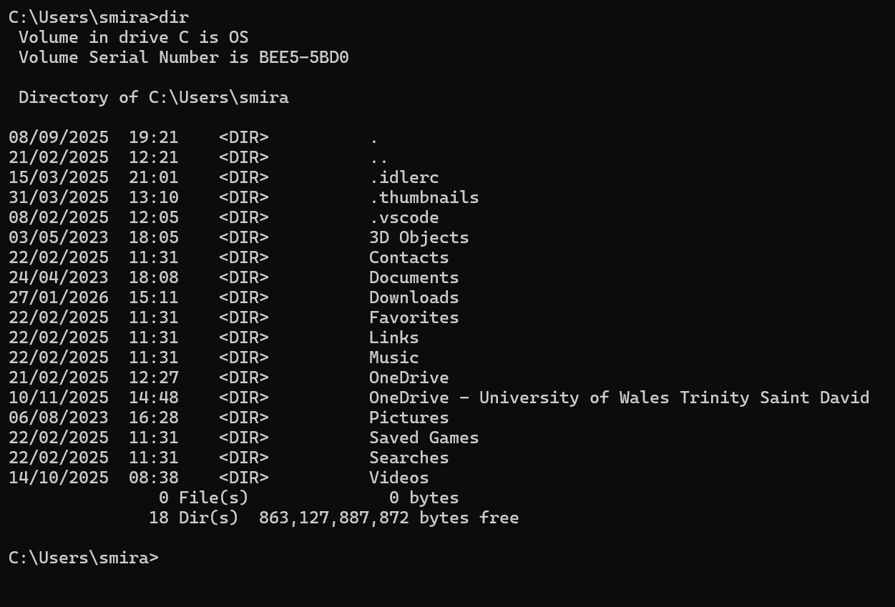
Figure 6: DIR

Example 2:
The mkdir (make directory) command creates new folders within the file system and assigns user-defined names, enabling systematic data organisation and a clear directory structure in command-line environments.
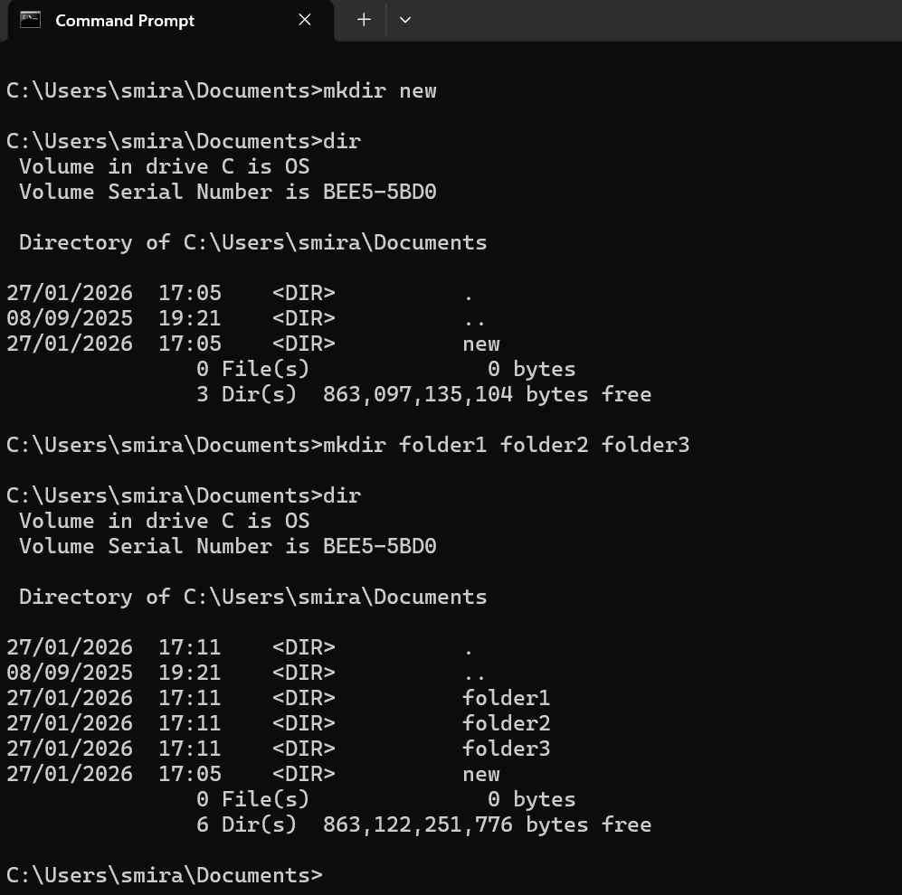
Figure 7: MKDIR

Example 3:
In the illustrated example, the cd command is utilised to display and confirm the name of the current directory. In this instance, it is specifically employed to navigate to and open a designated folder.
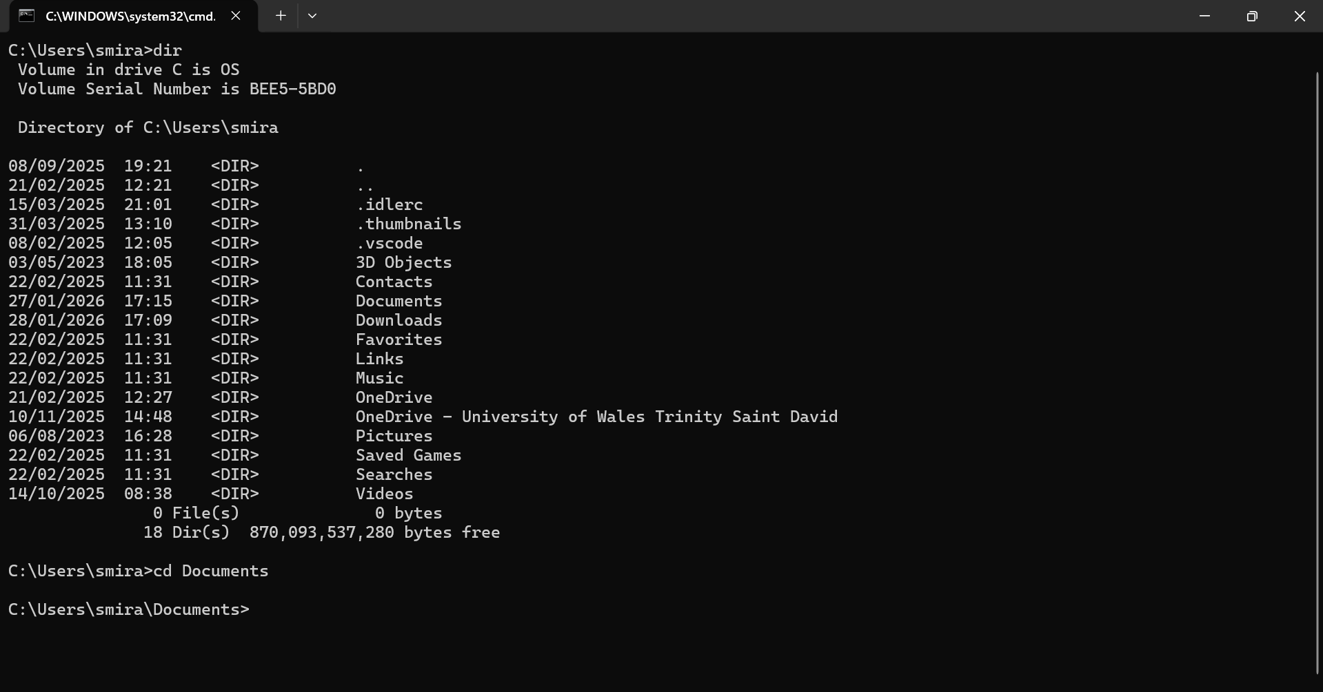
Figure 8: CD

Example 4:
The Remove Directory command shown in the image is used to delete a selected folder from the file system. It may also be employed to clear parts of the directory structure for maintenance purposes.
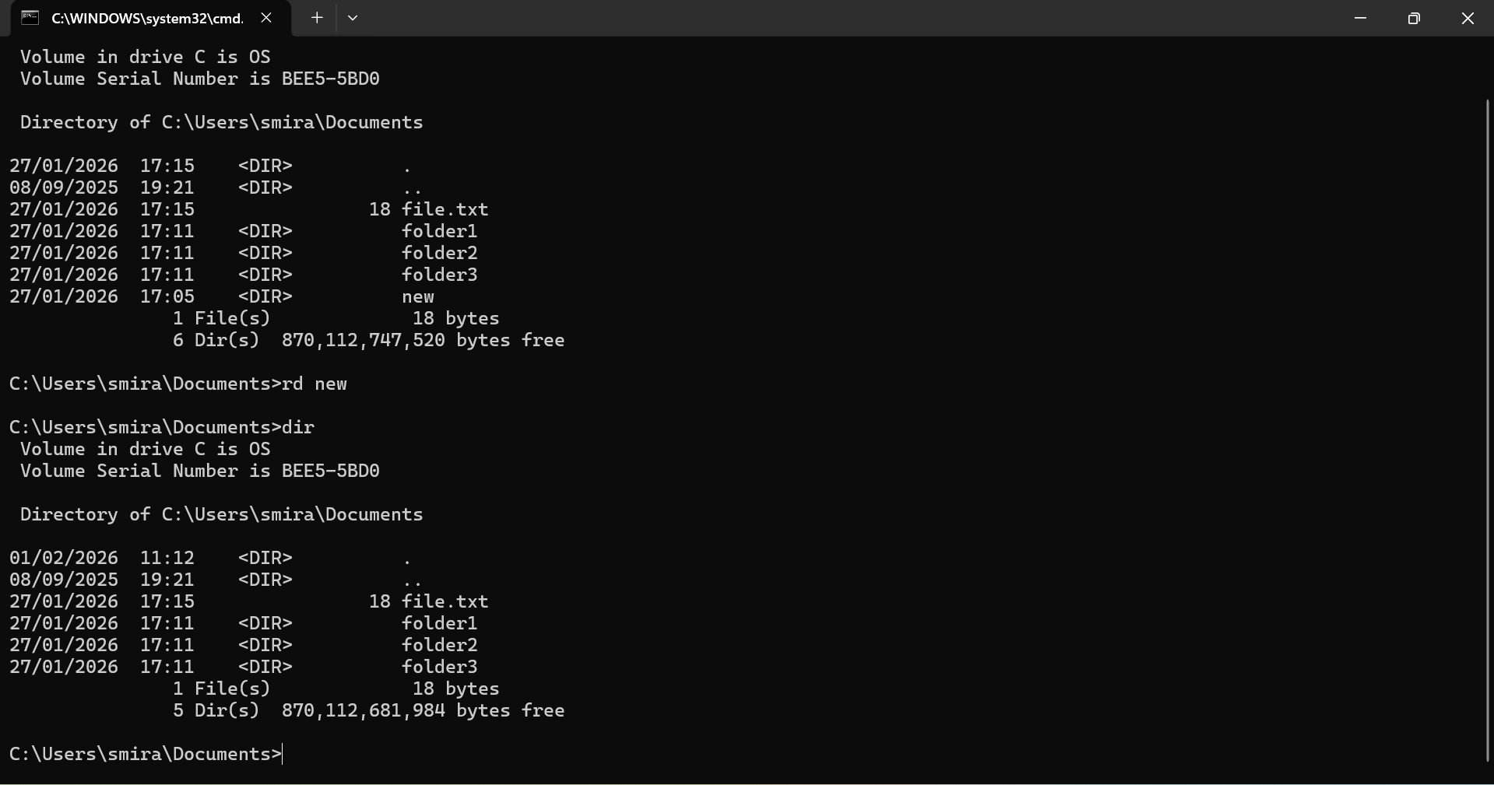
Figure 9: RD

Example 5:
In this instance, the echo command is utilised to display text on the screen without modifying its content. In the given example, the command is executed within the Documents directory to output information.
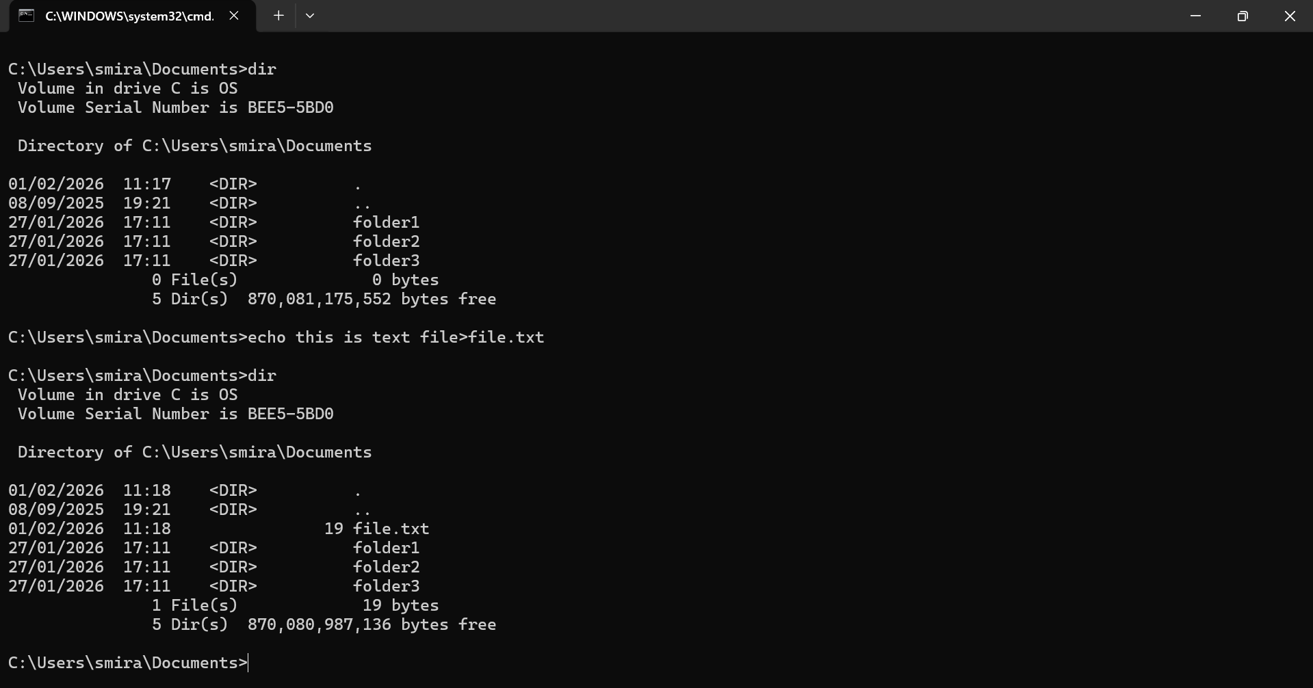
Figure 10: ECHO FILE

Example 6:
The Tasklist command in Microsoft Windows displays all running applications and services on local or remote systems, while Taskkill terminates selected processes by name or process ID, supporting administrative system management and troubleshooting.
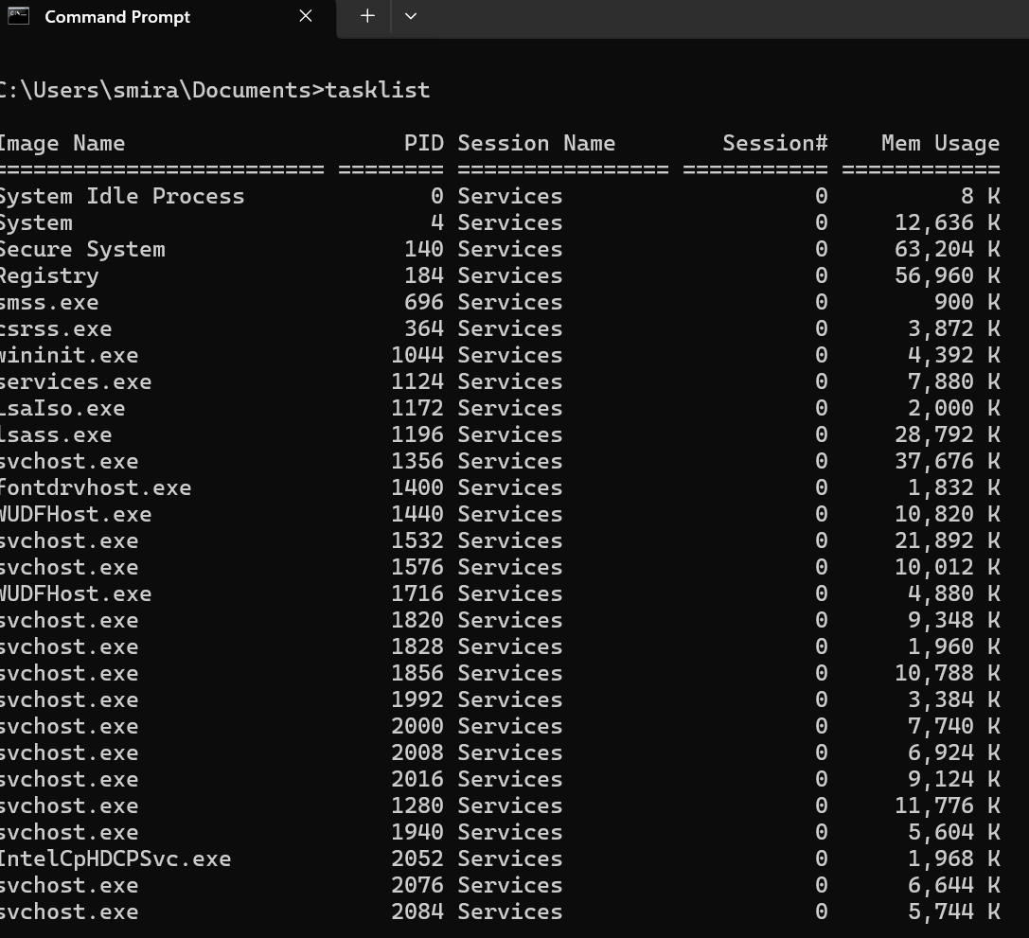
Figure 11: TASKLIST

Example 7:
The Systeminfo command in Microsoft Windows retrieves detailed configuration data, including hardware specifications, installed updates, operating system version, network details, and physical and virtual memory statistics, supporting diagnostics and administrative assessment.
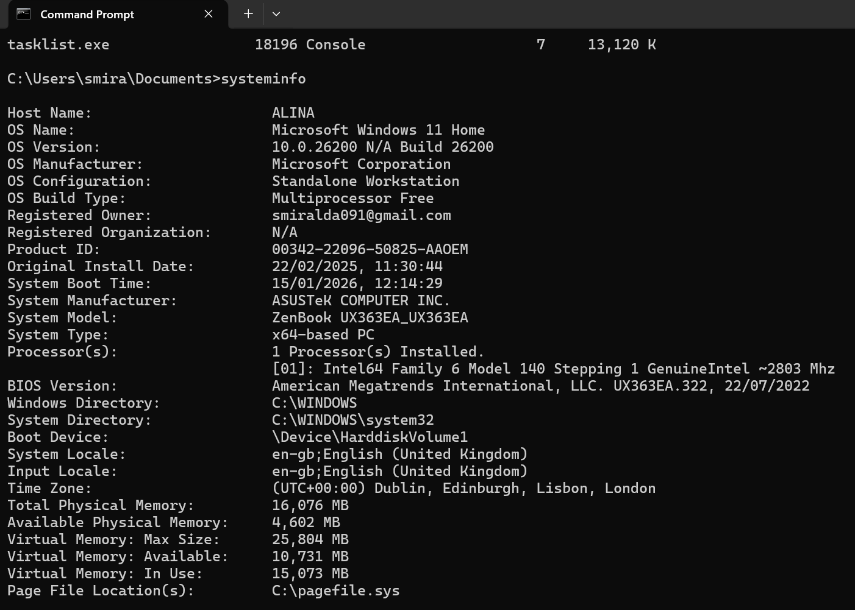
Figure 12: SYSTEMINFO

Example 8:
The network utility IPConfig is an essential tool for system administrators. This command enables the display of a computer's network configuration and facilitates the renewal or modification of network interface parameters and related settings.
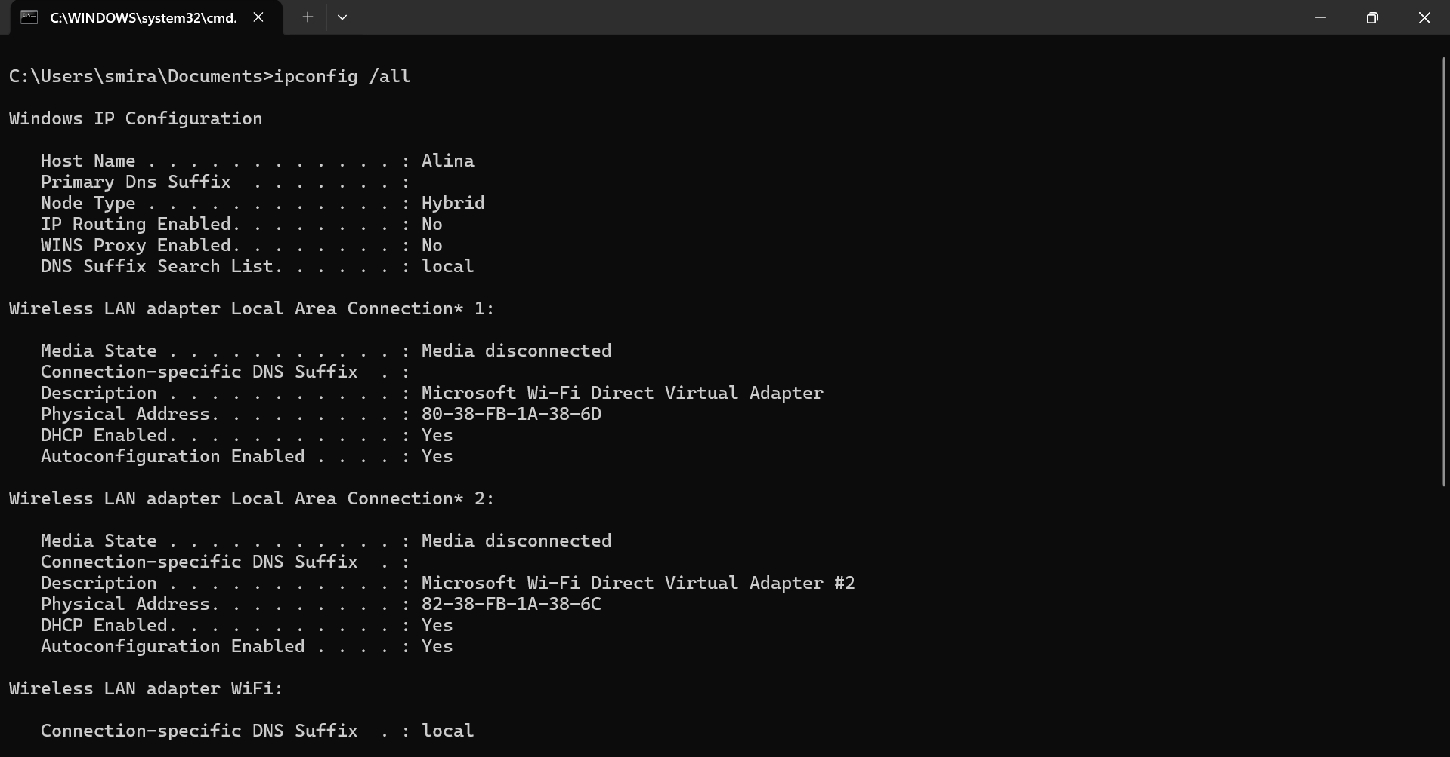
Figure 13: IPCONFIG

Example 9:
The Ping command is used to verify connectivity with another device. This utility also supports access control monitoring and assists in diagnosing and resolving network connection issues.
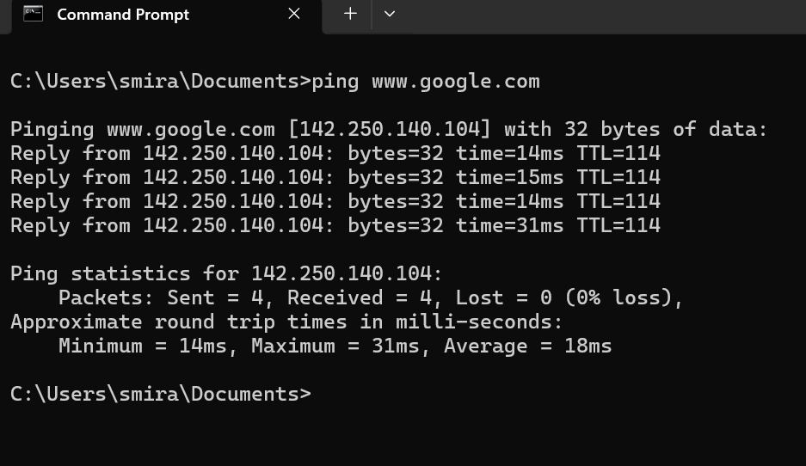
Figure 14: PING

Example 10:
The tracert command traces the route to a specified host, in this case google.com. It displays packet latency at each intermediate node, thereby revealing the complete path taken during transmission.
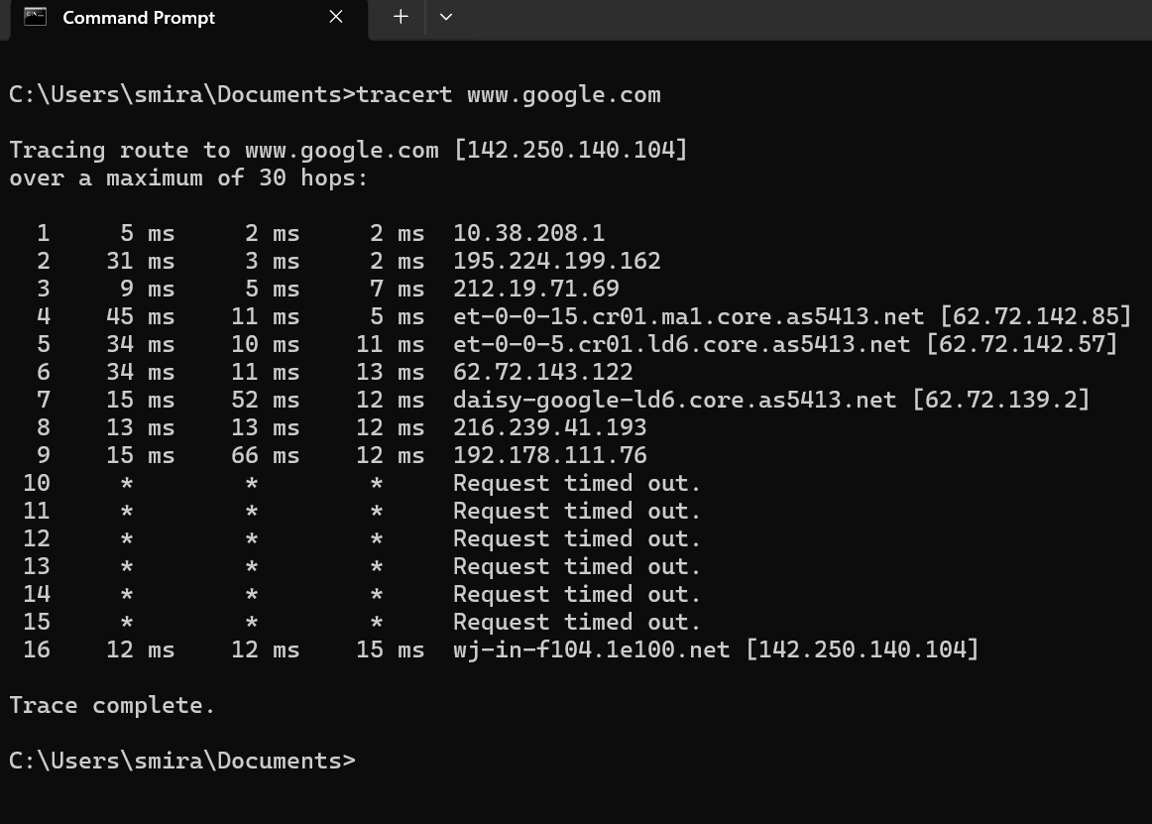
Figure 15: TRACERT

Use of Linux OS CLI commands
Linux is an operating system kernel, that is, a core program responsible for launching and installing applications, managing disk access, and handling network requests. Upon system login, a shell is initiated as a command-line interpreter; Bash provides a textual interface for executing commands and controlling programs. [8].

Example 1:
The su command is employed to obtain root privileges by switching to another user within the current session, thereby enabling the execution of commands with the permissions and authority of that user.
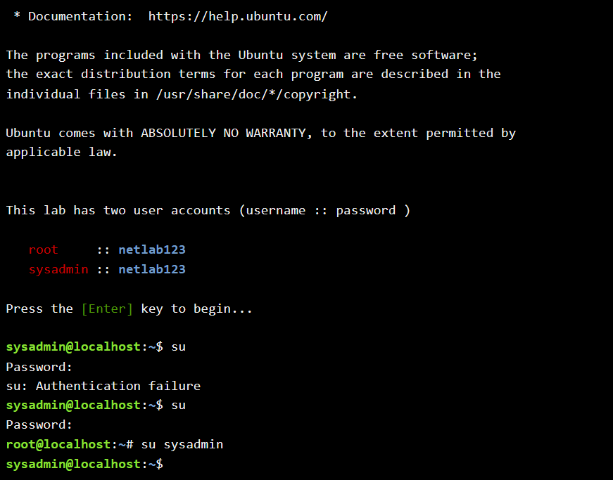
Figure 16: Authorisation

Example 2:
The pwd command displays the absolute path of the user's current working directory, thereby preventing navigational errors, confirming location context, and ensuring the accurate and reliable execution of shell scripts.
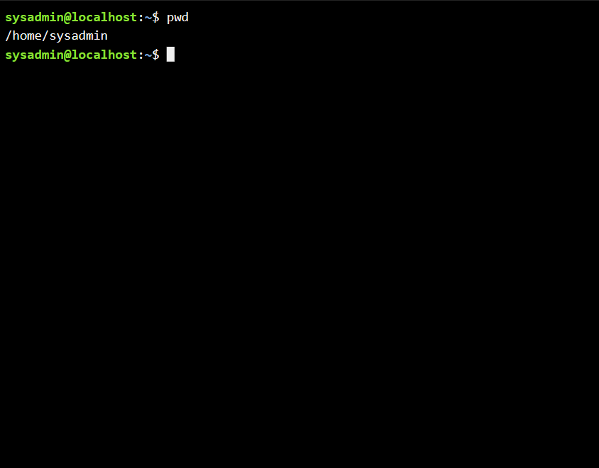
Figure 17: Home folder

Example 3:
The Is -I option provides detailed information, including ownership permissions, modification dates, and file or directory names. The Is -a option reveals hidden files and system directories.
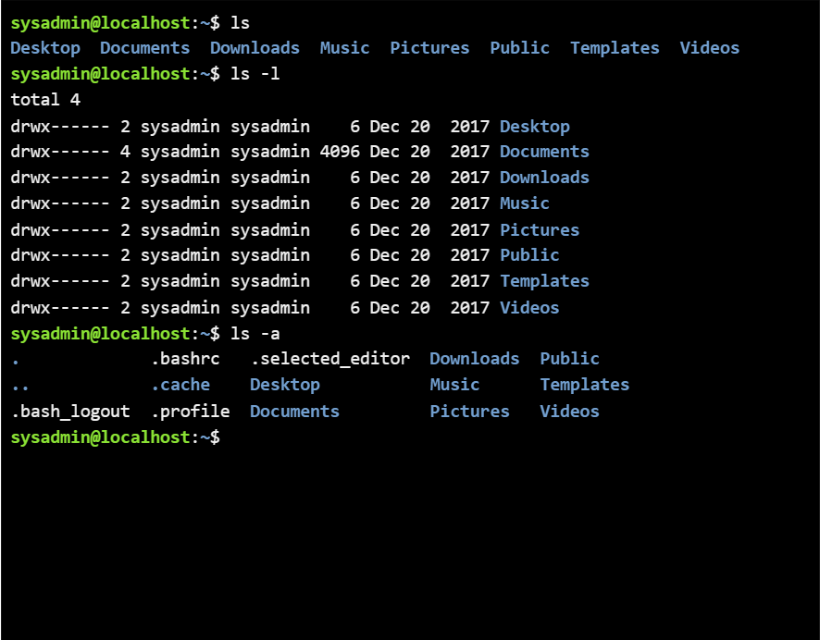
Figure 18: Displaying the contents of a directory

Example 4:
The cd command enables the user to change the current working directory to a specified location. It facilitates efficient navigation between directories and supports file management tasks.
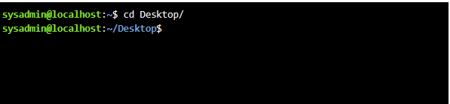
Figure 19: Changing to the root directory

Example 5:
The mkdir command enables the creation of one or multiple directories simultaneously from the command line interface.
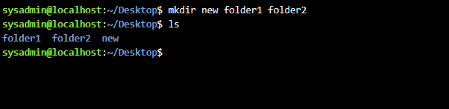
Figure 20: creating new folder

Example 6:
The rmdir command removes directories specified on the command line, provided that they are empty. It is designed to delete only vacant directories and will not remove those containing files or subdirectories.
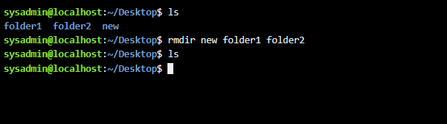
Figure 21: remove new folder

Example 7:
In this example, the touch command was used to create a new text file; however, it may also be employed to modify and manage file timestamps, including access and modification times, when required.
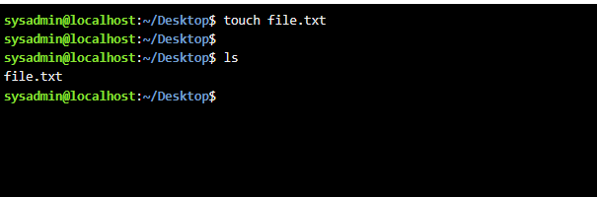
Figure 22: Create a new text file

Example 8:
The echo command outputs text or the value of variables to the standard output stream. It is commonly employed within Bash scripts to display informational messages, debugging statements, or variable contents during execution.
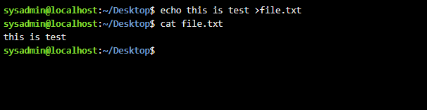
Figure 23: create file with text

Example 9:
The ipconfig command is utilised to configure and inspect network interface settings. This utility functions as a network management tool, enabling administrators to view and modify essential network configuration parameters.
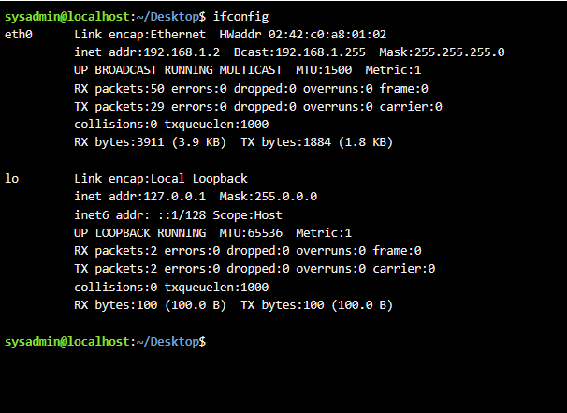
Figure 24: inspect network

Example 10:
The whoami command is a simple utility that displays the current username associated with the active user session, enabling identification of the account executing commands.
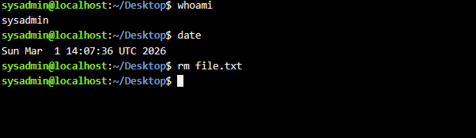
Figure 25: Check username

Use of Windows OS scripts
The Batch programming language is a file containing source code for batch processing operations. It may be employed for computer and system administration. Batch processing can also interact with users by displaying prompts and collecting information.
Furthermore, users may create, move, and copy data, generate simple reports, and write to and read from files [9].

Example 1:
The @echo off command in Windows OS scripts is employed to suppress the display of commands prior to their execution. As a result, the command itself remains hidden, and only the output text is visible. In this context, the set /p command displays variable values, prompts the user for keyboard input, and assigns the entered constant to a variable. It waits for user input, after which @echo outputs the result. It should be noted that this command does not append a new line character, which makes it particularly suitable for compact prompts. The set command, in general, creates or modifies environment variables. The /p switch specifies that the value will be provided by the user. num1, num2, and sum represent variable names. The equals sign introduces the prompt text. The set /a command performs arithmetic operations and outputs the calculated result. Finally, the pause command waits for a key press before terminating execution.
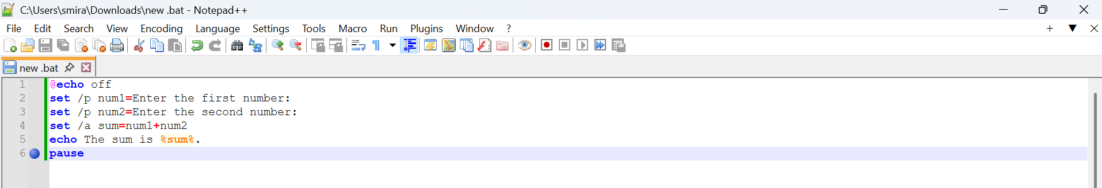
Figure 26: Batch script
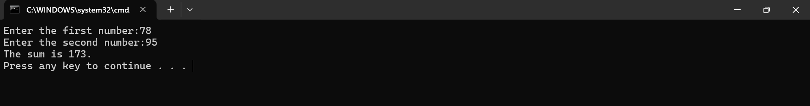
Figure 27: Batch script output

Example 2:
In this script, the command set/p age= is used after @echo off. This command allows the user to enter a value from the keyboard and confirm it by pressing the Enter key. In this example, the user will see the prompt "Enter your age". The variable age stores the value entered by the user. Next, the if statement is used to compare the entered number with the value 18. After the comparison, the echo command is used to output text to the screen. However, the message displayed depends on the value entered by the user. For this reason, the else statement is used, which allows the program to perform different actions depending on whether the condition is true or false. If the condition is satisfied, one message is shown; otherwise, a different message appears. Consequently, after entering their age, the user will see a message indicating whether they are permitted to vote or not.`
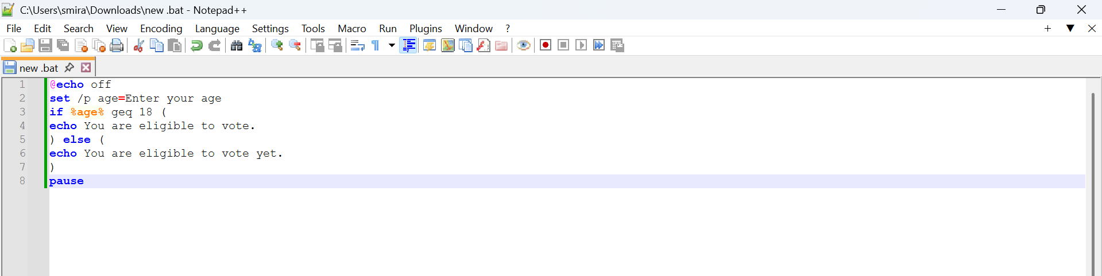
Figure 28: Batch script
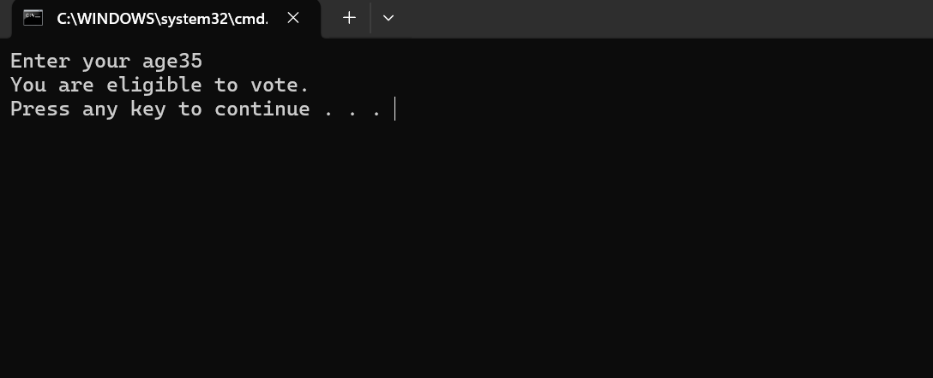
Figure 29: Output Batch script

Use of Linux OS scripts
Bash is an abbreviation of Bourne Again Shell. It is a programming language; more precisely, it is a scripting language for command- line shells. It is used to enter commands for execution. Bash is not compatible with C-style shells but follows POSIX shell standards. Its primary function is to execute other programs within control structures [10].

Example 1:
In this example, a Bash script in Linux uses the echo command to display prompts such as "Enter first number" and "Enter second number". These prompts inform the user that numerical input is required. The read command is then employed to capture the user's input from the keyboard and store it in variables. In this particular case, the variables represent numerical values provided by the user.
After the input has been received, the script performs a simple arithmetic operation. A variable named total is used to store the result of adding the first number to the second number.
Finally, the echo command is used again to present the result of the calculation to the user. The output message typically appears as "The sum is" followed by the calculated value. In the script itself, this is written as "The sum is total", where the variable total represents the computed sum.

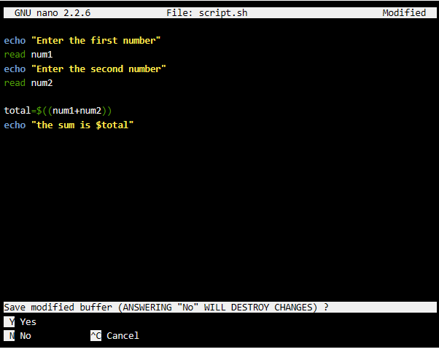
Figure 30: Bash script to add two numbers
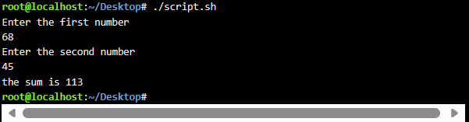
Figure 31: Test script to add two numbers

Example 2:
The nano command is a text editor in Linux that is commonly used to create and modify scripts, as well as to open and edit text files directly within the terminal environment.Files with the .sh extension are typically used for Shell scripts, indicating that the file contains commands intended to be executed by a shell interpreter.
Within the Nano editor, a list of commands and keyboard shortcuts is displayed at the bottom of the terminal window, enabling users to perform actions such as saving, exiting, or searching within the file. In order to make a written script executable, the command chmod +x must be applied to the file.
In this example, a for loop was used to assign and iterate through a set of values in the terminal. The command do, together with echo and a variable, was used to display output on the screen. The loop structure was then completed with the done command.
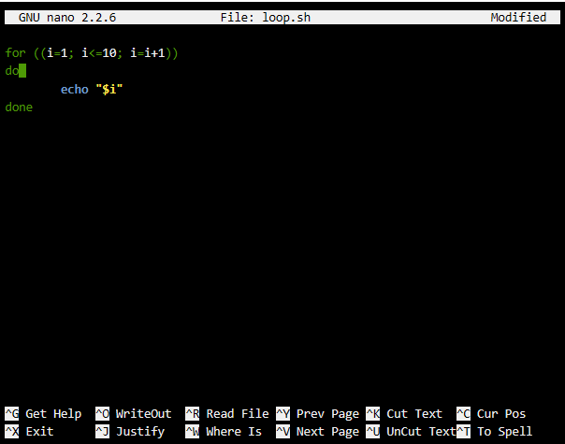
Figure 32: Bash script to create list of 9 numbers
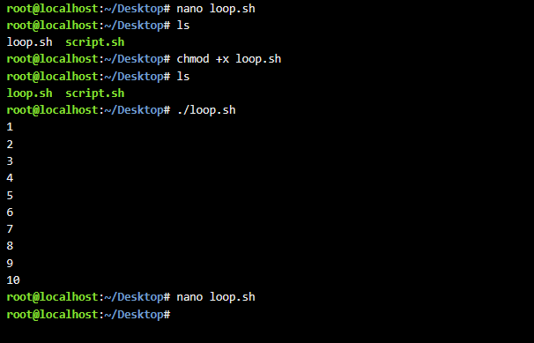
Figure 33: Bash script executable

Conclusion
This coursework describes and demonstrates the use of commands in the Microsoft Windows operating system and the Linux operating system. It also examines the application of their scripting environments. The discussion is supported by references drawn from relevant professional literature related to the studied topics.

References
[1] J. Krause, Mastering Windows Server 2019 : the complete guide for IT professionals to install and manage Windows Server 2019 and deploy new capabilities. Birmingham: Packt Publishing Ltd, 2019.
[2] J. Holcombe, Survey Of Operating Systems. 2019.
[3] W. Stanek, Windows 8.1 Administration Pocket Consultant Essentials & Configuration. Microsoft Press, 2013.
[4]V. Costello, “Non-Linear Editing,” Focal Press eBooks, pp. 365–405, May 2023, doi: https://doi.org/10.4324/9780429422669-16.
[5]“How to Enable Device Management in Windows 11: A Step-by-Step Guide - Solve Your Tech,” Solve Your Tech, Jun. 06, 2024. https://www.solveyourtech.com/how-to-enable-device-management-in-windows-11-a-step-by-step-guide/ (accessed Feb. 07, 2026).
[6]T. Jaeger, Operating System Security. Springer Nature, 2022
[7] T. Carpenter, Microsoft Windows Operating System Essentials. John Wiley & Sons, 2011.
[8] W. Soyinka, Linux Administration : : A Beginner’s Guide, Eighth Edition. New York, N.Y. : McGraw-Hill Education, 2020.
[9]J. McLarney, The Book of Batch Scripting. No Starch Press, 2024.
[10]T. Ryder, Bash quick start guide : get up and running with Shell scripting with Bash. Birmingham: Packt Publishing Ltd, 2018.

Appendices
Online Course name: Linux Unhatched

Figure 34: Certificate of completion

