Project Management Plan for Restaurant
MODULE CODE: BMSW 5104
STUDENT NAME: ILIE MARIAN CHORT
LECTOR NAME: ISAIAH OINO

Table of Contents

Introduction 3
Discussion 4
Title of the Project 4
Aims of the Restaurant 4
Scope of the Project 5
Project Time 5
Stakeholder’s Involvement 7
Employees 7
Manager and Chefs 7
External Shareholders 8
Customers 8
Suppliers 8
Risk Assessment of the Project 9
Allocation of the Resources 9
Prominent Facilities of Restaurant 11
Work Breakdown Structure 11
Attributes of Restaurant 12
Project Success Criteria 14
Project Deliverables and Constraints 14
Conclusion 15
References 16

2

Introduction
This assignment aims to examine the major aspects of the effective project management plan that will be executed for the medium-sized restaurant as it intends to extend the dining area to provide customers attractive ambiance. This assignment charter also outlines the supportable development and the effective plan to Restaurant, an innovative situated outlet in the demanding and jam-packed city of London, UK.
The scope of this assignment will take account of the expansion and management of a larger seated appealing atmosphere restaurant. The restaurant will certainly include a ballroom with almost sixty customer capacities and a terrace with almost fifty customer dimensions whilst maintaining Covid-19 safe standards (Piyatissa, 2021). It has been analysed that a comprehensive project management is a procedure of leading the effort of a crew in order to accomplish all project goal lines within the prearranged constraints.
This evidence is usually designated in project certification, generated at the commencement of the expansion process (Weerasekara, 2021). The crucial constraints of the project management mainly include time, scope, and budget. On the other hand, it has been evaluated that project management is the submission of processes, techniques, abilities, knowledge, and involvement to accomplish definite project objectives rendering to the project recognition criteria within approved parameters. Project management has concluding deliverables that are controlled to a determinate timescale and financial plan (Wichitpokin, 2019).

3

Discussion
According to the perspective of the past studies, it has been analysed that the determination of project management in the field of hospitality is to plan and bring about a project to magnificently complete its registered objectives and deliverables (Mann, 2020). It consists of categorising and handling risks, cautious resource management, insolent budgeting, and strong communication transversely in the numerous teams including chefs, waiters, order takers, and stakeholders of the restaurant (Tingginehe, et al., 2021).

Title of the Project
This project management plan will be constructed on making, designing and planning a diverse and spacious dining area to increase the bookings of the restaurant which will be familiarised in the forthcoming “Food Meal” for promoting to the leading restaurant businesses of the London (Tingginehe, et al., 2021).

Aims of the Restaurant
The restaurant mainly aims to strive in the direction of determining best conceivable efforts to grow the restaurant into a dwelling environment. Where the clients will have the chance to socialise with others and have tasty delicious meals and dinners. Restaurant mission is to provide a very comforting and contented environment of terrace and rooftop relishing the best view of region in town (Klimova, 2020).
In addition, the workers to be carefully chosen for the appropriate functioning of the restaurant will look out for chances to support the clients in relieving them out of their pressure by offering best in the class atmosphere, consumer-friendly facilities, and quality foodstuffs. Higher consultants concerned with the effective and efficient functioning of the restaurant will have to determine procedures in order to preserve a constant crisscross on the levels of gratification the personnel are entitled to, as a consequence providing a cost-effective and stable profit to the stockholders concerned (Klimova, 2020).

Scope of the Project
This project predominantly emphasises how any national and travelers might have delicious and tasty food from different cultured under one spacious roof (Aulia, et al., 2017). The project can plan, create, and marketplace its large dining area with soul relaxing ambiance in the diversity in chefs and meals where it has to contend the potential customers and compete with the resilient and recognised competitors (PAYMENT, 2018).
In this project, the overall scope is examined from the standpoint of a restaurant which desires to generate and enlarge its dining space to sustain a competitive situation in the food business of the realm. Market analysis is completed on the potential customers to distinguish their first choices regarding diversity and food under the project to shape and vend a valued and eminence food to effectively gain a competitive advantage in the market (Filimonau, et al., 2019).

Project Time
For the operative project plan, it has been perceived that proficient time requirement is a crucial factor that will play a fundamental role in the achievement of goals that are effectively aligned in the project (Tereso, et al., 2019). Without operative time provisions, the administrator of the project will be unsuccessful to accomplish the desired goals.
As a result, efficient time dissection has been done in the restaurant case in order to upsurge the reliability and authenticity of the project (Müller, et al., 2019). The affirming and the ending time of the project plan ought to be quantified and the critical pathway ought to be apportioned. According to the planned critical path, forty days will be essential for the construction of the spacious area and developing a perfect environment for the consumer.
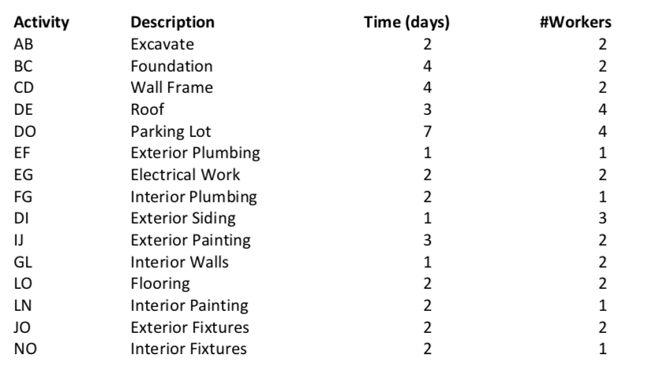
Figure 1: Time Allocation
Source: https://pmbasics101.com/project-budget-example/

It has been examined that superiority of the project is a significant fact which the administrator has to consider effectively (Ika, et al., 2020). If the administrator is unsuccessful to endure the better quality of the project plans along with the appropriate time utilisation, as a result, achievement of the desired objective will be in trouble (Müller, et al., 2019). As a result, the administrator of the restaurant ought to deliberate the appropriate time constraint, efficient resources, and take diagnostic decisions to preserve the quality.

Stakeholder’s Involvement
In regards to this respective project plan, the restaurant has two diverse kinds of stakeholder involvements that mainly include internal stakeholders and on the other hand, external stakeholders. Internal stakeholders of the restaurant are examined to be those individuals, who operate the organisation, and they are considered closely related with the restaurant since they effort as day to day operation of the restaurant (Chen, et al., 2019). Therefore they are the inside within the restaurant. Internal stakeholder’s involvements in this project plan of the restaurant include:

Employees
The Restaurant and dining outlet usually have high skill and proficient employees. They offer the best service to clients and attempt to retain prevailing customers and fascinating different customers. On the other hand, workers acquired good salary, bonuses a year, got occupation by training as well. Therefore, in the enlargement of the restaurant, the management will be required more skilled and trained employees (Ma, et al., 2018).

Manager and Chefs
Usually, in the restaurant, they have one or two managers on the basis of the dual shifts and chefs who stare after the whole process and customer’s service subdivision (Sanchez & Terlizzi, 2017). They put all effort in order to encounter both workers and shareholder requirements and customer expectations for the food. The manager examines the potential customer’s need and demand and the chef attempt to prepare food to fulfill those needs and demands. In a similar way, managers and chefs got income, bonus, revenue share, social position.

External Shareholders
Within the scenario of the project plan of the restaurant, it has been evaluated that external stakeholder’s involvement is those who generally do not work in the restaurant (Armenia, et al., 2019). They are neither inside the restaurant nor have any direct association in the restaurant. On the other hand, it has been analysed that external shareholder’s involvement plays a significant role in the restaurant. These shareholders mainly include:

Customers
The management of the restaurant is requisite to maintain a good and positive relationship with customers who purchase the food product, reserve table and dine in (Chen, et al., 2019). They are the foremost source of revenue in the restaurant. On the other hand, it has been analysed that customers got craving foods and efficient services from the restaurant.

Suppliers
In addition, the restaurant management also deals with the diverse supplier such as meat suppliers, vegetable or fruits suppliers along with spices suppliers (Ma, et al., 2018). They are responsible to provide superior raw materials such as drink, chicken, fish, meat, and many more.

Risk Assessment of the Project
The primary risk to the evolution of an efficacious project plan strategy has been perceived in the situations where there is a shortage of equality and diversity along with the factor of fairness in the management team (Chen, et al., 2019). It mainly elaborates that if the project management team and managers are unfair, unfortunate decisions are being expected to be made depressed of an encounter to the reputation quo.
In accumulation, the other risk factor of the project plan of the restaurant takes account of the inadequacy of time and money due to the recent Covid-19 pandemic (Müller, et al., 2019). Therefore, risk assessment is crucial for the project, as restaurant risk evaluation forms are papers that permit a restaurant management to regulate the risks and threats present in their locations. There are diversities of this form classification that the management ought to utilise to supply and target diverse concerns (Tereso, et al., 2019).

Allocation of the Resources
Resource allocation in the project management plan of the restaurant is the procedure of allocating, scheduling, and assigning accessible resources in the utmost operative and economical mode possible (Ika, et al., 2020). Project plan for the restaurant will always require resources on the other hand they can often be limited. Therefore, it has been examined that the process of the appropriate resource allocation is predominantly based on allocating and handling assets in a manner that funds a restaurant’s deliberate goals.
Resource allocation is a progression of scheduling, working, and conveying resources in a procedure that supports to reach main restaurant’s strategic goals that are based on the enlargement of the physical space to incline customer booking and dining (Yangjanita, 2019). It can create a project manager's effort operative and substantial. Even though the concept of resource allocation sounds simple, it is dynamic in carrying projects proficiently. Resource allocation in this restaurant project plan mainly takes account of handling tangible resources such as hardware to create the greatest use of weaker assets such as human resources (Filimonau, et al., 2019).
The utmost significant resource restaurant can use to construct the perfect resource allocation is the incorporation of its very own software of POS (points of selling) (Aulia, et al., 2017). The restaurant's software trails the most significant information about leading sales with the help of which restaurant project management can generate the ambiance accordingly such as which cultural dishes are marketing the best?
On the other hand, in this project plan, resource allocation consists of balancing challenging needs and significances of the potential clients and defining the most operative course of achievement in order to make the most of effective utilization of restricted resources and increase the greatest return on speculation (PAYMENT, 2018). On the other hand, resources allocation also takes account of proficient or experienced personnel (waiters and chefs), prior experience interior designers, and indulgence of the diversity along with constructive attitudes of the project management (Picciotto, 2020).

Prominent Facilities of Restaurant
One communal facility that restaurants will provide is determined amount of tables for each type of client in advance and inquire customers in the pre-booking conversations the location of the dining tables for that client type and the number of persons (Klimova, 2020). As a consequence, restaurants are concerned in finding optimum table provision to attend the two types of clientele to get the best out of profits.
In the meantime clienteles come trail a stochastic and distinct procedure, eat on a dining table that can be observed as being attended by a server in a waiting hall, and will serve customers when the restaurant is occupied, the dining procedure of clients and operating procedure of the restaurant is appropriate to be labeled by “queuing system” (Tingginehe, et al., 2021).
For a specific type of purchaser, if the arrival rate upsurges, the number of tables allocated in the terraces and rooftop for them increases. In that case, patience degree has contradictory influences on physical resource allocation for the two types of clients: if regular clients are not patient, more physical resources ought to be allocated to them; whilst if group based customers are not persistent, fewer tables ought to be allocated to them (Mann, 2020).

Work Breakdown Structure
The effective work breakdown structure is planned by meritoriously breaking the complete project into diverse operational tasks. As an end result; the project decision-making of the restaurant can distribute the accomplishments and undertakings amongst the competent members of the entire project plan team (Weerasekara, 2021). In the premeditated project, the entire works are split into the five most important effective tasks. Each of the five tasks is broken into diverse sectors. The complete work breakdown construction of the restaurant plan is quantified below:
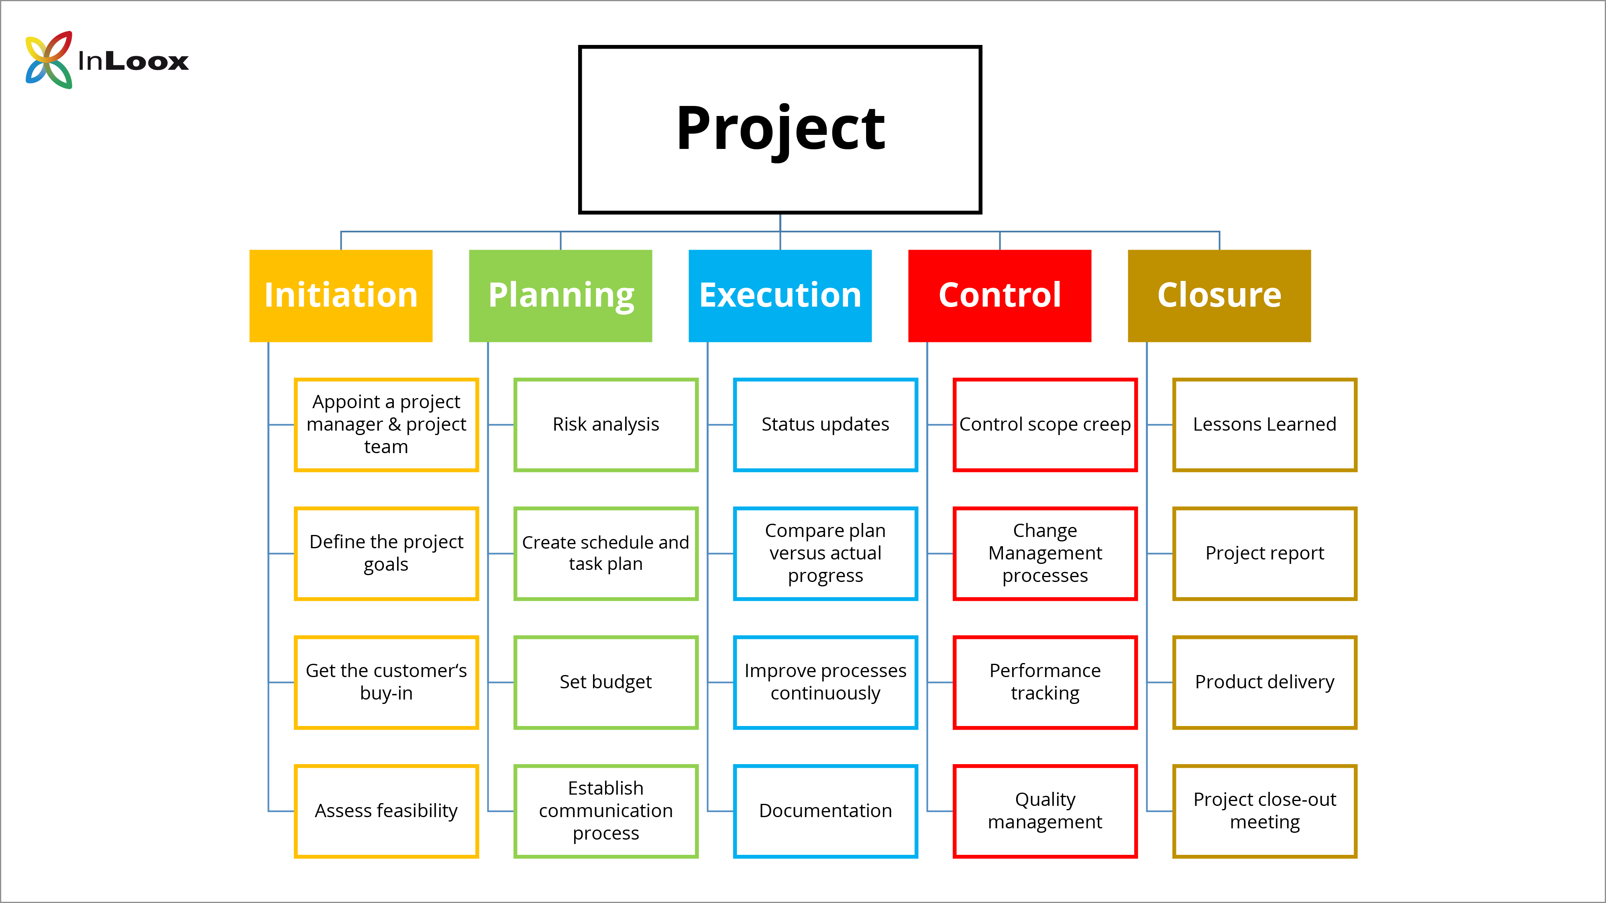
Figure 2: Work Breakdown
Source: https://pmbasics101.com/project-budget-example/

Attributes of Restaurant
The restaurant has freshly launched the innovative hotel idea progressively utilising the terrace space not only in summer but also in winter whilst arranging huts and warm atmosphere during winters. The restaurant is aiming to turn out to be a specialty in the restaurant retail business by introducing terrace space and roof top in the winter season to have perfect night view of London.
According to the perspective of Piyatissa, (2021), the economic recessions have traumatised the business mainly in the region of the UK; however, specialist chef signature items in the restaurant sector have been attaining the inclined demand. Despite the economic recession the restaurant business has been considered to have a bright spot within the market (Wichitpokin, 2019).
Hundreds of corporate have gone ruined as the lower sale; profit has declined in the recent economic recession during BREXIT and Covid-19. Food chains in the UK have enlarged huge petitions, and this has driven many restaurants to expand their business. This respective restaurant is predominantly focused on delivering different flavours of food including breakfast, daytime meals, and dinners with a combination of drinks in the perfect ambiance of terrace (Mann, 2020).
It is vibrant that the UK public loves to have dining in open spaces with tremendous regardless of evidenced preference for home eating habits. Foremost marketing problems faced by the Restaurant at the moment mainly include immense delinquents created by opponents. A lot of different Restaurants arrive in the market and prevailing restaurant gives eye-catching offers with fewer prices. Consequently, they drop their market share.
Restaurant atmosphere is also a significant issue at the instant. Whilst, generating extra space and creating more dining areas, the restaurant management will modify and create atmosphere and quality of the restaurant according to potential customers and employee’s requirements for the reason of new age group and multi-culture environment of the UK (Tingginehe, et al., 2021).
They are considering fewer prices of foodstuffs; on the other hand, restaurant foodstuffs are expensive. As result restaurant projects have to fascinate customers with commercial, quality food at reasonable prices and eye catching ambiance. The restaurant will also add diverse kind of foods for diverse type of individuals (based on the differences of age, class, or, culture) who lives in the social order of the UK (Klimova, 2020).
The restaurant project has to formulate diverse types of attributes and mouthwatering tasty meals to attract clients for pre-bookings of the restaurant to avoid long queues. Suppliers augmented the price of raw materials which distresses the price of foodstuffs and drinks, however, consumers do not like to wage for the reason of less income. Subsequently it turns out to be a giant issue to preserve regular quality and price. The restaurant is requisite to pay more consideration to media advertisement policies to promote the launch of the more spacious restaurant as customers will not have to wait in long queues (Aulia, et al., 2017).

Project Success Criteria
Success Criteria of the project of the restaurant are based on components of the project plan that have to be positioned in an appropriate place to make sure the accomplishment of the project. In simple expressions, they generate an enabling atmosphere for the project to be present in the leading place (Klimova, 2020). The project success criteria mainly include customer satisfaction and overall experience, and optimized workflow of the restaurant. The rebuilding at the restaurant will mend processes, particularly in the department of client service. Under the innovative spacious dining area, the customer department of this restaurant can attend to its customers in an enhanced way and address any apprehensions they have about food quality (Aulia, et al., 2017).

Project Deliverables and Constraints
The leading deliverables of the restaurant project include installation, construction, and resource administration, commercial and marketing, supplies, increasing the menu, licenses, indentures, necessary utensils, and closing. Moreover, the constraints of the project include scope, cost, risk, and resources (Ma, et al., 2018).

Conclusion
This assignment is based on the effective and appropriate project plan for the restaurant that is willing to increase the space to incline the table sitting and customer bookings. The assignment effectively discussed the main aim of the project and its scope. In addition, the assignment also highlights the risks associated with the project and deliberated the appropriate resource allocation. Moreover, work breakdown and time schedule along with the marketing analysis have been presented in the assignment.

References

Aanbari, F. T., & Kwak, Y. H. (2018, June). Impact on project management of allied disciplines. Project Management Institute.
Armenia, S., Dangelico, R. M., Nonino, F., & Pompei, A. (2019). Sustainable project management: A conceptualization-oriented review and a framework proposal for future studies. Sustainability, 11(9), 2664.
Aulia, R., Zakir, A., Dafitri, H., & Siregar, D. (2017, December). Mechanism of food ordering in a restaurant using Android technology. In Journal of Physics: Conference Series (Vol. 930, No. 1, p. 012030). IOP Publishing.
Bjorvatn, T., & Wald, A. (2018). Project complexity and team-level absorptive capacity as drivers of project management performance. International Journal of Project Management, 36(6), 876-888.
Chen, T., Fu, M., Liu, R., Xu, X., Zhou, S., & Liu, B. (2019). How do project management competencies change within the project management career model in large Chinese construction companies?. International Journal of Project Management, 37(3), 485-500.
Chofreh, A. G., Goni, F. A., Malik, M. N., Khan, H. H., & Klemeš, J. J. (2019). The imperative and research directions of sustainable project management. Journal of Cleaner Production, 238, 117810.
Filimonau, V., Fidan, H., Alexieva, I., Dragoev, S., & Marinova, D. D. (2019). Restaurant food waste and the determinants of its effective management in Bulgaria: An exploratory case study of restaurants in Plovdiv. Tourism Management Perspectives, 32, 100577.
Ika, L. A., Söderlund, J., Munro, L. T., & Landoni, P. (2020). Cross-learning between project management and international development: Analysis and research agenda. International Journal of Project Management, 38(8), 548-558.
Klimova, Т. V. (2020). ANALYSIS OF MATHEMATICAL MODEL OF THE FINANCIAL STATUS OF THE ENTERPRISE TO ACHIEVE SUSTAINABLE DEVELOPMENT OF HOTEL AND RESTAURANT COMPLEX. Publishing House “Baltija Publishing”.
Ma, X., Xiong, F., Olawumi, T. O., Dong, N., & Chan, A. P. (2018). Conceptual framework and roadmap approach for integrating BIM into lifecycle project management. Journal of Management in Engineering, 34(6), 05018011.
Mann, E. A. (2020). Fork in the Road: Design for commensality and well-being for Millennials and sustainability for local restaurants (Doctoral dissertation, University of North Carolina, Chapel Hill).
Müller, R., Drouin, N., & Sankaran, S. (2019). Modeling organizational project management. Project Management Journal, 50(4), 499-513.
PAYMENT, M. (2018). THE COURSE OF FOOD POISONING IN CATERING ESTABLISHMENT (A CASE STUDY OF SELECTED RESTAURANT IN ABA). pat, 0.
Piyatissa, W. B. A. C. (2021). Web Based Restaurant Management System (Doctoral dissertation).
Sanchez, O. P., & Terlizzi, M. A. (2017). Cost and time project management success factors for information systems development projects. International Journal of Project Management, 35(8), 1608-1626.
Tereso, A., Ribeiro, P., Fernandes, G., Loureiro, I., & Ferreira, M. (2019). Project management practices in private organizations. Project Management Journal, 50(1), 6-22.
Tingginehe, B. Y., Rarasati, A. D., & Ichsan, M. (2021, March). Schedule maintenance management system for HVAC system in restaurant: A review. In IOP Conference Series: Materials Science and Engineering (Vol. 1098, No. 2, p. 022071). IOP Publishing.
Weerasekara, U. S. (2021). Online Restaurant Management and Food Ordering System for ORMFOS (Doctoral dissertation).
Wichitpokin, C. (2019) Reservation and ordering system for jasmine restaurant.
Yangjanita, S. (2019). The influence of training towards service quality in jade restaurant medan (Doctoral dissertation, Universitas Pelita Harapan).]

