Ralitsa Dragostinova
Student number 2232407

E-portfolio report
Learning in the Digital Era – BMPL4007/BMPS4009

Table of Contents

Task 1 – Written summary 2
Task 1 – Written summary 3
Task 2 – Mind map 4
Task 3 – Presentation 5
Task 4 – Reflection 6
Reference list 7
Reference list ………………………………………………………………………………………………………………………………..8

Task 1 – Written summary
PREPARING FOR HIGHER EDUCATION
Preparing for Higher Education is a process of considering the main aspects of students’ life and daily routine leading to productivity and making students successful learners.
Every student should create their study environment regarding their individual needs. The main things to consider are where (which place) and when (at what time) they will be able to focus on their learning more effectively with minimum or less distraction so they could rely on their productivity and self-efficacy (McMillan et al, 2021, p. 39).
Time-managing is an essential skill for the student to achieve a healthy life balance between studying, family, work, and their mental well-being. If the students have the ability to manage their time right and focus on the right task, they will be able to fulfil their goals and progress in their future careers. (McMillan et al., 2021, page 24, 2021).
Eizenhower’s principles are a great example of how to start prioritising tasks effectively divided them into important and urgent (Mind tools, no date).
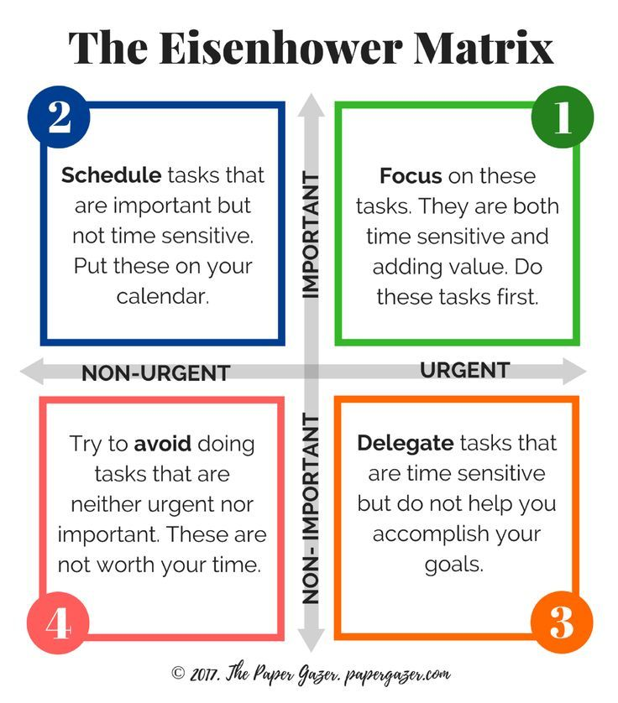
(The Paper Gazer, 2017)
However, it is likely for students to have difficulties in getting to start their tasks on time and suffering from procrastinating.
Blogger Tim Urban in his Ted talk (2016) described the procrastinator’s brain as an “instant-gratification monkey’’ and the non-procrastinator brain as a “rational-decision maker” which clearly illustrates the difference between both.

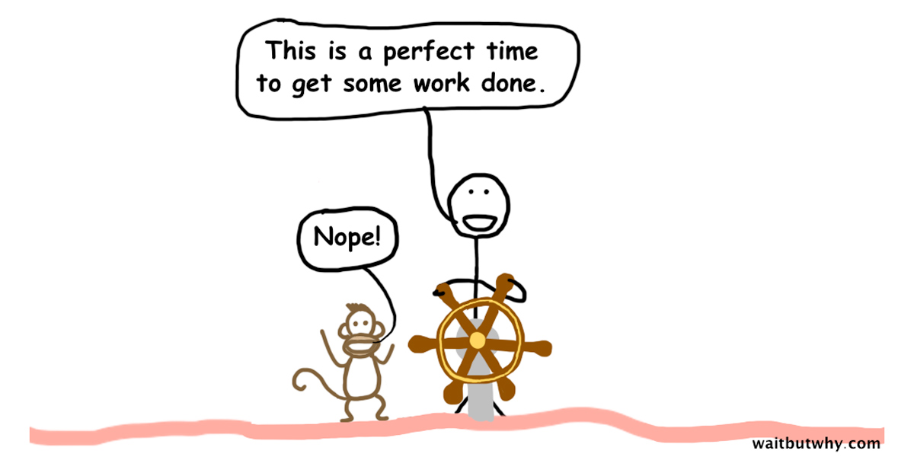
(Urban, 2013)

Thinking about the current task as a small step in the bigger picture of a future career could be a great way of motivating the student to start. Furthermore, students’ perfectionism could make them procrastinate to deliver their work. (McMillan et al., 2021, p. 30).

In conclusion, there are a variety of approaches to learners’ paths to success. If students treat learning as a big adventure they could be as successful in their growth as infants in their life (Cottrell, 2019, p.13).

304 words

Task 2 – Mind map

THINK AND WRITE CRITICALLY
Successful learners must think and write critically while using a wide range of resources for their work.
Students must reference their work to avoid plagiarism and acknowledge the authors’ main idea. References are always necessary when quoting, paraphrasing or summarising the original text. (Cite them right, 2022).
It is essential for students’ work to be correctly referenced in order to receive good marks and to have an academic look (Finch and Fafinski, 2018, p.278).
There are four different referencing styles and Harvard is the most commonly used by UWTSD.
Students must follow the ‘Referencing Handbook: Harvard’ for the ‘in-text citations and references’ and ‘reference list/bibliography’ to reference correctly (UWTSD: LLR, no date).

RESEARCH WITH CARE
Students must use trusted published sources and they should be able to recognise fake news, post-truth, misinformation and alternative facts following the recommended steps of the International Federation of Library Associations and Institutions (IFLA) or making a CRAAP TEST (UWTSD, no date).
The ability of the students to find credible resources will provide them with better results and much deeper knowledge of the researched topic. There is a variety of legal literature to be used from the library catalogues and online databases to find legal books, dictionaries, journals, articles, bibliographies and official publications such as different Parliamentary papers, statutes, bills etc. (Finch and Fafinski, 2018, pp.169-186).

BECOMING a DIGITAL LEARNER

LEARNING WITH TECHNOLOGIES

To be a learner in this era without technology is like being a bird without wings. The student cannot demonstrate their full potential and knowledge without using Microsoft Office, Microsoft Teams, the Internet etc. Learning in the digital era allows students to represent their work through a variety of software such as PowerPoint, Word, Microsoft Stream etc.

290 words

Task 3 – Presentation
Please follow this link to view my presentation:
https://youtu.be/2GrnSs91VaA

Task 4 – Reflection
I am going to introduce my reflections using Borton's three-stage model (Cottrell, 2017, p.201) on starting higher education, becoming familiar with online learning and resources and the process of writing my first assignments.
I was very motivated to become a student at UWTSD to study ‘Law and Legal Practice’ and I was pleased to be offered a place.
The evidence overwhelmingly shows, studying Law is a challenging route but taking into consideration the benefits it brings later it is worth attending.
Next, I am proud to be part of my student community and I appreciate the opportunity to learn from my tutors and build relationships with other students.
Furthermore, I became familiar with online learning through Microsoft Teams and the university website on Moodle, Harvard references, Turnitin, and different software (Word and PowerPoint) I must use to write my assignments.
The face-to-face and online lessons I have attended were so helpful, useful and practical and I was able to find and research different topics, learn to think logically and work in a team.
The process of writing my first assignments was complicated and challenging for me. For the first time, I researched a topic academically to form my thesis and arguments using reliable sources (Godfrey, 2018, p.10). I did my best to structure good essays, think critically and put the Harvard referencing into practice.
Additionally, I realised that I need to manage my time with care to complete my work on time and to achieve a good study-work-family balance.
Thinking critically, enrolment in Law and Legal Practice course was the very first step on my ladder which leads to my new career footpath, and it will enhance and affect every aspect of my later life (Cottrell, 2017, p.212).
In conclusion, studying higher education is very beneficial and I believe it will be life-changing and rewarding.
307 words

Reference list
‘Cite them right online’ (2022) Elements that you may need to include in your references. (Accessed: 19th February 2023) DOI: 10.5040/9781350928060.9
‘Cite them right online’ (2022) What is referencing?: why reference? (Accessed: 19th February 2023) DOI: 10.5040/9781350928060.3
Cottrell, S. (2017) Critical Thinking Skills: Effective Analysis, Argument and Reflection. 3d Ed. London: Palgrave Macmillan

Cottrell, S. (2019) The study skills handbook. 5th Ed. London: Red Globe press
Erikson, J. (2016) Reshaping identity in our 60’s and beyond [photo] Available at:
https://www.collaborativelifecoaching.com/reshaping-identity-60s-beyond/ Accessed: (Accessed: 23rd February 2022)

Finch, E. and Fafinski, S. (2018) Legal skills 7th Ed. Oxford: University press
Godfrey, J. (2018) How to use your reading in your essays. 3d Ed. London: Palgrave Macmillan
Helsinki, (2020) Identity and self-esteem [photo] Available at: https://www.hel.fi/sote/perheentuki-en/school-aged-children/growth-and-development/identity-and-self-esteem/ (Accessed: 23rd February 2022)
Kostadinov, D. (no date) Bulgarian Alphabet [photo] Available at: https://bg.wikipedia.org/wiki/Българска_азбука (Accessed: 22nd February 2023)
Lyle, E. (2020) Identity Landscapes: Contemplating Place and the Construction of Self., in Markides D. and Markides J(ed.) The Conversation We Never Had: Shared Autobiography in Relation to Place and Each Other Jennifer Markides and Derek Markides, Brill Sense

McMillan, K.et al. (2021) The study skills book.4th Ed. Harlow: Pearson educatio, Limited
Raykova,D.(2018)[Facebook] 12 October, Available at: https://www.facebook.com/photo/?fbid=2698019463548901&set=p.2698019463548901 (Accessed: 22th February 2022)
Tannenbaun, S. and Salas, E. (2020), Teams That Work: The Seven Drivers of Team Effectiveness. Oxford University Press

The Mind Tools Content Team (no date) Eisenhower’s Urgent/Important Principle. Available at: https://www.mindtools.com/al1e0k5/eisenhowers-urgentimportant-principle (Accessed:14th February 2023)

The Paper Gazer (2017) Eizenhower Matrix Guide and Printable. [image] Available at: http://papergazer.com/eisenhower-matrix (Accessed: 14th February 2023)
UNESCO, (no date) 100 Rila Monastry St. Ivan of Rila [photos] Available at: https://welcome.bg/en/listing/rila-monastery-staint-ivan-of-rila/ Accessed: (23rd February 2022)
Urban, T (2016) Inside the mind of a monster. [video]. Available at: http://www.ted.com/talks/tim_urban_inside_the_mind_of_a_master_procrastinator/?language=en(Accessed: 14th February 2023)

Urban, T. (2013) Why Procrastinators Procrastinate. [image] Available at: http://www.waitbutwhy.com/2013/10/why-procrastinators-procrastinate.html (Accessed: 16th February 2023)
US: Bealing, J. (2014), Research reveals the cultural origins of self-esteem. [Broadcast: news items] Available at: https://www.sussex.ac.uk/broadcast/read/23318 (Accessed: 22nd February 2023)

UWTSD: Library and Learning Resources (no date) Referencing Handbook: Harvard 1st Ed. (PDF)
UWTSD, (no date) Unit 1: Becoming a digital learner. [lecture]Available at: https://moodle.uwtsd.ac.uk/mod/scorm/player.php?a=4562&currentorg=unit_1_topic_1_ORG&scoid=9971&sesskey=ITKDu85hcb&display=popup&mode=normal (Accessed:17th February 2023)
UWTSD (no date) Unit 2: Becoming a team player: Identity and sense of place. [lecture]. Available at: https://moodle.uwtsd.ac.uk/mod/scorm/player.php?a=4568&currentorg=unit_2_topic_1_ORG&scoid=9983&sesskey=JcP1nKFIep&display=popup&mode=normal (Accessed: 21st February 2023)
UWTSD (no date) What is identity? [video] Available at: https://uwtsd.hosted.panopto.com/Panopto/Pages/Viewer.aspx?id=6b3a87fa-7f5b-4f83-be45-aee001088613 (Accessed: 20th February 2023)
Wright, L. (2018) Personal Identity. [photo] Available at: https://www.wrightminds.co.uk/personal-identity/ (Accessed: 22nd February 2023)

