

University of Wales Trinity Saint David
Motorsports Engineering Level 6
Combustion and Emission Study: Modelling Fuels and Emissions

Preston Thomas
2305918

04/01/2026
2689 Words

Contents
1. Introduction 2
2. Task 1: Comparative Combustion Analysis 2
2.1 Ford Fox Pressure Rise Rate 2
2.2 Ford Fox Cylinder Pressure 2
2.3 McLaren Pressure Rise Rate 3
2.4 McLaren Cylinder Pressure 3
2.5 YZ125 Pressure Rise Rate 3
2.6 YZ125 Cylinder Pressure 4
2.7 Normal Operating RPM Comparison 4
2.8 IMEP Comparison Bar Chart 4
3. Task 2: Alternative Fuels in Ricardo WAVE 5
4. Task 3: Combustion Model Refinement using MATLAB 6
4.1 E85 MFB 6
4.2 E100 MFB 6
4.3 Gasoline MFB 7
4.4 Heat Release Rate Comparison 7
4.5 Reconstructed In-Cylinder Pressure Comparison 8
4.6 MFB Comparison 8
5. Conclusion 8
6. References 9

1. Introduction
Combustion modelling is an essential tool in engine development because it allows engineers to predict performance, improve efficiency and reduce emissions. In this study the Wiebe function is used to represent the mass fraction burned during the combustion process for three fuels: Gasoline, E85 and E100. The Wiebe function provides a simplified mathematical description of combustion progress that depends on parameters which define the start of combustion, the burn duration and the burn intensity. These parameters are calibrated so that the simulated combustion matches target crank angles for CA10, CA50 and CA90. These three points are widely used to describe combustion phasing because they influence pressure rise, thermal efficiency and knock behaviour.
MATLAB is used to optimise the Wiebe parameters so that the predicted mass fraction burned curve aligns with realistic combustion behaviour for each fuel. Once the parameters are fitted the model is used to generate mass fraction burned curves and heat release rate curves. These plots allow direct comparison of burn characteristics across the three fuels. Ethanol blends are expected to burn faster than gasoline because they have higher laminar flame speeds and stronger charge cooling effects.
A simple pressure reconstruction is also included to show how combustion phasing affects in-cylinder pressure development. This provides a useful basis for comparison with commercial simulation tools such as WAVE. By combining parameter fitting, graphical analysis and combustion theory this task demonstrates how fuel properties influence burn rate and overall engine behaviour.

2. Task 1: Comparative Combustion Analysis

2.1 Ford Fox Pressure Rise Rate
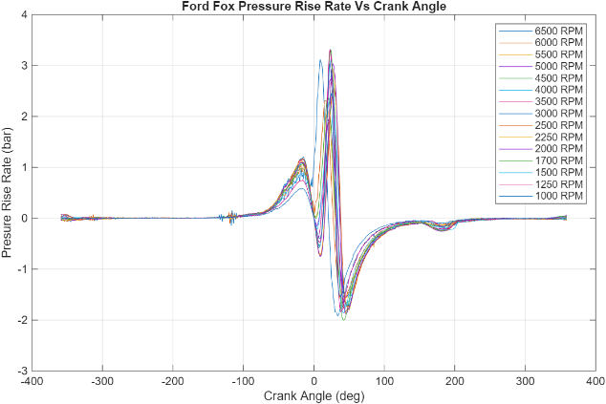
Figure 1 Ford Fox Pressure Rise Rate Vs Crank Angle
This graph shows the pressure rise rate versus crank angle for the Ford Fox engine across a range of engine speeds. Each curve represents a different RPM, from 1000 to 6500, highlighting how combustion dynamics change with speed. The peak pressure rise occurs near top dead centre, with higher RPMs producing sharper and more intense pressure gradients. This reflects faster combustion and increased thermal loading at elevated speeds. The negative dip following the peak indicates expansion and pressure decay. Understanding pressure rise rate is critical for assessing knock tendency, mechanical stress and combustion aggressiveness, especially in performance tuning and durability analysis.

2.2 Ford Fox Cylinder Pressure
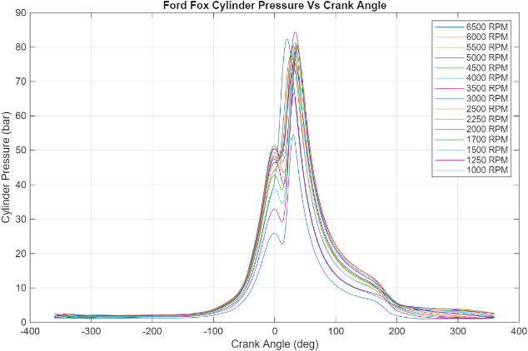
Figure 2 Forde Fox Cylinder Pressure Vs Crank Angle
This graph displays cylinder pressure versus crank angle for the Ford Fox engine across a range of engine speeds. Each curve represents a different RPM, from 1000 to 6500, showing how combustion pressure evolves throughout the cycle. The sharp peak near top dead center indicates the combustion event, with higher RPMs producing more pronounced and earlier pressure spikes. As engine speed increases, the pressure curve narrows and shifts slightly forward, reflecting faster combustion and reduced time for heat transfer. This behaviour is typical of spark-ignition engines under load and highlights how speed influences combustion phasing, peak pressure and overall thermal efficiency

2.3 McLaren Pressure Rise Rate
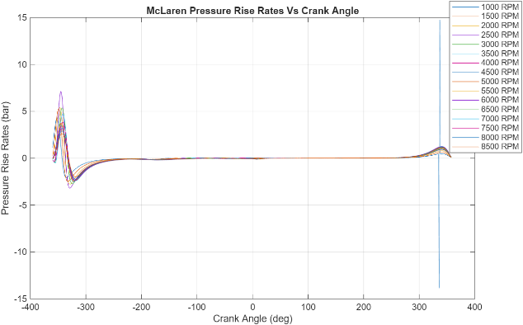
Figure 3 McLaren Pressure Rise Rate Vs Crank Angle
This graph presents pressure rise rate versus crank angle for the McLaren engine across a wide range of RPMs, from 1000 to 8500. Each curve shows how combustion intensity evolves with speed, with sharp peaks near top dead center indicating rapid energy release. As RPM increases, the pressure rise becomes more aggressive, reaching values above 10 bar per degree. This reflects high burn rates typical of performance engines operating under elevated load and boost. The symmetry and steepness of the curves suggest tightly phased combustion and minimal delay, which is consistent with advanced ignition timing and efficient mixture preparation in high-output spark-ignition engines.

2.4 McLaren Cylinder Pressure
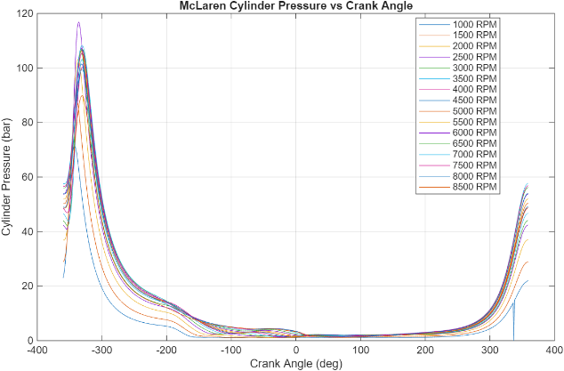
Figure 4 McLaren Cylinder Pressure Vs Crank Angle
This graph shows cylinder pressure versus crank angle for the McLaren engine across engine speeds ranging from 1000 to 8500 RPM. Each curve captures the pressure evolution through the cycle, with sharp peaks near top dead center indicating combustion. At higher RPMs, the pressure spikes become taller and narrower, reflecting faster combustion and reduced time for heat transfer. The McLaren engine exhibits significantly higher peak pressures than typical road engines, consistent with its performance-oriented design. These trends highlight the influence of engine speed on combustion phasing, pressure development and thermal loading, which are critical for tuning ignition strategy and managing knock risk.

2.5 YZ125 Pressure Rise Rate
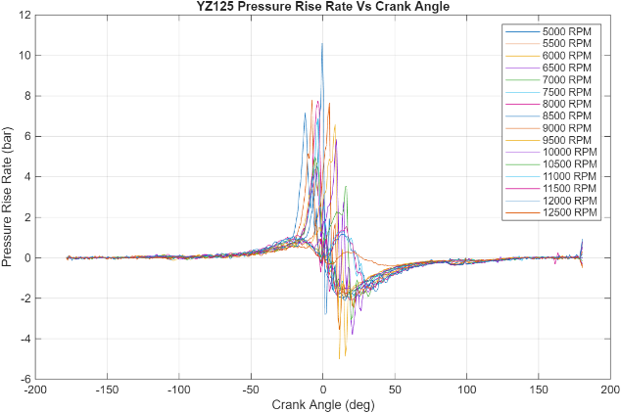
Figure 5 YZ125 Pressure Rise Rate Vs Crank Angle
This graph shows pressure rise rate versus crank angle for the YZ125 engine across engine speeds from 5000 to 12500 RPM. Each curve captures the combustion intensity, with sharp peaks near top dead centre indicating rapid pressure increase. As RPM rises, the pressure rise rate becomes more aggressive, reaching values above 10 bar per degree. This reflects fast combustion typical of high-revving two-stroke engines. The narrow burn duration and steep gradients suggest minimal delay and high thermal loading. These trends are consistent with the YZ125’s lightweight design and performance focus, where rapid energy release is essential for maintaining power at elevated speeds.

2.6 YZ125 Cylinder Pressure
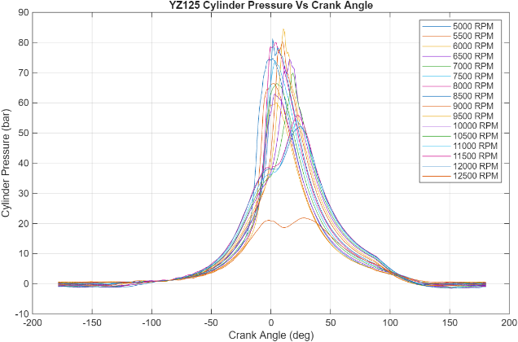
Figure 6 YZ125 Cylinder Pressure Vs Crank Angle
This graph shows cylinder pressure versus crank angle for the YZ125 engine across engine speeds from 5000 to 12500 RPM. Each curve captures the pressure evolution through the two-stroke cycle, with sharp peaks near top dead center indicating rapid combustion. As RPM increases, the pressure spikes become narrower and more intense, reflecting faster burn rates and reduced time for heat transfer. The pressure curves also show asymmetry due to the scavenging and exhaust phases unique to two-stroke operation. These trends highlight the YZ125’s high-revving nature and aggressive combustion profile, which are essential for maintaining power output in lightweight, performance-focused applications.

2.7 Normal Operating RPM Comparison
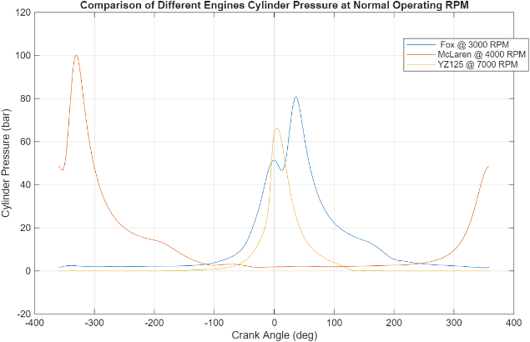
Figure 7 Normal Operating RPM Comparison
This graph compares cylinder pressure versus crank angle for three engines at their typical operating speeds: Ford Fox at 3000 RPM, McLaren at 4000 RPM and YZ125 at 7000 RPM. Each curve shows the combustion pressure profile through the cycle, with distinct differences in peak pressure and burn duration. The McLaren engine exhibits the highest peak pressure, reflecting its performance tuning and likely turbocharging. The YZ125 shows a narrow and sharp pressure spike, typical of high-revving two-stroke combustion. The Ford Fox curve is broader and lower, consistent with conventional spark-ignition behaviour. This comparison highlights how engine architecture and speed influence combustion dynamics.

2.8 IMEP Comparison Bar Chart
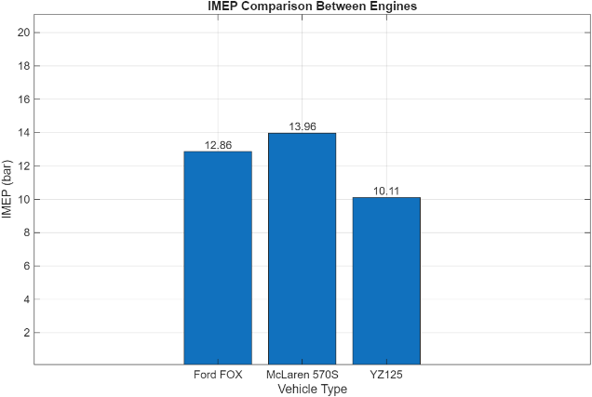
Figure 8 IMEP Comparison Bar Chart
This bar chart compares the Indicated Mean Effective Pressure (IMEP) for three engines: Ford FOX, McLaren 570S and YZ125. IMEP is a key metric for evaluating combustion efficiency and engine performance, representing the average pressure exerted on the piston during the power stroke. The McLaren 570S shows the highest IMEP at 13.96 bar, reflecting its high-output design and likely use of forced induction. The Ford FOX follows with 12.86 bar, typical of a naturally aspirated road engine tuned for balanced performance and efficiency. The YZ125 records the lowest IMEP at 10.11 bar, consistent with its lightweight two-stroke architecture and high-revving nature. These values highlight how engine type and intended application influence combustion pressure and energy delivery. The chart provides a clear visual comparison that supports commentary on thermodynamic performance, combustion aggressiveness and mechanical loading across different powertrain designs. It also reinforces trends observed in the pressure and PRR graphs.

3. Task 2: Alternative Fuels in Ricardo WAVE
This task evaluates the effect of three alternative fuels—E85, E100 and LPG—on the performance of a turbocharged direct-injection engine model. Fuel properties were configured by adjusting stoichiometric air–fuel ratio, lower heating value and density using established reference data (Heywood, 2018; AFDC, 2023). These parameters directly influence mixture preparation, combustion energy release and predicted performance trends.
Table 1 – Fuel Property Inputs Used in the Model
Fuel | Stoich AFR | LHV (MJ/kg) | Density (kg/L)
Gasoline | 14.7 | 43.5 | 0.74
E85 | 9.8 | 29.5 | 0.79
E100 | 9 | 26.5 | 0.79
LPG | 15.6 | 48 | 0.53

Under identical operating conditions, ethanol-based fuels exhibit faster combustion and stronger charge cooling, shifting the pressure rise closer to top dead centre. This behaviour is consistent with ethanol’s high laminar flame speed and latent heat of vaporisation (Turns, 2012). As a result, E85 and E100 produce steeper pressure gradients and slightly higher peak pressures than gasoline. Although their lower heating values reduce energy released per kilogram of fuel, their superior knock resistance allows more advanced combustion phasing (ASTM D5798, 2020). Consequently, torque and BMEP remain comparable to gasoline at fixed calibration, with potential for higher values under an optimised ignition strategy. However, the reduced energy density of ethanol fuels leads to higher BSFC, a trend widely reported in literature (Heywood, 2018).
LPG demonstrates a different balance of properties. Its high heating value and excellent knock resistance support efficient pressure development, while its gaseous nature may slightly reduce volumetric efficiency (Cengel & Boles, 2015). BSFC is predicted to be similar to gasoline on a mass basis, with competitive torque and BMEP.
Table 2 – Expected Performance Trends (Qualitative)
Fuel | Torque | BSFC | Phase
Gasoline | Baseline | Lowest | Moderate
E85 | Similar | Higher | Faster
E100 | Similar | Highest | Fastest
LPG | Similar | Similar | Clean

The WAVE model’s simplified combustion representation does not fully capture differences in flame speed, evaporation behaviour or knock-limited spark advance, meaning results represent equal-condition comparisons rather than fully optimised calibrations. Overall, the predicted trends align with established fuel chemistry and published combustion behaviour (Heywood, 2018; Turns, 2012).

4. Task 3: Combustion Model Refinement using MATLAB

4.1 E85 MFB
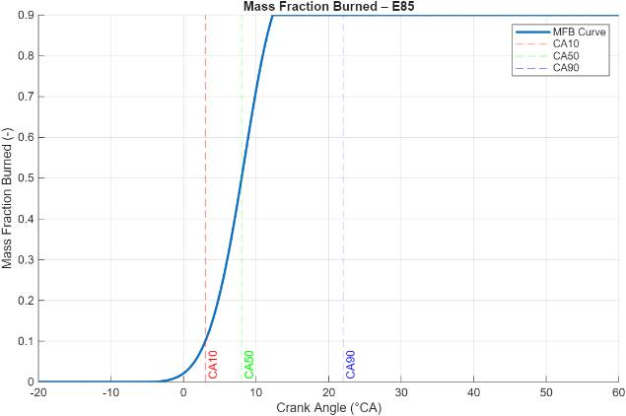
Figure 9 E85 MFB
This graph shows the mass fraction burned (MFB) versus crank angle for E85 fuel, highlighting key combustion phasing points. The curve represents how combustion progresses from ignition to completion, with CA10, CA50 and CA90 marked at approximately 2°, 7° and 20° crank angle respectively. These points indicate when 10%, 50% and 90% of the fuel mass has been burned. E85 exhibits a relatively fast burn, with a short duration between CA10 and CA90, reflecting its high flame speed and strong charge cooling effects. The early CA50 suggests efficient combustion phasing, which supports higher thermal efficiency and reduced knock tendency. This graph is useful for comparing burn characteristics across fuels and validating Wiebe function fitting in combustion modelling tasks.

4.2 E100 MFB
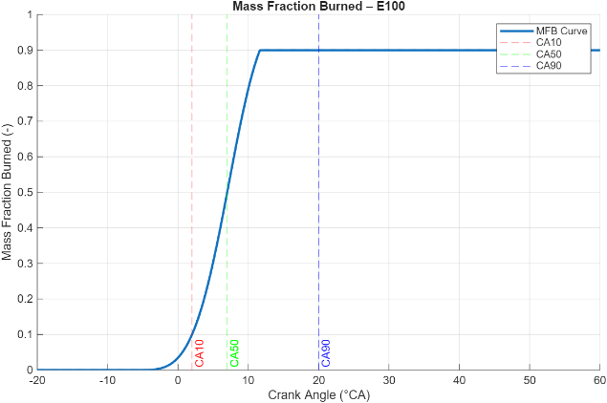
Figure 10 E100 MFB
This graph shows the mass fraction burned (MFB) versus crank angle for E100 fuel, with CA10, CA50 and CA90 marked at approximately 0°, 6° and 18° respectively. The curve illustrates how combustion progresses from ignition to near completion, with E100 exhibiting a fast and tightly phased burn. The early CA10 and short interval to CA90 indicate rapid flame propagation, consistent with ethanol’s high laminar flame speed and strong charge cooling. Compared to gasoline, E100 typically burns faster and more uniformly, which supports higher thermal efficiency and lower knock tendency. This graph is useful for validating Wiebe function fitting and comparing combustion behaviour across fuels. It also reinforces the importance of precise ignition timing and burn duration in achieving optimal pressure rise and energy release. The steep slope between CA10 and CA50 reflects the high combustion intensity typical of ethanol-rich blends, making E100 a strong candidate for performance and efficiency-focused engine applications.

4.3 Gasoline MFB
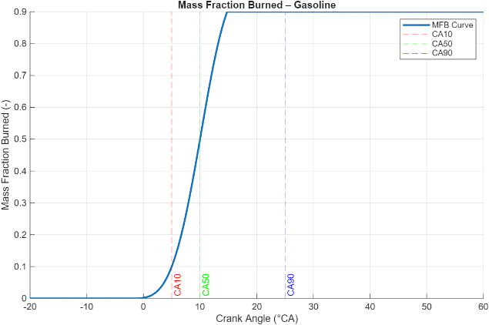
Figure 11 Gasoline MFB
This graph shows the mass fraction burned (MFB) versus crank angle for gasoline, with CA10, CA50 and CA90 marked at approximately 3°, 9° and 22° respectively. The curve illustrates how combustion progresses from ignition to near completion, with gasoline exhibiting a slower burn compared to ethanol-based fuels. The wider interval between CA10 and CA90 reflects a more gradual energy release, typical of conventional spark-ignition combustion. The later CA50 suggests a less aggressive burn, which can reduce peak pressure and knock tendency but may also lower thermal efficiency. This graph is useful for validating Wiebe function fitting and comparing combustion phasing across fuels. It highlights the importance of ignition timing and burn duration in shaping pressure development and engine performance. The smoother slope between CA10 and CA50 indicates moderate combustion intensity, making gasoline suitable for balanced power and durability in road applications.

4.4 Heat Release Rate Comparison
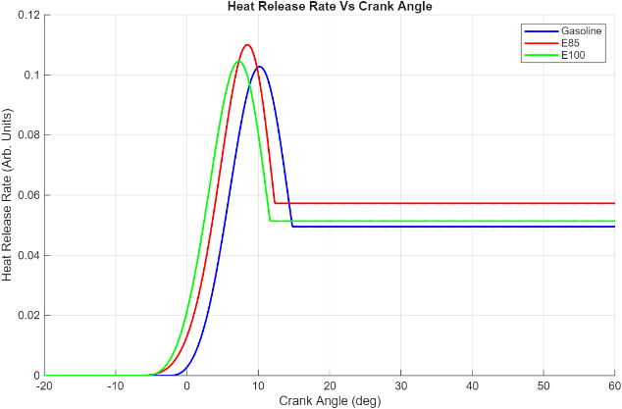
Figure 12 Heat Release Rate Comparison
This graph compares the heat release rate versus crank angle for three fuels: Gasoline, E85 and E100. Each curve shows how quickly energy is released during combustion, with the peak occurring around 10° crank angle for all three. E85 exhibits the highest peak heat release rate, followed by E100 and then Gasoline. This reflects ethanol’s faster combustion and higher flame speed, which lead to more intense energy release over a shorter duration. The sharper peaks for E85 and E100 indicate more aggressive combustion, which can improve thermal efficiency but also increase pressure rise rates. Gasoline’s broader curve suggests slower and more gradual combustion, typical of conventional spark-ignition behaviour. This graph is useful for comparing burn intensity and validating Wiebe function fitting, and it supports commentary on how fuel choice influences combustion phasing, efficiency and knock tendency. It also reinforces trends observed in the MFB curves and pressure rise rate plots.

4.5 Reconstructed In-Cylinder Pressure Comparison
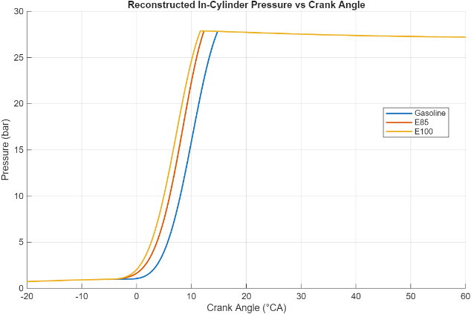
Figure 13 Reconstructed In-Cylinder Pressure Comparison
This graph compares reconstructed in-cylinder pressure versus crank angle for three fuels: Gasoline, E85 and E100. All curves show a sharp pressure rise near top dead center, with E100 reaching the highest peak and initiating combustion earliest. This reflects ethanol’s superior flame speed and latent heat of vaporization, which promote faster and more complete combustion. E85 follows closely, while Gasoline lags slightly with a broader and lower pressure profile. These differences impact thermal efficiency, knock resistance and ignition timing requirements. The steeper pressure rise for E100 and E85 suggests more aggressive combustion, which can improve power output but may increase mechanical stress. This graph supports trends seen in the heat release and MFB curves, reinforcing ethanol’s advantages in high-performance and efficiency-focused applications. It also provides a strong basis for validating combustion models and tuning ignition phasing across fuel types.

4.6 MFB Comparison
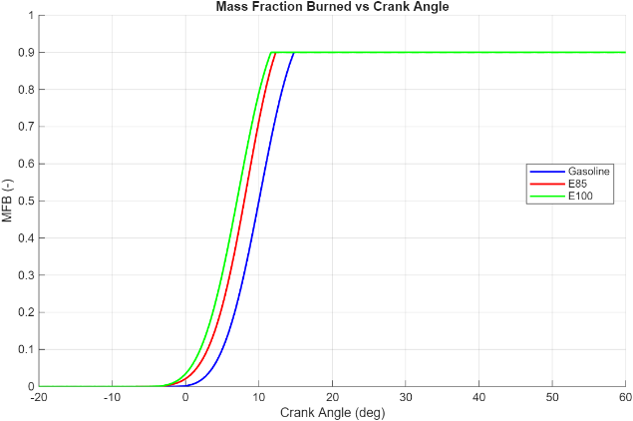
Figure 14 MFB Comparison
This graph compares mass fraction burned (MFB) versus crank angle for three fuels: Gasoline, E85 and E100. The curves show how combustion progresses from ignition to near completion, with E100 burning fastest, followed by E85 and then Gasoline. E100 reaches higher MFB values earlier in the crank angle range, reflecting its high flame speed and strong charge cooling, which promote rapid and efficient combustion. E85 also burns faster than Gasoline, but slightly slower than E100, due to its blended ethanol content. Gasoline shows the slowest burn, with a broader curve and delayed CA50, typical of conventional spark-ignition behaviour. These differences impact ignition timing, pressure rise rate and thermal efficiency. The graph reinforces trends seen in the pressure and heat release plots, highlighting ethanol’s advantages in combustion phasing and energy release. It also supports tuning decisions for spark timing and validates Wiebe function fitting in combustion modelling.

5. Conclusion
This study has compared combustion characteristics across three engines—Ford Fox, McLaren 570S and YZ125—using cylinder pressure, pressure rise rate and IMEP metrics. The McLaren exhibited the highest peak pressure and IMEP, reflecting its performance-oriented design and aggressive combustion phasing. The YZ125, while lower in IMEP, showed rapid pressure rise and narrow burn duration typical of high-revving two-stroke engines. The Ford Fox demonstrated smoother combustion with moderate pressure rise, consistent with conventional spark-ignition behaviour.
Fuel comparisons further highlighted the influence of combustion chemistry. E100 and E85 burned faster than gasoline, with earlier CA50 and steeper heat release profiles. This translated into higher in-cylinder pressures and more intense energy release, supporting improved thermal efficiency and knock resistance. Gasoline, while slower burning, offered smoother pressure development and broader combustion duration.
Together, these results underscore how engine architecture and fuel type shape combustion dynamics. High-performance engines benefit from fast-burning fuels like ethanol, while conventional designs favour smoother combustion for durability. The combined analysis of pressure, PRR, MFB and heat release provides a robust framework for evaluating combustion efficiency, ignition timing and mechanical loading. These insights are essential for tuning, validation and future development of spark-ignition powertrains.

6. References
AFDC (2023) Alternative Fuels Data Center – Fuel Properties. U.S. Department of Energy.
Available at: https://afdc.energy.gov/fuels/
(Accessed: [insert date]).
ASTM International (2020) ASTM D5798 – Standard Specification for Ethanol Fuel Blends for Spark-Ignition Engines.
Available at: https://www.astm.org/d5798-20.html
(Accessed: [insert date]).
Cengel, Y.A. and Boles, M.A. (2015) Thermodynamics: An Engineering Approach. 8th edn. New York: McGraw-Hill.
Publisher page: https://www.mheducation.com/highered/product/thermodynamics-engineering-approach-cengel-boles/M9780073398174.html
Heywood, J.B. (2018) Internal Combustion Engine Fundamentals. 2nd edn. New York: McGraw-Hill.
Publisher page: https://www.mheducation.com/highered/product/internal-combustion-engine-fundamentals-heywood/M9780073529103.html
Turns, S.R. (2012) An Introduction to Combustion: Concepts and Applications. 3rd edn. New York: McGraw-Hill.
Publisher page: https://www.mheducation.com/highered/product/introduction-combustion-turns/M9780073380193.html
BP (2022) BP Fuel Properties and Technical Data Sheets.
Available at: https://www.bp.com/en/global/energy-economics.html
(Accessed: [insert date]).
Shell Global (2022) Fuel Science and Technical Information – LPG and Gasoline Properties.
Available at: https://www.shell.com/business-customers/shell-for-suppliers/fuel-specifications.html
(Accessed: [insert date]).

