GIOVANNI LETO
(2130450)
Report (2000 Words)

INDIVIDUAL REPORT
THE USE OF TECHNOLOGY IN THE MODERN HEALTHCARE WORKPLACE

DIGITAL SKILLS AND RESEARCH METHODS (LCHS4002)
TASK 2 ASSIGNMENT – JUNE 2022 TERM
LECTURE: KOUSHIK MODAK

Table of Contents

INTRODUCTION 2

DIFFERENT TECHNOLOGIES USED IN HOSPITAL 4

Electronic health records. 4

Electronic health record examples 4

Remote patient monitoring 5

Urgent care applications 6

RELEVANT ISSUES ASSOCIATED WITH MODERN TECHNOLOGY 8

The methodology 9

CONCLUSION 10

LIST OF REFERENCES 11

INTRODUCTION

In this descriptive report I will write about the use of technology in the modern healthcare workplace in hospitals and I choose to focus in different type of technology including Electronic health records, Remote patient monitoring and Urgent care applications. I will explain how this technology are getting use in different hospital, why been significant and why they were introduced. I will explain about any relevant issues associated to the technology in hospital

DIFFERENT TECHNOLOGIES USED IN HOSPITAL
Technology in the hospital is always evolving, some of these to update the system have introduced novelties such as the following listed
Electronic health records.
Electronic health records (EHRs) are any digital document or system that contains information on an individual’s health and care. This could be online, on an internal network, or on a device. Numerous well-known examples are available. These can range from simple electronic diaries to elaborate networks including numerous healthcare organisations and sectors. By 2020, NHS England expects to be paperless, a goal it stated in 2015. This expectation was revised in the more recent NHS Long Term Plan to state that "a level of core digitalization by 2024" should have been achieved by all services. Most of this is supported by the shift to EHRs.
Many hospitals, trusts, and organisations have already made the transfer to EHRs as a result of that instruction. Around the nation, there are several worldwide digital exemplar sites that have put these systems in place and are acting as models for other services.
The private sector can also benefit greatly from EHRs. EHRs with good design will take care of:
- Record management
- Security
- Compliance with general data protection regulation (GDPR)
Electronic health record examples
Almost every hospital and doctor's office in Suffolk makes use of TPP's SystmOne. This is also utilised by the community pain management service, the fracture liaison service, the out-of-hours doctors, the musculoskeletal physiotherapy team, and the community rehabilitation and nursing services.
Hospital clinicians can view data from SystmOne, and data can also retrieved from nearby hospitals through a health information exchange. All of these services, in addition to local governments and social care providers, are covered under a comprehensive local data-sharing agreement to facilitate communication. In reality, this means that a clinician at the MSK outpatient clinic has access to the patient's entire medical file, including a list of all medications they have ever taken, a history of all previous episodes of care, regardless of the service that provided those care, and all correspondence between those services.
(Chartered society of physiotherapy, 2020)

Remote patient monitoring
Hospital operate procedures underwent significant modification as a result of the global COVID-19 epidemic, particularly approaches to treating and caring for patients at high risk. As a result, hospitals are utilising digital imaging platforms that connect to hospital networks more frequently, allowing staff to remotely monitor many patients.
Clinical teams now have more ways to evaluate patients' conditions without always having to be physically present in the same space thanks to remote monitoring.
Digital technology advancements have made it possible to safely stream High Definition video—shot by remotely operated cameras in the care ward—across hospitals' traditional IT networks in real time.
Combining this with options that can transmit patient data and video from other devices enables nursing staff to monitor the health of high-risk patients from any location on the hospital campus using a networked PC, tablet, or dedicated display. The majority of remote monitoring systems have one or more cameras that constantly record videos of high-risk patients either in the intensive care unit (ICU) or a temporary operating room (OR) space. In this situation, a remotely operated camera offers apparent advantages because the camera's field of vision and other parameters can be changed without the actual presence of a human operator. Staff members have remote access to the patient's room and any medical data there. The goal of video monitoring is not to take the place of the nursing staff's specialised knowledge. What it can offer, though, is a chance for nurses to offer high-quality care to more patients. Remote patient monitoring has made it possible for hospitals to more effectively handle the heavy workloads of their clinical teams. In a big ward, one staff member can examine multiple patients via video, saving time on rounds that require them to visit multiple wards or walk between beds.
The requirement for personnel to constantly put on and take off Personal Protective Equipment, which may be in short supply, can be considerably reduced by reducing the amount of physical contact time between physicians and patients.
BENEFITS OF REMOTE PATIENT MONITORING
Monitor patient medication adherence: Patient health depends on treatment adherence. Clinicians can create medication adherence activities using virtual care, which makes it simple for patients to adopt and comprehend their individual medication regimen habit.
Reduce ED visits, hospitalisations and hospital stay: Patients are given pertinent, enlightening information about their diseases or therapies at the time. By encouraging patients to take an active role in their healthcare, raise their level of awareness, and continue to be involved in maintaining a healthy status, hospitalizations are decreased.
Empower patients to be in control of their own healthcare: The remote patient monitoring educates patients with the knowledge and motivation to maintain healthy habits through engaging health activities, empowering them to take charge of their own health.
(Remote patient monitoring, 2022)

Urgent care applications
Urgent care apps are smart phone applications that can be remotely accessed. When there is an emergency, they can alert the nurses and doctors. With the help of these apps, users can ask a certified nurse about their medical concerns, and if necessary, a professional doctor will contact them back shortly. Additionally, users or patients can use these apps to get the assistance they need from online doctors when seeking medical care, whether it be for themselves or others, particularly during emergency or speciality care. Patients have a high need for post-hospital apps in the current environment during post-hospital care.
One example of this new technology is the application call “NHS QUICKER ”. If you require urgent treatment, there are numerous services you can choose. When you select "Find Local Services," NHSquicker will provide a selection of the most popular services. This includes pharmacies, dental offices, clinics for sexual health, and minor injury units. The Directory of Services (DOS), which is kept up by the NHS, is where the information originates from. Depending on your GPS position or the postcode you supplied, the information is accessible. 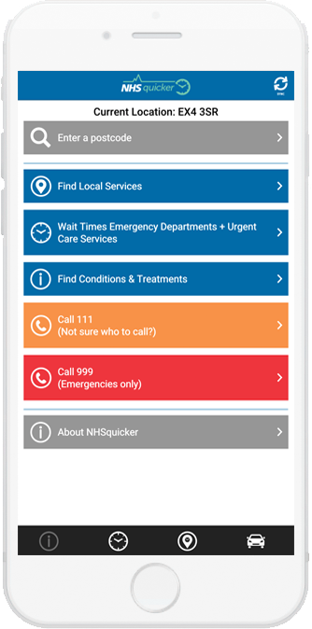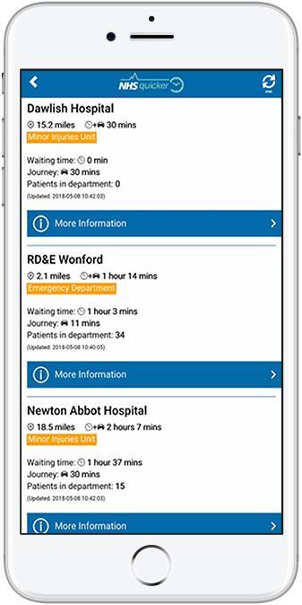
Choosing when to attend an urgent care clinic can be done by checking the current wait times. The urgent care facilities may be seen in both list and map views. Additional information is accessible in the list view, including links to Google Maps and information about facilities and opening hours. According to travel and wait times, the list will always show the five closest locations. Depending on whether you choose to drive, take public transportation, or walk, the distance you must travel will affect how long it takes. When the app is used, it will only display urgent care facilities that are open at that moment.
No matter how far away they are from one other, the list will always contain at least one Emergency Department (ED). The wait time and the number of persons waiting may have changed by the time you arrive because these are actual wait times.

(Allied market research, 2022)
(NHS quicker, 2018)

RELEVANT ISSUES ASSOCIATED WITH MODERN TECHNOLOGY

The medical sector has experienced numerous changes as a result of the digital revolution over the past ten years. The days of keeping, organising, and recovering patient information in a clinical context using big file folders are long gone. The widespread transition to an electronic health record from a document-based backup system is one of the most significant advancements in the healthcare industry (EHR). Such patient-centered documentation are accessible at any time by authorised hospitals, simplifying the healthcare process. The patient's entire medical history is available to the medical team in real-time, including details on diagnoses, potential therapies, follow-ups, drug issues, laboratory test results, and much more. Even though the system is made foolproof, still there are some issues with electronic health records which are of concern Like everything else in the world, EHR also has its own pros and cons, Some common problems with HER are:
Security Risks From Criminal Computer Hackers: Hackers are interested to the software used to collect electronic health records. Organizations using an EHR have been required to protect sensitive patient information from hackers since Congress passed the Health Insurance Portability and Accountability Act (HIPAA) in 1996. If patient information is compromised, hospital risk facing legal action from them. Another risk to be aware of is the potential for electronic records to be taken over by hackers who then encrypt patient data and hold it hostage until they pay the ransom to decrypt it. Hospitals should be sure to ask a potential software vendor how they would keep patient details secure. A security audit of your company conducted by a third party will be very helpful in strengthening your system. Prior to the patient records moving into your EHR, it is preferable to detect risk today.
Data inaccuracies: Integrity guarantees that the data is accurate and unaltered. By eliminating medical errors, EHRs help to promote public health, decrease health inequities, and increase patient safety. The accuracy and dependability of the data recorded into the electronic record have, however, been questioned. When options such "cut and paste" are used incorrectly, the patient's current state and course of treatment are inaccurately depicted. This behaviour is inappropriate because it puts patients at risk and exposes healthcare providers and organisations to responsibility. The drop-down menu and placement of crucial information in the trash are two additional features that may compromise the integrity of the data. Such choices restrict the options available to the doctor who, if pressed for time, may make a mistake that has serious consequences. To make EHRs user-friendly and accurate, companies and clinicians have been trying to fix software issues. Data loss or destruction occurs during data transfer, raising questions about the reliability of the data base as choices about patient care are based on it. Medical identity theft is an increasing issue. As a result, erroneous information is entered into the victim's file. The person's insurance company receives bills for medical services that were not actually rendered to the policy holder, and neither the patient nor the physician are immediately aware that the information being used to steer the patient's future care is inaccurate.
The methodology that in decide to use in this report is mixed method that is a combination of qualitative and quantitative research. Qualitative research refers to the use of non-numerical observation to answer “why” questions, and the quantitative research use data that can be counted or converted into numerical form address “how” questions.
To find a credible sources to support my research was really important the job that we made with Megan that explain to us how to do it. The steps that I follow was to:
- The information should be up to a date and current
- The source be relevant to my research
- The author and publication should be a trusted authority
- The web sources, the URL and layout signify that it is trustworthy

(Advanced data systems corporation, 2019)
(National library of medicine, 2015)

CONCLUSION

This is the conclusion of my first report on the use of technology in the modern healthcare workplace. This report is based on secondary date only focusing on the technology in hospital. This report was very helpful for me because I had the possibility to learn how to write a report using different type writing methods like data collection and research methods. It was very interesting to find out what new technologies we have in the modern healthcare, learn how this technology are used and how important this change is. During the time that I wrote this report, the use of the platform Moodle was very important, I’m sure that I still need to improve my writing but I’m satisfied of my work.

LIST OF REFERENCES

Allied market research (2022) Urgent care apps market overview (online) Available at: https://www.alliedmarketresearch.com/urgent-care-apps-market (Access date 15 August 2022)

American Recovery and Reinvestment Act, HR 1, 111th Congress, 1st Session. Available at: https://www.ncbi.nlm.nih.gov/pmc/articles/PMC4394583/ (Access Date 15 August 2022)

Orion health (2022) Remote patient monitoring (online) Available at: https://orionhealth.com/uk/products/virtual-care/ (Access date 14 August 2022)

NHS quicker (2018) NHSquicker (online) Available at: https://nhsquicker.co.uk (Access date 16 August 2022)

Russell, J (2020) Electronic health records (online) Available at: https://www.csp.org.uk/professional-clinical/digital-physiotherapy/electronic-health-records (Access Date 13 August 2022)

