Digital Skills and Research Methods
Submitted By: Mohamed Fazle Elahee
Student ID: 1806201

Contents
Introduction 3
Evaluating the effectiveness of the use of Modern technologies 4
Technology 1 4
Technology 2 6
Exploring social media as a tool 7
Discuss about how social media is supporting marketing, information gathering and communication? Support your discuss with evidence drawn from journal activities 7
Safety and Security measures on social media 8
Evidence of own professional online presence 9
Conclusion 10
References 11

Introduction
Digital technologies have improved the ways businesses perform their activities and objectives. Present world totally depends on the digital technologies. In the current global business scenario, business organizations need to use digital skills for attaining the organizational objectives in the most effective and efficient way. These kinds of digital skills are highly needed for the all kinds of business organizations because there are certain tasks in which the existing employees may not be good at. For example, an organisation may not have a skilled logo designer but they may need logo design which would represent their business. For such small task, it is pointless to hire a graphic designer. To accomplish the task, digital skill could be hired online. In addition to that, businesses may need to do research regarding customer preferences of certain product and services. Such information could easily be found in social networking sites where customers express their opinion and give feedback to products and services. In this report, how effective usage of modern technologies could be in businesses, how social media is used as a tool and various criteria related to social media is going to be presented.

Evaluating the effectiveness of the use of Modern technologies
Every business organization needs different kinds of technologies to get their organizational objectives perform in efficient and effective manner. For utilizing these kinds of digital technologies in the business sector, businesses need specific skilled people, who are good at using different kind of technologies in a business organization (Nick, 2017). Different businesses use different type of social media for their development. The contribution of social media in businesses can be as following-
- When business organization uses the different kinds of modern and digital technologies in the production time, they easily increase their production.
- When business organization uses the different kinds of modern and digital technologies in the business sector, they can complete their overall task very fast than doing manually.
- These kinds of different modern and digital technologies give the business organization to record different kinds of information for future using.
- Different kinds of digital and modern technologies help the business organization to improve the communication process.
- Sometime business organization needs huge cost for the man power. For using the modern and digital technology in their business sector, this cost can be reduced.
Business organization uses many technologies in the business sector for getting better performance and these kinds of two modern technologies are described in below-

Technology 1
Cloud File Storage: Business organization at the present time, depend on different kinds of modern and digital technologies because maximum time it gets positive result. One of the most dependable sites is internet because now business organization can easily store their valuable information into the different online storage and cloud file storage is one of those sites. It helps the business organization to store their different kinds of business data so that they can easily use these data for their further using. At past time, they most of the time depended on some low capability type storage system like as CD, DVD, floppy disk etc. that were very expensive for them. Modern time is the digital generation and different kinds of software maker organizations make different kinds of software like as Apple Inc. makes iCloud storage system, Google makes Google drive, Microsoft makes OneDrive etc. For accessing all these storage systems must need internet connection because all these are online cloud storage system. Business organization can easily use this software and they can give strong password that’s why it is safe from other people (Figeiredo & Thomas, 2016).
Google Drive: At every moment, business organization needs to storage their different kinds of information that can help them to get future benefits from the business sector, from where they can easily restore all the information from their server for instant use. To do this regularly, one of the most essential method is the Google drive. Google drive is the one kind of best storage system that is provided by the Google. Business organization constantly needs different kinds of information for the business development, which are needed to secure from the other different hackers. For this reason, they most of the time, store all their official data into the Google drive by creating an account. Business organization gets different kinds of benefits by using this kind of cloud storage system. When business organization uses the online security system for recording all kinds of business information, they can get chance to log in into the account from anywhere in the world via internet. Computer or laptop hard drive can be damaged by any reason or crashed for different issues, but this Google account cannot be damaged or crashed for any reason so that they can easily log in here and collect any information from the storage very easily (Amara, 2017). To use the Google drive, everyone must need to open a Google account. Business organization can get some free storage for the first time after opening the account and they get almost 15 GB storage capacity. If they need to expand this size, they must need to pay for it.
Dropbox: Another very important cloud system is the Dropbox that some business organization use. Everyone needs to provide some basic information for creating the Dropbox account and they can easily storage different kind of information into this Dropbox account very easily. There is not huge storage capacity in the Dropbox. In this system only 2 GB is available for the people to storage the data.

Technology 2
CRM Software: Business organization most of the time uses some specific software for doing some specific tasks. For this reason, they select a software for their business sector that is CRM that gives the biggest support to the business organization to manage the customer relationship. Business organization tries to develop their business by giving different kinds of services to the customers of the entire world. Their main target is to increase the customer’s number in the whole world. A positive relationship between business organization and customers is highly needed for the business organization for getting the best result from the business sector. This customer relationship management software at the present time is increased day by day in the business world. Business organization needs to collect different kinds of information from the customers about their products or about customers’ demand. For this reason, they most of the time give the preference to this software because this software provides different kinds of information to the business organization on behalf of customers.
Salesforce: Another essential customer relationship management software is salesforce which is used in the business organization most of the time. Business organization needs to maintain the overall relationship with the customers so that they use the salesforce software in their business sector. Business organization can easily customize this software because it is customizable. By using this software, business organization can get different kinds of benefits like they can improve their relationship, they can go very closer to the customers, they can provide better service to the customers, it helps to increase team work process, gives different kinds of analytical data (Aleks, 2016). Business organization needs to spend some money for using this salesforce software and its monthly subscription fee is £5. When they want to increase the fee for extra benefits, they get some extra ordinary facilities from this software.
Zoho: For every single element has some competitors in the world. As like as salesforce has a competitor and that is Zoho. This is one kind of software for the business organization that helps them to provide same services to the customers. It can give service personally to the customers. There are many users has, who use this Zoho software and the approximate number is 20,000,000. All kind of business organizations use this software for giving the services to the customers. Business organization also needs to expense some money for subscription and this is £29 per month. This package for 3 users and 500 customers but it has a professional profile that needs £69 per month for subscription and here has unlimited customers and users.

Exploring social media as a tool
Business organization needs to research from the people about their overall business site, products quality. For this reason, they most of the time depend on the digital technologies like social media, where people can easily give their opinion. That’s why most of the business organizations always give the preference to the different kinds of social media for their development. Social media is faster technology than the other modern technologies in the business sector. Business organization can easily share their all kinds of products via social media and people can easily get the information from the social media within the short time. Most of the time, business organization prefers the Facebook, Instagram, Twitter etc. as the best social media. They can do their all kinds of functional work by these social media.

Discuss about how social media is supporting marketing, information gathering and communication? Support your discuss with evidence drawn from journal activities
Support of Social Media in Marketing: When business organizations use the social media as their marketing process, they can easily provide the different pictures of the products or other description into their official page. Therefore, customers easily see all the advertisement by internet. That’s why it can be said that social media gives biggest support to the business organization for marketing.
Support of Social Media in Better Communication: Social media is the best method for communicating with the customers. Business organization can easily use the social media for better communication because by this process, they can directly communicate with the customers and can know their perception (Patrick, 2018).
Support of Social Media in Collecting Information: Business organization can easily collect different kinds of information from the customers by using different kinds of social media. They can communicate with the customers by private chatting and try to know their opinion that helps them to collect information about their services.

Safety and Security measures on social media
Most of the time, business organizations try to get huge amount of production which need a lot of support technologies. Every business organization needs to secure their social media to protect its data and precious information. That’s why they can stay in the safe zone from the different kinds of hackers they can maintain some methods to secure more their online social media and some are given below-
- They need to use alpha numeric and strong password.
- Only highly trustable employees should be given access to social networking sites.
- They can use some password protection devices.
- Must protect the server from the spam site.
- Must log out the account after using.

Evidence of own professional online presence

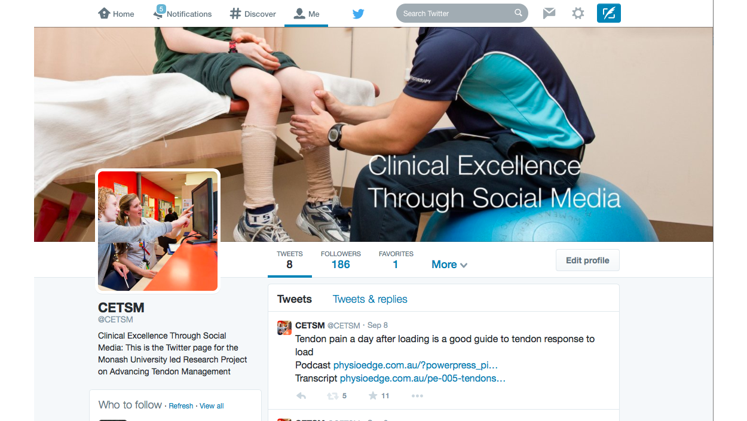
This is the Twitter page, which I have of my own business which is an evidence of my professional online presence.

Conclusion
At the end of this report, some valuable findings have been presented such as every business organization needs different kind of technologies for getting the organizational objectives to be performed very successfully. Most of the business organizations always give the preference to the different kinds of social media for their development. When business organization uses the different kinds of modern and digital technologies in the business sector, they can complete their overall task very fast than doing manually. It can be defined as one of the most dependable sites in internet because now business organization can easily store their valuable information into the different online storages. When business organization uses the online security system for recording all kind of business information, they can get chance to log in into the account from anywhere in the world via internet. Business organization needs to maintain the overall relationship with the customers so that they use the sales force software in their business sector.

References


