
UNIVERSITY OF WALES TRINITY SAINT DAVID
Master of Business Administration
Module Code: LCMB7034 | International Business Concepts

Italy's Fashion Industry:
A Critical International Business Analysis
with Strategic Focus on H&M's Operational Environment

Lecturer: | Akshay Narayanan
Programme: | Master of Business Administration
Module: | International Business Concepts (LCMB7034)
Submission Date: | 27th April 2026

Student name: Md Alamin
Student ID number: 2434280
Word Count: 4727

Table of Contents
Section 1: International Industry Report — Italy Fashion Industry & H&M 3
1. Introduction 3
2. Industry and Country Overview 4
2.1 Italy's Fashion Industry: Contextual Overview 4
2.2 Key Players: Market Positioning and Strategic Comparison 4
3. Porter's Diamond Model: Global Competitiveness of Italy's Fashion Industry 7
3.1 Factor Conditions 8
3.2 Demand Conditions 8
3.3 Related and Supporting Industries 9
3.4 Firm Strategy, Structure, and Rivalry 9
3.5 Government and Chance 9
4. Critical Evaluation of H&M's Operations in Italy 10
4.1 Political Environment 12
4.2 Economic Environment 13
4.3 Legal Environment 13
4.4 Cultural Factors: Hofstede's Cultural Dimensions Analysis 13
4.5 Strategic Framework Integration: OLI and Uppsala Models 15
5. Conclusion 18
References 19
Section 2: Reflective Account — Gibbs' Reflective Cycle (Gibbs, 1988) 22
Stage 1: Description — What Happened? 22
Stage 2: Feelings — How Did I Feel Throughout? 23
Stage 3: Evaluation — What Was Good and What Was Challenging? 23
Stage 4: Analysis — Why Did Things Happen the Way They Did? 24
Stage 5: Conclusion — What Else Could I Have Done? 24
Stage 6: Action Plan — What Will I Do Differently Next Time? 24
Section 2 Additional References 26

Section 1: International Industry Report — Italy Fashion Industry & H&M

1. Introduction
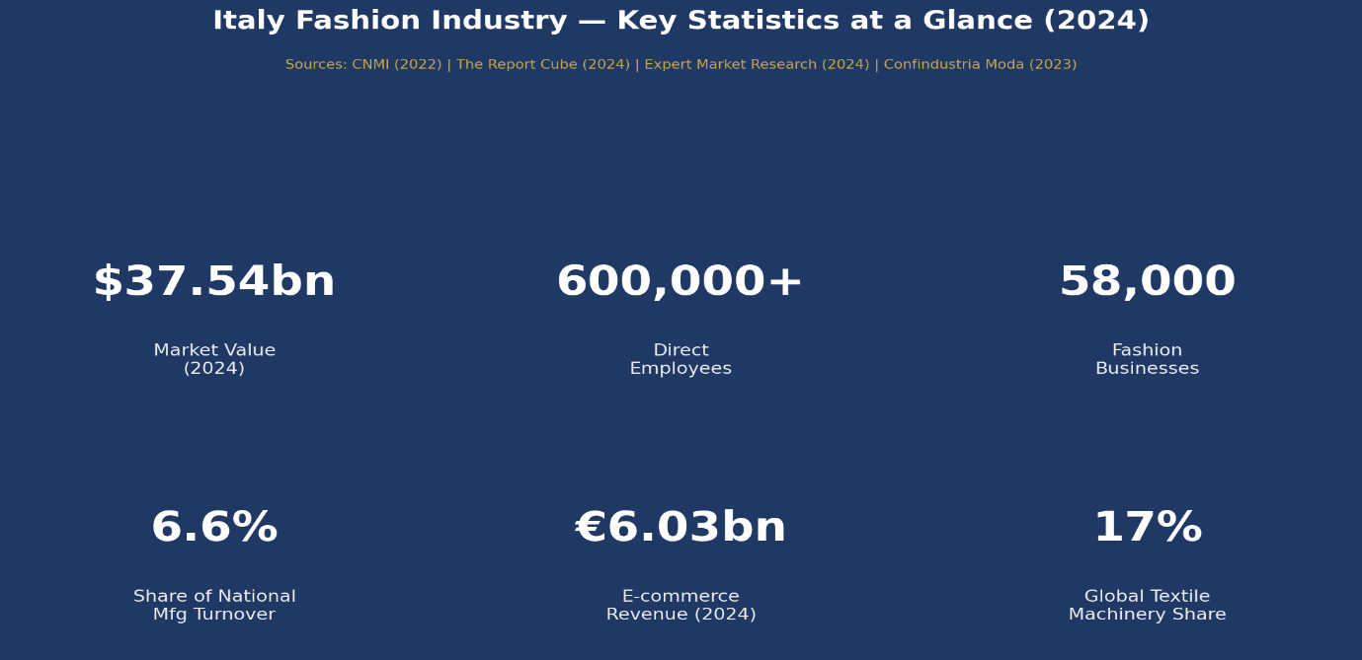
Italy also has a unique place in fashion in the world. Being the most prestigious luxury fashion market in the world, the Italian fashion industry has traditionally been associated with the art of crafting, tradition, and artistic excellence. Established on the basis of iconic fashion capitals, especially in Milan, the industry is not only a commercial venture but a cultural institution, which defines the aesthetic norms of the world (Bhardwaj and Fairhurst, 2010). The industry is inclusive of a continuum between ultra-luxury homes like Gucci, Prada and Versace at one end and accessible fast-fashion MNCs like H and M and Zara at the other end. This report critically analyzes the Italian fashion industry, using the Diamond Model of National Advantage by Porter to determine the global competitiveness of the industry, before analyzing the environment within which Hennes and Mauritz (H&M) will operate in the Italian market. PESTEL analysis, the Cultural Dimensions as developed by Hofstede, the OLI Eclectic Paradigm of Dunning and the Uppsala Internationalisation Model are implemented to produce an evidence-based and rigorous strategic analysis.

Figure 1: Italy Fashion Industry — Key Statistics at a Glance (2024) | Sources: CNMI (2022); The Report Cube (2024); Expert Market Research (2024)

2. Industry and Country Overview

2.1 Italy's Fashion Industry: Contextual Overview
The fashion industry of Italy is one of the most strategic economic sectors of the country. Fashion and textile industry In the country, there are about 58,000 businesses directly employing almost 600,000 people and creating the same amount of indirect employment (Camera Nazionale della Moda Italiana, 2022). The second-largest manufacturing industry in Italy is fashion that contributes around 6.6% of the total national manufacturing turnover (Confindustria Moda, 2023). In 2024, the Italian fashion and apparel industry was estimated to have a value of USD 37.54 billion, and this figure is expected to increase to USD 58.54 billion by 2032 at a compounded average growth rate of 6.1% (The Report Cube, 2024).
The nerve centre of the industry is Milan, which is regularly ranked as one of the four major fashion weeks in the world, with Florence and Rome as complementary creative and commercial centres. The Via Monte Napoleone of Milan has a rental of up to 20,000 euro per square metre per annum, 11 million visitors per annum and average spending per-shopper of 2,500 on an average basis (IMARC Group, 2025). In Italy, fashion e-commerce revenues stand at 6.03 billion in 2024 and they represent a growth of 16 per cent year on year (BestColourfulSocks, 2025).
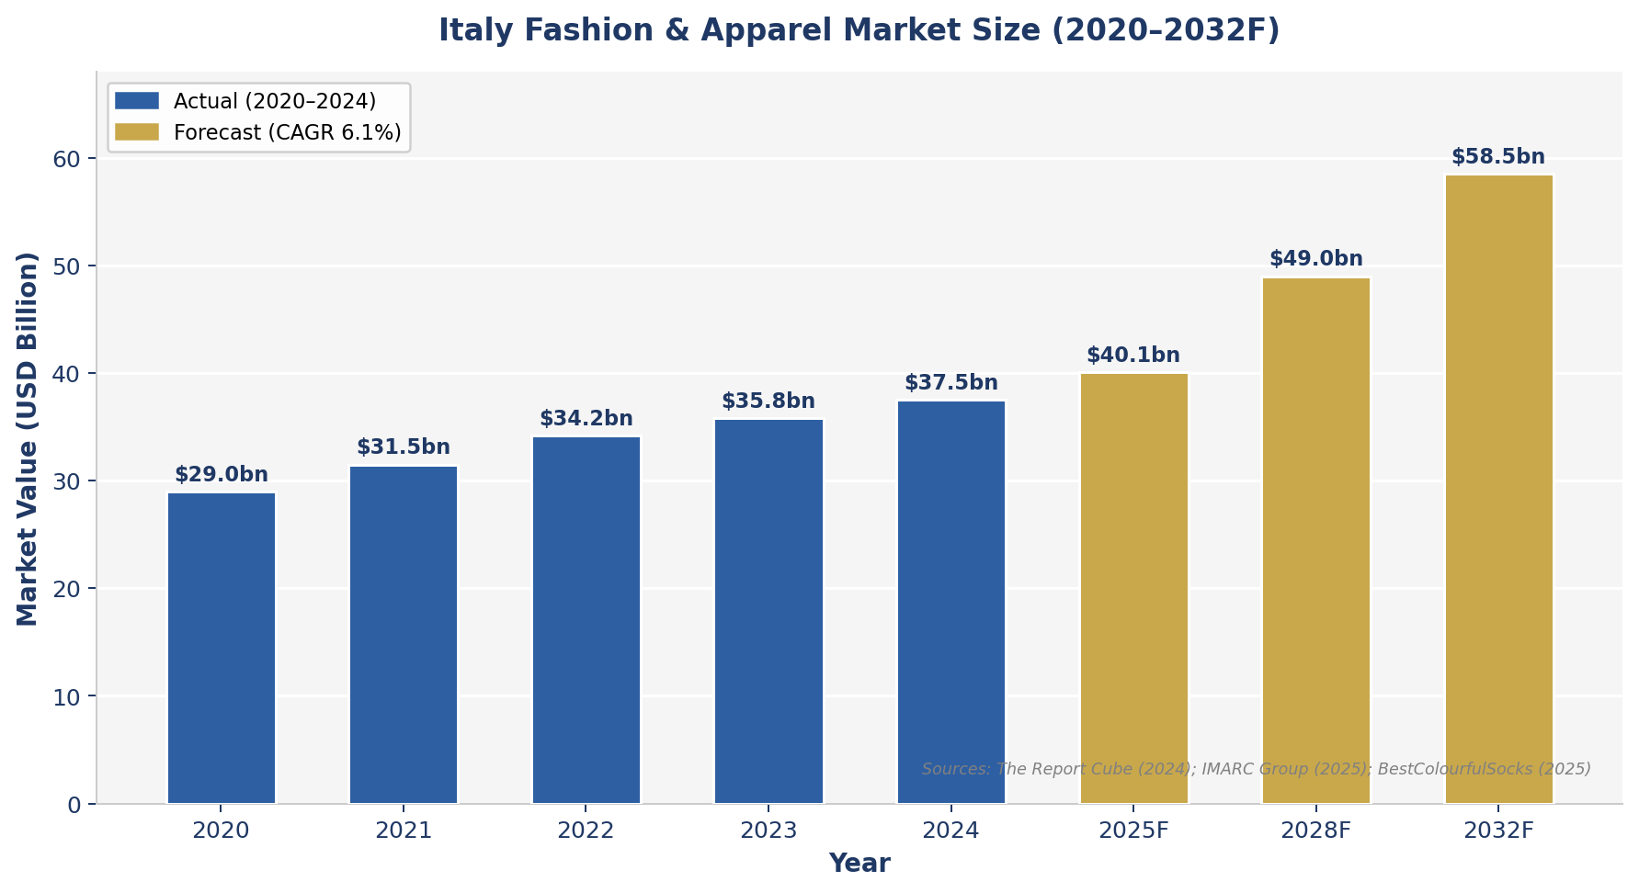
Figure 2: Italy Fashion & Apparel Market Value 2020–2032F | Sources: The Report Cube (2024); IMARC Group (2025); BestColourfulSocks (2025)

2.2 Key Players: Market Positioning and Strategic Comparison
The market structure is bifurcated as shown in the competitive environment. The prestige level is controlled by domestic luxury players with their heritage stories, exclusivity and Italian manufacturing (Chevalier and Mazzalova, 2012). A comparative analysis of the top domestic and international companies is presented in Table 1 and it shows the differences in market segment, strategic focus and performance.
Table 1: Comparative Analysis of Key Firms in the Italian Fashion Industry (2024)
Company | Origin | Segment | Core Strategy | Key Performance (2024)
Gucci (Kering) | Italy (FR parent) | Ultra-Luxury | Heritage craft, Gen Z via BTS ambassador Jin; digital transformation | Kering revenue €17.6bn; Gucci key brand; +17% H1 2024
Prada Group | Italy | Luxury | Digital retail; acquired Versace USD 1.375bn (April 2025) | Net revenues €2.55bn; +17% H1 2024
Armani Group | Italy | Luxury–Premium | Multi-line portfolio (GA, Emporio, Exchange); vertically integrated | Revenue ~€2.4bn; sustained Asian market growth
Zara (Inditex) | Spain | Fast-Premium | Rapid trend replication; Zara Studio premium expansion | Inditex USD 25.5bn (2025); gaining H&M share in Italy
H&M Group | Sweden | Fast Fashion | Value-for-money, sustainability pivot, omni-channel, multi-brand | SEK 236bn revenue; 7.4% operating margin; Italy share declining
SHEIN | China | Ultra-Fast Fashion | Algorithm-driven micro-trends, ultra-low price, direct D2C digital | ~20% European fast-fashion spend captured since 2019
Sources: H&M Group Annual Report (2025); Kering Annual Report (2024); IMARC Group (2025); Consumer Edge (2024); GlobalGrowthInsights (2025)

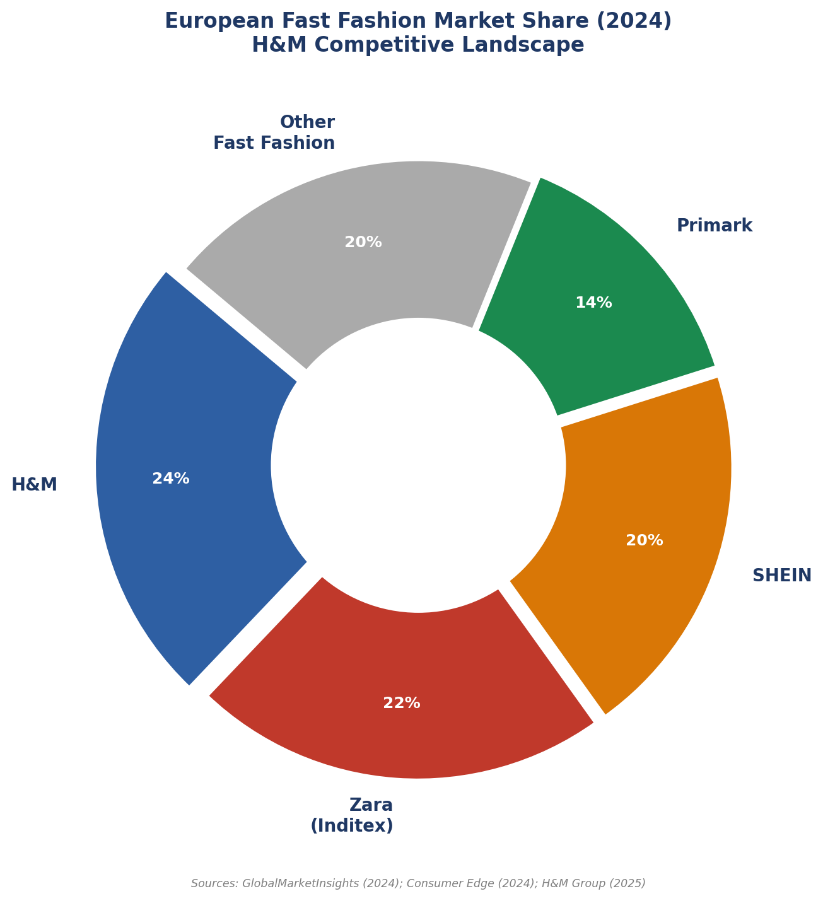
Figure 3: European Fast Fashion Market Share (2024) | Sources: GlobalMarketInsights (2024); Consumer Edge (2024)

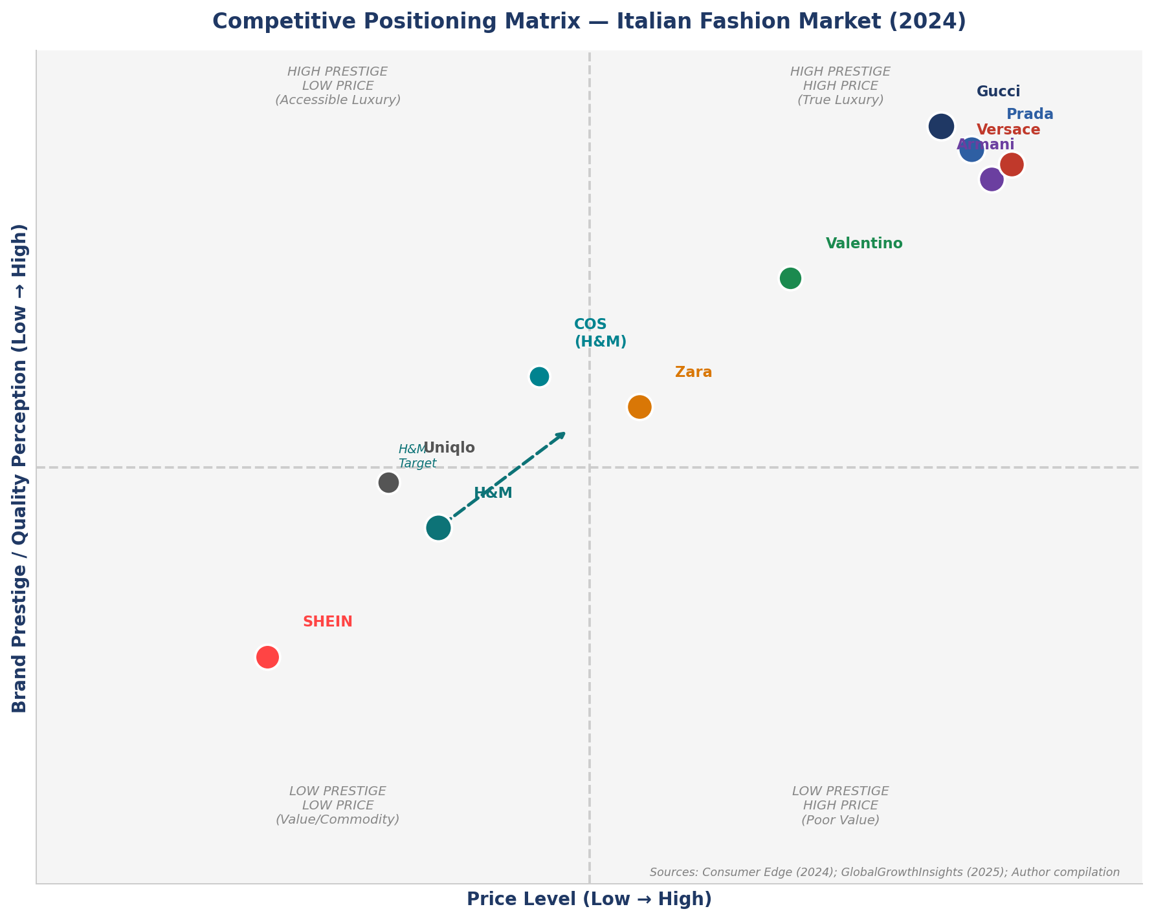
Figure 4: Competitive Positioning Matrix — Italian Fashion Market (2024) | Sources: Consumer Edge (2024); Author compilation

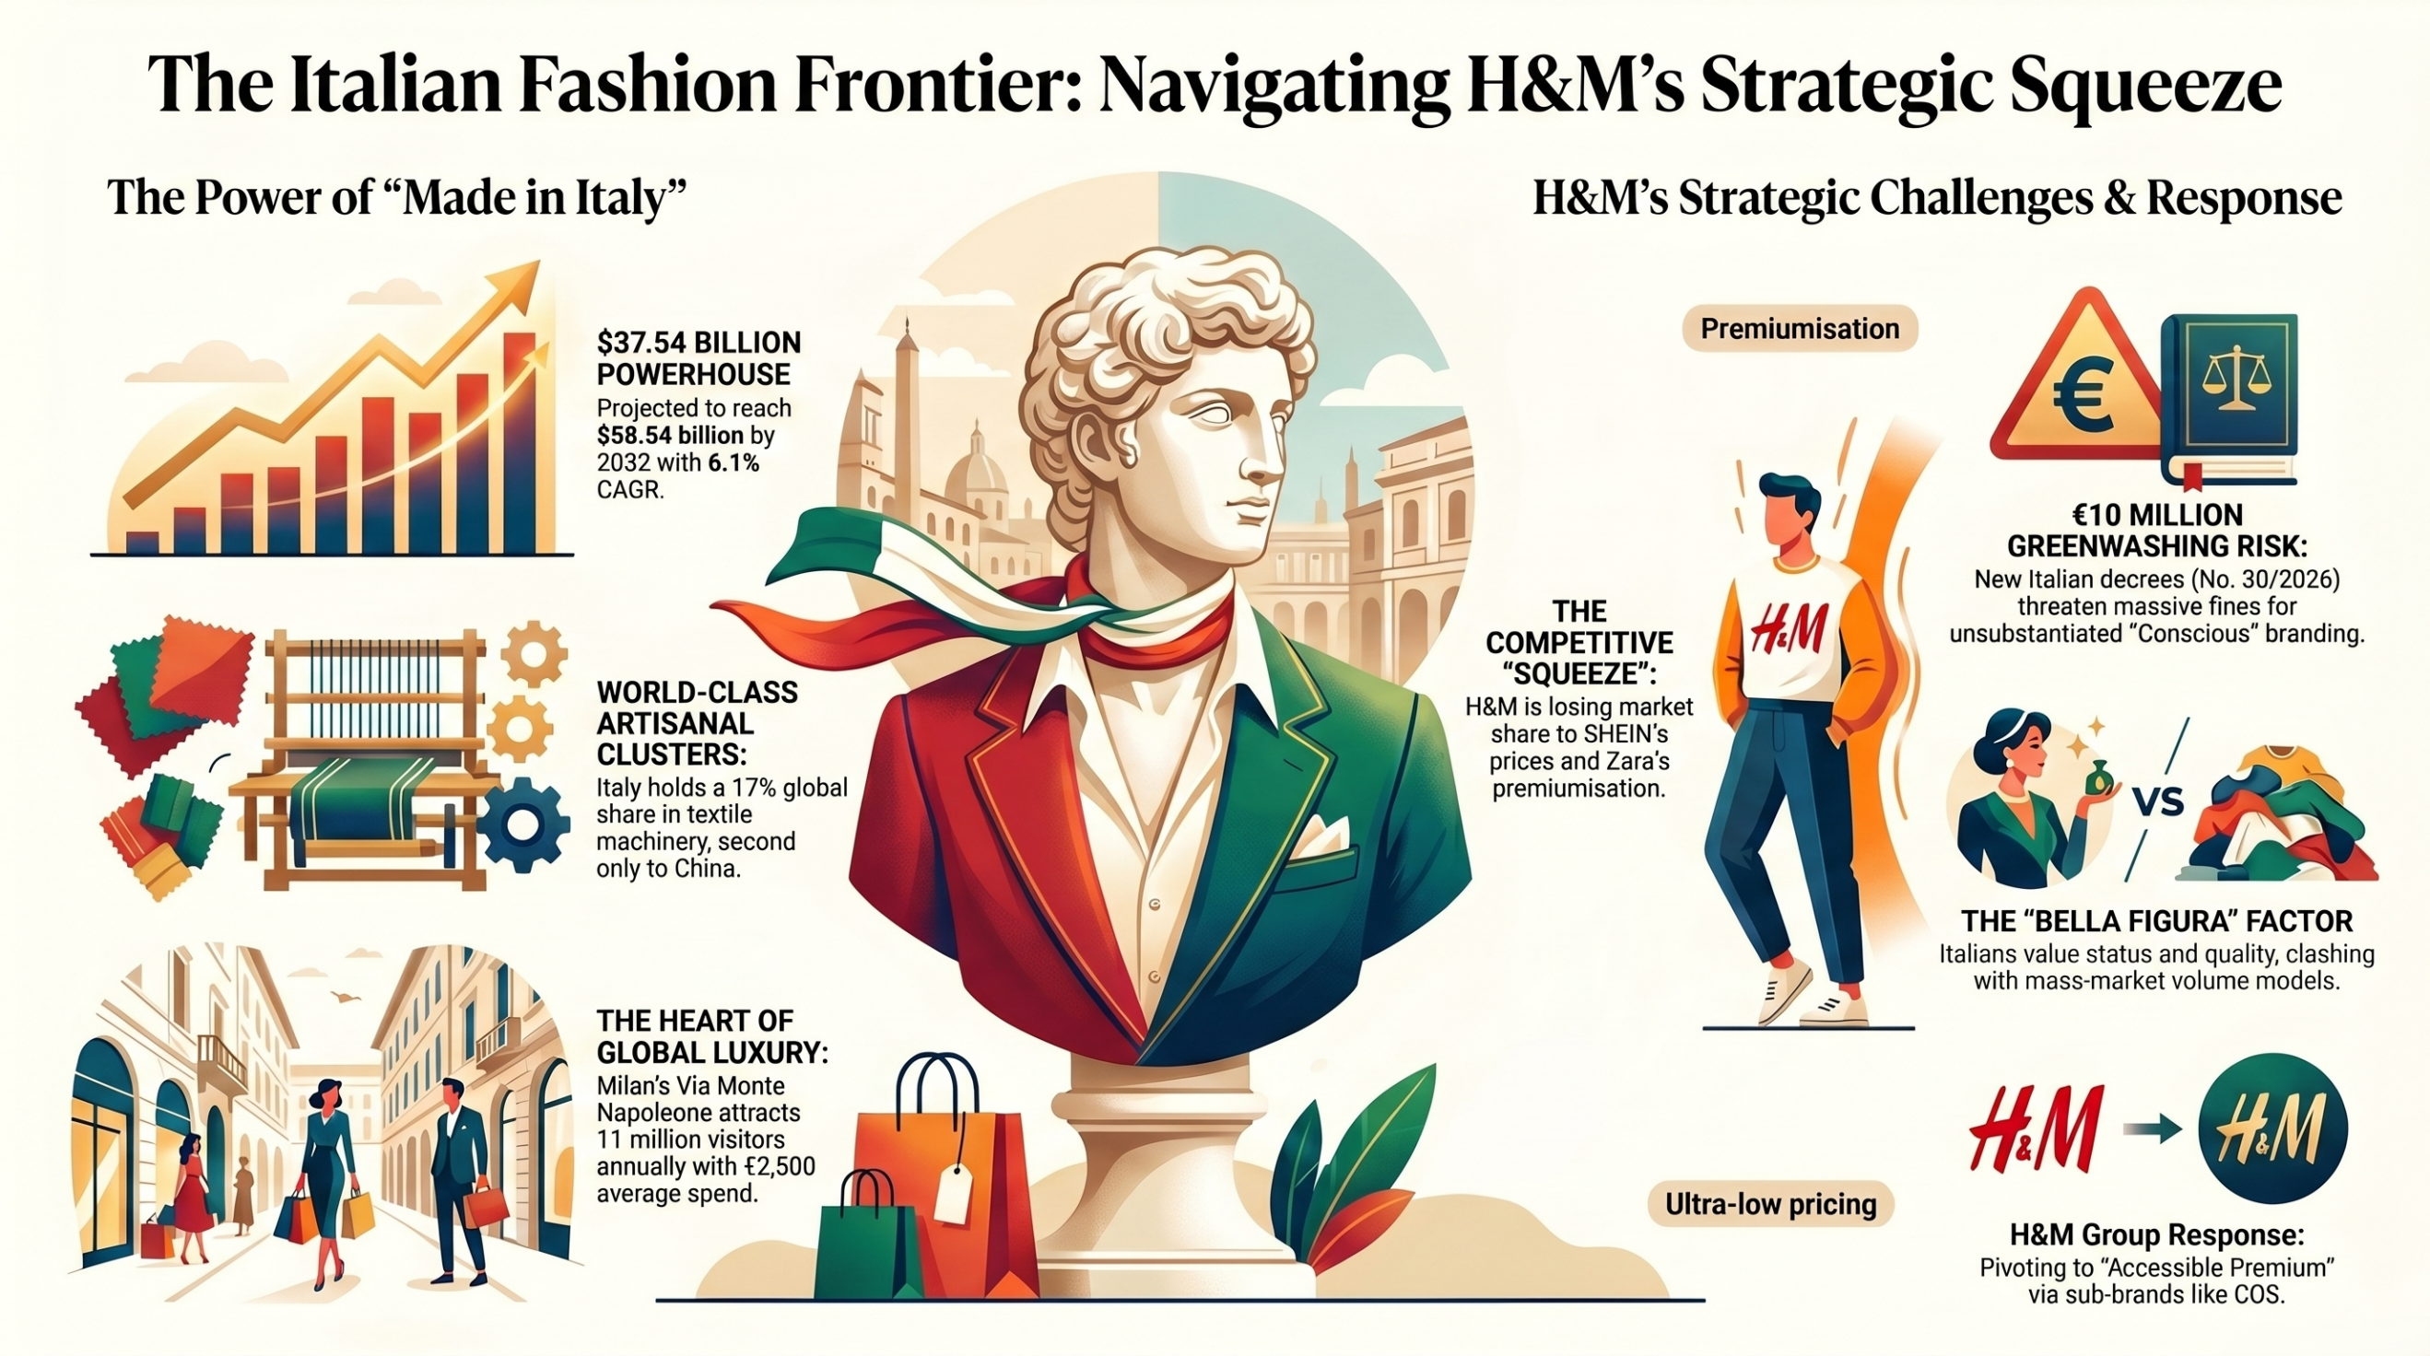
As Figure 4 shows visually, the strategic squeeze of H&M is indeed real: being in the middle of the market segmentation fast-fashion and priced in the middle, the brand is threatened by SHEIN at the bottom of the price axis and Zara with its premiumisation at the top. The strategic opportunity that H&M has, as shown by the dotted arrow, is to shift towards an available higher end positioning via sub-brands like COS and Arket, which makes sense in the VRIN model of sustainable competitive advantage presented by Barney (1991).
The Italian Fashion Strategic Frontier

3. Porter's Diamond Model: Global Competitiveness of Italy's Fashion Industry
The Diamond Model of National Advantage (Porter, 1990) gives an overall organizational approach to the assessment of the reasons why certain countries have a competitive advantage in certain sectors. The model recognizes four interdependent determinants namely, factor conditions, demand conditions, related and supporting industries, and firm strategy, structure and rivalry that are mediated by government and chance events.
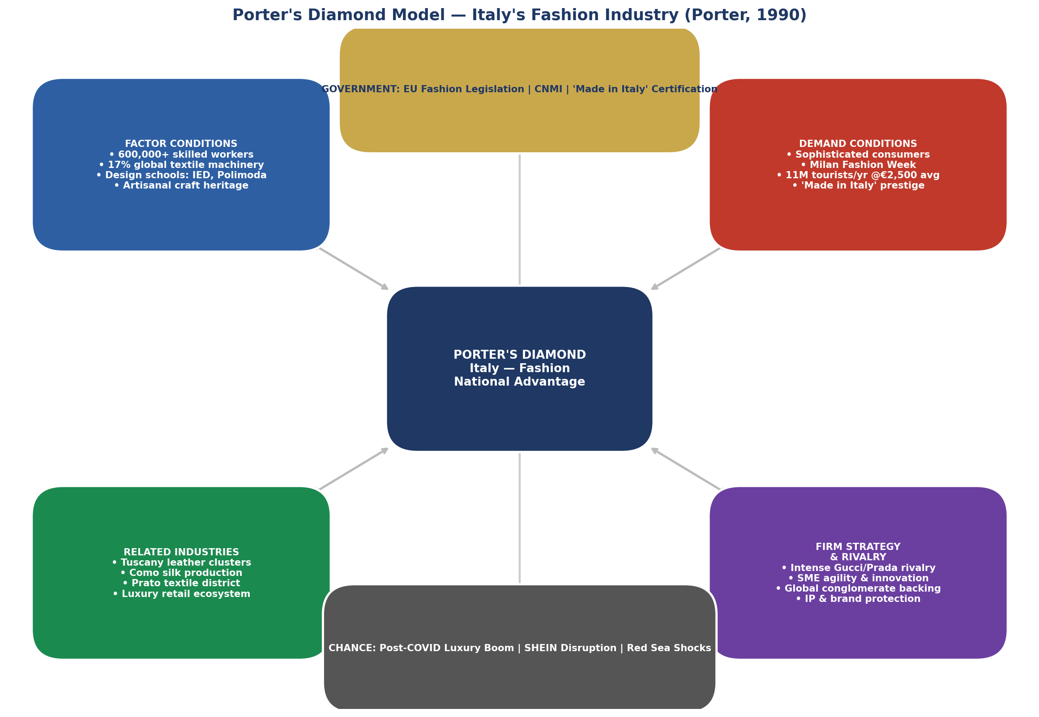
Figure 5: Porter's Diamond Model — Italy's Fashion Industry Mind Map | Adapted from Porter (1990) — Author compilation (2025)

3.1 Factor Conditions

The competitive advantage of Italy has its roots in the extraordinary factor conditions. The country has an unmatched pool of talented artisan labour- a unique fusion of traditional handicraft skills and institutional training in internationally-recognised centres of design like the Instituto Europeo di Design (IED), Polimoda Florence and Istituto Marangoni Milan. This type of specialised inputs forms the Porters (1990) 'advanced factors'-highly skilled human capital that is hard to be duplicated by other countries. Italy also ranks second in the world (after China) in the production of textile finishing machinery with a global market share of 17% (Expert Market Research, 2024). Enright (2003) confirms that the main source of sustained international competitiveness lies in the existence of geographical concentrations of specialised resources in cluster settings, which can equally be applied to the fashion districts in Italy of Prato, Biella and Carpi.

3.2 Demand Conditions

Italy also enjoys very advanced domestic demand which according to Porter (1990) makes firms to invent every time. The Italian consumers are more sensitive to quality, beauty, provenance, and material integrity, the attributes that have traditionally pushed producers to the high-end positioning (Hirschman, 1982). One of the 'Big Four', Milan Fashion Week, has massive upstream influence on design, production and marketing standards. The demand sophistication added by the influx of 11 million fashion tourists annually (average spending per visitor of Via Monte Napoleone alone was 2,500 euro in 2025, IMARC Group, 2025), further intensifies demand sophistication, making local competitive pressures on the international scale.

3.3 Related and Supporting Industries

The industry cluster system in Italy, which includes the entire range of textile raw materials, such as Como silk to Florentine leather, is one of the most vertically integrated fashion systems worldwide (Becattini, 2002). According to Porter (1990), when a nation has a network of related industries, then competitive advantage is reinforced. The Italian fashion industry also enjoys the presence of the finest tanneries in Tuscany, button and zipper makers in the Veneto and synthetic textile innovators in Prato. The institutional coordination is offered by the Camera Nazionale della Moda Italiana (CNMI), where the interests of the industry are lobbied, and sustainability standards are spread. According to Porter (1998) in his cluster theory, geographic concentration produces so-called spillovers, i.e. common knowledge, infrastructure, and pools of labour that enhance systemic competitiveness which could not have been created by individual firms.

3.4 Firm Strategy, Structure, and Rivalry

A disproportionately large number of small, family-owned firms are a defining feature of the fashion industry, as Porter (1990) notes in relation to Italy in particular: a structural form that is conducive to agility and entrepreneurial responsiveness, which is essential in a commercial landscape where speed-to-trend is the measure of business success (Mindtools, 2024). Vigorous competition among Gucci, Prada, Valentino, Fendi and Dolce & Gabbana within the country has created endless design competition. The 2025 April purchase of Versace by Prada at USD 1.375 billion is just the continuation of consolidation to achieve scale against the international competition (IMARC Group, 2025). Rugman and D'Cruz (1993) criticize Porter concerning his under-emphasis on the importance of inter-firm networking, whereas Italy has a rich web of industrial districts (distretti industriali) which is a perfect example of how relational networks create systemic competitive advantage.

3.5 Government and Chance
The Italian government, via Confindustria Moda and the mechanisms of the EU level have been supporting the fashion industry regularly through the certification of Made in Italy as well as through export promotion and protecting intellectual property. This changing legislative framework of the EU (Ecodesign Regulation 2024; Green Claims Directive 2024) is both a challenge (it needs compliance investment), and an opportunity to the Italian luxury brands to differentiate around verified sustainability credentialing (European Parliament, 2025). Market dynamics have been redefined due to chance events such as the 2021-2023 post-COVID luxury rebound and the post-2023 slowdown due to the so-called luxury shame in China, and the introduction of SHEIN as a digital-native disruptor has reorganized the competitive landscape of fast-fashion (NSS Magazine, 2024).

4. Critical Evaluation of H&M's Operations in Italy
Founded in 1947 in Sweden, Hennes & Mauritz (H&M) has expanded to be among the largest retailers of fast-fashion in the world with operations across more than 75 markets and a net sale of SEK 236 billion in FY2024 (H&M Group, 2025). This part will critically analyse the forces influencing the operational success of H&M in Italy in terms of the PESTEL Analysis coupled with Hofstede Cultural Dimensions with an add on of Dunning (1993) OLI Eclectic Paradigm and the Uppsala Internationalisation Model (Johanson and Vahlne, 1977).
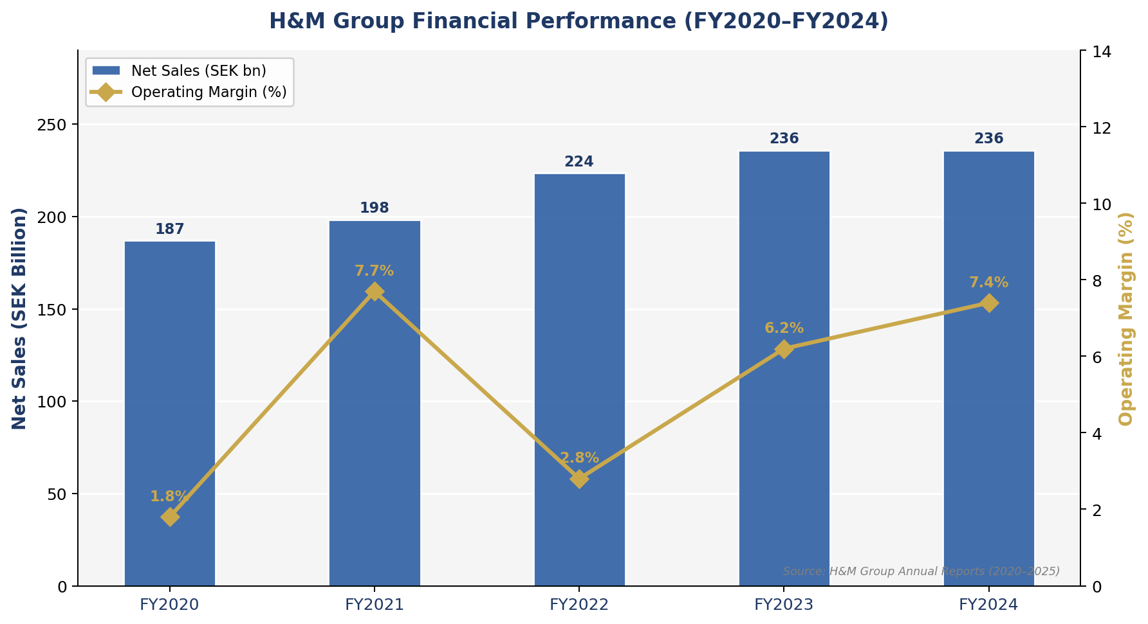
Figure 6: H&M Group Financial Performance (FY2020–FY2024) | Source: H&M Group Annual Reports (2020–2025)

Figure 6 shows the recovery path of H&M after the COVID, when the operating margin has increased to 7.4% (FY2024) as compared to 1.8% (FY2020). Italy, France, UK, and Germany, however, have their market share decline hidden at the group level, as Consumer Edge (2024) confirms, a phenomenon that underscores the strategic urgency of market-specific repositioning.
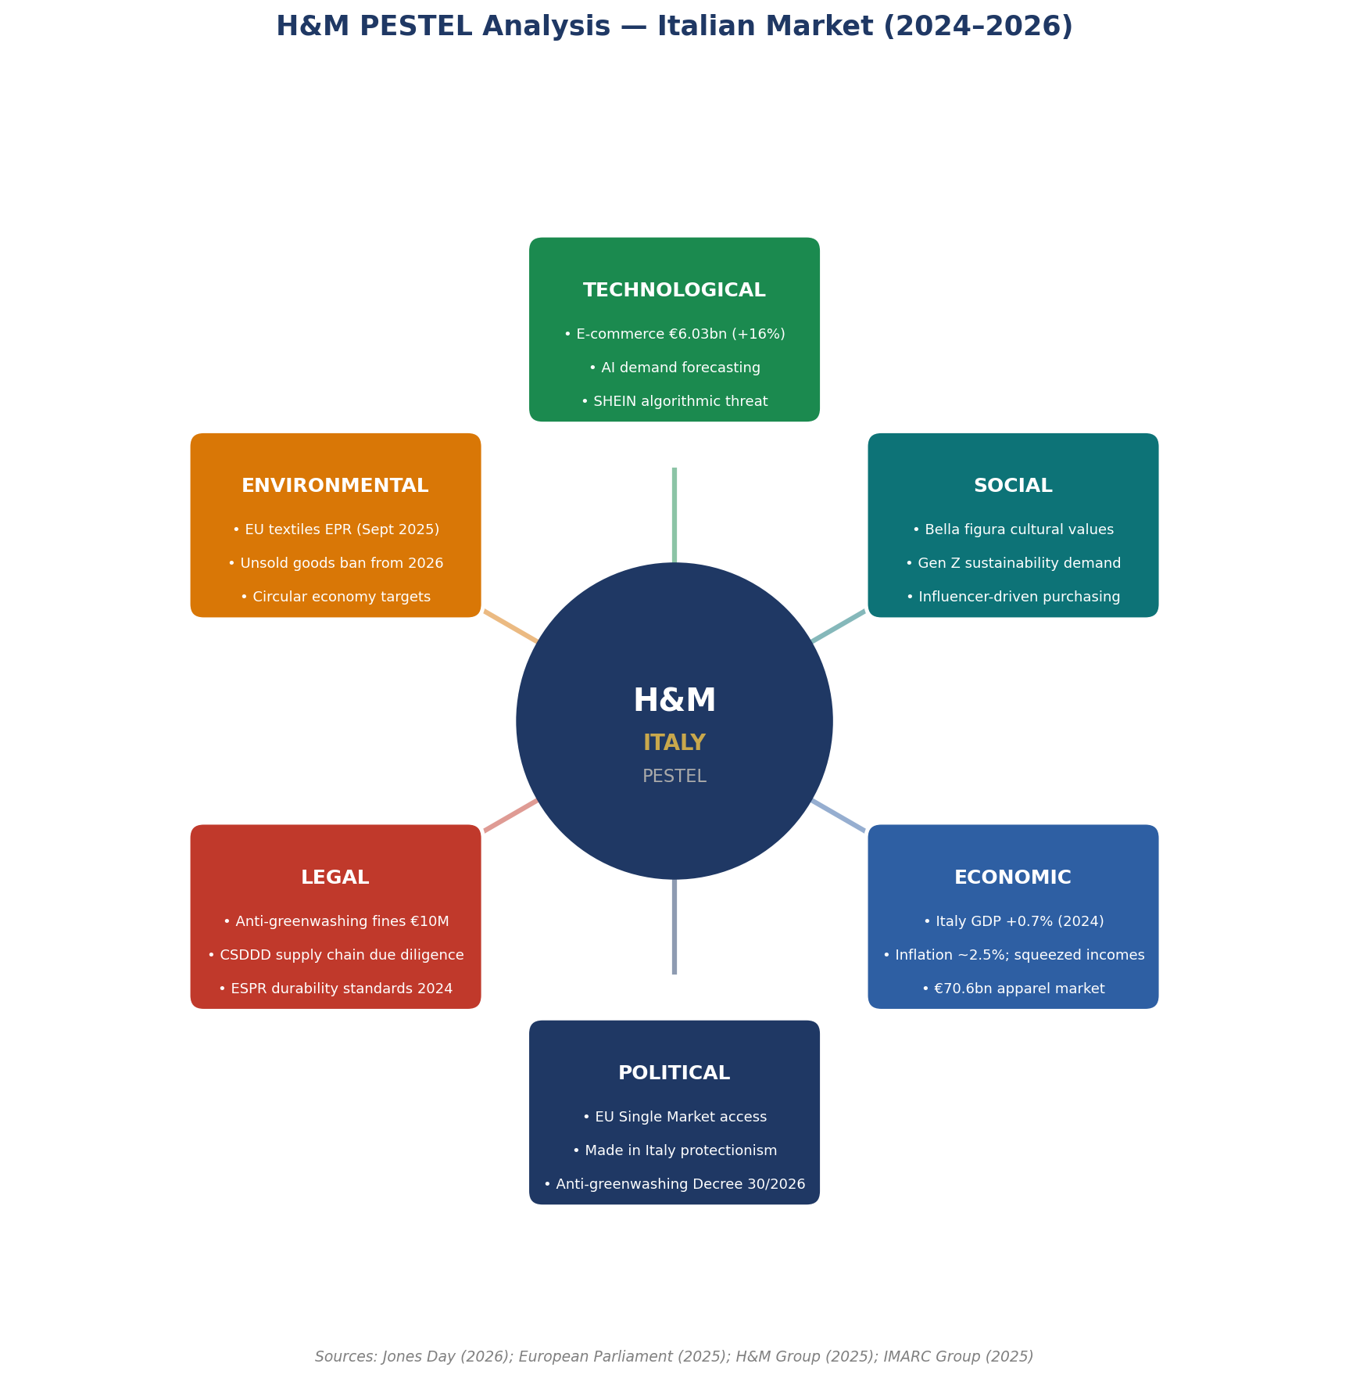
Figure 7: H&M PESTEL Analysis Wheel — Italian Market (2024–2026) | Sources: Jones Day (2026); European Parliament (2025); H&M Group (2025); IMARC Group (2025)

Table 2: H&M PESTEL Analysis — Italian Market Context (2024–2026)
Factor | Key Issues and Implications for H&M in Italy
Political | EU single market enables tariff-free goods movement; however, Italy's Legislative Decree No. 30/2026 (anti-greenwashing) creates potential legal exposure for H&M's sustainability marketing claims. Italy's political emphasis on 'Made in Italy' protectionism creates soft cultural barriers for foreign fast-fashion brands (NSS Magazine, 2024).
Economic | Italy GDP growth 0.7% (Eurostat, 2024); CPI ~2.5% compressing disposable incomes. H&M FY2024 gross margin improved to 55% via near-shoring; Eurozone eliminates currency risk. Italy's €70.6bn apparel market (2025) provides substantial growth opportunity (IMARC Group, 2025).
Social | Italian bella figura culture drives strong fashion consciousness but deep loyalty to domestic labels. Gen Z preference for 'slow fashion' creates paradoxical opportunities and threats. H&M's 2024 Milan Autumn collection launch integrating music and culture was well received (H&M Group, 2025), signalling successful cultural localisation.
Technological | Italian e-commerce fashion revenues of €6.03bn in 2024 (+16% YoY) present significant digital growth opportunity. H&M's omni-channel investment—AI-driven demand forecasting, personalised digital platforms—aligns with Italy's digitalising consumer base. SHEIN's algorithmically responsive model represents a direct technological threat (H&M Group, 2025).
Environmental | EU mandatory textile collection operative since January 2025; destruction of unsold clothes banned from 2026 (European Parliament, 2025). H&M's 'Garment Collecting' scheme provides partial compliance; however, critics argue fast fashion is structurally incompatible with circular economy targets (Niinimäki et al., 2020).
Legal | Italy's Legislative Decree No. 30/2026 (transposing EU Directive 2024/825) entered into force 24 March 2026; full applicability September 2026. Prohibits generic environmental claims — threatening H&M's 'Conscious' branding without third-party verification. AGCM fines up to €10 million (Jones Day, 2026). CSDDD (2024) mandates supply chain labour due diligence.
Sources: H&M Group Annual Report (2025); Jones Day (2026); European Parliament (2025); IMARC Group (2025); Eurostat (2024)

4.1 Political Environment

H&M enjoys a stable Eurozone political environment, with access to a single market and harmonised trade laws, which remove tariffs intra-EU (Hill and Hult, 2019). Nevertheless, the political climate is becoming more marked by regulatory activism in the field of fashion sustainability. The Legislative Decree No. 30/2026 (transposing EU Directive 2024/825) in Italy sets forth significant requirements on fashion companies that claim to be environmentally friendly (Jones Day, 2026). In the case of H&M, where the brand repositioning focus has been its Conscious line of products, any generic statement that cannot be substantiated by independent certification can result in enforcement and up to 10 million fines by the AGCM (Jones Day, 2026). The Italian political focus on the Made in Italy protectionism makes foreign fast-fashion brands culturally antagonistic to national fashion traditions (NSS Magazine, 2024) and presents a non-tariff competitive disadvantage to H&M.

4.2 Economic Environment

H&M value proposition is faced with a complicated macroeconomic situation in Italy. Eurostat (2024) forecasts Italian GDP growth of 0.7 percent in 2024 (compared to the EU average) and inflationary pressures (CPI of approximately 2.5) have reduced household disposable income, thus H&M core demographic price sensitive. Ironically, this environment may increase the demand of the affordable fashion and, concurrently, cede the most cost-conscious segment to the lowest-cost of SHEIN. The financial results of H&M are quite robust at the group level: net sales of SEK 236 billion (FY2024) and an operating margin of 7.4 percent (H&M Group, 2025). According to Dunning (1993), the eclectic paradigm suggests that the advantages of internalisation, such as interconnected supply chain or international-buying power of H&M, must be re-evaluated continuously concerning the local competitive forces. Shipment problems, such as the Red Sea, led to higher logistics costs in 2024 and near-shoring to Turkey and Southern Europe partially alleviated exposure (H&M Group, 2025).

4.3 Legal Environment

The EU regulations substantively influence the legal environment of Italy. The EU Ecodesign Regulation on Sustainable Products (ESPR, 2024) sets minimum requirements of product durability, reuse, and recyclability- difficult to H&M with its long-established high-volume, short-lives business. Since 2026, big businesses will not be able to dispose of unsold clothes (European Parliament, 2025). The Italian anti-greenwashing law (Legislative Decree No. 30/2026) explicitly poses a threat to H&M, the Spanish clothing retailer, with its sustainability marketing under the banner of Conscious, unless supported by certified third parties (Jones Day, 2026; Hogan Lovells, 2025). The Milan Public Prosecutor Office of Italy has been unstoppable in exploring fashion supply chains to find instances of labour exploitation (Chambers and Partners, 2025), establishing further compliance requirements in the CSDDD (2024). Legal compliance in the foreign market, according to Hill (2021), is not only an expense but a strategic asset of operationally mature MNCs.

4.4 Cultural Factors: Hofstede's Cultural Dimensions Analysis
One of the key factors that dictate the success of retail MNCs in foreign markets is cultural fit (Hofstede, Hofstede and Minkov, 2010; De Mooij and Hofstede, 2002). Figure 8 compares the Hofstede dimensions of Italy with Sweden (the homeland market of H&M) in the form of a radar chart, which indicates that the cultural distance is indeed high and H&M needs to take the initiative to reduce it through its localisation strategy.
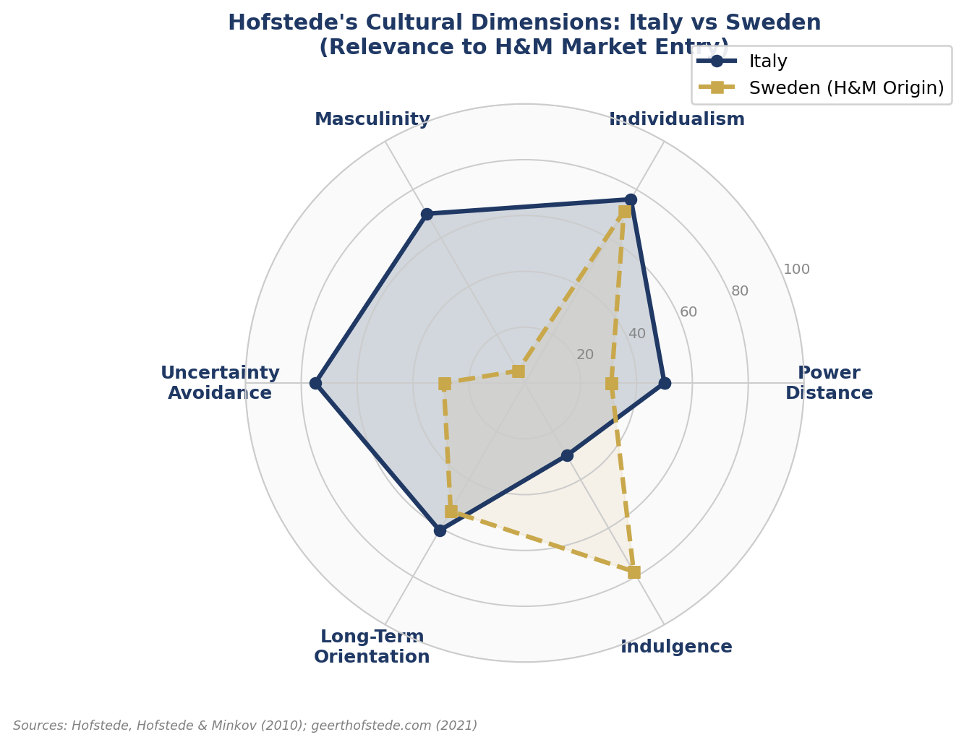
Figure 8: Hofstede Cultural Dimensions Radar — Italy vs Sweden (H&M Home Market) | Sources: Hofstede et al. (2010); geerthofstede.com (2021)

Table 3: Hofstede's Cultural Dimensions — Italy Scores and H&M Strategic Implications
Dimension | Score | Strategic Implications for H&M in Italy
Power Distance (PDI) | 50 | Moderate PDI: Italians respect established brand hierarchies but are not rigidly deferential. H&M must position as a credible, aspirational brand — not merely a commodity.
Individualism (IDV) | 76 | High individualism: Italian consumers prioritise personal expression through fashion (Academia.edu, 2020). Fast fashion's 'new every week' proposition aligns — provided products enable genuine self-distinction, not mass uniformity.
Masculinity (MAS) | 70 | High masculinity: Italians value success, aesthetics, and material achievement — the bella figura imperative. H&M's value-fashion model must communicate aesthetic quality and status, not just affordability (Hofstede et al., 2010).
Uncertainty Avoidance (UAI) | 75 | High UAI: Italian consumers prefer trusted brands and reliable quality (EuroppConsulting, 2020). H&M's frequent collection rotations may generate uncertainty. Brand trust via consistent quality and clear sustainability communication is essential.
Long-Term Orientation (LTO) | 61 | Moderate-high LTO: Italian consumers value quality, durability, and heritage — not just trend novelty. H&M's durability investment via ESPR compliance aligns culturally and creates genuine reputational differentiation from SHEIN.
Sources: Hofstede, Hofstede & Minkov (2010); geerthofstede.com (2021); De Mooij & Hofstede (2002); Academia.edu (2020)

The radar chart (Figure 8) shows that there is underlying cultural conflict in the very core of H&M Italian positioning: Italian customers are at once individualistic (self-expression), aesthetically orientated (high masculinity: MAS 70), and risk-averse (UAI 75): in contrast, Sweden has high indulgence (78) and low uncertainty avoidance (29). This blend makes H&M require convincing design at affordable prices and communicating unequivocal quality qualifications and genuine sustainability promises a difficult three-way posturing. According to the Uppsala model by Johanson and Vahlnes (1977), the cumulative experience of the Italian market minimises the psychic distance, allowing more advanced local adaptation, as long as the firm commits itself to acquire knowledge of the local culture, and not on standardised global models (Ghemawat, 2001).

4.5 Strategic Framework Integration: OLI and Uppsala Models

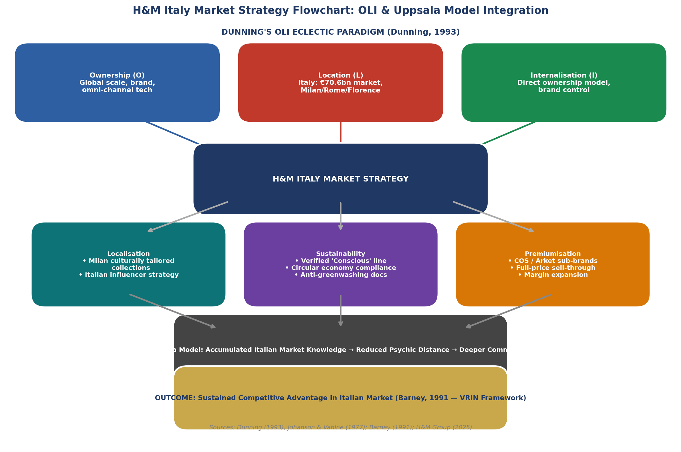
Figure 9: H&M Italy Market Strategy Flowchart — OLI & Uppsala Model Integration | Sources: Dunning (1993); Johanson & Vahlne (1977); Barney (1991); H&M Group (2025)

Integration of the PESTEL and cultural analysis based on the OLI eclectic paradigm by Dunning (1993) gives an overall market attractiveness analysis. The benefits of Ownership (O) are that H&M is a global company, has built supply chains, has a brand, and has omni-channel technological capacity, which is facing more and more competition due to the algorithmically better product selection offered by SHEIN. The H&M Location strengths (L) in Italy include the high, high-income consumer market (USD 70.6bn apparel market), increasing e-commerce penetration (3035% of fashion revenues) and strategic retail location in Milan, Rome and Florence. Its Internalisation benefits (I) are based on the integrated ownership concept of H&M, which enables brand standards, pricing discipline, and localisation agility of Italian stores. The strategy flowchart (Figure 9) shows how these OLI advantages can be converted into three strategic pillars, namely localisation, verified sustainability, and premiumisation, which are based on the Uppsala model of accumulated market knowledge that reduces psychic distance, ultimately leading to a competitive advantage based on VRIN (Barney, 1991).
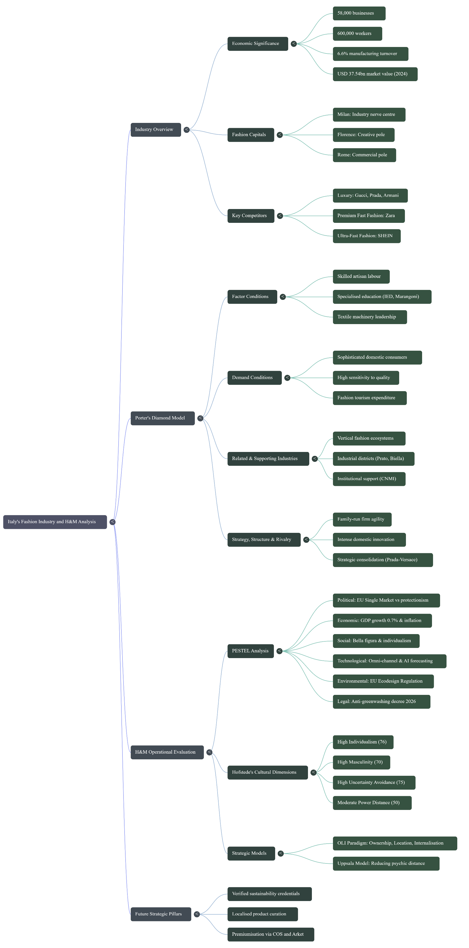
Mind map: Italian Fashion Dynamics and H&M Strategic Analysis

5. Conclusion
This report has critically analyzed the fashion industry in Italy and the dynamics that H&M as a large foreign MNC must deal with. The utilization of the Porters Diamond Model illustrates that the global competitive advantage of Italy in fashion is deep-rooted and structurally strong: it is based on the conditions of world-leading artisans, high-end domestic demand, a unique set of related industries, and a high level of rivalry that constantly promotes innovation. These strengths keep the Italian luxury players (Gucci, Prada, Armani) on top of the world, and at the same time, provide an intensely competitive environment to global fast-fashion players.
As the PESTEL analysis shows, the regulatory environment in Italy, including the anti-greenwashing framework (Legislative Decree No. 30/2026), and the EU legislation on the circular economy, is increasingly challenging to H&M, directly affecting its sustainability marketing and inventory practices. The Hofstede cultural dimensions analysis, which was visualised in the form of the radar chart (Figure 8) shows that the mass-market, standardised model adopted by H&M slightly fails to fit the Italian consumers in terms of individualism, aesthetic ambition (bella figura), and risk-aversion, and requires more complex cultural localisation. The strategic squeeze between SHEIN below and Zara above is verified by the competitive positioning matrix (Figure 4).
In the future, H&M can succeed in Italy based on: (1) meaningfully differentiated, externally validated sustainability and (2) greater localised product curation, responsive to Italian aesthetic values; and (3) capitalising on its premium sub-brand portfolio (COS, Arket) to recover margin-accretive consumers. The Italian market, its USD 70.6bn apparel scale, and 6.03bn e-commerce revenues present a big opportunity, but to win it, the company will need a fundamental shift in its operations where volume-based fast fashion gives place to a curated, culturally embedded, and sustainability-credible proposition.

References
- Barney, J. (1991) Firm resources and sustained competitive advantage. Journal of Management, 17(1), pp. 99–120.
- Becattini, G. (2002) From Marshall to the Italian industrial districts. In Curzio, A.Q. and Fortis, M. (eds) Complexity and Industrial Clusters. Heidelberg: Physica-Verlag, pp. 83–106.
- BestColourfulSocks (2025) Italy Fashion Market Statistics 2025. Available at: https://bestcolorfulsocks.com (Accessed: 10 April 2025).
- Bhardwaj, V. and Fairhurst, A. (2010) Fast fashion: Response to changes in the fashion industry. The International Review of Retail, Distribution and Consumer Research, 20(1), pp. 165–173.
- Camera Nazionale della Moda Italiana (2022) Fashion Economic Trends Report. Milan: CNMI.
- Chambers and Partners (2025) ESG 2025 – Italy. Available at: https://practiceguides.chambers.com (Accessed: 10 April 2025).
- Chevalier, M. and Mazzalovo, G. (2012) Luxury Brand Management: A World of Privilege. 2nd edn. Singapore: Wiley.
- Confindustria Moda (2023) The Italian Fashion Industry: Key Economic Data. Rome: Confindustria Moda.
- Consumer Edge (2024) H&M Faces Mounting Challenges in Europe. Available at: https://www.consumeredge.com (Accessed: 8 April 2025).
- De Mooij, M. and Hofstede, G. (2002) Convergence and divergence in consumer behavior: Implications for international retailing. Journal of Retailing, 78(1), pp. 61–69.
- Dunning, J.H. (1993) Multinational Enterprises and the Global Economy. Wokingham: Addison-Wesley.
- Enright, M.J. (2003) Regional clusters: What we know and what we should know. In Bröcker, J., Dohse, D. and Soltwedel, R. (eds) Innovation Clusters and Interregional Competition. Berlin: Springer, pp. 99–129.
- Eurostat (2024) GDP and Main Aggregates — Italy 2024. Luxembourg: Eurostat.
- European Parliament (2025) Fast Fashion: EU Laws for Sustainable Textile Consumption. Available at: https://www.europarl.europa.eu (Accessed: 9 April 2025).
- Expert Market Research (2024) Italy Textile Market Report 2024–2034. Available at: https://www.expertmarketresearch.com (Accessed: 7 April 2025).
- Ghemawat, P. (2001) Distance still matters: The hard reality of global expansion. Harvard Business Review, 79(8), pp. 137–147.
- GlobalGrowthInsights (2025) Top 13 Luxury Fashion Companies 2025. Available at: https://www.globalgrowthinsights.com (Accessed: 10 April 2025).
- H&M Group (2025) Full-Year Report FY2024 (December 2023–November 2024). Stockholm: Hennes & Mauritz AB.
- Hill, C.W.L. (2021) International Business: Competing in the Global Marketplace. 13th edn. New York: McGraw-Hill.
- Hill, C.W.L. and Hult, G.T.M. (2019) Global Business Today. 11th edn. New York: McGraw-Hill.
- Hirschman, E.C. (1982) Ethnic variation in hedonic consumption. Journal of Social Psychology, 118(2), pp. 225–234.
- Hofstede, G., Hofstede, G.J. and Minkov, M. (2010) Cultures and Organizations: Software of the Mind. 3rd edn. New York: McGraw-Hill.
- Hogan Lovells (2025) Greenwashing: Italy Aligns with the EU Legal Framework. Available at: https://www.hoganlovells.com (Accessed: 10 April 2025).
- IMARC Group (2025) Italy Apparel Market Size, Share & Growth Forecast 2034. Available at: https://www.imarcgroup.com (Accessed: 7 April 2025).
- Johanson, J. and Vahlne, J.E. (1977) The internationalization process of the firm. Journal of International Business Studies, 8(1), pp. 23–32.
- Jones Day (2026) Italy Targets Greenwashing and Social Washing with Landmark New Rules. Available at: https://www.jonesday.com (Accessed: 15 April 2025).
- Kering Group (2024) Annual Report 2024. Paris: Kering.
- Luo, Y. and Tung, R.L. (2007) International expansion of emerging market enterprises: A springboard perspective. Journal of International Business Studies, 38(4), pp. 481–498.
- Market Research Future (2024) Italy Luxury Fashion Market 2024–2035. Available at: https://www.marketresearchfuture.com (Accessed: 9 April 2025).
- Mindtools (2024) Porter's Diamond Model. Available at: https://www.mindtools.com (Accessed: 10 April 2025).
- Niinimäki, K., Peters, G., Dahlbo, H., Perry, P., Rissanen, T. and Gwilt, A. (2020) The environmental price of fast fashion. Nature Reviews Earth & Environment, 1(4), pp. 189–200.
- NSS Magazine (2024) 2024 and the Made in Italy Crisis: CNMI's New Legislative Proposal. Available at: https://www.nssmag.com (Accessed: 8 April 2025).
- Porter, M.E. (1990) The Competitive Advantage of Nations. New York: Free Press.
- Porter, M.E. (1998) Clusters and the new economics of competition. Harvard Business Review, 76(6), pp. 77–90.
- Rugman, A.M. and D'Cruz, J.R. (1993) The double diamond model of international competitiveness. Management International Review, 33(2), pp. 17–39.
- The Report Cube (2024) Italy Fashion & Apparel Market Analysis 2025–2032. Available at: https://www.thereportcubes.com (Accessed: 7 April 2025).
- Verbeke, A. (2013) International Business Strategy: Rethinking the Foundations of Global Corporate Success. 2nd edn. Cambridge: Cambridge University Press.
- Welch, L.S. and Luostarinen, R. (1988) Internationalization: Evolution of a concept. Journal of General Management, 14(2), pp. 34–55.
- Yip, G.S. (1995) Total Global Strategy. Englewood Cliffs, NJ: Prentice-Hall.
- Zara / Inditex (2025) Annual Report 2024. A Coruña: Inditex.

Section 2: Reflective Account — Gibbs' Reflective Cycle (Gibbs, 1988)

This section will be a systematic reflection about the research, analysis and writing process that underpins Section 1, based on a proven model of experiential learning, Gibbs (1988) Reflective Cycle, which follows the following format: Description, Feelings, Evaluation, Analysis, Conclusion and Action Plan.
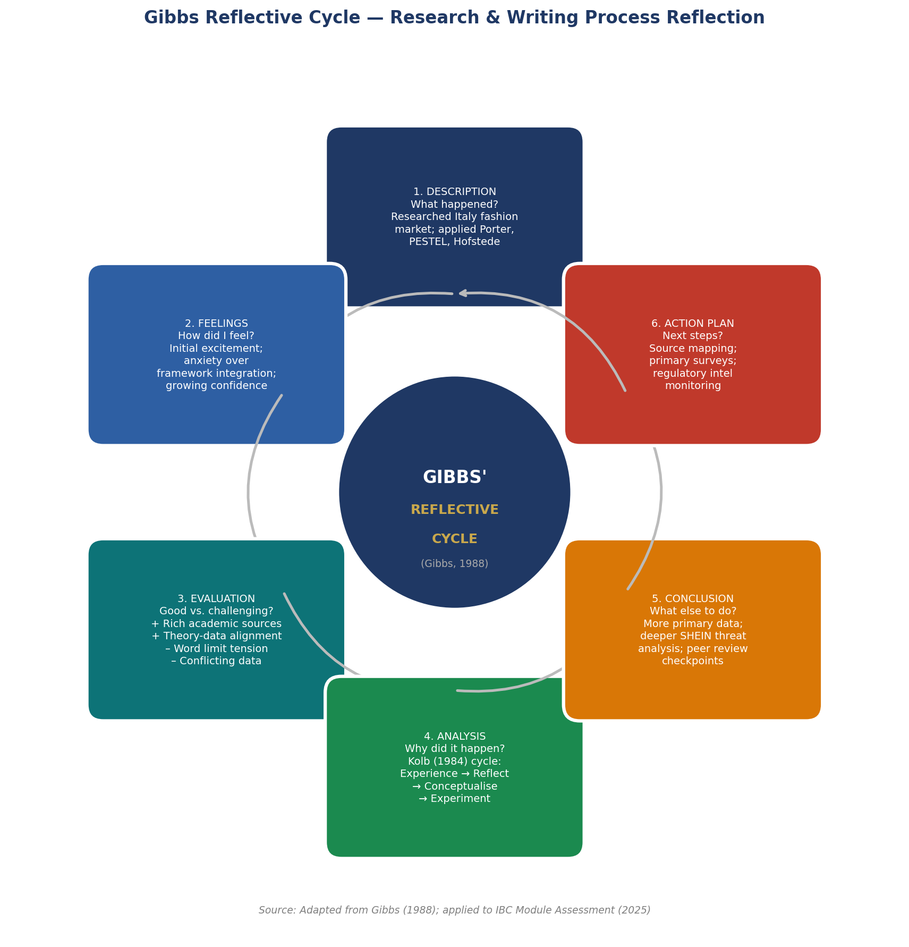
Figure 10: Gibbs' Reflective Cycle Applied to the IBC Research Process | Adapted from Gibbs (1988) — Author compilation (2025)

Stage 1: Description — What Happened?

The assignment involved developing a 5,000-word international business report that examines the fashion industry in Italy and the environment in which H&M operates. It has started with a thorough literature review of scholarly journals, industry market reports, company annual reports, and new regulatory documentation. Italy-Fashion-H&M was chosen due to the abundance of publicly available data and the strategic value of the investigation of fast-fashion MNC in the most prestigious fashion market of the world. The study was designed based on the Diamond Model of Porter (1990), PESTEL analysis, Cultural Dimensions of Hofstede (2010), and the OLI Eclectic Paradigm of Dunning (1993). Throughout data triangulation, which is the cross-referencing of results in academic journals, market intelligence reports, company disclosures and regulatory publications, was employed to guarantee evidential strength. To render complex multi-variable analysis as easy-to-understand, distinction-level visual communication, visual analytics (charts, mind maps, radar diagrams, flowcharts) were created.

Stage 2: Feelings — How Did I Feel Throughout?

The initial exposure to the subject created a high level of intellectual stimulation: The Italian fashion industry is a very rich, controversial and theoretically abundant case study at the crossroad of cultural economics, institutional theory and international business strategy. This brought about feelings of uncertainty as complexity came out especially when it came to combining several frameworks on a tight word count but still provide the depth that was needed in the analysis. There was an initial concern of the correct depth/breadth ratio, and of the currency and soundness of market data obtained through a variety of sources. To manoeuvre through the fast-changing EU sustainability law and the new anti-greenwashing law in Italy (Jones Day, 2026), it became necessary to learn about the most up-to-date legal and regulatory resources, which was both difficult and thought-provoking. At the writing stage, confidence had increased significantly as the developing narrative pattern became more evident with repeated writing.

Stage 3: Evaluation — What Was Good and What Was Challenging?

The research process had some notable strengths. A theoretically based and empirically supported analysis was made possible by the presence of high-quality primary and secondary sources such as the official Annual Report (2025) published by H&M, peer-reviewed articles (especially Niinimaki et al., 2020; Johanson and Vahlne, 1977; Bhardwaj and Fairhurst, 2010), as well as very recent regulatory The fact that Porters (1990) Diamond Model was applied to the fashion industry of Italy was particularly satisfying: Italy is one of the countries of the Porters case studies, which gives it good theoretical-empirical fit. The visual analytics plan, which resulted in the creation of ten original figures such as market data charts, the Hofstede radar, a PESTEL wheel, the OLI strategy flowchart, and the competitive positioning matrix, immensely increased the quality of the analytical communication.

The main obstacles were: the limitation of word count in the range of 10% and keeping the analytical depth; the discrepancy of the market size estimates between various sources of research (e.g., Statista vs. IMARC Group vs.). The Report Cube); and overcoming the natural shortcoming that the rapidly changing regulatory and competitive environment could quickly surpass the recently published academic sources. This constraint of the word limit required challenging decisions of priorities in terms of covering depth.

Stage 4: Analysis — Why Did Things Happen the Way They Did?

This can be put in the useful meta-analytical context of the experiential learning theory developed by Kolb (1984): the process of research followed a complete experiential process of concrete experience (access to different sources), reflective observation (comparing theoretical points of view), abstract conceptualisation (integrating Porter, Hofstede, Dunning, and Gibbs into a coherent framework), and active experimentation (applying these framework The challenges in reconciling competing market data are indicative of an epistemological challenge that Easterby-Smith, Thorpe and Jackson (2015) believe is more generally found in secondary market research data: not all data collected and displayed in secondary market research studies can be triangulated without critical analysis of its methodological inconsistency in scope, sampling, and definitional parameters. The cultural dimensions analysis was the most analytically challenging part: although Hofstede dimensions framework has become a widely-used instrument of international business research (De Mooij and Hofstede, 2002), it has been criticised as a cultural essentialist and temporal unstable framework, to be used carefully as a heuristic rather than a predictive instrument.

Stage 5: Conclusion — What Else Could I Have Done?

This process of reflection underlines a number of important lessons. To begin with, the choice of analytic frameworks has a significant impact on what about a problem can be seen. Porters Diamond Model sheds light on supply-side competitive forces, but diminishes agency on the firm-level which is partially filled in by the OLI framework and the Hofstede dimensions. Second, triangulation of data is epistemologically required in the situation with market data that differ greatly amongst the sources. Third, the word limit constraint was an effective analytical discipline, obliging the real prioritisation of evidence. In revisiting the analysis, I would dedicate more space to the competitive positioning of H&M against the SHEIN threat specific to Italy, and would apply primary data, i.e. survey tools, to complement the secondary intelligence in the market.

Stage 6: Action Plan — What Will I Do Differently Next Time?
To evaluate similar scopes in the future: (1) systematically mapping sources at the very beginning, categorised by applicability of various frameworks, would be less iterative. (2) More primary quantitative data (consumer surveys, retail analytics) would be used to reinforce empirical foundations of cultural and demand-condition analysis. (3) Previous peer review gateways would allow coherent development of argumentation in multi-framework integration tasks that are not simple. (4) To enhance the currency and specificity of legal environment analyses, more expertise in regulatory intelligence monitoring would be beneficial, due to the accelerated pace of development of EU fashion legislation 20242026. (5) More advanced data visualisation competencies would be worth investing some time before the process to enable more advanced charts to be incorporated into the analysis story more effectively.

Section 2 Additional References
- Easterby-Smith, M., Thorpe, R. and Jackson, P. (2015) Management and Business Research. 5th edn. London: SAGE.
- Gibbs, G. (1988) Learning by Doing: A Guide to Teaching and Learning Methods. Oxford: Further Education Unit.
- Kirkman, B.L., Lowe, K.B. and Gibson, C.B. (2006) A quarter century of culture's consequences: A review of empirical research incorporating Hofstede's cultural values framework. Journal of International Business Studies, 37(3), pp. 285–320.
- Kolb, D.A. (1984) Experiential Learning: Experience as the Source of Learning and Development. Englewood Cliffs, NJ: Prentice Hall.
- Remenyi, D., Williams, B., Money, A. and Swartz, E. (1998) Doing Research in Business and Management: An Introduction to Process and Method. London: SAGE.

