NAME: MARIA JENI HAMPU
STUDENT ID :2611054
MODULE: NEW DIGITAL SKILLS- LCLM4002
DEADLINE: 4TH October 2026

DS1 My Digital Life

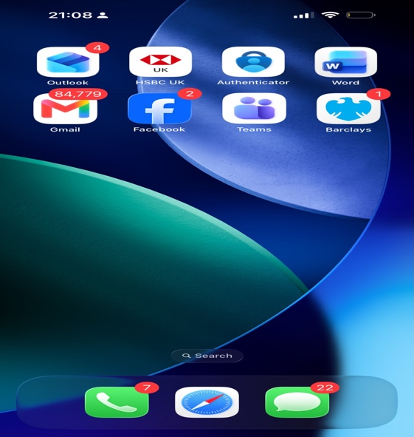 This picture illustrates all the apps I usually use in my day to day life as parts of my digital skills life.
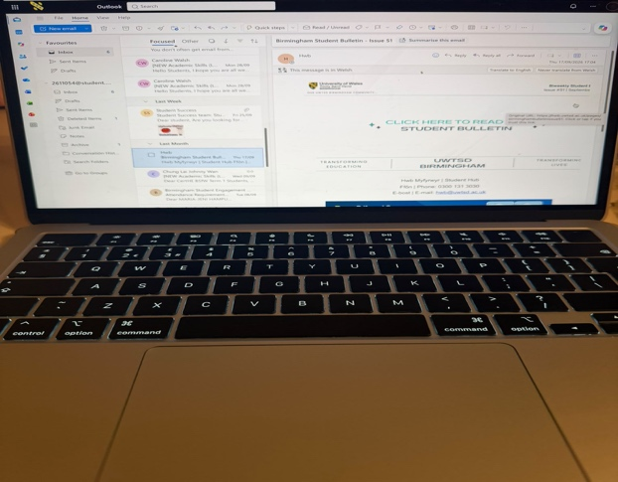This picture shows me using outlook emails to keep up with all the new information from work and communicate with teachers.

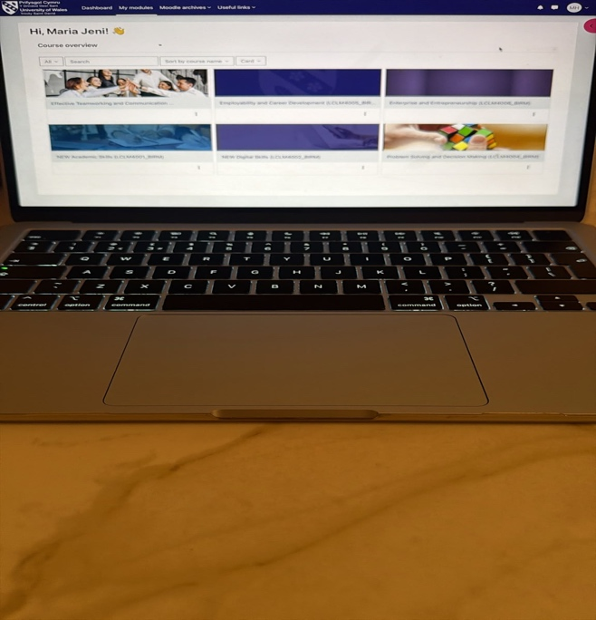This picture illustrates that I can use the student portal to access all my modules and keep up with all the assessments.

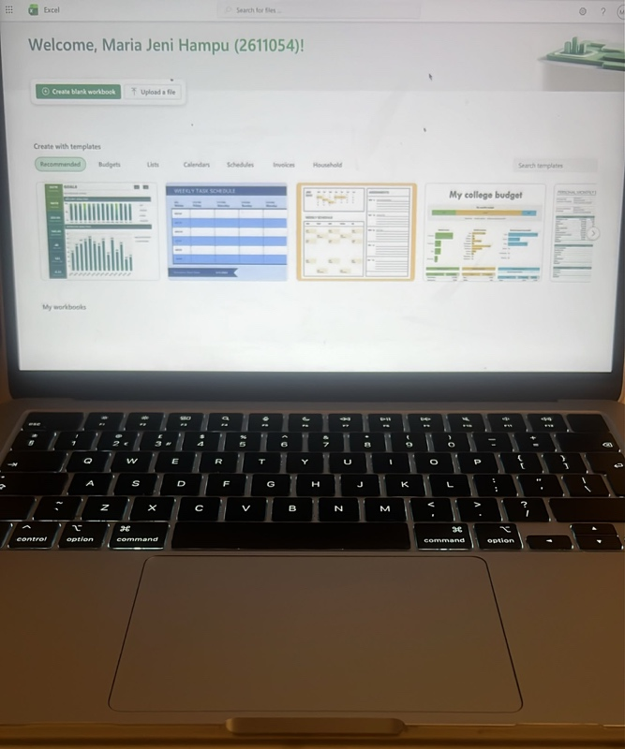This picture shows that I can access excel Microsoft office as part of my digital skills. This also shows my capability of using digital skills and work on my laptop to complete my work. This app I usually use to create spreadsheets which helps me keep organised.

My Short Reflection
I used digital skills to communicate with others, keep updated with schoolwork or personal life, manage my finance and interact with others through social media. Mostly, I feel confident with managing my finances through my banking apps. In the future I would like to improve on sending emails as I feel like sometimes, I cannot find my right words and I always over thinking my emails before sending them. I often use the social media apps and my finance apps, and weekly my student portal to engage with my learning. I would like this module to help me with developing my confidence in writing emails and develop new digital skills that will help me evolve in my future education.
Finally, digital skills are very important for me as it helps em manage my education and personal life as well. It connects me with so many people, family, colleagues and creates new relationships.

