


Development and Validation of A uHPLC-UV Method For Quantitative Analysis of Conventional Explosives
by
Silas Gareth Jordan Blevins

Supervisor: Ewa Kazimierska

Project submitted as part of the requirements for the award of BEng (Hons) OME

March 2026

Declaration of Originality

I, SILAS GARETH JORDAN BLEVINS declare that I am the sole author of this Project; that all references cited have been consulted; that I have conducted all work of which this is a record, and that the finished work lies within the prescribed word limits.

This work has not previously been accepted as part of any other degree submission.

FORM OF CONSENT

I, SILAS GARETH JORDAN BLEVINS hereby consent that my Project, submitted in candidature for the BEng (Hons) OME degree, if successful, may be made available for inter-library loan or photocopying (subject to the law of copyright), and that the title and abstract may be made available to outside organisations.

Copyright And Release Terms

This document was produced with mentorship from Dstl for University of Wales Trinity St David (UWTSD) under The OME Degree Apprenticeship Programme.
Copying and use of the document is restricted to that set out in the above Order/Contract and the document may not otherwise be used or disseminated without the consent of Dstl.

© Crown Copyright 2026
Defence Science and Technology Laboratory UK

Approval for wider use or release must be sought from:

Intellectual Property Group
Defence Science and Technology Laboratory
Porton Down, Salisbury, Wiltshire SP4 0JQ

ABSTRACT

The quantitation of explosives involves the application of analytical chemistry techniques to determine the relative amounts of explosive materials contained within a sample. This capability is critical to a range of domains within the study of energetics including material characterisation, forensic investigations, technical intelligence, and safety. Within Dstl’s Chemical Analysis Service (CAS), one of the primary techniques used for this is Ultra-High Performance Liquid Chromatography (uHPLC). This report describes how a method was developed which delivered improved analytical performance for the end user, and details the steps made towards validating this method for operational use by CAS. Selectivity of the method was improved through the selection of a new column and mobile phase, and validation experiments demonstrated the method to be repeatable and linear, with further experiments planned for the future to validate robustness, intermediate precision, and bias.
Table of ContentS

Copyright And Release Terms iii
ABSTRACT iv
Table OF FIGURES – Main Text vii
Table of Figures - Appendices ix
LIST OF TABLES - Main Text xii
List of Tables – Appendices xiii
Chapter 1 Project Overview 15
1.1 Introduction 15
1.2 Aim 15
1.3 Objectives 16
1.4 Principles of the Method 16
1.5 Requirements and Criteria 18
1.6 Structure Of The Project 18
Chapter 2 – Literature Review and Quality Requirements 20
2.1 Literature Review 20
2.2 Quality Requirements 22
Chapter 3 – Design of Experiments 24
3.1 Method Development 24
3.2 Method Validation 25
Chapter 4 – Conduct of Experiments 26
4.1 Method Development 26
4.2 Method Validation 34
4.2.1 Repeatability 34
4.2.2 Linearity 35
4.2.3 Validation of the Multi-Component Standards 36
4.2.4 Precision and Bias 36
4.2.5 Interferents 37
4.2.6 Robustness 39

Chapter 5 – Analysis of Results 42
5.1 Method Development 42
5.2 Method Validation 45
5.2.1 Repeatability 45
5.2.2 Linearity and Working Range 46
5.2.3 Validation of Multi-Component Standards 48
5.2.4 Precision and Bias 49
5.2.5 Interferents 50
5.2.6 Robustness 51
Chapter 6 - CONCLUSIONS AND RECOMMENDATIONS 55
6.1 Conclusions 55
6.1.1 Review of Objectives 55
6.1.2 Method Development 56
6.1.3 Method Validation 56
6.2 Reccomendations for Further Research 57
Chapter 7 – Reflections 59
chapter 8 - REFERENCES 60
chapter 9 - BIBLIOGRAPHY 63
APPENDICES 64
Appendix 1 PROJECT MANAGEMENT 64
Appendix 2 Logbook 65
Appendix 3 Chromatograms and plots 68
Appendix 4 Bill of Materials 88
GLOSSARY 92
List of Abbreviations 92
Definitions of Technical Terms 93

Table OF FIGURES – Main Text
Figure 1: Annotated chromatogram identifying key information 17
Figure 2: Annotated image of the instrumental setup used in INS/SM085 17
Figure 3: Chromatogram produced by the initial 'PhenylACN' Method during scoping experiments 26
Figure 4: The chromatogram produced by the existing INS/SM085 Method. 27
Figure 5: The chromatogram produced by 'Method 22' [13] 28
Figure 6: The chromatogram produced by 'Method 31' [13]. It is not fully understood why this method did not produce any peaks. 28
Figure 7: The chromatogram produced by the initial phenyl column method, including NTs and DNTs 29
Figure 8: The chromatogram produced from the 'PhenylACN2090' method tested during method development. 30
Figure 9: The Chromatogram produced from the 'PhenylACN 2070' method tested during method development 30
Figure 10: Chromatogram produced from the ‘PhenylACN ISO1’ method tested during method development 31
Figure 11: Chromatogram produced by the 'PhenylACN2P9' method tested during method development. 32
Figure 12: Chromatogram produced by the '2P9_055' method with no guard column fitted, which met all selectivity requirements 33
Figure 13: Chromatogram produced by the ‘2P9_055’ method with a guard column fitted 33
Figure 14: Comparison of peak areas for each analyte from the tested methods 42
Figure 15: Comparison of peak heights for each analyte from the tested methods 43
Figure 16: Comparison of peak resolutions for each analyte from the tested methods 43
Figure 17: Overlay of peaks from multicomponent standard validation showing the difference between sample (larger peaks) and standard (smaller peaks) for EGDN at 50ng/µL 49
Figure 18: Overlay of peaks from multicomponent standard validation showing the difference between sample (larger peaks) and standard (smaller peaks) for NG at 50ng/µL 49

Table of Figures - Appendices
Figure A - 1: GANTT Chart with planned vs actual dates 64
Figure A - 2: Key to GANTT Chart 64
Figure A - 3: Method Development Chromatogram 'PhenylACN3090' method 68
Figure A - 4: Method Development Chromatogram 'PhenylACN4090' method 68
Figure A - 5: Method Development Chromatogram 'PhenylACN5090' method 69
Figure A - 6: Method Development Chromatogram 'PhenylACN3070' method 69
Figure A - 7: Method Development Chromatogram 'PhenylACN1070' method 70
Figure A - 8: Method Development Chromatogram 'PhenylACN3080' method 70
Figure A - 9: Method Development Chromatogram 'PhenylACN2080' method 71
Figure A - 10: Method Development Chromatogram 'PhenylACN1080' method 71
Figure A - 11: Method Development Chromatogram 'PhenylACNISO2' method 72
Figure A - 12: Method Development Chromatogram 'PhenylACN2P1' Method 72
Figure A - 13: Method Development Chromatogram 'PhenylACN2P2' method 73
Figure A - 14: Method Development Chromatogram 'PhenylACN2P3' method 73
Figure A - 15: Method Development Chromatogram 'PhenylACN2P4' method 74
Figure A - 16: Method Development Chromatogram 'PhenylACN2P5' method 74
Figure A - 17: Method Development Chromatogram 'PhenylACN2P6' method 75
Figure A - 18: Method Development Chromatogram 'PhenylACN2P7' method 75
Figure A - 19: Method Development Chromatogram 'PhenylACN2P8' method 76
Figure A - 20: Method Development Chromatogram 'PhenylACN2P10' method 76
Figure A - 21: Method Development Chromatogram 'PhenylACN2P11' method 77
Figure A - 22: Method Development Chromatogram 'PhenylACN2P12' method 77
Figure A - 23: Method Development Chromatogram 'PhenylACN2P13' method 78
Figure A - 24: Method Validation Chromatogram - RDX 78
Figure A - 25: Method Validation Chromatogram - HMX 79
Figure A - 26:Method Validation Chromatogram - EGDN 79
Figure A - 27: Method Validation Chromatogram – DEGDN 80
Figure A - 28: Method Validation Chromatogram - NG 80
Figure A - 29: Method Validation Chromatogram - TNT 81
Figure A - 30: Method Validation Chromatogram - Tetryl 81
Figure A - 31: Method Validation Chromatogram - PETN 82
Figure A - 32: Method Validation Chromatogram - Multicomponent 1 82
Figure A - 33: Method Validation Chromatogram - Multicomponent 2 83
Figure A - 34: Linearity plot for EGDN in the 1-250ng/µL range 83
Figure A - 35: Linearity plot for RDX in the 1-250ng/µL range 84
Figure A - 36: Linearity plot for TNT in the 1-250ng/µL range 84
Figure A - 37: Linearity plot for Tetryl in the 1-250ng/µL range 85
Figure A - 38: Linearity plot for HMX in the 1-250ng/µL range 85
Figure A - 39: Linearity plot for DEGDN in the 1-250ng/µL range 86
Figure A - 40: Linearity plot for NG in the 1-250ng/µL range 86
Figure A - 41: Linearity plot for PETN in the 1-250ng/µL range 87

LIST OF TABLES - Main Text
Table 1: Components and concentrations of Multicomponent Standard 1 35
Table 2: Components and concentrations of Multicomponent Standard 2 35
Table 3: Aliquot and Volumetric Flask volumes for Standard Preparation 35
Table 4: List of Potential Interferents 38
Table 5: Mean, Standard Deviation, and %RSD of retention times for each analyte as calculated from Repeatability experiments 45
Table 6: Mean, Standard Deviation, and %RSD of peak areas for each analyte as calculated from Repeatability Experiments 45
Table 7: r² values for analytes as demonstrated during linearity experiments 46
Table 8: Average % Residuals at each concentration level for linearity experiments between 1 and 250 ng/µL 47
Table 9: Average % Residuals at each concentration level for linearity experiments between 10 and 250ng/µL 47
Table 10: Prepared vs Measured Concentrations of the Single-Component Standards as seen in the Multicomponent Validation Experiments. 48
Table 11: Observations from initial interferent analysis 50
Table 12: Solutions prepared to determine resolution of interferents 51
Table 13: Deviation in Peak Area over 24 hours for all analytes at 10ng/µL 52
Table 14: Deviation in Peak Area over 24 hours for all analytes at 50ng/µL 53
Table 15: Deviation in Peak Area over 24 hours for all analytes at 100ng/µL 54

List of Tables – Appendices
Table A - 1: Project Logbook 67
Table A - 2: Bill of Materials 91

ACKNOWLEDGEMENTS

I would like to give thanks to all the teams and projects I have worked with throughout the five years of the OME Degree Apprenticeship, in particular the Forensic Explosives Research Team, and the Forensic Capability Development Programme, under which this research was conducted, as well as to the OME Degree Apprenticeship project as a whole, who provided a portion of the funding to enable this work to be carried out. I would like to individually thank the technical leadership within the Forensic Explosives Laboratory (FEL) for supporting me in the learning journey I have taken whilst carrying out this project, and for providing technical review, mentoring and advice on relevant supporting documents. I would also like to thank Dr Ewa Kazimierska UWTSD for her assistance as project supervisor.

Chapter 1 Project Overview

1.1 Introduction
The Forensic Explosives Laboratory (FEL) is a delivery team within the Defence Science and Technology Laboratory (Dstl) which provides forensic analysis of explosives and related samples to law enforcement and other customers [1]. To ensure that the quality of the results provided is in line with the requirements of the Forensic Science Regulator Code of Practice (FSR COP) [2] and ISO17025 [3], analytical methods are required to undergo validation to demonstrate their performance and suitability for service in line with quality guidelines. One such method is “INS/SM085: Quantitative Analysis of Explosives using uHPLC-UV” [4] which is a method used by the Chemical Analysis Service (CAS) to analyse the relative amounts of specific explosives in a sample. There was a requirement to carry out validation on this method to demonstrate its reliability and suitability for use, and to enhance understanding of the method. A series of experiments were designed to develop and validate the method, and the planning, conduct, and results of those experiments are discussed in the following sections.

1.2 Aim
The aim of this project was to complete the development and validation process for INS/SM085 and deliver it as a new standardised method in the FEL Quality Management System (QMS). This would entail making changes to the method in order improve its’ performance, and then conducting a full validation procedure in line with FEL’s validation protocol [5].

1.3 Objectives
The objectives of this project were:
- Identify best practice in UHPLC Analysis and method design, and understand how this can be applied to INS/SM085.
- Identify and implement improvements to the method based on previous and new research.
- Demonstrate compliance of INS/SM085 with quality guidelines and validation procedures, and the end user requirements.
- Issue INS/SM085 into the FEL Quality Management System (QMS).

1.4 Principles of the Method
INS/SM085 is an Ultra-High Performance Liquid Chromatography (uHPLC) method used to quantify the relative amounts of explosive materials in a sample. IUPAC describe chromatography as “A physical method of separation in which the components to be separated are distributed between two phases, one of which is stationary (stationary phase) while the other (the mobile phase) moves in a definite direction” [6]. In uHPLC, the mobile phase is a mixture of solvents pumped through a column packed with the stationary phase at high pressures, with the particle sizes within the stationary phase being sub-2µm [7]. As a reversed-phase method, analytes are retained by the column longer the more hydrophobic they are [8]. A gradient elution is used whereby the proportion of solvents in the mobile phase changes over time to optimise analyte separation [9]. After flowing through the column, analytes are detected using an Ultraviolet Photodiode Array (UV-PDA) which works by measuring the absorbance of the analyte at a specific wavelength [10] [11]. In the case of INS/SM085, the measured wavelength is 208nm. The absorbance is plotted against time to give a chromatogram, which appears as a series of peaks. Each peak corresponds to a specific analyte, and the time at which it arrives at the detector is known as the Retention Time (RT). The area of the peak is calculated by integration carried out by the instrument software.
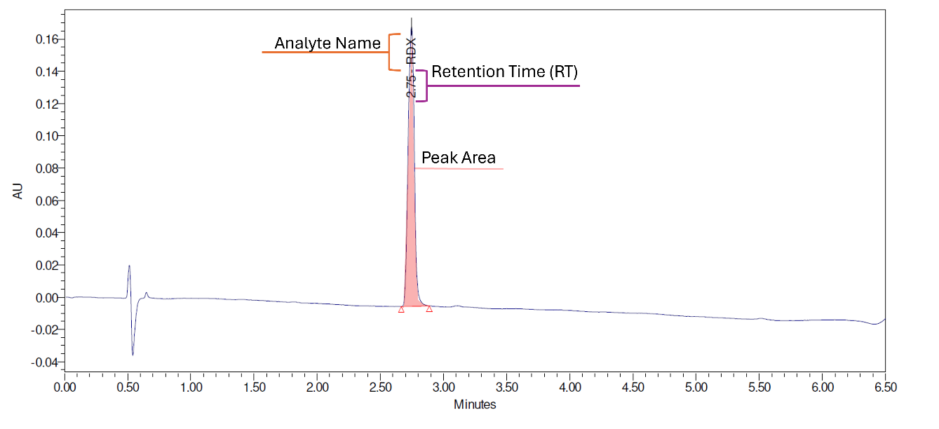
Figure 1: Annotated chromatogram identifying key information
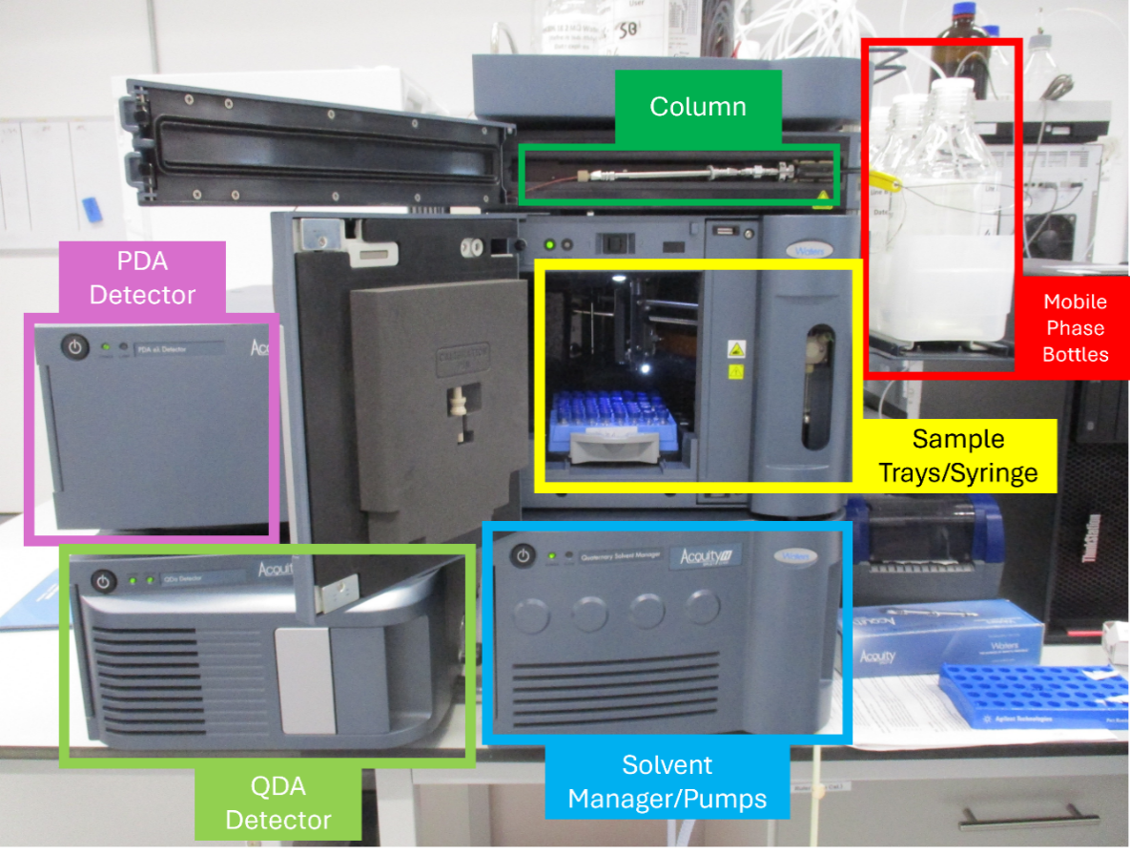
For quantitation, a calibration line of concentration against peak area is generated by injecting a series of standards prepared from Certified Reference Material across a range of concentrations. The peak area of the analyte in the sample chromatogram is compared to the calibration line to determine the concentration of that analyte within the sample.

Figure 2: Annotated image of the instrumental setup used in INS/SM085

1.5 Requirements and Criteria
The performance criteria for the method were outlined in the end-user requirement document [12], and are presented below:
- Be reliable and robust.
- Enable the identification and quantification of the required explosives using a single instrumental method, those being:
  - 2,4,6-Trinitrotoluene (TNT)
  - 1,3,5-Trinitro-1,3,5-triazinane (RDX)
  - 1,3,5,7-Tetranitro-1,3,5,7-tetrazocane (HMX)
  - Pentaerythritol Tetranitrate (PETN)
  - Nitroglycerin (NG)
  - Ethylene Glycol Dinitrate (EGDN)
  - Methyl(2,4,6-trinitrophenyl)nitramide (Tetryl)
  - Diethylene Glycol Dinitrate (DEGDN)
- If practicable enable the separation and quantification of the following additional analytes:
  - 2,4-Dinitrotoluene (2,4-DNT)
  - 2,6-Dinitrotoluene (2,6-DNT)
  - 3,4-Dinitrotoluene (3,4-DNT)

1.6 Structure Of The Project
This project was broken down into four main stages. Stage 1 was the planning stage, where the requirements of the project were compiled and reviewed. This stage produced two internal documents, those being An Integrated Project Plan (IPP) [13], and an introductory presentation [14], as well as the initial project proposal document [15]. Stage 2 was the method development stage, where a series of method development experiments were carried out to improve the method before validation. This stage produced a Method Development Plan [16] and a Method Development Report [17]. The contents of these documents are discussed in the relevant sections of the report. Stage 3 was the method validation stage, where experiments were carried out to demonstrate the method’s compliance with the end users’ requirements [12], as well as ISO17025 [3], and the Forensic Science Regulator FSR COP [2]. The contents of the Method Validation Report [18] are presented in the appropriate section of this report. Stage 4 was the implementation phase, where the method validation results and the final version of the method were used to support the integration of the method into FEL’s Quality Management System (QMS).
This report describes this work in detail, in the chapters laid out below:

- Chapter one provides an overview of the report, the aims and objectives of the research, and summarises the principles of the method.

- Chapter two summarises the research carried out in advance of the experiments and presents a literature review into UHPLC best practice and method development approaches.

- Chapter three describes how the experiments carried out for development and validation of the method were designed and explains the role that the literature and initial research played in this process.

- Chapter four outlines the conduct of the experiments and presents the outputs and results.

- Chapter five presents a summary of the analysis and interpretation of the results of the development and validation experiments.

- Chapter six discusses the conclusions reached during the research and presents recommendations for next steps and future research.

- Chapter seven reflects on the research, planning, and experiments carried out and how well objectives have been met.

Chapter 2 – Literature Review and Quality Requirements

Literature Review
To support the decisions made when planning the method development experiments, a review of literature and sources was undertaken. The goal of this review was to identify best-practice in LC, HPLC, and UHPLC method development, especially relating to the analysis of explosives, and considered Dstl internal research, scientific publications, and instrument manufacturer information. The first paper reviewed was a Dstl report discussing the development of a method for the trace analysis of explosives by UHPLC-MS [19] in 2021. This report described how the author had encountered the same lack of separation of TNT and Tetryl as had been experienced during previous work on INS/SM085 [13]. The report discussed a series of gradient compositions for the mobile phase which had been demonstrated to improve the separation of these peaks in the chromatogram, and so it was proposed to use these gradients as a basis for changes to the gradient on INS/SM085.

Given the proposal to utilise Mass Spectrometry as a second identification point on the method, especially in the absence of suitable NG/Tetryl/TNT separation, it was also necessary to research the best practice for the employment of Mass Spectrometry alongside UHPLC systems. Whilst the Dstl report [19] does refer to the use of MS, its primary focus is the chromatographic aspect of the method, and so it was determined to not be relevant to this section of the review. An article in Forensic Science International [20] discusses the use of LC-MS for the analysis of explosive materials and demonstrates the utility of hyphenation of techniques for enhancing analytical capabilities. However, the method used in this report is not a perfect analogue for INS/SM085, as it uses LC as opposed to UHPLC, meaning it operates at a much lower pressure, and the mass spectrometry aspect of the method utilised Atmospheric Pressure Chemical Ionisation (APCI) as opposed to the Electrospray Ionisation (EI) used in INS/SM085. Despite this, the overall conclusion of the report that MS hyphenation is beneficial to the analysis of explosives was considered when planning the development experiments. In addition to this report, the NIST Mass Spectra database was consulted, with a focus on the spectra of TNT [21], NG [22], and Tetryl [23]. Whilst these spectra were again produced by an MS using a different ionisation technique to that used in INS/SM085, they served to illustrate that the target explosives would have sufficiently different spectra to one another to allow them to be easily discerned.

To attempt to identify solutions to the poor peak shape exhibited by NG, a report published in the RSC Advances Journal was identified, relating to the analysis of synthesised NG by HPLC [24]. In this report, the peak produced by nitroglycerin is taller and sharper than that seen during previous work on INS/SM085. Whilst the column used in this study was similar to that used in INS/SM085, the mobile phase was significantly different, with an isocratic elution of 50% HPLC Grade Acetonitrile and 50% Water. This suggested that as an alternative to the gradients outlined in [19], a change to an Acetonitrile-based mobile phase could be beneficial. In addition to this study, consideration was given to the discussion of NG peaks in [19], wherein peak shape was improved by the gradients discussed earlier in this section, and so it was hoped that if these changes were implemented, the NG peak would also improve alongside improved separation of TNT and Tetryl.

To address the column protection aspect of the method, there was limited scholarly literature available, so the decision was instead made to consult manufacturer guidance and marketing materials to understand what was available. Welch Materials, a large chemical and equipment supplier, published an article on their website entitled ‘A Comprehensive Guide to Guard Columns and Pre-Columns’ [25] which describes the two standard approaches to column protection, those being Pre-Filters (as currently used in INS/SM085) and Guard Columns. The article described how guard columns serve to protect the column from contamination by providing both physical filtration (as with a pre-filter) and chemical adsorption (the mechanism by which the chromatographic column itself functions). Because guard columns contain a stationary phase this must be correctly matched to the stationary phase of the analytical column, it was necessary to ensure that a guard column only be purchased once the column to be used in the method was finalised. Given the benefits outlined in this article, and other Dstl research discussing the benefits of guard columns, it was elected that a guard column should be procured and tested.

All of the literature discussed above fed into the production of a method development plan [16] which outlined the experiments to be conducted. During the production of this document, and following some initial testing in the lab, additional literature was identified which further refined the development plan. In terms of enhancing separation, an article in the Journal of Chromatography [26] which discussed the analysis of Nitroglycerin and its metabolites in a medical context, suggested that a Phenyl or Diphenyl column could improve the separation of the target analytes due to their polarity. Initial testing of a phenyl column stored in the lab corroborated this and so the method development plan was updated to reflect potential column changes. In addition to this, manufacturer guidance on Formic Acid content in the mobile phase [27] suggested that the optimal Formic Acid content for Mass Spectrometry was 0.1%, which was 10x that initially used in the method, so it was proposed to alter this content to increase the suitability of the method for MS, should the QDA detector be used.

Quality Requirements
The method validation stage of the work was required to follow specific quality guidelines and policy, which are explained below.
FEL’s validation procedure [5] is the primary guidance for the management and conduct of method development and validation within the lab. It describes method validation as demonstrating ‘that a method, or procedure is fit for purpose within its operational context’. The validation process is broken down as follows:
- Define End-User Requirements (EUR)
- Determine Customer Risk Assessment
- Develop the method and finalise a draft method statement to be validated
- Prepare a validation plan outlining the experiments to be conducted
- Perform validation experiments and assess results
- Review and countersign all data
- Write and issue validation report
- Write and issue implementation plan
- Implement the method
This report primarily focuses on steps 3 to 7 of the process, however other steps are referenced as needed.
The validation procedure also defines specific terms used throughout validation and provides guidance on experimental design and calculations.
In addition to internal policy, validation is conducted in line with the Forensic Science Regulator Guidance on Validation (FSR-G-201 Issue 2) [28]. This document highlights the importance of validation in ensuring that the results of the method can be relied upon for intelligence or evidential use. Whilst this method is unlikely to be used for law enforcement work, results from analysis can form part of safety cases and intelligence assessments and so the confidence provided by validation remains critical.

Chapter 3 – Design of Experiments

Method Development
The plan for the method development phase of the project was laid out in an internal report [16], which described what experiments were to be conducted, and the order in which they were to be carried out. It was identified that since significant changes would be made to the method, the order in which the experiments were conducted would matter significantly. For example, a guard column could not be procured and tested until a new column to be used for the method was selected, as the guard column must match the main column. Therefore, the following sequence of experiments was proposed:
- Verifying the decision to use the Acquity BEH Phenyl Column instead of the Thermo C18 Column used on the existing version method by comparing the chromatograms produced by the existing method [4], as well as Methods 22 and 31 [19] on the C18 column, and the initial Acetonitrile-based method used on the Phenyl column.
- Iterating upon the gradient and flow rate used for the selected column to develop a method that delivers the desired selectivity (resolution of all peaks should be greater than 1.5) and improves peak height and area relative to the original method.
- Testing of a guard column to verify that adding one to the method does not result in any significant loss of performance. This phase would also include repeat runs of a multicomponent sample to verify repeatability of the new method before proceeding to validation.
- Testing of the QDA Mass Spectrometer accessory in Single Ion Monitoring (SIM) mode to provide an alternative method for the identification of analytes. This step was judged to be only strictly necessary if chromatographic resolution of all target analyte peaks was not achieved, but it would still deliver potential improvements to the method regardless.

Method Validation
As described in Section 2.2, validations in FEL are conducted in line with an approved validation procedure [5]. This document describes the technical and administrative requirements for validations and advises on approaches to statistical analysis.
The validation plan [29] outlined the following experiments to be carried out based on [5], and previous validations of similar methods.
- Repeatability: verifying that the method has acceptable repeatability through repeat injections of single-component standards.
- Linearity and Working Range: verifying that the method has acceptable linearity through repeat injections of multicomponent standards across a range of concentrations.
- Validation of the multi-component standards: verifying that the use of multi-component standards does not reduce quantitative accuracy due to reaction or degradation of individual analytes.
- Intermediate precision and Bias: verifying that changing the operator, column, and mobile phase batch does not reduce quantitative accuracy.
- Interferents: verifying that no chemicals expected to occur in an operational sample (e.g. plasticisers or propellant stabilisers) elute at the same time as any target analyte.
- Robustness:
  - Stability: verifying that the calibration standards can be used for long sequences and stored between analyses without degradation of analytes in solution.
  - Matrix Effects: verifying that sample matrices of operational samples do not affect quantitative accuracy.

Chapter 4 – Conduct of Experiments

4.1 Method Development
Before formally commencing the main set of method development experiments, a series of scoping experiments were conducted. The first of these experiments consisted of installing an Acquity BEH Phenyl Column, using a stationary phase similar to that suggested in [26]. The gradient used on this column used a mixture of Acetonitrile (ACN), Water, and Water+0.1% Formic Acid as the mobile phase, with ACN starting at 10%, and finishing at 90% at t=5 minutes, before reducing back to 10% to flush the column between t=5.1 minutes and t=6 minutes. Water+0.1%FA concentration was kept constant at 10%. This experiment yielded the following chromatogram when tested with a multicomponent standard containing all of the target analytes except the nitrotoluenes and dinitrotoluenes.

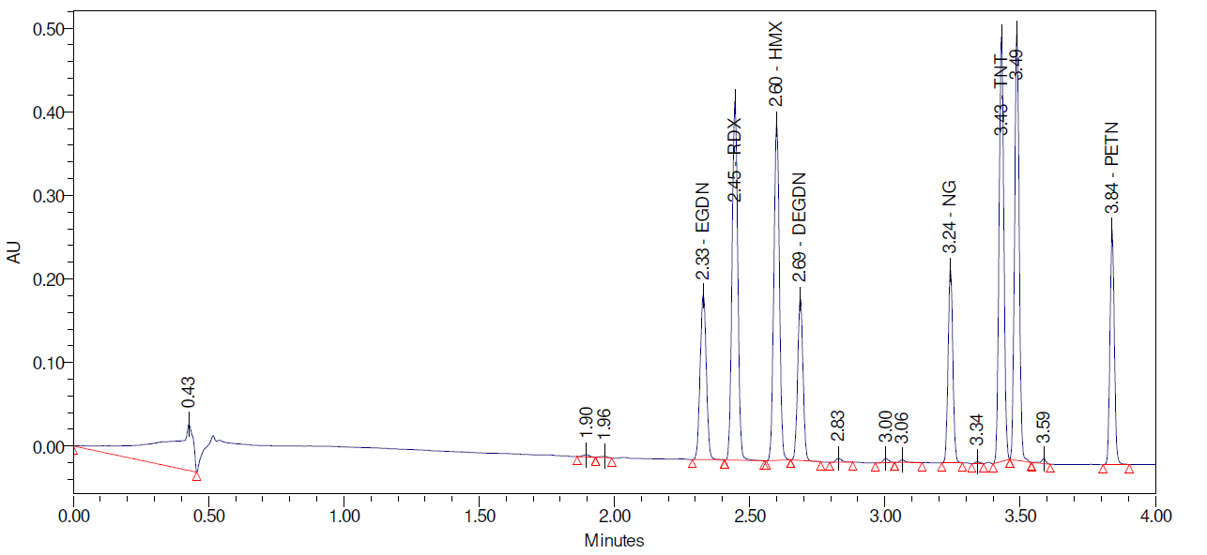
Figure 3: Chromatogram produced by the initial 'PhenylACN' Method during scoping experiments
The next scoping experiment tested a range of single-component standard, containing each of the target analytes individually, including the nitrotoluenes and dinitrotoluenes, in order to identify their retention times for this prototype method. This pair of experiments identified that the prototype method improved selectivity over the original method, achieving separation of TNT and Tetryl, as well as improved peak shape for NG, although it was identified that NG co-eluted with 3,4-DNT. This suggested that further development of this method should focus on improving the resolution of these two peaks.
The final scoping experiment was using the QDA in full scan mode with single-component standards to identify the major peaks in the mass spectra of each analyte, which verified that SIM could be effective at identifying the analytes.

Once these scoping experiments and development plan had been completed, the process of further developing the gradient to optimise resolution began. The first experiment to be carried out during this phase was the capturing of reference data for comparisons. This involved capturing a chromatogram from each of the following methods for comparison to newly developed methods:
- INS/SM085 Original Method
- Method 22
- Method 31
- Initial Phenyl Method
This series of experiments produced the following chromatograms:

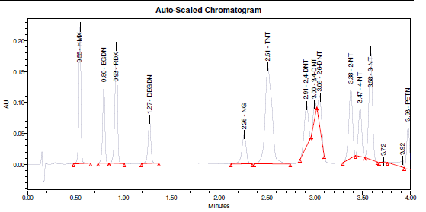
Figure 4: The chromatogram produced by the existing INS/SM085 Method.
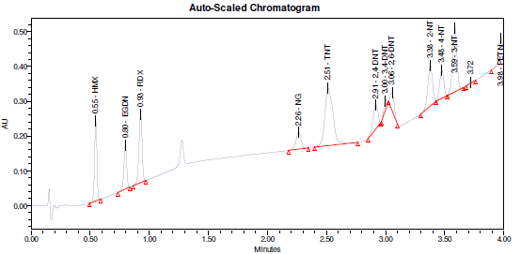
Figure 5: The chromatogram produced by 'Method 22' [19]

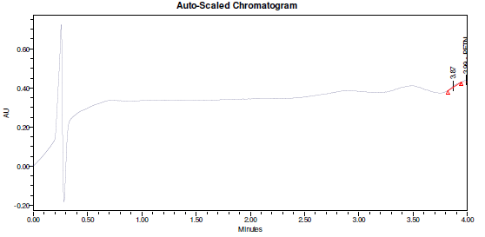
Figure 6: The chromatogram produced by 'Method 31' [19]. It is not fully understood why this method did not produce any peaks.
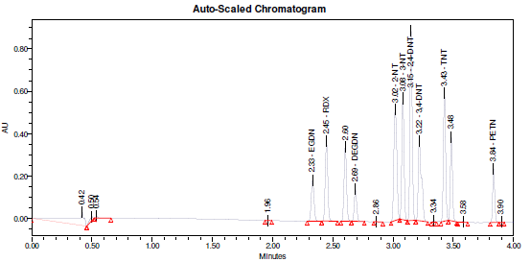
Figure 7: The chromatogram produced by the initial phenyl column method, including NTs and DNTs
These experiments showed that Methods 22 and 31 did not provide a significant improvement over the original method, but the phenyl column paired with an acetonitrile/water mobile phase did, confirming the findings of the initial scoping experiments. Although 3,4-DNT co-eluted with NG, it was assessed that resolution of these two peaks could likely be achieved with adjustments to the gradient and so it was decided to proceed with the phenyl column and ACN/Water mobile phase as a basis for further iterations.

The gradient iteration experiments involved testing a large range of gradients derived from the initial ‘PhenylACNMethod’ gradient, making changes based on the results of each set of experiments. Given the large number of gradients trialled, the chromatograms of each of these are presented in Appendix 3, with this section describing the iterative process, and displaying specific chromatograms of interest.
The first set of iterations involved changing the start point of the gradient, which was initially set at 10% ACN, to 20%, 30%, 40%, and 50% ACN, with the end point remaining constant at 90% ACN. These experiments indicated that up to 30% initial ACN concentration, the resolution of later peaks increased, which was beneficial to the resolution of NG from 3,4-DNT, but at 40% and 50% ACN, the resolution of earlier analytes decreased significantly, and so the next set of iterations were based on starting concentrations of 10%, 20%, and 30%

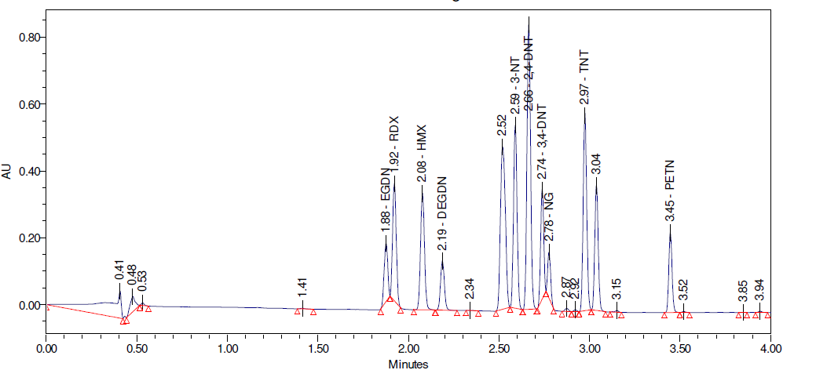
Figure 8: The chromatogram produced from the 'PhenylACN2090' method tested during method development.
The next test carried out was the varying of the end point of the gradient, from 90% ACN down to 80% and 70%. From these potential gradients, the most promising were identified as 2070 and 3070. This series of experiments overall indicated that a slower gradient would achieve the best resolution of all analytes, especially NG, and so the next set of tests used this information to inform their refinements.

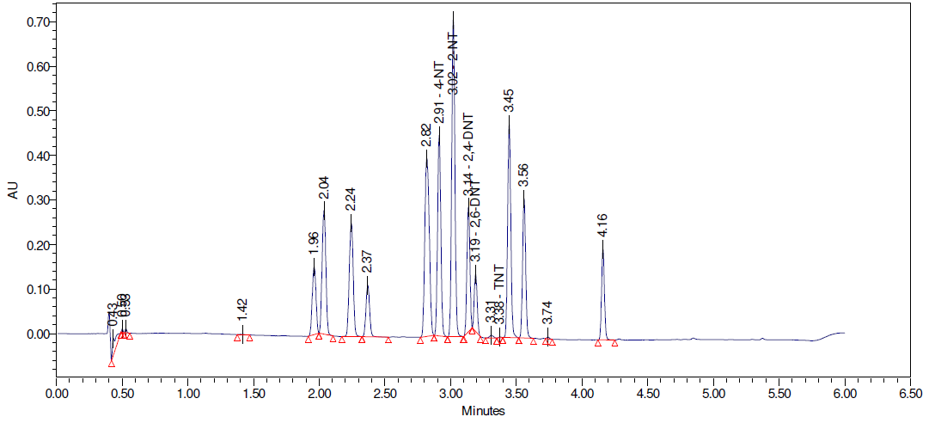
Figure 9: The Chromatogram produced from the 'PhenylACN 2070' method tested during method development
The next set of tests involved lowering the ending concentration of ACN from 70% to 60% to see if PETN (the latest eluting analyte) would still elute and be detected. This was demonstrated to be the case, and so it was decided that lower ending concentrations of ACN could be used in the following iterations.

An experiment was then conducted to test the inclusion of an isocratic step, where the ratios of solvents remain constant for a period of time. This had a negative effect on selectivity and response, and so was not pursued further.
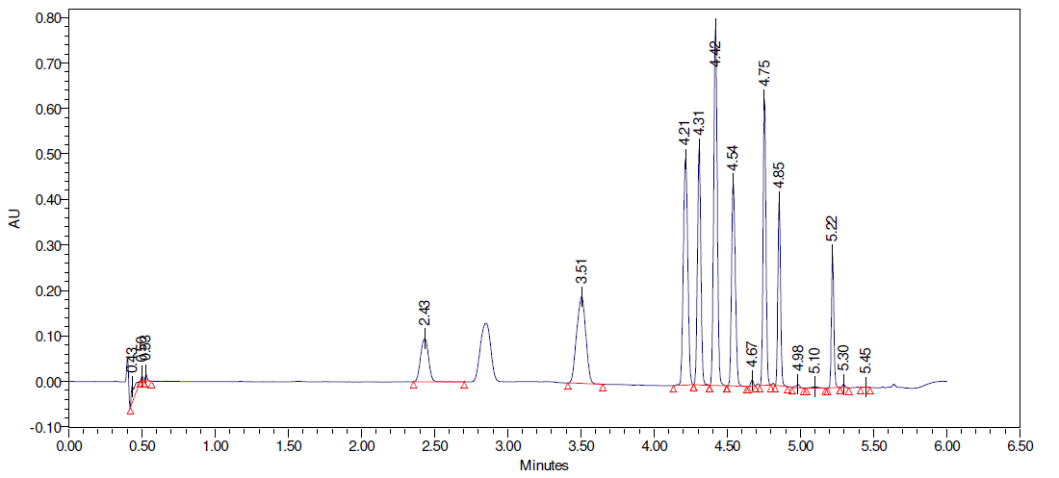
Figure 10: Chromatogram produced from the ‘PhenylACN ISO1’ method tested during method development
As the inclusion of an isocratic step was determined to not improve resolution of the target analytes, the next series of tests focused on a 2-point gradient, where the concentration of ACN increases at one constant rate for a given period of time, and then changes to a different constant rate for the remainder of the gradient. A wide number of 2-point gradients were tested to determine which achieved the highest resolution of NG whilst ensuring all other analytes also eluted with sufficient resolution. Following several iterations, it was identified that maintaining the end point of the gradient at t=5 minutes was unlikely to achieve acceptable resolution of the target analytes, and so a series of gradients were tested which moved the end point of the gradient to t=5.5 minutes. Of these, the most promising was a gradient referred to as ‘2P9’, i.e. the 9th two-point gradient tested, which achieved a resolution of 1.38 for NG. Although this was still not above the 1.5 threshold laid out at the start of the experimental design, it was identified as the best candidate method on which to base the next set of iterations
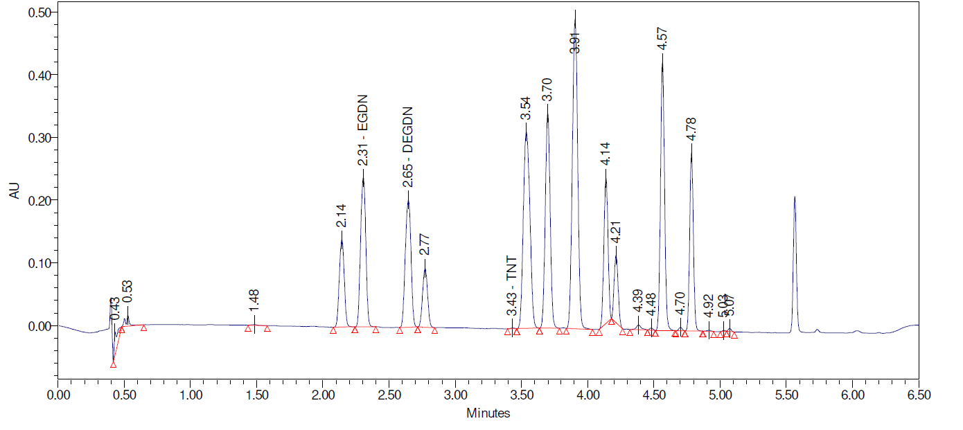
Figure 11: Chromatogram produced by the 'PhenylACN2P9' method tested during method development.
Given that the gradient had now been developed to a point that the majority of the performance requirements were met, it was decided to test the effects of changing the temperature of the column and the flow rate of the mobile phase. The temperature was set to 50°C and 60°C, as opposed to the 40°C as used in the existing method. This caused co-elution of multiple peaks to occur and so it was not pursued further. Lowering the flow rate from 0.65mL/min to 0.6mL/min and 0.55mL/min did demonstrate increased resolution, and specifically at 0.55mL/min, brought the resolution of NG above the 1.5 acceptance threshold, and the chromatogram for this method is presented below.

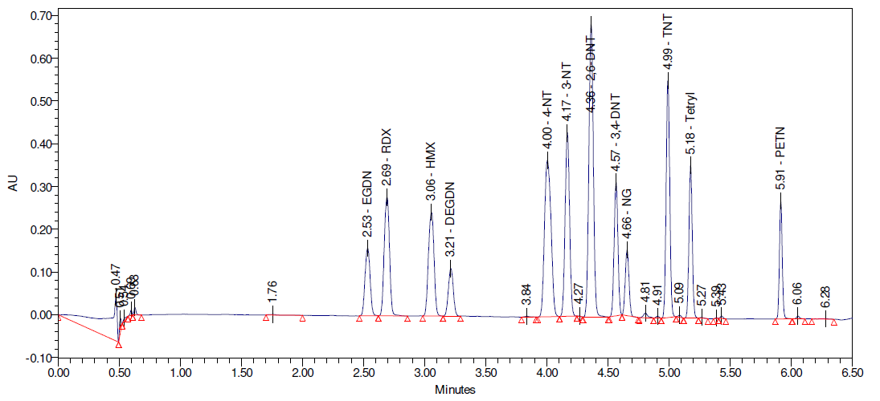
Figure 12: Chromatogram produced by the '2P9_055' method with no guard column fitted, which met all selectivity requirements

With the success of this method at meeting the majority of the end user requirements [12], the next step was to fit a guard column to investigate the effect on method performance. With the guard column fitted, the multi-component standard was run on the instrument and the following chromatogram was produced:
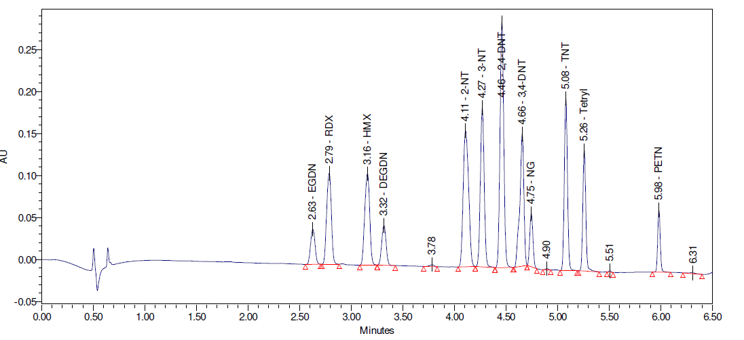
Figure 13: Chromatogram produced by the ‘2P9_055’ method with a guard column fitted
Whilst the addition of a guard column was observed to result in a shift in retention times as expected, the resolution of NG from 3,4-DNT also fell back below the Rs = 1.5 threshold laid out as a performance target, however this was not judged to be detrimental to the method overall as the end user requirements [12] described analysis of the DNTs as ‘if practicable’ and so removal of the DNTs from the method would not preclude validation. Once the basic performance of the method with a guard column was fitted, 11 repeats of the sequence were run in order to provide an initial insight into the repeatability of the method in advance of validation.
The final set of experiments run in the development process was testing of the mass spectrometer as an alternative method for detection and quantification of analytes, however the response was poor, and given that chromatographic separation had been achieved in line with the end user requirements, this was not pursued further.

Method Validation

Repeatability
The first validation experiment conducted was an investigation into the repeatability of the method. For this experiment, single-component standards of each target analyte were prepared by dilution of certified reference materials. All standards were prepared at a concentration of 50ng/μL. Each of these standards was injected into the instrument 11 times, with 2 blank injections between each analyte. The retention time and peak area of each injection was recorded and the mean, standard deviation, and %RSD were calculated to allow the results to be compared to the acceptance criteria. Initial analysis demonstrated acceptable repeatability for all analytes except RDX, for which one injection showed significantly reduced peak area. It was determined that the most likely cause of this was either a bubble in the syringe or poor pickup from the sample vial, and so a new vial of sample was prepared, and the instrument was re-primed, which then yielded RDX results in line with expectations. Example chromatograms for each analyte, as well as blanks, are presented in Appendix 3.

Linearity
The second validation experiment conducted was an investigation into the linearity of the method. For this experiment, multi-component standards containing combinations of the target analytes were prepared across a range of concentrations as per the tables below. Two multi-component standards were chosen to avoid mixing EGDN with DEGDN, or RDX with HMX, as small amounts of HMX exist in the CRM of RDX and vice-versa, and the same is true for EGDN and DEGDN.
Analyte | Concentrations (ng/μL) | Make-up Solvent
EGDN | 1,10,25,50,75,100,250 | ACN
RDX | 1,10,25,50,75,100,250 | ACN
TNT | 1,10,25,50,75,100,250 | ACN
Tetryl | 1,10,25,50,75,100,250 | ACN
Table 1: Components and concentrations of Multicomponent Standard 1

Analyte | Concentrations (ng/μL) | Make-up Solvent
HMX | 1,10,25,50,75,100,250 | ACN
DEGDN | 1,10,25,50,75,100,250 | ACN
NG | 1,10,25,50,75,100,250 | ACN
PETN | 1,10,25,50,75,100,250 | ACN
Table 2: Components and concentrations of Multicomponent Standard 2
The standards were diluted in volumetric flasks, with aliquots dispensed by electronic pipette as per the table below:
Concentration (ng/uL) | Aliquot (μL) | Volumetric Flask (mL)
1 | 20 | 20
10 | 20 | 2
25 | 25 | 1
50 | 50 | 1
75 | 75 | 1
100 | 100 | 1
250 | 250 | 1
Table 3: Aliquot and Volumetric Flask volumes for Standard Preparation
These multi-copmponent standard were injected into the instrument 11 times at each concentration, and the peak area was plotted against the concentration to generate a calibration curve. The r² value of this curve was measured to determine the linearity, with an acceptance criteria of r² > 0.998, and regression analysis was carried out to identify any significant residuals.
Several challenges were experienced during these experiments wherein linearity was poor (r²<0.998) and significant residuals were observed, especially at lower concentrations. This was determined to be due to errors in sample preparation, where a small aliquot (10µL) of standard was used. This was solved by using an electronic pipette with a higher precision of dispensed volume, and ensuring that the minimum aliquot used was 20µL, even if this meant stocks of CRM were consumed faster.

Validation of the Multi-Component Standards
The third validation experiment conducted was the validation of the multi-component standards described in section 4.3.2. Whilst it is desirable to be able to use multi-component standards in order to reduce the number of standards required to be prepared for an analysis, this should not come at the cost of quantitative accuracy. To determine this, each multicomponent was injected twice at 10, 25, 50, 75, and 100ng/μL, followed by 2 injections of each of the single-component standards described in section 4.3.1 (interspersed with blanks between each analyte), followed by standards again. The 4 injections of each standard were used to generate a calibration line within the instrument software, and the single-component standards were quantified based on this. If the measured concentration was within 5% of the prepared concentration, the analyte was deemed to be suitable for inclusion within a multi-component standard, but if the measured concentration fell outside of this range, calibration standards for that analyte would only be single-component in operational use of the method,

Precision and Bias
The Precision and Bias experiments aimed to capture the deviation in results that would be experienced during operational use of the method. To capture this, four operators trained in the method were selected to carry out analysis. Each operator would prepare their own set of calibration standards and prepare fresh eluents, regardless of if the eluent had expired or not. In addition, three different columns would be used during the course of the experiments. By pooling the various outputs of these experiments, the deviation between operators could be determined and bias could be quantified by observing the difference between the prepared and measured concentration of the single-component standards, as was done for the multi-component standard validation. During the first operator’s experiment, a loss in precision was identified and retention times were observed to shift significantly between injections, and the injection peak was observed to also move. Initial investigations determined this to be an issue with the syringe used to inject the samples, and repairs were initiated. However, these repairs were not completed as of the time of writing, and so completion of some further experiments was precluded.

Interferents
An interfering compound is described as ‘any chemical present in the sample which may give an analytical response at a similar retention time to the target analytes.’ [29]. It is important to identify potential interferents during validation, as they can lead to misidentification of analytes or quantitative errors. Based on known components of potential operational samples, the following materials were assessed as potential interferents:

Material | Description
2-NT | Common Additives, identified as potential interferents during method development
3-NT
4-NT
2,4-DNT
3,4-DNT
2,6-DNT
Dimethyl Phthalate (DMP) | Plasticisers, identified as potential interferents based on known sample components
Diethyl Phthalate (DEP)
Dibutyl Phthalate (DBP)
Nitroguanidine (NQ) | Explosive, typically found in Triple-Base propellants. Identified as a potential interferent based on known sample components
Stabilisers Multicomponent | Mixture of propellant stabilisers based on target analytes for a separate stabiliser analysis method. Identified as potential interferents based on known sample components.
Table 4: List of Potential Interferents
To determine if any of these materials did interfere with target analytes, each was injected individually at 50ng/uL to identify their retention times and compare to the known retention times of target analytes. Any compounds then identified as having similar RTs to a target analyte were injected alongside that analyte to determine if they would be resolved. For these experiments, the single-component injections were completed before the instrument failure, however the injection of interferents alongside specific analytes was not complete at the time of writing.

Robustness

Matrix Effects
In addition to the effects of specific interferents as discussed above, the analyte response, and thus the quantitative accuracy, can also be affected by other sample components, known as the sample matrix, and the impacts on the results are known as matrix effects [30]. In order to identify whether there were significant matrix effects from standard explosive samples, the following explosives were analysed.
- Plastic Explosive 8 (PE8)
- Single-Base Propellant
- Two different Double-Base Propellants (Referred to as DB1 and DB2)
To measure matrix effects, each sample was prepared in duplicate, and one of the resulting samples was spiked with reference explosives which were expected to occur in similar matrices. The sample preparation was carried out as follows.
- The explosives were weighed out in duplicate:
  - PE8 Sample 1: 0.51574g
  - PE8 Sample 2: 0.53198g
  - Single-Base Sample 1: 0.48123g
  - Single-Base Sample 2: 0.51687g
  - DB1 Sample 1: 0.51116g
  - DB1 Sample 2: 0.49608g
  - DB2 Sample 1: 0.48769g
  - DB2 Sample 2: 0.51930g
- Each sample was added to a 50mL volumetric flask and approximately 40mL of Acetonitrile was added.
- A magnetic stirrer bar was placed in each flask and left to stir for approximately four hours.
- After stirring all samples were made up to volume with Acetonitrile.
- To bring these samples within the working range of the instrument, they were diluted to a concentration of approximately 50ng/μL.
  - For the propellants this required a 200μL aliquot in a 10mL volumetric flask to bring the NG concentration within the working range.
  - For the PE8, this required a 50μL aliquot in a 10mL volumetric flask to bring the RDX concentration within the working range.
- One of each pair of samples was spiked with Certified Reference Material of a range of explosives before dilution, based on typical analytes known to occur in similar matrices
  - PE8: 200μL each of RDX, PETN, and Tetryl
  - Single-Base: 200μL each of NG, HMX, DEGDN, TNT, PETN
  - DB1: 200μL each of NG, HMX, DEGDN, TNT, PETN
  - DB2: 200μL each of NG, HMX, EGDN, TNT, PETN
To analyse the matrix effects, the concentration of each analyte in the spiked solutions would be compared to the unspiked solutions. A paired t-test would then be used to determine if there was any significant difference between the measured difference in concentration and the known concentration of the CRM spikes. These samples had been prepared before the instrument failure discussed in Section 4.2.4 occurred but they had not been analysed.

Stability
Stability experiments investigated two separate areas of standard stability. The first was the stability of the standards over 24 hours to verify that peak areas would remain consistent over the typical operational runtime of the instrument, and thus that quantitative accuracy would not be lost. This required repeat injections of standards over 24 hours across the expected working range of the instrument. The following sequence was repeated 13 times to make up a 24hr sequence:
- Multi 1 10ng/µL
- Multi 1 50ng/µL
- Multi 1 100ng/uL
- Multi 2 10ng/µL
- Multi 2 50ng/µL
- Multi 2 100ng/uL
- 10x ACN Blanks
Initial testing was carried out with all standards in one sequence, however it was identified that better results would be achieved by injecting separate sequences for each set of standards. Completion of these reviewed experiments was not achieved at the time of the instrument failure.
The second area of stability investigated involved determining the shelf life of the standards. This involved preparing a set of each of the standards at 10, 50 and 100ng/µL, and injecting the each alongside a freshly prepared set on days 1, 3, 7, 14, 21, and 28 after preparation to determine if the difference in peak area between the sets varied significantly. Data was captured up to Day 14, however operational use of the instrument and instrument failure interrupted these experiments and so they are to be restarted following instrument repair.

Chapter 5 – Analysis of Results

5.1 Method Development
Following the iterations on the method, and the successful achievement of Resolution > 1.5 for all analytes, the results of the new method were compared to those of the original gradient and Method 22 to quantify the improvements. The following charts were produced to visualise this data:

Figure 14: Comparison of peak areas for each analyte from the tested methods

Figure 15: Comparison of peak heights for each analyte from the tested methods

Figure 16: Comparison of peak resolutions for each analyte from the tested methods

From this data, it is shown that the new method provided significant increases in peak area and peak height for all analytes when compared to the original method and Method 22. In addition, whilst some individual peak resolutions were reduced by the new method, they all remained above the acceptance threshold of 1.5, and with the successful resolution of Tetryl, it served to confirm that the new method met all the criteria laid out in the method development plan to move forwards to guard column experiments.
When the guard column tests were complete, they illustrated that the overall performance impact on the method was minimal, with the exception of the resolution of NG being reduced below the Rs =1.5 threshold. After reviewing the End User Requirements for the method [12], it was determined that since the analysis of DNTs was stated to only be required ‘if practicable’, removing them from the list of analytes and reclassifying them as interferents would be an acceptable action and would not preclude validation.

5.2 Method Validation

5.2.1 Repeatability
As described in section 4.3.1, the retention times and peak areas for the 11 injections of each analyte were recorded, and the mean, standard deviation, and %RSD were calculated. These are presented in the tables below:
RT (min) | Analyte |  | EGDN | RDX | HMX | DEGDN | NG | TNT | Tetryl | PETN
RT (min) | Injection | 1 | 2.585 | 2.733 | 3.092 | 3.256 | 4.681 | 5.018 | 5.196 | 5.925
RT (min) | Injection | 2 | 2.583 | 2.741 | 3.092 | 3.255 | 4.685 | 5.019 | 5.196 | 5.925
RT (min) | Injection | 3 | 2.585 | 2.743 | 3.094 | 3.253 | 4.685 | 5.022 | 5.193 | 5.923
RT (min) | Injection | 4 | 2.584 | 2.744 | 3.096 | 3.252 | 4.686 | 5.019 | 5.192 | 5.924
RT (min) | Injection | 5 | 2.585 | 2.747 | 3.098 | 3.256 | 4.683 | 5.019 | 5.194 | 5.921
RT (min) | Injection | 6 | 2.585 | 2.745 | 3.095 | 3.256 | 4.684 | 5.018 | 5.197 | 5.921
RT (min) | Injection | 7 | 2.584 | 2.743 | 3.094 | 3.257 | 4.687 | 5.018 | 5.199 | 5.922
RT (min) | Injection | 8 | 2.584 | 2.748 | 3.095 | 3.256 | 4.682 | 5.015 | 5.196 | 5.919
RT (min) | Injection | 9 | 2.584 | 2.745 | 3.096 | 3.259 | 4.685 | 5.017 | 5.199 | 5.922
RT (min) | Injection | 10 | 2.585 | 2.745 | 3.096 | 3.258 | 4.685 | 5.018 | 5.198 | 5.922
RT (min) | Injection | 11 | 2.583 | 2.743 | 3.095 | 3.258 | 4.686 | 5.018 | 5.198 | 5.92
RT (min) | Mean |  | 2.584 | 2.743 | 3.095 | 3.256 | 4.684 | 5.018 | 5.196 | 5.922
RT (min) | Standard Deviation |  | 0.00079 | 0.00396 | 0.00178 | 0.00210 | 0.00181 | 0.00168 | 0.00236 | 0.00194
RT (min) | %RSD |  | 0.0304% | 0.1442% | 0.0575% | 0.0644% | 0.0386% | 0.0335% | 0.0454% | 0.0328%
Table 5: Mean, Standard Deviation, and %RSD of retention times for each analyte as calculated from Repeatability experiments
Peak Area  (AU*sec) | Analyte |  | EGDN | RDX | HMX | DEGDN | NG | TNT | Tetryl | PETN
Peak Area  (AU*sec) | Injection | 1 | 356017 | 590277 | 674447 | 298090 | 356863 | 713245 | 655282 | 329921
Peak Area  (AU*sec) | Injection | 2 | 353451 | 588115 | 681404 | 296464 | 358055 | 714388 | 663162 | 328356
Peak Area  (AU*sec) | Injection | 3 | 358785 | 589154 | 670623 | 295116 | 357806 | 715606 | 668904 | 330215
Peak Area  (AU*sec) | Injection | 4 | 354135 | 589099 | 670471 | 298528 | 356859 | 716951 | 669495 | 329726
Peak Area  (AU*sec) | Injection | 5 | 354382 | 591670 | 683811 | 292320 | 358678 | 714333 | 670896 | 329601
Peak Area  (AU*sec) | Injection | 6 | 354314 | 587552 | 683073 | 294951 | 359184 | 716731 | 677367 | 329957
Peak Area  (AU*sec) | Injection | 7 | 356382 | 587187 | 672289 | 296125 | 356714 | 714786 | 671707 | 331703
Peak Area  (AU*sec) | Injection | 8 | 354928 | 588741 | 675704 | 296030 | 355953 | 716222 | 678546 | 328844
Peak Area  (AU*sec) | Injection | 9 | 354535 | 588851 | 675224 | 295423 | 358769 | 716663 | 677990 | 329977
Peak Area  (AU*sec) | Injection | 10 | 354567 | 586288 | 674137 | 300060 | 357094 | 719486 | 677367 | 329292
Peak Area  (AU*sec) | Injection | 11 | 353387 | 590202 | 672604 | 296870 | 358031 | 719338 | 676670 | 329944
Peak Area  (AU*sec) | Mean |  | 354989 | 588831 | 675799 | 296362 | 357637 | 716159 | 671581 | 329776
Peak Area  (AU*sec) | Std.  Dev |  | 1558.204 | 1534.054 | 4807.866 | 2062.778 | 1015.078 | 1988.478 | 7286.836 | 847.400
Peak Area  (AU*sec) | %RSD |  | 0.439% | 0.261% | 0.711% | 0.696% | 0.284% | 0.278% | 1.085% | 0.257%
Table 6: Mean, Standard Deviation, and %RSD of peak areas for each analyte as calculated from Repeatability Experiments

5.2.2 Linearity and Working Range
As described in section 4.2.2, experiments were carried out to investigate the linearity and working range of the instrument. The r² values across the entire tested range (1-250ng/uL) are presented in Table 7 below, and the graphs produced for each analyte are shown in Appendix 3
Analyte | r² (1-250ng/µL)
EGDN | 0.9992
RDX | 0.9995
HMX | 0.9992
DEGDN | 0.9987
NG | 0.9988
TNT | 0.9998
Tetryl | 0.9987
PETN | 0.9982
Table 7: r² values for analytes as demonstrated during linearity experiments
To determine the actual working range of the method, regression analysis was carried out on the calibration lines to determine if there were significant residuals (Differences between the values predicted by the curve and the true values).
For all analytes, residuals were identified when the full concentration range of 1-250ng/µL. When the working range was reduced to 10-100ng/µL, residuals reduced to within an acceptable range for all analytes Multicomponent 1. Initial checks of Multicomponent 2 appeared to show less residuals however upon later review, they were determined to be unacceptably large no matter the selected working range, especially lower in the concentration range. This was determined to be due to the sample preparation errors outlined in Section 4.2.2 and so it is planned to repeat this experiment once the instrument repairs are complete.

Conc.  (ng/µL) | Average Residuals for 1-250ng/µL (%)
Conc.  (ng/µL) | EGDN | RDX | TNT | Tetryl | HMX | DEGDN | NG | PETN
1 | -50.3 | -60.0 | -437.1 | -108.2 | 603.1 | -134.4 | -164.5 | -171.3
10 | -16.5 | -10.9 | -3.2 | -41.4 | -8.6 | 29.0 | 15.1 | 1.6
25 | -0.7 | -3.1 | -5.9 | -16.0 | 9.2 | -16.8 | -18.6 | -19.6
50 | -1.1 | 1.1 | -2.4 | -6.9 | -2.6 | -5.3 | -4.1 | -4.4
75 | 2.7 | 2.0 | 0.5 | -3.8 | 1.2 | 1.4 | 1.4 | 5.3
100 | 2.8 | 1.6 | 2.2 | 0.18 | -1.9 | 0.6 | 2.3 | 1.6
250 | -0.6 | -0.5 | -0.2 | 0.6 | 0.3 | 0.1 | -0.2 | -0.4
Table 8: Average % Residuals at each concentration level for linearity experiments between 1 and 250 ng/µL
Conc.  (ng/µL) | Average Residuals for 10-100ng/µL (%)
Conc.  (ng/µL) | EGDN | RDX | TNT | Tetryl | HMX | DEGDN | NG | PETN
10 | -1.8 | -0.8 | 14.8 | 92.1 | -6.1 | 55.4 | 31.5 | 11.5
25 | 2.8 | -0.9 | -2.2 | -10.4 | 10.7 | -13.6 | -16.1 | -17.26
50 | -1.8 | 0.6 | -2.2 | -3.9 | -2.2 | -3.8 | -2.9 | -3.4
75 | 0.5 | 0.5 | -0.4 | -1.6 | 1.4 | 2.1 | 2.0 | 5.9
100 | 0 | -0.4 | 0.8 | 2.0 | -1.8 | 0.9 | 2.6 | 1.8
Table 9: Average % Residuals at each concentration level for linearity experiments between 10 and 100ng/µL
The tables above show that within a working range of 10-100ng/µL, most analytes do not exhibit significant residuals. The high residuals of TNT and Tetryl at low concentrations (highlighted yellow) are suspected to be due to the breakdown of tetryl in solution and will be further investigated following instrument repair. The high residuals of HMX, DEGDN, NG, and PETN are discussed above and will be investigated with a repeat experiment following instrument repair.

5.2.3 Validation of Multi-Component Standards
As described in section 4.3.3, experiments were carried out to investigate the suitability of the multi-component standards for quantitative analysis. The results are presented in Table 10 below.
Analyte | Prepared Concentration (ng/μL) | Measured Concentration (ng/μL) | %Difference
EGDN | 50 | 53.15 | 6.3%
RDX | 50 | 50.45 | 0.9%
HMX | 50 | 51.6 | 3.2%
DEGDN | 50 | 49.9 | -0.2%
NG | 50 | 54.8 | 9.6%
TNT | 50 | 49.55 | -0.9%
Tetryl | 50 | 48.35 | -3.3%
PETN | 50 | 50.05 | 0.1%
Table 10: Prepared vs Measured Concentrations of the Single-Component Standards as seen in the Multicomponent Validation Experiments.
For NG and EGDN, the difference between prepared concentration and actual concentration was outside of the ±5% acceptance criteria. To verify that this was not an integration issue, the peaks of the samples and the 50ng/µL standards were overlaid in the software and observed to have visibly different peak areas. These overlays are presented below.
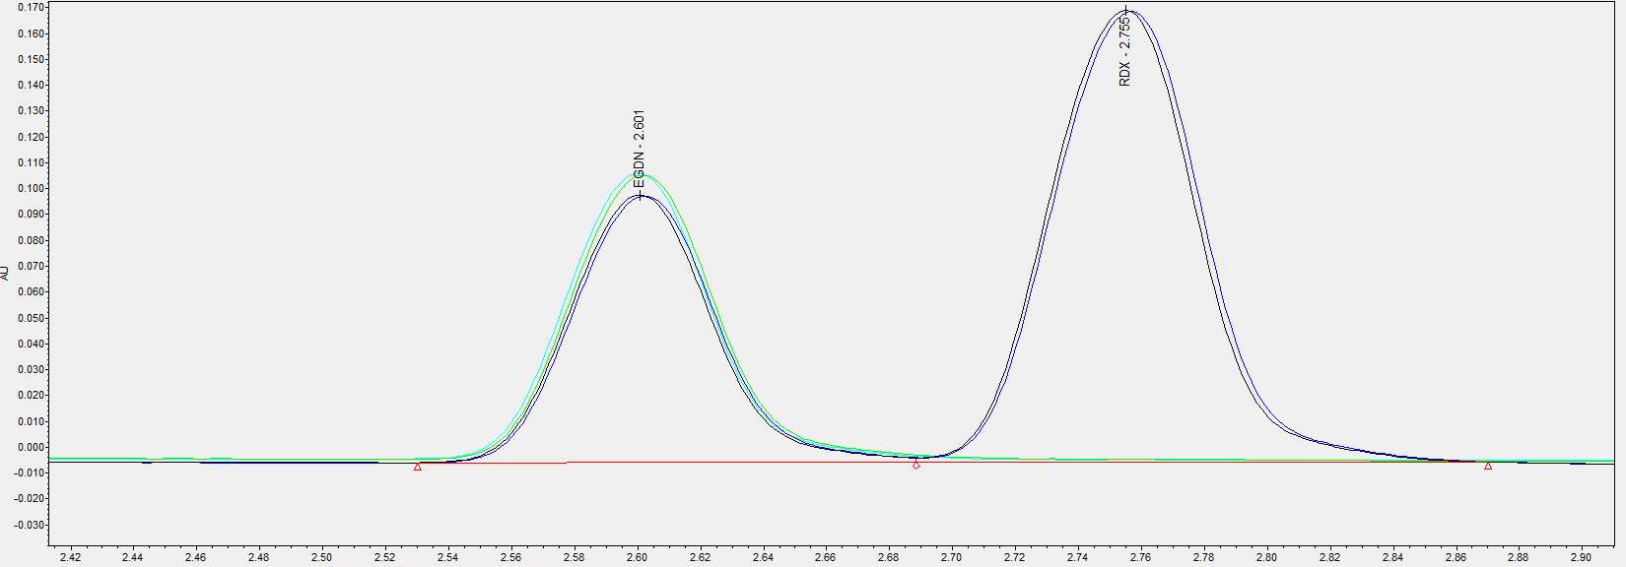
Figure 17: Overlay of peaks from multicomponent standard validation showing the difference between sample (larger peaks) and standard (smaller peaks) for EGDN at 50ng/µL
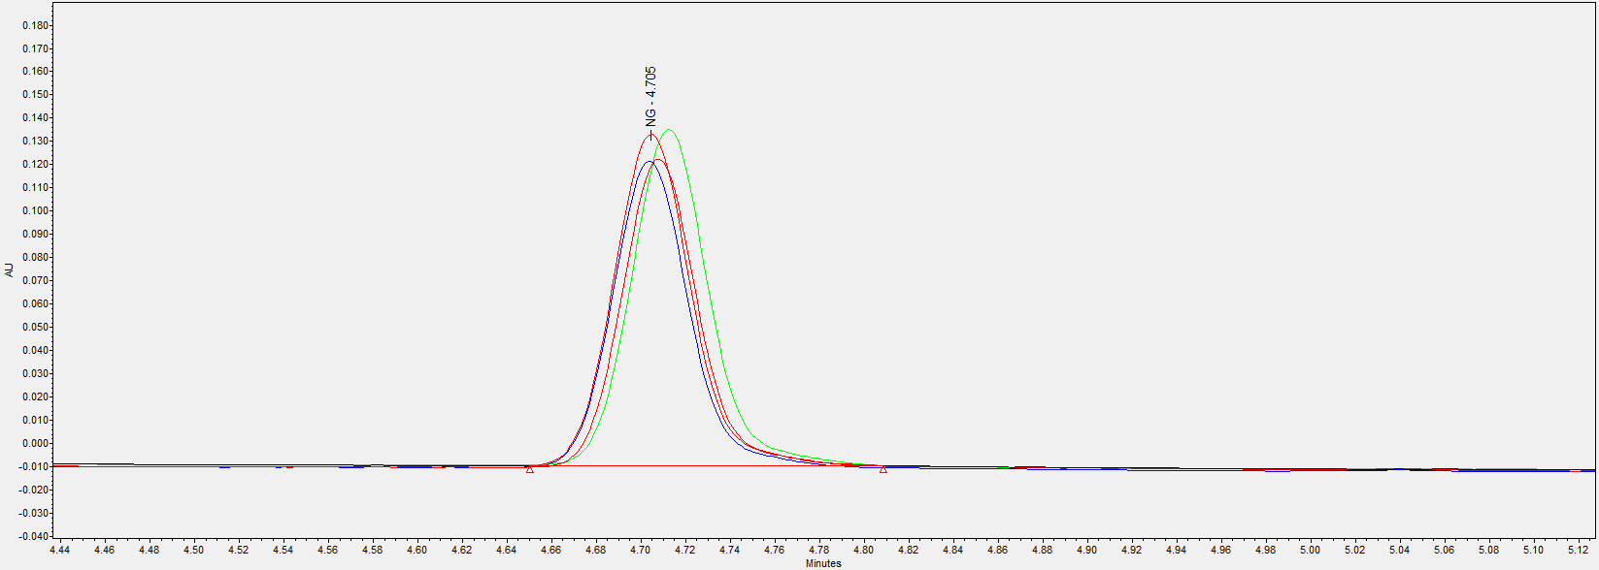
Figure 18: Overlay of peaks from multicomponent standard validation showing the difference between sample (larger peaks) and standard (smaller peaks) for NG at 50ng/µL
Given this difference, it was determined that NG and EGDN were not suitable for inclusion in multi-component standards and so for all following experiments, they were injected as single-component standards for calibration.

5.2.4 Precision and Bias
Due to the instrument failure occurring during the first set of precision and bias experiments, no results have been acquired or analysed at the time of writing. When the instrument repairs are complete, work will continue.

5.2.5 Interferents
A sequence of injections containing each potential interferent was analysed, the results of which are presented in the table below, and the chromatograms from which are presented in Appendix 3.
Material | Observations
2-NT | RT 4.090 min. Non-interfering
3-NT | RT 4.239 min. Non-interfering
4-NT | RT 4.083 min. Non-interfering
2,4-DNT | RT 4.420 min. Non-interfering
3,4-DNT | RT 4.630 min. Potential Interferent for NG
2,6-DNT | RT 4.433 min. Non-interfering
Dimethyl Phthalate (DMP) | RT 2.890 min. Potential Interferent for RDX and/or HMX
Diethyl Phthalate (DEP) | RT 4.575 min. Potential Interferent for NG
Dibutyl Phthalate (DBP) | RT 5.055 min. Potential Interferent for TNT
Nitroguanidine (NQ) | No RT – Does not elute. Non-interfering
Stabilisers Multicomponent | Peaks at 2.86, 4.89, 5.82, 6.05 minutes. Potential Interferent for RDX/HMX/TNT/PETN
Table 11: Observations from initial interferent analysis
To assess whether the potential interferents identified above were baseline resolved from the relevant analytes, the following solutions were prepared with all components at 50ng/μL. The instrument failure occurred after these samples had been prepared but before they were analysed, and so no results were produced to definitively determine resolution between analytes and suspected interferents

Solution | Contents
Interferent Combo 1 | 3,4-DNT+NG
Interferent Combo 2 | DMP+RDX+HMX
Interferent Combo 3 | DEP+NG
Interferent Combo 4 | DBP+TNT
Interferent Combo 5 | Stabilisers Multi+RDX+HMX+TNT+PETN
Table 12: Solutions prepared to determine resolution of interferents

5.2.6 Robustness

5.2.6.1 Matrix Effects
Matrix effect samples were prepared before instrument failure occurred but were not analysed, and so no results were produced. These samples are to be analysed following instrument repair.

5.2.6.2 Stability
During the repeat injections to determine 24-hour stability, all analytes other than TNT and Tetryl exhibited deviations of ±3% or less from the mean in their peak areas across all three concentrations tested. TNT was observed to deviate up to 10% from the mean peak area at 10ng/µL, and Tetryl was observed to deviate up to 15% from the mean peak area at 10 and 50ng/µL. This was suspected to be due to the instability of Tetryl in solution, and the fact that these two analytes elute alongside one another, leading to breakdown products and peak shape changes of Tetryl affecting the peak shape of TNT. The tables below describe the observed deviations.

10ng/µL
Analyte | % Deviation in 24hrs (Largest Peak Area) | % Deviation in 24hrs (Smallest Peak Area)
EGDN | 2.3% | -2.4%
RDX | 0.3% | 0.5%
TNT | 9.6% | -5.8%
Tetryl | 15.5% | -11.8%
HMX | 0.2% | -0.2%
DEGDN | 2.6% | -2.5%
NG | 1.4% | -0.8%
PETN | 2.2% | -1.3%
Table 13: Deviation in Peak Area over 24 hours for all analytes at 10ng/µL

50ng/µL
Analyte | % Deviation in 24hrs (Largest Peak Area) | % Deviation in 24hrs (Largest Peak Area)
EGDN | 0.7% | -1.1%
RDX | 0.4% | -0.5%
TNT | 1.7% | -1.4%
Tetryl | 6.2% | -15.2%
HMX | 0.1% | -0.1%
DEGDN | 0.6% | -0.8%
NG | 0.7% | -0.8%
PETN | 0.6% | -1.0%
Table 14: Deviation in Peak Area over 24 hours for all analytes at 50ng/µL

100ng/µL
Analyte | % Deviation in 24hrs (Largest Peak Area) | % Deviation in 24hrs (Largest Peak Area)
EGDN | 1.4% | -1.9%
RDX | 1.3% | -0.9%
TNT | 0.5% | -0.4%
Tetryl | 1.0% | -0.4%
HMX | 0.5% | -0.4%
DEGDN | 0.7% | -0.9%
NG | 0.8% | -1.0%
PETN | 0.9% | -0.7%
Table 15: Deviation in Peak Area over 24 hours for all analytes at 100ng/µL
For the 28-Day stability, instrument breakdowns and operational use of the instrument prevented sufficient data being gathered to identify a trend in peak area over the 28 days. It was identified from the limited data gathered that Tetryl would likely be unstable in storage, in line with other experiments and previous research.

Chapter 6 - CONCLUSIONS AND RECOMMENDATIONS

Conclusions

Review of Objectives
The aim of this research was to develop and validate INS/SM085 for use within the Forensic Explosives Laboratory’s Chemical Analysis Service. Although full completion of the validation was delayed due to the instrument failure, significant progress was still made against all but one of the original project objectives, those being:
- Identify best practice in UHPLC Analysis and method design, and understand how this can be applied to INS/SM085.
  - Objective complete. Literature review conducted and understanding of uHPLC techniques applied to Method Development plan.
- Identify and implement improvements to the method based on previous and new research.
  - Objective complete. Method development carried out delivering tangible improvements to method performance, with improved peak area and selectivity.
- Demonstrate compliance of INS/SM085 with quality guidelines and validation procedures, and the end user requirements.
  - Objective partially complete. Method validation experiments were paused due to instrument failure however all experiments conducted at the time of writing either demonstrate compliance with end user requirements or, if they do not, a cause has been identified. A plan is in place to resume the work at the nearest opportunity to complete remaining experiments.
- Issue INS/SM085 into the FEL Quality Management System (QMS).
Objective incomplete. Until validation has been completed, the method will not be able to be issued. This objective will be completed once validation resumes.

Method Development
The method development experiments carried out aimed to introduce improvements to the method performance based on shortcomings identified during previous research and operational use. Through the selection of a new column more suitable for the analysis of compounds containing nitro groups and changes to the composition, flow rate, and gradient of the mobile phase, the selectivity and analyte response was improved and the shortcomings were successfully mitigated. However, owing to co-elution and interferences with other analytes, analysis of NT and DNT isomers was determined not to be practicable whilst retaining the ability to analyse a wide range of explosives.

Method Validation
The method validation experiments aimed to demonstrate that the method was suitable for operational use. In the course of these experiments, the following conclusions were reached. For repeatability: the method demonstrated acceptable repeatability for all target analytes and met the acceptance criteria described in the end user requirements For linearity: all analytes were determined to produce acceptable calibration curves with r² values and working ranges meeting the acceptance criteria described in the end user requirements. A repeat experiment to verify performance of Multicomponent 2 is planned following instrument repair. For validation of the multi-component standards: NG and EGDN were determined to be unsuitable for inclusion in multi-component standards and so the method was updated to reflect this. For precision and bias: during these experiments, a loss of precision was observed with retention times shifting significantly between injections. No useful data had been gathered as of the time of writing but additional experiments are planned once the instrument has been repaired.
For interferents: potential interferents were identified through comparison of retention times of the potentially interfering compounds to the retention times of the analytes. Further work is required to determine resolution between analytes and interferents as instrument failure precluded this work being carried out in the original timeframe. For matrix effects: it was not possible to determine the matrix effect for any analyte at the time of writing due to instrument failure, and so further work is required to carry out these experiments and determine matrix effects once the instrument repairs are complete. For stability: initial experiments suggested that standards were acceptably stable over 24 hours, and that all analytes except tetryl would be shelf-stable for an acceptable period, however the interruption of these experiments by the instrument breakdown will require additional work and repeats following instrument repair.

RecComendations for Further Research
Given the interruption in experiments caused by the instrument failure, the following actions are required to complete the validation:
- Repeat of Multicomponent Standard 2 and NG Linearity based on review of initial data.
- Complete all precision and bias experiments.
- Resume interferent and matrix effect experiments.
- Restart and complete stability experiments.
In addition to completion of validation, several subjects have been identified that could be of interest as topics for further study or development
- Development of a method for the quantitative analysis of Nitrotoluenes and Dinitrotoluenes.
  - Although the end user requirements specified that NTs and DNTs should only be included in the method ‘if practicable’, there is still a potential requirement to quantify these materials and so research could be conducted to identify the best technique for this analysis and develop an appropriate method.
- Improved understanding of the behaviour of Tetryl in solution.
  - During the validation experiments, the breakdown of Tetryl in solution presented a number of challenges to the preparation and storage of standards. Research could be conducted to characterise the breakdown products and investigate if alternative techniques would be more suited to the quantitative analysis of Tetryl.

- Inclusion of Additional Analytes to INS/SM085.
  - This research has been focused solely on the target analytes prescribed in the end user requirements. There is potential scope for research into the inclusion of additional analytes, such as R-Salt, to the method.

Chapter 7 – Reflections

This research has provided an opportunity to improve understanding of best practice in uHPLC analysis and method development. The importance of selecting the correct pairing of column and mobile phase to match the chemistry of the analytes was demonstrated through the improvements made to selectivity by altering these aspects. In retrospect, time spent on administrative tasks such as review of internal documents could have been managed more effectively, and doing so would likely have meant that the method validation experiments could have begun at an earlier date, and so the effects of the instrument breakdown could have been mitigated, leading to these tasks being completed on time.

chapter 8 - REFERENCES

[1] | HM Government, “Dstl Marks 150 year history of its forensic explosives laboratory,” 11 August 2021. [Online]. Available: https://www.gov.uk/government/news/dstl-marks-150-year-history-of-its-forensic-explosives-laboratory.
[2] | Forensic Science Regulator, Code of Practice Version 2, London: HMG, 2025.
[3] | BSI Standards, BS EN ISO/IEC17025:2017 General requirements for the competence of testing and calibration libraries, BSI Standards, 2017.
[4] | Anonymous, INS/SM085 Quantitative Analysis of Explosives using UPLC (DRAFT) - OFFICIAL, Dstl, 2023.
[5] | Anonymous, QUA/QP022 Management and Conduct of Validation (Issue 03) - OFFICIAL, 2023.
[6] | International Union of Pure and Applied Chemistry, “"Chromatography" in "IUPAC Gold Book",” 2025. [Online]. Available: https://goldbook.iupac.org/terms/view/C01075. [Accessed 29 January 2026].
[7] | Agilent Technologies, “HPLC Fundamentals,” Agilent Technologies, 2026. [Online]. Available: https://www.agilent.com/en/product/liquid-chromatography/hplc-fundamentals?Campaign_Source=PAN_PSM_LPSD_B&gclid=4166119970bd17f0c6f8782809cb3327&gclsrc=3p.ds&msclkid=4166119970bd17f0c6f8782809cb3327&utm_source=bing&utm_medium=cpc&utm_campaign=B_PS_NBr_HPL. [Accessed 11 March 2026].
[8] | V. Ganesh, P. Poorna Basuri, K. Sahini and C. Nalini, “Retention Behaviour of Analytes in Reversed-Phase High-Performance Liquid Chromatography - A Review",” Biomedical Chromatography, vol. 37, no. 7, 2023.
[9] | L. R. Snyder and J. W. Dolan, High-Performance Gradient Elution: The Practical Application of the Linear Solvent Strength Model, John Wiley and Sons, 2007.
[10] | Waters, ACQUITY Premier eλ Photodiode Array (eλ PDA) Detector Overview and Maintenance Guide, Waters, 2022.
[11] | Cooksey, “Spectrophotometry,” NIST, 26 March 2025. [Online]. Available: https://www.nist.gov/programs-projects/spectrophotometry. [Accessed 9 March 2026].
[12] | S. G. Blevins and Anonymous, “Dstl/DOC132869 INS/SM085: Quantitative Analysis of Explosives using UPLC: End User Response - OFFICIAL,” Dstl, Salisbury, 2025.
[13] | S. G. Blevins, “Integrated Project Plan: Method Development and Valiation of INS/SM085: Quantitative Analysis of High Explosives using UHPLC - OFFICIAL,” Dstl, 2025.
[14] | S. G. Blevins, INS/SM085 Validation - FCDP 25/26 Start Up Meeting - OFFICIAL, Salisbury: Dstl, 2025.
[15] | S. G. Blevins, “DSTL/TR169320 OME Degree Apprenticeship Major Project Proposal - Validation of a UHPLC Method for the Quantitative Analysis of High Explosives - OFFICIAL,” Dstl, Salisbury, 2025.
[16] | S. G. Blevins, “DSTL/TR169591 INS/SM085 Quantitative Analysis of Explosives using UPLC: Method Development Plan - OFFICIAL,” Dstl, Salisbury, 2025.
[17] | S. G. Blevins, “INS/SM085: Method Development Summary - OFFICIAL,” Dstl, Salisbury, 2025.
[18] | S. G. Blevins, “DSTL/TR174566 INS/SM085: ‘Quantitative analysis of explosives using uHPLC-UV’ Validation Report - OFFICIAL,” Dstl, Salisbury, 2025.
[19] | Anonymous, “Development of a uHPLC-MS method for the analysis of explosives - OFFICIAL,” Dstl, Salisbury, 2021.
[20] | D. DeTata, P. Collins and A. McKinlet, “A fast liquid chromatography quadrupole time-of-flight mass spectrometry (LC-QToF-MS) method for the identification of organic explosives and propellants,” Forensic Science International, vol. 233, no. 1-3, pp. 63-74, 2013.
[21] | NIST Mass Spectrometry Data Centre, “Trinitrotoluene,” NIST, 2025. [Online]. Available: https://webbook.nist.gov/cgi/cbook.cgi?ID=C118967&Mask=200. [Accessed 14 May 2025].
[22] | NIST Mass Spectrometry Data Centre, “Nitroglycerine,” NIST, 2025. [Online]. Available: https://webbook.nist.gov/cgi/cbook.cgi?ID=C55630&Mask=200. [Accessed 14 May 2025].
[23] | NIST Mass Spectrometry Data Centre, “Tetryl,” NIST, 2025. [Online]. Available: https://webbook.nist.gov/cgi/inchi?ID=C479458&Mask=200. [Accessed 14 May 2025].
[24] | A. E. Contini, N. Flood, D. McAteer, N. Mai and J. Akhavan, “Low hazard small-scale synthesis and chemical analysis of high purity nitroglycerine (NG),” RSC Advances, vol. 5, no. 106, pp. 87228-87232, 2015.
[25] | Welch Materials, “A Comprehensive Guide to Guard Columns and Pre-Columns,” Welch Materials, 20 March 2025. [Online]. Available: https://www.welch-us.com/blogs/knowleage-base/comprehensive-guide-to-guard-columns-and-pre-columns. [Accessed 20 May 2025].
[26] | T. Miyayama, P.-S. Tsou, S.-M. Fung and H.-L. Fung, “Simeltaneous Determination of Nitroglycerin and Dinitrate Metabolites in Metabolism Studies using Liquid Chromatography-Mass Spectrometry with Electrospray Ionisation,” Journal of Chromatography B, pp. 21-26, 2006.
[27] | Waters, “What is the maximum percent formic acid solution that can be used with an LC/MS? - WKB198101,” Waters Knowledge Base, 21 December 2021. [Online]. Available: https://support.waters.com/KB_Chem/Other/WKB198101_What_is_the_maximum_percent_Formic_Acid_solution_that_can_be_used_with_an_LC_MS. [Accessed 6 June 2025].
[28] | Forensic Science Regulator, FSR-G-201 Guidance on Validation (Issue 2), London: HMG, 2020.
[29] | S. G. Blevins, “DSTL/TR133976 INS/SM085: Quantitative Analysis of explosives using uHPLC-UV Validation Plan - OFFICIAL,” Dstl, Salisbury, 2025.
[30] | A. Freitas, J. Barbosa and F. Ramos, “Matrix Effetcts in Ultra-High-Performance Liquid Chromatography-Tandem Mass Spectrometry Antibiotic Milti-Detection Methods in Food Products with Animal Origins,” Food Analytical Methods, vol. 9, pp. 23-29, 26.

chapter 9 - BIBLIOGRAPHY

- A. Braithwaite and F. J. Smith, Chromatographic Methods (Fourth Edition), London: Chapman and Hall, 1985.
- J. Yinon and S. Zitrin, Modern Methods and Applications in Analysis of Explosives, Chichester: John Wiley & Sons, 1996.
- British Standards Institution, BS EN ISO17034:2016 General Requirements for the Competence of Reference Material Producers, London: BSI Standards Limited, 2016.
- Anonymous, LAB/SOP054 Standard Explosives and Preparation of Standard Solutions - OFFICIAL, Salisbury: Dstl, 2024.

APPENDICES

Appendix 1 PROJECT MANAGEMENT

Figure A - 1: GANTT Chart with planned vs actual dates

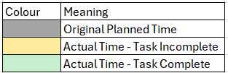
Figure A - 2: Key to GANTT Chart

Appendix 2 Logbook

Date | Activities Conducted
01/04/2025-17/04/2025 | Internal Dstl IPP and Presentation on the project were prepared and reviewed by the Project Technical Authority (PTA)
28/04/2025 | Presentation on Project Proposal given to FEL Project Management Team
30/04/2025 | Training Session familiarising myself with the current method.
14/05/2025 | Began working on internal literature review to identify method development options
19/05/2025 | Discussion of literature and development options with my mentor, formalising of plans and timelines
20/05/2025 | Began drafting Project Proposal and considering ideas for method development based on earlier discussions
29/05/2025 | Began drafting method development plan. Putting all ideas from discussions and literature reviews onto paper.
02/06/25 | Ran some HMX samples on the instrument to improve my understanding of the quantitation functions
03/06/2025 | Sent first draft of Method Development plan for review by Mentor
05/06/2025 | Session in the lab with my mentor to build understanding of method development and run some initial experiments on alternative columns
06/06/2025 | Reviewed feedback on first draft of method development plan and updated it to reflect the results of the initial experiments conducted 05/06/2025  Final Project Proposal approved for publication and submitted to university
13/06/2025 | Received feedback on second draft of Method Development Plan and wrote third draft. Clear plan now in place for development experiments
24/06/2025-26/06/2025 | Attended LGC Method Validation Course to gain understanding of validation techniques and form part of my FEL competency in Method Validation
30/06/2025-01/07/2025 | Carried out an experiment to determine retention times on the new column and improve understanding of its’ behaviour. Collected mass spectra for all explosive analytes
02/07/2025-03/07/2025 | Carried out an experiment to demonstrate the instruments ability to identify explosives by SIM based on the spectra collected on 1/7. Built understanding of how to edit the method.
July-September 2025 | Carried out further method development experiments. Refined the gradient to optimise analyte separation.
September-December 2025 | Completed the method development report and drafted the method development plan
January-March 2026 | Carried out method validation experiments and worked on validation report
February 2026 | Instrument failure occurred when significant retention time drift occurred during precision and bias experiments. Spare parts ordered but did not arrive in time to repair the instrument and complete experiments before report submission.
14/03/2026 | Dissertation completed and submitted for Permission to Publish
20/03/2026 | Dissertation, Poster, and Viva submitted.
Table A - 1: Project Logbook

Appendix 3 Chromatograms and plots

This appendix contains a series of chromatograms and other plots produced during the research which aid understanding of the processes followed but were deemed unnecessary to include in the main body of text.

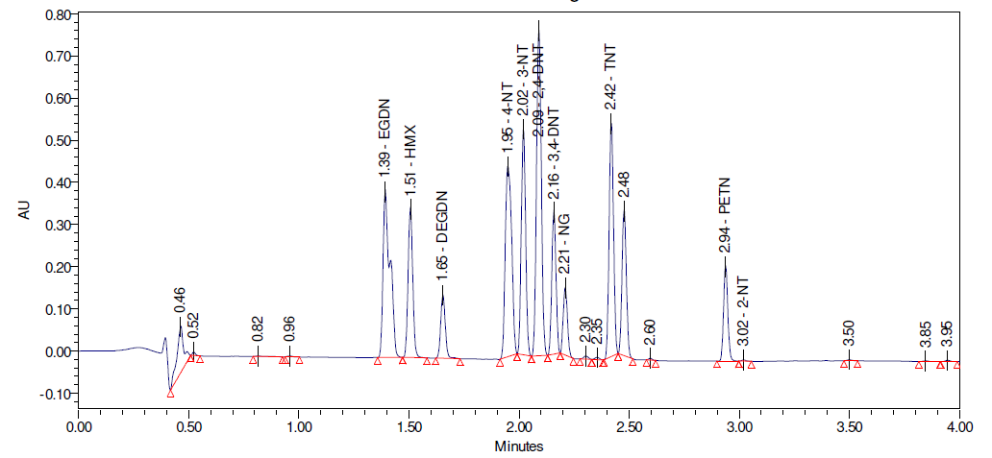
Figure A - 3: Method Development Chromatogram 'PhenylACN3090' method
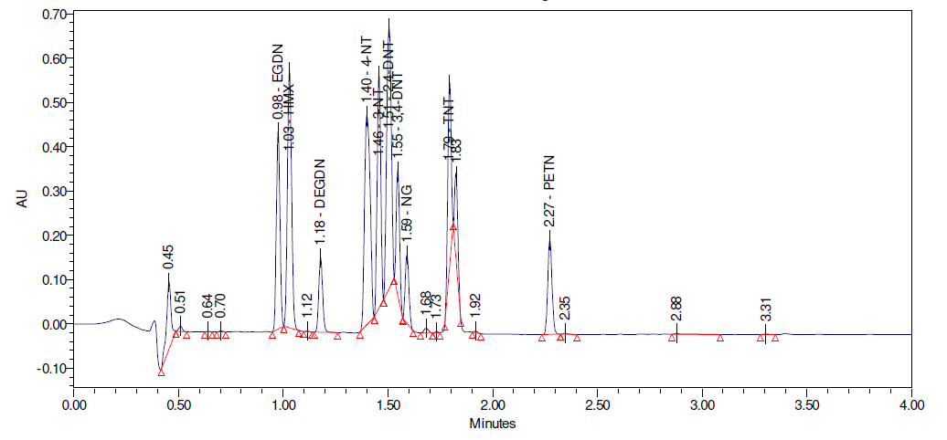
Figure A - 4: Method Development Chromatogram 'PhenylACN4090' method

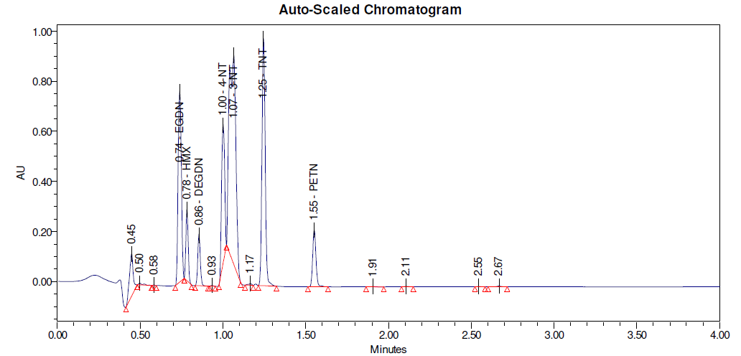
Figure A - 5: Method Development Chromatogram 'PhenylACN5090' method
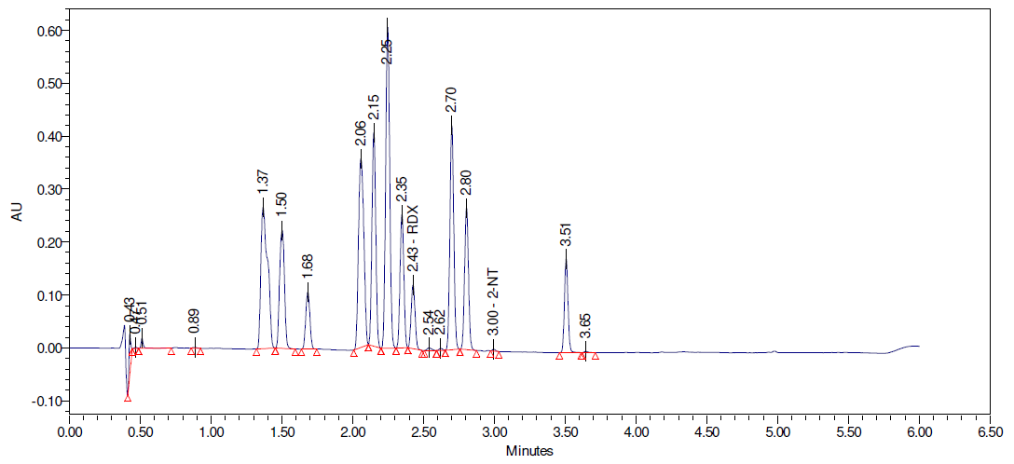
Figure A - 6: Method Development Chromatogram 'PhenylACN3070' method
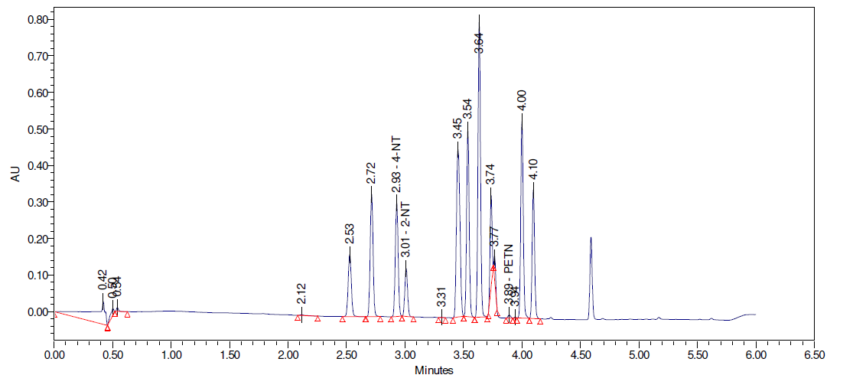
Figure A - 7: Method Development Chromatogram 'PhenylACN1070' method
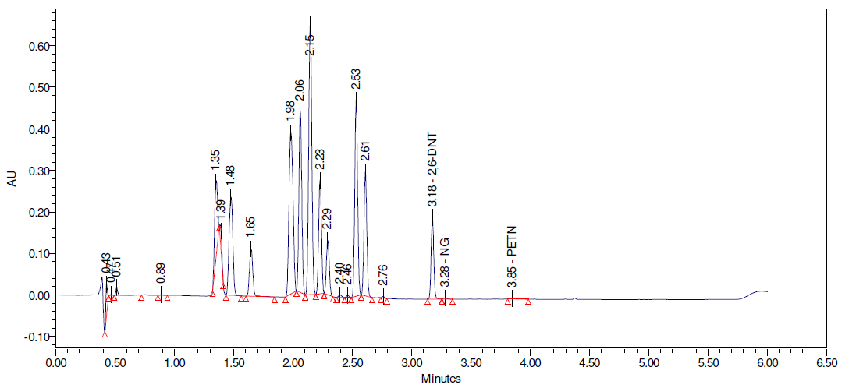Figure A - 8: Method Development Chromatogram 'PhenylACN3080' method
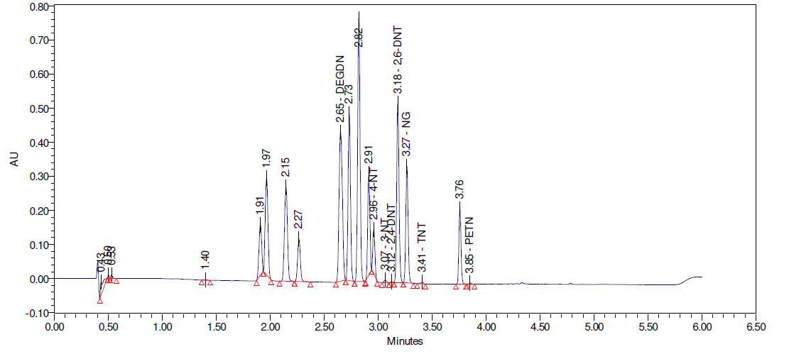
Figure A - 9: Method Development Chromatogram 'PhenylACN2080' method
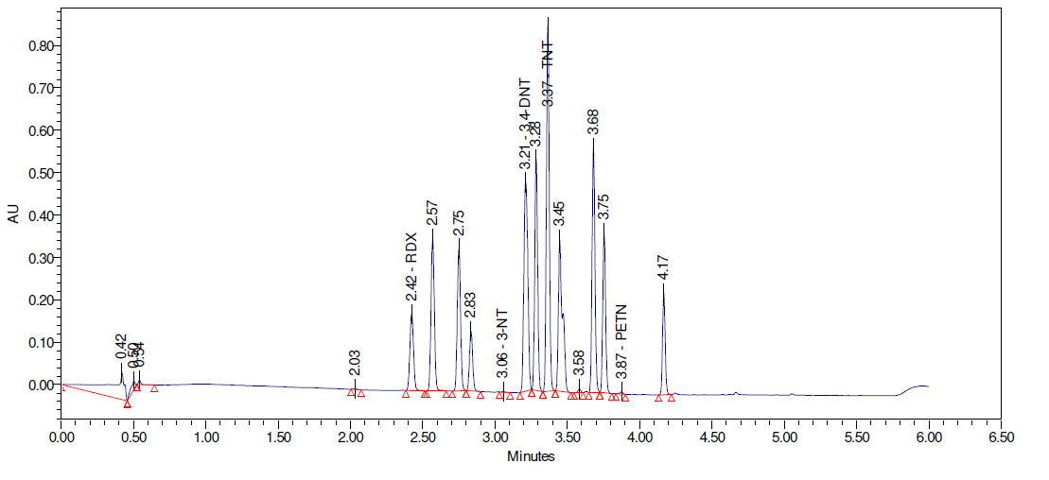Figure A - 10: Method Development Chromatogram 'PhenylACN1080' method
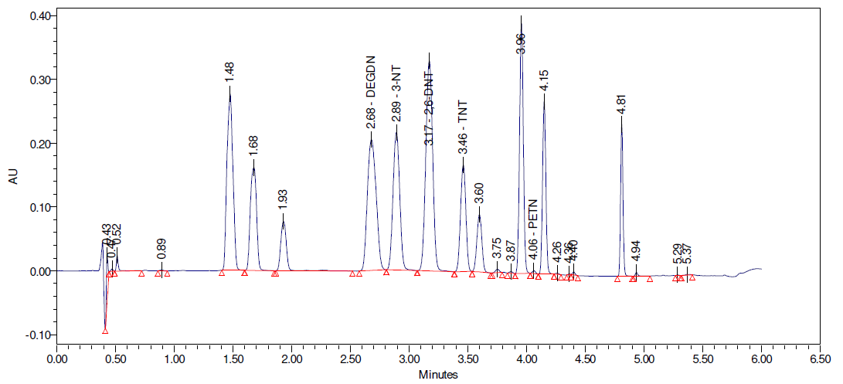
Figure A - 11: Method Development Chromatogram 'PhenylACNISO2' method
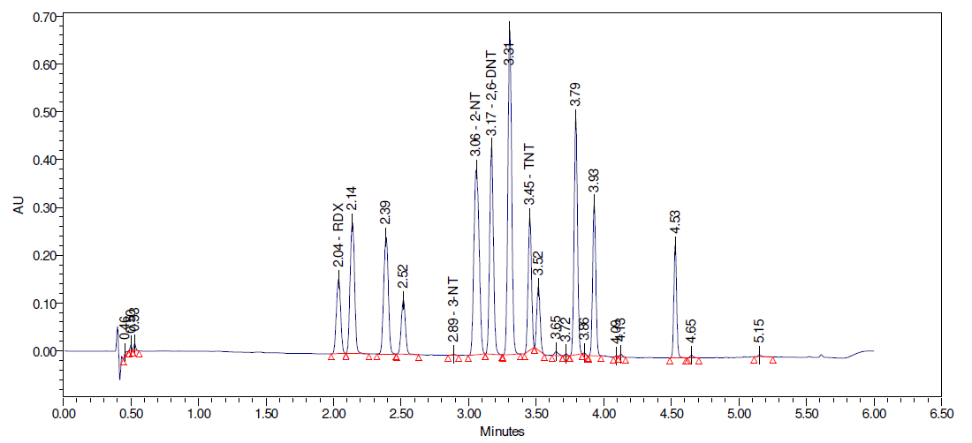
Figure A - 12: Method Development Chromatogram 'PhenylACN2P1' Method
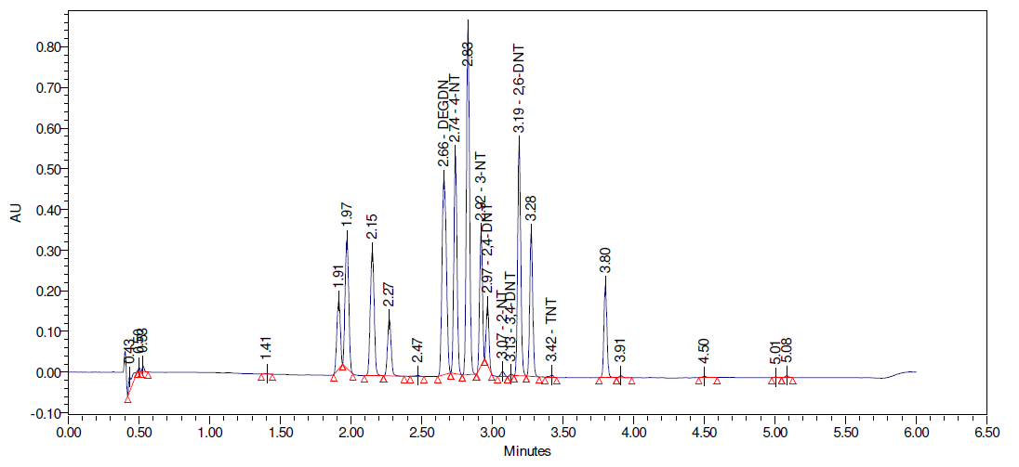
Figure A - 13: Method Development Chromatogram 'PhenylACN2P2' method
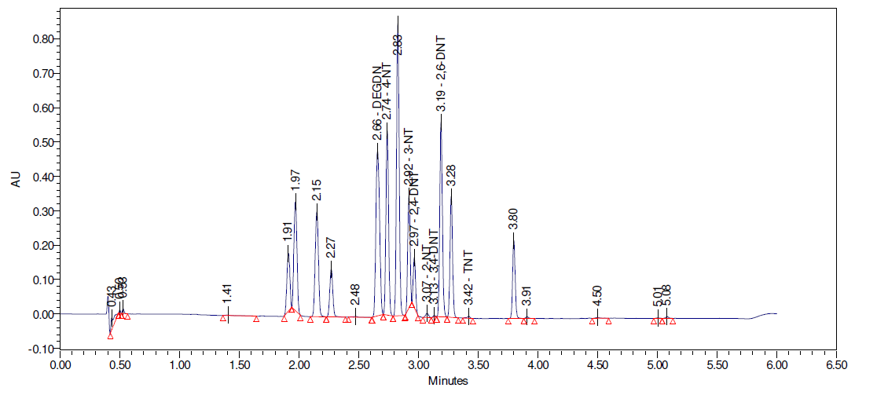
Figure A - 14: Method Development Chromatogram 'PhenylACN2P3' method
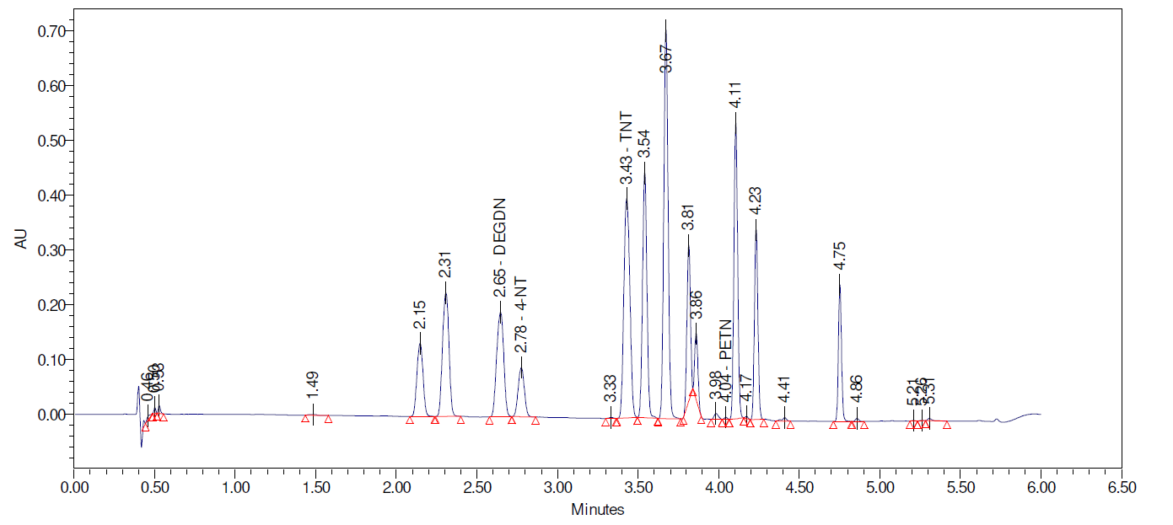
Figure A - 15: Method Development Chromatogram 'PhenylACN2P4' method
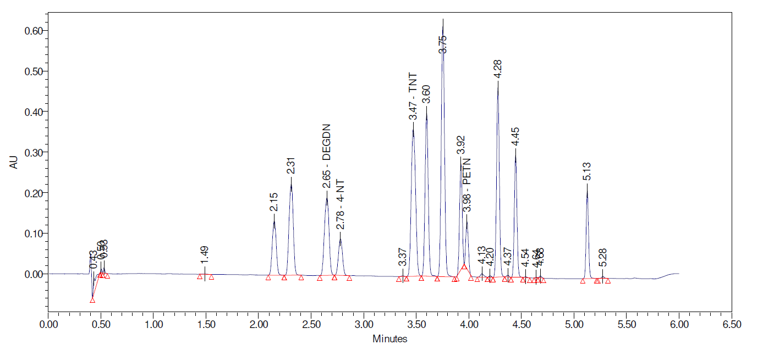
Figure A - 16: Method Development Chromatogram 'PhenylACN2P5' method
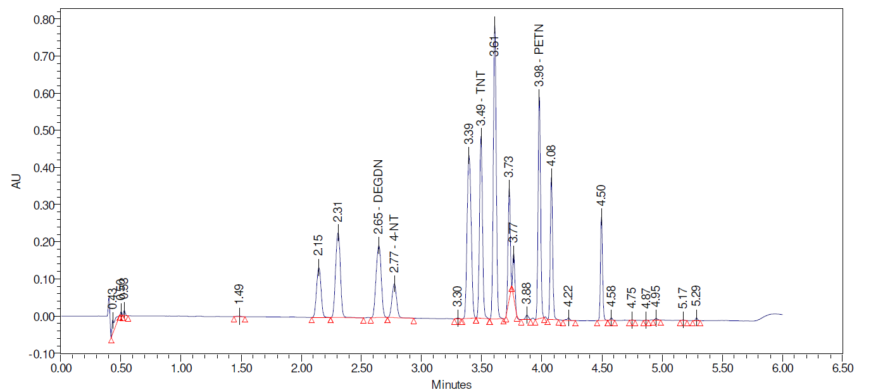
Figure A - 17: Method Development Chromatogram 'PhenylACN2P6' method
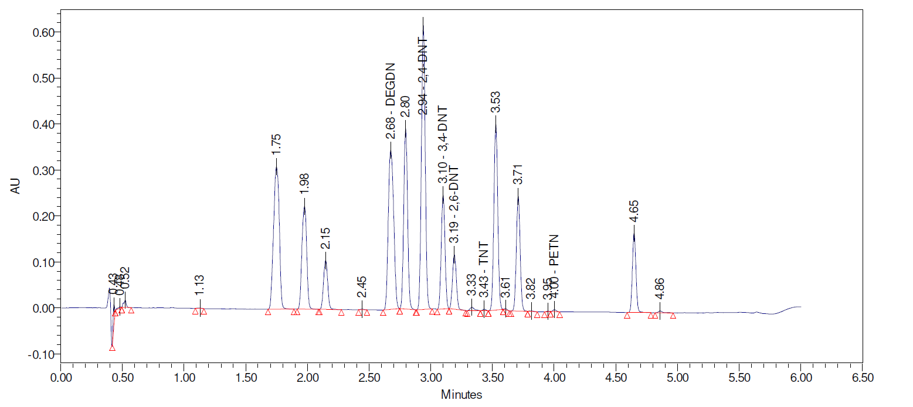
Figure A - 18: Method Development Chromatogram 'PhenylACN2P7' method
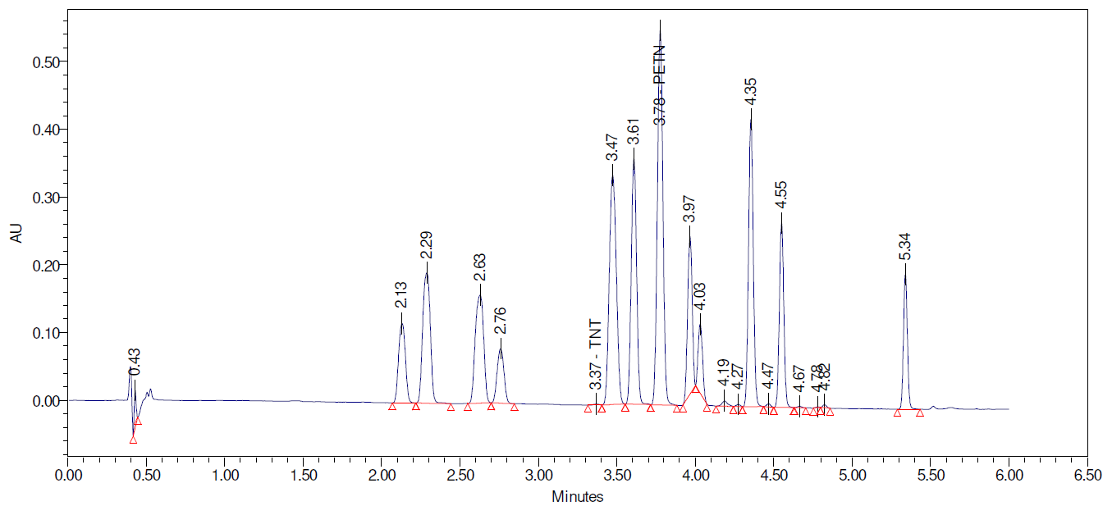
Figure A - 19: Method Development Chromatogram 'PhenylACN2P8' method
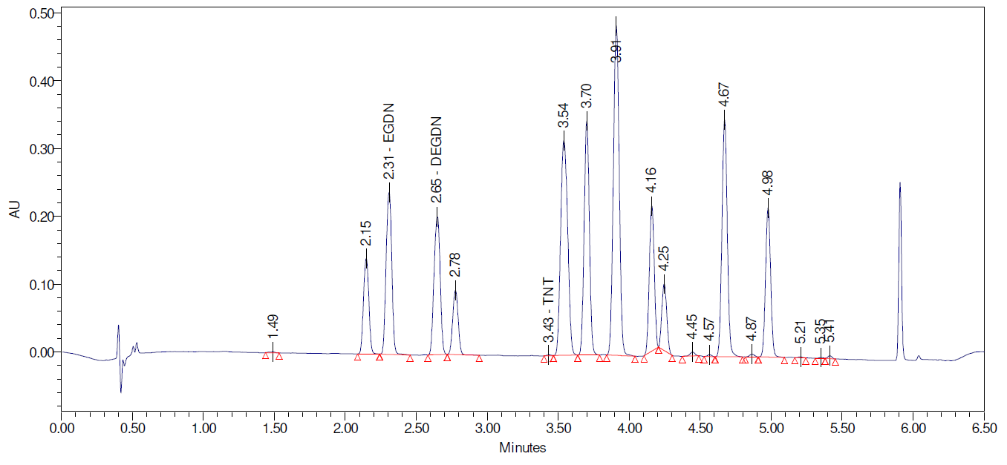
Figure A - 20: Method Development Chromatogram 'PhenylACN2P10' method
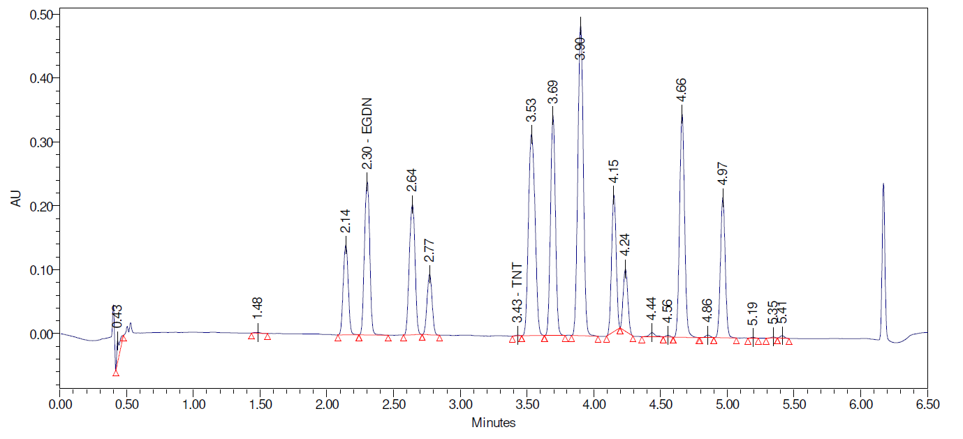
Figure A - 21: Method Development Chromatogram 'PhenylACN2P11' method
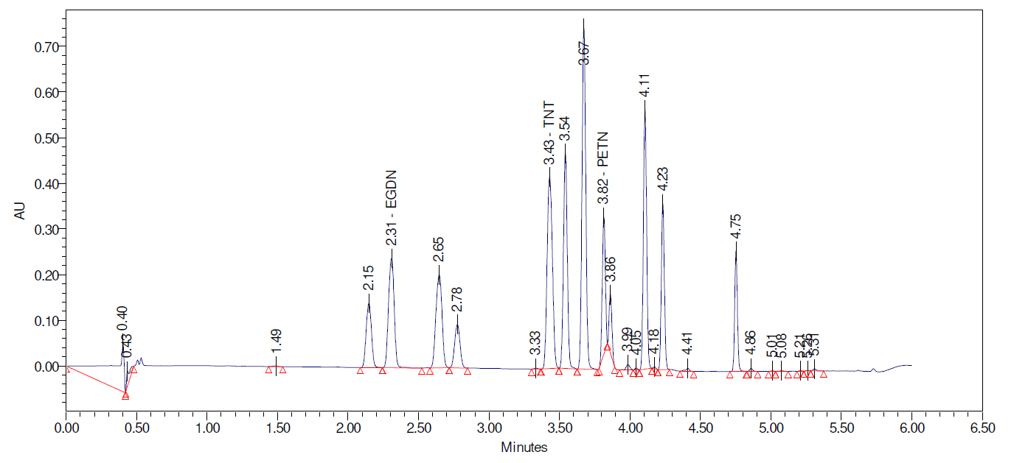
Figure A - 22: Method Development Chromatogram 'PhenylACN2P12' method
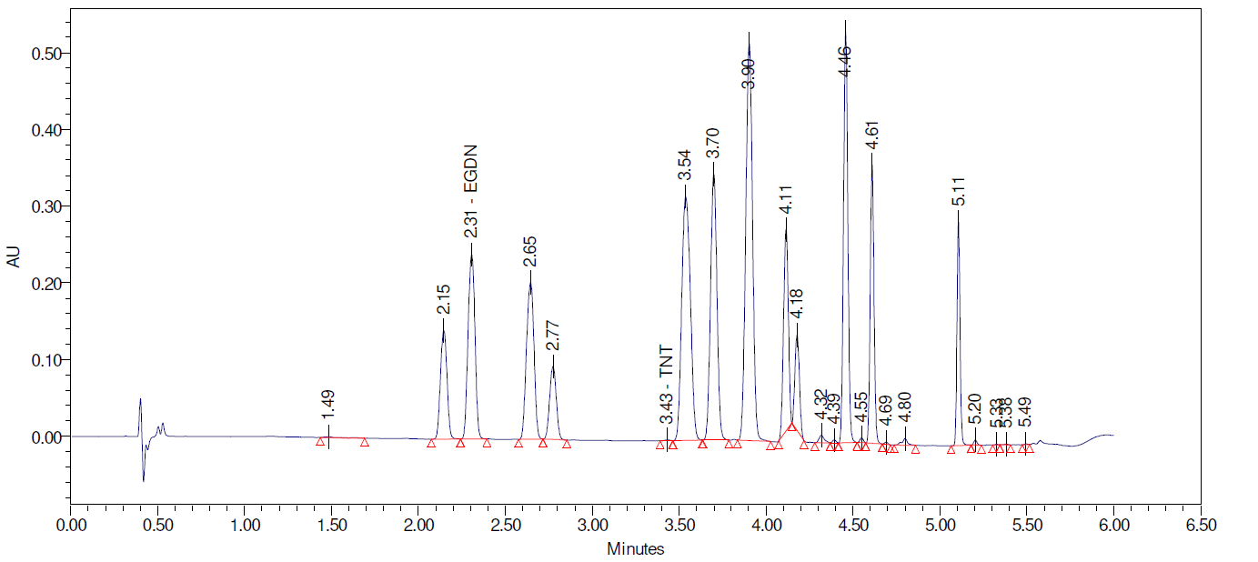
Figure A - 23: Method Development Chromatogram 'PhenylACN2P13' method
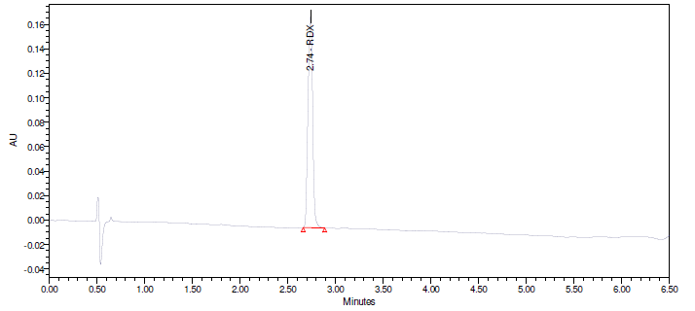
Figure A - 24: Method Validation Chromatogram - RDX

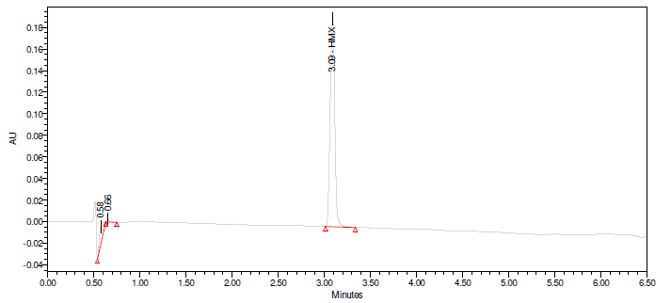
Figure A - 25: Method Validation Chromatogram - HMX
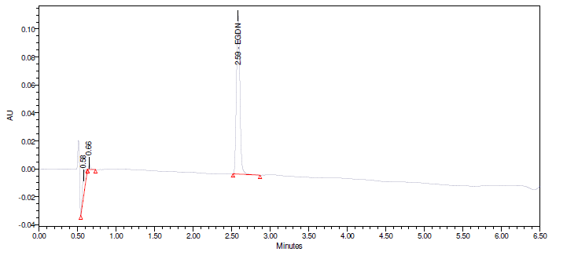
Figure A - 26:Method Validation Chromatogram - EGDN
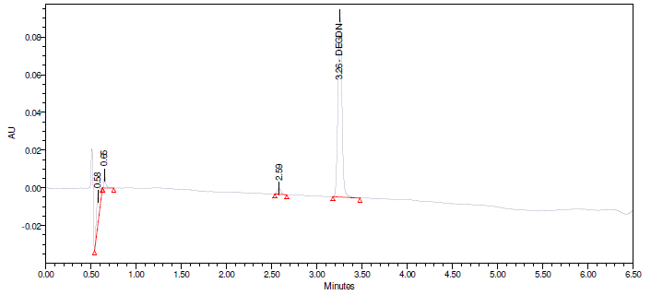
Figure A - 27: Method Validation Chromatogram – DEGDN
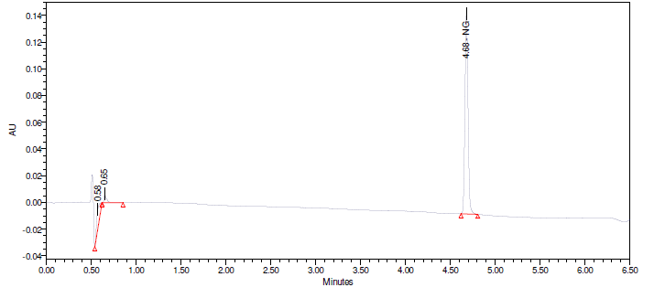
Figure A - 28: Method Validation Chromatogram - NG

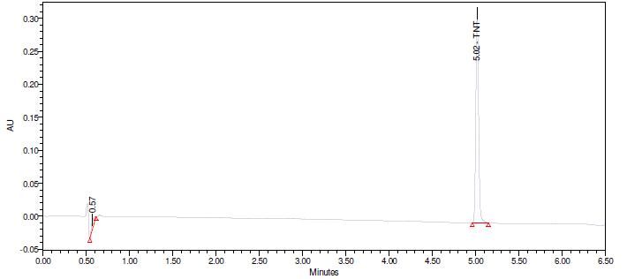
Figure A - 29: Method Validation Chromatogram - TNT
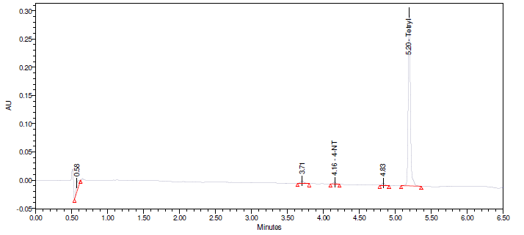
Figure A - 30: Method Validation Chromatogram - Tetryl
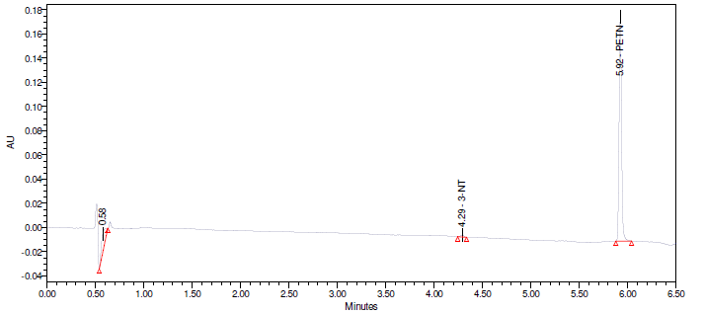
Figure A - 31: Method Validation Chromatogram - PETN

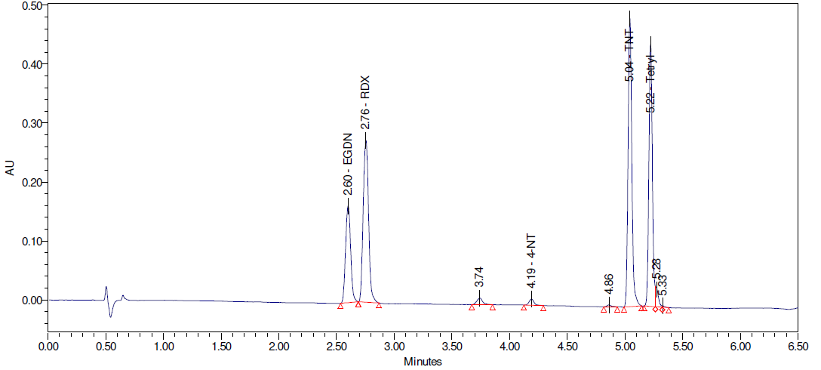
Figure A - 32: Method Validation Chromatogram - Multicomponent 1

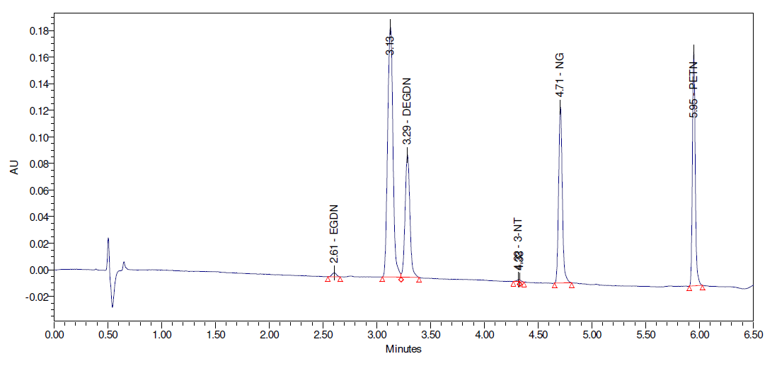
Figure A - 33: Method Validation Chromatogram - Multicomponent 2

Figure A - 34: Linearity plot for EGDN in the 1-250ng/µL range

Figure A - 35: Linearity plot for RDX in the 1-250ng/µL range

Figure A - 36: Linearity plot for TNT in the 1-250ng/µL range

Figure A - 37: Linearity plot for Tetryl in the 1-250ng/µL range

Figure A - 38: Linearity plot for HMX in the 1-250ng/µL range

Figure A - 39: Linearity plot for DEGDN in the 1-250ng/µL range

Figure A - 40: Linearity plot for NG in the 1-250ng/µL range

Figure A - 41: Linearity plot for PETN in the 1-250ng/µL range

Appendix 4 Bill of Materials

The below table lists the materials used during this study, describes their use and, where relevant, includes the chemical structure.
Material Name | Description and Role | Structure
Acetonitrile (ACN) | Polar Solvent and Mobile Phase Component | 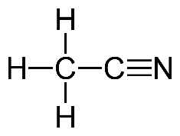
Water | Mobile Phase Component | 
Formic Acid | Mobile Phase Component (Buffer) | 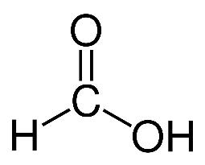
EGDN | Analyte (Supplied as 1000ng/µL CRM and diluted as required) | 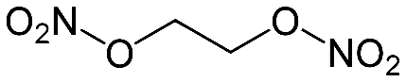
RDX | Analyte (Supplied as 1000ng/µL CRM and diluted as required) | 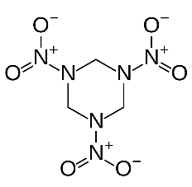
HMX | Analyte (Supplied as 1000ng/µL CRM and diluted as required) | 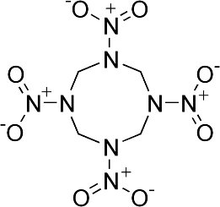
DEGDN | Analyte (Supplied as 1000ng/µL CRM and diluted as required) | 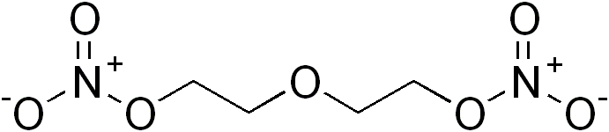
NG | Analyte (Supplied as 1000ng/µL CRM and diluted as required) | 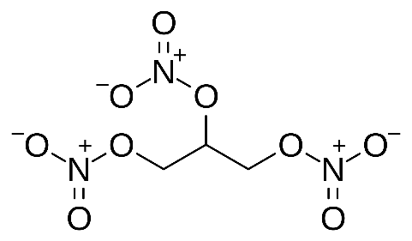
TNT | Analyte (Supplied as 1000ng/µL CRM and diluted as required) | 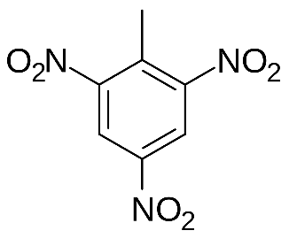
Tetryl | Analyte (Supplied as 1000ng/µL CRM and diluted as required) | 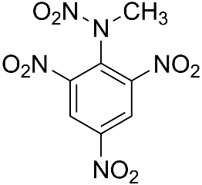
PETN | Analyte (Supplied as 1000ng/µL CRM and diluted as required) | 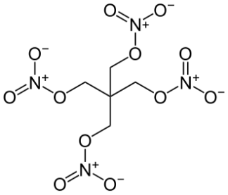
2-NT | Interferent (Supplied as 1000ng/µL CRM and diluted as required) | 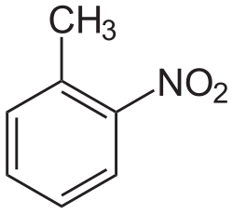
3-NT | Interferent (Supplied as 1000ng/µL CRM and diluted as required) | 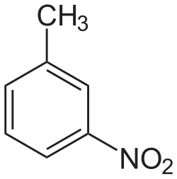
4-NT | Interferent (Supplied as 1000ng/µL CRM and diluted as required) | 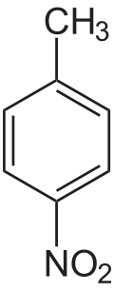
2,4-DNT | Interferent (Supplied as 1000ng/µL CRM and diluted as required) | 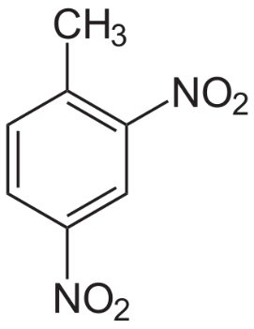
2-6-DNT | Interferent (Supplied as 1000ng/µL CRM and diluted as required) | 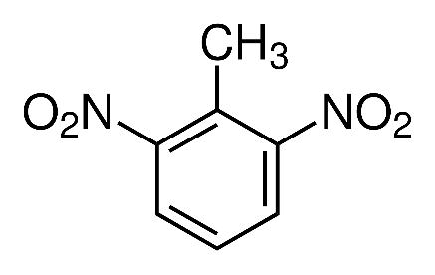
3,4-DNT | Interferent (Supplied as 1000ng/µL CRM and diluted as required) | 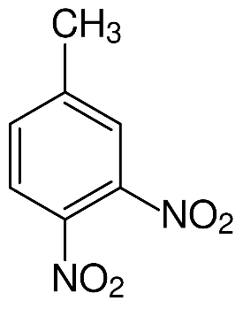
DMP | Interferent | 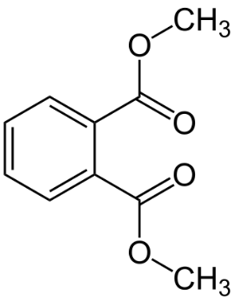
DEP | Interferent | 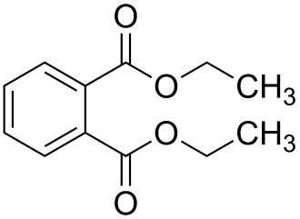
DBP | Interferent | 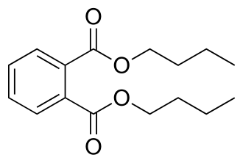
NQ | Interferent (Supplied as 1000ng/µL CRM and diluted as required) | 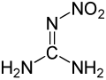
PE8 | Plastic Explosive, primary component RDX. Used for matrix experiments. | N/A
Single-Base Propellant | Propellant. Primary component Nitrocellulose. Used for matrix experiments. | N/A
Double-Base Propellants 1+2 | Propellants. Mixture of Nitrocellulose and Nitroglycerin. Used for matrix experiments | N/A
Table A - 2: Bill of Materials

GLOSSARY

List of Abbreviations
FEL Forensic Explosives Laboratory
Dstl Defence Science and Technology Laboratory
FSR Forensic Science Regulator
INS/SM Instrument Standard Method
uHPLC Ultra-High Performance Liquid Chromatography
UV Ultraviolet
CAS Chemical Analysis Service
QMS Quality Management System
IUPAC International Union of Pure and Applied Chemistry
PDA Photodiode Array
RT Retention Time
TNT 2,4,6-Trinitrotoluene
RDX Research Department Explosive
(1,3,5-Trinitro-1,3,5-triazinane)
HMX High Melting Explosive
(1,3,5,7-Tetranitro-1,3,5,7-tetrazocane)
PETN Pentaerythritol Tetranitrate
NG Nitroglycerin
EGDN Ethylene Glycol Dinitrate
DEGDN Diethylene Glycol Dinitrate
DNT Dinitrotoluene
IPP Integrated Project Plan
LC Liquid Chromatography
HPLC High Performance Liquid Chromatography
MS Mass Spectrometry OR Mass Spectrometer
APCI Atmospheric Pressure Chemical Ionisation
EI Electrospray Ionisation
EUR End User Requirements
ACN Acetonitrile
FA Formic Acid
%RSD % Relative Standard Deviation
CRM Certified Reference Material
NT Nitrotoluene
DMP Dimethyl Phthalate
DEP Diethyl Phthalate
DBP Dibutyl Phthalate
NQ Nitroguanidine
PE8 Plastic Explosive 8
DB Double-Base (Propellant)

Definitions of Technical Terms
.
Analyte A specific chemical which is of interest in an analytical procedure.

Bias The difference between the true result and the measured value.

Certified Reference A reference material of known provenance which has
Material been characterised to evaluate its properties (e.g concentration or purity) and is issued with a certificate which provides the values for those properties and also provides a statement of metrological traceability
Chromatogram The visual output of the detector. In the case of uHPLC-UV, this appears as a series of peaks.

Chromatography A physical method of separation in which the
components to be separated are distributed between
two phases, one of which is stationary (stationary
phase) while the other (the mobile phase) moves in a
definite direction.
See Also: Liquid Chromatography, Ultra-High Performance Liquid Chromatography, Chromatogram

Interferent A chemical found in the sample which has the potential to be incorrectly identified as an analyte of interest and/or cause errors in the quantitation of that analyte. See Also: Matrix

Linearity The ability of the method to obtain results which are directly proportional to the concentration of a specific analyte in the sample.
See Also: Working Range

Liquid Chromatography A family of chromatographic techniques in which
samples and the mobile phase are liquids or solutions.
See Also: Chromatography, Ultra-High Performance Liquid Chromatography

Mass Spectrometry An analytical technique that identifies chemicals by ionising them and measuring the mass to charge ratios of the ions produced.

Matrix All components of a sample which are not target analytes.
See Also: Interferent

Method Development The process of selection of an appropriate technique or process to meet user requirements and the conduct of experiments to optimise that process, along with the drafting of a written method.

Method Validation The process of providing objective evidence that a method, process, or device is fit for the specific purpose intended.

Photodiode Array An array of light-sensitive diodes that allow a current
to pass through depending on the amount of light they
are exposed to. Used to detect analytes in the method by measuring absorbance over time.

Precision The variability to be expected in a result when a method is performed by different operators using different consumable components at different times.

Repeatability The variability to be expected in a result when a method is performed by a single operator over a short timescale.

Resolution A measure of separation between two peaks in a chromatogram. Calculated by multiplying the difference between peak retention times by two, and dividing by the difference between the baseline widths of the peaks

Ultra-High Performance An LC technique in which the mobile phase containing
Liquid Chromatography the samples is pumped through the column (stationary phase) at high pressures.
See Also: Chromatography, Liquid Chromatography

Working Range The range of concentrations across which the method exhibits a linear relationship between analyte concentration and detector response, without significant deviation between predicted response and actual response.
See Also: Linearity

