Development of An Innovative product: PortabLE Powerbank rental Stations with POS Machines.

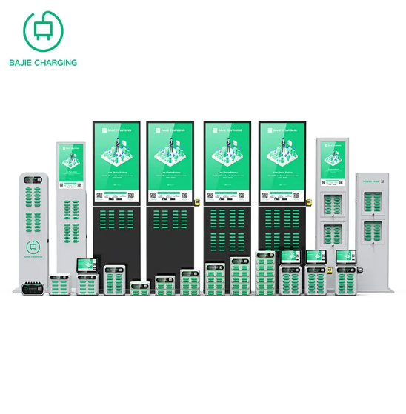
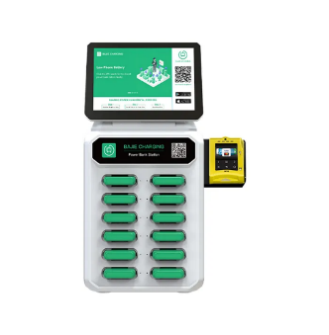
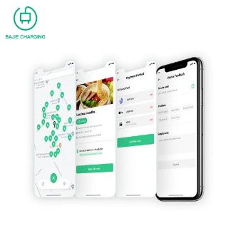
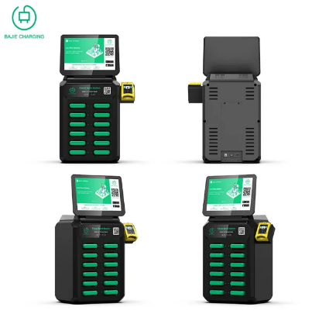
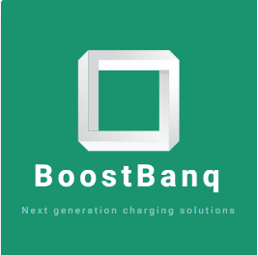
1st Look at BoostBanq Logo (Shopify, 2023). and Product Range (Shenzhen BAJIE Charging Technology Co.,Ltd, 2023)
Name: Natasha Nothando Tshili
Student Number: 2020475
Lecturer: Rexon Nting
Module Code: BMSW6102_LON
Module Title: Developing Innovation and Creativity for Business Advantage
Assignment Title: Development of Innovative Product OR Unique Service Proposition

Executive Summary
This report was written to highlight the stages of creating an innovative product of a portable power bank station to be sold on an e-commerce platform. It analyses the macro environment and the micro external environment. The report also looks at the STP model and the type of innovation model needed to implement such a product. The report looks at the advantages and disadvantages of using Shopify to set up a website, the website content and payment services available to merchants. Following this a marketing strategy is set out based on the marketing mix and the segmentation targeting and positioning to establish a target customer. Finally, the report investigates the privacy and data protection implications of running an e-commerce business in the UK.

Table of Contents
Executive Summary 2
Introduction 4
Section 1: Innovative product OR Unique Service Proposition 6
Product Introduction 6
PESTEL Analysis 8
Porter’s Five Forces Model and Competitors 12
STP Model 13
Open Innovation /Closed Innovation 15
Section 2: eCommerce (website set up proposal) 17
Ecommerce Platform: Shopify Set Up 17
Website Content 18
Payment Services 20
Section 3: Marketing Strategy 22
Promotion of Product: Marketing Mix 22
Target Customer: Segmentation and Targeting & Positioning 23
Section 4: Privacy and Data Protection 25
GDPR Rules and Data Protection Act of 2018 25
Data Security 25
Conclusion and Recommendation 26
References 27

Introduction

During the pandemic, taking advantage of advancements in technology was essential for the survival of businesses. This exposed the setbacks of a brick-and-mortar business model, because of the COVID lockdowns. In the current environment of economic volatility, inflation reached a 41 year high of 11.1% in 2022 (Harari et al., 2023). Drivers of the hikes in inflation are energy prices, fuel costs, and a rise in energy tariffs, following the Russian invasion of Ukraine (Harari et al., 2023). As a result of these inflationary pressures, businesses are experiencing increased operational costs, and brick-and-mortar businesses are being hit the hardest. Hence my development of an innovative product for an ecommerce business.
The main purpose of writing this report is to introduce an innovative product that will be sold via an e-commerce website. The report will offer an innovative business proposition, which will highlight four major areas of the proposed product. The first section will be the proposition of the product, covering details such as the customers, where and how I will sell the product, the name of the product, competitors, how I will sustain my innovative business proposition, and . In this section, I will conduct an analysis of the external environment using the PESTEL analysis model, Porter's Five Forces and the Segmentation, Targeting, and Positioning model. The second section will be about e-commerce, and it will cover the platform I will sell my product on, the content that will be on the platform, and the payment options that will be available. The third section will cover marketing which will cover the communication & marketing mix I will use to market the product; how I will target my customer through segmentation, targeting and positioning; and my utilisation of online marketing. The fourth section will cover privacy and data protection Areas such as the GDPR/Data Protection Act 2018, Privacy and Electronic Communication Regulations (PECR), cyber security, and the security of the platform I will sell my product on. Then I will conclude and offer recommendations.

Importance of Innovation
Many people confuse the term innovation with invention. Invention Is defined as, ‘the process of converting intellectual thoughts into a tangible new artefact,’ (Trott, 2016). However, innovation in a simple equation is ‘theoretical conception’ (idea), ‘technical invention’ (development), plus, ‘commercialization’ (Trott, 2016).
Myers and Marquis, defined innovation more broadly as, ‘a total process of interrelated sub processes. It is not just the conception of a new idea, nor the invention of a new device, nor the development of a new market. The process is all these things acting in an integrated fashion.” (Myers and Marquis, 1969). Ultimately there are many definitions of innovation, but the bottom line is that innovation is a process not a single event.
Innovation as a management process, is the successful implementation of a creative idea (Trott, 2016). It distinguishes that the product is the output of Innovation, consisting of generating the idea, technology development, manufacturing, and marketing (Trott, 2016).
There are seven types of innovation product innovation, process innovation, organisational innovation, management innovation, production innovation, commercial slash marketing innovation and service innovation. In this report I will focus on product innovation, as the basis of my innovation is an improvement to an existing product by my competitor Joos. In addition, I will look at commercial/marketing innovation as I will explore new market segments to market to (Trott, 2016).
Product Introduction
My chosen innovative product is a portable power bank rental station with the ability to accept card payments. The reason for choosing this product is because I identified competitors within the UK market, who had adopted the idea from the Chinese market, where this type of business/product was prevalent. However, I noticed areas that the brand neglected to address when implementing this product in the UK. Mainly, the functionality in all customer scenarios such as, if a client’s phone has already shut down. Also, because I am proposing a niche market of luxury establishments, the clientele loves a hassle free and fully serviced experience. The power station will be operated by hospitality teams and added as a service charge to client’s bills or tabs. Another case will be the self-service machines, located in emergency room waiting rooms and staff lunchrooms in hospitals, sports clubs, and gyms. Overall, my improvement to the product design and functionality, will be the addition of a POS machine to accept card payments.

Section 1: Innovative product OR Unique Service Proposition

Product Introduction

My innovative product proposition is called BoostBanq, which is a portable power bank station, with a POS system to receive card payments. Which would be distributed using a business to business (B2B) model.
This innovation of adding the point-of-sale system (POS) came about after researching two competitors offering similar products, Bricks from Sweden, and Joos in the UK. Joos, which is a UK-based business which produces a similar product, a portable power bank rental. A customer would need to scan a QR code, then download an application, register, and then insert card details to rent a power bank. This long process has recently been streamlined by Joos, by using an App Clip after scanning a QR code. However, I have introduced the addition of a POS system that would simply read your card contact less to gain authorisation and immediately eject a power bank for use. (See images below).
1st Look at BoostBanq Logo (Shopify, 2023). and Product Range (Shenzhen BAJIE Charging Technology Co.,Ltd, 2023)

The main reason for this innovation, was the scenario of a client needing to charge a phone that has shut down. In this case they would not be able to download the application, to get a power bank.
Another point of innovation is that dependent on where the stations are located, the rental process will differ based on the type of customer. Our ideal customers will be in five-star hotels or boutique hotels, luxury health spas, members only clubs, five-star restaurants, and VIP sections in London clubs, sports clubs, gyms, and emergency waiting rooms and staff break rooms in hospitals. In the hotel, spa, club or restaurant businesses, hospitality teams will provide the devices and bill the client at the end of dining, at checkout or when closing the tab. However, for locations such as gyms and hospitals, we would offer power bank stations that are self-service.
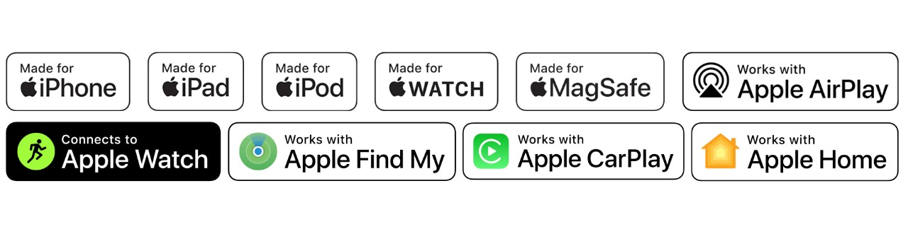
Suppliers will be Shenzhen BAJIE Charging Technology Co.,Ltd, from Alibaba, as they are an MFi certification authorised supplier.( Shenzhen BAJIE Charging Technology Co.,Ltd, 2023). Mfi is an Apple certification that permits products manufactured by approved suppliers to have a certified apple sticker on our devices. This will bring credibility to our brand by partnering with the external R&D of Apple’s standard through strategic partnerships with authorised suppliers (Apple, n.d.).
Apple Badges for MFi approved manufacturers. (Apple, 2023).

The BoostBanq stations are available in 5, 6, 8, 12, 24, or 48 slots styles, to fit the business’ needs. (see 1st Look at BoostBanq picture above).

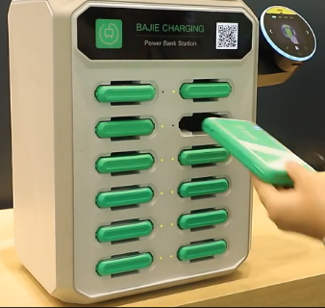
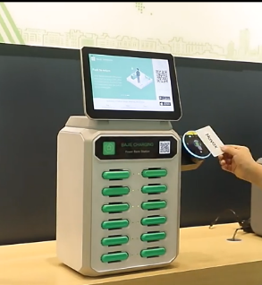

PESTEL Analysis

A PESTEL analysis is a externa environment scanning tool used to analyse external forces such as the current environmental volatility and the Russian invasion of Ukraine. PESTEL stands for political, economic, sociocultural, technological, environmental, and legal (Lynch, 2018). This framework is essential to assess the macro external opportunities or threats that can affect implementation of BoostBanq (Lynch, 2018). Due to the context of the report, I will focus on the situation during COVID and post COVID. In the final column, I will assess whether the current post COVID factors are of importance to BoostBanq’s proposition and to what extent.

 | Factors During COVID | Factors Post- Covid | Importance to BoostBanq
Political | * Lockdowns (COVID)  *Non-essential businesses closed | *War Crisis in Ukraine  *Vaccination Campaigns | MEDIUM
Economic | *Business closures and government intervention to save struggling businesses.  *Supply chain shortages and delays on cargo ships.  *Component shortages | *All-time highs in global inflation and increased costs of living.  *War in Ukraine has increased energy prices, fuel costs  *Expecting recession during 2023 until end of 2024  * Component shortages  *Supply chain shortages and delays on cargo ships(expensive). | HIGH
Socio- Cultural | *Digitisation of consumers (Social Media and increased ad revenue) and technological knowledge  *Social distancing measures  *Emphasis on mental health | *Remote working accepted as the new normal  * Social distancing measures eased  *Mental health awareness  Corporate Social Responsibility. | MEDIUM
Technological | *Social media marketing  * Testing of Covid resistant materials for use in production.  *Technologies were developed in response to COVID restrictions  * Remote working introduced during lockdowns, technology solutions  * increase in e commerce trade due to business closures | *Remote working continued for digital solutions for businesses  *Open AI becomes mainstream.  *Increased sharing by businesses on how they managed the pandemic and pivoted, by adapting technology. (More knowledge).  Higher digital literacy, and a need for streamlined new technologies that are functional for consumers.  *opportunities for partnering with large tech organisations like Apple through manufacturer licensing (Made for iPhone/iPad/iPod) MFi badges | HIGH
Environmental | *Global warming was being put at the forefront  *Sustainable business and need for transparency. | *COP 26 and COP 27 Net Zero initiatives and the Electric vehicle declaration (2040)  *UN Net Zero declaration  *Green Initiatives (Green technologies to quicken the race to net Zero  * Corporate Social Responsibility and transparency of (ESG) metrics | HIGH
Legal | *Lockdowns were mandated  *Vaccinations made mandatory for certain jobs  * 2020 Data Breach of Shopify, 200 merchant’s customer data was stolen | Vaccinations made mandatory for certain jobs.  *Data Protection Act 2018  PCI- DSS legislation  *GDPR Rules  * Privacy and Electronic Communication Regulations (PECR) | LOW

(Lynch, 2018)

Political
Key drivers include Russia's invasion of Ukraine post COVID and the cut of Russia's energy supply, which introduced inflationary pressures globally. The invasion has caused disruption in the business landscape because the loss of supply from Russia has increased energy pricing and fuel costs. Thus, increasing operational costs for businesses, leading to the closure of brick and motor businesses. This was following the COVID government lockdown restrictions, which led to closure of nonessential businesses. Initiating the transition to e-commerce for many businesses across the globe as a means of survival.

Economic
Key drivers include the inflationary pressures following COVID lockdowns and high inflation rates. In 2022 the UK's inflation hit a 41 year high of 11.1% in October. This has resulted in soaring energy prices, fuel costs and higher costs of living. Many organisations unable to increase wages and if they do it's not enough to balance out the hikes in inflation. This followed the COVID-19 restrictions causing component shortages, delays in cargo ships and disruptions in global supply chains.

Socio Cultural and Technological
During COVID consumers had to switch over to e-commerce to make purchases, which increased the digitization of many populations. Many technological advancements were opened to the public such as artificial intelligence platforms. Overall, the population is being sensitised to the use of technology in their everyday life.
Technological drivers that can affect the business environment of the development of my product is coproduction. My ecommerce revenue model is private labelling, and it is in the technology industry, I need to secure a supply chain that is consistent as my product utilise is components which are in a shortage. Another technological driver is partnering to benefit from a well-known brand identity, for example the MFA apple programme. It permits you to place badges such as our power banks which say made for iPhone, made for iPad, and made for iPod. In e-commerce this is important because you were able to use Apple's brand to drive traffic to your product.

Environmental
Cop 26 and cop 27 meetings making a push for businesses to join the race to net zero initiatives and the creation of green technologies (BEIS, 2022). I will need to do check on manufacturers and see their production methods and their alignment with sustainability goals. Having partnership with manufacturers engaging in unsustainable practices can lead to bad PR for my product. Therefore, it is essential to perform due diligence and on all co-production partners.

Legal
Legal drivers come from legislation that has to be followed as an e-commerce company. An example is if you are using card payments you need to make sure you are PCI- DSS compliant. Also because you're handling sensitive customer data and personal private information you must ensure your business is compliant with Data Protection Act 2018 and GDPR regulations.

Porter’s Five Forces Model and Competitors

The Porter’s Five Forces Framework helps with the analysis of an industry’s environment and its attractiveness. The framework looks at the following five competitive forces: extent of rivalry between competitors, threat of entry, threat of substitutes, power of buyers, and power of suppliers (Whittington et. al, 2019).

Threat to entry
There's a high likelihood of new entrance in this market, as a basic model of a portable power bank is readily available on Chinese manufacturing sites such as Alibaba. This means this innovative product does have low barriers to entry. However, it is costly to purchase a basic eight slot machine costs £220 excluding shipping costs to the UK and the added cost of customization.

Extent of rivalry between competitors
There's not much rivalry between existing competitors because this industry is fairly new, because it is a technological industry there are high startup costs. Currently, the uk has many charging stations that do not offer a portable power bank solution. Joos, Is the only UK rival with a similar product, hence me differentiating the product to add appearance machine so that people with phones that are completely off can still use the product. (Forbes, 2019)

Threat of substitutes
There is not a high threat of substitutes, as one of my strategies I would seek out businesses that do not utilise this technology currently. Also, I would utilise the data from the competitor applications to find where their portable power banks are located and strategically position myself to approach clients or market to clients not in those areas.

Power of buyers
Through our ecommerce platform we would offer discounts, by keeping an eye on competitors pricing and undercutting them. The strategy would deter buyers from switching to alternative brands and because our product is differentiated to anything that's available currently on the UK market. Being a first responder or secure our customer.

Power of suppliers
Due to high startup costs of an innovative technology product, it is essential that we partner with our suppliers to maintain consistency. We have contractual agreements so that our product cannot be mass produced for the Alibaba marketplace. We would negotiate terms of payment with suppliers and if purchasing a minimum order quantity, there is room for negotiation to pay after receiving funds from customers.

STP Model

The STP marketing model stands for segmentation targeting, and positioning. In the segmentation phase the goal is to identify your target customers and determine the main differentiating characteristics in each segment. The targeting and positioning phases involve evaluating the commercial attractiveness of each segment and provide product positioning for each segment. (Hanlon, 2022).

(Hanlon, 2022)

Segmentation
- Businesses that include five-star hotels or boutique hotels, luxury health spas, members only clubs, five-star restaurants, and VIP sections in London clubs Clientele in the UK.
- Businesses such as sports clubs, gyms, emergency waiting rooms, and staff break rooms in hospitals in the UK

Targeting
Segment one businesses, value privacy and a hassle-free integrated experience is most valued. Establishments whose clients include executives Tech savvy people, investors, politicians, business professionals and influencers.
- 2. For this segment self-service is essential, and the speed, and the ability to pay for the service when the phone is off. (trainers, athletes, doctors, nurses, moms, emergency patients).

Positioning
For both segments it is a solution for low battery life or no battery, it will be marketed to the business market segments. For segment 1 will be marketed 4 an integrated service at an extra cost at luxury establishments. For segment 2 it would be for self-service usage.

Open Innovation /Closed Innovation

To implement an innovative product idea, you must decide the appropriate innovation model and ensure that the chosen model creates sustainable innovation. There are various models of innovation but in this report the focus will be on open innovation and there will be a brief mention of closed innovation models. The more contemporary perspective on innovation models is one of (network models) and open innovation. (Trott, 2016). According to Chesbrough, open innovation is, ‘a paradigm that assumes that firms can and should use external ideas as well as internal ideas, and internal and external paths to market as firms look to advance their technology.’ (Chesbrough et al., 2014). It promotes and exchange of ideas through offering knowledge bases through licencing for example, it is views innovation as a collaborative effort. However, the more classic approach to innovation models focused on a closed innovation model, which is a stand-alone approach, with an internal research and development (R&D) base, and protected knowledge. Little knowledge leaves their R&D department. (Chesbrough et al. 2014).
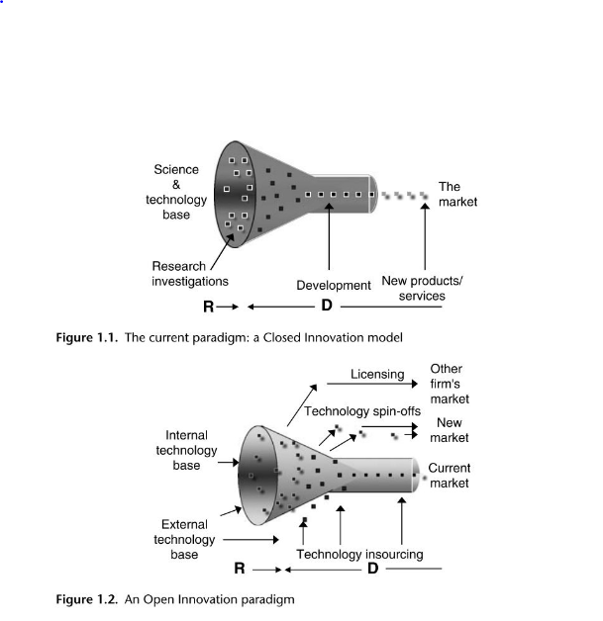

Section 2: eCommerce (website set up proposal)

E-commerce is defined as, ‘the process of buying and selling tangible products and services online.’ (Bloomenthal, 2023). It operates in several market segments such as business to consumer, consumer to consumer, consumer-to-business, business-to-business. E- Commerce platforms include custom built websites, package solutions, software provided as a service (SaaS), and online marketplaces. I chose to opt for SaaS e commerce platform, that offers extended features to market on other online marketplaces and on social media platforms. (Shopify, 2023).
For my product I will operate in the business-to-business segment. (Bloomenthal, 2023). E-commerce helps businesses gain access to a wider market The main things necessary to set up an e-commerce platform is the platform, the content, and the payment services.

Ecommerce Platform: Shopify Set Up

We will test the product on Shopify, a user-friendly e-commerce platform for website building, which offers an integrated payment system, a code free website builder, and offers domain purchase on their platform (Shopify, 2023). I chose this platform because it is easy to set up, as a start-up company in the research and development stage, we cannot afford to invest heavily in a custom-built website or higher a developer. The main costs upfront include a monthly charge for hosting your website (we will pay per year for the added discount $299, and the annual charge for the domain name: BoosBanq.com is $16 per year (Shopify, 2023). I chose Shopify plus to have access to all features, to allow flexibility to create the best user experience available.

After I have set up my domain name and opened an account, I can import my company information onto the Shopify platform and utilise the web designing tools to apply a template. Setting up an e-commerce platform like Shopify allows you to market your product on social media platforms like Instagram and TikTok, and online marketplaces like Amazon and eBay. (Shopify, 2023). My choice of this platform is because it broadens to my target consumer, through visibility on multiple platforms. (Shopify, 2023). I have access to Google Analytics as well as Shopify's analytics, I will be able to pull reports on key performance indicators and consumer behaviours. This knowledge is essential in re-tailoring marketing strategy in my STP model, based on performance of customer segments. (Shopify, 2023).
Some setbacks of the platform include its limitations on customisation when we have to incorporate certain self-developed tools for customer user interface. (Shopify, 2023). The set back would mean we would have to migrate our domain name once we have enough funding to hire a developer to build out our website and applications for the BoostBanq.

My product will implement the private labelling eCommerce revenue model, which involves a planning and designing our stations, then the supplier would manufacture our branding and design on the machines. (Bloomenthal, 2023). For quality control, I would have the product shipped to me and then delivered to the business.
The advantages of a platform like Shopify are the lower start-up costs, flexibility of changing market segments through ads, and increased product option selection. (Bloomenthal, 2023). Whereas, in a brick-and-mortar store I would need to keep inventory, but with Shopify I can market all available products and once an order comes forward it to the supplier (Shopify, 2023).

Some disadvantages of e-commerce are the limitations and offering a customer service experience, reliance on technology and this higher competition based on search engine optimization. (Bloomenthal). Also, e-commerce requires a digital presence to drive up the likelihood invisibility, and delays in shipments or component shortages can affect customer ratings and experience. (Bloomenthal, 2023).

Website Content

On Shopify, SaaS platform to list a product you need to provide the photograph, product title, product description, product weight, product price, product category, product type, compare at price and variations available. Below is an example of the customer end of the BoostBanq website. As you can see at the top, I chose a simple and clear to navigate setup I have 3 sections a home section, catalog, contact us. The content on the website will include all the options for the stations colour variations. Below is an example offer typical product listing, we would offer the stations in two colour variations black or white, we would put a compare at price, so our customers feel that they're getting a bargain, and a concise product description.

1 Website Prototype of 12 Slot Power Bank
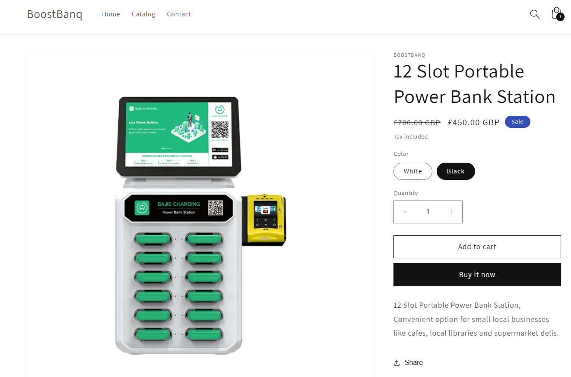 (BoostBanq, 2023).
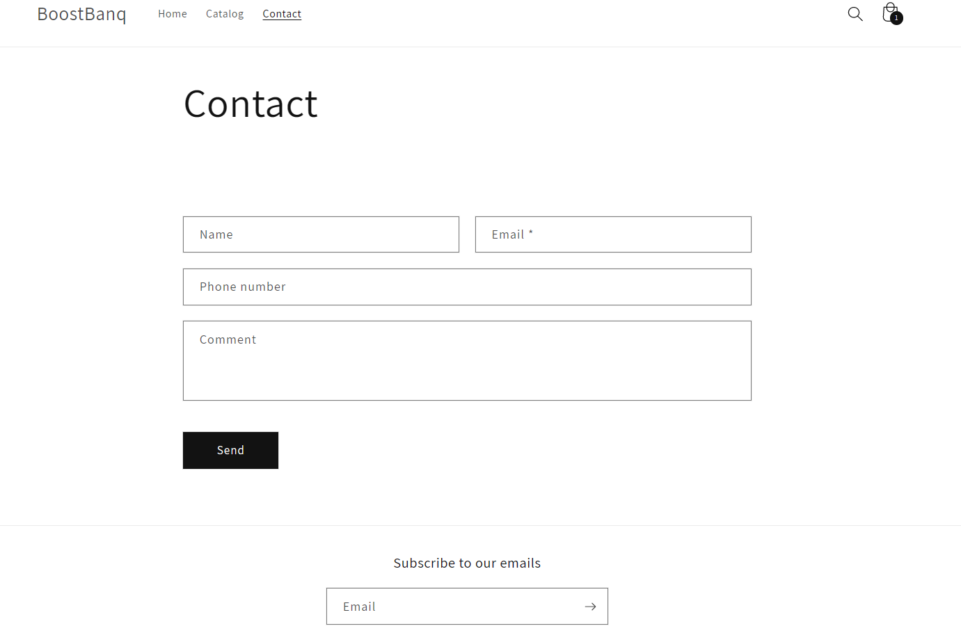
(BoostBanq, 2023).
I would also introduce a blog section to share new and exciting news within our industry or related to products to customers. And also have a subscription for e-mail marketing to keep customers updated on new product offerings restocking, and other marketing content.

Payment Services

Shopify offers several payment services both manual and automatic. From annual payment methods you have the option to include bank deposit, money order, cash on delivery. To process card payments which is a third-party online wallet that allows receiving pay-outs when orders are fulfilled. PayPal express checkout allows you to receive payments in foreign currencies and be able to deposit them to your business account. (Shopify, 2023). To set up the payment services for Shopify and PayPal you need to provide business information regarding your business address. PayPal offers 0% transaction fees, and if customers are eligible, they can utilise PayPal credit to make purchases without any additional setup required from the back end. (Shopify, 2023). I will utilise both the Shopify Payments and PayPal payment systems because they offer 0% transaction fees. (

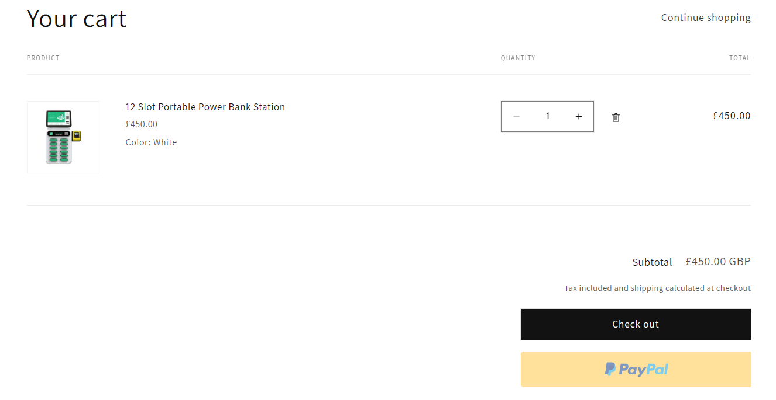
(BoostBanq, 2023).

Payments Compliance

PCI- DSS – card data protection stands for payment card industry data security standard compliance. (The payment card industry standard categories are maintain a secure network, protect card holder data, maintain a vulnerability management programme, implement strong access control measures, regularly monitor and test networks, and maintain and information security policy. Shopify is PCI compliant and the stands for all businesses that run on their platform. A Shopify website is automatically PCI compliant by default, and it covers the store, the shopping cart, and web hosting. (Shopify, 2023).
However, it is important to keep an eye on transactions in your store as Shopify has been a part of some data breaches in 2020. (Whittaker, 2021). The data breach involved an employee overseas in Asia, accepting bribery to release customer card information and customer data to a third party. An unfortunate reality of utilising e-commerce are the risks involved.

Section 3: Marketing Strategy

Promotion of Product: Marketing Mix
The marketing mix looks at the four P’s product, price, place, and promotion. The marketing mix was introduced by E. Jerome McCarthy in 1960. (Coursera, 2022). It was created to assist marketers in designing marketing plans that reflect the dynamic political and social context of their target market. (Coursera, 2022). All four p's must be in alignment to achieve business objectives.

The Marketing Mix
Product – the power bank station will be designed with a POS machine to meet the needs of all potential customers. The main consumer would be those with low battery or those with phones whose batteries have drained. The power bank would offer fast charging, apple MFI certification, wireless charging, and good ergonomics. The tangible product would be accessible as a self-service option for the segment two clientele. However, for the upscale businesses it would be offered as an added service and billed at the end of the use.
Price – the price for the 12-slot power bank would be set at £450 pounds and the total cost of customization transportation and purchase from our suppliers in China would cost around £280 pounds. The price of the slots would increase by £450 per additional 12 slots up to 48 slots, which is the maximum number of power banks possible. Our recommended rental retail pricing of the service, for our first segment we would recommend a £5 per hour charge added to clients bills or tabs. For the more self-service environments we would recommend a £3.50 charge per hour. Competitors pricing is on average above our competitors with Bricks offering a franchising deal of 20 for 3980 euros (£3471), as a network partner.
Although this offer is more affordable looking at the cost per unit, it would obligate a business for example call Matt to commit to owning 20 power stations opposed to just purchasing one. This leaves our ideal market of individual businesses open to us despite our higher price point.
Place –the power banks will be made available through our Shopify online storefront and would be advertised to Instagram, TikTok and can be purchased on online marketplaces such as eBay and Amazon. This would allow for businesses who purchases supplies through Amazon business accounts, to be exposed to our product.
Promotion- Our strategy will be to run ads via Facebook targeted at businesses in our chosen segments, we would market through social media platforms such as Instagram, TikTok and create video content to post to our website. These modes of advertising through social media would attract all potential clients from the younger procurement department heads to the older procurement heads for businesses. Some of these modes such a TikTok would appeal to different segments faster through making viral content.

Target Customer: Segmentation and Targeting & Positioning

Segmentation
The two key market segments we will cater to are the upscale hospitality businesses, and the second segment is the sports clubs, gyms, and hospitals. For the first segment the upscale businesses include: five-star hotels or boutique hotels, luxury health spas, members only clubs, five-star restaurants, and VIP sections in London clubs. The second segment includes businesses such as sports clubs, gyms, emergency waiting rooms, and staff break rooms in hospitals.
Targeting
Is also referred to as multisegment marketing, which looks at demographic, geographic and psychological and behavioural targeting. (Hanlon, 2022). For our two target B2B clients we decided to target the audiences based on their psychological and behavioural targeting
1. Segment one businesses have customers who, value privacy and a hassle-free integrated experience. Establishments whose clients include executives Tech savvy people, investors, politicians, business professionals and influencers.
2. For this segment self-service is essential, and the speed, and the ability to pay for the service when their phone is completely off. (Trainers, athletes, doctors, nurses, moms, emergency patients).
Positioning
For both segments it is a solution for low battery life or no battery, it will be marketed to the business market segments. For segment one, will be promoted as an integrated service at an extra cost at luxury establishments. For segment two it would be for self-service usage. We would target each segment business by offering a YouTube video demo of the user experience and utilising access business contact information to reach out to potential businesses through Facebook and social media channels. We would offer a promotional offering of a 15 day try and return policy to businesses, which would result is buy ins from businesses.

Section 4: Privacy and Data Protection

GDPR Rules and Data Protection Act of 2018
Introduce the GDPR rules and Data protection act of 2018 and explain how you are going to comply to them (need of consent, provision for customers to opt out of marketing communications, etc).
That the Data Protection Act 2018 is legislation that controls how personal information is used by businesses, organisations, or government. The Data Protection Act 2018 is the UK's version of General Data Protection Regulation (GDPR) (Gov.UK, n.d.). Under this legislation I must follow the following rules, my business would be compliant through fair, lawful, and transparent use of data collected. The data collected can only be used for specified and explicit purposes. Data must also be accurate and up to date wherever necessary, so I would have to ensure communication with customers and update details periodically. Data handling must be secure, providing protection against unauthorised access, loss, destruction, or damage. (Gov.UK, n.d.).
As a business I should always look out for any suspicious activity, or transactions to safeguard customer data. However, like in the instance of the data breach in 2020 with Shopify, the integrity of e-commerce platform employees is integral to maintaining compliance. There are certain limitations to what a business can control. In the event of a breach, I would inform customers immediately, to maintain full transparency of business operations. Routine checks of news of breaches should inform our business decisions on the SaaS platforms we choose to host our website on.

Data Security

To ensure the security of customer data I would obtain a TSL (Transport Layer Security) certificate or an SSL (Secure Sockets Layer) certificate. The certificates encrypt communication between external content and my ecommerce store and publishes it under https instead of http, so the website would have a padlock next to the URL to inform customers their data is encrypted (Shopify, 2023). Shopify offers A free TLS certificate when you buy a domain. However, Shopify does not offer SSL certificates from third parties on their platform. It is important to do routine cheques that the domain is connected, and the padlock icon is displayed beside the stores URL address, as technology can be unpredictable. (Shopify, 2023).

Conclusion and Recommendation

Overall, implementing an innovative product proposition is not a streamlined process and is cyclical in nature. Following an assessment of competitors within our market, our ecommerce platform and legislation; we must be mindful that there are numerous threats to the successful implementation of our product. These include a price point and our choice to host our website on a third-party SaaS platform. Competitors benefit from economies of scale, which we do not have access to as a startup business in the development stage. Also, because we are using Shopify to host our website, the platforms data is available to a wide range of employees across global markets, increasing the vulnerability of our customer data and chances of data breaches.
It is essential to partner, and co-produce with respected industry players such as Apple though picking manufacturers who are Apple MFI certified and using affordable manufacturing in China through platforms such as Alibaba. These two components will set us apart from our more affordable competitors who do not have the backing of apple certification and added features such as the POS system will set us apart from competitors offering similar products.
In the future, it is essential to make inquiries about product pricing from competitors, to ensure the setting of a competitive pricing strategy. A failure to do so, could leader product a failure before its introduction to market.

References

Apple (n.d.) MFi Program: How the Program Works. Available at: https://mfi.apple.com/en/how-it-works.html (Accessed: 03 April 2023).
BEIS (2022) UK and partners launch new measures at COP27 Solutions Day to drive progress on transition to Zero Emission Vehicles. Available at: https://www.gov.uk/government/news/uk-and-partners-launch-new-measures-at-cop27-solutions-day-to-drive-progress-on-transition-to-zero-emission-vehicles (Accessed: 01 April 2023).
Bloomenthal, A. (2023) Ecommerce Defined: Types, History, and Examples. Available at: https://www.investopedia.com/terms/e/ecommerce.asp (Accessed 03 April 2023).
Chesbrough, H. et al. (2006) Open innovation: researching a new paradigm. Oxford: Oxford University Press.
Chesbrough, H. et al. (2014) New Frontiers in Open Innovation. Available at: https://academic.oup.com/book/5676/chapter/148739732 (Accessed: 05 April 2023).
https://www.forbes.com/sites/tommywilliams1/2021/06/30/meet-joos-power-bank-rental-startup-ensuring-youll-never-run-out-of-battery/?sh=259b45016cca
Coursera (2022) The 4 Ps of Marketing: What They Are and How to Use Them. Available at: https://www.coursera.org/articles/4-ps-of-marketing (Accessed April 01 2023).
Gov.UK (n.d.) Data protection. Available at: https://www.gov.uk/data-protection (Accessed: 01 April 2023).
Hanlon, A. (2022) The segmentation, targeting, positioning (STP) marketing model. Available at: https://www.smartinsights.com/digital-marketing-strategy/customer-segmentation-targeting/segmentation-targeting-and-positioning/ (Accessed 01 April 2023).
Harari, D. et al. (2023) Rising Cost of living in the UK. Available at: https://researchbriefings.files.parliament.uk/documents/CBP-9428/CBP-9428.pdf (Accessed: 26 April 2023).
Lynch, R. (2018) Strategic management. 8th rev. edn. Harlow, United Kingdom: Pearson.
Myers, S. and Marquis, G. (1969) Successful industrial innovation: a study of factors underlying innovation in selected firms. Washington DC: National Science Foundation.
Shenzhen BAJIE Charging Technology Co.,Ltd (2023) All products. Available at: 2023 Hot Sale Restaurant 5000mah 12 Slots 4g Mobile Powerbank Docking Charger Shared Rental Power Bank Station - Buy Rental Shared Power Bank Station,Power Banks Power Station,Portable Charger Mobile Power Bank Vending Machine Advertising Screen Credit Card Powerbank Sharing Power Bank Rental Station Product on Alibaba.com (Accessed 15 April, 2023).
Shopify (2023) An Easy Website Builder to Create a Website in Minutes. Available at: https://www.shopify.com/website/builder (Accessed 01 April 2023).
Trott, P. (2016) Innovation management and new product development. 6th rev. edn. Harlow, United Kingdom: Pearson Education.
Whittaker, Z. (2021) US charges California man over Shopify data breach. Available at: US charges California man over Shopify data breach | TechCrunhttps://techcrunch.com/2021/04/05/shopify-breach-hacker-indicted/ch (Accessed 01 April 2021).
Whittington, R. et al. (2020) Exploring strategy, text and cases. 12th ed. Harlow: Pearson.

