

Student Name: Forhad Hosen.
Student Number: 1918431.
Module No: BMSW4002_LON.
Module Title: Effective Team Working and Communication
Lecturer:Lloyd Beharry .

Table of Contents
Introduction 1
1 Literature Review 2
1.1 Group dynamics, team working as well as communication 2
2 Findings 4
2.1 Understanding Strategies for effective team working 4
2.2 Demonstrating Communication skills in the workplace 5
2.3 Models of Communication 5
2.3.1 Shannon–weaver model of communication 6
2.3.2 Berlo’s SMCR model of communication 7
2.3.3 Schramm’s model of communication 7
3 Poor communication could be improved in the place of work 8
Conclusion 9
References 10

Introduction
Nowadays, group dynamics, team working and communication are the most essential components to do well in the workplace. Teamwork is the best way to complete any difficult task or even attain the ultimate goal most effectively and efficiently. Communication is the most significant way to keep a good relationship with the employer as well as the staff in the workplace. And, communication must be effective to attain the ultimate goals and objectives of any organization or even any group. Effective communication ensures smoothness and higher productivity with a successful vibe for any organization. However, in this report, strategies for effective team working, various models of effective communication with several tactics to improve the poor communication in the workplace by applying some essential communication skills have been demonstrated expressively.

1 Literature Review

1.1 Group dynamics, team working as well as communication
Simply, the term group dynamics is a system of behaviours of any kind of group or the procedure of forming any formal or informal group. So, it is pretty clear that group dynamics talk about the thoughts, patterns as well as behaviours of any kind of group. In addition to that, group dynamics is all about structuring the activities of any group, the communication, and power between two or more social groups (Group Dynamics in the Workplace | Maryville Online, 2021). However, when this group dynamics system applies on the workplace, there each of the workers or the group members must have one or more common goal for the organization. Each of them must perform according to the patterns structured by the group dynamics. Poor group dynamics hampers the possibility to attain the ultimate goal of the organization as well. But a strong and appropriate group dynamics can make the operations as easy as water. For instance: transparency on the evolution, the configuration of operational plans, accountability for the outcomes, etc are some of the essential components for effective group dynamics. Also, some significant tips for improving the poor or existing group dynamics in the place of work are: communicating effectively, never feeling shy away from the argument, listing out all of the aspects, etc.
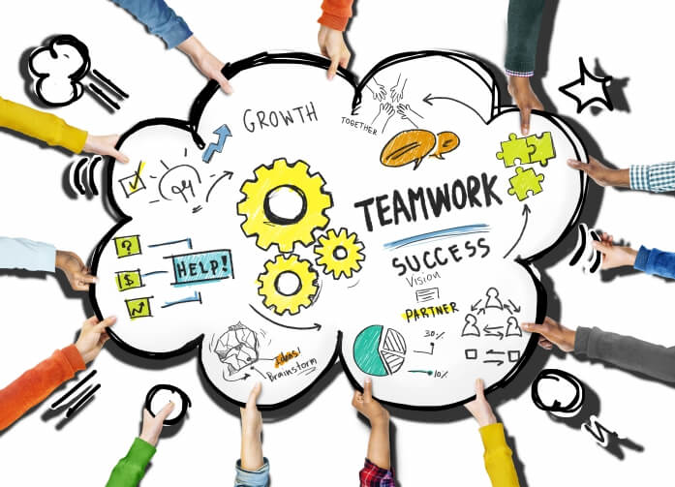
Figure 1: the significance of the team working in the place of work
(DFTB, 2018)
The figure above shows the significance of the team working in the place of work. Broadly, team working or collaborative working in the workplace increases the chances of success as well as assists the organization to attain its ultimate expected growth in the market. So, it is pretty clear that it is simply a collaborative effort of the team members where all of the members are working for the same goals and objectives. Teamwork is the best way to complete any difficult task or even attain the ultimate goal most effectively and efficiently. According to Katzenbach and Smith, in the workplace, the leader or the team members organize the team to discipline the tasks and attain the ultimate goal. There is various quality and strong brains are working together in a team or group in the workplace. Thus, the difficult tasks get easier because of the unity of different quality and sharpen brains (Staniforth, 2017). So, in the context of the place of work, the team working indicates split the difficult or large tasks into the group members as well as split the right work to the right person to whomever the leader knows better for that task. Brainstorming, trust, collaborative working, sharing expertise, and open to praise and suggest one another are the most significant examples of team working in the place of work.
Communication is the most significant way to keep a good relationship with the employer as well as the staff in the workplace. It can be done via writing, speaking, or applying any other modern or older medium. Whatever the way is, the communication must be effective to attain the ultimate goals and objectives of any organization or even any group. Effective communication ensures smoothness and higher productivity with a successful vibe for any organization (Rai and Rai, 2019). So, it is pretty clear how much essential to acquire effective communication skills in any organization for its employees to employers. According to texhelp.com, staff and employers can communicate in the place of work through 4 major mediums, such as phone, verbal, body, and written. Moreover, employees can apply some most essential effective communication tactics in the workplace like completeness, courtesy, consideration, compromise, correctness as well as consciousness, etc.

2 Findings

2.1 Understanding Strategies for effective team working
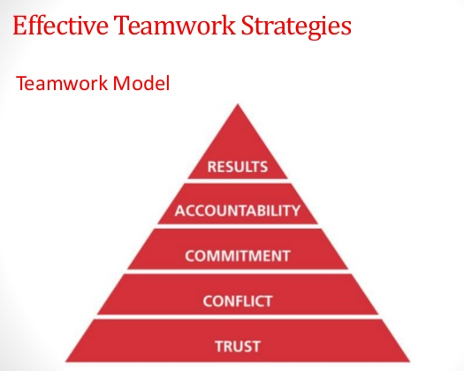
Figure 2: Strategies for effective team working
(Grainger, 2020)
Before understanding the strategies and application of effective team working in an organization, it is important to know why it is needed for any organization. Simply, teamwork is the best way to split the tasks into different brains. It is essential for any kind of organization to get a better outcome, to boost efficiency, to get better ideas and innovations, to ensure mutual support among staff and employers. However, there have some significant strategies or approaches which can build a successful effective team working environment in any organization. Results, commitments, accountability, conflict as well as trust are those approaches. By acquiring these strategies, the fresher students or the employees can do better in the teamwork of any organization. An efficient worker never has to be feared for any conflict, arguments can bring a better or even the best outcome sometimes. Also, trust and maintaining commitment increase the accountability of the employees in the organization. Ultimately, it brings the best outcome ever from a team in the place of work.

2.2 Demonstrating Communication skills in the workplace
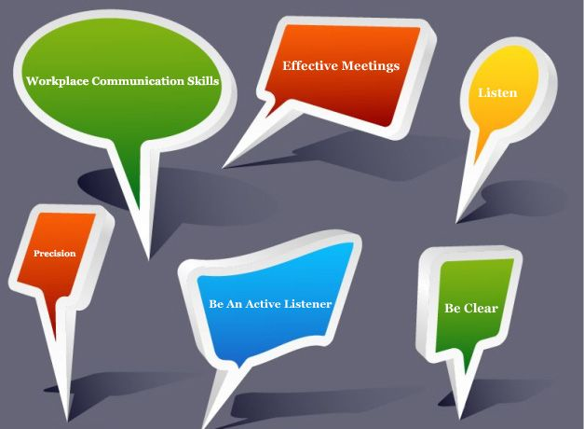
Figure 3: the essential communication skills
(These Are the Communication Skills Employers Look for in Employees, 2021)
The figure above shows some of the essential communication skills which are must need in the place of work. Normally communication in the place of study or any other relation is not the same as the communication of the workplace. There have something formal in the communication style of the workplace. Effective performance in the meetings, listening carefully and actively, showing precision, clear statement in any task, respectfulness, as well as proper responsiveness during the conversation with the audiences, are some of the essential and useful tactics to communicate effectively in the place of work (Staniforth, 2017). And, effective communication ensures smoothness and higher productivity with a successful vibe for any organization. In addition to that, the effective communication term also indicates the attitude of the employees of not talking too much as well as too little. According to thebalancecareers.com, open mind, confidence, friendliness as well as empathy are also very important to impress the boss or head of the place of work. So, an employee can do his/ her best by applying these tactics and communication skills in the workplace.

2.3 Models of Communication
There have some essential models of communication. The term model of communication describes the entire procedure of communication whatever for personal communication or communication in the workplace. However, the models of communication are discussed below:

2.3.1 Shannon–weaver model of communication
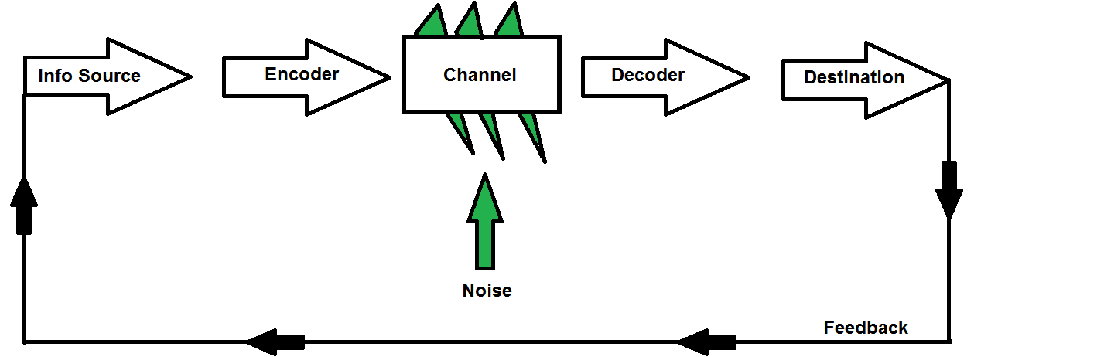
Figure 4: Shannon and Weaver model of communication
(Al-Fedaghi, 2019)
The figure above shows the Shannon and Weaver model of communication. It is known as the mother or route of all communication models. As of 1948, it is the first-ever complete and descriptive model of communication by Claude Shannon and Warren Weaver (Cobley and Schulz, 2020). It was critically designed from the mirroring of the radio and telephone technology at that time. However, this essential model of communication talks about the major five components of communication; such as source of the information, encoder, channel, decoder as well as the ultimate destination or the receiver. In this way, the channel can be disturbed or poked by the noise. But, the receiver of the information must provide feedback on the source of the information in this model. So, as it has a system of giving feedback, it is pretty clear that this model of communication is very significant for communicating in the workplace. An employee can ensure effective communication by applying this model in his/ her place of work.

2.3.2 Berlo’s SMCR model of communication
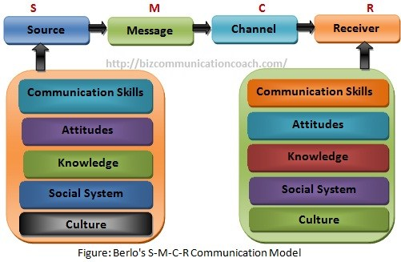
Figure 5: Berlo’s SMCR model of communication in the place of work
(Stead, 2018)
The figure above shows Berlo’s SMCR model of communication in the place of work. The words S, M, C, R stand for the source, the message, the channel, and the receiver. Sir David Berlo was designed this significant model of communication in 1960. This communication model starts with the source which includes various communication skills, knowledge, attitudes, cultures as well as a social system. According to David Berlo, these are the essential factors that can affect the communication between two individuals. And, eventually by the process of encoding and decoding the message reaches the receiver through a channel from the source.

2.3.3 Schramm’s model of communication

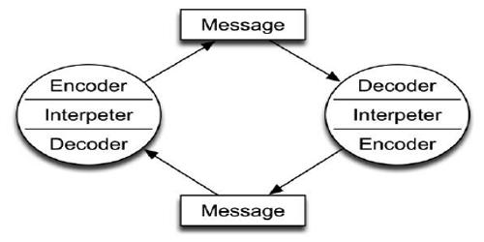
Figure 6: Schramm’s model of communication
(McQuail and Windahl, 2020)
The figure above shows Schramm’s model of communication. The entire process of communication has been described through three levels of communication; such as: syntactic, pragmatic, and semantic. However, in the context of this model, there have two parties of communication, one would deliver the message as well as another would receive the message. The one, who would deliver the message, would use the encoder, interpreter, and decoder to deliver the message. Then, the one who would receive the message would use the decoder, the interpreter, and then the encoder to understand the message. Thus, the proper communication would happen via this model in the workplace,

3 Poor communication could be improved in the place of work
Poor communication indicates ineffective and mess-up communication in the workplace. It can hamper the entire operational activities and decisions of the organization or even the tram working. Poor communication and ineffectiveness also can create a huge distance between the employee and the employer of any place of work (Grainger, 2020). For instance, during studying in this module week, one of the friends of the team did late to do his respective task because of his other personal issue. There has some negligence of him. And, ultimately the whole study group could not able to complete the task timely. So, it shows the poor communication system of that friend. If he informs the whole team timely, then any of the members could do his task timely. Also, there seems must inefficiency of the leader too. So, by following and applying the tactics discussed above all of the poor communication and inefficiency can be improved.

Conclusion
There has a proverb, ‘unity is strength’. This proverb represents the benefits and significance of a group working in the workplace. Group dynamics is all about structuring the activities of any group, the communication, and the powers between two or more social groups. When this system applies on the workplace, there each of the workers or the group members must have one or more common goal for the organization. Also, effective communication ensures smoothness and higher productivity with a successful vibe for any organization. However, in the literature review of this report, the group dynamics, team working as well as communication has been discussed. Also, in the findings part of this report, strategies for effective team working, communication skills and models of communication including Shannon–weaver model of communication, Berlo’s SMCR model of communication and, Schramm’s model of communication with an example of poor communication have been evaluated critically.

References
Al-Fedaghi, S., 2019. A Conceptual Foundation for the Shannon-Weaver Model of Communication. International Journal of Soft Computing, 7(1), pp.12-19.
Cobley, P. and Schulz, P., 2020. Theories and models of communication.
DFTB, T., 2018. Changing workplace culture. Don't Forget the Bubbles.
Grainger, A., 2020. Team-working: our part in making it effective. British Journal of Healthcare Assistants, 14(10), pp.474-480.
Maryville Online. 2021. Group Dynamics in the Workplace | Maryville Online. [online] Available at: <https://online.maryville.edu/blog/4-things-to-know-about-group-dynamics-in-the-workplace/> [Accessed 16 April 2021].
McQuail, D. and Windahl, S., 2020. Communication models. London: Prentice-Hall.
Rai, U. and Rai, S., 2019. Effective Communication. New Delhi: Himalaya Pub. House.
Staniforth, D., 2017. Teamworking, or individual working in a team? Team Performance Management: An International Journal, 2(3), pp.37-41.
Stead, B., 2018. Berlo's Communication Process Model as Applied to the Behavioural Theories of Maslow, Herzberg, and McGregor. Academy of Management Journal, 15(3), pp.389-394.
The Balance Careers. 2021. These Are the Communication Skills Employers Look for in Employees. [online] Available at: <https://www.thebalancecareers.com/communication-skills-list-2063779> [Accessed 16 April 2021].

