Module Title: Foreign Language and Cultural Awareness
Module Code: BMIH5003
Assignment Title: Intercultural Competence Report

Student Name: Wazadur Rob Chowdhury
Student ID: 2222624
Lecturer: Heidi Prosser

Executive Summary
In this report, an analysis is presented on the cultural differences between England and India, specifically focusing on their implications for intercultural leadership. The report addresses the Assistant General Manager of the 5-star Inclusivity Hotel & Spa, who is preparing to welcome employees from India to the London branch. By utilising the cultural features of the GLOBE Project, the report highlights cross-cultural differences that have a significant impact on the tourism industry. Various interconnected topics such as power relations, time management, work-life balance, communication styles, and multicultural leadership are explored in this analysis. The proposed solutions include the implementation of a comprehensive cross-cultural training program to ensure transparent communication, along with initiatives aimed at facilitating cultural integration. These efforts are intended to establish a sustainable and inclusive environment within the Anglo Cluster, ultimately enhancing service delivery for all employees.

Contents
Executive Summary 2
Introduction 3
Culture Overview: England vs. India at Inclusivity Hotel 4
GLOBE project Culture and Leadership Analysis 4
Challenges of Intercultural Leadership 6
Conclusion 6
Recommendations 7
References 7

Introduction
As the Assistant General Manager of the Inclusivity Hotel & Spa, this report aims to outline the cultural differences between England and India to facilitate the smooth integration of Indian employees into the London branch (Hofstede, G., 2001). Through an analysis of the GLOBE Project's culture and leadership study, potential challenges of intercultural leadership in the hospitality industry and the main differences between those nations will be identified, followed by recommendations for overcoming them.

Culture Overview: England vs. India at Inclusivity Hotel
In comparing England and India, several key differences emerge in terms of culture, customs, and societal norms, which are crucial for the Inclusivity Hotel & Spa to consider for the smooth integration of Indian employees into the London branch.
Firstly, communication styles differ significantly between the two countries. England tends to prioritise direct communication, characterised by explicitness and clarity (Hall, 1976), while India typically prefers more indirect and context-dependent communication, influenced by cultural practices and hierarchical structures (Gudykunst & Nishida, 1983).
Secondly, hierarchy and power dynamics vary between England and India. In England, there is generally less emphasis on hierarchy, with a more equal opportunities approach to management (Hofstede, 2001). On the contrary, India often exhibits a strong hierarchical structure, with respect for authority figures and seniority (Datta, 1988). Understanding and navigating these differences in leadership styles are essential for effective team management.
Thirdly, cultural attitudes towards time management differ. England places a high value on punctuality and adherence to schedules (Lewis, 2006), while India may adopt a more flexible approach to time, with a greater tolerance for lateness (Gelfand et al., 2011). This can influence expectations regarding work hours and efficiency within the hotel's operations.
Additionally, customs and traditions related to social interactions, dining etiquette, and religious practices vary significantly between England and India (Hofstede, 2001). Awareness of these cultural distinctions is crucial for ensuring a welcoming and inclusive environment for both employees and guests.
Overall, by acknowledging and respecting these key cultural differences, the Inclusivity Hotel & Spa can foster a harmonious and culturally sensitive workplace environment contributing to the successful integration of Indian employees into the London branch.

GLOBE project Culture and Leadership Analysis
The GLOBE Project is a renowned research initiative that investigates cultural dimensions and leadership behaviours across various societies. Analysing the GLOBE Project's findings can offer valuable insights into cultural and leadership differences between England and India, crucial for the Inclusivity Hotel & Spa's integration of Indian employees into the London branch.
Power Distance: In terms of power distance, England tends to exhibit lower power distance compared to India. This suggests that in England, there is a preference for flatter organisational structures and more participative decision-making processes, whereas India tends to have a stronger emphasis on hierarchical arrangements with greater regards to authority figures (House et al., 2004).
Assertiveness and Uncertainty Avoidance: Assertiveness and uncertainty avoidance present contrasting features between the two countries. England demonstrates higher assertiveness, indicating a culture that values competitiveness and ambition in leadership styles. In contrast, India places greater emphasis on harmony and collectivism, leading to more cooperative and relationship-oriented leadership approaches (Suh, T., Kim, Y., & Noh, Y. , 2019).
Performance and Future Orientation: In terms of performance and future orientation, England tends to prioritise performance orientation, focusing on achievement and results-driven leadership behaviours. On the other hand, India may lean towards future orientation, placing importance on long-term planning and adaptability to change (House et al., 2004).
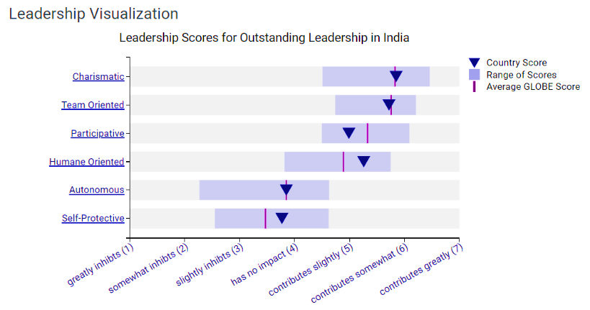

Figure 1

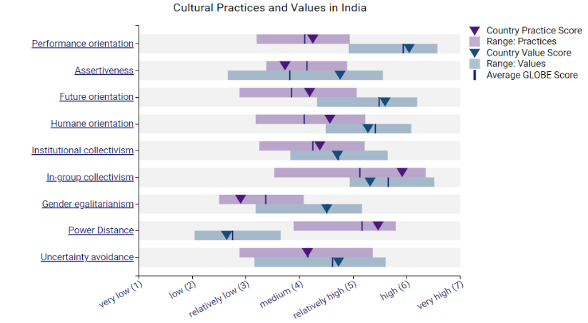

Figure 2

The above diagrams illustrate key differences in power distance, assertiveness, and future orientation between England and India, aiding the Inclusivity Hotel & Spa in navigating intercultural leadership challenges.
These differences emphasise the need for the Inclusivity Hotel & Spa to adopt a tailored approach to leadership and organisational culture when integrating employees from both England and India into its operations. By understanding and respecting these cultural differences, the hotel can cultivate a more inclusive and harmonious work environment assisting to effective leadership and teamwork.

Challenges of Intercultural Leadership
Intercultural leadership in the hospitality industry presents complex challenges, particularly when comparing culturally diverse countries like England and India within the framework of the Inclusivity Hotel and Spa.
Communication barriers are a major challenge, stemming from differences in language proficiency, communication styles, and non-verbal cues. While English serves as a common language, variations in accents and idiomatic expressions can lead to misunderstandings. India's contextually rich and indirect communication contrasts with England's more direct approach, requiring heightened cultural sensitivity (Hofstede, 2011).
Moreover, differing leadership styles pose significant hurdles for effective team management. England typically adopts an egalitarian leadership approach, promoting collaboration and decentralised decision-making. In contrast, India often embraces a hierarchical leadership model, emphasising respect to authority and centralised decision-making. Adapting leadership strategies to accommodate these discrepancies requires smart cross-cultural competence (Kaur & Mudhar, 2020).
Additionally, differing perspectives on time management and work-life balance can impact operational efficiency and employee satisfaction. England's punctuality and adherence to schedules contrast with India's flexible approach to time, where relationships and personal connections often supersede strict timetables. Balancing these differences while maintaining workflow efficiency poses a significant managerial challenge (Rana & Gopal, 2019).
Furthermore, cultural variations in guest preferences and service expectations demands customised hospitality delivery. While both countries value high-quality service, guest expectations may differ significantly. Understanding cultural transformations related to dining etiquette, communication protocols, and guest interactions is vital for providing personalised and culturally sensitive service (Rana & Gopal, 2019).
To address these challenges, intercultural leadership development programs and cross-cultural training workshops are essential. By fostering cultural competence among hospitality leaders and staff, the Inclusivity Hotel and Spa can navigate the complexities of intercultural leadership effectively, thereby enhancing guest satisfaction and organisational success.

Conclusion
In conclusion, navigating cultural disparities between England and India, as illuminated by the GLOBE Project, is essential for the successful integration of Indian staff into the Inclusivity Hotel & Spa London branch. By understanding and addressing these differences through tailored leadership strategies and cross-cultural initiatives, the hotel can foster a harmonious and inclusive workplace environment. This approach not only enhances staff cohesion but also contributes to exceptional guest experiences and organizational success.

Recommendations
Develop Cross-Cultural Competency Programs:
- Create structured training sessions focusing on cultural awareness, intercultural communication, and leadership styles tailored to accommodate the diverse workforce at the Inclusivity Hotel and Spa (Tung, 2016).

Facilitate Cross-Cultural Team Building Activities:
- Organise team-building workshops, cultural immersion experiences, and diversity celebrations to promote mutual understanding, trust, and collaboration among employees from various cultural backgrounds (Brewster et al., 2018).

Implement Intercultural Feedback Mechanisms:
- Establish regular feedback channels and multicultural forums where staff can openly discuss cultural differences, share insights, and address challenges collaboratively to foster an inclusive work environment (Gudykunst & Ting-Toomey, 2002).

References
Hofstede, G. (2001). Culture's consequences: Comparing values, behaviours, institutions, and organizations across nations. Sage Publications.
Hall, E. T. (1976). Beyond culture. Anchor Books.
Gudykunst, W. B., & Nishida, T. (1983). Bridging differences: Effective intergroup communication (Interpersonal communication texts). Sage Publications.
Lewis, R. D. (2006). When cultures collide: Leading across cultures. Nicholas Brealey Publishing.
Gelfand, M. J., et al. (2011). Differences between tight and loose cultures: A 33-nation study. Science, 332(6033), 1100-1104.
House, R. J., et al. (2004). Culture, leadership, and organizations: The GLOBE study of 62 societies. Sage Publications.
Suh, T., Kim, Y., & Noh, Y. (2019). A cross-cultural study of leadership styles of hotel managers between South Korea and the United States. International Journal of Contemporary Hospitality Management, 31(3), 1249-1266.
Javidan, M., et al. (2006). In the eye of the beholder: Cross cultural lessons in leadership from Project GLOBE. Academy of Management Perspectives, 20(1), 67-90.
Kaur, A., & Mudhar, N. (2020). A study of leadership styles in the hospitality industry: An overview. International Journal of Scientific Research and Management, 8(5), 146-149.
Rana, P., & Gopal, R. (2019). Time management in the hospitality industry: A comparative study of India and the UK. Tourism and Hospitality Research, 19(3), 343-356.
Tung, R. L. (2016). The cross-cultural imperatives of international human resource management. Journal of World Business, 51(1), 35-47.
Brewster, C., Sparrow, P., & Harris, H. (2018). Towards a holistic understanding of HRM and firm performance: A multi-level analysis. Human Resource Management Review, 28(2), 111-123.
Gudykunst, W. B., & Ting-Toomey, S. (2002). Culture and interpersonal communication. Sage.
Figures 1 and 2. - (Accessed on 20th February 2024). GLOBE Project. Retrieved from https://globeproject.com/results/countries/IND%3Fmenu=list.html#list

