

Skills for the Workplace
Module Assignment Submission

Student Name: | Arfana Akhtar
Student Number: | 1715085
Module No: | BMSW5004
Module Title: | Managing Projects in the Organisations
Lecturer: | Dr Gulnar Ali

Statement of Confirmation of Authenticity
By the act of making this submission, the student declares that this is the work of the student named above. The work has not, in whole or in part, been knowingly presented elsewhere for assessment, or where assessment has been built on a previous assessment, this has been identified. Where materials have been used from other sources it has been properly acknowledged. If this statement is untrue, the student acknowledges that an assessment offence has been committed.
Attention is drawn to the plagiarism and unfair practice policies of both the University and of ILM.

Contents
Introduction: 3
The definition of Project Management 4
Project Sponsors, Stakeholder and Scope: 4
Tools & Techniques of Project Management: 4
Project Communication Methods: 4
Benefits of Project Management: 4
Characteristics of Project Managers: 4
Organisational Structures to Support Projects: 4
Types of Project; The Project of Life, Prince 2 4
Risk Management Techniques: 4
Appreciation of Soft Skills e.g. Leadership, Management and Communication. 4
Stakeholder analysis e.g. Fair-Trade initiatives, a green agenda. 4

Introduction:

This report will be about a specific case study with an organisation and provide a critical assessment of the usefulness of project management tools and techniques.
The report will also show preparation with a plan for the implementation of the project and specify the relevant steps that must be followed and how the plan is going to be implemented. The specific case study will also need to show a clear understanding of the project plans with appropriate colleagues and stakeholders.
The report will critically evaluate the ability to manage the project and use the feedback from others to evaluate the ability to plan and implement a project and to also identify the strengths and the weaknesses within the organisation.
The report will also create or show an understanding of a self-development plan to improve the performance in managing the project within the organisation.
In this report it will also include the following indicative content which is listed below:
- Project Sponsors, Stakeholders and Scope.
- Tools & Techniques of Project Management.
- Project Communication Methods.
- Benefits of Project Management.
- Characteristics of Project Managers.
- Organisational Structures to Support Projects.
- Types of Project; the project life cycle, PRINCE 2
- Risk Management Techniques.
- Appreciation of Soft Skills e.g. Leadership, Management and Communication
- Stakeholder analysis e.g. fair-trade initiatives, a green agenda.

The definition of Project Management:

The definitions of the Project Management are the application of skills, tools, knowledge and techniques in order to project activities to meet or exceed stakeholders needs and expectations.

Project management is when the final decision is made and are constrained to finite timescales and budget.

A project is a unique task which is undertaken, then it can be then also determined as outcomes, outputs or even the benefits.

A project is usually deemed to be a successful result if done properly and met the objectives according to their acceptance criteria which is within a agreed time scale and budget, these can be broken down to three steps which is time, cost and quality which are the three building block of every project.

Below is a quick meaning of the three steps of time, cost and quality.

- Time – scheduling which is collection of techniques used to develop and to also present schedules or timetables, etc, that will show an estimate of when the work will be performed.
- Cost – it is when it shows a clear understanding of how much the cost will be of the work carried out or whatever is involved.
- Quality – how the fitness of quality for purpose of the deliverables and management processes be assured.

The core components of having a project management are listed below:
- Defining the reason of having a project in place.
- Capturing project requirements or specifying quality of the deliverables and to have an estimate of the resources and the timescales used.
- Preparing a business care to justify the investment of the organisation.
- Securing the corporate agreement and the funding.
- Developing and implementing a management plan for projects used.
- Leading and motivating the project delivery team within the organisation.
- Managing the risks, issues and the changes on the project.
- Monitoring the progression on the project until accomplish the right result.
- Managing the project budget withing the organisation.
- Maintain the communications withing the organisation, which is with the stakeholders and with the project organisation.
- Provider management of the company or who is dealing with the designated task.
- Closing the project in a controlled fashion and in a most appropriate wat possible without any conflicts or misunderstandings.

Having a project management in place is good and keeps records of progression and keeps workplace maintain good results and a very good quite environment to work in, because rules and regulations and good strategies are in place.

Without having a project manager to report to will be quite hard has it much better for everyone have a specific role to deal with and then reporting back to manager for the result or outcome of the work that was assigned to one.

After work been given by manger it is then better for the manager then look at what was required and if rules and regulations were used, and then if there are issues or conflicts the manager can then decide to make the right decision for a better outcome and to reach good results.

The manager can also use the right method to result a good outcome even when dealing with risk factors when dealing with risk factors in the workplace or when dealing with an incident in workplace or outside workplace for deescalating the situation properly.

In the assignment I will write about the different strategies in project management in the organisation and will also write about the different risk factor in organisations.

Project Sponsors, Stakeholder and Scope:

Stakeholders in the criminal justice systems is when people are affected by the criminal justice system. The stakeholder system can include internal and external stakeholders.
Internal stakeholders can be considered as the criminal justice system itself and external stakeholders are those when the criminal justice system serves and, in some ways, it also affects the system.
Identifying these stakeholders will bring valuable insight into the criminal justice system.
The list of Internal Stakeholders is listed below:
- Police Officers
- Judges
- Probation Officers
- Parole Officers
- Correctional Officers
- Lawyers
- Court Personnel
Those who is responsible for enforcing the law and those who explain the law in detail are part of the criminal justice system internally. Those who are suspected of crimes and are convicted they could also be considered as internal stakeholders within the criminal justice system.
All the stakeholders have a strong connection with each other, and they all have an affect each other too. In order to even properly prevent crime, apprehend offenders and treat offenders, all these stakeholders must do their specific jobs that is allocated to them.
The list of External Stakeholders is listed below:
- Elected Officials
- The Media
- Groups who serve victims of crime
- Businesses
- Families
- School
- Society in General

When there is a victim of crime who is of course been obviously been impacted, the media is also impacted when a crime is been reported. The ones that receive the media are also impacted too.
Everyone in one way or the other is affected by the criminal justice system, society is also affected from the laws that are passed to the treatment of offenders.

Tools & Techniques of Project Management:

Techniques in project management range from traditional to innovative ones. When choosing the right one depends on project specifics, its complexity, it involves teamwork and many other factors. Most of them can be used in different various fields, but there are also techniques that are traditionally used in various areas of activity or which are developed accordingly for certain fields. Below is a list of techniques that are used in project management.
Project Management Techniques
- Classic technique
- Waterfall technique
- Agile Project Management
- Rational Unified Process
- Program Evaluation and Review Technique
- Critical Path Technique
- Critical Chain Technique
- Extreme Project Management

Classic Techniques:
The traditional techniques are sometimes the most appropriate for running projects. The classic technique is one that prepares a plan of upcoming work, estimating tasks to perform, providing and getting information from the team, allocating resources also monitoring the quality and deadlines.
The classic technique is the most ideal one for running projects which is performed by a small group of teams when it’s not necessary to implement a complex process.

Waterfall Techniques:
This technique is considered as one of the traditional techniques, but it takes the simple classic approach to the next new level. The next steps are when the previous task is accomplished and is monitoring the progress and the performed steps.
Gantt charts are used quite a lot as it is showing a clear visual representation of dependencies and phases.
The Waterfall techniques is traditionally used for projects which are quite complex with detailed phasing is required and a successful delivery depends on rigid work structuring.
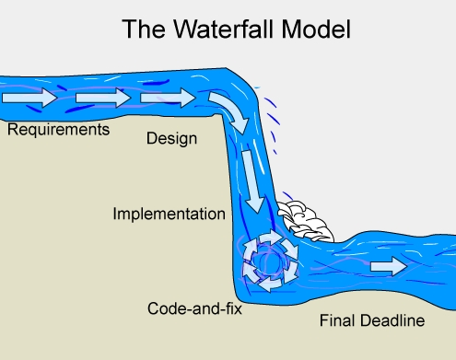
(Gantt Chart GanttPRO Blog, 2019)
Agile Project Management

Agile project management method is a set of principles which is based on the approach. It shows dividing project work into short sprints, using adaptive planning and continual improvement. There is also fostering teams which is self-organisation and collaboration targeted to produce maximum value.
Agile framework also includes techniques which includes techniques such as Scrum, Kanban, DSDM, FDD.
Agile is also used in software development projects that involve frequent iterations and performances done by small and highly collaborative teams.

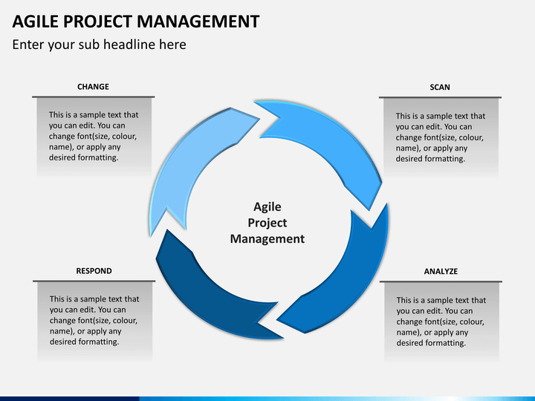
(Management, 2019)

Rational Unified Process:
Rational Unified Process (RUP) is a framework which is designed for the software development teams and projects. Implementing a successful development process, where the feedback is used for future from the product users for development phases.
RUP technique can be applied in a software development projects, where the end user satisfaction is the key requirement.

Program Evaluation and Review Technique:
Program Evaluation and Review Technique (PERT) is one of the most widely common approaches in various areas. It also involves complex and detailed planning and visual tracking of the results on the work on the PERT charts. It’s the core part which is the analysis of tasks which is performed within the project. The US Navy originally developed this technique during the Cold War to increase the efficiency of work on the new technologies.
This technique suits best for large and long-term projects which is usually for non-routine tasks and challenging requirements.
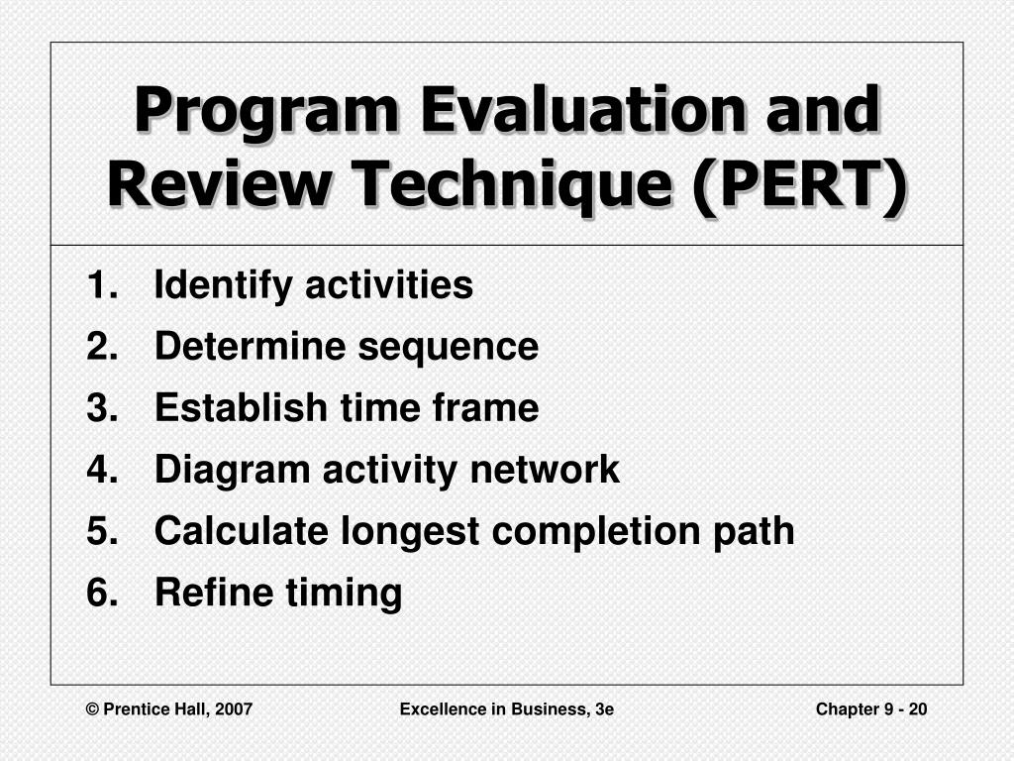
(Image.slideserve.com, 2019)

Critical Path Technique:
This technique is an algorithm for scheduling and planning project works which is often used as the PERT method in conjunction which is discussed above. This technique also involves in detecting in the longest path of sequence of tasks from the start to the end of a project and defining the critical task.
Critical tasks are that are influenced to meet the deadlines of the entire project and require close attention and have a thorough control.
Critical Path technique is used for the more complex projects where delivery terms and deadlines are critical which are in such areas as construction, software, defence, development and others.
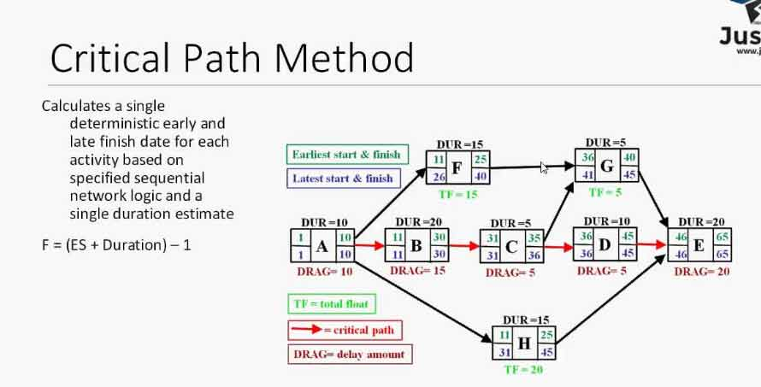
(Businessstudynotes.com, 2020)

Extreme Project Management:

Extreme project management method (XPM) clearly states elasticity in planning, reduction of formalism, an open approach and deterministic management.
Developing from extreme programming methods, where it is focused on human factor management rather than on formal methods and rigid phases.

XPM is used for large, more complex and where there are more uncertain projects where managing uncertain and unpredictable factors are more required.

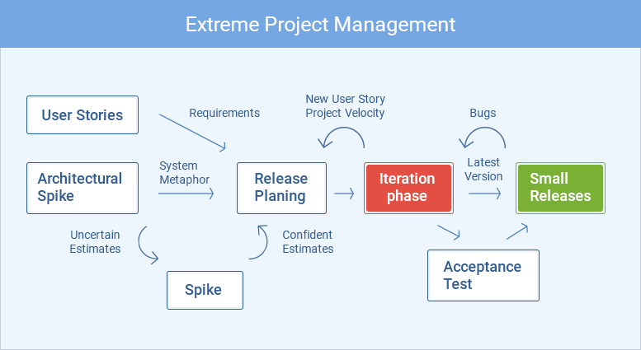
(Mldpvxgghies.i.optimole.com, 2020)

Project Communication Methods:

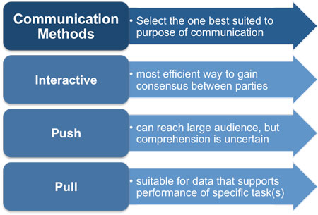 (Bing.com, 2020)

Effective project communication methods are simple methods used in organisations in order to accomplish a task I found a table which is shown above in three basic steps which are to be interactive, to push and to pull. Below It will state what each stage is about:
- Interactive Communication Method – this is an effective communication method, for using in interactive communication with stakeholders involved in the communication which then they can all respond to each other. Interactive methods include methods like; face to face, video conference, phone calls, and even messenger chats. These methods are more effective as they are used in projects, due to being able to see body language and facial expressions of the communicating stakeholders. This method can also be used to brainstorm idea to gather information or requirements for a project.
- Push Communication Method – This method is used to distribute information without feedback from the recipients. A lot of organisations use this method to notify shareholders through a press release. The Push method of communication is commonly found in projects and organisations.
- Pull Communication Method – This method is the pull communication which is best for a large audience which requires access to information at their discretion. In large projects when a meeting is conducted to a set of developers, to then enable developers to have full access the initial training material again, that’s when the pull method is used to upload slides and supporting content material via a corporate intranet. This methods also gives access when needed to other companies provided access to projects artefacts such as precedence diagram and decision trees which is used by others in other companies, this is why when it is needed by others the push method is the most appropriate method of communication.
The organisation in this assignment was about probation officer and the three steps shown above can also be used in this organisation and the most effective one will be the interactive one due to having a lot of face to face meetings, telephones calls, even there will be a lot of emailing required in order to give the right support needed for the clients care and well being in and when out of prison.
The push method will be more useful when the court or other organisations require information about the client, which will be easy to do to give and receive feedback.
The pull communication method will be best used when having meetings with other co-workers, or when meeting with family a small portfolio can be made with the required information to show each stage of progression and to also show what task are being met and what is still required by the client, basically to show a start to finish project with each client.

Benefits of Project Management:
The Benefits of having a Project Management in place is to enable;
- completion of projects in the projects within the shortest time possible while balancing cost and quality.
- Enhances the flexibility of the staff which can help accomplish more work even with having less resources.
- It provides accurate timely information to different levels of the organisation in consistent formats.
- It improves in decision making based on the facts and the exact project information.
- It improves the ability to achieve the business objectives and the goals.

Characteristics of Project Managers:

The Projects Character is a product that is a temporary project that is undertaken to create a unique service or product.

The goals of having or even meeting the needs is list below:

- Having a set of related activities that are not always repeated.
- Having a reassuring beginning and an end.
- Having specific clearly defined deliverables and goals.
- Being able to destroys resources that were used.
- Needs to be always manged well.

A Project Manager is a person who is responsible for the designated project who will also be held accountable for its failure or even its outstanding success of the project managed.

Organisational Structures to Support Projects:
Organizational structure is what describes the way a company or organization is usually setup. It can also be defined as using a hierarchy chart that shows how groups or functions report within the organization.
For Project Managers, the company's organizational structure will affect how the resources are assigned to the project and will then be a factor in how much influence the Project Manager will have within the organization.
There are three organisational structures which is listed below in bullet points;
- Functional Organisation Structure
- Project-Based Organisational Structure
- Matrix Organisational Structure

Functional Organisation Structure; Every employee is implemented with one function to deal with, and who has only one manager to report back to, which is the functional manager.
The functional manager deals with the employees work and handles the administrative work, which is the employee compensation, the manager also assigns and manages the workload.
In the functional organisational structure, it holds information like;
- Advertising
- Engineering
- Human Resources
- Manufacturing

The table below shows a functional organisational structure;
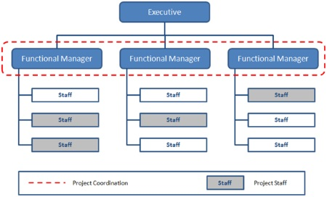
(Project-management-skills.com, 2020)

Project Based Organisational Structure; This method of structure is more based on projects and not the functions, this type of method is called the projectized organisational structure.
Most companies’ resources are more project work, which means the Project Managers have more knowledge of high levels of independence and authority for the assigned project and to control the project resources.
The diagram below shows a project based organisational structure;
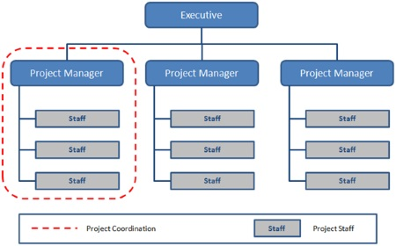
(Project-management-skills.com, 2020)
Matrix Organisational Structure; This method is a blend of the project based organisational structure and the functional organisational structure.
The matrix structure is when an employee has two or more managers they can report to, which is the functional manager and the project manager. At times they might have multiple projects that they are working on, so then they will have more manager they can report too.
There are three types of matrix organisations which is listed below;
- Weak Matrix
- Balanced Matrix
- Strong Matrix
Weak Matrix; This is where many of the features are maintained from the organisational structure. The project manager has more of a role then the Project Coordinator. Their ability to make decisions is low and most of the authority remains with the Functional Manager.
Below is a diagram of a weak matrix;
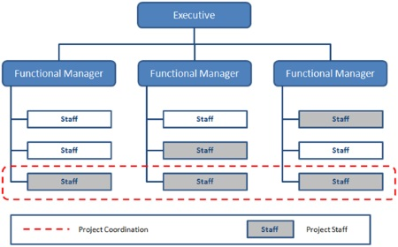
(Project-management-skills.com, 2020)

Balanced Matrix; This method recognises the importance of having a Project Manager, but the Project Manager dose not have full authority over the project staff, project budget and over the actual project.
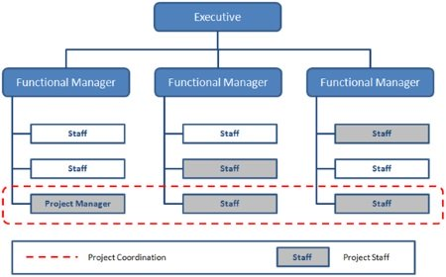
(Project-management-skills.com, 2020)
Strong Matrix; This method has many of the features of the projectized organisational structure. The strong matrix has full time project managers and productive administration staff. The project managers have considerable authority over the project in this organisational structure.

Types of Project; The Project of Life, Prince 2

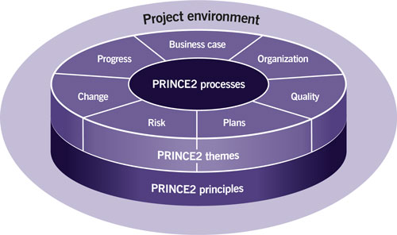

Risk Management Techniques:

A risk assessment is vital and very important to do in the organisation of probation work has your dealing with clients with many different risks.
A risk management is used to balance out risk levels and to initiate what level of help is required and what is needed.
It is also used to keep a record so it can be used when reviewed at a later stage to see the outcome, it can also be used to check the progression with the client.
A risk management technique is when your avoiding a risk, avoidance should be the first options when considering the risk control.
It is also retaining the risk as it is sometimes preferable to keep the level of risk as it is to avoid the cost of the initial risk being more than the cost damage.
It is also having the risk of having it spread, as it the sometimes often the most inexpensive way of reducing the chances however big or small the risk is to avoid calamity, to protect the level risk.
Risk management is also like preventing or reducing loss like when exposing yourself or the company your working for is unavoidable. Sometimes it can often reduce or eliminate the losses by taking the vital safeguarding against the level of risk, which is exposed, so it can be easily dealt with the appropriate method and the right strategy.
Every business or organisation have risk management strategies in place which can also vary from year to year or it can also be from project to project depending on the work or task that is being dealt with.
One method is or can be used to establish the risk level or to manage the risk level which is exposed, to then determine which strategies should be used to the list of potential risks, rate the probability of the risk reoccurring or even at the present time of dealing with the risk proposed, to then decide the best method or best strategies is to use to deal with the matter.
In most cases is it better to have many different options in hand to deal with the risk appropriately. In most cases it is good to be able to use a combination of experience along with the organisations data to determine the likelihood of the risk but relying solely on the experience can also be quite rarely given the accurate data back.

Appreciation of Soft Skills e.g. Leadership, Management and Communication.

Stakeholder analysis e.g. Fair-Trade initiatives, a green agenda.

Having the soft skills in every company or organisation it is good to have a good balance in the work place and the organisation will have good results when dealing with whatever is the issue weather its within the company with co-workers or dealing with clients, customers or just initially dealing with anything. Hence why is quite vital to have management dealing with certain work so others can report back to the right manager.
Having leadership is good as the management can be only focusing on progression good or bad and can focus in how to better the situation or even come up with certain strategies to deal with the problem.

Conclusion:

This assignment was overall looking at how mangers deal with problems within an organisation and how or what strategies are used to solve problems.
There are a lot of different strategies in every organisation, but every organisation also has different risk level and each company use different strategies to deal with the risk levels.
By doing this assignment I have also learnt many more ways of dealing with problems and how different manager should deal with a problem which is raised and what the outcome should be, I also learnt the many options can be used and the right way of dealing with the problem.

References:
Gantt Chart GanttPRO Blog. (2019). Waterfall Methodology in Project Management. [online] Available at: https://blog.ganttpro.com/en/waterfall-project-management-methodology-pros-and-cons/ [Accessed 10 Dec. 2019].
Management, A. (2019). Agile Project Management. [online] Sketchbubble.com. Available at: https://www.sketchbubble.com/en/powerpoint-agile-project-management.html [Accessed 10 Dec. 2019].
Image.slideserve.com. (2019). [online] Available at: https://image.slideserve.com/482709/program-evaluation-and-review-technique-pert-l.jpg [Accessed 11 Dec. 2019].
Bing.com. (2020). project communication methods image - Bing. [online] Available at: https://www.bing.com/images/search?view=detailV2&id=581D75EE519784FE330F3DC8543F6AE1BEC020CD&thid=OIP.KKkyGAx7nmCn9eJyZsV5NgHaFB&mediaurl=http%3A%2F%2Fwww.free-management-ebooks.com%2Fimages%2Fpmcm0213.jpg&exph=305&expw=450&q=project+communication+methods+image&selectedindex=8&ajaxhist=0&vt=0&eim=1,6 [Accessed 10 Jan. 2020
Businessstudynotes.com. (2020). [online] Available at: http://www.businessstudynotes.com/wp-content/uploads/2017/09/Critical-Path-Method.jpg [Accessed 7 Jan. 2020].
Mldpvxgghies.i.optimole.com. (2020). [online] Available at: https://mldpvxgghies.i.optimole.com/w:777/h:425/q:auto/https://www.actitime.com/wp-content/uploads/2018/09/chart5.png [Accessed 7 Jan. 2020].
Project-management-skills.com. (2020). [online] Available at: https://www.project-management-skills.com/images/functional-organizational-structure.jpg [Accessed 10 Jan. 2020].
Project-management-skills.com. (2020). [online] Available at: https://www.project-management-skills.com/image-files/projectized-organizational-structure.jpg [Accessed 10 Jan. 2020].
Project-management-skills.com. (2020). [online] Available at: https://www.project-management-skills.com/image-files/weak-matrix-organizational-structure.jpg [Accessed 10 Jan. 2020].

