Marketing Management
ASSESSMENT 2

NAME: MOHAMMED FARHAN KUNHAYI
STUDENT ID: 2132168
MODULE: LCMB7001
LECTURER: TUSHARA BALENDRAN

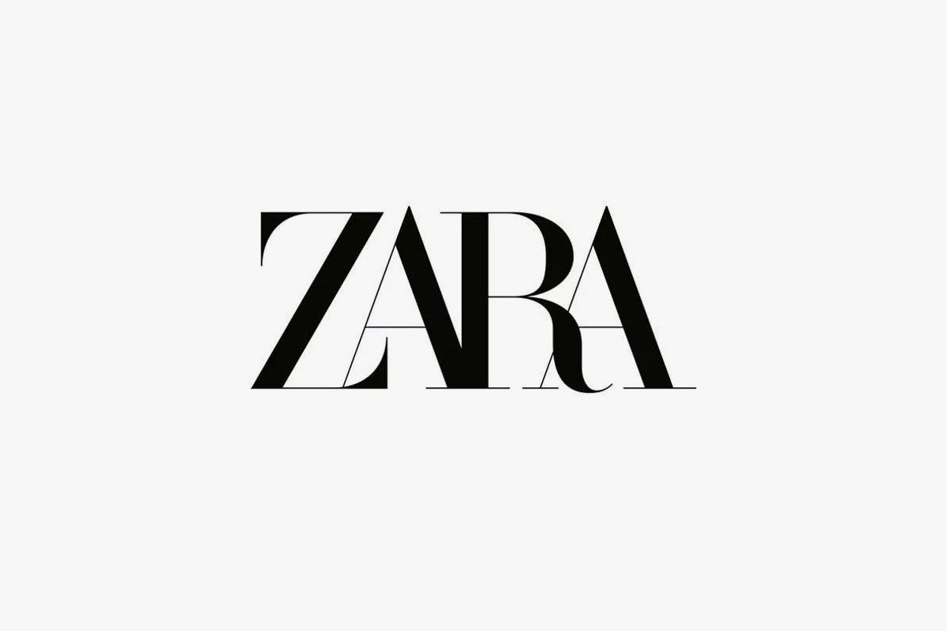

TABLE OF CONTENTS

- INTRODUCTION……………………………………………………………………………………………….1

- PESTEL ANALYSIS……………………………………………………………………………………………..1

- PORTER’S FIVE FORCES………………………………………………………………………….………..3

4.SWOT ANALYSIS………………………………………………………………………………………..………4

-ADVANATAGES AND DISADVANATGES OF SWOT…………………………………….…….6

5.SEGMENTATION TARGETING AND POSITIONING……………………………………….…….6

6.MARKETING MIX……………………………………………………………………………………..………7

7.CONCLUSION AND RECOMMENDATION ………………………………………………..……….8

INTRODUCTION

This paper examines Zara, one of the most successful fashion retailers. Comparative shopping and observational studies were utilised to analyse the brand. PESTLE, SWOT, and Michael Porter's Five Forces are used (1980).
In PESTLE, we study Zara's market position via political, economic, social, cultural, technical, legal, and environmental aspects. Zara's future is obvious. Zara's prospects look good.
Zara's Porter's Five Forces Analysis examines its rivals and industry variables.
We'll do a SWOT analysis to examine Zara inside and outside. Segmentation, targeting, and brand positioning will be discussed. Also, marketing mix, a company's approach for promoting its brand or product. We'll conclude with tips on using the Ansoff matrix.

PESTEL ANALYSIS

A PESTEL analysis is a tool used to figure out the macro forces that an organisation must deal with. Political, Economic, Social, Technological, Environmental, and Legal are what the letters stand for. Organizations operating in the analysed environment can use the data and information gleaned from a PESTEL analysis to make informed decisions about how to respond to changes in the market and strengthen their position in the industry (Walsh 2005).
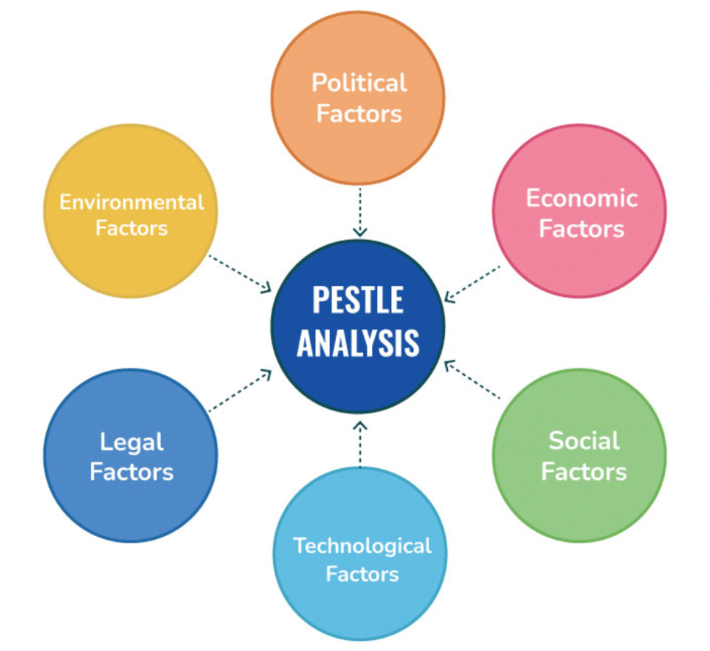
Figure 1: Pestel Analysis Model Framework (Speaking Nerd, n.d.)

POLITICAL: Depending on politics, it can be difficult for retail brands to operate globalland free trade policies facilitate exports and imports. Zara can either expand into the new market by stocking clothes for the demographic at all their stores or by opening new Zara Brand Outlets like their existing Massimo Dutti and Bershka locations. If Zara goes with the first option, it could run into trouble if the government of the country that is getting the new brand clothes (materials for factories) imposes a "Quotas" or "Tariffs"-tax on imports, which could force Zara to raise prices in that country to make up for the tax. However, the governments of some countries may not be willing to accept a licence for Zara's Brand Outlets if they already have many foreign brands available to their citizens (Hoang and Ducie, 2018). political factors are unfavourable for Zara.

ECONOMIC: Spain has one of the highest rates of unemployment in the European Union. Because of this, Spain's labour costs are relatively inexpensive when compared to those in other European countries. Zara is a Spanish brand, so the company rarely sends work to other Asian countries for production. It's because the brand's home country has a lot of cheap labour. Economic considerations also influenced Zara. Covid-19 and lockdown have closed enterprises worldwide. Zara must close 2270 stores globally. Brexit has affected fashion. Clothing sales have plummeted. Brexit prevents European brands from trading freely in the UK (Shaw A. A., pestle analysis of zara, 2020). Depending on how a business responds to various market conditions, this component may have either a favourable or unfavourable effect.

TECHNOLOGY: This looks more favourable to Zara. When the pandemic of COVID-19 struck the world, a wave of lockdowns and company closures occurred, which resulted in the emptying of streets, shopping malls, and shops all over the globe. Zara moved quickly to make investments in e-commerce and the technology that supports online retail. Zara's e-commerce platform features an interactive user interface, and customers all over the world interact with it daily. The brand makes use of sophisticated analytical tools and algorithms to determine the trends and shopping patterns of customers. Additionally, in order to engage with its customers, the brand makes use of a variety of communication platforms (Shaw A. A., SWOT & PESTLE Analysis, 2020)

SOCIAL: Social factors assess the socio-cultural influences of consumers and your target demographics. Zara is a worldwide store, so its New Brand Outlets must not all follow the 'Standardization Method' of selling the same clothing. Each New Brand store should sell based on local demand and culture. Zara can't offer revealing apparel to Arab women since it's against their culture. Zara can't sell Bangladeshis dreary hues or fast-changing styles since they favour bright colours and rarely change their clothes (Kasi, 2016). according the above analysis this factor seem to be favourable for Zara.

ENVIRONMENTAL: In the PESTEL framework's environmental dimension, various trends may affect garment companies. Climate change and global warming may provide future challenges to fashion industries, especially in underdeveloped countries (OECD, 2009).

Zara has promised to make eco-friendly merchandise. The company focuses about animal welfare, sustainable materials, clean water, biodiversity, and other subjects. Taking environmental concerns seriously will develop client loyalty (Shaw A. A., 2020). favourable factor

LEGAL: Zara is ethical and sustainable. They aim to use these concepts across their business and supply chain. Zara must follow rules. The company's living wage laws vary. The corporation invested in supply chain management to assure brand legality. The company experienced copyright issues when designing new clothes. Adidas and Balenciaga accuse the brand of copying. Outdated legal notions allow imitation without penalties. Zara should enforce copyright because their clothes take time and money (MBA Skool Team, 2019)

PORTER’S FIVE FORCES
Michael Porter of Harvard Business School initially presented the five forces theory in 1979. The five forces framework is a straightforward method for analysing the external factors that affect a company's performance (Johnson, Scholes, & Whittington, 2008).The five factors that make up Porter's model are as follows: Rivalry among existing competitors, the threat of new entrants , the bargaining power of suppliers ,the bargaining power of buyers , and the threat of substitutes.

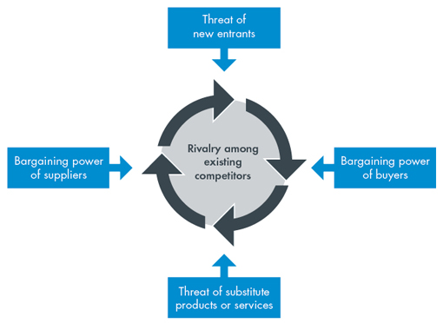
Figure 2: Porter’s five forces (Porter's Five Forces of Competitive Position Analysis, 2013)

BARGAINING POWER OF BUYERS : Zara's advertising expenditure is between 0% and 0.3%. It depends on spoken words. Fashion's consumerist character is unpredictable. Customers may buy whatever takes their eye, notwithstanding company fashion statements. Despite the store's famous great quality and inexpensive prices, people wait in line for every fashion frenzy at ZARA. Limited quantities increase their enthusiasm. 10% of the stock remains unsold. The firm must watch prices to avoid losing clients. To state that the power of customer is moderate (Adamkasi, 2017).

THREAT OF NEW ENTRANTS : Zara faces a relatively low level of competition from new companies in 2022. This is due to the fact that it is challenging to break into the fashion industry and develop a presence for oneself. A new competitor would have to spend a lot of money to match Zara's supply chain and distribution network. In addition, Zara possesses a powerful brand identity that is tough to imitate (Portersfiveforcesteam, 2022).

THREAT OF SUBSTITUES: Similar products from other companies pose a replacement threat. Zara's pricing approach is built on quality, hence costs are sometimes higher than rival products, which may scare away low-income earners. Customers may buy similar items from a rival company that sells them cheaper. Low switching costs illustrate why substitutes are a threat. Zara delivers higher-quality products than its competitors, but not enough to discourage a buyer from buying a rival's product. However, the corporation produces high-quality items to raise switching costs. The corporation invests considerably in R&D and continuously introduces new models (Studycorgi, 2022)

RIVALRY AMONG EXISTING COMPETITORS: Zara has to deal with tough competition from big brands like H&M, GAP, etc. Zara can compete with its rivals because of its strong brand and loyal customer base, as well as its unique products. It is worth more than $14 billion as a brand. It uses a business model called fast fashion, which means it offers unique and often-updated fashion trends at high-street prices. This gives it an edge over its competitors (TEAM, 2022)

BARGAINING POWER OF SUPPLIERS: Being a subsidiary of Inditex gives Zara more leverage in negotiations with its suppliers. Although at the moment, due to its expansion, the brand counts on certain independent suppliers, it is vertically integrated, which means that Zara is responsible for all stages of the design, production, distribution, and sale of its products.

SWOT ANALYSIS

SWOT Analysis is a basic yet effective method for assessing an organization's resources, market opportunities, and external threats to its future (Thompson et al., 2007: 97). A SWOT analysis evaluates your company's strengths, weaknesses, opportunities, and threats.

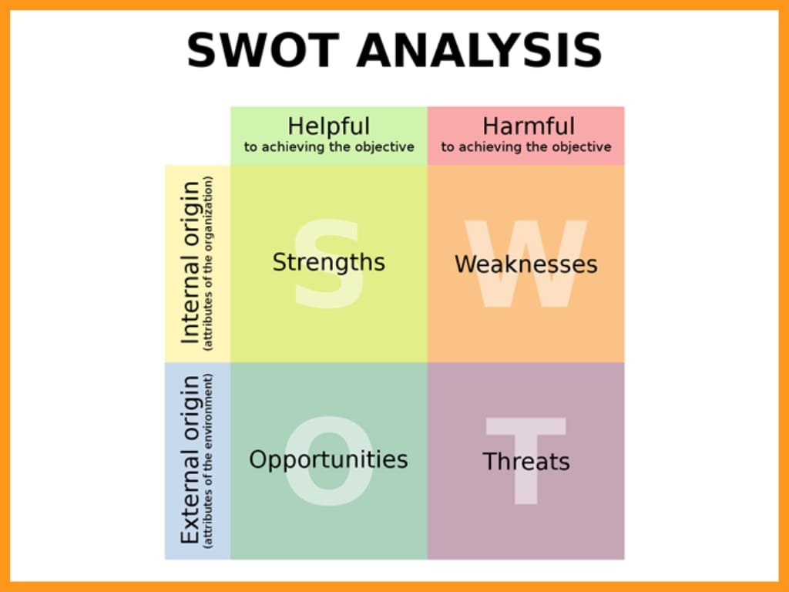

Fig 3 SWOT ANALYSIS

STRENGTH

Zara's many strengths have earned it Inditex's most popular and profitable subsidiary. It has 54% of its operations near its Spanish headquarters and a solid supply and retail network (Inditex). IT technologies ease communication and data exchange with 1,985 suppliers and 8,155 manufacturers globally (Inditex). Online and retail collections are refreshed twice a week, and 10 logistic hubs deliver to any destination globally within 48 hours. 2,118 locations in 202 markets make them the world's largest fashion retailer (Inditex). While other firms take months to get things to stores, they just need three weeks to do concept sketches. . Zara targets young people who want but can't afford good fashion. This method boosts popularity and customer loyalty since clients may acquire new fashions on a budget.

WEAKNESS

Due to the necessity to replace outdated trends and offer new designs, clothing quality is low and sustainability is difficult to manage. The brand must stay true to its environmental commitments to offset its garments' limited lifespan and manufacturing-related carbon emissions. Zara's apparel and accessories for men, women, and children lack concentration. Zara offers broad, trend-driven clothing. Customers may choose different companies that specialise in jeans or dresses. When the pandemic arrived in 2019, it showed Zara's dependency on physical stores. Online sales alleviated the company downturn but were only 89% of 2019 rates (Sudhakara,2020). Inditex will shut 1,200 Zara stores 16% in June 2020 to focus on internet sales.

OPPORTUNITIES

By using Zara's brand assets, the company may develop quickly. Zara's business approach focuses on the client experience. In this digital era, AI is changing the retail business, with worldwide AI sales expected to expand from $643.7 million in 2016 to $36.8 billion in 2025. (Mani,2020). Investing in AI and other technologies might create a new retail future.
Zara relies on its physical stores and may increase brand visibility and income by focusing more online. More individuals are using smartphones and computers to connect online, altering daily life. The brand might increase sales by devoting more time in digital marketing and e-commerce.

THREAT

Competition is Zara's biggest danger. Zara must compete with online retailers providing identical things for less thanks to the internet. Shien and Romwe emulate Zara and H&M with the rise of quick fashion.High-fashion shirts for $5. Zara is vulnerable as copycat launch pricing battles. As a global brand competing in 202 markets, trade restrictions and foreign business rules threaten Zara. The brand must follow labour and trade standards that vary by nation. When the epidemic reached Europe, several governments shut down industries and limited travel. So, Supply routes and production were disrupted by lockdowns. As COVID19 remains, Zara must adjust to new circumstances and prepare for postpandemic business.

ADVANATAGES AND DISADVANTAGES
SWOT examines internal and external factors that help goal achievement. Internal analysis starts strategic management. Internal analysis identifies competitive advantage capabilities. External analysis analyses environment, industry, and rivals to uncover market possibilities and hazards.
External analysis matches strategies with the corporate environment. Internal analysis indicates which resources need to be enhanced and maintained. Weighing strengths, weaknesses, opportunities, and risks. Current and future possibilities and threats are analysed. Strengths and weaknesses make unrealistic opportunities less likely. Opportunities counter dangers, weaknesses counter strengths, and strengths counter threats. SWOT Analysis displays a company's state and permits action strategies. The method can assist build strategy if done appropriately. It has limitations and constraints while being a fundamental management tool with planning advantages. SWOT analyses micro factors.
Qualitative factors are hard to use in decision making. Internal and external qualitative analysis starts a planning process analysis. Literature suggests SWOT is insufficient for strategic planning. Research implies qualitative and quantitative methods might improve SWOT.

SEGEMENTATION,TARGETING AND POSITIONING

SEGMENTATION
Two elements drive ZARA's segmentation strategies that are Demographic segmentation (Gender) and Personal Characteristic segmentation(Taste/style).
Demographic Segmentation
This type of market segmentation is based on clients' ages, genders, and education levels. As a quick fashion business, ZARA must give the public with the basics of wearing, which only three groups require females, men, and newborns. ZARA has predominantly female clientele. It's proof that ZARA made the proper option in market segmentation by splitting submarkets by consumer gender. ZARA has men's, women's, and children's lines. All these types are owing to youngsters, ladies, and men as consumers. ZARA also develops broader product lines for its female clientele
Personality Characteristic Segments:
Consumers' jobs, cultures, and traits are used to segment them. Due to the fact that 75% of ZARA's clients are women, the company must diversify its product lines to increase profits.females prefer elegant, cool, and attractive closings. Younger women have bolder dress tastes than older women, who are more traditional. ZARA Using personal traits, divide the female market into three submarkets. ZARA offers three product lines, TRF Basic and Women, to meet the demands of bold, formal, and quality-conscious women(Yinghong Chen,2022)
TARGETING
ZARA's target market is well-educated 25-35-year-olds with above-medium income. This clientele is fashion-savvy. They appeal to fashion-conscious people.
Needs and preferences in clothes. So ZARA has a deeper line categorization. For example, ZARA's women's apparel is separated into three series: Zara Women for evening and workplace attire, ZARA Basic for popular casual wear, and ZARA TRF, a youthful series with a sporty edge. All rebuilt items for diverse markets, and update speed is quick. Simultaneously, customer demand may be addressed(Yinghong Chen,2022)
POSTIONING
Positioning is planning a company's offering and image to attract target customers (Kotler, P. 2011). It refers to where items or services would be sold. The product positioning strategy establishes the distinctiveness of goods and services compared to competing options. The position strategy mostly formed of three dimensions. They're consumer issues, corporate and product differentiators.

MARKETING MIX
Marketing mix is the coordinated effort of several distinct promotional channels used by a business to elicit a certain reaction from its target audience. Product, price, promotion, and place make up the "4Ps of Marketing," a collection of marketing tactics(Riaz, 2011)

PRODUCT

Product strategy is how organisations achieve marketing goals by supplying tangible and intangible goods. ZARA sells items. It controls variety, specs, styles, packaging, branding, and service. Effective product strategy improves branding, packaging, promotion, and sales to strengthen a company's competitiveness. Zara's global intelligence bureaus acquire local trend information. ZARA's weekly addition of new counters can please creative customers. Zara designers copy luxury brand products with high-quality materials to boost sales(Ye, SH., 2021)

PRICING

Zara's product pricing must continually be competitive to maintain the company's solid reputation and high volume of satisfied customers. Zara caters to the common client who wants to keep up with the latest fashions without breaking the bank. To a large extent, this accounts for Zara's success among today's youth (davar, 2020)

PROMOTION

While the majority of companies depend on marketing to develop brand awareness, Zara maintains the strategy of “zero expenditure in marketing”. This unconventional yet unexpectedly efficient method allows the fashion company to publicise opening new outlets. The success of the shop is predicated on the positive word-of-mouth generated by the meticulously maintained showrooms (davar, 2020)

PLACE

Zara, a company that has always placed a premium on rapid expansion, is currently present in various countries with over two thousand locations. The dominant apparel label has also expanded rapidly thanks to its involvement in e-commerce (davar, 2020)

CONCLUSION
The research highlighted the significance of applying analysis tools to enhance and expand a firm. Knowing the company's weaknesses and development prospects, as well as having a solid grasp of market positioning, segmentation, and the marketing mix, are all essential for success and should be the focus of any analysis of the company's internal and external environments. The marketing department of a corporation can only come up with fresh concepts and plans by considering all of these variables.

RECOMMENDATION
The Ansoff matrix is one of the best frameworks for enhancing sales or profitability (Meldrum & McDonald, 1995).The Ansoff Matrix analyses competitive strategies. Zara may utilise Ansoff Matrix to study Market Penetration, Market Development, Product Development, and Product Diversification strategies.
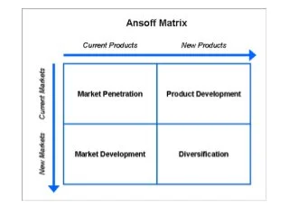
FIG 4 Ansoff matrix (Mackenzie, 2014)

A company employs market penetration to increase market share. Now, it's sales driven. Market penetration may be done via extending sales contact points, connecting directly to customers, upgrading the dealer network, and increasing customer basket share.
Zara develops new items or adds functionality to existing ones. Zara can diversify when the product and market are new. Diversification is employed when a company sees an opportunity in another industry.

References
Adamkasi. (2017, may 17). Porter Five Forces Model of Zara. Retrieved from PORTER ANALYSIS: https://www.porteranalysis.com/porter-five-forces-model-of-zara/
Ha, J. (2021, April 19). Zara Strategic Analysis. Retrieved from University of Nebraska-Lincoln: https://digitalcommons.unl.edu/cgi/viewcontent.cgi?article=1368&context=honorstheses
HEAARTOFCODES. (2022, JAN 22). SWOT Analysis of Zara 2022: Zara SWOT Analysis 2022. Retrieved from HEART OF CODES: https://heartofcodes.com/swot-analysis-of-zara-2022/
Kasi, A. (2016, March 10). PESTLE-PESTEL-PEST analysis of Zara. Retrieved from Free Pestel Analysis: https://freepestelanalysis.com/pestle-pestel-pest-analysis-of-zara/
MBA Skool Team. (2019, Oct 28). Zara PESTLE Analysis. Retrieved from mba SKOOL: https://www.mbaskool.com/pestle-analysis/companies/17975-zara.html
OECD. (2009). Integrating Climate Change Adaptation into Development Co-operation. Retrieved from OECD: http://www.oecd.org/dac/43652123.pdf
Porter's Five Forces of Competitive Position Analysis. (2013, JUNE 11). Retrieved from CGMA: https://www.cgma.org/resources/tools/essential-tools/porters-five-forces.html
Portersfiveforcesteam. (2022, MARCH 1). Zara Porter's 5 Five Forces: Detailed Analysis 2021. Retrieved from Porter's Five Forces : https://www.portersfiveforces.org/zara-porters-5-five-forces/
Shaw, A. A. (2020, dec 20). pestle analysis of zara. Retrieved from SWOT & PESTLE Analysis : https://swotandpestleanalysis.com/pestle-analysis-of-zara/
Shaw, A. A. (2020, Dec 20). PESTLE Analysis of Zara. Retrieved from SWOT & PESTLE Analysis: https://swotandpestleanalysis.com/pestle-analysis-of-zara/#Impact_of_Fashion
Shaw, A. A. (2020, december 20). SWOT & PESTLE Analysis. Retrieved from pestle analysis of zara: https://swotandpestleanalysis.com/pestle-analysis-of-zara/#Trade_Agreement_with_Europe
Speaking Nerd. (n.d.). Advanced Guide to Application of PESTLE Model. Retrieved from Speaking Nerd: https://speakingnerd.com/strategy/strategy-models/pestel-analysis
Studycorgi. (2022, august 9). Zara in the United Kingdom's Retail Fashion Market: Free Essay Example. Retrieved from Studycorgi: https://studycorgi.com/zara-in-the-united-kingdoms-retail-fashion-market/
swot analysis of zara. (n.d.). Retrieved from Edrawsoft : https://www.edrawmind.com/article/zara-swot-analysis.html
TEAM. (2022, FEB 15). Zara Porter Five Forces Analysis. Retrieved from MBA SKOOL: https://www.mbaskool.com/five-forces-analysis/companies/18278-zara.html#entrants
Xaif. (2022, january 3). Detailed SWOT Analysis of Zara - 2022 Update v. Retrieved from IIDE: https://iide.co/case-studies/swot-analysis-of-zara/#1_Strengths_of_Zara
Zara SWOT Analysis 2022 – Zara SA: The Inditex Group - Business SWOT Analysis . (2022, jan 2). Retrieved from Business SWOT Analysis -: https://bswotanalysis.com/zara-swot-analysis/
Zara SWOT Analysis 2022 – Zara SA: The Inditex Group - Business SWOT Analysis . (2022, january 2). Retrieved from Business SWOT Analysis - : https://bswotanalysis.com/zara-swot-analysis/
Zara SWOT Analysis: 7 Awesome Things You Need To Know. (2022, july 17). Retrieved from mktoolboxsuite.com: https://mktoolboxsuite.com/zara-swot-analysis/

devar (2020). Marketing Mix of Zara: The 4Ps Strategy marketing. [online] Advergize. Available at: https://www.advergize.com/marketing/marketing-mix-of-zara-the-4ps-strategy/.
Riaz, W. Marketing Mix, Not Branding. Asian Journal of Business and Management Sciences. 2011, Vol. 1 No. 11, p.p. 43-52.
Ye, SH., (2021) . Application analysis of 4P theory in Zara marketing strategy, [online] Available at: [Accessed 12th January 2022]

Annual Report 2019 (Rep.). (2019, June). Retrieved April 10, 2021, from Inditex website: https://www.inditex.com/documents/10279/645708/2019+Inditex+Annual+Report.pdf/25a a68e3-d7b2-bc1d-3dab-571c0b4a0151

Mani, C. (2020, August 21). Seven Ways Artificial Intelligence is Disrupting the Retail Industry. Retrieved April 11, 2021, from https://www.forbes.com/sites/forbestechcouncil/2020/08/21/seven-ways-artificialintelligence-is-disrupting-the-retail-industry/?sh=b65c4b756ae3

Chaudhuri, S. (2020, June 10). Zara owner to Close 1,200 stores as it Outlines Post-coronavirus Future. Retrieved April 11, 2021, from https://www.wsj.com/articles/zara-to-close-1-200- stores-as-it-outlines-post-coronavirus-future-11591794618

CHERMACK, T. J. & KASSHANNA, B. K. (2007). “The use and misuse of SWOT Analysis and implications for HRD professionals”, Human Resource Development, 10 (4), pp. 383-399

Johnson, G., Scholes, K., & Whittington, R. (2008). Exploring corporate strategy: Text & cases. Researchgate.net. Retrieved from https://www.researchgate.net/publication/272353374_Exploring_Corporate_Strat egy_Text_Cases
Hoang, P., & Ducie, M. (2018). Cambridge IGCSE and O Level Economics 2nd edition. Hachette UK. Kotler, P. (2011). Philip Kotler's contributions to marketing theory and practice. Review of Marketing Research: Special Issue–Marketing Legends (). Emerald Group Publishing Limited.
Walsh, P. R. (2005). Dealing with the uncertainties of environmental change by adding scenario planning to the strategy reformulation equation. Management Decision

