  Component One:  What are the key skills required when working in the housekeeping team? 750 words (+/- 10%)  Contribution to Overall Module Assessment: 25% | Student No: | 2127769
 | Module Title: | Operating Hotel Facilities
 | Module Code: | BMIH 4006
 | Lecturer: | Laurence Blake
Premier Inn is a popular hotel chain with locations across the UK, and its housekeeping teams play a critical role in maintaining the hotel's cleanliness and guest satisfaction. Here are some key skills required when working in the housekeeping team at Premier Inn:
Attention to detail: Housekeeping staff at Premier Inn must have a keen eye

- for detail to ensure that every room is clean, tidy, and well-presented. This includes checking every corner of the room, making the bed neatly, and ensuring that bathroom fixtures and surfaces are spotless.
- Time management: Premier Inn housekeeping staff must be able to manage their time effectively to meet the hotel's standards of cleanliness and efficiency. They must be able to work quickly and efficiently while maintaining high-quality standards.
- Communication skills: Good communication skills are essential for Premier Inn housekeeping staff to ensure that they understand their tasks and communicate with their team members and supervisors. They must also be able to communicate effectively with guests, responding to their requests and concerns promptly.
- Physical stamina: Premier Inn housekeeping staff must have the physical stamina to perform a range of tasks, including cleaning, lifting and moving furniture, and changing linens. They must be able to work on their feet for extended periods and lift heavy objects when necessary.
- Teamwork: Working in a housekeeping team at Premier Inn requires a collaborative and supportive approach. Housekeeping staff must work together to ensure that all rooms are cleaned to the same high standard and that guests are satisfied with their stay.
- Flexibility: Premier Inn housekeeping staff must be flexible and adaptable, willing to work different shifts and schedules as required. They must also be able to adjust their work routine to accommodate changes in the hotel's occupancy levels and cleaning schedules.
- Customer service skills: Premier Inn housekeeping staff play an important role in ensuring that guests have an enjoyable and comfortable stay. They must be friendly, polite, and courteous, responding promptly to guests' requests and concerns.
- Health and safety: Premier Inn housekeeping staff must be aware of health and safety regulations and take appropriate precautions to ensure their safety and that of their guests. This includes using cleaning chemicals safely, handling equipment correctly, and reporting any hazards or incidents to their supervisors.
- Initiative: Premier Inn housekeeping staff must be able to take initiative and work independently, identifying areas that require cleaning and taking action without being prompted. They must also be able to make decisions quickly and efficiently when necessary.
Overall, working in the housekeeping team at Premier Inn requires a combination of physical, technical, and interpersonal skills, which are essential for maintaining a clean and comfortable environment for guests. By mastering these skills, Premier Inn housekeeping staff can contribute to the hotel's success and guest satisfaction.

Word Count

Component Two:
Contribution to Overall Module Assessment: 25%
In this scenario – You have just been promoted to team leader for a floor within the hotel. A guest complains that on their arrival, their room had not been properly cleaned. Create an action plan and answer the following questions.

Problem | Why did it happen? | What are you going to do? | How will you prevent this from happening in the future? | What measures would you introduce to improve team effectiveness?
The bed linen is stained | Poor quality control | I offer to clean their room immediately or I can offer them another room | I initiate a meeting with all the hotel staff and talk about all the existing problems | I make sure the cleaning staff are well trained and have all the necessary tools and equipment
The floor is not vacuumed | Insufficient time for cleaning | I apologize to the guests for the inconvenience caused | I explain to them how important the opinion and wishes of the customers are for the hotel | I regularly check the quality of cleanliness in each room to ensure that cleanliness standards are consistently met
The towels in the bathroom are not placed properly | Inadequate training | I ask the guest which specific area was not properly cleaned and I make sure that this area is cleaned | I also listen to the opinion of the staff and try to give them more cleaning time between bookings | Communicate with cleaning crews to identify any issues related to available time and resources
The glass has traces of cleaning solutions | Poor communication between staff | I offer compensation to guests, such as a discount on their stay or free services | And after the cleaning is done, I will personally check the rooms to make sure that everything is properly cleaned | I encourage cleaning teams to work as a team and communicate with each other to optimize the cleaning process.

Component Three:
Contribution to Overall Module Assessment: 50%
Your task is to create and prepare a presentation following the detailed scenario provided below.

As the floor housekeeping manager and given the recent guest complaints you need to put together a basic training presentation for your colleagues within the housekeeping team to get the best out of them, ensure that brand standard is being achieved and that Health and Safety procedures are also being followed.

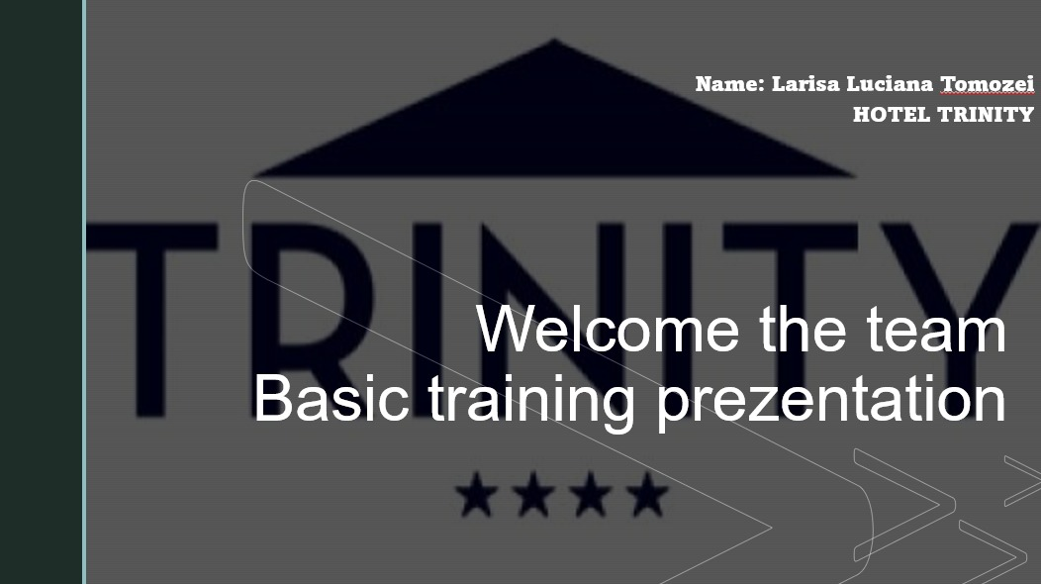

Training Notes: Name: Larisa Luciana Tomozei HOTEL TRINITY
Welcome the team
Basic training presentation
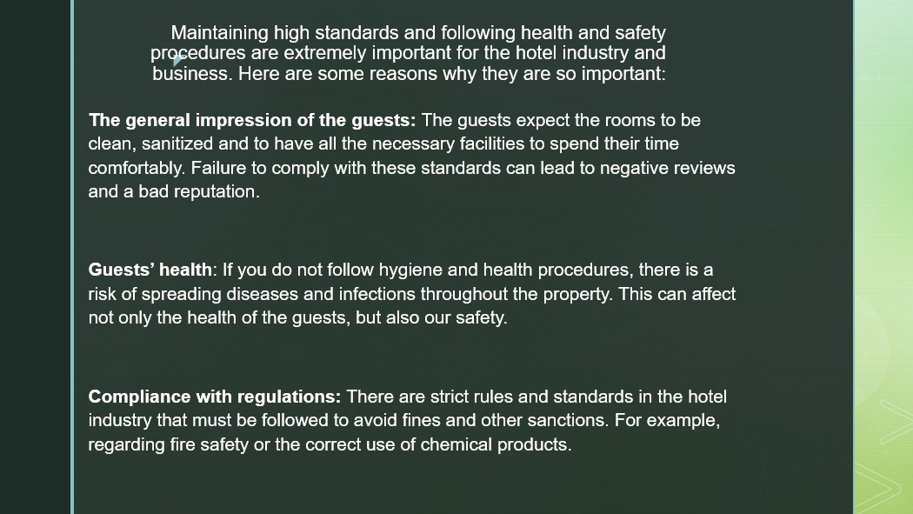

Training Notes: Maintaining high standards and following health and safety procedures are extremely important for the hotel industry and business. Here are some reasons why they are so important:
The general impression of the guests: The guests expect the rooms to be clean, sanitized and to have all the necessary facilities to spend their time comfortably. Failure to comply with these standards can lead to negative reviews and a bad reputation.

Guests' health: If you do not follow hygiene and health procedures, there is a risk of spreading diseases and infections throughout the property. This can affect not only the health of the guests, but also our safety.

Compliance with regulations: There are strict rules and standards in the hotel industry that must be followed to avoid fines and other sanctions. For example, regarding fire safety or the correct use of chemical products.
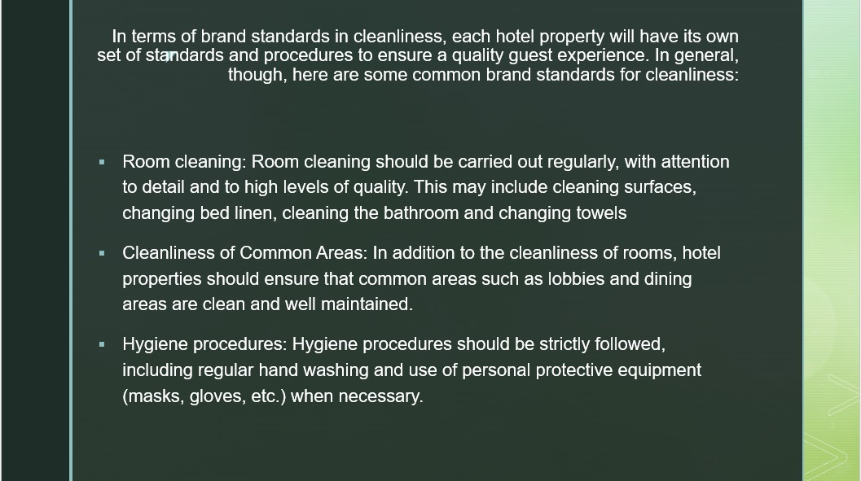

Training Notes: In terms of brand standards in cleanliness, each hotel property will have its own set of standards and procedures to ensure a quality guest experience. In general, though, here are some common brand standards for cleanliness:
Room cleaning: Room cleaning should be carried out regularly, with attention to detail and to high levels of quality. This may include cleaning surfaces, changing bed linen, cleaning the bathroom and changing towels.

Cleanliness of Common Areas: In addition to the cleanliness of rooms, hotel properties should ensure that common areas such as lobbies and dining areas are clean and well maintained.

Hygiene procedures: Hygiene procedures should be strictly followed, including regular hand washing and use of personal protective equipment (masks, gloves, etc.) when necessary.
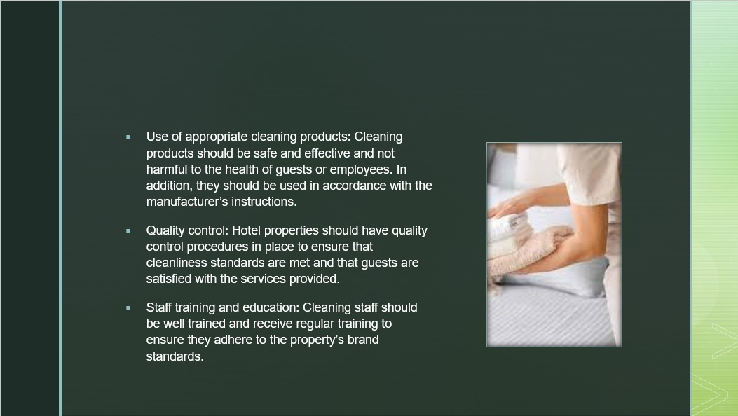

Training Notes: Use of appropriate cleaning products: Cleaning products should be safe and effective and not harmful to the health of guests or employees. In addition, they should be used in accordance with the manufacturer's instructions.

Quality control: Hotel properties should have quality control procedures in place to ensure that cleanliness standards are met and that guests are satisfied with the services provided.

Staff training and education: Cleaning staff should be well trained and receive regular training to ensure they adhere to the property's brand standards.
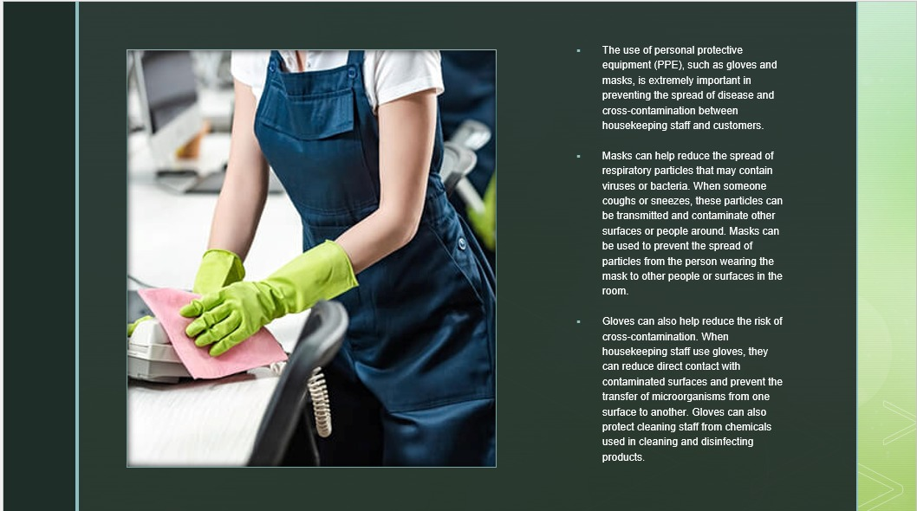

Training Notes: The use of personal protective equipment (PPE), such as gloves and masks, is extremely important in preventing the spread of disease and cross-contamination between housekeeping staff and customers.

Masks can help reduce the spread of respiratory particles that may contain viruses or bacteria. When someone coughs or sneezes, these particles can be transmitted and contaminate other surfaces or people around. Masks can be used to prevent the spread of particles from the person wearing the mask to other people or surfaces in the room.

Gloves can also help reduce the risk of cross-contamination. When housekeeping staff use gloves, they can reduce direct contact with contaminated surfaces and prevent the transfer of microorganisms from one surface to another. Gloves can also protect cleaning staff from chemicals used in cleaning and disinfecting products.

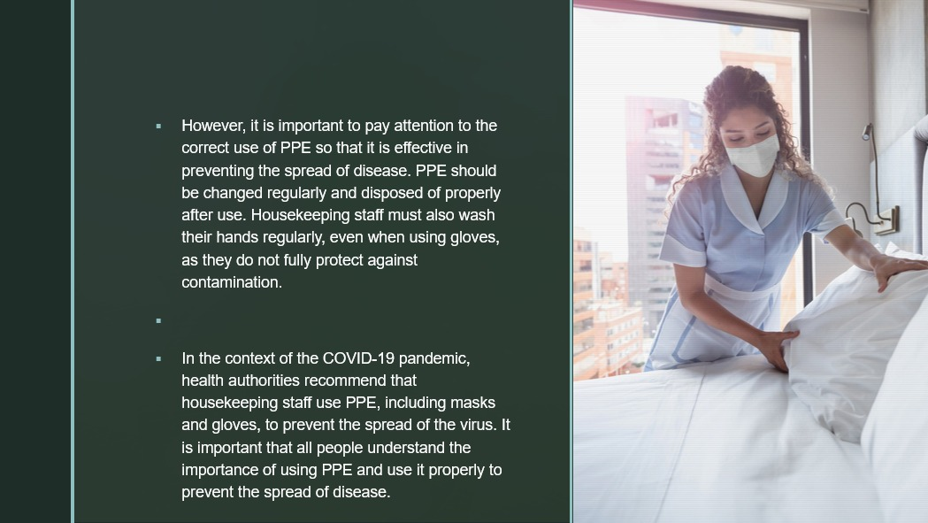

Training Notes: However, it is important to pay attention to the correct use of PPE so that it is effective in preventing the spread of disease. PPE should be changed regularly and disposed of properly after use. Housekeeping staff must also wash their hands regularly, even when using gloves, as they do not fully protect against contamination.

In the context of the COVID-19 pandemic, health authorities recommend that housekeeping staff use PPE, including masks and gloves, to prevent the spread of the virus. It is important that all people understand the importance of using PPE and use it properly to prevent the spread of disease.
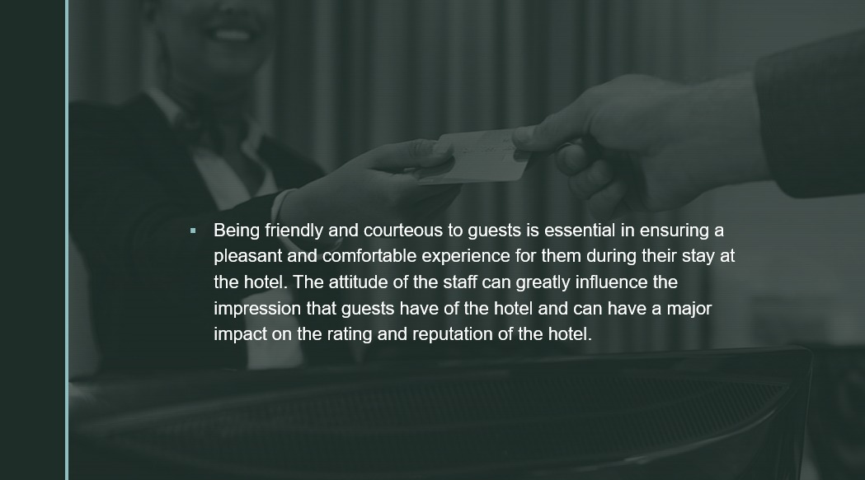

Training Notes: Being friendly and courteous to guests is essential in ensuring a pleasant and comfortable experience for them during their stay at the hotel. The attitude of the staff can greatly influence the impression that guests have of the hotel and can have a major impact on the rating and reputation of the hotel.
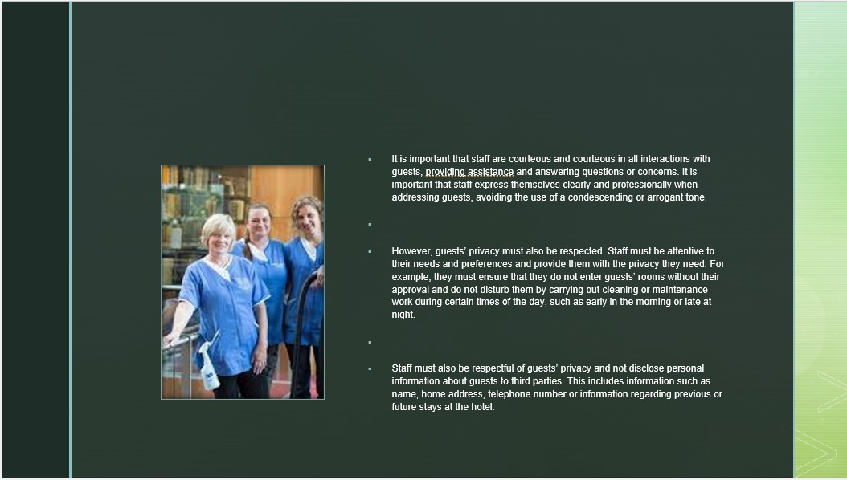

Training Notes: It is important that staff are courteous and courteous in all interactions with guests, providing assistance and answering questions or concerns. It is important that staff express themselves clearly and professionally when addressing guests, avoiding the use of a condescending or arrogant tone.

However, guests' privacy must also be respected. Staff must be attentive to their needs and preferences and provide them with the privacy they need. For example, they must ensure that they do not enter guests' rooms without their approval and do not disturb them by carrying out cleaning or maintenance work during certain times of the day, such as early in the morning or late at night.

Staff must also be respectful of guests' privacy and not disclose personal information about guests to third parties. This includes information such as name, home address, telephone number or information regarding previous or future stays at the hotel.
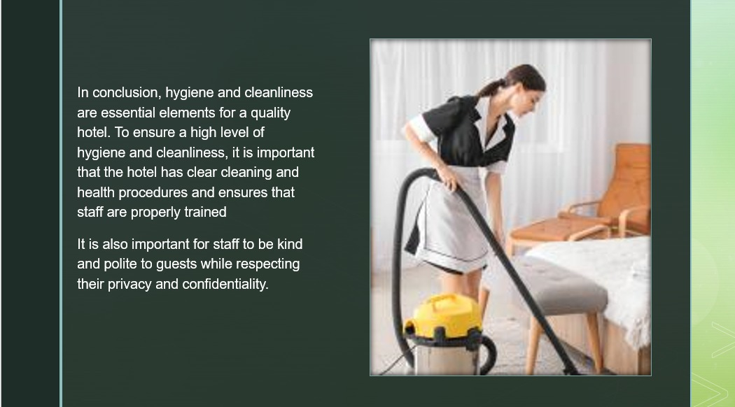

Training Notes: In conclusion, hygiene and cleanliness are essential elements for a quality hotel. To ensure a high level of hygiene and cleanliness, it is important that the hotel has clear cleaning and health procedures and ensures that staff are properly trained.
It is also important for staff to be kind and polite to guests while respecting their privacy and confidentiality
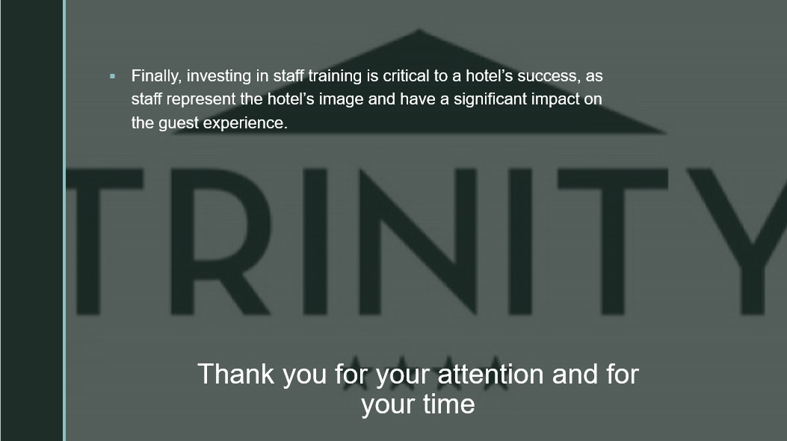

Training Notes: Finally, investing in staff training is critical to a hotel's success, as staff represent the hotel's image and have a significant impact on the guest experience.
Thank you for your attention and for your time

References

"The importance of housekeeping in hotels":
https://www.hospitalitynet.org/opinion/4083336.html
"Why Housekeeping is Important in the Hospitality Industry":
https://www.hotelnewsresource.com/article101120.html
“8 skills that you can learn from your cleaner”
https://housekeep.com/blog/2018/12/13/8-life-skills-you-could-learn-your-housekeeper/
“Guide to Housekeeping Skills”
https://www.indeed.com/career-advice/career-development/housekeeping-skills
“The true role of housekeeping in hospitality”
https://www.rubbermaidcommercial.com.au/blog/hospitality/the-true-role-of-housekeeping-in-hospitality/
“3 Keys to excellent housekeeping”
https://blog.guestrevu.com/3-keys-to-excellent-housekeeping
“3+ Housekeeping Action Plan Examples” https://www.examples.com/business/plans/housekeeping-action-plan.html
“9 Best Practices to Optimise Hotel Housekeeping Operations” https://www.ezeeabsolute.com/blog/optimise-hotel-housekeeping-operations/

“FREE 9+ Hotel Action Plan Samples [ Sales, Emergency, Housekeeping ]” https://www.sampletemplates.com/business-templates/action-plans/hotel-action-plan.html .
“Sample Hotel IT Emergency Action Plan / Contingency Plan “
https://setupmyhotel.com/train-my-hotel-staff/securityandloss/296-contingency.html?utm_content=cmp-true
- Eight Simple Ways Hotels Can Streamline Housekeeping Duties https://hospitalitytech.com/eight-simple-ways-hotels-can-streamline-housekeeping-duties
- Ways to Protect your Hotel Guest’s Information https://www.warwickinc.com/blog/ways-to-protect-your-hotel-guests-information/
- Trinity’s Housekeeping Team https://www.tcd.ie/news_events/articles/trinitys-housekeeping-team/
- Training Programme for Housekeeping Staff https://poloandtweed.com/blog/training-programme-for-housekeeping-staff
- A safe place of work https://www.hse.gov.uk/toolbox/workplace/facilities.htm
- The Hotel Checklist You Need To Gain the Edge in Brand Standards https://blog.safetyculture.com/industry-trends/the-brand-standards-checklist-you-need-to-give-your-hotel-the-edge-in-the-sharing-economy
- 3 Housekeeping Performance Standards Every Hotelier Needs https://www.xenia.team/articles/hotel-housekeeping-performance-standards
- HOW TO IMPROVE HOTEL HOUSEKEEPING SERVICE STANDARDS [CHECKLIST] https://hotelcleaningservices.com/how-to-improve-hotel-housekeeping-service-standards-checklist/
- How to Use Floor Cleaning Equipment Effectively https://1st4cleaningsupplies.co.uk/blog/how-to-use-floor-cleaning-equipment-effectively/
What is the purpose of training and development? https://www.futurelearn.com/info/courses/training-development-work/0/steps/88512

