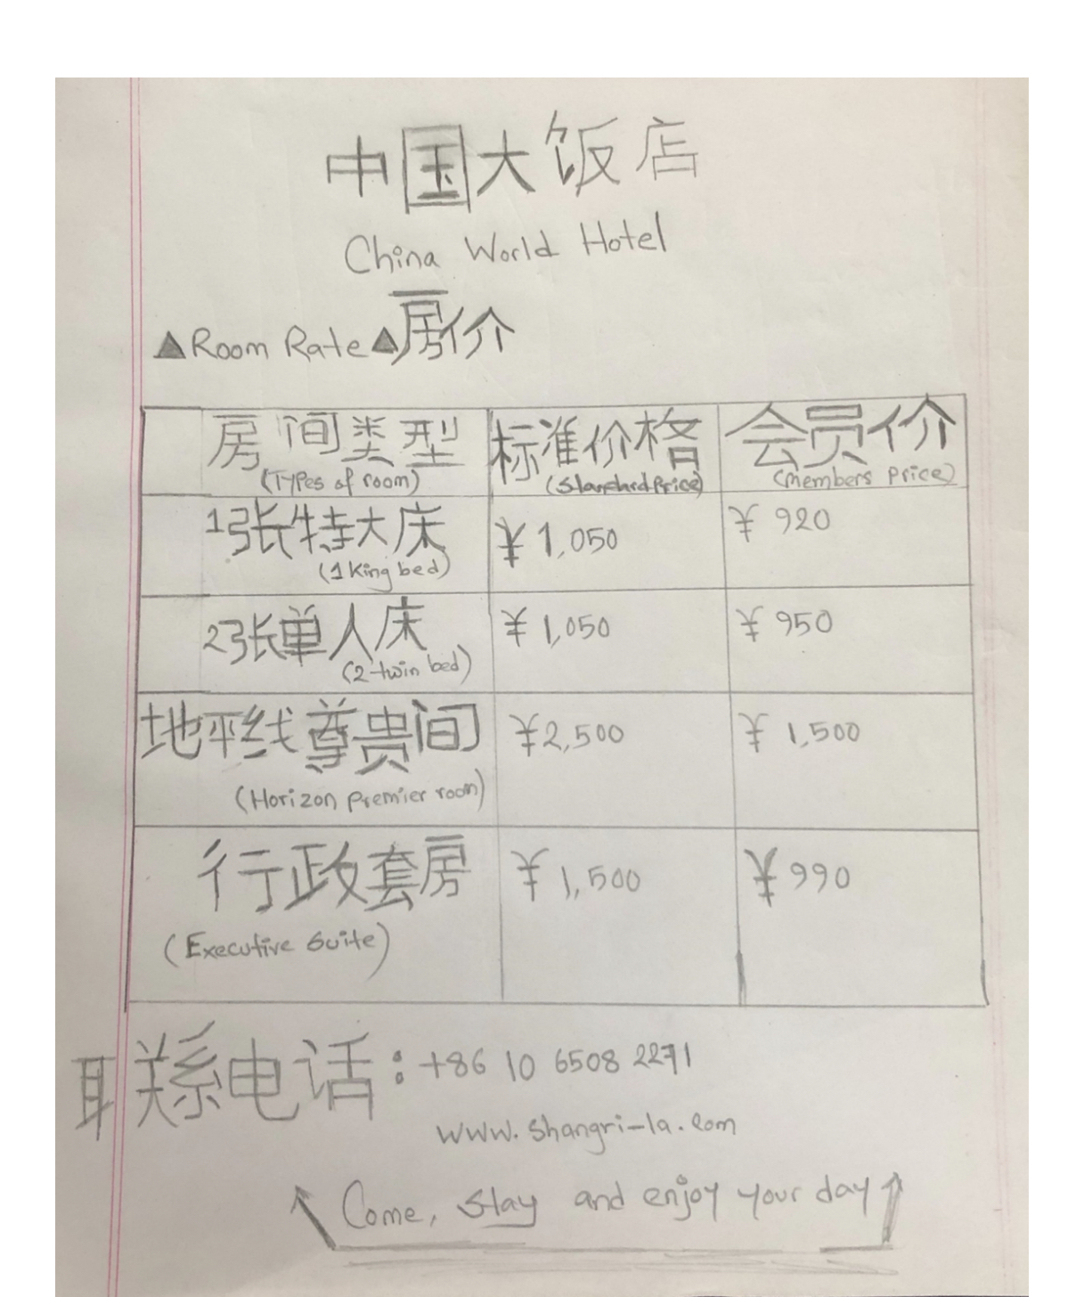
北京华世界大酒店客房价格在消费者的公平价格上显示。
Student: 2012450
Model: foreign language and cultural awareness
Lecture name: Jinping li
Third assignment: hotel display board

