The marketing plan is written for
Premier Inn Hotel and Resort

Student Name
Florin Ispas

Student ID number
2212651

Marketing Essentials BMIH4005

Lecturer

Christopher Wilkin

Table of Contents
Introduction 3
Marketing Mix of Premier Inn Hotel 3
The Marketing Environment (Micro) 4
The Marketing Environment (Macro) 5
Creating Customer Value & Engagement 6
Effective use of Digital Marketing 6
Conclusion 7
References 8
Appendix 10
Gant Chart of Marketing Activities 10

Introduction
Established in 1987, Premier Inn hotel has been serving its customers with valuable and superior customer service which is its core competitive weapon. This hotel has more than 800 hotels across domestic and international boundaries. This hotel establishes itself as a global brand of full-service hotels and other resorts controlled and managed by the flagship brand of Whitbread. The core principle of Premier Inn hotel is to ensure the continuous improvement of the "stickiness" of customers (Ellis-Chadwick, 2020). Service like free room nights as well as perks during their stay including free Wi-Fi and room upgrades. In this report, the core marking activities of Premier Inn hotel is discussed to show how this hotel use these factors to capture new market or to attract new customers.

Marketing Mix of Premier Inn Hotel
The marketing mix is the set of promotional and strategic activities used by companies to promote products, attract target customers, or create value for the company (Kotler, 2020).
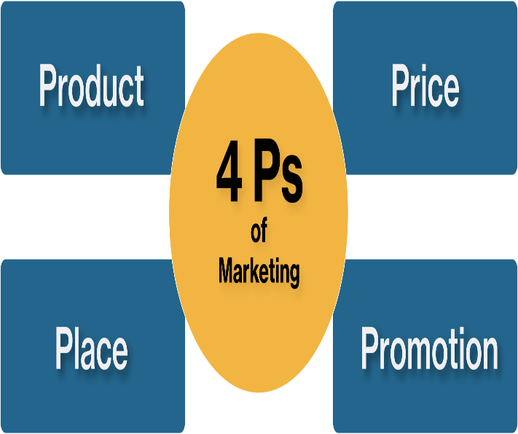
Figure 02: Marketing Mix (Kotler, 2020).
- Product: In the case of Premier Inn Hotels the rooms offered to the customers are the main products, as being a hotel service provider that mainly engages in the hotel business (Mariussen, 2017). Here, the main objective of Premier Inn Hotel is to provide value-added customer service such as summer packages, family packages, and discounts to attract customers.
- Price: Hotel Premier Inn tries to control the operational cost to offer superior customer service at the lowest cost to attract customers (Zook et al., 2020). On thieve, the daily average cost of staying in a Premier Inn hotel is around 128 U.S. dollars.
- Place: The area where the Premier Inn hotel establishes in Washington D.C in the United Kingdom. So, for any kind of study tour, business tour, vacation, and other purposes people from different countries come here every year to spend quality time (Ghauri, 2014).
- Promotions: For Premier Inn hotel to introduce its commercial product to the customers and to let the customers know about its service, it uses widely used different social media such as Facebook and tweeter to promote its brand.

The Marketing Environment (Micro)
Some crucial internal factors also have a great impact on the operational process of Premier Inn Hotels Such as the customer, the competitors, and different third parties involved in its operations (Ryan, 2012).
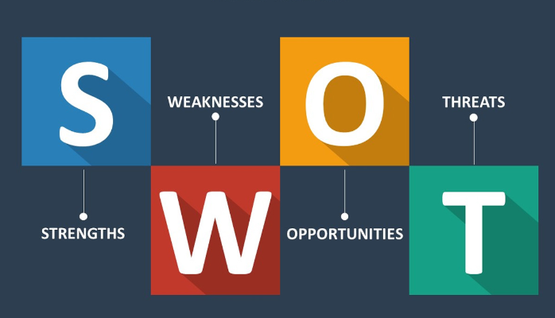
Figure 02: SWOT analysis (Ryan, 2012).
Strengths: The main strength of Premier Inn hotel is its brand value which attracts customers and helps to capture market share and customer support. Moreover, its internal operational process is well-designed to reduce costs which increases the profit margin. | Weakness: The core weakness of Premier Inn Hotel is that its promotional strategies are not that much well-reaching to attract customers. Moreover, many other hotels provide the same benefits and facilities at a lower price than Premier Inn Hotel which can lead the hotel to lose its customer base (Ellis- Chadwick, 2019).
Opportunity: Now people are more concerned about their health than anything else. As Premier Inn hotel is well-organized and ensures the safety of customers, it takes the required steps to ensure the hygiene level (Ebell et al., 2020). It also introduces robotic workers to lessen the interaction of human employees with customers. | Threats: The post-math position of COVID -19 in hotels and tourist spots is not as healthy as before because people are less interested in travelling or tours. As a result, the demand for a hotel room also decreases cutting the profit margin (Xiao, 2012).

The Marketing Environment (Macro)
Here, the macro environment that affects the whole Premier Inn hotel as a whole is described. Because the impacts of the macro environment are beyond controlled ad Premier Inn Hotel can't reduce the effect fully.
Factors | Impacts
Political | The first one is the political environment which poses threats to daily operations for example when there is political unrest situation in the United Kingdom and all around the globe, people will prefer to stay how rather going outside to spend quality time (Jiménez et al., 2020).
Economical | Economic factors help Premier Inn hotel target the desired customer base based on geographical location and other factors such as income level or personality. As the people of the United Kingdom love to enjoy their time (Parente, 2018).
Social | After COVID-19, the United Kingdom also impose some rules and regulations to ensure the safety of tourists that have a great impact on regular activities.
Technological | With the page of time, Premier Inn hotel also introduces different modern technologies that help it to boost its operations and activities. And, modern technologies also ensure safety for both customers and Premier Inn Hotels as they can easily store crucial information and documents. Thus, it can ensure 24/7 hour service for customers (Baldwin, 2020).
Legal | Due to the enforcement of both environmental and customer right law, Premier Inn also maintains these regulations implied with its operations.

Creating Customer Value & Engagement
It is said that customers are the king for which a hotel designs its activities and operations. To attract customers the hotel needs to offer attractive and valuable services that can add value to their satisfaction level (So et al., 2013). For example, to create extra value for customers the Premier Inn Hotel is engaging in different digitalization processes online booking, websites for information, and online information providing. Moreover, the hotel should ensure the safety and hygiene of the customers. Thus, Premier Inn Hotels should use artificial intelligence and robotics system to reduce the waste of time and cost minimization. Besides, the employees and manager also have a crucial role to play to capture market share (Cave, 2020). The hotel should arrange warm greetings for the customer who just check-in and the tech system to use the phone as a key. Moreover, the competitors pose threat to its profit, target market, and customer base (Moul, 2015). Thus, Premier Inn hotel follows comparative strategies such as setting a lower price and offering discounts and prizes for customers.

Effective use of Digital Marketing
Modern technologies are more like a blessing for Premier Inn Hotels that pave the way to target both online and offline customers (Antonova, 2019). Premier Inn hotel uses Facebook, Instagram, and Twitter for advertisements and to post videos and photos of occasions and programs arranged by this hotel. Moreover, YouTube is one of the most popular media for sharing information where Premier Inn hotel shares videos of hotel rooms and other facilities (Lee, 2018). On the eve, customers can easily get this information before booking a room in a Premier Inn hotel and can compare service with other hotels. Here, different kinds of marking involve such as SEO marketing to list the name of Premier Inn hotel in the search list. In content marketing such as using a mail system to send information regarding discounts and offers (Fuchs et al., 2020). In this way, the introduction of digital marketing is prevailing the path for Premier Inn hotel to get the advantages of modern technologies

Conclusion
The marketing mix is the set of activities that companies use to introduce their commercial product or service to customers. In this report, the company background of Premier Inn Hotel is used to show how the hotel applies these 4ps to attract customers. Here, it has been found that Premier Inn hotels use the core product strategy such as ensuring service quality and customer benefits to attract customers. SWOT analysis is conducted and it has been found that the core strengths of Premier Inn hotel are its brand value and quality of service. The process of creating value for customers is shown and the most effective activity is to ensure the satisfaction level of customers. Moreover, the importance and benefits of digital marketing are also reflected in this report.

References
Antonova, O. (2019) “Three ways to use ASMR-technologies in modern advertising and marketing,” Modern Economics, 17(1), pp. 6–10
Baldwin, R. and Cave, M. (2020) “Can regulators ensure environmental sustainability?,” Taming the Corporation, pp. 125–152.
Bowie, D. Buttle, F. Brookes, M & Mariussen, A (2017), Hospitality Marketing. 3rd Ed, Routledge, London.
Chaffey, D and Ellis- Chadwick, F. Kotler, P., Armstrong, G., Harris, L. and He, H., 2020. Principles of marketing. 8th European Ed, London: Pearson Education Limited. (2019) Digital Marketing. 7th Ed, Pearsons, London.
Ebell, M.H., Bierema, L. and Haines, L. (2020) “Graduate students significantly more concerned than undergraduates about returning to campus in the era of COVID-19.”
Fuchs, M., Tuta, M. and Höpken, W. (2020) “Adoption of e-mail marketing in the Hotel Sector,” Information and Communication Technologies in Tourism 2008, pp. 279–290.
Ghauri, P N (2014) International Marketing, 4th Ed, McGraw Hill, London.
Jiménez, Á.V., Flitton, A. and Mesoudi, A. (2020) “When do people prefer dominant over prestigious political leaders?”
Jobber, D. and Ellis-Chadwick, F (2020), Principles and practice of marketing. 9th ed. London:
Lai, G. and Xiao, W. (2012) “Stocking more versus less: The roles of demand volatility and profit margin with market valuation,” SSRN Electronic Journal [Preprint].
Li, J. and Moul, C.C. (2015) “Who should handle retail? Vertical contracts, customer service, and Social Welfare in a Chinese mobile phone market,” International Journal of Industrial Organization, 39, pp. 29–43
Parente, S.T. (2018) “Factors contributing to higher health care spending in the United Kingdom compared with other high-income countries,” JAMA, 319(10), p. 988.
Ryan, D. (2012) Understanding Digital Marketing: Marketing Strategies for Engaging the Digital Generation. Kogan Page, London.
Smith PR & Zook ZE (2020) Marketing Communications. 7th Ed, Kogan Page, London
So, K.K. et al. (2013) “Customers’ perceptions of Hotel Brands Survey,” PsycTESTS Dataset “

Appendix

Gant Chart of Marketing Activities
Gant Chart is the graphical presentation of all the activities that will be carried out by Premier Inn Hotel to implement its marketing activities (Ebell et al., 2020).
Activities | Start | End | Jan-Feb | March-April | May-June | July-August | Sep-Oct | Nov-Dec | Jan-Feb
Advertising:
TV | March | August
Radio | Nov | Dec
PPC | Sep | Oct
Activity Channel | Jan | June
Personal Selling: | July | Dec
Sale Promotion: | Oct | Feb
Public Relation: | March | Oct
Market research: | Jan | Sep
Direct Marketing: | March | Dec



