Morgan Jenkins (2528481)
2528481@student.uwtsd.ac.uk
BSC/HND Computing
ACCA4023- Introduction to Web and Database Concepts

Contents
Contents 1
1. Abstract 2
2. Introduction 2
3. Requirements 2
3.1 Functional Requirements 2
3.2 Non-Functional Requirements 3
3.3 Target Audience 4
3.4 Design Constraints 4
4. Implementation 5
4.1 Website Screenshots 5
4.2 Design Choices 7
4.3 Coding Approach 7
4.4 Responsive Design 7
4.5 Validation (HTML and CSS) 8
5. Evaluation 10
5.1 Usability 10
5.2 Accessibility 10
5.3 Search Engine Optimisation (SEO) 10
5.4 WCAG 2.1 Evaluation 10
5.5 Comparison of Two Live Websites 11
6. Conclusion 11
7. References 12
8. Appendices 13

Abstract
This report details the design, validation, implementation and accessibility of my created website, Iron Brew Coffee, a fictional artisanal café. This website was developed with HTML and CSS with a focus on mobile first design, responsiveness and accessibility. This report will outline the requirements of this website, explain the design decisions made during development and evaluate the final product based on user experience and industrial standards whilst also using several testing tools to ensure they meet appropriate accessibility standards. I will also include a comparison of two existing live websites to contextualise best practices in action.

Introduction
To complete this assignment, I have created a hand coded website using HTML and CSS, which has been done without the aid of automated design tools and website builders. This website needed to be both responsive and accessible and functional across a range of devices. Responsiveness in design has become more important as technology has advanced with most of global web traffic being driven with mobile devices[1], [2]. To meet these aims I have developed Iron Brew Coffee, a fictional café inspired by the artisanal coffee culture often seen in independent stores. This site contains an introduction/home page, a menu page, a page about the café and a contact page. I focused the design on a premium feel and emphasised responsiveness and accessibility.
This report details the whole development process beginning with planning the requirements of this site, decisions on design, how those design decisions were implemented, validation steps and an evaluation. Areas of usability, accessibility and search engine optimisation are supported with academic literature, and the report will conclude with a comparison between two well-known commercial websites. This will demonstrate an understanding of industry standards and as a measuring stick for my developed website.

Requirements
Requirements for the Iron Brew Website have been split into functional and non-functional requirements. This ensures that both the business needs and the end-user needs are met and any technical constraints are addressed.

Functional Requirements
- Provide information on a fictional café.
- Present a menu of drinks and food items.
- Communicate the café’s vision and brand identity.
- Allow users to find the café by providing a functional map.
- Keep navigation consistent across all pages.
- Display content in a clear and consistent manner across all devices.

Non-Functional Requirements
Responsiveness
The principles of Responsive design have been evaluated with principles from Marcotte [2]and by following mobile-friendly design best practices[1]. The website must be able to adapt to different screen sizes and devices. Consistent readability needs to be maintained across mobile, tablet and desktop. Studies show that by improving responsiveness and the mobile experience, user engagement is increased[3].

Accessibility
Content must be legible to both the able and the impaired. It must be operable, understandable and conform to the WCAG 2.1 Guidelines[4]. Studies have shown that missing alt text and a poor heading structure are some of the most common issues in website accessibility[5]. Recommendations from accessibility researchers suggest the use of the WAVE tool to assess accessibility[6].

Usability
Navigation throughout the site must be intuitive, Krug’s work emphasises “Don’t make me think” exemplifies this indicating a user should navigate through a site naturally and without confusion[7]. This also ties into accessibility as a clear and consistent typography makes understanding the content of the webpage simple[8].

Performance
Pages must be able to load quickly without need for external scripts or large media files. This is because studies have shown that when load times exceed two seconds users will consider this disruptive to their experience[9] and has a negative experience on user engagement. This can be measured using such tools as Google’s Lighthouse features which measure metrics that contribute to website performance e.g. Largest Contentful Paint, First Input Delay[10]. These can be optimised using techniques like image compression, minifying any CSS and allowing caching of content in an effective way[10].

SEO
The Website must be constructed in a way to support search engine optimisation and visibility. To do this appropriate use of meta tags, semantic HTML, image descriptions and meta descriptions must be used. Research has shown that by including these aspects it can have a large impact on search rankings[11].

Target Audience
This website is aimed at:
- Coffee Lovers
- Local Customers
- Tourists
- Young Adults aged 18-35
- People who enjoy luxury cafés.

It was decided to focus my design on a black and gold colour scheme, as these would lend an air of luxury and appeal to those who value premium, handcrafted experiences.

Design Constraints
- Must be Hand-coded
- No website builders or template code
- Must use relative paths
- Able to function offline independent of IDE’s

Implementation

Website Screenshots

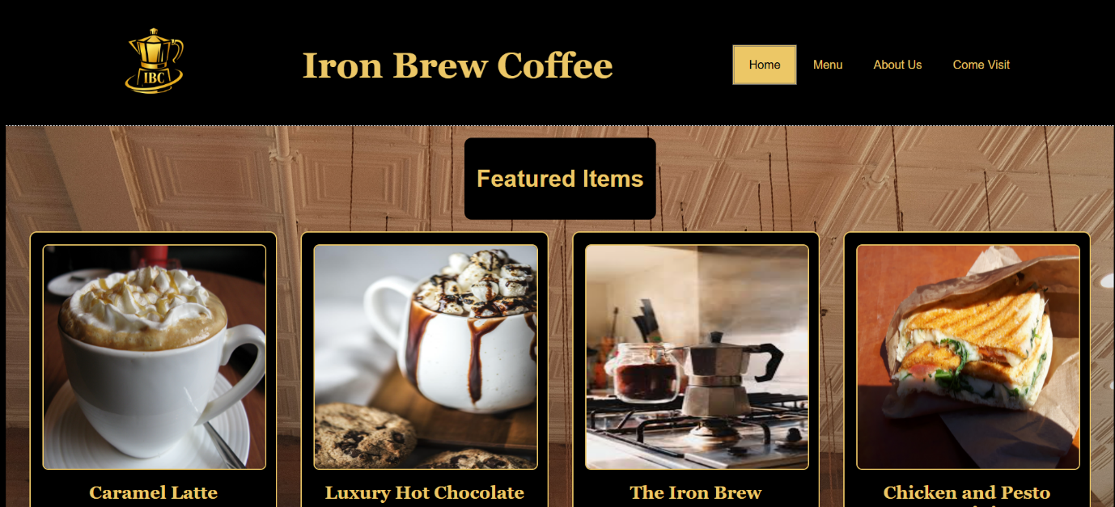
Index Page- Shows featured items in photocards that are active links to the menu page at that particular item.

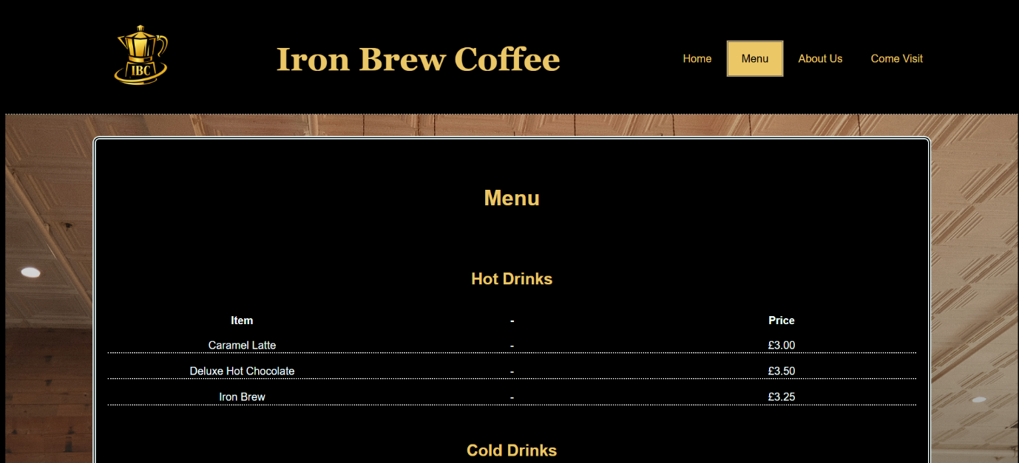

Menu Page- Utilises a table to display the items for sale at the café.
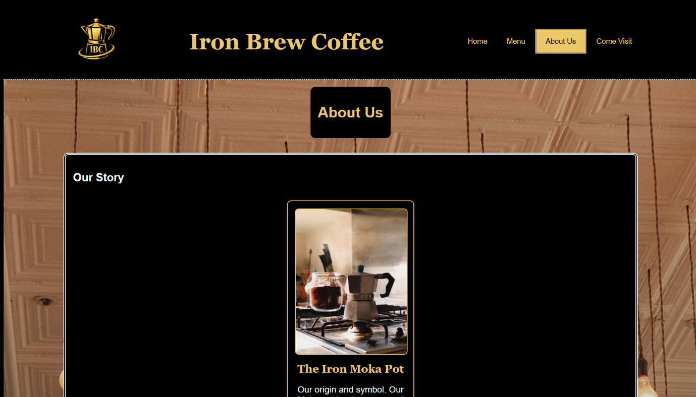

About us Page- A page displaying the information about the café, utilises the menu and photo-card classes from the previous pages, keeping theming and style consistent.

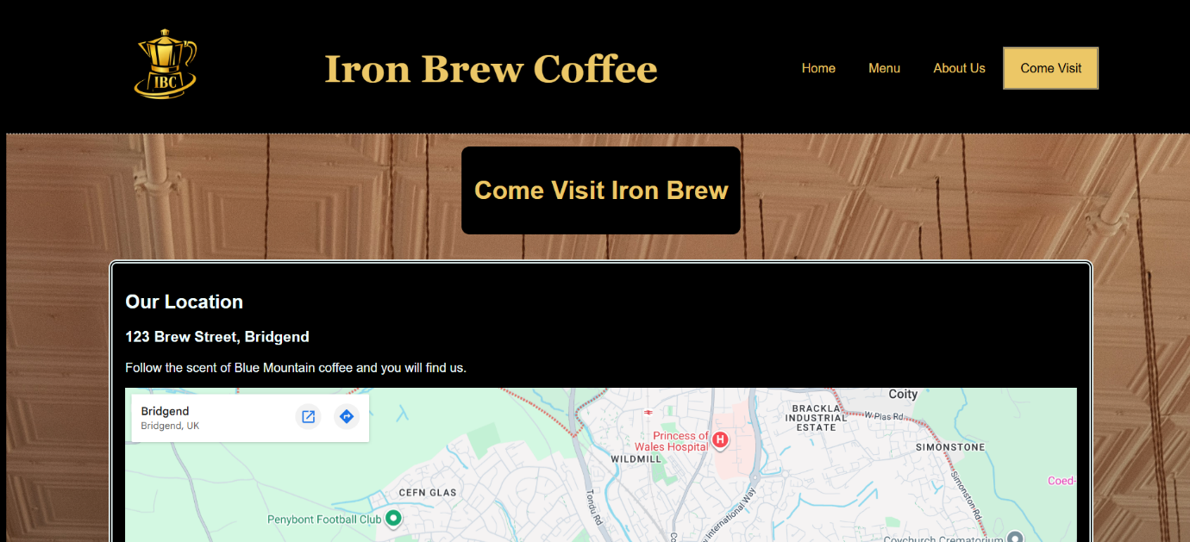

Contact Page- Includes the address of the café (the address is fake), a google maps embed (if there were a real address this would include a pin) and a contact form. The contact form does not handle HTTP requests as that is beyond the scope of this project.

Design Choices
Branding and Colour Scheme
The website uses a black and gold palette to convey luxury and craftsmanship. Research shows that darker backgrounds paired with metallic accents create a perception of exclusivity and premium quality [12], [13]. This aligns with the fictional café’s identity as an artisan brand.
Typography
The site uses a serif font for headings and a sans-serif font for body text. This combination improves readability and visual hierarchy, consistent with Shneiderman’s principles of effective interface design [8].
Layout
- The layout is structured using Flexbox to organise page content
- A consistent navigation bar is used across all pages
- A Table is used for the menu which increases readability and consistency
- The ‘About Us’ page reuses menu and photo card features to keep theming consistent
Imagery
A brand logo was generated using generative AI using the brands colours to reinforce brand identity. Further stock images were used to reinforce the theme of a luxury, artisanal café.

Coding Approach
The focus when coding this site was to follow a mobile first approach[1], [3] as it is far easier to build around mobile and then expand it to a larger screen size than the reverse. Semantic HTML5 elements were used, <header>, <nav>, <main> and <footer>. This allows accessible devices to understand the web page and impacts SEO and future maintainability[11]. The CSS was organised into logical sections and by creating reusable classes such as with .menu and .photo-card. These classes would then reuse typography and colour choices and provide a consistent feel and design that can be maintained throughout the site.

Responsive Design
- For this project responsiveness was achieved by using:
- CSS Flexbox for the layout
- CSS Grid for the menu page
- Creating Media Query Breakpoints for common mobile and tablet sizes
- Creating Scalable images by setting max-width to a percentage
- Following Mobile First Design principles[1], [3]

Validation (HTML and CSS)
All HTML validation was performed using the W3C Validator.
Results
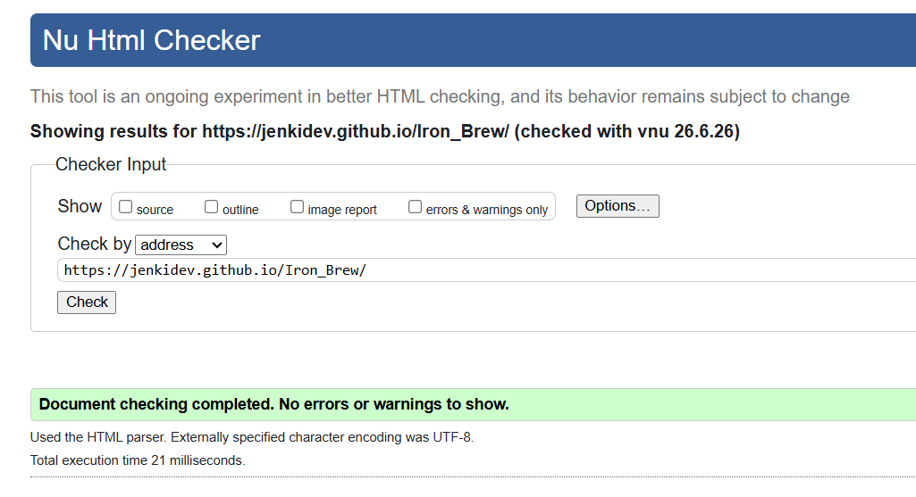Index Page
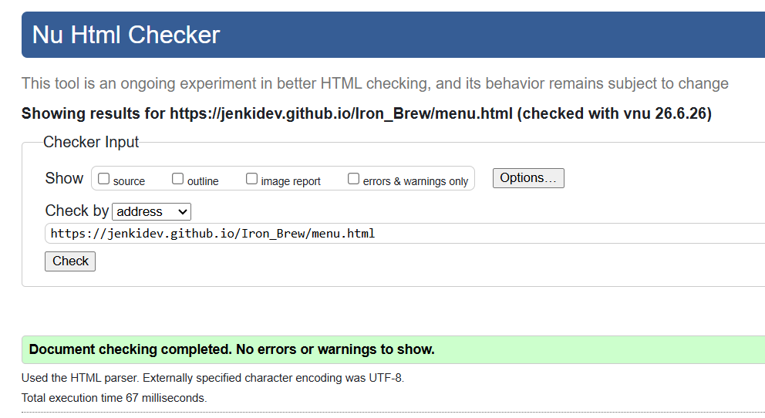 Menu Page
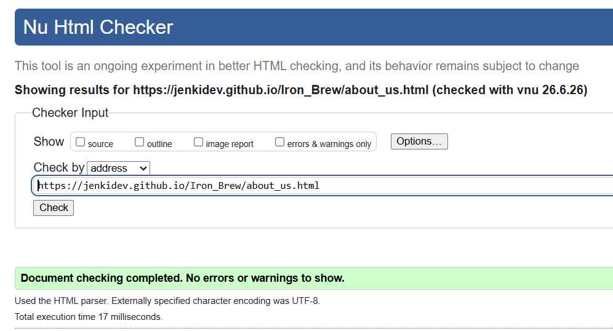 About Us Page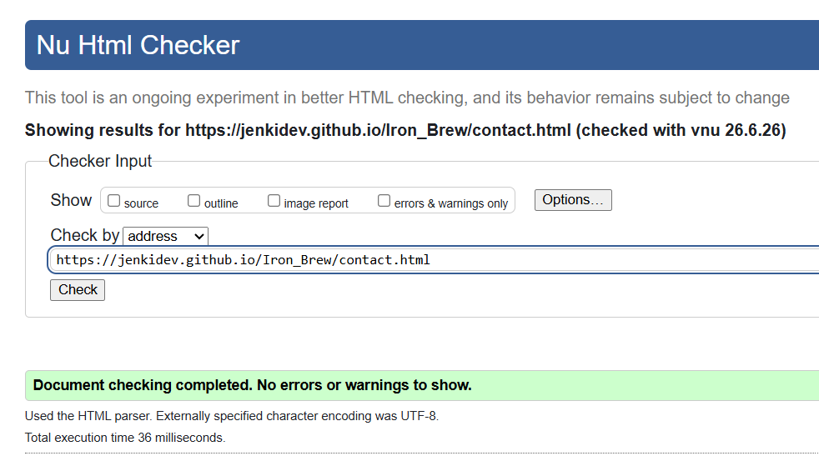 Contact Page

The W3C validator needed to be run all webpages and as can be seen above all pages passed
Validation.
All CSS validation was performed using the W3C CSS Validator.
Results

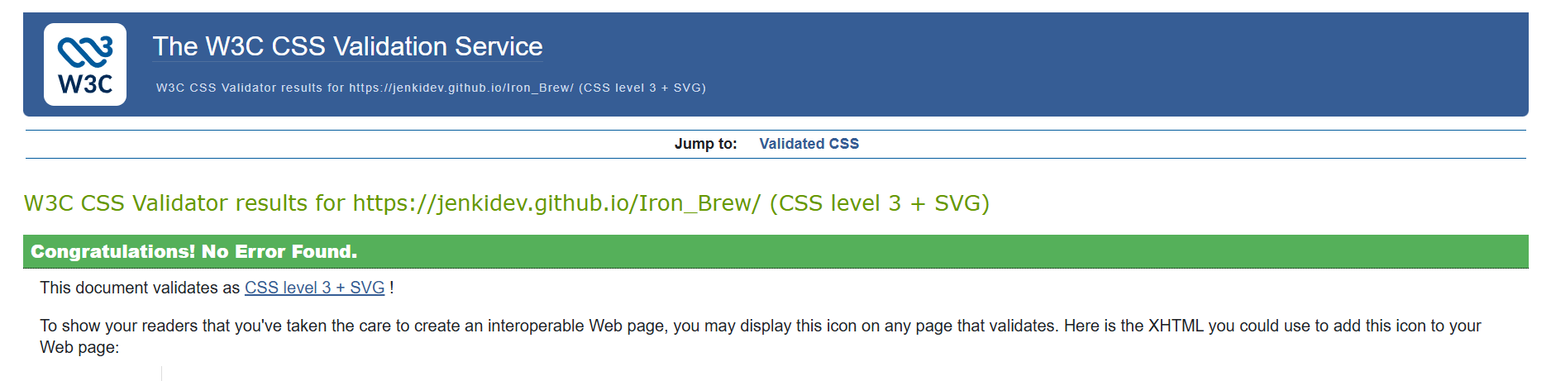
As can be seen the CSS passed validation, only one stylesheet was created that covers the whole website so only the index page needed checking.

Evaluation

Usability
A website is considered usable if a user can effectively navigate and interact with all the websites features without hinderance. Krug and Shneiderman characterise usability as emphasising simplicity, keeping a consistent style and as having a clear navigation through the website [7], [8]. This goes for website content as well as structural design, as for this website, content is clear as a left to right manner on large screens but changes to a column-based design on smaller screens.

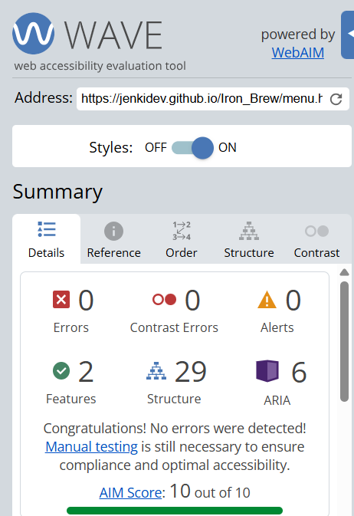
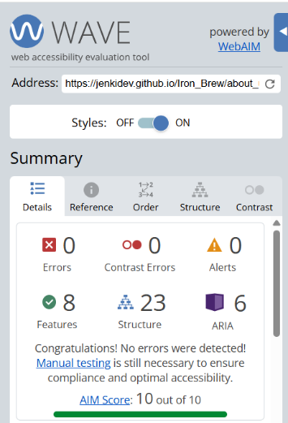
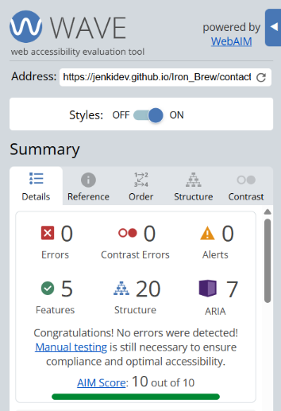
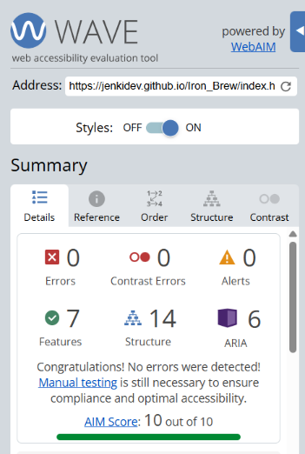
Accessibility

The Wave Accessibility tool is an effective method for measuring the accessibility of a website[6]. The website was built to follow good accessible practice and as such did not receive any errors upon evaluation in this aspect. These tests, however, do not prove that a website is truly accessible as before a website would go live there would be significant manual testing as there can be accessibility concerns which are not detected by these tools.

Search Engine Optimisation (SEO)
As previously explained Search Engine Optimisation is a way to improve search visibility in major search engines. To ensure that my site had good SEO I included <title> tags on all web pages and included <meta name=””> on all pages that contains a description of the page. Further SEO techniques are utilised such as keeping URLS clean and understandable, descriptive headings for each page and alt text for images[11].

5.4 WCAG 2.1 Evaluation
Goldenrod changed to #ecc766 over accessibility concerns as they did not meet accessible greyscale requirements[4].
Added dashes to the table to not have empty space which can confuse screen readers.

5.5 Comparison of Two Live Websites

For the comparison of two websites, I will be comparing the websites for the Costa and Starbucks corporations. As both are café chains it provides a good basis for comparison on the features of usability, accessibility, SEO and responsiveness as both are trying to achieve the same objective.
Usability
In terms of usability, I would say that both are effective in what they set out to do. Starbucks has a focus on information and communicating its mission statement and as such is slightly more cluttered with information. Costa appears to have a focus primarily on its products and new creations, this creates a cleaner look by focusing on images and effective use of space.
Accessibility
When analysed with the WAVE tool I was shown that the home page for Costa had 4 errors and 17 alerts compared with Starbucks which had 10 errors and 30 alerts. As a result, it can be said that Costa has the more accessible website.
SEO
Costa contains strong Meta descriptions and well-structured page hierarchy; Starbucks has a weaker heading hierarchy.
Responsiveness
Both Costa and Starbucks show strong responsiveness where they transition into a column view for displaying their content. However, when checking with Google Lighthouse tools it shows a greater performance for the Costa website.
Conclusion
Whilst differences between these websites are slim, Costa does show a better performance in most key areas notably in the accessibility where it contained less errors.

Conclusion
Being created with base HTML and CSS and following web standards with a responsive design, the Iron Brew website successfully meets the requirements for this assignment. The Validation results confirm that the codebase is structurally sound whilst further testing for usability and accessibility show strong performance and an accessible design. The comparison of the two live websites highlights the best industry practices and reinforce the design choices made on this website. Future improvements could expand the design with effective use of a framework such as Tailwind or Bootstrap. A future enhancement would connect a server-side database, allowing the contact form to submit HTTP requests and store user submitted information.

References

References
[1] A. Express. Mobile-first design best practices | Adobe Express. Available: https://www.adobe.com/uk/express/learn/blog/designing-mobile-first-content.
[2] E. Marcotte, Responsive Web Design. (2nd Edition ed.) 2011.
[3] Anonymous "Mobile-First Design: A Complete Guide With Examples and Best Practices (2026)," 2026. Available: https://www.uxpin.com/studio/blog/a-hands-on-guide-to-mobile-first-design/.
[4] Anonymous "Web Content Accessibility Guidelines (WCAG) 2.1," Available: https://www.w3.org/TR/WCAG21/.
[5] Anonymous "WebAIM: The WebAIM Million - The 2026 report on the accessibility of the top 1,000,000 home pages," Available: https://webaim.org/projects/million/.
[6] Anonymous "WebAIM: Alternative Text," Available: https://webaim.org/techniques/alttext/.
[7] S. Krug, Don't make Me Think, Revisited : A Common Sense Approach to Web Usability. 2014.
[8] B. Shneiderman et al, Designing the User Interface : Strategies for Effective Human-Computer Interaction. 2017.
[9] D. F. Galletta et al, "Web site delays: How tolerant are users?" Journal of the Association for Information Systems, vol. 5, (1), 2004. .
[10] R. Barrett, "The SEO’s Guide to Site Speed, Core Web Vitals, Lighthouse, & CrUX Data," 2025. Available: https://www.lumar.io/blog/best-practice/seo-guide-to-site-speed-core-web-vitals-lighthouse-crux-data/.
[11] Sealy and Aisling. Enhance your article's visibility: a guide to SEO for journal authors. Available: https://www.wiley.com/en-gb/publish/editor-insights/enhance-your-article-s-visibility-a-guide-to-seo/.
[12] A. Nissen, R. Riedl and R. Schütte, "Users’ reactions to website designs: A neuroimaging study based on evolutionary psychology with a focus on color and button shape," Comput. Hum. Behav., vol. 155, pp. 108168, 2024. Available: https://www.sciencedirect.com/science/article/pii/S0747563224000359. DOI: 10.1016/j.chb.2024.108168.
[13] M. K. Cunningham, "The Value of Color Research in Brand Strategy," JSS, vol. 05, (12), pp. 186, 2017. . DOI: 10.4236/jss.2017.512014.

8. Appendices
Index.html
<!DOCTYPE html>
<html lang="en">
<head>
<meta charset="UTF-8">
<meta name="viewport" content="width=device-width, initial-scale=1.0">
<meta name="description" content="Iron brew coffee, a cafe based around an old iron moka pot passed own in the family.">
<meta name="keywords" content="Coffee, Warm cafe, Board games, Library, Food and Drink">
<meta name="author" content="Morgan Jenkins">
<link rel="stylesheet" href="assets/css/styles.css">
<title>Iron Brew</title>
<link rel="icon" type="image/x-icon" href="assets/images/favicon.png">
<script src="https://kit.fontawesome.com/6ff8f8d318.js" crossorigin="anonymous"></script>
</head>
<body>
<header>
<div><img class="logo" src="assets/images/IBC_logo.png" alt="Logo for the website, a stylised moka pot with IBC in the lower half."></div>
<h1 class="brand-name">Iron Brew Coffee</h1>
<nav class="topnav">
<ul class="nav-links">
<li><a class= "active" href="index.html">Home</a></li>
<li><a href="menu.html">Menu</a></li>
<li><a href="about_us.html">About Us</a></li>
<li><a href="contact.html">Come Visit</a></li>
</ul>
</nav>
</header>

<main>
<div class="splash">
<div class="splash-header">
<h1>Featured Items</h1>
</div>
<div class="card-grid">
<a href="menu.html#caramel-latte" class="photo-card">
<img src="assets/images/Cafe_Latte.jpg" alt="Coffee Cup with a caramel drizzle on top">
<h2>Caramel Latte</h2>
<p>Rich espresso with steamed milk and caramel drizzle.</p>
</a>
<a href="menu.html#hot-choc" class="photo-card">
<img src="assets/images/Hot_Choc.jpg" alt="Hot chocolate in a coffee cup with cream and chocolate syrup">
<h2>Luxury Hot Chocolate</h2>
<p>Melted dark chocolate flakes topped with steamed milk.</p>
</a>
<a href="menu.html#iron-brew" class="photo-card">
<img src="assets/images/Moka.jpg" alt="Iron Moka pot">
<h2>The Iron Brew</h2>
<p>Our namesake. Blue Mountain coffee prepared in a vintage iron mokka pot.</p>
</a>
<a href="menu.html#panini" class="photo-card">
<img src="assets/images/Panini.jpg" alt="A panini with chicken and tomato">
<h2>Chicken and Pesto Panini</h2>
<p>Flame grilled chicken Breast, mozzerella and a sun-dried tomato pesto.</p>
</a>
<a href="menu.html#choc-cake" class="photo-card">
<img src="assets/images/Choc_Cake.jpg" alt="A fudgy chocolate cake">
<h2>Chocolate Cake</h2>
<p>A double layer chocolate cake topped with a fudge icing.</p>
</a>
</div>
</div>
</main>

<footer>
<div class="hours">
<p>Opening Hours</p>
<ul class="hours-list">
<li>Monday: 8:00 AM - 5:00 PM</li>
<li>Tuesday: 8:00 AM - 5:00 PM</li>
<li>Wednesday: 8:00 AM - 5:00 PM</li>
<li>Thursday: 8:00 AM - 5:00 PM</li>
<li>Friday: 8:00 AM - 6:00 PM</li>
<li>Saturday: 9:00 AM - 6:00 PM</li>
<li>Sunday: 9:00 AM - 4:00 PM</li>
</ul>
</div>
<div>
<ul class = "socials">
<li class="nav-item"><a href="https://www.facebook.com/" class="nav-link text-black" aria-label="Facebook" target="_blank"><i
class="fa-brands fa-facebook"></i></a>
</li>
<li class="nav-item"><a href="https://twitter.com/" class="nav-link text-black" aria-label="X (formerly known as twitter)" target="_blank"><i
class="fa-brands fa-x-twitter"></i></a>
</li>
<li class="nav-item"><a href="https://www.instagram.com/" class="nav-link text-black" aria-label="Instagram" target="_blank"><i
class="fa-brands fa-instagram"></i></a></li>
</ul>
</div>
</footer>
</body>
</html>

Menu.html
<!DOCTYPE html>
<html lang="en">
<head>
<meta charset="UTF-8">
<meta name="viewport" content="width=device-width, initial-scale=1.0">
<link rel="stylesheet" href="assets/css/styles.css">
<title>Iron Brew</title>
<script src="https://kit.fontawesome.com/6ff8f8d318.js" crossorigin="anonymous"></script>
</head>
<body>
<header>
<div><img class="logo" src="assets/images/IBC_logo.png" alt="Logo for the website, a stylised moka pot with IBC in the lower half."></div>
<h1 class="brand-name">Iron Brew Coffee</h1>
<nav class="topnav">
<ul class="nav-links">
<li><a href="index.html">Home</a></li>
<li><a class= "active" href="menu.html">Menu</a></li>
<li><a href="about_us.html">About Us</a></li>
<li><a href="contact.html">Come Visit</a></li>
</ul>
</nav>
</header>

<main>

<div class="splash">
<div class="menu">
<div class="splash-header">
<h1>Menu</h1>
</div>
<div class="splash-header">
<h2>Hot Drinks</h2>
</div>
<table>
<tr>
<th>Item</th>
<th>-</th>
<th>Price</th>
</tr>
<tr>
<td id="caramel-latte">Caramel Latte</td>
<td>-</td>
<td>£3.00</td>
</tr>
<tr>
<td id="hot-choc">Deluxe Hot Chocolate</td>
<td>-</td>
<td>£3.50</td>
</tr>
<tr>
<td id="iron-brew">Iron Brew</td>
<td>-</td>
<td>£3.25</td>
</tr>
</table>
<div class="splash-header">
<h2>Cold Drinks</h2>
</div>
<table>
<tr>
<th>Item</th>
<th>-</th>
<th>Price</th>
</tr>
<tr>
<td>Iced Tea (Lemon or raspberry)</td>
<td>-</td>
<td>£2.85</td>
</tr>
<tr>
<td>Bottle Soft Drink</td>
<td>-</td>
<td>£2.35</td>
</tr>
</table>
<div class="splash-header">
<h2>Sandwiches</h2>
</div>
<table>
<tr>
<th>Item</th>
<th>-</th>
<th>Price</th>
</tr>
<tr>
<td id="panini">Chicken and Pesto Panini</td>
<td>-</td>
<td>£6.95</td>
</tr>
<tr>
<td>Egg and Cress</td>
<td>-</td>
<td>£4.95</td>
</tr>
</table>
<div class="splash-header">
<h2>Desserts</h2>
</div>
<table>
<tr>
<th>Item</th>
<th>-</th>
<th>Price</th>
</tr>
<tr>
<td id="choc-cake">Chocolate Cake</td>
<td>-</td>
<td>£4.85</td>
</tr>
<tr>
<td>Pannetonni</td>
<td>-</td>
<td>£4.50</td>
</tr>
</table>
</div>
</div>

</main>

<footer>
<div class="hours">
<p>Opening Hours</p>
<ul class="hours-list">
<li>Monday: 8:00 AM - 5:00 PM</li>
<li>Tuesday: 8:00 AM - 5:00 PM</li>
<li>Wednesday: 8:00 AM - 5:00 PM</li>
<li>Thursday: 8:00 AM - 5:00 PM</li>
<li>Friday: 8:00 AM - 6:00 PM</li>
<li>Saturday: 9:00 AM - 6:00 PM</li>
<li>Sunday: 9:00 AM - 4:00 PM</li>
</ul>
</div>
<div>
<ul class = "socials">
<li class="nav-item"><a href="https://www.facebook.com/" class="nav-link text-black" aria-label="Facebook" target="_blank"><i
class="fa-brands fa-facebook"></i></a>
</li>
<li class="nav-item"><a href="https://twitter.com/" class="nav-link text-black" aria-label="X (formerly known as twitter)" target="_blank"><i
class="fa-brands fa-x-twitter"></i></a>
</li>
<li class="nav-item"><a href="https://www.instagram.com/" class="nav-link text-black" aria-label="Instagram" target="_blank"><i
class="fa-brands fa-instagram"></i></a></li>
</ul>
</div>
</footer>
</body>
</html>

About_us.html
<!DOCTYPE html>
<html lang="en">

<head>
<meta charset="UTF-8">
<meta name="viewport" content="width=device-width, initial-scale=1.0">
<link rel="stylesheet" href="assets/css/styles.css">
<title>Iron Brew</title>
<script src="https://kit.fontawesome.com/6ff8f8d318.js" crossorigin="anonymous"></script>
</head>

<body>
<header>
<div><img class="logo" src="assets/images/IBC_logo.png" alt="Logo for the website, a stylised moka pot with IBC in the lower half."></div>
<h1 class="brand-name">Iron Brew Coffee</h1>
<nav class="topnav">
<ul class="nav-links">
<li><a href="index.html">Home</a></li>
<li><a href="menu.html">Menu</a></li>
<li><a class="active" href="about_us.html">About Us</a></li>
<li><a href="contact.html">Come Visit</a></li>
</ul>
</nav>
</header>

<main>
<div class="splash">

<div class="splash-header">
<h1>About Us</h1>
</div>

<div class="menu">
<h2>Our Story</h2>

<div class="card-grid">
<div class="photo-card">
<img src="assets/images/Moka.jpg" alt="Iron Moka Pot">
<h2>The Iron Moka Pot</h2>
<p>Our origin and symbol. Our Moka pot has been passed down in our founders family for
generations
so when you enjoy
one of our coffees you are tasting a rich family history steeped into the iron.
</p>
</div>
</div>
</div>

<div class="menu">
<h2>Our Mission</h2>
<p>
To honour the art of traditional brewing while offering a warm, welcoming space for our community.
Honest coffee crafted with care.
</p>
</div>

<div class="menu">
<h2>Our Values</h2>
<ul>
<li><strong>Craftsmanship</strong> - Every cup is brewed with intention.</li>
<li><strong>Authenticity</strong> - Honest flavours and honest methods.</li>
<li><strong>Community</strong> - A café built for connection, we have a personal library and several
board games.</li>
<li><strong>Sustainability</strong> - Ethically sourced beans, responsible practices.</li>
</ul>
</div>

<div class="menu">
<h2>What Makes Us Different</h2>
<ul>
<li>We brew using moka-inspired methods rooted in our original iron pot.</li>
<li>We specialise in premium Blue Mountain coffee.</li>
<li>Our café blends vintage industrial charm with warm, modern comfort.</li>
<li>Every drink is handcrafted, roasted in our own personal roastery - nothing rushed, nothing
mass‑produced.</li>
</ul>

<div class="card-grid">
<div class="photo-card">
<img src="assets/images/blue-mountain.jpg" alt="Blue Mountain Beans">
<h2>Blue Mountain Beans</h2>
<p>Rich, smooth, unforgettable.</p>
</div>

<div class="photo-card">
<img src="assets/images/tim-raderschad-IKvl3PLi8pQ-unsplash.jpg" alt="Café Interior">
<h2>Our Space</h2>
<p>Industrial warmth with a modern touch.</p>
</div>
</div>
</div>

<div class="menu">
<h2>Meet the Team</h2>

<div class="card-grid">

<div class="photo-card">
<img src="assets/images/Cartoon_man.jpg" alt="Founder">
<h2>Elias Hart</h2>
<p>Founder & Head Brewer</p>
</div>

<div class="photo-card">
<img src="assets/images/Cartoon_woman_roast.jpg" alt="Roast Master">
<h2>Mara Quinn</h2>
<p>Roast Master</p>
</div>

<div class="photo-card">
<img src="assets/images/Cartoon_woman_host.jpg" alt="Café Host">
<h2>Jonas Reed</h2>
<p>Café Host</p>
</div>

</div>
</div>

<div class="menu">
<h2>Our Vision</h2>
<p>
As we grow, we remain committed to the heart of Iron Brew — the iron pot that started it all.
We’re expanding our roasting craft and looking to branch out into our own unique blends by
partenering with local farmers and distributors.
</p>
</div>
</div>
</main>

<footer>
<div class="hours">
<p>Opening Hours</p>
<ul class="hours-list">
<li>Monday: 8:00 AM - 5:00 PM</li>
<li>Tuesday: 8:00 AM - 5:00 PM</li>
<li>Wednesday: 8:00 AM - 5:00 PM</li>
<li>Thursday: 8:00 AM - 5:00 PM</li>
<li>Friday: 8:00 AM - 6:00 PM</li>
<li>Saturday: 9:00 AM - 6:00 PM</li>
<li>Sunday: 9:00 AM - 4:00 PM</li>
</ul>
</div>
<div>
<ul class="socials">
<li class="nav-item"><a href="https://www.facebook.com/" class="nav-link text-black"
aria-label="Facebook" target="_blank"><i class="fa-brands fa-facebook"></i></a>
</li>
<li class="nav-item"><a href="https://twitter.com/" class="nav-link text-black"
aria-label="X (formerly known as twitter)" target="_blank"><i
class="fa-brands fa-x-twitter"></i></a>
</li>
<li class="nav-item"><a href="https://www.instagram.com/" class="nav-link text-black"
aria-label="Instagram" target="_blank"><i class="fa-brands fa-instagram"></i></a></li>
</ul>
</div>
</footer>
</body>

</html>

Contact.html
<!DOCTYPE html>
<html lang="en">
<head>
<meta charset="UTF-8">
<meta name="viewport" content="width=device-width, initial-scale=1.0">
<link rel="stylesheet" href="assets/css/styles.css">
<title>Iron Brew</title>
<script src="https://kit.fontawesome.com/6ff8f8d318.js" crossorigin="anonymous"></script>
</head>
<body>
<header>
<div><img class="logo" src="assets/images/IBC_logo.png" alt="Logo for the website, a stylised moka pot with IBC in the lower half."></div>
<h1 class="brand-name">Iron Brew Coffee</h1>
<nav class="topnav">
<ul class="nav-links">
<li><a href="index.html">Home</a></li>
<li><a href="menu.html">Menu</a></li>
<li><a href="about_us.html">About Us</a></li>
<li><a class= "active" href="contact.html">Come Visit</a></li>
</ul>
</nav>
</header>

<main>
<div class="splash">
<!-- Page Header -->
<div class="splash-header">
<h1>Come Visit Iron Brew</h1>
</div>

<!-- Location Section -->
<div class="menu">
<h2>Our Location</h2>
<h3>123 Brew Street, Bridgend</h3>
<p>Follow the scent of Blue Mountain coffee and you will find us.</p>

<iframe
style="border:0px; width:100%; margin:0px; height: 600px" allowfullscreen="" src="https://www.google.com/maps/embed/v1/place?key=AIzaSyBVizdQeh3udy11xDc5Ao2YStR2gLc-rfc&amp;q=bridgend&amp;maptype=roadmap&amp;zoom=14">
</iframe>
</div>

<!-- Opening Hours Section -->
<div class="menu">
<h2>Opening Hours</h2>
<table>
<tr><th>Day</th><th>-</th><th>Times</th></tr>
<tr><td>Monday</td><td>-</td><td>8:00 AM – 5:00 PM</td></tr>
<tr><td>Tuesday</td><td>-</td><td>8:00 AM – 5:00 PM</td></tr>
<tr><td>Wednesday</td><td>-</td><td>8:00 AM – 5:00 PM</td></tr>
<tr><td>Thursday</td><td>-</td><td>8:00 AM – 5:00 PM</td></tr>
<tr><td>Friday</td><td>-</td><td>8:00 AM – 6:00 PM</td></tr>
<tr><td>Saturday</td><td>-</td><td>9:00 AM – 6:00 PM</td></tr>
<tr><td>Sunday</td><td>-</td><td>9:00 AM – 4:00 PM</td></tr>
</table>
</div>

<!-- Parking & Access Section -->
<div class="menu">
<h2>Parking & Access</h2>
<ul>
<li>Free on‑street parking</li>
<li>Wheelchair‑accessible entrance</li>
<li>Bike stands available nearby</li>
</ul>
</div>

<!-- Contact Form Section -->
<div class="menu">
<h2>Contact Us</h2>
<form>
<label for="Name">Name</label><br>
<input id="Name" name="Name" type="text"><br>

<label for="email">Email</label><br>
<input id="email" name="email" type="email"><br>

<label for="message">Message</label><br>
<textarea id="message" name="message"></textarea><br><br>

<button type="submit">
Send Message <i class="fas fa-envelope"></i>
</button>
</form>
</div>
</div>
</main>

<footer>
<div class="hours">
<p>Opening Hours</p>
<ul class="hours-list">
<li>Monday: 8:00 AM - 5:00 PM</li>
<li>Tuesday: 8:00 AM - 5:00 PM</li>
<li>Wednesday: 8:00 AM - 5:00 PM</li>
<li>Thursday: 8:00 AM - 5:00 PM</li>
<li>Friday: 8:00 AM - 6:00 PM</li>
<li>Saturday: 9:00 AM - 6:00 PM</li>
<li>Sunday: 9:00 AM - 4:00 PM</li>
</ul>
</div>
<div>
<ul class = "socials">
<li class="nav-item"><a href="https://www.facebook.com/" class="nav-link text-black" aria-label="Facebook" target="_blank"><i
class="fa-brands fa-facebook"></i></a>
</li>
<li class="nav-item"><a href="https://twitter.com/" class="nav-link text-black" aria-label="X (formerly known as twitter)" target="_blank"><i
class="fa-brands fa-x-twitter"></i></a>
</li>
<li class="nav-item"><a href="https://www.instagram.com/" class="nav-link text-black" aria-label="Instagram" target="_blank"><i
class="fa-brands fa-instagram"></i></a></li>
</ul>
</div>
</footer>
</body>
</html>

Styles.css
body{
background-color: black;
color:azure;
font-family: Arial, Helvetica, sans-serif;
}

header {
display:flex;
justify-content: space-evenly;
align-items: center;
border-bottom: 1px dashed white;
}

.logo {
width: 10rem;
height: 10rem;
border-radius: 25%;
}

.brand-name{
color: #ecc766;
font-family:Georgia, 'Times New Roman', Times, serif;
font-size: 3rem;
}

.topnav {
display: flex;
padding-left: 0;
flex-direction: row;
}

.nav-links{
display: flex;
list-style-type: none;
}

.topnav a{
color: #ecc766;
text-align: center;
padding: 14px 16px;
margin: auto 1px;
text-decoration: none;
}

.topnav a:hover{
color:black;
background-color: #ecc766;
}

.topnav a.active{
color: black;
background-color: #ecc766;
border-style: double;
border-color: dimgrey;
}

.splash {
display: flex;
flex-direction: column;
justify-content: end;
align-items: center;
background-image: linear-gradient(to top, rgba(50, 50, 50, 1.0), rgba(50, 50, 50, 0)),
url("../images/tim-raderschad-IKvl3PLi8pQ-unsplash.jpg");
background-position: center;
background-size: cover;
background-repeat: no-repeat;
min-height: 400px;

}

.splash p{
margin-top: 5px;
max-height: 100%;

}

.splash-header{
color: #ecc766;
background-color: black;
margin-top: 1rem;
padding: 1rem 1rem;
border-radius: 10px;
text-align: center;
}

/*---Photo card start ---*/

.card-grid {
display: flex;
flex-wrap: wrap;
justify-content: center;
}

.photo-card {
display: block;
text-decoration: none;
background-color: black;
border: 2px solid #ecc766;
border-radius: 10px;
width: 20%;
padding: 1rem;
text-align: center;
color: azure;
transition: transform 0.2s ease, box-shadow 0.2s ease;
margin: 1rem;
}

.photo-card:hover {
transform: translateY(-5px);
box-shadow: 0 0 25px rgba(218,165,32,0.6);
}

.photo-card img {
width: 100%;
height: 50%;
border-radius: 8px;
border: 2px solid #ecc766;
}

.photo-card h2 {
color: #ecc766;
margin-top: 0.8rem;
font-family: Georgia, serif;
font-size: 1.5rem;
}

.photo-card p {
font-size: 1.2rem;
margin-top: 0.5rem;
}

/*---Photo card end ---*/

/*---Menu Start ---*/

.menu{
background-color: black;
width: 80%;
margin: 2rem auto;
padding: 1rem;
border-radius: 10px;
border: 5px double;
}

table {
table-layout: fixed;
width: 100%;
}

.splash-header{
color: #ecc766;
background-color: black;
margin-top: 1rem;
padding: 1rem 1rem;
border-radius: 10px;
text-align: center;
}

table td {
width: 33%;
border-bottom: 2px white dotted;
padding-top: 1rem;
text-align: center;
}

/*---Menu End ---*/

/*--- Form Start ---*/

form input{
width:100%;
margin-bottom:1rem;
}

form textarea{
width:100%;
height:120px;
}

form button{
padding: 0.5rem 1rem;
background:#ecc766;
border:none;
border-radius:5px;
font-weight:bold;
}
/*--- Form End ---*/

/* --- Footer Start---*/
footer {
margin-top: auto;
display: flex;
flex-direction: row;
justify-content: space-around;
color: #ecc766;
background-color: black;
font-weight: bold;
}

.hours{
justify-content: center;
}

.hours-list{
padding-left: 0;
list-style-type: none;
}

.socials {
display: flex;
justify-content: space-between;
list-style-type: none;
padding: 0px;
}

.socials i{
font-size: 2rem;
margin: 1rem;
color: #ecc766;
}

/* --- Footer End---*/

/*-----Media Queries for responsive design------*/

/* Large screens (desktops ≥1200px) */
@media screen and (min-width: 1200px) {
.brand-name {
font-size: 3rem;
}
.topnav a {
padding: 16px 20px;
}
}

/* Medium screens (tablets 768px-1199px) */
@media screen and (max-width: 1199px) and (min-width: 768px) {
header {
flex-direction: column;
text-align: center;
}

.logo {
width: 8rem;
height: 8rem;
}

.brand-name {
font-size: 2.5rem;
}

.topnav {
flex-wrap: wrap;
justify-content: center;
margin-bottom: 2rem;
}

.splash p {
font-size: 1.8rem;
}

.photo-card p{
font-size: 1rem;
}

footer {
flex-direction: column;
align-items: center;
}
}

/* Resolves awkward text overflow issue when at inbetween sizes */
@media (max-width: 990px) {
.photo-card {
max-width: 400px;
width: 45%;
}
}
/* Resolves awkward text overflow issue when at inbetween sizes */
@media (max-width: 770px) {
.photo-card {
width: 90%;
max-width: none;
}
}

/* Small screens (phones ≤767px) */
@media screen and (max-width: 767px) {
header {
flex-direction: column;
align-items: center;
}

.logo {
width: 6rem;
height: 6rem;
}

.brand-name {
font-size: 2rem;
text-align: center;
}

.topnav a {
display: block;
width: 100%;
padding: 10px 0;
}

.nav-links{
display: flex;
flex-direction: column;
}

.topnav li{
width: 100%;
}

.topnav ul {
padding: 0px;
}

.splash {
min-height: 250px;
justify-content: center;
text-align: center;
}

.splash p {
font-size: 1.5rem;
}

footer {
flex-direction: column;
align-items: center;
text-align: center;
}

.hours-list li {
font-size: 1rem;
}

.socials {
justify-content: center;
padding: 0px;
}

.photo-card {
width: 90%;
height: 100%;
}

.photo-card img {
height: 70%;
}

.photo-card p{
font-size: 1rem;
}
}

