Assignment-2. A Report: Marriott International. 2000 words (+/-10%)

CHAUDHRY MUHAMMAD ASIM
STUDENT ID: 2246597
BMIH5004

Management and Organisational Behaviour

Module Lead: Daniel Payne
Tutor: Antoinette Milne

AI Acknowledgement:

I conﬁrm that I have not used any AI tools in the research and creation of this assignment. I conﬁrm that I have not presented any AI generated materials as my own work. I conﬁrm I have copies of my drafts, notes, and other resources I used, which I may be asked to provide in evidence.

Executive Summary
This report gives the full overview of the operations of Marriott International, including its organisation structure, corporate culture, and strategic objectives for both corporate and individual hotel levels. The report examines policies sincerely focused on the people, a core component of its strength as a global leader in hospitality. The report further explores Marriott's core values of putting people first, strive for excellence, and embracing change- and their impact on operations and employee engagement. The report also reviews the organisation's efforts on diversity, equality, and inclusion (DEI), including the impact of DEI on workforce productivity. The highlights directed towards the organisation sought to affirm that this unique organisational culture, anchored in the founder's philosophy of providing a great workplace, has been integral to its position as one of the best workplaces for more than 25 years.

Table of Contents
Executive Summary 3
Introduction: 5
Marriott International’s Organisational Structure: Evolution, Analysis, and Strategic Adaptation. 5
Marriott’s Organisational Structure 5
Corporate-Level Hybrid Model 5
Property-Level Functional Structure 6
Structural Evolution and Drivers of Change 7
Organisational Culture and Goals: 8
Corporate Culture and Impact on Operations 9
Factors contributing to the development of Marriott's organisational culture: 9
Organisational Goals. 10
Recent Change Initiatives at Marriott International: 10
Expansion into the Midscale Hotel Segment 10
Evaluation and Impact 10
Management of Change 11
Overhaul of Human Resources Technology 11
Evaluation and Impact 11
Management of Change 11
Theoretical analysis: 11
Strategic Direction of Marriott International 11
Conclusion: 12
Recommendations: 12
REFERENCES LIST: 14

Introduction:
Founded by J. Willard and Alice Marriott in 1927, Marriott International has become the world's largest hospitality company, with over 9,000 properties under 30 major brands in 131 countries and territories. After establishing headquarters in Bethesda, Maryland, Marriott International has built an extensive portfolio, including luxury names like The Ritz-Carlton and St. Regis, while its premium brands include Marriott Hotels and Sheraton (Marriott International, 2024) with a strong global presence and a diverse brand structure that sufficiently covers many target markets with upper income brands available to the consumer of any income level.
This report will formally review Marriott International and its organisational structure, corporate culture, and strategic objectives. The report will discuss change initiatives that have occurred recently, their influence on the organisation, and assess its strategic direction. Despite numerous challenges in Marriott's strategies and operations, this report explores all those challenges in light of the integration of management and organisational behaviour theories. Finally, it will end with the recommendations for improved positioning of Marriott in the hospitality sector, with illustrations of best practices as well as recommendations for an action plan for implementation.

Marriott International’s Organisational Structure: Evolution, Analysis, and Strategic Adaptation
Typically, the organisational structures include hierarchical (centralised decision-making), functional (departmental specialization), matrix (dual reporting lines), and hybrid (a combination of various structural types). These structures provide a balance between effectiveness and efficiency, adaptability and scalability in the execution of the strategic objectives. (Daft, 1998).
Marriott’s Organisational Structure
Corporate-Level Hybrid Model
Marriott International utilizes a hybrid organisational model that contains both matrix and functional elements, which serve to balance global consistency with local responsiveness. At the corporate level, authority, centralised under the President and CEO Anthony Capuano, is exercised in a function division (marketing, operations) and geographical region (Greater China, Europe) (Dudovskiy, 2023). While this structure allows for some consistency in brand standards, the regional leaders are free to respond quickly and directly to local market needs (O'Neill, 2024). The example of the Greater China region demonstrates this divergence since it comprises semi-autonomous sales and operations functional teams and has its way of complying with corporate policies and regional regulations, respectively (Research-Methodology, 2023).

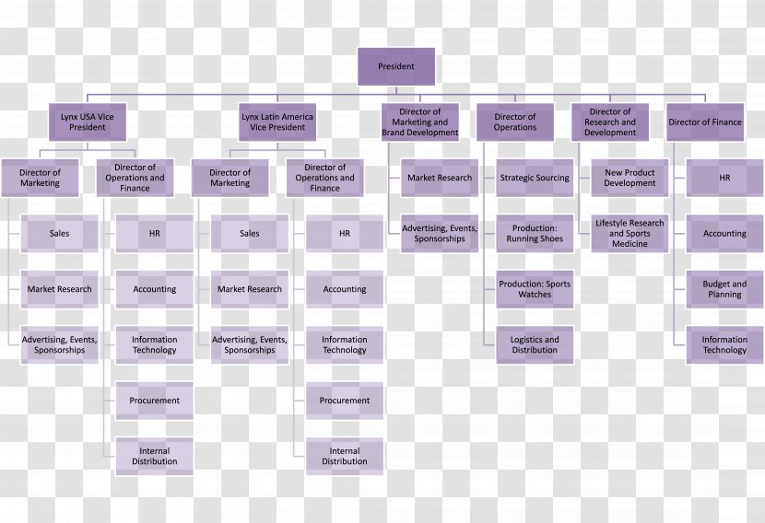
(Mavink, n.d.)

Property-Level Functional Structure
Individual Marriott hotels tend to adopt a functional structure, whereby every department (front desk, food services, housekeeping) ultimately reports to the general manager. This theoretically enhances efficiency through the concentration of expertise within specialist teams while maintaining a clear line of responsibility. (Kroll, 2017).
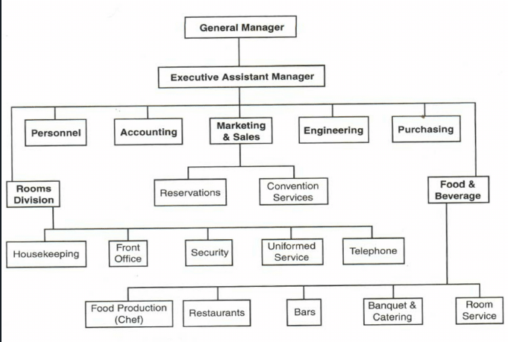
(Mara Solutions, n.d.)

Structural Evolution and Drivers of Change
Marriott's organisation has undergone substantial transformations as a result of market changes.
2023 Leadership Restructuring:The restructuring at the leadership level-namely in early 2023 with the departure of president Stephanie Linnartz-where CEO Anthony Capuano reduced the reporting lines to further dilute regional silos for the sake of expediting decision-making (Research-Methodology, 2023). Change to such an extent was aligned with contingency theory, as such structural forms should change in response to external pressures such as competition and market demand (Skift, 2024).
2024 Cost Reduction Program: Program of $90 million cost-reduction yearly was launched in November 2024 to improve development and revenue management in its 2024 plan for better cross-regional integration (O'Neill, 2024). Corporate jobs have been trimmed to remove redundancies; the company has doubled in size since 2015 (Skift, 2024).
Theoretical Alignment: The hybrid organisational structure of Marriott directly does resonate with contingency theory, which discusses designing the organisation around externalities such as competitive pressures or global expansion (Investopedia, n.d.). This matrix-functional hybrid model allows Marriott to ensure brand consistency while giving autonomy to regional leaders, an in-between balance crucial for the diverse markets in the hospitality industry (Research-Methodology, 2023).
Competitor Comparison
Marriott’s organisational structure differs from that of major competitors.
Hilton Worldwide: A combination of a divisional structure exercised with emphasis on regional independence over worldwide integration (Jones, 2024).
Hyatt Hotels: Utilises functional hierarchy and is thus not quick-performing framework as compared to the matrix of Marriott (Organimi, 2025).
IHG Hotels & Resorts: A hybrid model but not regionalised and still has an intricate structure such that the decision-making of IHG is slower than that of the streamlined divisional approach of Hilton (IHG, 2023).
Marriott’s broad span of control and well-defined chain of command enhance its operational efficiency. Its structure is molded by few key factors, including its global presence, diverse portfolio of brands, and ability to adapt to local markets—aligning with aspects of contingency theory. Recent leadership changes reflect strategic adaptability. Marriott’s organisational design fosters flexibility and a competitive edge, enabling it to effectively manage its extensive range of brands.

Organisational Culture and Goals
Marriott International has gained recognition as one of the largest hotels on a global, represented through a well-defined corporate culture, strategic goals, and objectives. This report is intended to provide a thorough outline of the corporate culture at Marriott and its influence on operations, and it will provide a discussion about goals at corporate and individual levels.

Corporate Culture and Impact on Operations
Organisational culture means the prevailing values, beliefs, and norms of how people communicate and cooperate in an organisation (Mullins, 2023). Marriott, more centrally known for its Clan Culture, accentuates teamwork, participation, and family spirit in its work environment. The company's People First philosophy, emphasizing individual well-being, training, and promotion of career development. (Mullins, 2019). It helps propel employee satisfaction and excellent service quality which is considered paramount in the hospitality sector (Mullins & Dossor, 2013).
Charles Handy identifies the four types of organisational culture: Power, Role, Task, and Person (Boddy, 2017). Marriott's model aligns closely with Task Culture, wherein top performing teams from diverse departments work together to ensure efficiency while remaining agile with respect to their particular set of experiences. Such culture propels creativity and flexibility toward the demands of the guests.
In contrast, firms like Hilton are more prone to market culture which is highly competitive on the outside and performance-oriented. Hilton has been focused on an aggressive growth strategy. Although it was the right direction towards the achievement of robust financial goals, this doesn't always compare to a good human focus at workplace with regard to employee engagement and retention (Armstrong, 2021). In contrast, Marriott applies a Clan Culture to its employee engagement, which in turn creates a more committed workforce in delivering quality service to their guests.

Factors contributing to the development of Marriott's organisational culture
• Leadership Commitment: Line managers exemplify the values of the company in everything they are doing, all the time. (Adair, 2009).
• Staff Reward and Growth: Investment in training programs and a stimulating career path encourage staff motivation and retention (Arnold, 2020).
• Customer-Centric Approach: The guest experience encourages quality and a culture of collaboration at all levels of the workforce (Rollinson et al., 2008).
• Corporate Social Responsibility: (CSR): The 'serve 360' program by Marriott points to the organisation's commitment to sustainability and social good, consistent with contemporary consumer values (Marriott International, 2021).

Organisational Goals
For a company like Marriott, the aim is to become world’s top organisation by providing exceptional experiences across its diverse brand portfolio. The recent launch of the Moxy brand in Spain, for example, was created for millennial and generation Z travellers searching for affordable, experience-driven hotel stay (Marriott International, 2024).
At the individual hotel level, Marriott emphasises exceptional operations and adaptability to local markets. Each property establishes specific performance objectives focused on increasing revenue, guest satisfaction, and sustainability efforts. A significant example of this commitment is showcased in the "Serve 360" programme, which underlines Marriott's pledge to environmental responsibility through initiatives aimed at decreasing carbon emissions and increasing renewable energy usage within its properties (Marriott International, 2021).
In a competitive landscape where numerous organisations emphasise a Market Culture approach, Marriott sets itself apart by nurturing a Clan Culture combined with a people-first philosophy. This employee-centered strategy improves service quality and boosts staff retention rates. Nevertheless, introducing elements of Adhocracy Culture, known for fostering innovation and flexibility, could further improve Marriott’s competitive advantage.
Recent Change Initiatives at Marriott International

Expansion into the Midscale Hotel Segment
In 2024, Marriott aimed to achieve savings of $90 million annually by the end of 2025 pushing into the midscale market via its City Express by Marriott brand. This initiative targets budget-conscious travellers while broadening its portfolio (Skift, 2024).
Evaluation and Impact
This strategy not only meets the growing demand for affordable accommodations but also mitigates reliance on higher-end segments while providing stability in revenue streams. However, maintaining Marriott’s high standards of service can be challenging when catering to price-sensitive customers.
Management of Change
The company has effectively improved its existing brand portfolio by focusing on clear financial goals and deliberate strategic intent, a sign of strong change management capabilities. Consistent branding alongside guest satisfaction necessitates continuous monitoring.

Overhaul of Human Resources Technology
Marriott selected Accenture to reboot the system it needed for HR and implemented an Oracle Fusion HCM system. This refines HR processes, enhances employee experience, and scalability across regions (Accenture, 2025).
Evaluation and Impact
It has created a single HCM platform to enhance operation and integrity of data to manage talent with due consideration to the fact that employees must have different experiences within global HR frameworks, with regulatory differences at a regional level posing challenges.
Management of Change
It was a calculated move, evidenced in Marriott's experience with Accenture and Oracle. It is not something that can easily be done, requiring intense training and support to put in place and take full advantage of what is available.

Theoretical analysis
Marriott's three strategic initiatives of midscale expansion, consolidated sustainability, and human resource technology overhaul, align with the major organisational behaviour theories. McGregor's theory Y resonates the belief Marriott has in employee autonomy and digitalisation of HR, with Oracle Fusion constituting a launching pad for the staff to navigate their careers with very little queuing (McGregor, 1960). Lewin's democratic leadership theory can be seen in Marriott's collaborative efforts towards sustainability and market expansion, engaging different stakeholders to effect change inclusively and effectively (Lewin, 1951). Adair's action-centered leadership theory is displayed by how Marriott balances the corporate need for sustainability, the dynamics of teamwork, and individual career growth through sustainability training and HR transformation (Adair, 1973).

Strategic Direction of Marriott International
Global Expansion and Brand Diversification: Marriott International embraces a multifaceted strategy to promote global growth, brand diversification, digital innovation, and sustainability. The hospitality giant seeks to develop its grip on the industry by targeting both the midscale and luxury markets, fine-tuning its approaches with regards to regional needs, and improving guest experience using better technology (Hotel Dive, 2024).
Localisation Strategy: Another key strategy is Marriott's localisation approach, which tries to fine-tune services according to the culture and economic climate in particular regions. This careful customization serves the company well in addressing unique market needs while successfully preserving its powerful global brand identity (Travel Trade Journal, 2024). Porter's five forces model application to strategic planning would further strengthen the group's analytical framework and enhance decision-making in diverse markets (The Strategy Institute, 2024).
Digital Transformation and Customer Engagement: Marriott leverages digital technologies such as AI-powered personalisation and the Marriott Bonvoy program to boost customer retention and engagement (ResearchGate, 2024). Their strategy reflects Mintzberg's 5 Ps framework (plan, ploy, pattern, position, perspective) in achieving objectives (The Strategy Story, 2025). Marriott’s direction is on sustainable development, diversifying into new brands, adapting according to the market, and utilizing technology due to customer engagement for its long-term success.

Conclusion
Marriott International’s success is predominantly because of its robust organisational culture, adaptable structure, and targeted strategy towards innovation, sustainability, and brand diversification. The most recent activities—digitalization of HR, sustainability, and market penetration—have strengthened Marriott's market position.
Recommendations
1. Enhance Sustainability Initiatives: Marriott should practice carbon-neutral operations, increase renewable energy sourcing into the properties, and minimize waste. Hilton's innovative LightStay program could be a perfect benchmark case that illustrates one way to aggregate environmental impacts into one common score (Hilton, 2024).
2. Invest in Artificial Intelligence (AI) for Enhanced Customer Experience: For increased guest satisfaction, Marriott can invest in AI-based personalization strategically through the Marriott Bonvoy application. AI may predict guest needs and preferences and replicate successful strategies of Accor's ALL application and Hilton's high-end AI concierge service (Accor, 2024; Hilton, 2024).
3. Strengthen Employee Development Programs: Marriott should diversify training programs and leadership opportunities to improve the employee development. Based on the highly reputable Thrive program at Hyatt, it could also develop well-structured, continued learning journeys that would enhance retention and employee morale (Hyatt, 2011).
4. Expand into New Emerging Markets: The organisation should vigorously target the emerging markets with great potential across Asia and Africa. This would position Moxy and Aloft brands nicely to get hold of the market share of the younger travellers. Lastly the Accor’s remarkable penetration in Indian markets is a model for Marriott (Accor, 2024).

REFERENCES LIST:
- Accenture (2025) Global HR Hub | Marriott Case Study. Available at: https://www.accenture.com/us-en/case-studies/travel/marriott-hr-transformation (Accessed: 24 February 2025).
- Accor (2024) Accor continues its expansion in India. Available at: https://press.accor.com/middle-east-africa-turkey-asia-pacific/accor-continues-its-expansion-in-india/?lang=en (Accessed: 24 February 2025).
- Adair, J. (1973) Action-Centred Leadership. London: McGraw-Hill.
- Adair, J. (2009) The Inspirational Leader (2nd edn). London: Kogan Page.
- Armstrong, M. (2021) Armstrong's Handbook of Performance Management (7th edn). London: Kogan Page.
- Arnold, J. (2020) Work Psychology (7th edn). Harlow: Pearson Education Limited.
- Boddy, D. (2017) Management: An Introduction (7th edn). Harlow: Pearson.
- CIO Dive (2024) Marriott gears up for another year of major tech spending. Available at: https://www.ciodive.com/news/marriott-international-tech-spend-digital-transformation-plan-ai/715036/ (Accessed: 24 February 2025).
- Corporate Finance Institute (2025) Boston Consulting Group (BCG) Matrix. Available at: https://corporatefinanceinstitute.com/resources/management/boston-consulting-group-bcg-matrix/?form=MG0AV3 (Accessed: 26 February 2025).
- Daft, R.L. (1998) Organization Theory and Design (6th edn). Cincinnati, OH: South-Western College Publishing.
- Dudovskiy, J. (2023) 'Marriott Organizational Structure Overview', Research-Methodology.net, 22 October. Available at: https://research-methodology.net/marriott-organizational-structure-overview/ (Accessed: 24 February 2025).
- Ecolab (2017) Marriott International Achieves Significant Savings in Water – Ecolab Case Study. Available at: https://ceowatermandate.org/resources/marriott-international-savings-water-ecolab-case-study/ (Accessed: 24 February 2025).
- Hilton (2024) LightStay: A decade of managing our environmental and social impact. Available at: https://stories.hilton.com/hilton-history/lightstay-a-decade-of-managing-our-environmental-and-social-impact (Accessed: 24 February 2025).
- Hotel Dive (2024) Marriott outlines strategic growth across midscale and luxury brands. Available at: https://www.hoteldive.com/news/marriott-strategic-growth-midscale-luxury-brands/695035/ (Accessed: 24 February 2025).
- Huczynski, A. & Buchanan, D. (2019) Organisational Behaviour (10th edn). Harlow: Pearson.
- Hyatt (2011) Hyatt announces Hyatt Thrive: Comprehensive corporate responsibility framework that helps improve local communities, environment worldwide. Available at: https://newsroom.hyatt.com/2011-06-10-HYATT-ANNOUNCES-HYATT-THRIVE-COMPREHENSIVE-CORPORATE-RESPONSIBILITY-FRAMEWORK-THAT-HELPS-IMPROVE-LOCAL-COMMUNITIES-ENVIRONMENT-WORLDWIDE (Accessed: 24 February 2025).
- IHG (2023) 'How our business works', InterContinental Hotels Group PLC, 31 December. Available at: https://www.ihgplc.com/en/about-us/how-our-business-works (Accessed: 25 February 2025).
- India’s Hotel Gold Rush Lures Marriott, Hilton, and Other Giants (2024) Skift. Available at: https://skift.com/2024/04/27/indias-hotel-boom-latest-investments-from-marriott-hilton-and-other-chains/ (Accessed: 24 February 2025).
- Investopedia (n.d.) Organizational structure. Available at: https://www.investopedia.com/terms/o/organizational-structure.asp (Accessed: 24 February 2025).
- Jones, S. (2024) 'Hilton Hotel Organizational Structure: Free Guide for Beginners', EdrawMind, 8 August. Available at: https://edrawmind.wondershare.com/org-chart/hilton-hotel-org-structure.html (Accessed: 25 February 2025).
- Kroll, H.N. (2017) 'Marriott International Inc.: Organizational complexity', H.N. Kroll Blog, 26 February. Available at: https://hnkroll.wordpress.com/2017/02/26/marriott-international-inc-organizational-complexity/ (Accessed: 24 February 2025).
- Lewin, K. (1951) Field Theory in Social Science. New York: Harper & Row.
- Mara Solutions (n.d.) Hotel organization. Available at: https://www.mara-solutions.com/post/hotel-organization (Accessed: 25 February 2025).
- Marriott International (2024) 2024 SERVE 360 REPORT - Environmental, Social & Governance. Available at: https://serve360.marriott.com/wp-content/uploads/2024/07/2024ESGProgress.pdf (Accessed: 24 February 2025).
- Marriott International (2024) About Marriott International. Available at: https://www.marriott.com/marriott/aboutmarriott.mi (Accessed: 17 February 2025).
- Marriott International (2024) Sustain Responsible Operations. Available at: https://serve360.marriott.com/sustain/ (Accessed: 24 February 2025).
- Marriott International (2021) Serve 360 Report. Available at: https://serve360.marriott.com/wp-content/uploads/2021/09/2021_Serve_360_Report.pdf (Accessed: 24 February 2025).
- Marriott International (2024) Moxy Hotels Debuts Its Playful Spirit in Spain With the Opening of Moxy Barcelona. Available at: https://news.marriott.com/news/2024/10/03/moxy-hotels-debuts-its-playful-spirit-in-spain-with-the-opening-of-moxy-barcelona (Accessed: 24 February 2025).
- Mavink (n.d.) Marriott International Organizational Chart. Available at: https://mavink.com/explore/Marriott-International-Organizational-Chart (Accessed: 19 February 2025).
- McGregor, D. (1960) The Human Side of Enterprise. New York: McGraw-Hill.
- Mullins, L. & Dossor, P. (2013) Hospitality Management and Organisational Behaviour (5th edn). Harlow: Pearson.
- Mullins, L. (2019) Organisational Behaviour in the Workplace (12th edn). Harlow: Pearson.
- Mullins, L. (2023) Management and Organisational Behaviour (13th edn). Harlow: Pearson.
- O'Neill, S. (2024) 'Marriott unveils overhaul: $90 million in cuts, updates on midscale push', Skift, 4 November. Available at: https://skift.com/2024/11/04/marriott-unveils-overhaul-cut-costs-push-midscale-brands-boost-loyalty/ (Accessed: 24 February 2025).
- Organimi (2025) 'Hyatt Hotels' Organizational Structure', Organimi, 25 February. Available at: https://www.organimi.com/organizational-structures/hyatt-hotels/ (Accessed: 25 February 2025).
- ResearchGate (2024) Strategic Management: Marriott International’s Approach. Available at: https://www.researchgate.net/publication/376757217_STRATEGIC_MANAGEMENT_MARRIOTT_INTERNATIONALS (Accessed: 24 February 2025).
- Rollinson, D. et al. (2008) Organisational Behaviour and Analysis (4th edn). Harlow: Addison-Wesley Longman.
- Skift (2024) Marriott Playbook: Cut Costs, Push Midscale, and Boost Loyalty. Available at: https://skift.com/2024/11/04/marriott-unveils-overhaul-cut-costs-push-midscale-brands-boost-loyalty/ (Accessed: 24 February 2025).
- The Strategy Institute (2024) 'Porter's Five Forces: The Ultimate Competitive Strategy Blueprint'. Available at: https://www.thestrategyinstitute.org/insights/porters-five-forces-the-ultimate-competitive-strategy-blueprint (Accessed: 26 February 2025).
- The Strategy Story (2025) 'Mintzberg’s 5Ps of Strategy with Examples'. Available at: https://thestrategystory.com/blog/mintzbergs-5ps-of-strategy-with-examples/ (Accessed: 26 February 2025).
- Travel Trade Journal (2024) Marriott International: Localising strategies in varied and diverse locations. Available at: https://traveltradejournal.com/marriott-international-localising-strategies-in-varied-and-diverse-locations/ (Accessed: 24 February 2025).

