Qu https://uxbooth.com/articles/quick-lit-reviews-reduce-ux-research-time-and-supercharge-your-design/ ick Lit Reviews Reduce UX Research Time and Supercharge

Not the best source but it looks “interesting”.

Steve

Quick Lit Reviews Reduce UX Research Time and Supercharge Your Design

MARCH 24TH, 2020

WRITTEN BY

Jolie Dobre https://uxbooth.com/author/jdobre
Author

A quick and dirty literature review (Lit Review) is a way to capture and synthesize information about a topic (a design problem, a new technology, an unfamiliar business area, etc.). It’s a simple structure that will allow you to document relevant information in an organized and intentional format. Creating the Lit Review can take a relatively short time compared with formal UX research; but leaves you with a lasting resource that can organize your thoughts, inform your strategy, educate others, and positively influence team behavior and design.

What is a Literature Review?
You may have been exposed to a Lit Review in school as a part of undergraduate or graduate work. Lit Reviews are often performed in preparation for a master’s thesis, doctoral dissertation, or when writing journal articles (“Literature review,” 2019). A Lit Review is a survey of the available published information on a particular topic. A simple review can be composed of just a summary of sources but often includes an overview of the information available and a synthesis of the major findings (The Writing Center, n.d.).
When most people think of a Lit Review they associate it with the highly rigorous, complex, and time consuming Systematic Review and Meta-Analysis. This type is familiar because it is often referenced in journal articles and is performed by graduate students and academic researchers. It includes an exhaustive review of scholarly papers and recent research and an assessment of the search results to offset bias and ensure all relevant research is included. It then uses qualitative and quantitative methods to synthesize findings and has strict rules for the structuring of results (Pare & Kisiou, 2017; Uman, 2011; Venebio, 2017). The average time to conduct a Systematic Review is 1,139 hours (J Med Libr Assoc, 2018)—hardly practical for UX!
What people don’t realize is that the format of the Lit Review can be modified for different fields of study and by purpose. The simple Narrative Review provides a broad perspective on a topic and can be produced quickly and cheaply. It can be performed in mere hours, allows authors to select the material that interests them, ignores selection bias, and permits simple thematic or content analysis (Pare & Kisiou, 2017; The Writing Center, n.d.).

What is a Quick & Dirty Lit Review?
A Quick and Dirty Lit Review (Q&D Lit Review) is a Narrative Review that does not concern itself with formatting for final presentation, liberally uses copy and paste to capture useful information, and —most importantly — leverages qualitative coding techniques to analyze information as it is collected. In business we don’t have the time or budget for deep rigor, long analysis, or well-written prose; but we can still benefit from capturing information from multiple sources for analysis, reuse, and dissemination.
The Q&D Lit Review is also broadened to include non-peer reviewed work and other, non-published work. Often, in business our specific problem may not be supported by an existing body of research so information must be acquired from other sources such as informal, online articles, development forums, social media, talking with colleagues, user interviews, etc. Capturing these other, less reputable sources allows us to consider and incorporate the newest information and trends, while qualitative coding techniques allow us to easily compare themes across sources and quickly compare the value of new ideas against older, tested ones.

When to do a Q&D Lit Review?
A Lit Review can be performed any time you want to quickly get up to speed on a topic. However it is not a replacement for deeper, more rigorous research. Think of it as the first step in your UX research strategy. The Lit Review should bring your UX Research needs into focus. It is ideal when you don’t yet know the questions to ask, or when you want to know what you don’t know. Expect more focused questions to arise out of your initial Lit Review.

How to perform a Q&D Lit Review
A Q&D Lit Review follows the six basic steps of all Lit Reviews (Pare & Kisiou, 2017); but to save time and increase efficiency, steps 3, 4, 5 & 6 are done concurrently:
- Formulate your research question
- Search the literature
- Screen for the material you want to include
- Assess the quality of what you are including
- Extract the data
- Analyze the data
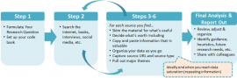
Figure 1 The Quick and Dirty Lit Review is structured for speed and efficiency. The six basic steps of the Narrative Review are condensed to shorten data collection and coding time.

Formulate Your Research Question & Set-Up (15-20 min)
The first step in performing a Q&D Lit Review is to consider what you are researching and formulate a clear research question. This may seem like a trivial step but clearly formulating a research question will keep you focused and guide the rest of your actions (McCombes, 2020). At this stage your research question may be very broad. Some example questions from my own experiences include:
- What should I consider when designing a Log On screen?
- How will the transition to WCAG2.1 affect accessibly testing and accessible design?
- How can I make Tableau as accessible as possible?
- What is the best way to collect user feedback on a Drupal site page?
Often I find that the process of articulating the question yields keywords or additional sub-questions that I will use later. It also gives me a start on my inductive code set.
Note: To get an introduction to developing codes and coding qualitative data read Themes Don’t Just Emerge — Coding the Qualitative Data (Yi, 2018).
At this stage you must also set up your code book (the document where you ‘code’ your data). I like to use a table in Word because it’s easy to copy and paste into, it allows me to add formatting (bold and bullets) to my text, yet still retains a tabular format that makes it easy to sort and filter codes or sources and reorganize data rows. At a minimum, your code book should have three columns: Codes, Data, and source URLs. You may choose additional rows if you want primary and secondary codes, or if you want to easily track source type (i.e. journals, news, social media, interview, etc.), or the keywords you used to find the content.

Search the Literature (30-60 seconds per source)
Information can be acquired from any source: online magazines and journals, informal online posts, online training, development forums, social media, prior usability testing transcripts, impromptu interviews with colleagues or clients, office memos, competitor websites, etc. Printed material is also useful, but you may want to scan it to reduce keyboarding time, or be prepared to summarize the text. I have a shelf with a number of UX and software development books that I like to thumb through and extract ideas from before I begin my online search.
The broader your search is the more comprehensive your review will be; and more comprehensive equals more time. Don’t lose sight of the fact that this is supposed to be quick! If you’re short on time, limit yourself to 30 or 60 minutes. If you have more time, continue searching and reviewing sources until you see the core ideas and guidance repeating.

Screen, Assess, Extract, & Analyze (5-10 min per source)
For each article (or post, interview transcript, etc.) you find, skim for content relevant to your research question. As you see relevant ideas or concepts copy and paste them into your code book. Your codes can be words or phrases, whatever helps you organize the information.
You can also add your own commentary to the cell. I notate the data with my thoughts and questions as they occur. I’ll italicize that text so I can quickly review it later. My notes may lead me to search for additional information, or simply help me interpret the text and recall more valuable information.
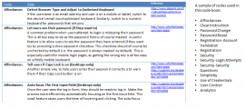
Figure 2 Illustration of a code book used to answer the question “What should I consider when designing a Log On screen?” Other codes appearing in the book are also displayed.
Visuals are a major part of UX. If you see a great design pattern or illustration of ideas, take a screenshot and add it to an appendix below the table. Use image captions to briefly summarize its importance and capture the source URL.
As you cut, paste, and organize content you’ll start to see similarities between articles. You may see the same phrase or guidance repeated (sometimes often enough to suspect plagiarism). Occasionally you’ll see content that directly contradicts other guidance. This may cause you to review previous articles and re-examine their statements. You’ll find that you’re reading articles from a more analytical perspective than you would be if you were not coding the data.
As you add sources, continue to organize and re-order the code book so that similar ideas are grouped together. Create theme statements as they occur to you. Merge cells that contain very similar ideas, so that one theme represents ideas repeated by different sources. Combining screening, assessment and extraction with analysis as you read allows you to quickly synthesize and internalize the information.
If a source lacks valuable information, copy the URL to the bottom of your table and provide a short sentence to summarize the article for yourself and why you did not extract information from it. Provide a code like “No Info” so you can sort them out. This will allow you to capture the full breadth of your research effort. It may also prove useful if, as your research develops, you realize that you may have overlooked something valuable and you want to reread a source, or if a source has very basic information that you later realize may be valuable to junior team members. It is also a useful way to keep yourself on task. If you’re not copying valuable information into your code book you may not be reading the articles you should be reading, you may be falling victim to distraction and click-bait. Keeping yourself honest is a good way to conserve and manage your time.

Final Analysis & Report Out (5-60 min)
Once you’ve used the time you have, or once you start to see information repeating, it’s time to stop searching and start reviewing what you’ve collected. At this point themes and high level conclusions will be evident. Skim your entire code book to see if anything new jumps out when you look at the full data set. Occasionally, key guidance is not exciting enough to draw your attention; but when you see it repeated several times you realize its importance. Incorporate these late stage thoughts into your theme statements and conclusions.
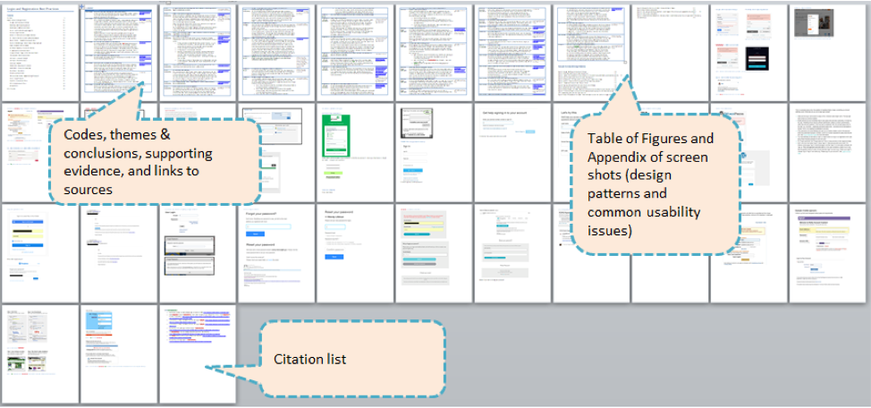
Figure 3. This sample code book for a Login page redesign resulted in a list of best practices, design heuristics, and common issues which helped drive requirements and design. It also facilitated a deep partnership with the security team to balance ease of access with data-security concerns. Total sources: 8. Research time: 2 hours.
Review all your themes, conclusions, and notes to ensure that they are written in a manner that is meaningful to others. Create full and complete thoughts that summarize what you’ve learned and relate it to actions, behaviors, or processes that can be performed to solve your research problem. This is important for several reasons. First, it forces you to think reflexively. Reflective thinking is critical to complex problem-solving; it forces you to step back and think about how to solve a problem and how a set of problem-solving strategies can be leveraged to achieve a goal. (University of Hawaii, n.d.) Secondly, much of the value of the Lit Review is in its ability to quickly transfer information to others. If your thoughts are not clear and instructive, you cannot transfer knowledge. Finally, projects may be delayed or compete with other priorities. If you must revisit a project in six months, or if you have to balance multiple projects, you want your research to be meaningful to you.
When you do share your review, you may need to reorganize it so it tells a cohesive story for new readers. Depending on your audience, you can simply add a Table of Images to display the screen shots you’ve assembled. Or, if you plan to share your report with a client, you may want to convert your findings into a more narrative format as well as enter full citations for your sources.
As a beginner, expect to spend at least four hours to a day, on your first Lit Review. Your reading speed will affect your time. (I took a course in speed reading years ago and that allows me to skim many articles and quickly make value judgments. I then slowly re-read the material that I believe has value for my research question.) It takes time to integrate valuable information from various sources and you may need additional time to revisit and compare articles. If you are new to qualitative coding, expect a learning curve. It can be difficult to discern the correct code-set for your research problem if you are not a seasoned coder. Consider learning more about qualitative coding before you begin.

Top 10 Reasons & Tips for a Quick and Dirty Lit Review

You’re likely doing the research already
To stay abreast of current design trends, technology innovations, and accessibility guidelines it’s likely you already read a great many UX articles, attend conferences or trainings, and network with other UX professionals. In other words, you’re already reviewing the “literature”; you’re just not documenting it in a way that makes it useful to you. If you’ve ever found yourself thinking “where did I see that?” or “what are the best practices?” in response to a design problem or question, then the structure of the Lit Review will help you.

Keep focused when researching online
We’ve all had the experience of reading an article online then getting distracted by click bait. Suddenly you’ve wasted an hour and have nothing to show for it. The Lit Review keeps you focused on drilling into a very specific topic. If you’re not cutting and pasting into the document, then you’re not reading relevant content and you have to move on.

Quickly identify patterns and contradictions
As you cut, paste, and organize content you’ll start to see similarities and contradictions between articles. This will cause you to review previous articles and re-examine their statements. You’ll find that you’re reading articles from a more analytical perspective.

Citations matter
When engaging with a client, design or development team, disagreements are bound to arise. Your research will support your ideas and provide persuasive justifications for design or process decisions. It’s not just you saying how it should be done; it’s coming from numerous well respected professionals. Using citations from reputable sources will add to your own trust and credibility.

Stand on the shoulders of giants
Merriam Webster defines an Expert as “one with the special skill or knowledge representing mastery of a particular subject”. The Lit Review provides a broad understanding of the topic area and equips you with the relevant facts as well as access to the authoritative sources of those facts. That equates to mastery. Congratulations, you are now an expert.

Establish a custom heuristics set to evaluate your design
As you collect and organize your information you will begin to see patterns that define the attributes of good design. You and your team can use these as heuristics to inform your design process and to evaluate and usability test your prototypes.

Avoid the mistakes of others
People are eager to share what works and what doesn’t. With a handful of articles or informal interviews, you can assemble a quick list of potential pitfalls and then establish strategies to avoid them.

Save time in the long run
Uninspired design cycles, falling victim to common mistakes, and late stage rework are all costly and time consuming. Knowledge can be the competitive edge that distinguishes your product’s user experience from that of the competition and shortens overall development time.

Your colleagues will love you
By performing the research and distilling it down to the core themes and issues, you shorten the learning curve of your colleagues. You also increase their confidence in you.

Someone is paying you to learn new things!
The Lit Review is a great excuse to get inspired, expand your knowledge, and create a useful deliverable at the same time.

Citations
J Med Libr Assoc. (2018). It takes longer than you think: librarian time spent on systematic review tasks. Journal of the Medical Library Association (JMLA), 198–207. Retrieved from https://www.ncbi.nlm.nih.gov/pubmed/29632442
Literature review. (2019). Retrieved January 2, 2019, from https://en.wikipedia.org/wiki/Literature_review
McCombes, S. (2020). https://www.scribbr.com/research-process/research-questions/
Pare, G., & Kisiou, S. (2017). Handbook of eHealth Evaluation: An Evidence-based Approach [Internet Ed.]. Victoria (BC): University of Victoria. Retrieved from https://www.ncbi.nlm.nih.gov/books/NBK481583/
The Writing Center. (n.d.). Literature Reviews. Retrieved from https://writingcenter.unc.edu/tips-and-tools/literature-reviews/
Uman, L. S. (2011). Systematic Reviews and Meta-Analyses. J Can Acad Child Adolesc Psychiatry, 20(1), 57–59.
University of Hawaii. (n.d.). Reflective Thinking: RT. Retrieved from
http://www.hawaii.edu/intlrel/pols382/Reflective Thinking – UH/reflection.html
Venebio. (2017). 5 differences between a systematic review and other types of literature review. Retrieved January 2, 2019, from https://venebio.com/news/2017/09/5-differences-between-a-systematic-review-and-other-types-of-literature-review/
Yi, E. (2018). Themes Don’t Just Emerge — Coding the Qualitative Data. Medium, Project UX. Retrieved from https://medium.com/@projectux/themes-dont-just-emerge-coding-the-qualitative-data-95aff874fdce%0D

