Created BY RACHEL BANCROFT
STUDENT I:D 1817416

Questionnaire Analysis

1.
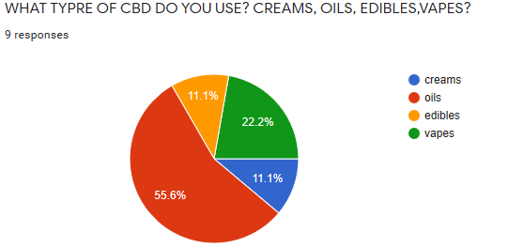
This pie chart above tells me numerous information from my questionnaire survey, it shows that all the 9 people in question use some form of CBD. This shows that a small percentage uses a CBD form of cream. This could be for multiple reasons i.e arthritis, sclerosis, or even those who have sore or inflamed muscles.
CBD cream is a lotion that has been infused with CBD. Used topically, you can directly apply CBD to your skin. It can be used for pain relief or skin care. Generally, CBD cream is available over the counter or from natural health stores.
https://potstocknews.com/cbd-cream/
{assessed 24/03/20}
- My findings from the pie chart above also tell me that there is a small percentage of people who actually use CBD in a form of edibles, being sweets and chocolate or cakes. This can have a different effect and does not happen straight away where an oil or cream can have its effects from as little as 15-20 minutes, or nearly straight away. However when you eat CBD it can take up to 3 hours to get into your bloodstream.
CBD consumed in the edible form generally takes 1-3 hours to hit the bloodstream, whereas tinctures and vaped forms tend to be faster and shorter lived. Although symptom relief may take a bit longer, edibles may be a delicious, longer-lasting option for those looking for a standard maintenance dose.
https://www.cbdcentral.com/how-to-make-cbd-edibles/
{assessed 24/03/20}
My findings from the pie chart above show me that a slightly higher percentage of people use CBD within vapes. This is a common cause nowadays as marijuana in the UK is still currently illegal however people tend to use CBD and THC within vapes to have some form of effect.
Benefits of CBD E Liquid: CBD E-Liquid products have been recognized to provide a wide ranging variety of benefits. There are many ways to consume CBD E Juice or CBD vape juice, many of which are easy to find and use. These CBD products can help you improve and lead a healthy lifestyle.
https://www.bing.com/search?q=cbd+vape+liquid+benefits&FORM=QSRE2
{assessed 24/03/20}
Lastly my findings from my pie chart as above currently tell me that the highest percentage of people currently use CBD within an oil form. This oil form can be put on the tongue, or put in food or drinks. Oils can help hugely with anxiety relief by reducing stress levels, sleep levels where suffering from insomnia. From cancers to acne.
There’s some controversy around cannabis products like CBD oil because of recreational marijuana use. But there’s growing awareness about the possible health benefits of CBD oil.
https://www.healthline.com/health/cbd-oil-benefits
{assessed 24/03/20}
This data from my pie chart shows me from the information I have received that I need to target my CBD business more so in a form of more selection of CBD oils as my research shows I have 55.6%. This would achieve huge sales for my business. And a huge potential to expand the business further profiting more financial growth.
2.
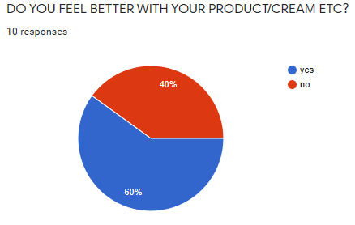
Out of all the 10 people within my questionnaire findings 10% more of the people indicate that they feel better with their CBD product. Whether this be a CBD form of creams, a CBD form of oils, a CBD form of edibles, or a CBD form of vapes, CBD as a hole is having a huge impact to peoples lives as they have great benefits of proven research to help with numerous health issues. This is a fantastic opportunity for our business as 60% felt better by using a form of CBD.
The list of benefits CBD provides is long and growing, as scientists continue to unearth new health benefits and use cases for CBD.
https://www.cbdoil.org/cbd-benefits/
{assessed 24/03/20}

Website Analysis

This is a website I created about a CBD business. I started by having a front page of my website and also a contact us page.
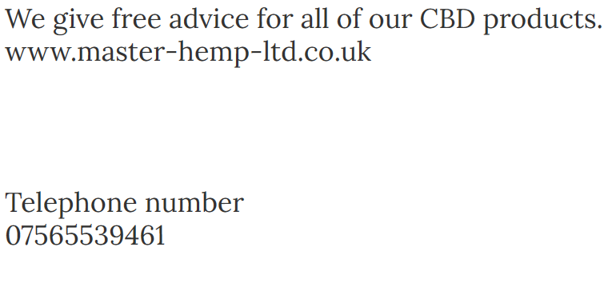
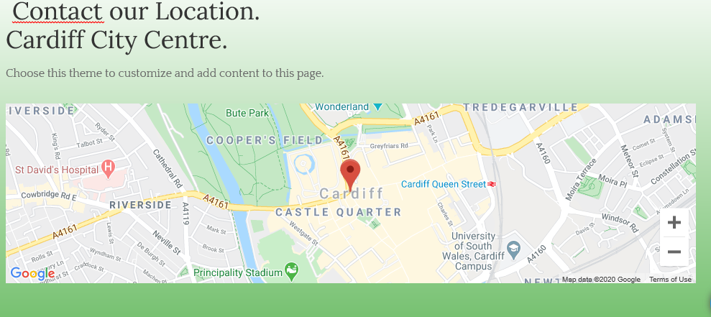
I included this contact page so when people are looking at our web page they can see where we are location and if they want to get in contact with us then they can. Very useful to include a map – google ranks higher if I include a map within my webpage.
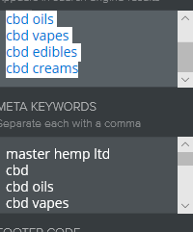
I FOUND THAT IF I INSERTED MORE KEY WORDS HERE THEN I WOULD GET HIGHER UP THE GOOGLE PAGE.

GOOGLE EMAIL ADDRESS – 1817416.UWTSD@STUDENT.AC.UK
PASSWORD – CORONAVIRUS6
RACHEL BANCROFT.
Module grade & Feedback

