
the analysis of business practice in new zealand from the perspective of uk companies
Based on international business communication theories

December 27, 2019
University of Wales Trinity Saint David

Hongli Shang (1904764)

Executive Summary

The report aims to evaluate the sensitivities and challenges for UK companies to operate business practices in New Zealand based on international business communication theories. The first part introduces cross-cultural business communication briefly, including its definition and the influence of culture in communication.
Main findings of this report aim to analyse how to operate a successful cross-cultural communication between the UK companies and their counterparts in New Zealand. This report puts Hofstede’s cultural dimension theory into a scene of business chain and analyse how the cultural dimensions influence the business and how to do business in New Zealand for UK companies based on several organisational examples in consider of the cultural dimensions. Then, their specific cultural differences in 1) greeting, 2) gift giving, 3) attitudes to time, 4) negotiating styles and 5) significance of gestures are considered. Moreover, there are several potential challenges for UK companies based on stereotypes to New Zealand which are 1) language barriers, 2) time and 3) internal cultural difference.
To conclusion, their cultural differences require changing ways of doing business to some extent and three suggestions which are 1) making an appointment in advance, 2) being accompanied by trusted internal employees who have knowledge of their local languages and 3) avoiding talking about private issues are given to promote the performance of UK companies that would like to expand their business in New Zealand.

Table of Contents

Executive Summary 1
Introduction 3
Main Findings 4
3.1 CULTURAL DIFFERENCES BETWEEN NEW ZEALAND AND THE UK 4
3.1.1 Differences Based on Hofstede’s Cultural Dimension Theory 4
3.1.2 Specific Differences Reflecting in Business Practice 7
3.2 PREVIOUS BUSINESS PRACTICE IN NEW ZEALAND FOR UK COMPANIES 9
3.3 CHALLENGES OF BUSINESS COMMUNICATION IN NEW ZEALAND 11
3.3.1 Stereotypes of New Zealand In Business 11
3.3.2 Challenges and Potential Failures 12
Conclusion 14
Bibliography 15

Introduction

For a UK company, it is inevitable to communicate and negotiate with its counterparts if it would like to expand the business overseas (Huang, 2010). One of important factors to promote a successful communication is the awareness of different cultures. On the one hand, different cultural variables, for example, different languages can bring about barriers to business communications (Huang, 2010). On the other hand, understanding different cultural dimensions of counterparts will promote the success of business communication and improve the efficiency of a company (Kreiser et al., 2010).
Cross-cultural business communication usually takes place when a company is faced with understanding different business customs, beliefs and communication strategies (Kreiser et al., 2010). Some main factors including language differences, the high or low context of a culture and cultural dimensions are significant in communication (Hall, 1976; Hofstede, 1980). It involves the understanding of ‘how people from different cultures speak, communicate and perceive the world around them’ (Martin and Chaney, 2012).

Main Findings

A successful communication can not only win the respect and trust from the counterpart, but also promote a deeper understanding in business (Huang, 2010), such as releasing the stressful atmosphere and understanding expectations of business in each other (Kreiser et al., 2010). This part concentrates on how to achieve a successful cross-cultural communication.

3.1 CULTURAL DIFFERENCES BETWEEN NEW ZEALAND AND THE UK

3.1.1 Differences Based on Hofstede’s Cultural Dimension Theory

The different dimensions of this theory reflect different cultural characters of a country (Hofstede, 1980). According to Hofstede’s cultural dimension theory, there are several differences between the UK and New Zealand (see Fig. 3-1). It is believed that a country’s culture is also reflected in its business system (Martin and Chaney, 2012). This report will put Hofstede’s theory into a scene of the business chain to discuss how the differences of these cultural dimensions between New Zealand and the UK influence the way of doing business (see Fig. 3-2).

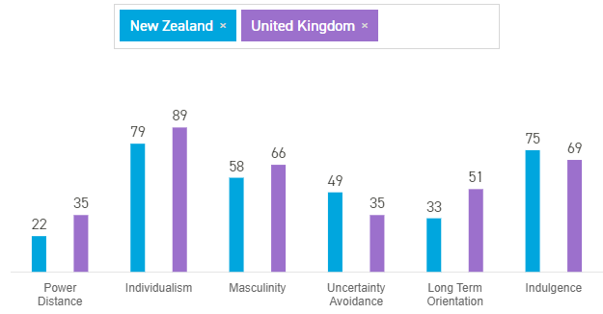
FIGURE 3-1 COMPARISON OF HOFSTEDE’S SIX CULTURAL DIMENSIONS OF THE UK AND NEW ZEALAND
Source: Hofstede Insights (2019)
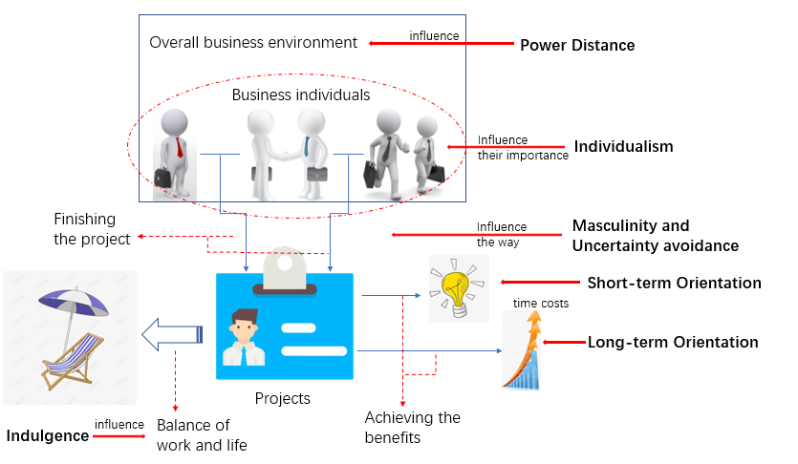
FIGURE 3-2 THE RELATIONSHIP BETWEEN CULTURAL DIMENSIONS AND DOING BUSINESS
Source: Hofstede (1980)

Power distance is related to the overall business environment. It refers to the acceptive and satisfying degree for people with less powers towards the unequal distribution of power in an organisation or a society (Hofstede, 1980). Both countries belong to low power distance (Hofstede Insights, 2019). It means in terms of the business environment, they can reach an agreement without too much suffer. Such an environment that satisfies businesspeople of both countries are equal and relaxing (Hofstede, 1980).
Besides, it is individuals who are significant to consist of a whole business environment. Individualism focuses on individuals in a business environment rather than groups (Hofstede, 1980). The two countries both belong to the individualism (Hofstede Insights, 2019). Therefore, if a UK company would like to cooperate with a New Zealand partner, it is beneficial to give people autonomy to use their initiative and reward individual performance (Hofstede, 1980). Taking a successful practice for example, Unilever is one of successful global companies in New Zealand which stress the gender equal and more female employees of New Zealand are hired and promoted (Unilever, 2018). Considering the low power distance and individualism in New Zealand (Hofstede Insights, 2019), it is beneficial to motivate them to work hard.
Furthermore, the way of doing business is also an important part in a business system which can also be influenced by cultural dimensions. On the one hand, competition, success and achievement are encouraged in a masculine culture (Hofstede, 1980). They both belongs to masculinity (Hofstede Insights, 2019) which means the similarity of pursing becoming the best, to some extent, makes for their agreement in awarding and promotion (Hofstede, 1980).
On the other hand, uncertainty avoidance refers to the tolerant degree of uncertainty in a culture. A high score means a strong intention of uncertainty avoidance (Hofstede, 1980). The figure 3-1 indicates that New Zealand shows no preference while people in the UK are comparatively tolerant to uncertainty (Hofstede Insights, 2019). It means in the UK, it is flexible to achieve business objectives and trivial details are not required. However, clear instructions and procedures are expected to be offered in New Zealand when they do business together (Hofstede, 1980; Hofstede Insights, 2019).
Moreover, Long-term and short-term orientations reflect the different acceptability of time costs of benefits. Long-term orientation cultures show a strong acceptability of time costs in order to achieve more significant objectives. With the score of 51, there is nearly no preference in the UK while New Zealand belongs to short term orientation (Hofstede Insights, 2019). In business, to achieve the short-term benefits, New Zealanders prefer traditional rules and norm to achieve goals. Therefore, if the UK companies respect their traditions and regulations, the business communication will be more likely to succeed (Hofstede Insights, 2019). For example, Woolworths New Zealand has become a continuously growing company in New Zealand. Their leadership team is experienced and clear instructions are provided which is considered as a factor of its success (Woolworths, 2020).
Finally, the character of indulgence shows the balance of work and life. This dimension indicates the wiliness of people to control their desires and impulses (Hofstede, 1980). Both New Zealand and the UK belong to the indulgence. It means on this dimension, the UK companies do not have to change their business ways that include avoiding talking about business in holiday and decrease the chance of work overtime (Hofstede Insights, 2019).

3.1.2 Specific Differences Reflecting in Business Practice

Greeting. In New Zealand, the traditional Māori greeting is Hongi. They press their nose together and touch foreheads each other (Mclntosh, 2004). For other Kiwis, the greeting is causal that generally includes smiling and shaking hands (Commisceo Global, 2019). While in business occasions, the most acceptable greeting way in the UK is shaking hands (Giftypedia, 2013). At the same time, people also shake hands upon leaving and the handshakes do not have to be too hearty, just a light friendly touch (Commisceo Global, 2019).
Gift giving. When it comes to gift giving in business occasions, it is not popular in New Zealand, as well as in the UK (Giftypedia, 2009; Giftypedia, 2013). However, several kinds of gifts are acceptable in New Zealand, such as chocolates, flowers and books (Giftypedia, 2009). The appropriate gifts in the UK include desk accessories, a delicious meal or books (Giftypedia, 2013). Moreover, in New Zealand, the meaning of gifts is more important than the value of gifts. Therefore, the gifts are not lavish (Giftypedia, 2009). In the UK, to avoid bribes, the acceptable gifts are also not expensive (Commisceo Global, 2019).
Attitudes to time. Appointment is necessary in New Zealand. However, it is relatively difficult to make an appointment in December and January because of summer vacations. Attending on time or some minutes early shows personal reliability and respect to the partner (Commisceo Global, 2019). In the culture of the UK, people also have a strong awareness of time. Therefore, their counterparts are expected to attend the meeting on time. Moreover, during July and August as well as some important festivals, such as Christmas and Easter, it is not suitable to organise business activities in the UK due to vacations (Martin and Chaney, 2012).
Negotiating style. New Zealanders appreciate honesty and directness. When negotiating with them, their counterparts are expected to be realistic and patient. Setting a realistic goal and being honest will helpful to gain their trust (Commisceo Global, 2019). In the UK, sometimes the negotiating style is informal, and humour plays an important role in the communication. Moreover, they avoid quick decisions which are considered as a lack of serious thinking and they do not make absolute statements (Commisceo Global, 2019).
Significance of gestures. The cultures of both New Zealand and the UK belong to the low-context culture which means the low use of non-verbal communication (Hall, 1976). However, there are also some gestures in their cultures respectively which need to be noticed (Cultural Atlas, 2019). In New Zealand, for example, although eye contact generally means the sincerity of someone, a long-time eye contact, however, may be regarded as an offense. Besides, the head is sacred in Māori culture and should not be touched without permission (Cultural Atlas, 2019). In the UK, the gesture of V for a victory is insulting. Moreover, tapping the nose means someone keeps personal reserve. At last, touching wood, for example, a table, is done for good luck (Commisceo Global, 2019).

TABLE 3-1 DIFFERENCES BETWEEN NEW ZEALAND AND THE UK IN BUSINESS PRACTICE
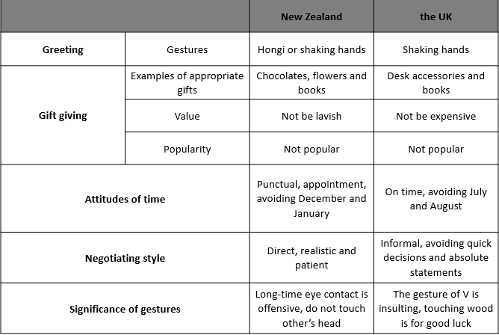
Source: Commisceo Global (2019); Cultural Atlas (2019); Giftypedia (2009); Giftypedia (2013); Martin and Chaney (2012); Mclntosh (2004)

3.2 PREVIOUS BUSINESS PRACTICE IN NEW ZEALAND FOR UK COMPANIES

Besides the mentioned examples in former parts, there also have been several successful and meaningful explorations for the UK companies to operate business practices in New Zealand. There are two typical examples of these explorations.
The British New Zealand Business Association (BNZBA). This organisation was established in 1917 which composes of both the UK and New Zealand business representatives (see Fig. 3-3) as well as other international businesses. After decades development, it has been a significant channel to facilitate the operation of business between the two countries (BNZBA, 2019). The main effect of BNZBA is providing information and networking opportunities services to its membership. Among its several advantages, connection is a strong benefit to facilitate their businesses. It has strong connections in the New Zealand business community and is also international affiliate of the British Chambers of Commerce that means it has a strong convening power and brings businesses together effectively (BNZBA, 2019).
Unilever’s success in New Zealand. Unilever is a large global transactional consumer goods company whose headquarters are in the Dutch and the UK (Unilever, 2019). Recent years, it has gained great success in New Zealand. Its turnover in New Zealand in 2017 was 207,869,000 dollars (Unilever, 2017). It has implemented a set of actions to promote international business communication to improve its performance in New Zealand further (Unilever, 2019). On the one hand, gender equal is stressed. More female employees are hired and promoted (Unilever, 2018). Considering that New Zealand belongs to low power distance and individualism according to Hofstede’s theory (Hofstede, 1980), these actions can make employees, especially female employees satisfied and motivated to work hard. On the other hand, it creates a normalising flexible working environment. Its business declared ‘all roles flex’ in 2016 (Unilever, 2019). As a result, male employees are more flexible to arrange their work. Flexibility is significant for New Zealand considering of its character of indulgence (Hofstede, 1980).

FIGURE 3-3 SOME REPRESENTATIVES OF BNZBA
Source: BNZBA (2019)

3.3 CHALLENGES OF BUSINESS COMMUNICATION IN NEW ZEALAND

3.3.1 Stereotypes of New Zealand In Business

Internal differences of ethnic groups. There are several main ethnic groups in New Zealand including Pākehā, Māori, Pacific Nations and Asian New Zealanders. Their different business characters mainly reflect in competence and warmth (Sibley et al., 2011). Generally, Pākehā, the European New Zealanders, are considered as high competence and high warmth. Māori, however, are viewed as low competence and low warmth. When it comes to the other two groups, Pacific Nations are warm but not so competent while Asian New Zealanders are competent but lack of warmth (Sibley et al., 2011). The feature of diverse cultural differences is a potential challenge to start a business considering of cross-cultural communication (Relocation, 2015).
Business environment. One of positive stereotypes of New Zealand is that it is a low corruption country (Transparency International, 2018). In fact, it is evidenced by the World Bank which displays ten indexes to evaluate a country’s business environment. Among them, the New Zealand performs well in most fields (see Fig. 3-4). Especially, it ranks the first when it comes to start a business and get credit. Overall, its business environment is the best with a total score of 86.8 (World Bank, 2019). In some ways, it is one reason why it is attractive to foreign companies.
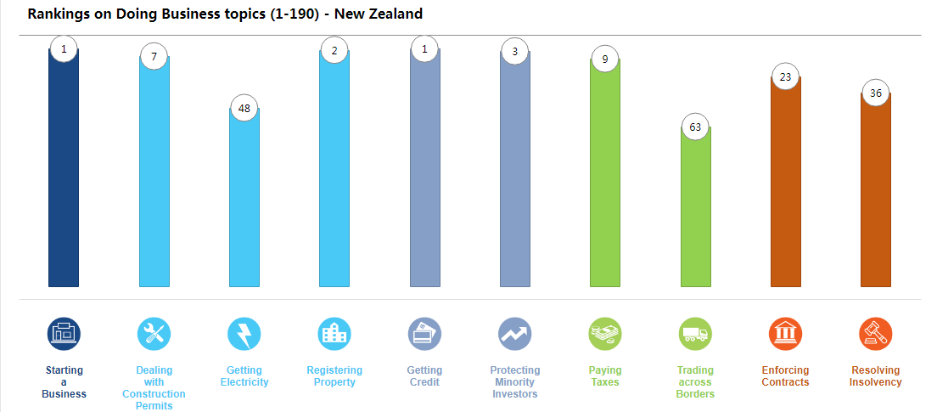
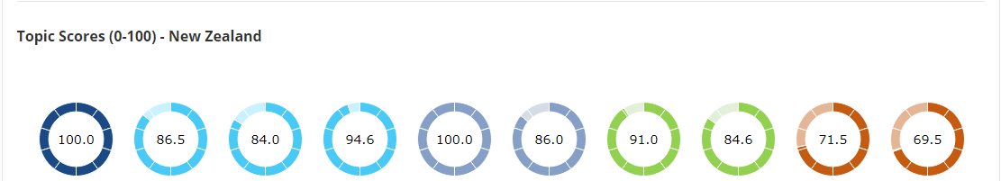
FIGURE 3-4 NEW ZEALAND’S RANKINGS AND SCORES ON DOING BUSINESS TOPICS
Source: World Bank (2019)

3.3.2 Challenges and Potential Failures

Language barriers. On the one hand, even though English is a language spoken by over 95% population in New Zealand, there are also still other official languages in New Zealand which are Māori and New Zealand sign language (New Zealand Immigration Concepts, 2019) which means not everyone speaks English in New Zealand. On the other hand, although both New Zealand and the UK are English speaking countries, there are also differences of their English. For example, the word ‘sweet’ generally refers to candy or is used to compliment a girl in the UK English while in New Zealand English, it is often used to express agreement to someone or something. If a UK company does not know these differences in their languages, it will be a potential barrier to their communication (Langer and Davies, 2011). Being accompanied by several skilled employees who understand their languages is regarded as an effective solution (Relocation, 2015).
Time. For one thing, the two countries belong to different time zones and hemisphere which determine the difference of their local time. The different local times may be one potential failure of communication considering they may need to communicate through phones or internet (Lawless et al., 2019). For another, since the Employment Contracts Act took effect, working time can be determined by employers and employees (New Zealand Immigration Concepts, 2019). The uncertainty working time is another challenge.
Internal cultural difference. As is known that there are different ethnic groups in New Zealand among which European New Zealanders and Māori are two main groups (Sibley et al., 2011). The two groups show their differences in many fields such as greeting ways and languages. Taking greeting as an example, European New Zealanders tend to shake hands with others while the traditional greeting custom of Māori is Hongi. Learning how to get along with Māori is necessary before a company would like to expand its business in New Zealand (Relocation, 2015). Considering Hofstede’s cultural dimension theory concentrates on cultural differences of inter-countries (Hofstede, 1980), it is too general to analyse the internal cultural differences in New Zealand. Therefore, it is a potential failure to operate business practice in New Zealand (Relocation, 2015). It is beneficial for the UK company to choose such employees who have knowledge of New Zealand culture to join the business communication (Relocation, 2015).

Conclusion

To sum up, New Zealand as a member of commonwealth shares similarities with the UK. For instance, people both speak English and they both belong to the same cultural dimensions except in the dimensions of uncertainty avoidance and long-term orientation (Hofstede, 1980). In some ways, the UK companies do not have to change their ways when communicate with New Zealanders. However, there are also differences reflected in specific fields such as language (Langer and Davies, 2011) and time (Lawless et al., 2019). To avoid potential failures, there are three specific suggestions for the UK companies to perform well in business communication with their New Zealand counterparts.
Making an appointment in advance. The two countries are different not only in local time but also in holiday time. Because time is significant in business communication (Lawless et al., 2019), it is feasible to make an appointment in advance. Moreover, it is also a kind of respect to their culture (Commisceo Global, 2019).
Being accompanied by trusted internal employees who have knowledge of their local languages. In case of the negotiation representative of counterpart is a Māori speaker or someone who uses local slangs (Langer and Davies, 2011), finding several trusted employees who understand their languages together can avoid potential failures (Relocation, 2015).
Avoiding talking about private issues. To show the respect of local culture, it is better not to talk about private topics with New Zealand counterparts (Relocation, 2015). However, some topics like weather are expected to talk to release stressful atmosphere (Martin and Chaney, 2012).

Bibliography

BNZBA (2019) About BNZBA. [Online] Available at: https://www.bnzba.co.nz/about-us (Accessed: 26 December 2019).
Commisceo Global (2019). British Culture, Customs, Business Practices & Etiquette. [Online] Available at: https://www.commisceo-global.com/resources/country-guides/uk-guide (Accessed: 15 December 2019).
Commisceo Global (2019). New Zealand - Culture, Etiquette and Customs. [Online] Available at: https://www.commisceo-global.com/resources/country-guides/new-zealand-guide (Accessed: 15 December 2019).
Cultural Atlas, (2019). New Zealand culture. [Online]. Available at: https://culturalatlas.sbs.com.au/new-zealand-culture/new-zealand-culture-etiquette#new-zealand-culture-etiquette (Accessed: 15 December, 2019).
Giftypedia (2009). New Zealand gift giving customs. [Online]. Available at: http://www.giftypedia.com/New_Zealand_Gift_Giving_Customs (Accessed: 15 December 2019).
Giftypedia (2013). England Gift Giving Customs. [Online]. Available at: http://www.giftypedia.com/England_Gift_Giving_Customs (Accessed: 15 December 2019).
Hall E. T., (1976) Beyond Culture. Anchor.
Hofstede, G., (1980) Culture's Consequences: International Differences in Work-Related Values. Beverly Hills, CA Sage.
Hofstede, G.J., Minkov, M. (2010) Cultures and Organizations: Software of the Mind. Revised and Expanded third ed.. McGraw-Hill USA, New York.
Hofstede Insights (2019) Country Comparison. [Online] Available at: https://www.hofstede-insights.com/country-comparison/new-zealand,the-uk/ (Accessed: 14 December 2019)
Huang L. (2010) Cross-cultural Communication in Business Negotiations. International Journal of Economics and Finance. 2(2). pp. 196-199.
Kreiser, P.M., Marino, L.D., Dickson, P., Weaver, K.M. (2010) Cultural influences on entrepreneurial orientation: the impact of national culture on risk taking and rroactiveness in SMEs. Enterpren. Theor. Pract. 34, 959–983.
Langer N. and Davies W. (2011) Linguistic Purism in the Germanic Languages. Walter de Gruyter.
Lawless M. T., Archibald M. M., Ambagtsheer R. C., Kitson A. L. (2019) Factors influencing communication about frailty in primary care: A scoping review. Patient Education and Counselling.
Martin J.S. and Chaney L.H. (2012) Global business etiquette: A guide to international communication and customs. Westport, Conn: Praeger Publishers
Mclntosh A. J. (2004) Tourists’ appreciation of Maori culture in New Zealand. Tourism Management. 25(1). pp. 1-15.
New Zealand Immigration Concepts, (2019). English and the official languages in New Zealand. [Online]. Available at: https://www.new-zealand-immigration.com/migrate-to-new-zealand/language/ (Accessed: 26 December 2019).
Relocation S. F., (2015) Living in New Zealand and Maori culture. [Online] Available at: https://www.santaferelo.com/en/moving/news-and-blog/living-in-new-zealand-and-maori-culture/ (Accessed: 26 December 2019).
Sibley C. G., Stewart K., Houkamau C., Manuela S., Perry R., Wootton L. W., Harding J. F., Zhang Y., Sengupta N., Robertson A., Hoverd W. J., Newman T. W., Asbrock F. (2011) Ethnic Group Stereotypes in New Zealand. New Zealand Journal of Psychology. 40(2). pp. 25-36.
Transparency International (2018) Corruption Perceptions Index 2012. [Online] Available at: https://www.transparency.org/cpi2012/results (Accessed: 26 December 2019).
Unilever (2019) About Unilever. [Online] Available at: https://www.unilever.com/about/who-we-are/about-Unilever/ (Accessed: 26 December 2019).
Unilever (2018). Building a gender equal business in Australia and New Zealand. [Online] Available at: https://www.unilever.com.au/sustainable-living/latest-progress-in-australia-and-new-zealand/enhancing-livelihoods/building-a-gender-equal-business.html (Accessed: 26 December 2019).
Unilever (2017). Unilever New Zealand Limited Annual report For the year ended 31 December 2017. [Online] Available at: http://reportingnz.org/wp-content/uploads/2018/07/175-Unilever-New-Zealand-Limited-AR-SEARCHABLE.pdf (Accessed: 26 December 2019).
Woolworths (2020) Our company. [Online] Available at:
https://www.woolworthsnz.co.nz/our-company/our-history (Accessed: 16 January 2020).
World Bank (2019) Doing Business. [Online] Available at: https://www.doingbusiness.org/en/data/exploreeconomies/new-zealand/#DB_gc (Accessed: 26 December, 2019).

