Student Name: Maria Mihaela Avram
Student Number: 1809524
Module Title: Introducing the Modern Workplace
Module Code: LCBB4003
Module Lecturer’s Name: Anupam Mazumdar
Assignment Title: Kellogg’s

Table of Contents
Introduction 3
Organizational overview (Kellogg's) 4
The concept of leadership and its functions in organizations 6
The usage of various leadership and management theories at Kellogg's 8
Maslow’s Hierarchy of needs 9
Analysis of the effects of organizational structure, culture and employee performance on Kellogg’s performance and their loopholes 10
Conclusion 12
Reference List 13

Introduction
In today’s world, the importance of cultural practices in all sorts of human endeavour is quite evident. Culture generally influences the perception of an individual about life. In the modern era, the effect of culture has also extended to the performance level of business organizations. For organizations, the term ‘culture’ refers to the business culture followed in that company which impacts directly to the productivity of that organization. Apart from culture, the organizational structure and the quality of employees also influence the overall performance level of that company. In this report, all of these factors such as organizational structure, culture and the quality of employees have been described and their effects on the organizational performance have also been analyzed. This report contains a brief overview of Kellogg's and a detailed discussion about the structure and culture followed in that organization along with their impacts and also the employee status and its worth. The various functions of leadership and management has also been explored with reference to Kellogg's and has been backed up by several theories and models. The necessity of employee satisfaction has also been discussed along with its application in Kellogg's company with the support of Maslow’s hierarchy. This report also describes the various aspects of business culture followed in Kellogg's company with the support of Edgar Schein model and the effects of all of these factors towards the improvement of Kellogg's productivity. The loopholes of these factors with regards to Kellogg's have also been highlighted and certain areas of improvements have been recommended.

Organizational overview (Kellogg's)
Kellogg's is a famous name in the food industry which started its journey in 1990’s as the Sanitary food company, being founded by the brothers W.K. Kellogg and Dr. John H. Kellogg. It has its headquarter in Battle Creek, Michigan, United States and manufactures cereal and convenience foods such as cookies, crackers, frozen foods and toaster pastries. Kellogg's markets its product portfolio with the brand names such as Corn Flakes, Keebler, Pringles, Eggo, Cheez-it, Nutrigain, Murray and many more. The company has its manufacturing units in 17 different countries and markets them in more than 180 countries. The total number of employees of Kellogg's is 32.944 as per 2017 data. The revenue generated by the company is 1292.3 crores USD as per 2017 data (Sethi and Bafna, 2018). Organizational structure helps to decide the flow of information between various levels within the company. Businesses irrespective of their shapes and sizes use organizational structures on a heavy note (Winnubst, 2017). They generally follow a decentralized hierarchy within the organization which delegates the daily operations and decision making responsibilities from top management to the middle and lower level of management (Ashkenas et al., 2015) This structure ensures relieving of burden from any one level, con firms efficient decision making and prepare the employees to face any adverse situations. An image of the organizational structure of Kellogg’s company is mentioned below to understand the roles of various levels:
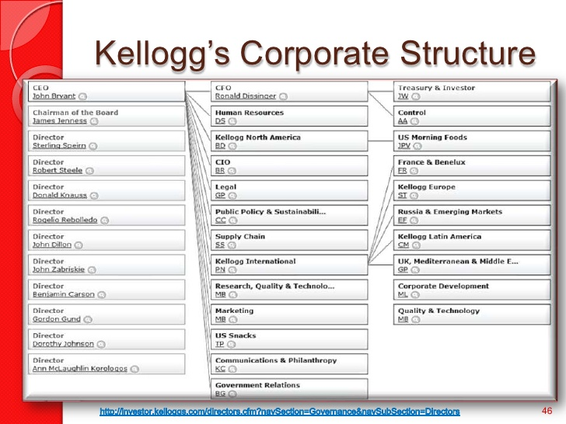
Fig 1: Corporate Culture of Kellog’s
(Source: Winnubst, 2017)
The term ‘Organizational culture’ refers to the various beliefs, assumptions, values and ways of interaction that are prevalent within the organization which develop an unique psychological and social environment within that organization (Hogan and Coote, 2014). Organizational culture encompasses the various beliefs, expectations, philosophies attitudes, written and unwritten rules, vision, values, norms, systems, symbols, language, assumptions and many more. On a simpler note, organizational culture refers to the norms which an organization follows to conduct its business, to treat its employees, consumers and the wider community. It also highlights the level of freedom allowed to the employees towards decision making and idea sharing. Kellogg’s company follows some specific corporate culture in their organization such as having a clear vision to enrich and delight the world through food and brands that matter. They also operate under a mission which is to nourish families so that the company can flourish and thrive due to which they have made their slogan accordingly which is ‘loved by kids, approved by mums’. Kellogg’s evaluates their performance on two matrices which are sustainable growth and investments and also focus on the career development of their employees heavily by offering them several growth opportunities.
Organizational performance includes the thorough analysis of the organization’s progress against the goals and objectives of the company. It involves the real time comparison between the inputs provided and the outputs received. Organizational performance is generally measured on three areas which are financial performance, market performance and shareholder value performance. The performance of Kellogg’s company in the market for last couple of years is quite impressive. The company has achieved $28M in water and cost savings in their manufacturing sites from 2005 to 2015. 15200 smallholder farmers and 10,000 women has been supported through Kellogg’s programs from 2014-2014, 68% waste reduction has been reported by the company from 2005 to 2014. The company holds a strong performance in the market having 52% of the market share in snacks division which has grew from a lower percentage of 25% between 2000 and 2015 (Kelloggcompany.com., 2019).
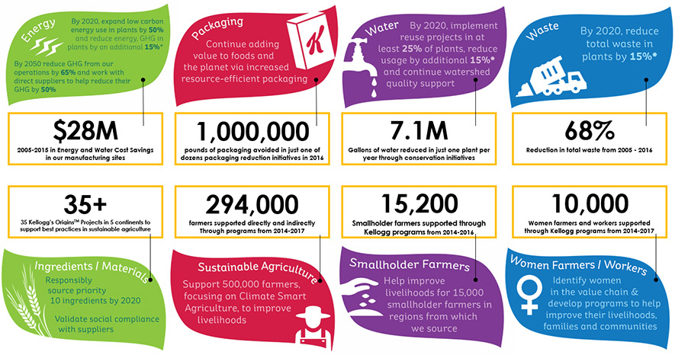
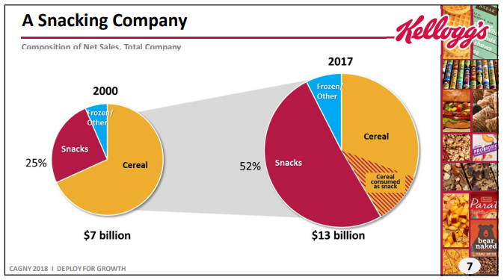
Fig 2: The performance of Kellog’s
(Source: Kelloggcompany.com., 2019).

The concept of leadership and its functions in organizations
The term leadership mainly highlights the ability of an individual to lead or direct an individual or a group of people to achieve a common goal or objective by developing, explaining and motivating all the members about a clear vision (Daft, 2014). It is an important element to direct the functions of the management and has several functions which are mentioned below:
- Setting Goals for the team members
- Organising the available resources and distribute it equally within the members
- Co-coordinating with all the team members properly
- Directing and motivating the members to perform well
- Linking between management and the workers for the proper cascading of the information (Cronin et.al., 2015)
- Adaptable to variations to perform under challenges
Management refers to the whole process of planning, organising, and co-coordinating the entire activities of a business organization to achieve the organization’s mission, vision and goal set by the leader, within a given time period (Laudon and Laudon, 2016). The different functions of management are as follows:
Planning
The most important job of any manager is planning which involves setting the vision and mission statement of the organization, deciding about the company strategies, goals and objectives.
Organizing
The term organizing refers to the management of the whole organizational structure according to which the entire organization operates on daily basis. It involves reconciling all the available resources to achieve the goals and objective which are already set.
Controlling
It is another vital job of a manager to ensure whether any particular job or the entire operational activities of the organization is going in the right direction or not. It includes continuous monitoring of the functions of different organizational levels and take corrective actions if any loophole is identified. This function also encompasses the regular assessment of performance level of the employees to correct and increase their output.
Directing
This job of a manager helps to inform the employees about their individual goals and guide them to achieve those goals in order to achieve the company’s goals and objectives.

Both the terms leadership and management has been described below with the support of various theories along with their implications in the Kellogg’s company:
Path goal theory for the leaders
The path goal theory refers to the unique style or behaviour of leaders that suits highly with the employees and work environment of the organization in order to achieve the company goal. The style includes motivating the employees, empowering them and offering them job satisfaction so that they become more productive (Malik et al., 2014).
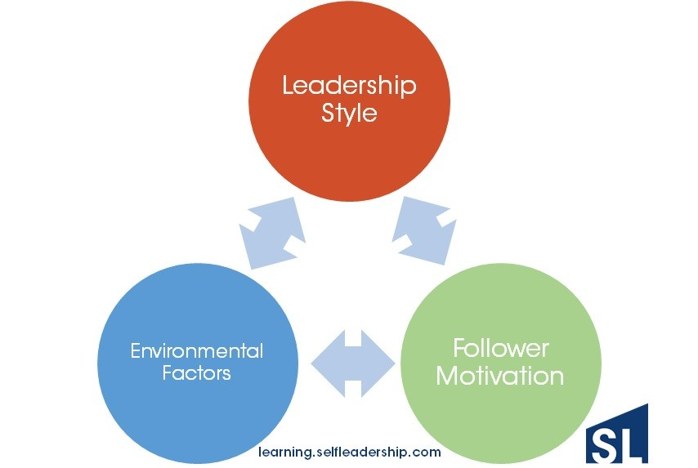
Fig 3: The interrelationship between the leadership styles, employee motivation and the business environmental factors
(Source: Malik et al., 2014)

The usage of various leadership and management theories at Kellogg's
The path goal theory for the leaders highlights the importance of unique leadership styles for the betterment of the organization. In Kellogg’s the management puts their main focus on the people not the results which helps to extract the best skills from their employees and use them to maximize the company’s productivity. The management also puts a lot emphasis on teaching, grooming, correcting the employees and maintains human element in all of their operations.
Situational theory emphasize on the activities adopted by the leaders to face and overcome different complex business situations or challenges. For example, the leadership and management styles adopted by Kellogg’s while hiring a new employee is autocratic and persuasive which is instructing the employee about the company operations, structure, culture and others. The company follows democratic leadership style at the time of facing market challenges when the leaders accepts the decisions and opinions from the team members. Kellogg’s follow a coaching leadership style and Laissez-faire management style while guiding any employee through their personal development programs.
The behavioural theory at the same time highlights the importance of studying the behaviours of the individual employees. In Kellogg’s lot of motivating factors are maintained for the employees such as the employees are offered attractive salary which is competitive in nature and are also provided with incentives such as childcare vouchers, alternatives to cash, company cars for or discounted schemes of life insurance etc. This manipulates the employees to stay loyal to the company.

Maslow’s Hierarchy of needs
The term need refers to the necessity of a living being to live life in a healthy way. There are various sorts of need such as need of a consumer to purchase goods which are value for money, need of an organization to run in the market successfully, need of an employee to work under a satisfactory environment etc. Now, the need of an employee can include several layers. There is an established theory made by Maslow describes the various layers of employee needs through a hierarchy or a pyramid each level of which highlights certain attributes. The bottom of the pyramid indicates the physiological needs of the employees such as need for food cloths and warmth and other basic instincts. On top of that lays the level referring to the safety needs of the employees such as shelter etc. The level above the safety needs indicates the needs of the employees for their belongings, loved ones and relationship. The next higher level expresses the esteem needs of the employees such as status or prestige and accomplishments (Cherry, 2014). The top level refers to the self-actualization needs which includes the needs of the employees for self fulfillment, personal growth etc. A schematic diagram of the Maslow’s hierarchy, is given below:-
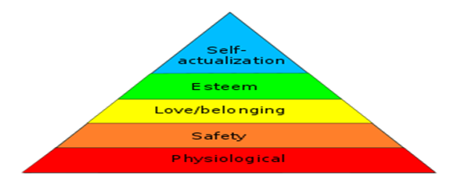
Fig 7: Maslow’s Hierarchy of Needs
(Source: Cherry, 2014)
In Kellogg’s the Maslow’s hierarchy is followed to understand all possible needs of their employees and also addressed on a stricter note to keep them satisfied with their job roles. Kellogg’s offer competitive salary, childcare vouchers etc. to accomplish the physiological needs of their employees. They value the safety of their employees and offer a safe environment to all their employees across the globe to fulfill their safety needs. Kellogg’s organizes weekly ‘Group Hurdles’ to which is an informal way of interaction for the employees to receive and request information on any part of the business. The company offers various rewards to the employees on regular intervals for their achievements and thus providing them a feeling of prestige and accomplishments. Kellogg’s also tries to fulfill the need of self fulfillment of their employees by allowing them to take ownership of business projects or opportunities offered to them.

Analysis of the effects of organizational structure, culture and employee performance on Kellogg’s performance and their loopholes
The organizational structure, various cultural aspects prevalent in the company and the performance level of their employees are helping the company to proceed towards growth. Still there are certain areas where the company needs improvement in terms of structure, culture and management of employee’s performance level. Development opportunities are offered to the employees that involve long working hours which might result in high attrition rate. So the company should take supportive actions to maintain work/life balance. More emphasis should be given on training and development of the employees to make them competitive in nature and much more productive.

Conclusion
The terms organizational culture, employee performance and organizational structure all cumulatively contribute towards the improvement of the organization’s productivity. They help to create the brand image, shapes the way employees interact at the workplace, offers guidance regarding specific human resource issues like managerial authority etc. Proper understanding of the organizational culture among the employees and its strict maintenance across all levels of the organization’s structure, will result in the maximum utilization of the employee’s skills and experiences. In Kellogg’s strong leadership styles are applied and empathetic approaches are followed towards fulfilling employee needs and addressing employee beliefs and assumptions to maintain a healthy business environment in their organization.

References
Ashkenas, R., Ulrich, D., Jick, T. and Kerr, S., 2015. The boundaryless organization: Breaking the chains of organizational structure. John Wiley & Sons.
Cherry, K., 2014. Hierarchy of needs. Retrieved Aug, 16, p.2014.
Cronin, L.D., Arthur, C.A., Hardy, J. and Callow, N., 2015. Transformational leadership and task cohesion in sport: The mediating role of inside sacrifice. Journal of sport and exercise psychology, 37(1), pp.23-36.
Daft, R.L., 2014. The leadership experience. Cengage Learning.
Davis, R., Campbell, R., Hildon, Z., Hobbs, L. and Michie, S., 2015. Theories of behaviour and behaviour change across the social and behavioural sciences: a scoping review. Health psychology review, 9(3), pp.323-344.
Hogan, S.J. and Coote, L.V., 2014. Organizational culture, innovation, and performance: A test of Schein's model. Journal of Business Research, 67(8), pp.1609-1621.
Kelloggcompany.com. (2019). [online] Available at: https://www.kelloggcompany.com/en_US/home.html [Accessed 4 Apr. 2019].
Laudon, K.C. and Laudon, J.P., 2016. Management information system. Pearson Education India.
Malik, S.H., Aziz, S. and Hassan, H., 2014. Leadership behavior and acceptance of leaders by subordinates: Application of path goal theory in telecom sector. International Journal of Trade, Economics and Finance, 5(2), p.170.
Sethi, R. and Bafna, P., 2018. A case study on ipr infringement: Kellogg's company V/S national biscuit company. ZENITH International Journal of Multidisciplinary Research, 8(7), pp.339-342.
Winnubst, J., 2017. Organizational structure, social support, and burnout. In Professional burnout (pp. 151-162). Routledge.

