FEDERICA GIOCOLI

2121746

Assessment 1

Human Resource Management LCMB7000

Impact of internal and external HR practices on organization productivity

Luxottica case of study

Table of Contents
1
Introduction 3
Brexit and abolition of the integrated European market 3
After Brexit and the labour market in the UK that impacted Luxottica Group 5
Brexit, open trade and labour mobility 6
Factors for adopting New forms of Human Resourcing 7
Monitoring UK legislation 8
The dilemma of adopting a policy to become efficient 9
Framework for hiring and training 9
Conclusion 10
References 12

Introduction
The winds of change were visible in the labour market when in 2019 Brexit had captured the attention of everyone. Firms in the United Kingdom were deeply engaged in remodelling their contingency plans following the passing of Brexit, then came the disruptions wrought by the novel coronavirus which impacted all the sectors and created a daunting task for remodelling. The Brexit and the disruption by COVID 19 created a favourable situation for change in the Labour Market because the end of the Brexit transition meant that the UK business had to muster themselves to find footing in a new voyage of international trade. This led to a fundamental change in small and large British firms to become competitive at home and in the international market. Then when COVID 19 engulfed the whole of the UK, the economy the UK found itself grappling with the hesitancy to repent the economy during the lockdown. These challenges were unprecedented and put insurmountable pressure on the turbulent labour market to adopt the new practice and adopt new working conditions. When there was a change in labour market conditions, the demand for labour also changed or the labour available also changed such as skilled labour and labour with insufficient knowledge or experience. This condition demanded to closely inspect the Human Resource available in the market for Luxottica groups, who are best known for the quality eyewear glasses worldwide. Luxottica saw the need to improvise the plight which was a consequence of Brexit, which led them to mend their Human Resourcing strategy.

Brexit and abolition of the integrated European market
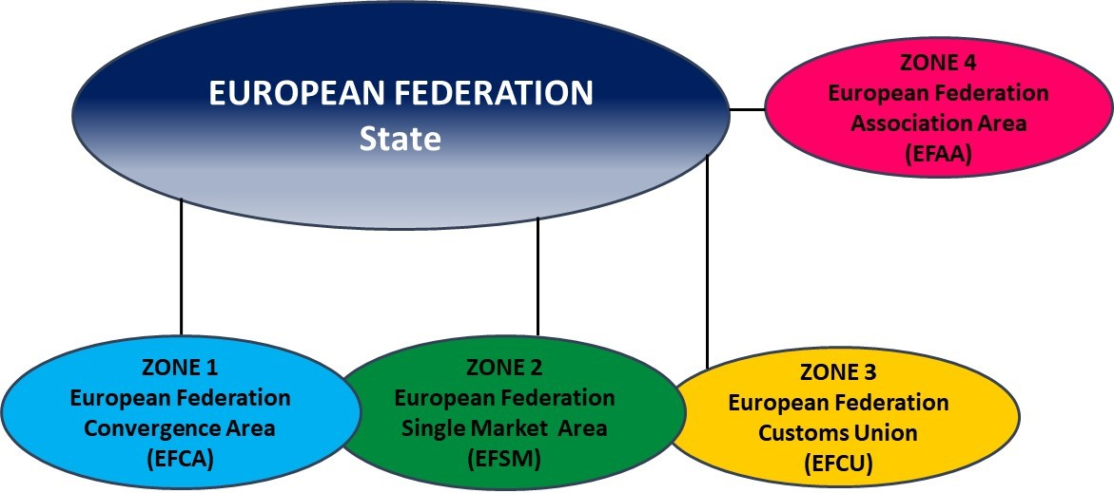
Fig: European federation during Brexit
Citation: Javorcik et al., 2020
The integration of the European Union is the most integrated market in the world. The clause under the Single Market law allowed any business firm authorized by one of the Member states to operate in any of the members of the EU without facing any barriers by the system known as “passportorting”. So the Brexit of the UK means that the UK lost its “passport”. The United Kingdom Government’s White Paper, which was published on 12th July 2018 removed all the mutual recognition but it offered an option of “equivalence”. Equivalence will allow EU and UK business firms to carry out certain activities across borders which will underpin the activities that were deemed to gain comparable outcomes. This has led to the restrictions on the free labour movement in the UK labour market, it also impacted foreign investment and trade flow in the UK's economy. There was also a freeze in hiring and online jobs advertisement fell to 1.5 million which was the result of a fall in business confidence. If Equivalence is revoked by any of the parties, the UK will be a third world country in the eyes of the EU (Javorcik et al., 2020).
In the past two decades, there was an increase in the share of European Union nationals up to 6.3% who were more educated and liked to work more than natives of the Uk. This indicated that the immigrant had a positive impact on the labour market and the economy as one research shows that EU nationals tend to pay more taxes. And According to the UK Labour Force Survey, EU nationals with low technical skills tend to cluster in low technical manufacturing who work in the industry and manufacturing sector. After Brexit, there was a huge gap that opened up in low technical skills jobs in the UK which was detrimental for the Luxottica Group and severely impacted the Luxottica Group in the UK and Europe (Javorcik et al., 2020).

After Brexit and the labour market in the UK that impacted Luxottica Group
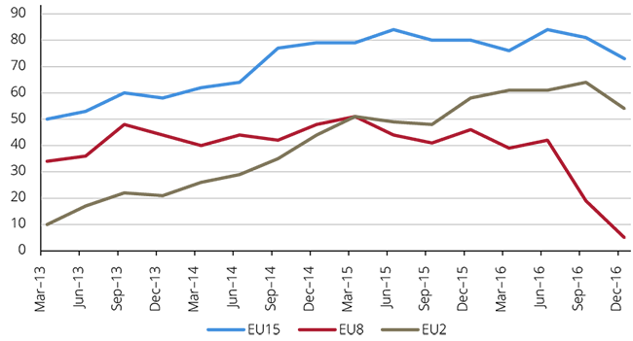
Fig: Labour market and Brexit
Citation:Wadsworth 2018
The number of EU nationals has dropped after Brexit. Some theories suggest that it has a positive aspect as there will be the employment of native population and overall effect on wages of native. But there is a theory that cautions by claiming that it can have a diverse effect on the quality of native labour. After Brexit, the deficiency of EU nationals has led to the development of a particular type of market where skilled native conditions are worsening and low skilled native conditioning improving as they are bagging good money. This situation, where foreign labour is not available for hiring and has led to the situation where natives with low skills are hired. Since the labour is not sufficient Luxottica Groups are financially burdened by paying the wages without the quality of the product being produced in the UK (Wadsworth 2018).
Adding salt to the injury is the impact of political threat and legal economy for the labour market of the Brexit. Until Brexit, the UK was obliged to maintain the legality of the Occupational Safety and Health (OSH) regime which was in tune with the EU OSH Law. From the legal perspective, OSH is the first legal effect of the separation. The law will not legitimately be relied upon for the health and safety standards of workers. Luxottica has a wide chain that is spread across Europe and the health and safety standards of the company are based on the OSH regime. Brexit has made it difficult for companies to operate on the same line as their other infrastructure which is situated in the UK as they have to frame new policies to regulate the safety and health of the workers. There was a European Union Withdrawal bill that was passed in the parliament and repealed the UK European Communities Act 1972 (Simionescu et al., 2017). The bill was aimed to sever all the legal ties of legislative jurisdiction of the EU and set up various rules post-Brexit, transpose the rules that applied to the UK and the most important of them bestow the law-making power to the UK Government. The great political effect on the labour market came due to the bipolar position of the Labour Party in the UK. When this all transpired Luxocitta had to adopt different sets of policies for the labour market which added great difficulty to the working of the Luxottica (Wadsworth 2018).

Brexit, open trade and labour mobility
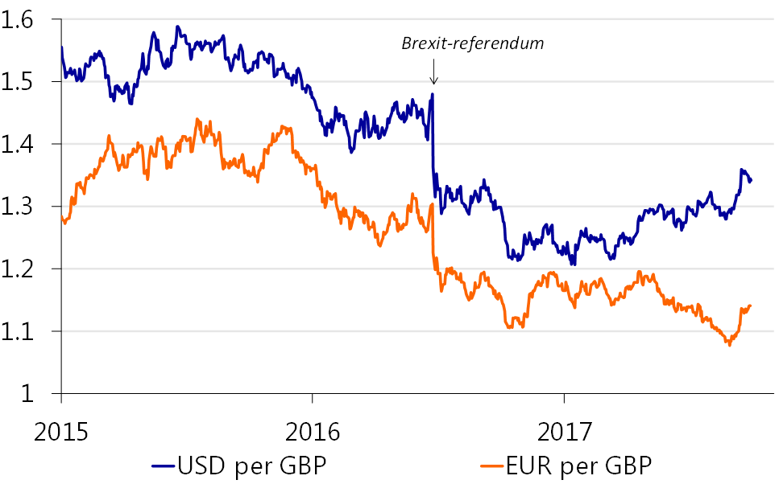
Fig: Economic impact of Brexit
Citation: Griffith et al., 2021
Economic theory states that the movement of production factors will allow better allocation of resources at the global level which will lead to an increase in welfare. The same applies to the capital setup also where labour mobility is sensitive due to policies that restrict the migration of labour. Endogenous growth theory gives us the perspective that liberal trade will generate more benefits for the industries which will give a handy competitive edge to the company (Griffith et al., 2021). This theory also proves that the pace with which an economy can grow will also attain specialization, henceforth will lead to the reduction of production cost. And noted that the countries with very high levels of open trade facilities will promote a potential to explore technological innovation, which will determine the status of the company. These two theories point toward the shrouded effect of Brexit on the Labour Market and its relation to the development of the company. The movement of production which is linked with the trade will affect the mobility of products along with labour. The twin factors of restriction of mobility of labour and production have already taken their toll on Luxottica which is being impacted due to the restrictions imposed on imports (Griffith et al., 2021). The new law restrictions on imports have saturated Luxottica based in the UK as and there is a lack of innovation to rise to the daunting task. The other factor of labour has been burdening them with the lack of specialization available in the UK market while looking for a human resource which has led them to adopt, test and modify the human resourcing strategies due to the change in the trend of Human Resource.

Factors for adopting New forms of Human Resourcing
For the Luxottica Human Resourcing team, there was a daunting task to come up with new strategies to tackle the problems presented by Brexit. But they were able to rise to the occasion. The official Brexit of the UK from the European Union on 31st January 2020, but the ground for Brexit was prepared in 2016 when the UK went for a referendum for Brexit (Davenport and Levell, 2022). Since the referendum dilemma prevailed amongst the human resourcing team of Luxottica who were monitoring the situation as it unfolded because their human resources were somewhat reliant on the European Union in the UK. Brexit has created tantrums due to volatility of the market which had impacted Luxottica finance as the cost of conducting business with the EU had become expensive due to the introduction of new trade deals. The questions that the Human Resource had to ask again and again were How to organize Luxottica in line with the new reality and How to navigate the landscape post Brexit?

Monitoring UK legislation
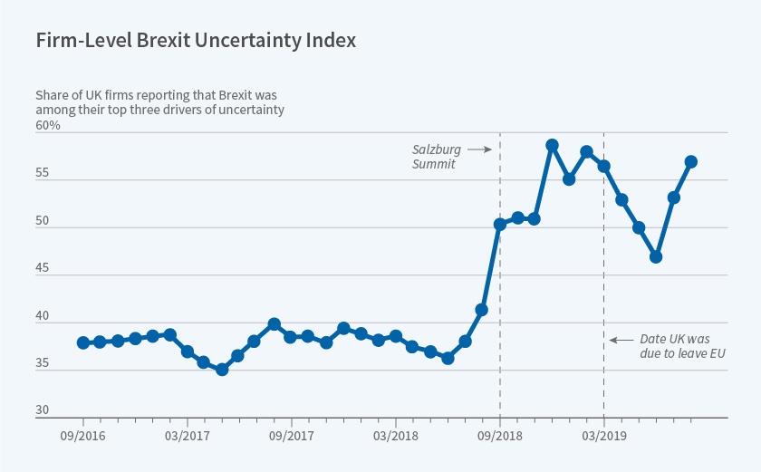
Fig: Brexit uncertainty index
Citation: Ridgway, 2019
The Human Resourcing team was closely monitoring the legislation of the UK as it seemed inevitable that all the laws of the UK which had their basis in European Union legislation would be discarded and the Government were willing to make laws related to immigration. The major turn of events post World War II in the UK was the referendum to leave the European Union and the single integrated market it offered (Ridgway, 2019). The majority of the population wanted to leave the European Union as they felt that they were being impacted by the immigrants from the European Union in a negative aspect. The Government was ousted and a new Government who has a pro-Brexit view came to power. This referendum is the new dawn for the economy of the UK. The new Government was very enthusiastic about introducing new legislation that will abort the European Union laws. So the Human Resource had to equip themselves with the new reality and the aspirations of the people who were against the immigrants working in the UK (Ridgway, 2019). This made Human Resources conclude that they should limit their reliability on the immigrants and instead frame a new policy to recruit native people. But the problem did not end there, the main area of concern for Human resources was the efficiency of the native worker in the Luxottica business set-up.

The dilemma of adopting a policy to become efficient
Brexit created many hurdles for recruiting foreign nationals, this citation became cumbersome as companies began to face problems with the employees of the company who were citizens outside of the UK. Many immigrant employees were disheartened and preferred to return to their home soil, they faced an influx of immigrants leaving the company for home, this happened due to legal challenges that they were encountering with the passing of each day post-Brexit (Czubińska et al., 2018). This situation perplexed us as many natives were not skilful in the art of making eyewear glasses and were not familiar with Luxottica's business model. The Human Resource took many drastic steps to improve the hiring of the native population with proper analysis of the situation (Broad and Turnbull, 2019). The Human Resource through thoro analysis found the effects of Brexit on the Labour Market European Union. They found a footing in hiring a quality worker as the Labour market in the European Union was also impacted by Brexit, it gave hope and aspirations to the Human Resource of Luxottica. They found that the labour outside of the UK who were native to the UK were returning as they were facing challenges in European Companies. The returning labourers were skilled, they were returning and they needed a Visa to continue their work (French, 2018). The Silver lining in the cloud for the Human Resource helped them to recuperate from the illness of Brexit. The Human Resource of Luxottica formulated a systematic approach to hiring all the people who were returning to the UK that were related to the field that they specialized in, i.e eyewear glasses. They made a systematic framework that will notify the labour on their returning voyage.

Framework for hiring and training
The Silver lining that was visibly needed to be grasped properly so that the potential it possesses cannot be shattered into the ground. The Human Resource of Luxottica made a daring strategy to promote the vacancy that they have to recruit native people. Their first strategy was to advertise using banners in the airport in the UK where all the returnees will land and can avail themselves of an opportunity to look at the jobs that Luxottica provided. They also adopted other means of advertisement and expected people to join their company. The advertisement paid off and floods of CVs rolled in, but this created another major problem in scanning every CV and considering eligible candidates. This ended the misery of not being able to hire staff. But considerable vaccines were left unfilled (Jallow et al., 2021). The next strategy that Human Resources adopted was to train the native population after hiring. The training of the native population added a tremendous financial burden for Luxottica who were facing the wrath of COVID 19. The insurmountable challenges were on the verge of ending then came the pandemic which prompted the Human Resource to mend and change the strategy. COVID possessed new avenues of challenge where the main arsenal to counter plight was hit hard. There was tremendous pressure on the economy of the UK which was a result of both Brexit and COVID19. The lockdowns hit the economy hard. Despite all the challenges presented by COVID19 and Brexit, Luxottica was able to stand tall due to the quality of the Human Resource team it possessed. As they formulated the adoption of the latest technology and practised new forms of working conditions such as work form and installation of automated machines (Jallow et al., 2021).

Conclusion
The wave of change brought forth by the dual challenge of Brexit and Covid 19 on the labour market swept the way for changes. There was a considerable strain on the remodelling of the policies in tune with the challenges possessed by Brexit. There was a period of uncertainty when a referendum was voted for the exit of the UK from the European Union. It led to the abolition of the integrated market with the UK, which formed a separate market entity for the UK. Abolition of the integrated market affected the number of immigrants coming from other EU nations which had a deep impact on the UK's economy and created vacancy. The positive aspect of Brexit lies in the fact that the native labour market boomed with a demand for labour to fill the vacancy but this posed a challenge to Luxottica as skilled native people were not sufficient which burdened them financially and compromised the quality of their product. The laws of the UK which were based on the EU were also abolished by the enthusiast UK Government who were willing to legislate new laws on immigration. The new legislation added misery to Luxottica as they used to follow a framework along the lines of the European Union, now tasked to compile the new legislation of the UK and adopt the new policy. Brexit challenges the human resource person of Luxottica as they had to abide by the new public opinion of the Uk and oblige by the new laws. Though the challenges were daunting through labour market analysis of the EU, some hope was found when they looked into the market. The hopes were potential for their success and the Human Resource team delivered a masterstroke by utilizing the constitution of the market.

References
Broad, R. and Turnbull, N., 2019. From human trafficking to modern slavery: the development of anti-trafficking policy in the UK. European Journal on Criminal Policy and Research, 25(2), pp.119-133.
Czubińska, G., Łużniak-Piecha, M., Golińska, A. and Kulczyk, J., 2018. Should we stay or should we go? Poles in the UK during Brexit. Brexit and Polonia: Challenges facing the Polish Community during the process of Britain leaving the European Union, p.83.
Davenport, A., and Levell, P., 2022. Brexit and labour market inequalities: potential spatial and occupational impacts. Oxford Review of Economic Policy, 38(1), 50-67.
French, S., 2018. Between globalisation and Brexit: Migration, pay and the road to modern slavery in the UK hospitality industry. Research in Hospitality Management, 8(1), pp.23-31.
Griffith, R., Levell, P. and Norris Keiller, A., 2021. Potential Consequences of Post‐Brexit Trade Barriers for Earnings Inequality in the UK. Economica, 88(352), pp.839-862.
Jallow, O., Fanani, Z. and Hamidah, H., 2021. British-Qualified Accountants Outside the UK: Post-Brexit Case. Jurnal Ilmiah Akuntansi dan Bisnis, 16(1), pp.163-172.
Javorcik, B., Stapleton, K., Kett, B. and O’Kane, L., 2020. Unravelling deep integration: Local labour market effects of the brexit vote. CEPR Discussion Paper.
Ridgway, M., 2019. Brexit: human resourcing implications. Employee Relations: The International Journal.
Simionescu, M., Strielkowski, W. and Kalyugina, S., 2017. The impact of Brexit on labour migration and labour markets in the United Kingdom and the EU. Terra Economicus, 15(1), pp.148-156.
Wadsworth, J. 2018. Off EU go? Brexit, the UK labour market and immigration. Fiscal Studies, 39(4), 625-649.

