

The Merits and Defects of Mobike within M-Commerce

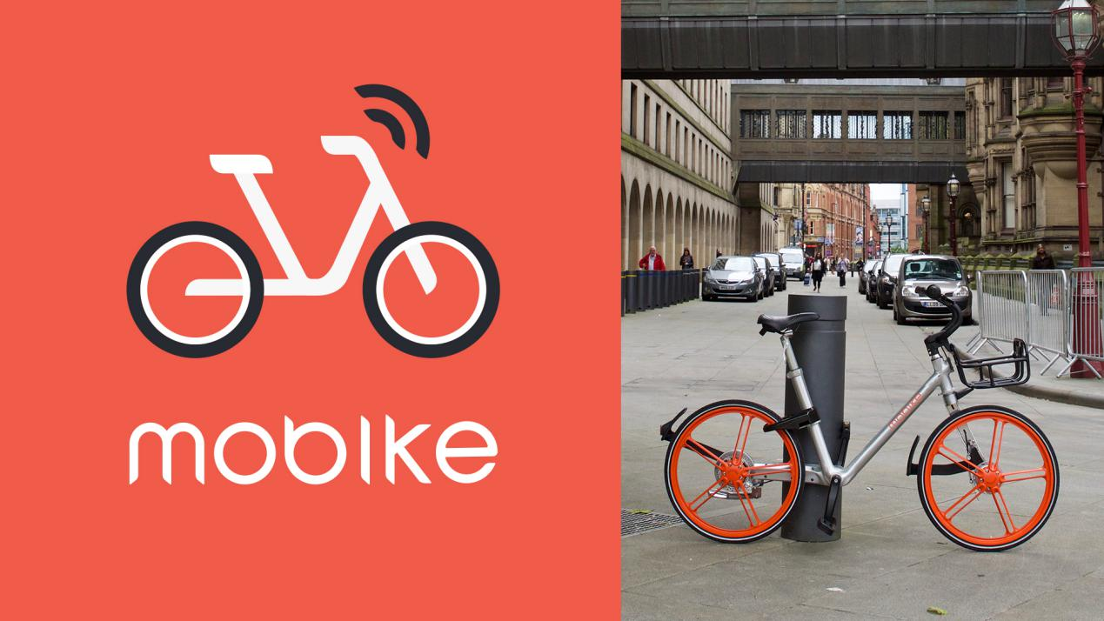

Author: Sisi Chen (1601522)
Submission Date: 15th January 2018
Commissioned By: Chris Thomas
Word Count: 3269 words
Table of Content
Executive Summary…………………………………………………… 2
1.0 Introduction………………………………………………………… 3
1.1 Objectives…………………………………………………………. 3
1.2 The Definition of m-Commerce…………………………………… 3
1.3 Company Overview………………………………………………... 4
2.0 Main Findings……………………………………………………….. 4
2.1 Strategic Analysis………………………………………………….. 5
2.2 Strategy Formulation………………………………………………. 9
2.3 Strategy Implementation………………………………………….. 10
3.0 Conclusions……………………………………………………… 12
4.0 Recommendations……………………………………………….. 12
Bibliography List………………………………………………………. 13
Appendices…………………………………………………………….. 16

Executive Summary
This report is divided into four main parts, including introduction, main findings, conclusions and recommendations. From introduction chapter, the report indicates its study aims, the definition of business theme and the company view. The author chooses Mobike, a corporation provides bike sharing service as her study target due to m-commerce theme. Next, the report utilises an e-business strategy framework made by Jelassi and Enders (2008) to analyse and evaluate the benefits and limitations of Mobike in its m-business from the section of main findings. After that, in the chapter of conclusions, this report draws a conclusion for these data discussed in the main findings part. Finally, the report can give some advice for Mobike in its chapter of recommendations.

1.0 Introduction
1.1 Objectives
The aim of this report is to acquire Mobike’s development and implementation in M-Commerce theme through analysing the advantages and disadvantages of this corporation. Additionally, the report indicates that how these figures focus on the strategy.
1.2 The Definition of M-Commerce
Figure 1: The Relationship between E-Business, E-Commerce and M-Commerce
E-business

E-commerce
M-commerce

The source: D. Chaffey, 2002, P.9
From this photo, it indicates that e-business is bigger than e-commerce and m-commerce. That means e-business is more complex than other two and both these two are specific parts in e-business. In order to have a better understand the concept of m-commerce, the e-commerce’s definition needs to be known.
According to Laudon and Traver (2010), e-commerce is “Digitally enabled commercial transactions between and among organisations and individuals.” Moreover, from the ‘Essential Internet’ of Business Source Complete (2003), it is argued that “Mobile commerce, which is widely predicted to be the next wave of e-commerce. Sometimes known as m-business, it encapsulates any kind of information transfer or transaction that can be initiated from a mobile phone or other portable information appliance device. Commonly cited examples include booking of services such as flights or other tickets, personal banking and share trades.”
1.3 Company Overview
Mobike is one of Chinese corporations and provides the bike sharing services to increase a new urban transport for short journeys. With today’s IoT (Internet of Things) technology – mobile app and smart lock system (the exclusive QR code on the bike – scan it for unlock) to achieve a cashless and station-free platform, Mobike allows its users to pick up or park its bicycles at anytime and to any legal parking destination. The mission of Mobike is to improve the quality of city life through adopting the idea of affordable shared-bike to avoid traffic congestion and reducing whole city’s carbon emission.
Mobike was established on the 27th Jan. 2015. Up to the end of the year 2016, it achieves three to four times of its initial aim – a million trips. Additionally, in just two years, the investors have put $928 into this enterprise. This action drives Mobike to stand in a leading position. Mobike is headquarterd in Beijing, China.
Here it can be seen that ‘Mobike About and FAQ’ from mobike.com and ‘Chinese Bike-Sharing Startup Mobike Has Its Eye on Expansion from wired.com (2017).
2.0 Main Findings
This chapter utilises the Jelassi and Enders (2008)’s e-business strategy framework which consists of strategic analysis (SWOT analysis), strategy formulation and strategy implementation to analyse the benefits and challenges of Mobike in m-commerce.
Figure 2: The E-business Strategy Framework
Strategic Analysis Strategy Formulation Strategy Implementation
External analysis
Strategy options
Opportunities/threats
Strengths/weaknesses
Exploring new market spaces
Sustaining competitive advantage

Internal analysis
Creating and capturing value
Interaction with users/customers
Interaction with suppliers
Internal organisation

Implementation

2.1 Strategic Analysis
Strengths:
Convenient mode of transportation for everyone
For university students, particular in non local students, Mobike’s shared-bike is a convenient and cheap transport for the short journey of city. The main reason is that buying a bicycle is expensive and storing a bicycle in the university will face the risk of losing. However, it is a necessary mode of transportation for students to go everywhere on campus (Chinese campuses and universities are big) and city. Thus, Mobike’s bike sharing is the good service for them. It cost little, RMB 1.00 or 2.00 per hour (according to different styles of bicycles). Although at the first time it requires users to pay RMB 299.00 deposit, the deposit is a refundable capital. When users do not want to ride shared-bike anymore, they can easily address and gain the refund. All these processes are completed in Mobike’s app. Additionally, Mobike puts plenty of its products into the campuses. Furthermore, users do not need to worry about the loss of bicycles. The shared-bike does not belong to everyone and can pick up and park at any place.
For the people who drink a lot after a family gathering or friends’ parties, it is a convenient and safe transport for users, users’ family and other ordinary people. In China, many traffic accidents occur due to driving under the influence. This behavior is dangerous and makes people injure, even makes them dead. The outcome is serious and also breaks people family’s heart. Nevertheless, Mobike can reduce this condition. With its app’s precise positioning, drinkers can correctly seek out shared-bike near the place where they hold their parties and then they have a safe riding to their homes. On the one hand, about drivers themselves, it is a safe and convenient way to go home. On the other hand, it is a better way to decline some severe losses for drivers and ordinary people’s families.
The source is from ‘Mobike FAQ’, mobike.com (2017).
Cooperate with most popular Chinese social media enterprise – Tencent, gain more potential consumers and finance support
Tencent Holdings Limited (Tencent) runs a series of integrated internet platforms, such as social networks, payment, entertainment, information, utilities and platform services. With similar influence like Facebook in western countries, Tencent’s social networks business is the biggest media in China. Both Tencent QQ and Wechat are Tencent’s instant messaging platforms and they own the highest usage rates. In the QQ Wallet and Wechat Wallet, customers can easily seek out the small programme about Mobike. Through clicking on that programme, the users can start to their shared-bike riding. Cooperate with Tencent, it means that Mobike owns more than 900 million potential users, a huge market share that can help it to form a dominate position in China.
Except for bringing enormous consumers, Tencent invests lots of capitals in Mobike to support Mobike’s development at every part. During the latest financing round, Mobike has raised over $ 600 million. This is the largest one in the global bike-sharing industry. Furthermore, this landmark round of financing was led by Tencent. The chairman of Tencent said he admired the Mobike’s vision and believed the future of Mobike’s prospect would be optimistic. Hence, Tencent would utilise all its resources to support Mobike.
Here it can be seen that ‘Mobike Raises Over $600 Million in Series E Financing Led by Tencent’ from mobike.com, ‘Tencent Holdings Limited’ from MarketLine.com (2017) and ‘Cooperate with Tencent, Mobike Create a New Strategy to Keep its Leading Position’ from tech.sina.com.cn.
Avoid congestion, shrink carbon footprint
Mobike’s mission is also its core strategy. If the enterprise wants to develop well, it will need not only to consider the demand of its consumers and the profit goal, but also to consider the corporate social responsibility (CSR).
Nowadays, both Chinese traffic and environment are bad. From government to ordinary people, most of people are thinking how to solve these problems. At this moment, Mobike creates a cheap and convenient bike sharing service with its app to appeal to citizens to ride bicycles instead of driving cars in order to fulfill its mission – declining traffic jam and decreasing carbon emission. This is Mobike’s CSR. Furthermore, Mobike uses many awards to evidence that its mission is not an empty word, such as WWF’s the first ‘Climate Solver Sustainable Urban Mobility Special Award’ and UN Environment’s ‘2017 Champion of Earth Award’. These prises will attract and make its users trust the quality of this company. Finally, this strategy forms the consumer loyalty. Mobike wins an award of the Most Relevant Brands in China (the outcome of a survey from 13,500 customers), placed 14th overall and 1st in the Travel and Transportation category, described as setting consumers “free from the hassles of daily commutes.”
The sources are from ‘WWF Awards Mobike ‘Climate Solver Sustainable Urban Mobility Special Award’, ‘Mobike Receives 2017 Champions of the Earth Award from UN Environment’, and ‘Mobike Ranks #14 of Most Relevant Brands in China’, mobike.com (2017).
Weaknesses:
No network, no use
It is known that m-commerce is a subset of e-commerce. Thus, m-business also needs internet to support its operation. Thus, customers’ smart phones must have a network for starting their ridings with the shared-bike of Mobike. If consumers don’t have an internet, don’t have a steady network, don’t have a signal in their mobile phones or need to charge their phones, they won’t use the shared-bike. This will make Mobike lose some potential consumers. It is a common characteristic or disadvantage for all the mobile e-commerce (Steinbock, 2008).
Opportunities:
Economic globalisation, expand overseas market
According to today’s economic tendency – economic globalization, it is a good opportunity for Mobike to expand its market into other countries to gain more profits. Moreover, expanding its market into different countries can also promote the development of Mobike’s technology due to various requests about technology in different countries. At present, Mobike has expanded to the main cities in UK, US, Germany, Italy, Australia, Netherlands, Thailand, Malaysian, Korean and Japan. For instance, when Mobike expanded to America, it began to cooperate with two corporations about professional high-tech technology, Qualcomm and AT&T, to allow its users can use their smart phones to easily locate, unlock and securely pay for their mobike journeys with AT&T’s 4G LTE connectivity and Qualcomm Technologies LTE IoT modems.
Here it can be seen that ‘Mobike powered by AT&T and Qualcomm in the US’ from mobike.com.
Threats:
Damage heavily, lost severely
Sharing economy is an emerging and has high-request economic mode. It is good for society and environment that human beings rely on. Furthermore, it offers convenience for people. However, it seems that human civilisation appears to the condition of retrogression. As a leading bike sharing company, Mobike also suffers some destruction made by people, such as burned bike structures, parked in the private place, damage the QR code and other breakage problems.
Bad examples:
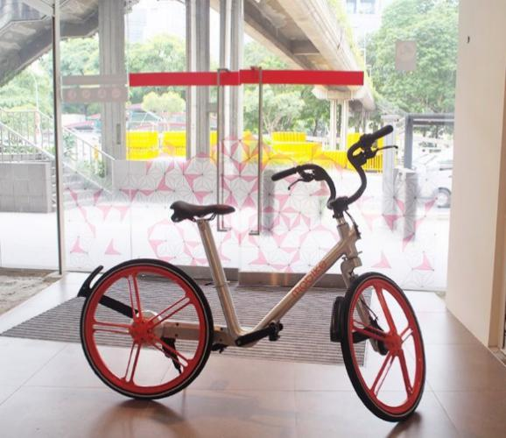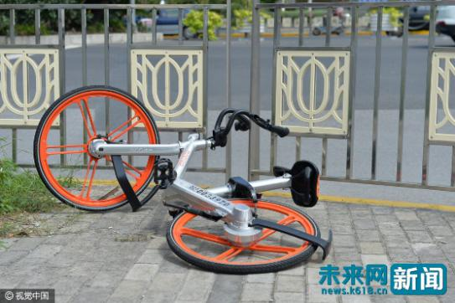
Good example:
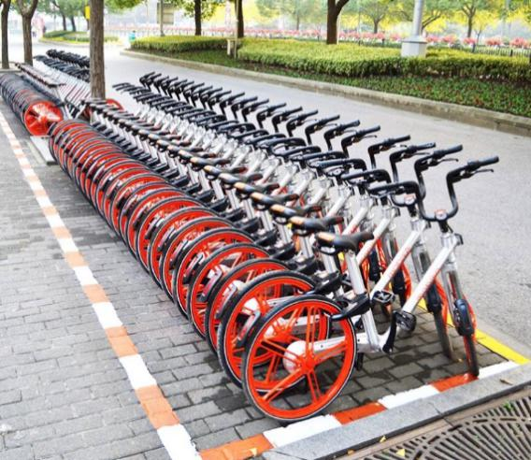
These problems cause the big cost loss of shared-bike for Mobike. It is not just bicycles’ loss problem. This corporation put enormous funds into its bikes for designing the technique and technology of shared-bike. Just mentioned in strengths and opportunities parts, Mobike cooperates with many famous and professional enterprises in order to give the best experience for its customers’ trip. Thus, these damage problems are the main threats for Mobike.
The source are from ‘Mobike FAQ’, mobike.com and ‘Sharing Economy Case Study - The SWOT Analysis of Mobike’, ocn.com.cn (2017).
Too many rivals, hard to dominate and reap profits
In China, mobile e-commerce’s shared-bike industry has become very mature and there are plenty of competitors for Mobike in China, such as Ofo sharing bicycles, Youon, U-bicycle, and other bike sharing enterprises. Each corporation has itself merits and pricing standard which attracts users to join in it. Thus, it is hard to be dominated and gain more market shares. Particular in one of Mobike’s big competitors, ofo sharing bicycles, has the lower price and deposit when users start their ridings with ofo than Mobike. This action maybe causes some losses of the Mobike’s customers and has an influence on earning profits and leading the bike sharing industry.
Here it can be seen that ‘Sharing Economy Case Study – The SWOT Analysis of Mobike’ from ocn.com.cn (2017).
2.2 Strategy Formulation
Sustaining competitive advantage
After the SWOT Analysis, the advantages of Mobike are better than other companies need to be kept in order to achieve its competitive edge.
All the missions of bike sharing enterprises are that to do the environment-friendly corporations for reducing the carbon mission. However, only can Mobike receive the rewards from United Nations and WWF. This means that Mobike’s contribution is positive and approved. Moreover, Mobike has announced two versions of Mobike’s white paper to appeal to and highlight the cycling’s importance. Thus, the customers can trust Mobike and choose it to be their modes of transportation for energy conservation. This strategy is a good way for earth and every citizen can easily do some contributions for it. They will be pleasant to do this activity with Mobike. This is the sustainable way to attract more consumers to join in.
The sources are from ‘The Mobike White Paper: Bike-Share in the City’ and ‘How Cycling Changes Cities – Mobike's Second Whitepaper Goes Global’, mobike.com (2017).
Mobike’s IoT technology support is another benefit to continuously develop well in China. First, through enormous investors’ investment, it has adequate funding in its R&D (research and development) department to study the best high-tech in the mobile phone for providing the better consumers’ experience. Additionally, Mobike has cooperated with China Mobile Research Institute, Qualcomm and AT&T to explore the future development of IoT technology and to consider how to ensure the safety of technology. These are also crucial points for users to decide which company’s product needs to be chosen.
Here it can be seen that ‘Mobike, Qualcomm and the China Mobile Research Institute – The Future of IoT Technology’ and ‘Mobike powered by AT&T and Qualcomm in the US’, mobike.com (2017).
Exploring new market spaces
Just mentioned in the opportunity and threat chapters, Mobike has expanded its market into overseas due to the limited domestic market. In the year of 2017, Mobike starts to develop its overseas market and the first step is to come to Singapore on the 21st March. After that, Mobike also successfully starts its business in UK, Thailand, Australia, Italy, Japan and other countries. Inheriting the Chinese strategic mode, wherever it expands it markets, Mobike has cooperated with the most popular social media to achieve its influence and gain more potential customers. For example, recently Mobike cooperated with Japan national instant messaging platform - LINE which owns approximate 127,000,000 users in Japan. On the one hand, this action can easily help Mobike to attract it consumers. On the other hand, with LINE’s mature technology issue, Mobike doesn’t need to spend enormous cost in advertising its shared-bike.
The source is from ‘LINE invested Mobike, what are the other bike sharing enterprises' situations’, sohu.com (2017).
2.3 Strategy Implementation
Internal organisation
The theory is shared by different scholars (Hagel and Singer 1993; Jelassi and Enders 2008). The internal organization consists of customer relationship management, product innovation and infrastructure management.
About customer relationship management, Mobike regards the young people as its target consumers at first, because these people like to follow the new technology and fashion trend. Thus, Mobike designs its shared-like with beauty and smart system to attract increasingly the young generation to join in. Furthermore, Mobike cooperates with the most popular social media between youngs to let more potential users know and want to ride a shared-bike with Mobike. Next, Mobike expands its target users from young people to all the citizen who wants to do some contributions for the not good environment. Therefore, Mobike announces two white papers and try its best to win some awards to prove its ability for reducing the carbon footprint. This makes its customers trust it and be loyal with it. This is a good way for Mobike to build a closer relationship with its customers. Its consumers can use different kinds of social media to contact with Mobike’s customer service, such as its app, its blogs and other social media.
For product innovation, mobile e-commerce is one industry that needs more innovations to appear, because it is a commerce with high-tech. If one company doesn’t persistent research for new technology, it will lose the market. In China, to be general, there are some m-business failures due to this reason. Hence, Mobike has a positive attitude to make its products much more smart and safety with today’s IoT technology. It operates with Chinese and other countries’ top technology corporations to discuss and study how to do the best and offer a better customer experience from the technology.
In the part of infrastructure management, it has the same situation with Mobike’s product innovation. As an m-commerce enterprise, technology and network framework are its infrastructure. Mobike needs to try its best to research the high-quality infrastructure for improving customer satisfaction. Furthermore, Mobike also needs to seek out a list of solutions ahead in order to easily address the problems made by the infrastructure.
Interaction with suppliers
At the early period of establishment, Mobike tries to find all the shared-bike suppliers in China to help it to produce its smart bikes. However, due to the high requests of Mobike - 4 year-spoke (not break) and QR code bike locks, no supplier wants to cooperate with it. Thus, Mobike starts to create itself factory to produce the bikes. Only a few parts of the bike needs Mobike to ask for suppliers’ works.
It is a hard time for Mobike, to design, to produce and address other problems about production line. Nevertheless, it has applied more than 20 patents now without suppliers. Hence, this company doesn’t have many interaction with suppliers.
Here it can be seen that ‘The ‘Black Technology’ of Mobike, how many challenges it needs to face’ from dzwww.com and ‘ofo controled 40% supply chain while Mobike cooperated with Foxconn (Paidai)’ from bbs.paidai.com (2017).
Interaction with users/customers
Mobike pays more attention on word of mouth marketing, therefore it costs a little on its advertisements. Nonetheless, it creates its app with ‘contact us’ section and its blog to show its ideas, news and products information, and the blog is easily accessed by everyone to make a review. Additionally, it cooperates with popular social media to have a conversation between the company and its users. All of them are good ways to make the interactions with Mobike’s consumers.
3.0 Conclusions
To conclude, through above analysis, the development trend of Mobike is optimistic, not only in China, but also in other countries. Although it has many rivals in China, the big one is Ofo sharing bicycles and recently Ofo has some problems with its investors. Hence, no one can have a huge influence like Mobike. With its strengths of convenience, cooperating with social media and green mission, the future of Mobike will be more successful. There is only one big challenge for Mobike. That is no network. For the mobile e-commerce, it can not do anything without network. The outcome of this problem is heavy. Nonetheless, after the analysis and evaluation for Mobike’s strategy framework, the report indicates Mobike has competency to resolve this problem because it pays a lot for exploring and improving the new technology.
The source is from ‘ofo controled 40% supply chain while Mobike cooperated with Foxconn (Paidai)’, bbs.paidai.com (2017).
4.0 Recommendations
About the future development of Mobike, this report just offers 2 recommendations for improving its weakness – no network, no use. First one is to install an equipment which can charge user’s smart phone on the handlebar of the bike in order to solve the problem of ‘no electricity, no network’. It has two benefits. On the one hand, it can retain customers although consumers’ mobile phones have no electricity. On the other hand, with this equipment, the users do not miss some important messages or call when they ride Mobike’s shared-bike. This can enhance customer satisfaction. The second one is to cover the Wi-fi signal in the public bike area for addressing the problem that some customers who have no network just now but still want to ride the bicycles. Maybe Mobike will research the advance technique to resolve these problems. This report just states its opinions.

Bibliography List
‘M-commerce’ 2003, Essential Internet, pp. 129-130, Business Source Complete, EBSCOhost, viewed 31 December 2017.
Advantage.marketline.com.ezproxy.uwtsd.ac.uk. (2017). Chinese bike-sharing startup Mobike has its eye on expansion. [online] Available at: http://advantage.marketline.com.ezproxy.uwtsd.ac.uk/Product?ptype=Company+News&pid=9C1A04F5-A440-4A36-9C42-839196F88EF8 [Accessed 3 Jan. 2018].
Advantage.marketline.com.ezproxy.uwtsd.ac.uk. (2017). Tencent Holdinds Limited. [online] Available at: http://advantage.marketline.com.ezproxy.uwtsd.ac.uk/Product?pid=38DC9484-BD40-4067-9745-244839257804&view=BusinessDescription [Accessed 7 Jan. 2018].
Bbs.paidai.com. (2017). ofo controled 40% supply chain while Mobike cooperated with Foxconn（Paidai）. [online] Available at: http://bbs.paidai.com/topic/1167136 [Accessed 15 Jan. 2018].
Bocij, P. and Chaffey, D. (2002). Business information systems: technology, development and management for the e-business. Harlow: Pearson Education, p.9.
Chaffey, D. (2011). E-business and e-commerce management. Harlow: Pearson Education.
Dzcom. (2017). The ‘Black Technology’ of Mobike, how many challenges it needs to face. [online] Available at: http: //www.dzwww.com/shandong/sdnews/201702/t20170210_15525385.htm [Accessed 14 Jan. 2018].
Griffith, E., (2017). Chinese Bike-Sharing Startup Mobike Has Its Eye on Expansion. [online] WIRED. Available at: https://www.wired.com/story/chinese-bike-sharing-startup-mobike-has-its-eye-on-expansion/ [Accessed 1 Jan. 2018].
Ha ge er., Hagel, J., Xin ge., Singer, M. and Dong qing. (1999). Wang luo jia zhi. Bei jing: Jing ji ke xue chu ban she.
Jelassi, T. and Enders, A. (2008). Strategies for e-business. Harlow [u.a.]: Prentice Hall.
Laudon, K. and Traver, C. (2010). E-commerce. Upper Saddle river (N.J.): Pearson.
Mobike.com. (2017). About - Mobike. [online] Available at: https://mobike.com/global/about [Accessed 31 Dec. 2017].
Mobike.com. (2017). FAQ - Mobike. [online] Available at: https://mobike.com/global/faq [Accessed 31 Dec. 2017].
Mobike.com. (2017). Mobike powered by AT&T and Qualcomm in the US. [online] Available at: https://mobike.com/global/blog/post/mobike-smart-tech [Accessed 8 Jan. 2018].
Mobike.com. (2017). Mobike Raises Over $600 Million in Series E Financing Led by Tencent. [online] Available at: https://mobike.com/global/blog/post/mobike-raises-600millionusd [Accessed 6 Jan. 2018].
Mobike.com. (2017). Mobike Ranks #14 of Most Relevant Brands in China. [online] Available at: https://mobike.com/global/blog/post/mobike-brand-relevance [Accessed 8 Jan. 2018].
Mobike.com. (2017). Mobike Receives 2017 Champions of the Earth Award from UN Environment. [online] Available at: https://mobike.com/global/blog/post/champion-of-the-earth [Accessed 8 Jan. 2018].
Mobike.com. (2017). Mobike, Qualcomm and the China Mobile Research Institute – The Future of IoT Technology. [online] Available at: https://mobike.com/global/blog/post/future-of-iot [Accessed 13 Jan. 2018].
Mobike.com. (2017). The Mobike White Paper: Bike-Share in the City. [online] Available at: https://mobike.com/global/blog/post/mobike-white-paper [Accessed 13 Jan. 2018].
Mobike.com. (2017). WWF Awards Mobike ‘Climate Solver Sustainable Urban Mobility Special Award’. [online] Available at: https://mobike.com/global/blog/post/wwf-sustainable-award [Accessed 8 Jan. 2018].
Mobike.com. (2018). How Cycling Changes Cities – Mobike's Second Whitepaper Goes Global. [online] Available at: https://mobike.com/global/blog/post/cycling-changes-cities [Accessed 13 Jan. 2018].
Ocn.com.cn. (2017). Sharing Economy Case Study - The SWOT Analysis of Mobike. [online] Available at: http://www.ocn.com.cn/touzi/chanye/201707/yenqk04091841.shtml [Accessed 9 Jan. 2018].
Sohu.com. (2017). LINE invested Mobike，what are the other bike sharing enterprises' situations. [online] Available at: http://www.sohu.com/a/211860906_324615 [Accessed 13 Jan. 2018].
Steinbock, D. (2008). The mobile revolution. London: Kogan Page.
Tech.sina.com.cn. (2017). Cooperate with Tencent, Mobike Create a New Strategy to Keep its Leading Position. [online] Available at: http://tech.sina.com.cn/roll/2017-03-30/doc-ifycwyxr8767072.shtml [Accessed 7 Jan. 2018].

Appendices
Figure 1: The Relationship between E-Business, E-Commerce and M-Commerce
Figure 2: The E-business Strategy Framework

