MSc Applied Computing

Leadership and Management

Team Selection, Formation and Leadership

John Rees

Lauren Paige Collins – P134209

Contents

Table of Figures 3
1.0 Introduction 4
2.0 Executive Summary 5
3.0 Options for Selecting Staff Members 7
3.0.1 Person Specification 8
3.0.2 Selection 9
3.0.3 Interview Technique and Agreement 9
3.1 PSED in Practice 10
3.2 Recommendations 11
4.0 Accelerate the Development of an Effective Team 12
4.0.1 Forming the Team 12
4.0.2 Qualities of an Effective Team 12
4.0.3 Belbin’s Team Roles 13
4.0.4 Adopting the Right Team Manager 15
4.1 High Performance Working Practices 17
4.2 Recommendations 19
5.0 Analysation of Leadership Approaches 20
5.0.1 Lewin’s Three Style Leadership 20
5.1 Recommendations 22
6.0 Monitoring Team Development 23
6.0.1 Key Performance Indicators 24
6.1 Recommendations 25
7.0 References 26
8.0 Bibliography 29

Table of Figures

Figure 1 Recruitment and Selection Process [29] 7
Figure 2 Belbin's Team Roles [13] 13
Figure 3 Effective Manager [28] 16
Figure 4 Elements of a High Performing Work System [27] 18
Figure 5 Lewin Three Style Leadership Diagram [31] 21
Figure 6 How Individual Actions like to Organisational Vision via KPI's [30] 23

Introduction

A new software development company based in Swansea has employed a new project manager. Swansea App Synthesis Ltd require from the project manager to select and develop a new team for the company, which is going to discussed throughout this report.
To do this, half of the staff members have been selected from within the company and the remaining half need to be employed by the newly hired project manager. The team are required to work on a project which is being conduct on behalf of the NHS (National Health Service) Wales Informatics Service, as there is an investigation into the use of Analytics on Health Data. As a result of this, the project manager is required to create a report to be given to the Managing Director of Swansea App Synthesis Ltd. containing an advanced vision on how the team will be developed.
Included within this report, will be the chosen options which will be adapted for employing new staff members and the various ways to aid in developing the effectiveness of the team. Alongside these techniques, the possible leadership approaches that could be implemented will be analysed and evaluated. A variety of KPI’s will also be identified for monitoring this particular team’s development progress. Finally, an executive summary will be produced for the Managing Director, containing an explanation for the selected approaches and how these will affect the organisation and employees.

Executive Summary
The project that is concerning the NHS Wales Informatics Service, requires a new team to be developed. The group currently in place contains half of the staff that are required to fulfil the project as the five members have been transferred from an existing project within the organisation. As a result, another five members must be recruited to fulfil the job description of addressing the use of analytics on health data.
To begin the recruitment process, a detailed job description is going to be created by using a detail analysis within section 3.0. Following the seven point plan will produce the detail job description required to advertise the positions. Alongside the job description, a person specification will be created using Roger’s Seven Point Plan and Fraser’s Pattern of Personality. The features included within both these models will allow for a clear indication of the type of people that are required to successfully fulfil the job role within this project. The selection process of the candidates will be conducted by sifting through the applications that do not meet the set standards. Once complete, the remaining applications will be contacted to inform of interview date, time and place. The interviews will be held in house with another member of staff present to aid where required. Each interview will be allocated the set time, which will allow additional time to be set for the necessary testing and questions. As a result of the NHS Wales Informatics Service being part of the public sector, it has been ensured that extra steps have been taken to implement the legislations set by the Public Sector Equality Duty.
Once the required team members have been chosen and hired, the next step will be to ensure the acceleration of the development of the team. It will be ensured that the team will have the right balance and all have the necessary required skills to be involved within a project of this nature. It is understood that within a team of so many people, that there is going to be a mix of personalities so it is categorical that an appropriate model is chosen to accelerate the team to the full potential possible. Belbin’s team roles is going to be assigned to the team, allowing each team member to have a contributing role to the overall development of the project. It is believed that this is a particularly effective model to apply to this project team, allowing every member to contribute and communicate with one another to increase the successfulness of this project.
To accelerate the development of the team accurately, suitable factors are to be applied to management also. Section 4.0.4 includes a critical analysis of the seven factors, which will not only improve the project manager and project team relationship but will also have a sufficient effect on the progress of the project. To ensure effective development a set of High Performance Work Practices are going to be applied to the overall team. Garman and colleagues identified a variety of elements to apply to employees which will in turn improve the quality of the organisation and will ensure complete employee fulfilment in the work place.
The team are going to require effective leadership throughout the course of this project and after deliberation, it has been decided for Lewin’s Three Styles of leadership to be applied to the management. The three different styles within this model will allow for connection between the three to be produced, to overall create an effective leadership approach. This particular framework is popular and will allow for efficient understanding of what type of leadership will be most acceptable to the manager, the employees and the project.
Finally, to monitor the development of this vital team, a set of Key Performance Indicators are going to be applied. The KPIs identified have a wide scope which can be separated further, if necessary, to ensure the correct KPIs are being adapted to monitor this particular team successfully. The method of using indictors to monitor development will be overall beneficial for the work ethic of employees and the quality of work which is applied into the project.

Options for Selecting Staff Members

Employing new staff within a business can often be a difficult task, especially when certain positions require a certain type of person to fulfil the role. What can sufficiently help is applying the correct techniques to aid the process and ensure the right person for the job is recruited.
Although there are many different ways to aid in selecting staff, there some key points to consider when recruiting within any role. These are: -
- “The seniority/level of position
- The degree to which managerial/leadership ability is critical to success
- The degree to which technical competence is critical to success
- The time and effort required to use the technique, in proportion to the risk of poor selection
- Available resources
- The budget
- The skills, knowledge and qualifications of assessors” [1]
The above seven points cover the vital elements that should be analysed and applied when beginning the application process for any job role. Ensuring that the answers to the above points have been established, will aid further in both the application and selection process.
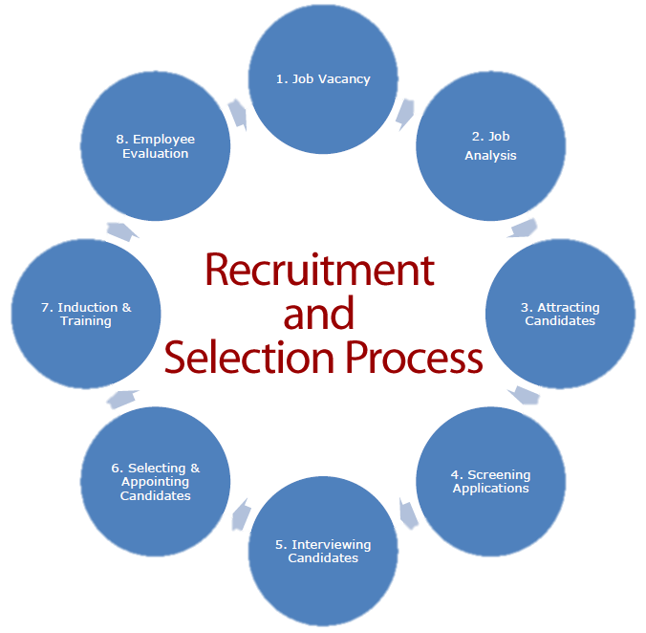
Although there are many different elements that should be considered when advertising a new job role within a company, the key component is ensuring there is an effective recruitment and selection process in place.

Figure 1 Recruitment and
Selection Process [29]

There are many different recruitment and selection processes available, many of them contain very similar points. “Recruitment decisions should not be based on the results of one selection method alone. Very often you need to combine two or more techniques to assess a range of skills, knowledge and qualities in candidates” [1].

3.0.1 Person Specification
To aid with person specification there are two popular systems that could be implemented to make an informative decision. One system is applying Rodger’s Seven Point Plan and the other is Munro Fraser’s Pattern of Personality.
In the below table are the aspects of Roger’s Seven Point Plan [2]:-
- Physical Make-up | Appearance, health, fitness, manner and voice.
- Attainments | Qualifications and type, work experience.
- General Intelligence | Level of general intelligence required
- Special Aptitudes | Required skills and adapting existing skills - mechanical, manual dexterity, computer literacy.
- Interests | Out of work activities – physically active, intellectual, social etc.
- Disposition | Work on own initiative and as a team, steadiness, time keeping.
- Circumstances | Personal/Domestic circumstances, occupations of family.
In the below table are the aspects of Fraser’s Pattern of Personality [3], also referred to as the Five Fold Grading System:-
- Impact on Others | Physical make-up, appearance, speech and manner.
- Acquired qualifications | Education, vocational training, work experience.
- Innate Abilities | Natural quickness of comprehension and aptitude for learning.
- Motivation | The kinds of goals set by the individual, consistency and determination in following them up, success in achieving.
- Adjustment | Emotional stability, ability to deal with stress and ability to get on with people.
Although if these systems do not meet the organisations requirements or aid in creating a person specification, aspire recruitment have listed five factors to consider hiring new clients through a selection process. The five factors are [4]: -
- Skill - Identifying the skillset required from candidate.
- Personality - This can often depend on the culture and dynamic of the organisation. The aim is for chosen candidate to fit in and work well.
- Desire - A persons drive and passion can be used to overlook a skill that the candidate may lack.
- Attitude - Often depend on the results from the interview. The job description must be the focus and whether the candidate has a ‘can do’ attitude.
- Communicate Expectations - Ensure a clear job description has been created and communicating this to the candidate aids in hiring the right person.

3.0.2 Selection
Although these previous mentioned systems can be implemented to aid with the process, there are many different aspects that the organisation will have to go through before reaching the hiring stage. Once the required person/ team has been identified using one of the above systems, the next stage is the method to adapt for selection (the organisation doing it its self, recruitment agency etc.) and the initial sort through, which involves examining grammar and spelling, format, coloured ink, previous experience and relative qualifications. Analysing this information will reduce the amount of application forms, resulting in the appropriate applications remaining for interviewing. Final stage within this phase, is for the organisation to decide whether any tests are required from the applicants e.g. Aptitude tests, numerical, verbal etc.

3.0.3 Interview Technique and Agreement
Interviewing candidates can often be difficult and time consuming, especially when a number of applicants have applied. “The job interview is a chance to connect the dots and determine whether a candidate is really qualified for a job. It’s not always an easy meeting to navigate but adopting best practice employer interview techniques can make a significant difference”. [5] Within the interview process, there are the basics which need to be established, which allow for the interviews to be sufficiently organised. Once all the required interviews are prepared, next is the interview techniques that are going to be used by the organisation.
Interview Basics
- Suitable time for all involved.
- Time allocated to complete the interviews.
- Limit how many interviews are going to take place and the order which they will take place.
- Choose who with the organisation are going to be the interviewers, and where it will take place.
- Ensure no unnecessary interruptions will arise or occur.
- Ensure the interviewer is provided with all the necessary information regarding the candidates.
- Pay the required expenses (if applicable)
- And finally, ensure candidates are notified promptly of the interview date, time and location.
Interview Technique
- Depending on the person specification created for the job, use this as check list and take notes of the responses received from candidates.
- Attempt to keep environment contented but professional. Interviewer must maintain control of the interview.
- Explain the position and clearly state the needed requirements. Be honest and direct with the candidates and be objective with relative information.
- Aim to have open-ended questions for the candidate and clearly answer any questions received from the applicant.

PSED in Practice
When recruiting staff, there are a variety of different aspects which are required to be met. One aspect which should be addressed within this particular environment, is the Public Sector Equality Duty (PSED). “The PSED places the onus on public sector authorities to ensure that their policies and practices, including those relating to their employees, are not discriminatory and that help to advance equality of opportunities” [6]. The PSED ensures that public bodies and others that perform public functions have due regard to: -
- “Eliminate unlawful discrimination, harassment, victimisation and any other conduct prohibited by the Equality Act 2010;
- Advance equality of opportunity between people who share a protected characteristic and people who do not share it; and
- Foster good relations between people who share a protected characteristic and those who do not” [7].
Within the Equality Act 2010, there are nine different areas of discrimination which are often referred to as protected characteristics. These are: -
- Age
- Race
- Religion or belief
- Sex
- Sexual orientation

- Disability
- Gender reassignment
- Marriage and civil partnership
- Pregnancy and maternity [8]
Within a workplace there are many different legislations that are required to be followed. These aspects of PSED are very important within the workplace and ensures that employees who work within the public authority are respected.
To ensure that the organisation meets the requirements of the PSED specific duties, McKay [9] has specified a range of actions which could be implemented by the business. These include: -
- “Report on mainstreaming the equality duty.
- Publish equality outcomes and report on progress in delivering these.
- Assess and review policies and practices.
- Gather information on the composition of its employees, and on recruitment, development, and retention of people. This annual information should be disaggregated by protected characteristic, and then published and used to inform action on equalities.
- Publish gender pay gap information.
- Publish statements on equal pay.
- Consider award criteria and conditions in relation to public procurement.
- Conduct equality impact assessment on an ongoing basis.
- Publish information in a manner that is accessible to the public” [9]

Recommendations

As result of Swansea App Synthesis LTD, requiring more staff to be employed to develop a new team, there are many different aspects that the organisation are required to considered before beginning the selective process. The first step is for the company to critically go through the steps stated in 3.0. Ensure that the company has the required answers to those seven points, will aid greatly within the recruitment stage, as a detailed job description is always required. Once complete the company should be able to successfully move on to the recruitment and selection of the requested employees. In figure 1 an appropriate diagram has been identified for the recruitment and selection process which has been recommended to Swansea App Synthesis Ltd. to adapt the model when recruiting. This particular diagram is well detailed and will guide the company to make informed decisions
The person specification for this role is vital, as it needs to be ensured that the right type of person/people are selected for a job role which involves addressing the use of analytics on health data. In section 3.0.1, two influential models which could be adopted for the basis of person specification were included and discussed. Both Rodger’s and Fraser’s models are very useful but also quite similar in certain elements. As a result, it is recommendation that the company analyse the features between these two models and adapt the features that are required for the role within the job description, due to the job role requiring a precise set of skills.
Once the company has identified the type of person that is required to fulfil the requirements of the job and the job description has been made available to people to apply for the job, the company can then begin to go through the selection process. It is recommended that the organisation go through the applications themselves and conduct the interviews in house. The process for sifting through the applications can be viewed within section 3.0.2. Within this phase, the company can then make the decision if any tests are required to aid in narrowing the amount of candidates.
Regarding the interview, the basics and techniques of an effective interview process can be viewed within section 3.0.3. It is recommended that the organisation apply the pointers mentioned, as it will sufficiently aid with selecting the right candidates from a pool of applications. The interviews should be conducted on site, where the applicants are also able to get a good feel and idea of what type of work place Swansea App Synthesis Ltd. is. The project manager would need to be present along with another member of staff relating to the job, which could help with the interview process and provide necessary advice. The interviews should be conducted within a suitable time frame (45 minutes to 1 hour) and any additional time that is required, should be assigned to questions from both the interviewer and the candidate and any essential testing if required.
As a result of the of team being assembled on behalf of NHS Wales Informatics Service, PSED elements are required to be implemented due to this organisation working with a public sector body. It should be ensured that the nine characteristics previously stated in section 3.0.3 are adapted within this workplace. No candidate or employee should be discriminated against for any reason. The actions also included within this section should be applied within the organisation to avoid any unnecessary issues arising.

Accelerate the Development of an Effective Team
When managing a team, how the team are performing reflects on the capability of the project manager within the department. “Team performance is one of the most common things that needs to be addressed in business and there are often simple, but effective, measures that can be taken to unite a team towards one common strategy.” [10] The ability to work well within a team is a required skill within most work places, as a result of most human activity relating to teamwork one way or another.

4.0.1 Forming the Team
Building a team within a particular workforce can often be very beneficial as teams are able to contribute more towards a particular project rather than individual members, as “A good team can outperform “better” individuals.” [11] Although it must be emphasised that high performing teams are not build instantly, as it takes time to find the right balance of individuals and skill sets. Ensuring that a sufficient team leader is in place, will ensure fast productivity, drive the team towards the main goal and encourage the team’s performance. The leader must also be able to manage the difficulties that could arise from the team progressing and relieves any foreseen conflicts before escalating.

4.0.2 Qualities of an Effective Team
Striving to produce an effective team can be vital, not just for the team itself, but also for the management that aided in developing an effective team. “A work group is composed of members who are striving to create a share view of and goals and develop an efficient and effective organisational structure in which to accomplish those goals.” [12] To produce an effective team, a variety of individuals are required who are able to contribute a range of skills. Alongside this, these individuals will need to balance out correctly and complement one another. It should be ensured that everyone within the team understands the duties assigned and recognise that everyone is to help one another, there are goals for every person to strive for and that the project it is not a competition. A leader should be assigned but may change depending on the work scenario or situation.
There are many different aspects which aid teams to work well, resulting in an effective team. It is important that a team all listen to one another and all take part in debates, ensuring no member is singled out or that the views of that person are not valued. Alongside this, although the process is to work in a team overall, there are sometimes conflicts that arise from differences within the team. Disagreements should be professionally managed and every member should be supported and supportive to one another. One main aspect that should be emphasised is that the team’s accomplishments and failures should be used to push the team forward. Mistakes should be learnt from and then used to push the team to achieve.

4.0.3 Belbin’s Team Roles

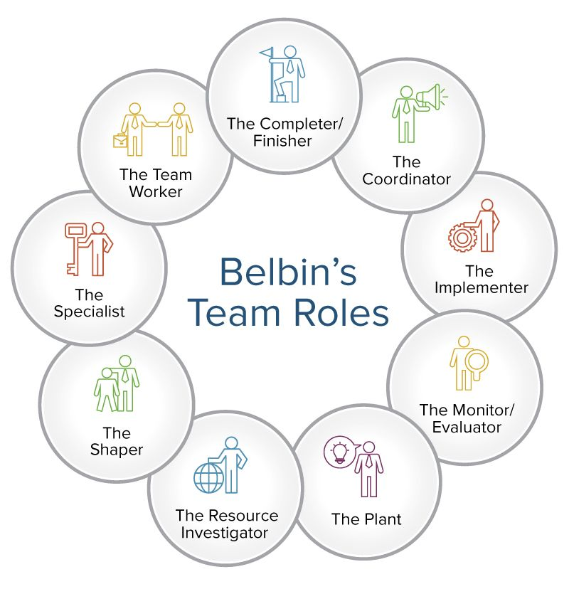
When a team is working at its best, the team fall into a rhythm and every member in the team gains a certain responsibility. It was believed by Belbin that “The types of behaviour in which people engage are infinite. But the range of useful behaviours, which make an effective contribution to team performance, is finite.” [13]
Belbin has identified nine vital team roles in an organisation, which have been divided into three categories. These consist of Action Orientated Roles, People Orientated Roles and Thought Orientated Roles.

Figure 2 Belbin's
Team Roles [13]

Action Orientated Roles
- Shaper
These individuals tend to people who have high levels of energy and are good at solving issues promptly. The shaper tends to succeed under pressure and is often the person other people within the team will turn to for help and advice but the shaper also strives to push the team members to constantly improve. This can often cause confrontation with other team members who prefer steadiness.
- Implementer
People who tend to be implementers are usually goal orientated. These individuals excel at project organisation and aim to turn ideas into actual results. Practically minded, very controlled and succeed in a consistent environment. The main issue with this, is that these people tend to not like change and are slow to adapt.
- Completer/Finisher
These individuals are also very goal orientated but also detailed. Quality of work and conditions are a major concern for the completer which can come as a strength and downfall. Completers work alone much of the time and relied upon to conduct any work that is missed by other members. This can often make these people stressed and unwilling to delegate work load
People Orientated Roles
- Coordinator
These individuals tend to be the team leaders due to the natural organisation and delegation skills. Usually liked members of the team, building agreements, recognising people’s abilities and strengths and aiding the team where possible with its goals. The only issue that tends to arise with the coordinator, is that the individuals enjoy having power and do not fulfil the complete role. Tend to persuade others to do more work to make up for the work that coordinator avoids.
- Team Worker
The team worker aims to provide support, ensures that other members within the team are working together and tries to resolve any issues in the team as these individuals tend to spot issues before others. “These tend to be popular people who are very capable in their own right, but who prioritize team cohesion and helping people get along.” [14] The main strength of this individual can also be a weakness. Team worker is often indecisive and avoids passing judgement in any situation which can tend to irritate other members.
- Resource Investigator
This individual is often the social one within the group and tends to be the group representative. The resource investigator tends to excel and negotiating with others involved within the organisation, which often does not come easily as skill, E.g. stakeholders. These people are very optimistic and enthusiastic which can fade quite quickly and cannot stick to just one role, due to enjoying variety in the job role.
Thought Orientated Roles
- Plant
The plant tends to enjoy coming up with new ideas and approaches for the team to adapt, as these individuals enjoy being creative and work alone. The weakness of this characteristic is that the person who fulfils this role will tend to not like rules or restraints, be poor communicators and does not take criticism well from piers.
- Monitor-Evaluator
Very logical and critical thinkers and have a variety of knowledge, which can aid for any decisions that need to be made. Work well with the Plant as the monitor-evaluator enjoys analysing and evaluating ideas, but can often be seen by the plant as this person that enjoys destroying ideas “Their prioritization of critical, analytical thought means they can come across as dispassionate and reactive.” [13]
- Specialist
This person tends to have all the necessary knowledge required to complete the job at hand. Very aware of status in the group, ensures that it is maintained by putting all available energy into this. Can tend to be single-minded and limit contributions to the group and are unable to see the big picture that others in the team can.

4.0.4 Adopting the Right Team Manager
Although there many different aspects which aid in producing an effective team, ensuring the correct team manager to manage the team is in place can have a great effect on the team performance. “A product leader is ultimately responsible for the success or failure of a product and, by extension the company itself. The impact of that cannot be underestimated” [15].
The person who takes on this role, will be required to genuinely care about the team and wants to take the time to aid in understanding and developing the team further. Providing constructive feedback is key to management and aids the manger to work on particular group duties and arrangement. The manager should have the ability to work alongside the team, arrange the necessary tasks and ensure that the tasks are divided sufficiently to individuals within the team. Williams [16] has suggested the following seven factors that a team manager should implement as these factors could be critical to the success of a team.
  - “Build a strong business case” [16]
A project should not begin unless there is compelling reason for the project to be conducted. The client requesting the project should clearly explain why it is required to ensure it is worth the team’s time and effort. Subsequently, the team should be provided with the right from the team manger to express concerns on development or return from possible completion of the project.
  - “Gain organisational commitment to the team” [16]
Individuals that are chosen for a team project must ensure that full commitment is provided to the team, organisation and the project. It must be ensured that the team is a balance of the right skills and personalities to ensure successful completion. As a result the team should be ensured that it is able to make decisions, but to not be wreck less with the freedom provided. The organisation and team manager should also ensure that the team consists of the same individuals from the beginning, to avoid potential issues arising from a team turnover.
  - “Give the team confidence that it can succeed” [16]
If the team are provided with confidence, this will encourage more motivation to be given into the creation and development of the project. “If the team feels it has ownership of the project process, it will have the confidence to get the job done, and subsequently the project effort will be successful” [16].
  - “Partner with the project customer” [16]
It is vital that a project management team work with the client on a project, rather than against. As a result of the client requesting the project that is being conducted, the client must be included in the decisions. Client involvement will aid to eliminate unnecessary issues, allowing the team to completely concentrate on requirements of the project.
  - “Partner with the external vendors” [16]
When working on a project, there are some cases where external products or services are required to aid the development. Much like keeping the client in the now, the same process should be done for external vendors.
  - “Enable team members to succeed” [16]
What can often be described as a difficult task, but it also most important, is to drive team members to work to a maximum level. To encourage this, the team manager should ensure the necessary steps are taken to show appreciation and provide feedback for what is working and what is not working for the team and the overall project.
  - “Encourage personal growth” [16]
Individuals within a team should always be motivated within the work place. Aiding the members in the team to have a personal vision of what could be achieved can help individuals greatly to incorporate that into the performance when working as a team. One of the key assets of being strong team manger knowing how exactly that individual wants to progress within the profession.
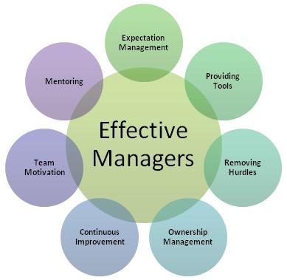

Figure 3 Effective Manager [28]

High Performance Working Practices

Within an organisation, High Performance Work Practices (HPWP) are required to be established. “High performance work practices are described as human resource management practices that augment organisational performance through enhancing employees’ competencies, motivation, commitment and productivity” [17]. By applying HPWP, the improvement on an organisations size has been recognised and these practices have aided in effectively hiring and developing high performing employees within an organisation.
Garman and colleagues [18] have identified and organised the following practices into four categories. Within the four categories are a number of practices which should be considered for implementing HPWP’s. These practices can be viewed in the tables below: -
Engaging Staff [18]
Conveying mission and Vision | This involves implementing activities to communicate the scope and purpose to the employees within the business.
Information and Sharing | Ensuring that relevant information on the organisation, its performance and other relevant details is shared with the appropriate employees.
Employee Involvement in Decision Making | Employees within the organisation should be supported to contribute to important decisions. For example, meetings, suggestion systems etc.
Performance-contingent Compensation | Putting a policy in place that links employee’s salary and/or bonus structure. This can aid in encouraging the employees to strive for success and meet the goals set.

Acquiring and Developing Talent [18]
Rigorous Recruiting | Planning effective activities which attracts new employees. This could include referral incentives, employee labelling etc.
Selective Hiring | When hiring for positions within a company, it is vital that the positions are filled with the suitable qualified candidate.
Extensive Training | If the organisation is to invest in the development of the staff, it can be viewed as a useful strategy to implement to aid in achieving better organisational success.
Career Development | Career opportunities available for new and existing employees with training available to support staff on new career paths.
Empowering the Front line [18]
Employment Security | When working for an organisation it is important that employees feel safe in the job role. Employees should feel comfortable to speak up about any issues or concerns.
Reduced Distinctions | Ensuring that the organisation emphasises equality across all employee roles within the organisation.
Teams/decentralized Decision Making | When teams are required, ensure that employees are allocated to the correct project. Also allow the teams to then organise how projects are going to be conducted and completed.

Aligning Leaders [18]
Management Training linked to Organisational Needs | Processes to have resources in place to develop leadership roles including tactical direction for the overall organisation. This can be achieved through setting goals, appropriate training and feedback, etc.
Succession Planning | Process to identify requirements in effective leadership. This can be achieved through workforce analysis, career planning and promotion targeting for possible future leaders.
Performance-contingent Compensation | Allowing appropriate employee members to have portion of leadership within the role. This can aid in achieving department goals.

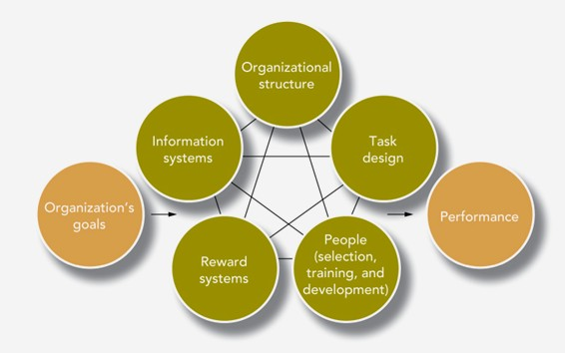
Figure 4 Elements of a High Performing Work System [27]

Recommendations
When aiming to accelerate the development of a team, there are many different factors which need to be analysed to do this effectively. The forming requirements of the team has been stated that, the team already consists of five members and that another five individuals were required to form the complete requested team. Once the remaining roles have been filled, it needs to be understood that the team are not going to work perfectly straight away. Some individuals may take a longer amount of time to settle in and build confidence.
The success and quality of the team will always have some sort of reflection on the team manager, but by ensuring a well-balanced team are in place with the necessary skills, those individuals can then always be developed further. It has been recommended that Swansea App Synthesis Ltd. team members should adapt to team roles as identified by Belbin. The nine vital team roles that have been identified and can be viewed within section 4.0.3. Belbin’s identified team roles have been defined as “a tendency by an individual to behave, contribute or interrelate with others in a team in certain ways.” [19] Although there are some weaknesses to some of the roles mentioned within this model, all of these individuals put together can make an effective team and a range of skills are always required, despite the skills stated on a job description.
Alongside an effective team is an effective team manager. When being the project manager, there needs to be thorough understanding of the project, the team, and wanting be involved within its development process. Seven key factors have been identified within 4.0.4 which the project manager should apply when managing the formed project team. Doing so will not only motivate and encourage the team to work at its best, but it will also prove the capabilities of the manager and the dedication levels that individual has towards the organisation, the team and the project.
Implementing High Performance Work Practices (HWHP) into the work place, will not just help with the development of staff, but will overall improve the quality of the organisation for others and effectively aid hiring potential employees. There are many different practices included within the four categories discussed in section 4.1, and it is recommended that the organisation apply the required practices where necessary to overall improve the quality of the organisation and employee satisfaction.

Analysation of Leadership Approaches
Leadership can be a very important quality to have, if used correctly. It can also be “a complex process: effective leadership requires the leader’s qualities and skills to connect with people and their needs as well as the needs of the leadership situation. Leaders seek to influence the actions, beliefs and the feelings of others” [20].
The difficulty in leadership is mirrored in the development of leadership theory. In the past, early leadership has mainly been focused on the abilities and performance of previous successful leaders. As society has evolved, so has the theory of leadership and there is now a better understanding of the many elements involved in leadership, which are: -
- “Needs and expectations of people at work;
- Impact of different leadership styles on followers and how the attitudes, behaviour and competence of followers impact leaders; and the
- Effectiveness of different leadership styles in different situations” [20].

Lewin’s Three Style Leadership
There are many different leadership approaches which could be applied when handling a team within an organisation. Lewin [21] identified three different style of leadership which could be applied within the work place. There are strengths and weaknesses to all three styles, but matching the circumstances of the person, the organisation and the flexibility of the individual, the three style model can be a productive guide to effective leadership.
- Authoritarian Leadership (Autocratic)
Authoritarian leadership state clear goals, what methods are required to be implemented to achieve those goals and the time frame that the goals should be achieved in. Decisions are made by the leader with little contribution from others. This leadership style tends to focus on the instruction that the leader gives and ensuring control of the employees to follow the instruction, as there is a clear division between the two. The leader tends to not involve themselves in the group work being conducted and as result the creative process that the employees apply to the work, does not get appreciated as much as it should. This type of leadership can be significant but is best suited to high risk environments and narrow projects. “Lewin noted that leaders who adopt this style can be seen by others as dictatorial and tend to get stuck in one mode of behaviour.” [22]

- Participative Leadership (Democratic)
This type of leadership involves the leader voicing the required properties and morals when setting aims and decisions for a project, but will also ask the employees for recommendations and takes on board any advice given. Although the leader includes employees within the decision making process, the leader does have the final overall say. Adapting this style can be particularly useful within a problem solving environment and can improve many aspects which can be more beneficial than the Authoritarian leadership style. This should be applied to a competitive but not an urgent situation.

- Delegative Leadership (Laissez – Faire)
The Delegative approach to leadership tends to be that the leader offers all the responsibility of the decision making to the employees within the team. The leader enables the team to set the aims of the project, what methods should be applied to achieve those goals, allows the employees to identify the required job roles and finally agree the time frame that the project should be completed in. This can be very beneficial if the overall group has the same work ethic and if the individuals within the team is trusted by the leader.

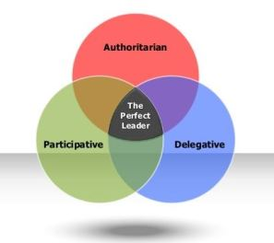

Figure 5 Lewin Three Style Leadership Diagram [31]

Recommendations

When managing a team within an organisation, it can sometimes be challenging to not only find the right leadership style for the individual who is managing a team, but also the right leadership style that works well for the team being managed. Although the project manager is technically above the team members, a certain amount of respect is still required from the manager to ensure a content workplace.
There are a variety of leadership styles which could be integrated into the work place, but for this particular organisation, Lewin’s three style leadership elements have been recommended which can be viewed with detail explanations in 5.0.1.
There are strengths and weaknesses to the three different styles, but the advantage to this, is that each style can be adapted depending on the organisation that is worked in, the type of employees that the project manager is working with and finally the type of project and time scale that is being worked with. Although autocratic is viewed a discouraging leaderships style “Lewin's framework is popular and useful, because it encourages managers to be less autocratic than they might instinctively be.” [23] If the project leader is particularly flexible, these three leadership styles can be connected which will allow the manager to use the correct style for certain situations and employees that the project manager may find themselves involved with.

Monitoring Team Development
There are many different responsibilities that are required to be met when being a project manager within a company, but one of the most important elements is to monitor the project groups within the organisation.
To successfully monitor the development of a team, the appropriate Key Performance Indicators (KPIs) are going to be identified. “Key performance indicators are the vital navigation instruments used by managers to understand whether their business is on a successful voyage or whether it is veering off the prosperous path” [24]. KPIs are an effective technique to discover whether a company is attaining the business objective. When the correct set of indicators are applied, this will aid management to understand who within a team is performing well and who may not be performing as they should be. These can also be used to focus on certain areas within an organisation to discover what areas may need attention from management.
Identifying the correct KPIs for the use of monitoring a team can be difficult. It needs be ensured that the indicators chosen are related to a certain business outcome, alongside the measure of performance. These below steps can be used to identify the appropriate the KPIs.
- “What is your desired outcome?
- Why does this outcome matter?
- How are you going to measure progress?
- How can you influence the outcome?
- Who is responsible for the business outcome?
- How will you know you’ve achieved your outcome?
- How often will you review progress towards the outcome?” [25]
In the below figure, strategic practice is being displayed through a pyramid. It can be viewed how KPIs link with the organisations vision through the actions. In the middle of pyramid KPIs can be found, as they are a result of strategy, objectives and CSFs (Critical Success Factors). The below the KPI are the actions that are required to reach successful completion of the project.
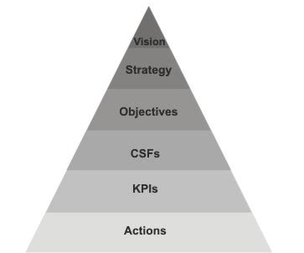

Figure 6 How Individual Actions like to Organisational Vision via KPI's [30]

6.0.1 Key Performance Indicators
If effective KPIs are set within an organisation, these can also be viewed as actionable steps towards the completion of project. What is important to remember is that “KPIs can only be concrete actions that represent some form of productivity specific to that job description. If a KPI is abstract, unclear and otherwise immeasurable, your team member’s performance won’t be tracked correctly.” [26] Below are six key performance indicators [26] that could be applied within an organisation to monitor the development of the team members.
- Presence
The presence of the team members can often not be thought of in great detail. If some team members prefer to work alone or seem to be pushing themselves away from the group, this can often be the cause of an underlying issue. Team work involves a considerable amount of communication with one another, if this is not occurring from all assigned members, this could result in the project not being completed successfully or as promptly as originally thought. It is key to ensure all team members are present for the work being conducted, allowing for thorough productivity.
- Leadership
Although leadership is required within a team, it’s not just to ensure the job is completed within a certain time frame, it is also boosting the confidence level of the individuals within the team and the team overall. Having the ability to motivate encourages people to be more productive. Giving a talk on motivation or a feedback session can go along way for encouraging a team and the overall performance.
- Hourly Commitment
The timed commitment that employees can provide to the organisation and the project, can have a major effect on the productivity levels. The amount of time spent working, tends to show a person’s commitment to the role. Monitoring this will allow for a clear indication of productivity and procrastination, aiding in any modifications that may need to be applied within the team.
- Work Quality
To ensure a complete analysis on the team member’s work, the management will need to ensure that the individual from management has a clear understanding of the work that the team members are working on. This can work with hourly commitment, as a member of the team may have been in the office for hours but does the quality of work reflect it. It is important to be fair in this process and ensure that this process is being done to monitor and improve performance levels only.

- Personal Development
The fulfilment and development of team members should be monitored closely. Individuals that are not happy within a role or organisation result in leaving, due to disregard of the work conducted, personal aims and productivity. People like to adopt new skills within careers to improve professional knowledge. Small signs of gratitude can make a major difference to employees’ satisfaction. The time spent on personal development can be measured against both work quality and hourly commitment. This can then provide management an indication of whether team development has improved.
- Daily Coaching
Depending on the size of the organisation, daily coaching to employees could be a viable option. Doing this can allow for discovering the team members routine, incentive and personal aims. As a result of this, the project manager will have a clearer idea of exactly motivates the members of the team.

Recommendations
To identify the key performance indicators for an organisation can often be problematic, due to project and employee turnover, so as result KPIs are often changed to meet the new requirements. Within section 6.0, a variety of steps have been identified which could be applied when the organisation are specifying KPIs to monitor the development of the organisation and then team. Following the seven stated steps will aid in justifying the correct required indicators that meet the needs of monitoring development. Figure 6 within this section has provided a clear understanding how individual actions link to Organisational Vision via KPIs. This pyramid could be particularly useful to Swansea App Synthesis Ltd. in aiding to identify further KPIs when required.
Within 6.0.1, six KPIs have been identified to aid to Swansea App Synthesis Ltd. in the monitoring of team development. These KPIs are quite big, in the sense of the amount of information that each covers but depending on the certain monitoring that is required of the team’s development, these six points could be broken down if required which would result in further precise KPIs. Implementing the identified KPIs to the organisation would be overall beneficial. Not only will it allow for sufficient monitoring of the development levels, but it will aid the project manager to have a better understanding overall. This could involve where the team employees are within the job role or project and help may have been required but the employees may not have been comfortable bringing up the subject, which may not have been recognised by the management if the stated KPIs were not implemented.

References

[1] | “Understand the different selection techniques for recruiting staff,” 2019. [Online]. Available: https://www.bath.ac.uk/guides/understand-the-different-selection-techniques-for-recruiting-staff/. [Accessed 20 March 2019].
[2] | C. Capon, “Employee recruitment process - Rodger's Seven Point Plan,” 2004. [Online]. Available: wps.pearsoned.co.uk/wps/media/objects/1514/1550600/ch07.ppt. [Accessed 02 April 2019].
[3] | “Selection - Fraser,” [Online]. Available: https://nscpolteksby.ac.id/ebook/files/Ebook/Hospitality/Human%20Resource%20Management%20in%20the%20Hospitality%20Industry%20(2005)/6.%20Chapter%205%20-%20Selection.pdf. [Accessed 02 April 2019].
[4] | “5 Factors to Consider in Candidate Selection,” 27 July 2017. [Online]. Available: https://www.aspirehiring.ca/5-factors-to-consider-in-candidate-selection/. [Accessed 05 April 2019].
[5] | R. Half, “Employer interview techniques,” 23 April 2018. [Online]. Available: https://www.roberthalf.co.uk/advice/recruitment-process/employer-interview-techniques. [Accessed 02 April 2019].
[6] | S. Williams, P. Scott, Employment Relations under Coalition Government: The UK Experience, 2010-2015, Routledge, 2016.
[7] | ACAS, “Public Sector Equality Duty (PSED),” [Online]. Available: http://www.acas.org.uk/index.aspx?articleid=5990. [Accessed 29 March 2019].
[8] | C. Advice, “What's the public sector equality duty?,” 2019. [Online]. Available: https://www.citizensadvice.org.uk/law-and-courts/discrimination/public-sector-equality-duty/what-s-the-public-sector-equality-duty/. [Accessed 29 March 2019].
[9] | A. McKay, “Public Sector Equality Duty,” August 2012. [Online]. Available: https://www.closethegap.org.uk/content/resources/CTG-PSED-guidance-for-employers-August-2012.pdf. [Accessed 15 April 2019].
[10] | D. Coolican, “How to accelerate team performance,” 30 March 2015. [Online]. Available: https://www.trainingjournal.com/articles/feature/how-accelerate-team-performance. [Accessed 8 April 2019].
[11] | J. Rees, “Moodle UWTSD - Teamwork,” 16 Spetember 2018. [Online]. Available: https://moodle.uwtsd.ac.uk/course/view.php?id=3243. [Accessed 20 April 2019].
[12] | S. Wheelan, Creating Effective Teams: A Guide for Members and Leaders, SAGE Publications, 2010, p. 2.
[13] | “How to Use Teamwork Roles to Build Winning Teams,” 2019. [Online]. Available: https://www.smartsheet.com/how-to-use-team-roles-to-boost-performance. [Accessed 25 April 2019].
[14] | “Belbin Team Roles - How Understanding Team Roles Can Improve Team Performance,” 2019. [Online]. Available: https://www.mindtools.com/pages/article/newLDR_83.htm. [Accessed 25 April 2019].
[15] | Barnfield, R. et al., Product Leadership: How Top Product Managers Launch Awesome Products and Build Successful Teams, O'Reilly Media, 2017, p. 16.
[16] | J. Williams, Team Development for High-tech Project Managers, Artech House, 2002, pp. 44-45.
[17] | P. Manolitzas, E. Grigoroudis, Effective Methods for Modern Healthcare Service Quality and Evaluation, Medical Information Science Reference, 2016.
[18] | “High-Performance Work Practices,” August 2015. [Online]. Available: https://www.ahrq.gov/professionals/quality-patient-safety/cusp/clabsi-hpwpreport/clabsi-hpwpap.html. [Accessed 15 April 2019].
[19] | “High performing teams: Belbin’s team roles,” 2019. [Online]. Available: https://www.managementcentre.co.uk/high-performing-teams-belbins-team-roles/. [Accessed 30 April 2019].
[20] | “Leadership Theories, Styles and Approaches,” [Online]. Available: https://www.iwise2.com/leadership-theories-styles-and-approaches. [Accessed 2 April 2019].
[21] | K. Cherry, “Leadership Styles and Frameworks You Should Know,” 11 March 2019. [Online]. Available: https://www.verywellmind.com/leadership-styles-2795312. [Accessed 27 April 2019].
[22] | “Leadership Styles (3-Style Model) - Kurt Lewin,” [Online]. Available: https://www.businessballs.com/leadership-models/leadership-styles-3-style-model-kurt-lewin/. [Accessed 27 April 2019].
[23] | “Leadership Styles,” 2019. [Online]. Available: https://www.mindtools.com/pages/article/newLDR_84.htm. [Accessed 30 April 2019].
[24] | B. Marr, Key Performance Indicators (KPI): The 75 measures every manager needs to know, Pearson, 2012.
[25] | “What is a KPI?,” 2019. [Online]. Available: https://www.klipfolio.com/resources/articles/what-is-a-key-performance-indicator. [Accessed April 2019].
[26] | “6 Effective metrics for measuring team performance,” 14 June 2018. [Online]. Available: https://blog.azendoo.com/6-metrics-for-measuring-team-member-performance/. [Accessed 27 April 2019].
[27] | “Creating and maintaining high- performance organizations,” 2016. [Online]. Available: https://slideplayer.com/slide/5283360/. [Accessed 15 April 2019].
[28] | “Effective Managers Born or Made,” 28 March 2016. [Online]. Available: http://mbadissertations.blogspot.com/2016/03/effective-managers-born-or-made.html. [Accessed 20 April 2019].
[29] | “Recruitment and Selection Process,” 2019. [Online]. Available: https://www.locusassignments.com/solution/unit-14-recruitment-selection-process-assignment-help. [Accessed 20 March 2019].
[30] | “Performance Management and KPIs,” 2018. [Online]. Available: https://www.mindtools.com/pages/article/newTMM_87.htm. [Accessed 27 April 2019].
[31] | “Effective Leadership and Management Style,” 2016. [Online]. Available: https://culcgurung12.wordpress.com/2016/03/10/effective-leadership-and-management-style/. [Accessed 27 April 2019].

Bibliography

https://www.employment-studies.co.uk/system/files/resources/files/mp36.pdf
[Accessed 22/04/19]
https://www.projectmanager.com/training/8-essential-kpi-metrics-teams
[Accessed 15/04/19]
https://www.gameffective.com/monitoring-team-performance/
[Accessed 22/04/19]
https://www.iwise2.com/node/102
[Accessed 27/04/19]

