

Project Management and Innovation (Assignment 2)
AI-Based Smart Study Planner for University Students
Name: Sonya Vakarelova
Student Number: 2426532
Course: BSc Applied Computing
Module: Changemakers – Creativity & Value Creation (ACCA5033)
Lecturer: Dr Osman Elgawi
Submission Date: 16/03/2026

Contents
Introduction 2
Task 1: Project Management 3
1.1 Project Scope and Planning 3
1.2 Technologies and Resources 4
1.3 Project Timeline, Schedule and Constraints 5
1.4 Development Methodology 6
1.5 System Design 6
1.5.1 Interface Design (Wireframe) 6
Task 2: Enterprise 7
2.1 PEST Analysis 7
2.2 SWOT Analysis 8
2.3 Legal and Ethical Considerations 9
2.4 Tech Start-up Idea 10
Task 3: Project Reflection 10
3.1 Developing New Skills 10
3.2 Impact on Society 11
3.3 Risks and Challenges 11
Conclusion 12
References 12
Appendices 13
Appendix A - Gantt Chart Development 13
Appendix B - Wireframe Design 14
Appendix C - PEST and SWOT Analysis Tables 15

Introduction
Project management and innovation are important elements in the development of modern technology solutions. In the field of applied computing, effective planning and organisation help ensure that digital systems are developed successfully and meet the needs of users [2]. Many students experience difficulties managing academic tasks, including organising assignments, meeting deadlines and balancing multiple subjects. As academic demands increase, traditional study planning methods such as paper planners or basic digital calendars are often not flexible enough to adapt to changing schedules and individual study habits.
This report explores the concept of developing an AI-Based Smart Study Planner for university students. The proposed system aims to support students by using artificial intelligence to organise study tasks, prioritise deadlines and generate personalised study schedules. By analysing the information entered by users, the system can recommend study plans that help students manage their time more efficiently and improve productivity [1], [13].
The report first examines the project management aspects of the proposed system, including the project scope, technologies, timeline and development methodology. It then discusses enterprise considerations such as PEST and SWOT analysis, as well as legal and ethical issues related to the project. Finally, the report reflects on the potential benefits of the project, the development of new skills and possible challenges that may arise during implementation.

Task 1: Project Management
Project management is an essential part of developing successful technology solutions. It involves planning, organising and managing resources to achieve project goals within defined time and resource constraints. Effective project management helps ensure that projects are completed efficiently and that potential risks are identified early in the development process [2]. This section outlines the project scope, technologies and resources required, as well as the project timeline, constraints, development methodology and design elements for the proposed AI-Based Smart Study Planner for University Students.

Project Scope and Planning

The selected project for this report is the development of an AI-Based Smart Study Planner designed to help university students manage their academic workload more effectively. Many students experience difficulties with time management, organising assignments and prioritising study tasks. As academic tasks increase, traditional planners and manual scheduling tools often struggle to adapt to changing deadlines and individual study habits [13].
The proposed solution is a smart digital planner that uses artificial intelligence to organise tasks, manage deadlines and generate personalised study schedules. The system will analyse task priorities, due dates and user preferences to recommend efficient study plans. By adapting to the student’s workload, the system aims to improve productivity and reduce academic stress [1].
The project scope includes the design and development of a user-friendly interface, task management features, deadline tracking and AI-based scheduling support. Additional features may include reminders, progress tracking and performance insights. The overall goal of the project is to develop a practical system that supports student time management.

Technologies and Resources
The development of the AI-Based Smart Study Planner requires a range of software technologies and development tools that support both system functionality and user experience. These technologies help create an intelligent platform that assists students in managing their academic tasks more effectively.
For the front-end development, technologies such as HTML, CSS and JavaScript can be used to design the visual interface of the application. These technologies allow developers to create interactive pages where students can add tasks, monitor deadlines and view their study schedules. This makes it easier for students to organise their coursework and quickly understand their priorities. A simple and intuitive interface is important to ensure the system is accessible and easy to use for a wide range of users [2].
For the back-end development, Python is a suitable programming language because it supports artificial intelligence and data analysis. Many AI libraries such as Scikit-learn, Pandas and TensorFlow allow developers to analyse data, identify patterns and
generate personalised scheduling recommendations. This enables the system to adapt to a student’s study commitments and provide more efficient study plans [1].
A database system, such as MySQL or Firebase, would be required to store user information, academic tasks and scheduling data. The database allows the system to track deadlines, save user preferences and update schedules dynamically, ensuring that students can access their study plans at any time.
During the design stage, tools such as Figma or Balsamiq can be used to create interface wireframes. These tools allow developers to visualise the system layout and user interaction before the development stage begins.
In addition to technical tools, human resources are also important. The project may involve a software developer, a tester and student participants who can provide feedback during the evaluation phase. Combining appropriate technologies with effective project planning helps ensure the system can be developed efficiently and meet student needs.

Project Timeline, Schedule and Constraints
To organise the development of the AI-Based Smart Study Planner, a project timeline was created using a Gantt chart. The chart shows the main stages of the project and how long each stage is expected to take during the twelve-week development period.

Figure 1 Gantt chart showing the planned development timeline for the AI-Based Smart Study Planner.

As shown in the chart, the project is divided into six stages: research, planning, design, development, testing and evaluation. The research stage focuses on understanding existing AI tools and study planning systems. During the planning and design stages, the system requirements and structure are defined. The development stage takes the longest time because it involves building the main functionality of the application. Testing ensures the system works correctly, while the final evaluation stage reviews whether the system meets the project objectives.
However, several constraints may affect the project schedule. These include the limited twelve-week development period, potential technical challenges when implementing AI features, and the need to manage time effectively while completing other academic work.

Development Methodology
For the development of the AI-Based Smart Study Planner, an Agile development methodology will be used. Agile is a flexible approach that allows the system to be developed in smaller stages while making improvements throughout the process[3],[12]. This method is suitable for this project because it allows testing and adjustments to be made during development.
Using Agile means the project can be developed in several iterations, where each stage focuses on implementing and improving specific features of the system. For example, the initial stage may focus on creating the basic study planner interface, while later stages may include the integration of AI features that provide personalised study recommendations.
Another advantage of the Agile approach is that it allows continuous testing and evaluation during development. This helps identify potential issues early and ensures the system meets the project requirements. It also allows improvements to be made based on feedback during the development process.
Overall, Agile provides a flexible and efficient way to develop the AI-Based Smart Study Planner while ensuring the system can be improved throughout the project lifecycle.

System Design
The system design stage helps to visualise how the AI-Based Smart Study Planner will function before the development process begins. Creating design diagrams allows the structure of the system and the interaction between the user and the application to be clearly understood.

Interface Design (Wireframe)
A wireframe was created to illustrate the basic layout of the AI-Based Smart Study Planner interface. The wireframe shows how users will interact with the system and where the main features of the application will be located.
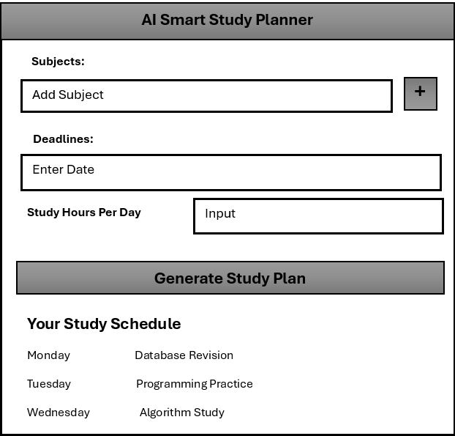
Figure 2 Wireframe showing the interface layout of the AI-Based Smart Study Planner.

The wireframe demonstrates how users can enter their subjects, deadlines and available study hours to generate a personalised study schedule. Once the information is entered, the system produces a study plan that organises tasks across different days. This design helps ensure the interface is simple and easy for users to understand and navigate.

Task 2: Enterprise

2.1 PEST Analysis
A PEST analysis examines the external factors that may influence a technology company by considering political, economic, social and technological elements that affect business development [10].
Political factors include regulations related to data protection and digital technologies. Organisations developing AI applications must comply with laws such as the General Data Protection Regulation (GDPR) to ensure that user data is collected and stored securely [5].
Economic factors include the growth of the digital education market and the increasing demand for productivity tools for students. The expansion of online learning platforms creates opportunities for innovative educational technologies [4].
Social factors relate to the increasing pressure on students to manage their time effectively. Many students struggle with organising academic tasks and deadlines, which increases the demand for tools that support productivity and learning organisation.
Technological factors include rapid advancements in artificial intelligence and data processing technologies. These developments enable the creation of intelligent systems that analyse user input and generate personalised study plans [1].
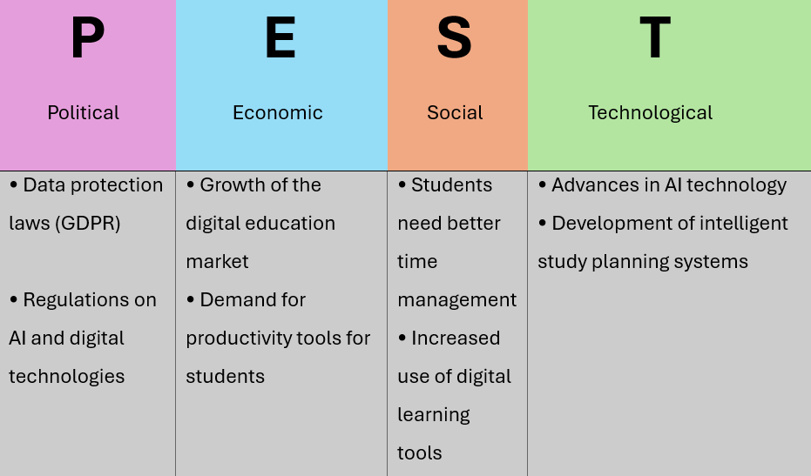
Figure 3 PEST Analysis showing the external factors affecting the development of the AI-Based Smart Study Planner.

2.2 SWOT Analysis

A SWOT analysis evaluates the strengths, weaknesses, opportunities and threats of a potential technology solution and helps assess its overall viability [10].
Strengths
The AI-Based Smart Study Planner provides personalised study schedules that help students manage their time more effectively. The integration of artificial intelligence allows the system to generate intelligent recommendations based on user input.
Weaknesses
Developing AI systems may require technical expertise and reliable data. The accuracy of the generated study plans may depend on the quality of the information provided by users.
Opportunities
The increasing use of digital learning technologies creates opportunities for educational productivity tools. The system could also be expanded for use in universities or integrated with existing learning management platforms.
Threats
Competition from existing productivity applications and digital planning tools may present challenges. In addition, technical issues or limited user adoption could affect the success of the system.
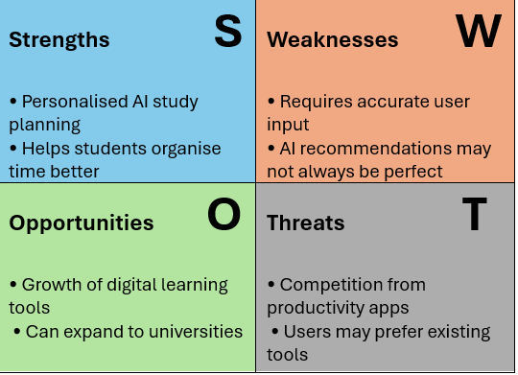
Figure 4 SWOT analysis of the AI-Based Smart Study Planner concept.

2.3 Legal and Ethical Considerations
When developing an AI-based application, legal and ethical considerations must be addressed. One important legal factor is data protection. The system must ensure that any personal information provided by users is stored securely and used only for the intended purpose.
Ethically, developers must ensure that the AI system operates transparently and does not misuse user data. Users should understand how their information is used and how study recommendations are generated.

2.4 Tech Start-up Idea
The proposed technology start-up for this project could be called SmartStudy AI. The aim of the start-up would be to develop intelligent study planning tools that help students organise their academic workload more effectively.
The business could operate as a private limited technology company, focusing on educational technology solutions. The company’s business strategy would focus on developing AI-based productivity tools for students and educational institutions.
Potential funding opportunities could include technology start-up grants, university innovation programs, and investment from technology incubators or venture capital organisations.

Task 3: Project Reflection

3.1 Developing New Skills
This project provides an opportunity to develop several new technical and professional skills related to applied computing. One of the key areas I aim to develop is my understanding of artificial intelligence technologies and how they can be used to support educational tools. By exploring the idea of an AI-Based Smart Study Planner, I can improve my knowledge of how intelligent systems analyse data and generate useful recommendations for users.
Working on this project idea also helped me understand how artificial intelligence could be applied to solve real problems faced by students in education.
Another important skill I would like to develop is software development and system design. Creating an application that organises study schedules requires understanding how to structure software systems, manage user input and design simple user interfaces. Learning programming languages such as Python, which is widely used in artificial intelligence and data processing, would also support the development of this project.
In addition, working on this project idea can help improve problem-solving and analytical thinking skills. Developing digital systems often requires identifying user needs and designing solutions that address real problems. These skills are important for future careers in the computing industry.

3.2 Impact on Society
The proposed AI-Based Smart Study Planner could have a positive impact on society, particularly in education. Many students struggle with managing their time effectively and organising their academic tasks. A digital system that generates personalised study schedules could help students plan their work more efficiently and reduce the risk of missing important deadlines.
Digital learning technologies are becoming increasingly important in modern education [4], [13]. Intelligent study planning tools could help students stay organised and manage their workload more effectively. By using artificial intelligence, the system could provide suggestions that help students balance their study time and prioritise important tasks.
The project could also contribute to improving student wellbeing. Academic pressure and multiple deadlines can create stress for many students. A tool that helps organise tasks and create structured study plans could make it easier for students to manage their workload and reduce academic stress.

3.3 Risks and Challenges
Although the AI-Based Smart Study Planner has potential benefits, there are also several risks and challenges that may affect the project if it were developed further. One challenge is the accuracy of the study recommendations generated by the system. The system would rely on information provided by users, such as deadlines and study priorities. If the data entered by users is incomplete or inaccurate, the generated study schedule may not be effective.
Another potential challenge is data privacy and security. Since the application may store personal information such as study tasks and schedules, it is important to ensure that user data is protected. Developers would need to follow data protection regulations and implement secure data storage methods to protect user information.
Technical challenges may also arise during development, particularly when implementing artificial intelligence features. To reduce these risks, the system could initially be developed as a simple prototype focusing on basic scheduling features before adding more advanced AI functionality in later stages.

Conclusion
This report examined the concept of developing an AI-Based Smart Study Planner designed to help university students manage their academic workload more effectively. The project management section outlined the project scope, required technologies and development timeline, supported by a Gantt chart and system design wireframe. The use of an Agile methodology was identified as an appropriate development approach, allowing iterative improvements and continuous testing throughout the development process.
The enterprise analysis explored external and internal factors influencing the project through PEST and SWOT frameworks. These analyses highlighted the increasing demand for digital productivity tools in education, while also identifying potential challenges such as competition from existing applications and the importance of data protection.
The reflection section demonstrated how developing this project idea can support the development of technical, analytical and problem-solving skills. Overall, the proposed AI-Based Smart Study Planner demonstrates how artificial intelligence can be applied to support student productivity, improve time management and contribute to a more organised academic experience.

References
[1] S. Russell and P. Norvig, Artificial Intelligence: A Modern Approach, 4th ed. Harlow, UK: Pearson, 2021.
[2] T. H. Davenport and R. Ronanki, “Artificial Intelligence for the Real World,” Harvard Business Review, vol. 96, no. 1, pp. 108–116, 2018.
[3] K. Schwaber and J. Sutherland, The Scrum Guide: The Definitive Guide to Scrum: The Rules of the Game. Scrum.org, 2020.
[4] OECD, Artificial Intelligence in Education: Challenges and Opportunities. Paris, France: OECD Publishing, 2021.
[5] European Parliament, “General Data Protection Regulation (GDPR),” Regulation (EU) 2016/679, 2016.
[6] World Economic Forum, The Future of Jobs Report 2023. Geneva, Switzerland: World Economic Forum, 2023.
[7] McKinsey Global Institute, The State of AI in 2022 and Beyond. McKinsey & Company, 2022.
[8] UNESCO, AI and Education: Guidance for Policy Makers. Paris, France: UNESCO Publishing, 2021.
[9] J. Bughin, “Artificial Intelligence and the Future of Work,” MIT Sloan Management Review, vol. 61, no. 4, pp. 1–8, 2020.
[10] P. Kotler, H. Kartajaya and I. Setiawan, Marketing 5.0: Technology for Humanity. Hoboken, NJ: Wiley, 2021.
[11] M. E. Porter and J. E. Heppelmann, “How Smart, Connected Products Are Transforming Competition,” Harvard Business Review, vol. 98, no. 6, pp. 96–114, 2020.
[12] A. Cockburn and J. Highsmith, “Agile Software Development: The People Factor,” IEEE Computer, vol. 44, no. 11, pp. 131–133, 2020.
[13] N. Selwyn, Should Robots Replace Teachers? AI and the Future of Education. Cambridge, UK: Polity Press, 2021.
[14] D. Chui, M. Hazan and R. Roberts, The Economic Potential of Generative AI. McKinsey Global Institute, 2023.

Appendices

Appendix A - Gantt Chart Development
This appendix presents the original project timeline created in Microsoft Excel for the development of the AI-Based Smart Study Planner. The timeline illustrates the main stages of the project, including research, planning, design, development, testing and evaluation over a twelve-week period.
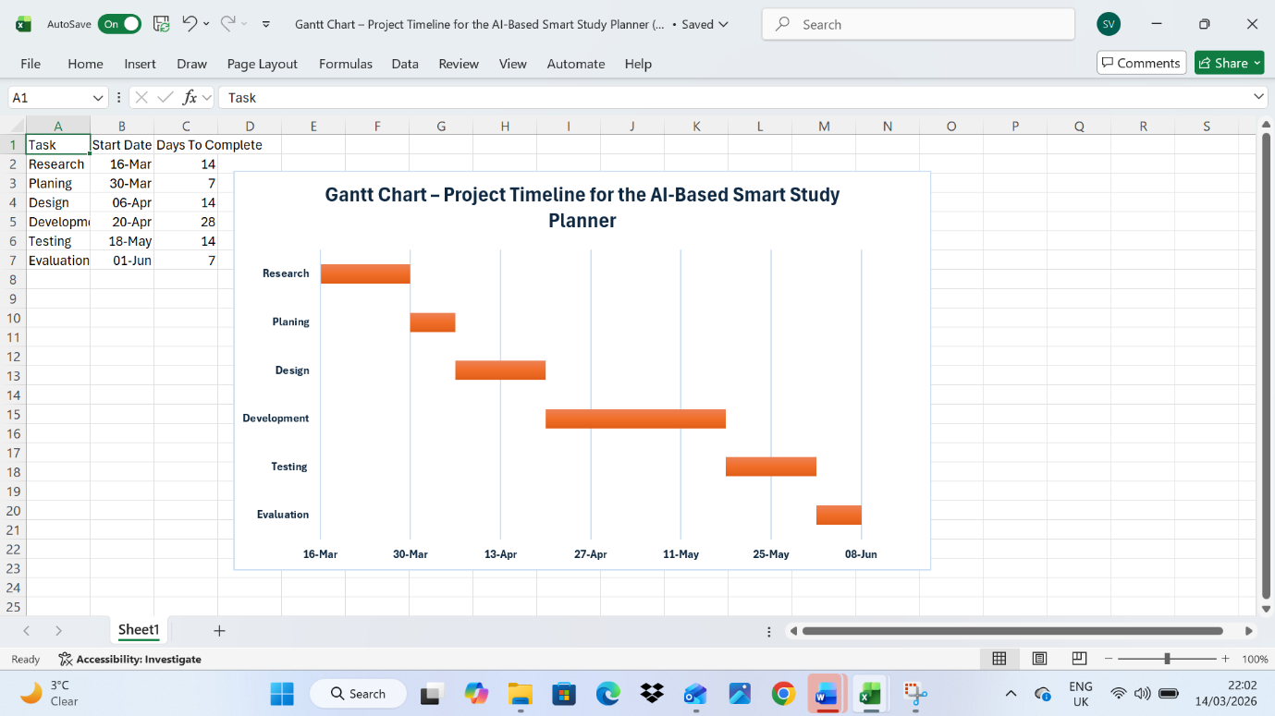
Figure A1: Screenshot of the Excel Gantt chart used to create the project timeline.

Appendix B - Wireframe Design
This appendix includes the initial wireframe created during the system design stage. The wireframe illustrates the layout of the AI-Based Smart Study Planner interface and demonstrates how users can enter subjects, deadlines and study hours to generate a personalised study schedule.
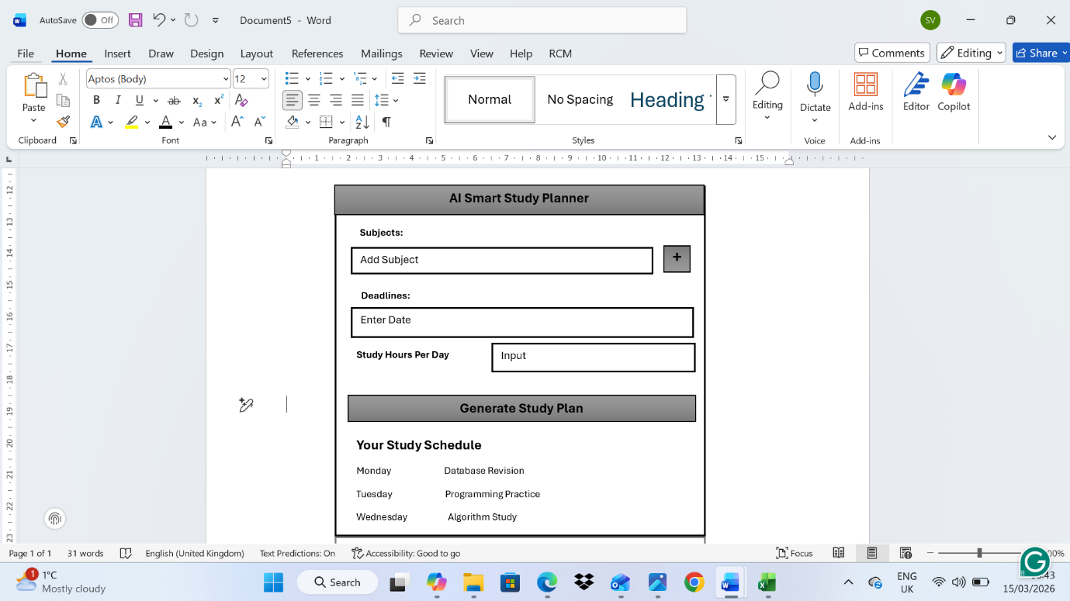
Figure B1: Screenshot of the wireframe layout for the AI-Based Smart Study Planner interface.

Appendix C - PEST and SWOT Analysis Tables
This appendix contains the detailed PEST and SWOT analysis tables used to evaluate the external and internal factors affecting the proposed technology solution. These analyses help identify opportunities, challenges and strategic considerations related to the AI-Based Smart Study Planner project.
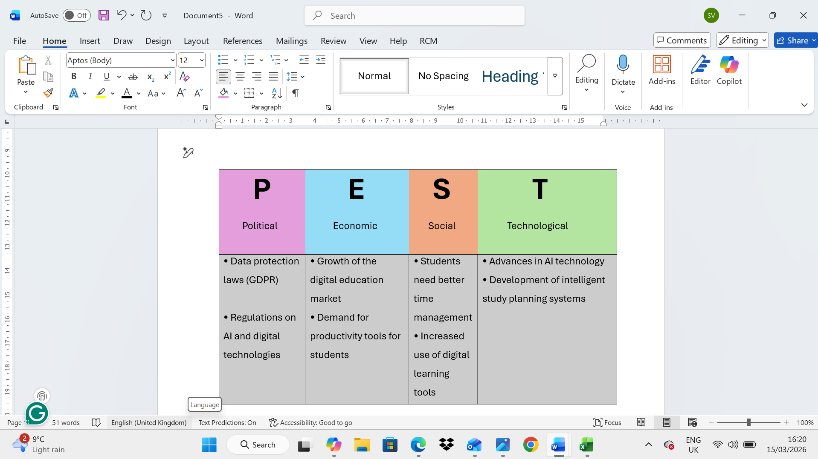
Figure C1: Screenshot of the PEST analysis table for the AI-Based Smart Study Planner

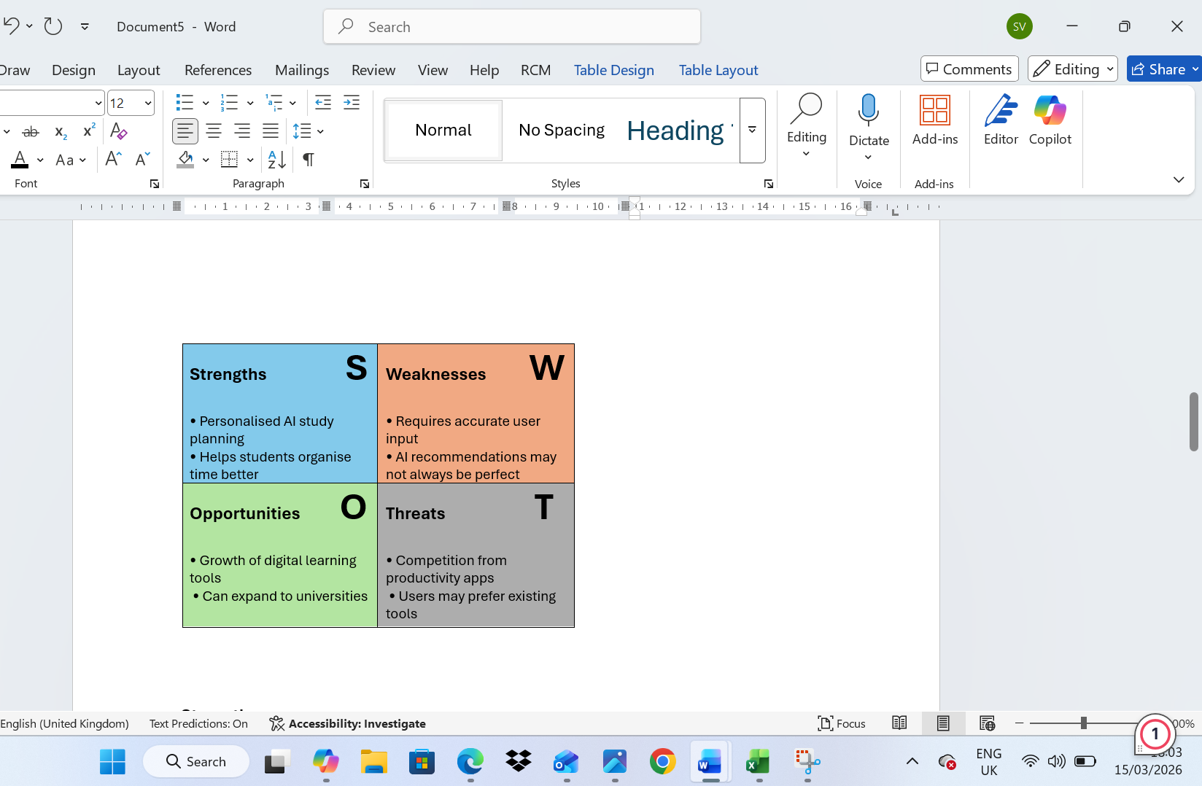
Figure C2: Screenshot of the SWOT analysis table for the AI-Based Smart Study Planner.

