Presentation Guidance

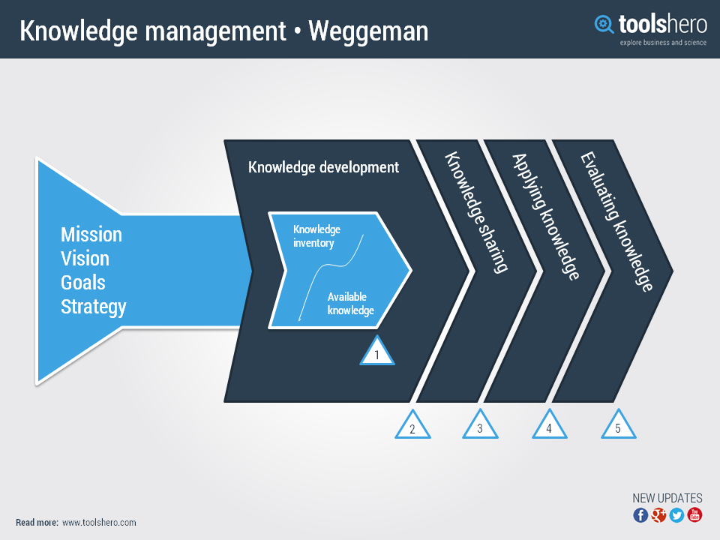
Develop and deliver a poster presentation of a one area of a Knowledge Management Value Chain (KMVC). This is an example of a KMVC:

The purpose of a KMVC is to show how knowledge becomes valuable. Knowledge (like most things) is only valuable if it can be applied and used to improve some aspect(s) of the organisation. As a result, knowledge management should be strategic and its development and use planned accordingly:

Things you could consider under each area are detailed below. Remember, it is just one area you should cover in your presentation:

Knowledge Acquisition:
- Where do they get data/information/knowledge from? What sort of knowledge do they acquire?
- How do they ensure this is accurate/up-to-date/reliable?
- Do they use internal or external sources, or both?
- If they use manuals as a knowledge source, do they use other explicit knowledge (combination) or tacit knowledge (externalisation) to develop this?
- Do they have scheduled meetings for knowledge sharing (socialisation - tacit to tacit)?
- Is there an established community or practice?
- Is knowledge valued/given high currency in the organisation?

Knowledge Storage:
- What systems/platforms do they use to store knowledge?
- Are these appropriate? Purpose-built/making-do, modern/outdated, user-friendly/overly-complex, providing the right amount of/too little/too much knowledge?
- How accessible are they to those working in the organisation? Both in terms of physical access (equipment) and skills/ability to use the systems.

Knowledge Dissemination:
- How is knowledge shared in the organisation?
- Is knowledge pushed from the top-down or pulled from the bottom-up?
- Who decides who gets to access what knowledge? What is the basis of this?
- Is there a knowledge sharing culture?
- How does the organisation ensure that employees have understood the knowledge they have received in order to apply it? (Explicit to tacit – internalisation)
- Do they provide the opportunity for practice or simulation or testing knowledge before applying it/putting it into practice?

Knowledge Application:
- Is it at this stage that actual internalisation happens?
- Is ‘hands-on’ experience necessary? (Knowledge is a lived experience after all)
- How is knowledge applied to improve processes within the organisation or the products and/or services produced/offered by the organisation?
- Is the application of knowledge evaluated?
- Does the organisation review how useful the knowledge has been or what impact it has had?
- How do they/do they ensure knowledge is being used most effectively?

Note: These lists are not prescriptive or exhaustive. They are simply guidance!

You need to draw on KM theory, where possible. You also need to go beyond just description of KM – be critical in your thinking. Don’t just say what they are doing, think about why they are doing it, how well (or not) they are doing it - link the material we have covered in lectures.

Consider a comparative element to your presentation: Compare Amazon to another organisation. So, if Amazon is good at knowledge acquisition, for example, contrast this with another that is not so good at this, compare their methods (so, potential reasons why they are good at it or not) and analyse the outcomes for strategic KM, etc. Likewise, if Amazon is poor at knowledge storage, for example, compare this with another organisation who is good at this, again comparing methods/outcomes, etc.

Notes:

- You will, of course, need references for this in your supplementary notes but these should not be on your Poster PowerPoint slide. Any theories you make links to will need to be referenced, as will the source(s) of your organisational information;
- Remember: Use only ONE PowerPoint slide for your poster and produce supplementary notes (plus reference list) - upload both of these to Moodle. There will be separate Turnitin portals for each of these.

