Student name: | Lydia Heguye | Student ID number: | 2010628
Programme: | MBA
Module: | Change and Stability Management
Module code: | BMMB7000D | Contribution to Overall Module Assessment (%): | 75%
Lecturer: | Dr Roisin Mullins | Internal Verifier: | Mike Davies & Dr Shehla Khan
Assignment Title: | Organisational Change  Case study | Word count (or equivalent): | 3000 words
Submission deadline: | Part 2 Report  8th July 2022 | Return date of provisional marks & written feedback: | 5th August 2022

Table of Contents
Introduction 1
Introduction to Organisation 1
Hospitality Industry and Pandemic 2
Premier Inn and Pandemic Effects 4
Change Management Models 5
Lewis Change Management Model 5
Resistance Factor for Premier Inn 6
Application of Model 7
Stage Unfreeze 7
Stage Change 7
Stage Refreeze 8
Recommendation 8
Conclusion 8
References 10

Introduction
The aim of the assignment is to discuss the key change management models that have been used or could be used to manage the progressive changes happening in an organisation due to Covid- 19 global pandemic. The assignment will critically review and evaluate the effectiveness in maintaining the overall stability of the operations and the extent to which additional measures are required for the development of furthermore events. First, the assignment will discuss the brief history of the organisation and the reason it required changes. Followed by the key change management models required for this purpose and outlines of how this model can be used considering the change required for the organisation. The identification of the resistance factors for the change and how to deal with them followed by the recommendations for future events and conclusion. The selected organisation for this purpose is Premier Inn, a hotel chain based in the UK that has gone through changes because of the Covid- 19 pandemic as the hospitality industry has seen major fallback since the start of Covid-19.

Introduction to Organisation
The selected organisation is Premier Inn hotel. Premier Inn was established in 1987 by Whitbread, then operating as the company named Travel Inn. It is one of the United Kingdom limited- service hotel chain and is regarded as the UK’s largest hotel brand, with more than 800 hotels and 72,000 rooms altogether (Premier Inn, 2022). The hotel chain is operational in many countries such as the UK, Ireland, Germany, and Middle Eastern countries. The headquarters of the hotel is located in Dunstable, UK. and was founded by Whitbread. The company has more than 10 thousand employees with yearly revenue of about 398 million British pounds (Lock, 2021). The hotel chain accounts for 70% of the total earnings of the organisation. The graph shows the Whitbread earnings worldwide by the business segments they have for the years 2019 to 2021. Restaurants and hotel brand Premier Inn, owned by the company, has the highest revenue generation and therefore, the company is best known for its hotel brand (Lock, 2021). Since the hotel chains are mostly service- based therefore, the services share for the approx. 80.2% of the business segment, and the remaining 20% is product-based. As the pandemic arrived, the hotel occupancy rate of the premier Inn hotel went down to 29.4% (Lock, 2022). Whereas the other hotels in the UK have also seen a major fall, however, the occupancy of the rate of the hotels always remained above 80%, and in London, specifically which declined after the travel restrictions due to the Covid -19 pandemic.
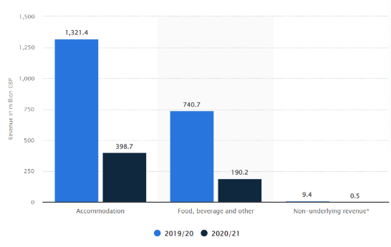
Figure 1 Whitbread's Revenue Source: (Lock 2021)

The hospitality industry mainly refers to the food and accommodation services, which include cafes, hotels and restaurants etc. The hospitality industry has been hit hard by the pandemic, and the impact was even worse on the clubs and bars for a year almost (Davahli et al., 2020). The spending of the consumer, though, started increasing after the mid of 2021 when the restrictions lifted up, but it continued to be remained below 70% of the pre-pandemic levels. The food and drink business has also remained half of the pre-pandemic levels. The economic output of the industry was around 59.3 billion pounds for the year 2018 and comprised of 3% of the total UK economy. In the month of March 2020, the pandemic took away 2.53 million jobs which are almost 7.1% of the population working in the UK (Hutton, 2022).
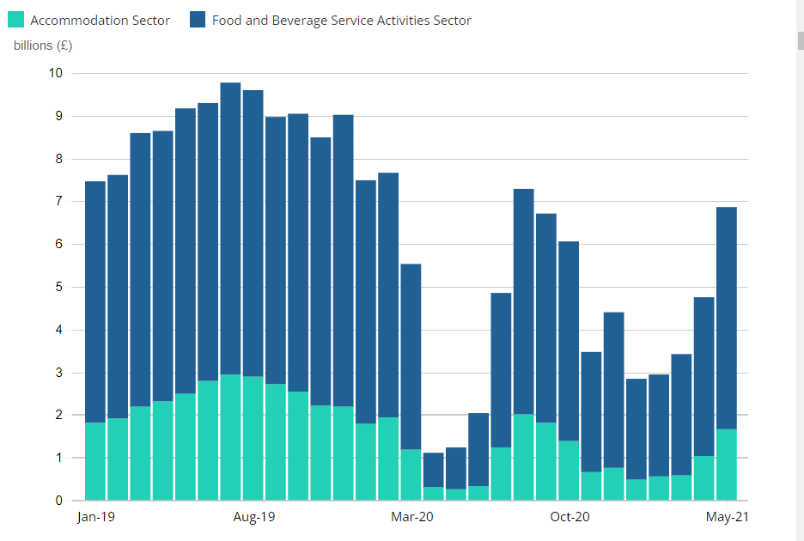
Figure 2 Revenue Hospitality Industry UK Source: (ONS, 2021)
The restrictions due to the pandemic lowered down the output of the hospitality industry by 42% in 2020 as compared to 2019. The share of the hospitality industry also fell from 3% to 2% (Nadkar, 2020). The hospitality industry in the UK and even worldwide have seen the effects of the Brexit, which acted as a transition period for them and after the pandemic lockdowns and restrictions from the government because of Covid-19 has not only decreased the revenue but has moved the industry to adopt the changes with most of the proportions of the business temporarily closed. The graph shows the business turnover for the accommodation and food & beverages sector in the UK from the years 2019 to May 2021 (ONS, 2021). It can be seen on the graph that the revenue generated by the sector in 2020 is 1.2 billion as compared to the 3.4billion in the year 2021 when the restrictions are partially eased. However, this is only 25% of the total income of the sector from pre-pandemic levels.
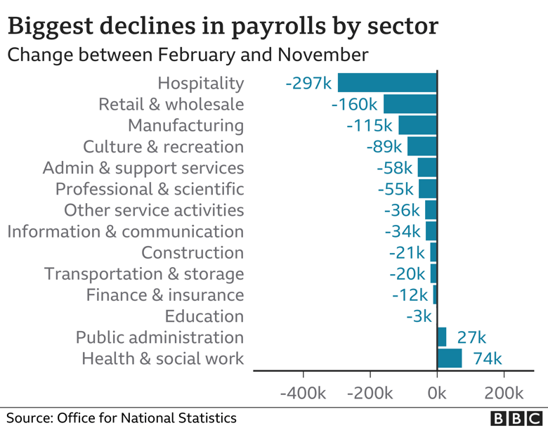
Figure 3 Unemployment Rate Source: (King 2021)

Premier Inn and Pandemic Effects
Premier Inn has also seen a major setback to its sales and revenue because of the pandemic. The brand has faced a major closure because of the lockdowns and travel restrictions. The main pandemic affects that the hospitality industry faces is reduction of the jobs. Due to the pandemic, hotel chains such as Premier Inn also faced difficult times and cut up to 6000 jobs in their hotels and restaurants (Nadkar, 2020). The competitors of the hotel, such as Holiday Inn, have announced a 10% reduction in jobs at the corporate level. It comprised of 18% of the total workforce of the company and expected a large proportion to work voluntarily. The share of the company also fell by 2.9%, and the company faced the worst hit by the pandemic because of the cancellation of the business trips and holiday trips. However, some analysis claims that the pandemic masked the effects of Brexit on the UK hospitality industry. The total loss of sales reported was of 1 billion British pounds (Kollewe, 2021). These all circumstances demanded the urgency to apply a change management model to boost the sales of the hotel. Now, the reopening of the hotels had made the hotel chain to manage the sales and had seen strong demand in the UK seaside towns and tourist spots; however, the demand is remained subdued in major urban areas and London. The hotel is now hoping for an increase in sales as the travel restrictions have been completely lifted up. For this purpose, the hotel has gone through many changes, which were mostly to adopt the new normal and evaluate the business requirements after the lifting up of the restrictions. The changes that are happening for the Premier Inn can be effectively studied in the light of change management models.

Change Management Models
The change management model is referred to as the process of renewing the organisation's direction, structure and capabilities (Galli, 2018). It is used to serve as the methodology to meet the changes required in an organisation because of internal and external factors. The concept behind the change management models is to guide when the changes are happening, navigating the companies when the transformation process is happening and ensure that these changes are accepted and are practicable afterwards. There are several models that can be used to increase the success rate of change management. However, the top models include Lewin’s change management model and McKinsey's 7-S model (Galli, 2018).
By utilising the model, the roadblocks can be identified and anything that is causing friction. Furthermore, the change management model will help in creating the short-term goals and make the change management plan achievable. Therefore, momentum can be kept while the process of implementation is performed. Change management models that could be used for Premier Inn and its situational crisis can be Lewis's change management model. It is a simple and effective model that can reflect the measure required to accommodate the changes for Premier Inn hotel.

Lewis Change Management Model
Kurt Lewin developed the model known as the Lewis change management model and is popular because of its three- stage plan, also known as Lewin’s 3-stage model of change (Hussain et al. 2018). The model breaks down changes into more manageable parts. These parts are called as stages to Unfreeze, Change and Refreeze. The steps that are working in continuation, such that the unfreeze stage is to wait and stop at the current process happening in the organisation and analyse how it can be improved so that everyone who belongs to the company can understand the need for the change (Lewis, 2014). Then later came the second stage, which is the change and to implement the desired changes, which further required guidance for the employees throughout this period. Lastly, when the desired changes have been deployed, then according to the feedback, the company must refreeze the desired change. This is indeed an ongoing process; however, the changes developed in such a way are sustainable and are easy for the management to handle. However, it must be understood that the few phases do not guarantee a fast finish of the process; adequate training and a long period of time are required to overcome the resistance. Furthermore, the model is used to make wide changes in the organisation, such as pandemics and their effects (Lewis, 2014).
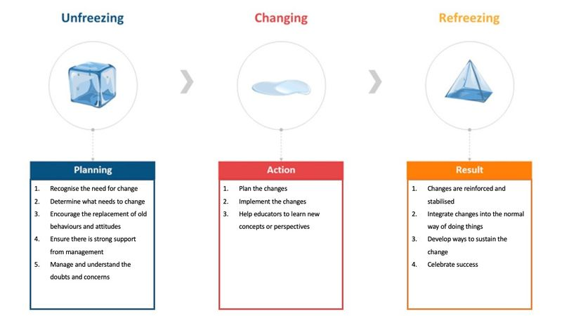

Resistance
The need for the change and the use of the model is described in the section above also; a detailed analysis of the fallback of the hospitality industry and Premier Inn hotel have also been highlighted in the previous sections. Therefore, a list of major challenges faced by Premier Inn that acted as resistance for the changes required in the company is mentioned below. These resistances are for most of the hotel chains in the UK and worldwide other hotel chains since the pandemic was a global issue and was new for everyone. Therefore, the change model will work as a guideline for most hotel chains suffering from the issues created by the pandemic on to their sales, revenues, brand image etc. (Le, 2021).
- The decline in sales because of the travel restrictions, border restrictions and lockdowns.
- Unavailability of guidelines to reopen.
- The unemployment rate is increasing due to the unavailability of funds to pay.
- Unavailability of a healthy working environment.
- Less availability of the digital models to engage the consumers and the digital marketing.

Application of Model
To evaluate and understand the demand for change for Premier Inn hotel Lewin’s change management model is proposed. There are three stages of the model unfreeze, change and refreeze (Hussain et al. 2018).

Stage: Unfreeze
Conditions: The declining sales of the hotel Premier Inn due to pandemic lockdowns and cancellation of business trips and holiday trips, increasing unemployment rate and the inability of the industry to pay the employees as well to accommodate them with limited sales, use of limited manpower for business operations, and Covid health and safety guidelines which the industry was unsure in the beginning and later it became mandatory to accommodate within the management (Hutton, 2022).
For this stage, the Premier Inn and even the other hotel chain was unaware of how and when the guidelines will come up. Therefore, most hotels shut down their major operations, which was a wise decision as it would at least reduce the overhead cost they are bearing, including the utilities. The closing has limited the expenses in the hard times till they have the guidelines to open. Furthermore, it provides them time to manage and rethink the strategy that they can follow for later while gathering the employees and management on the same page. This assists in managing the change in an effective way because everyone is aware of the changes that are happening (Dube et al., 2021).

Stage: Change
The hotel industry has already seen difficult times; therefore, to increase the generation of revenue while complying with the new normal is the ultimate goal of the organisation. Therefore, hotels must keep the local travel agents in an alliance so that the local operations can restart. This will help in reducing the rate of unemployment that has been created because of the lack of funds available. Opening of restaurants with food delivery services to increase sales as dine-inns are closed will further help the hotel chains to boost their sales. The adoption of digital marketing can assist in creating a platform for the hotels such as Premier Inn to create a brand image in a new way so that it gives benefits to both consumers and the company. The locals would be able to enjoy food, while the company will enjoy the sales as well as will stay connected and engage with the consumers. Job rotation and sharing for employees with other hotel chains is another solution to both problems, i.e., lack of funds and unemployment. Lastly, the reduction of the operational cost by fully closing the hotel floors if the lockdown persists or the continue somehow again in future. Compliance with Covid – 19 guidelines and staying stuck to them will help reduce the chances of less resistance in future (Davahli et al., 2020).

Stage: Refreeze
Development of practices such as building constructive feedback mechanism among employees that keep up the morale high in difficult times, building a feedback mechanism using digital platforms from the employees as well as consumers to ensure that correct measures have been taken. Necessary compliance with pandemic guidelines to restart the business as soon as lockdowns are lifted up, health and safety protocol so that people feel safe while choosing Premier Inn for their business and holiday trips (Kim, 2020).

Recommendation
- Digital marketing and auditing of the marketing assets can ensure from where the company can boost its sales and the reasons behind the choosing and not choosing the hotel. It will help in optimising the new actions required/ strategy and promoting again when the business starts picking up.
- Ensure the consumers about the complete awareness and compliance with the covid -19 guidelines and ask them to share about their knowledge and experience about the hotel.
- Management of revenue by continuing the short-term forecasts that predict the travel demands in future.
- Start adding extra value to the business instead of offering more discounts to boost sales.
- Implement SOPs for the food and beverage dine-in and delivery system for locals as well.

Conclusion
The pandemic has greatly affected the hotel industry under which the UK's biggest hotel chain Premier Inn also faced difficult times. The hospitality industry has been hit hard by the pandemic, and the impact was even worse on the clubs and bars for a year almost. The spending of the consumer, though, started increasing after the mid of 2021 when the restrictions lifted up, but it remained below 70% of the pre-pandemic levels. Therefore, the change management model can be used to go through the tough times effectively and efficiently. It is proposed that versatile leadership and Lewin’s change management model can be useful to combat the aftereffects of the Covid-19. Change management is an ongoing process; however, the changes developed in such a way are sustainable and are easy for the management to handle. However, it must be understood that the few phases do not guarantee a fast finish of the process; adequate training and a long period of time are required to overcome the resistance. Furthermore, the model is used to make wide changes in the organisation, such as pandemic and its effects.

References
Davahli, M. R., Karwowski. W., Sonmez, S. and Apostolopoulos, Y. (2020) The hospitality industry in the face of the COVID-19 pandemic: Current topics and research methods. International Journal of Environmental Research and Public Health, Volume 17, p. 7366. Available at: doi:10.3390/ijerph17207366 (Accessed: 30th June 2022)
Dube, K, Nhamo, G. and Chikodzi, D. (2021) COVID-19 cripples global restaurant and hospitality industry. Current Issues in Tourism, Volume 24, p. 1487–1490. Available at: https://doi.org/10.1080/13683500.2020.1773416 (Accessed: 28th June 2022)
Galli, B. J. (2018) Change management models: A comparative analysis and concerns. IEEE Engineering Management Review, Volume 46, p. 124–132. Available at: https://www.tandfonline.com/doi/full/10.1080/13683500.2020.1773416 (Accessed: 28th June 2022)
Hussain, S. T. et al., (2018) Kurt Lewin's change model: A critical review of the role of leadership and employee involvement in organizational change. Journal of Innovation & Knowledge, Volume 3, p. 123–127. Available at: https://doi.org/10.1016/j.jik.2016.07.002 (https://www.sciencedirect.com/science/article/pii/S2444569X16300087) (Accessed: 28th June 2022)
Hutton, G. (2022) Hospitality industry and Covid-19.
Available at: https://commonslibrary.parliament.uk/research-briefings/cbp-9111/#:~:text=Overall%2C%20hospitality%20economic%20output%20over,2%25%20in%202020%20and%202021. (Accessed: 28th June 2022)
Kim, R. Y. (2020) The impact of COVID-19 on consumers: Preparing for digital sales. IEEE Engineering Management Review}, Volume 48, pp. 212-218. Available at: DOI:10.1109/EMR.2020.2990115. (Accessed: 30th June 2022)

King, B. (2021) Unemployment rate: How many people are out of work?.
Available at: https://www.bbc.com/news/business-52660591 (Accessed: 30th June 2022)
Kollewe, J. (2021) Premier Inn owner Whitbread swings to £1bn loss amid Covid lockdowns.
Available at: https://www.theguardian.com/business/2021/apr/27/premier-inn-whitbread-loss-covid-lockdowns-beefeater-brewers-fayre (Accessed: 28th June 2022)
Le, D. and Phi. G. (2021) Strategic responses of the hotel sector to COVID-19: Toward a refined pandemic crisis management framework. International Journal of Hospitality Management, Volume 94, p. 102808. Available at: https://doi.org/10.1016/j.ijhm.2020.102808.
(https://www.sciencedirect.com/science/article/pii/S0278431920303601)(Accessed: 1st July 2022)
Lewis, L. (2014) Change management. Meeting the Challenge of Human Resource Management, pp. 146 - 156.
Lock, S. (2021) Whitbread annual revenue 2019-2021, by segment.
Available at: https://www.statista.com/statistics/739891/revenue-whitbread-united-kingdom-uk-by-segment/ (Accessed 28th June 2022)
Lock, S. (2022) Hotel occupancy rate in London (UK) 2008-2022.
Available at: https://www.statista.com/statistics/323719/annual-hotel-occupancy-rate-in-london-uk/ (Accessed: 30th June 2022)
Nadkar, T. (2020) Premier Inn owner to cut 6,000 jobs due to pandemic hit. [Online]
Available at: https://www.reuters.com/article/us-whitbread-layoffs-idUSKCN26D0LY
(Accessed: 28th June 2022)
ONS (2021) Coronavirus and its impact on UK hospitality: January 2020 to June 2021.
Available at: https://www.ons.gov.uk/businessindustryandtrade/business/activitysizeandlocation/articles/coronavirusanditsimpactonukhospitality/january2020tojune2021 (Accessed: 30th June 2022)
PremierInn (2022) About us.
Available at: https://www.premierinn.com/gb/en/why.html (Accessed: 28th June 2022)
Terence, B. (2022) UK Economic Strategy Presents Opportunity for Businesses, Including Hotels, To'Level Up’. Available at: https://vtechworks.lib.vt.edu/bitstream/handle/10919/109340/UK%20Economic%20Strategy%20Presents%20Opportunity%20for%20Businesses%2C%20Including%20Hotels%2C%20To%20%27Level%C2%A0Up%27.pdf?sequence=1&isAllowed=y (Accessed: 28th June 2022)
Trisna, B. and Lu, C. (2020) The Adoption of Versatile Leadership to Cope with Aftereffect of COVID-19 in Jakarta Hotel Industry: Lewin’s Three Stages of Change Approach. Available at: https://www.researchgate.net/publication/355040976_The_Adoption_of_Versatile_Leadership_to_Cope_with_Aftereffect_of_COVID-19_in_Jakarta_Hotel_Industry_Lewin%27s_Three_Stages_of_Change_Approach (Accessed: 28th June 2022)

