Community Engagement
The Community Management of Fujitsu
Carmen Georgiana Marcut 2028979
Dr Olu Adegbite

Introduction
Communities are the driving force behind this innovative world (Akland, 2011). Fujitsu is a global technology leader, providing innovative solutions that help their customers in every aspect of their lives. It is an engineering and electronics company that has been developing its business widely through clear, inspiring purpose for more than 60 years. The company’s vision: “Make IT Bigger and Better”, underpins all its operations globally. The main aim of this report is to provide an up-to-date overview of the Fujitsu UK community engagement strategy, themes and its approach to engaging with those communities it feels most important to have close links with. The report looks at the internal community engagement strategy, how it is set up and managed, who are involved in the process and what support is available internally. It also includes a review of many of the processes like job requirements of the staffs and ways of acquiring them that take place as part of this strategy.
Discussion and Analysis
1. Usage of human and material resources to better improve lives in the community
Human resources combined with the material ones are the primary assets for a company (Budiani, 2020). Fujitsu has used its human and material resources to better improve lives in the community. They have employed an approach to meeting the needs of the community by collaborating with other local organizations, governments and NGOs to find solutions to social problems. This collaborative work relationship has helped them identify a wide range of programs that are most effective at addressing various issues across the region. In addition, they have also supported projects which run parallel to Fujitsu’s own business objectives. The company has been providing help and support through training, job creation by introducing technology, and creating new programs targeted to specific needs of the community (Howard, 2015). Fujitsu has been trying to change lives in the community by providing professional opportunities for people, who otherwise might not have the chance. The company provides for future leaders who, in turn, help others. At Fujitsu, they believe that human and material resources should be channeled toward supporting the communities in which they work and live. As a result, they have a firm belief in their community support model which focuses on three core values:
- Promote social awareness and understanding,
- Advance education and research,
- Advancing contributions to science and technology for future generations
Fujitsu is a company that is responsive to changing market needs. As a result, technology and data have been used to learn more about the needs of customers and help them better understand new products and services. To compete in today’s dynamic business world successfully, the integration of technologies with the company operations is a must (Bhattacharya and Sen, 2004). Fujitsu also gives employees the opportunity to explore these ideas as well. Fujitsu is a world leader in creating solutions for businesses and people to improve the way they work and live. They are committed to delivering high-value technology and services that are essential to the world’s most demanding customers. Fujitsu helps their customers create and implement solutions that harness the power of big data, artificial intelligence and cloud technologies to transform the way they compete, enhance productivity and improve lives.
2. Key themes upon which Fujitsu carry out its community engagement activities
While carrying out the community engagement works, businesses tend to base them upon some pre-selected themes (Jones, Felps and Bigley, 2007). The Fujitsu Group has been committed to inclusive business practices since it was founded as a technology company in 1946. They are constantly working with their community partners on initiatives that promote diversity and inclusion, particularly at the grassroots level. The key themes upon which Fujitsu UK carry out its community engagement activities include, innovation, open and inclusive culture, career development and community development, as well as promoting volunteering. Fujitsu UK community engagement is focused on supporting people who are thinking of helping to bring companies and businesses together, improving their skills and capabilities as communicators, helping them to introduce themselves in a way that will help businesses across the world to be more efficient. Fujitsu has a long history of supporting communities, especially business communities. From providing technical support on setting up new businesses, through piloting and showcasing new technologies at events such as Summer Jam and Solutions Day. An example of their ethical behavior is working towards reducing the company’s carbon footprint by investing in renewable energy projects.
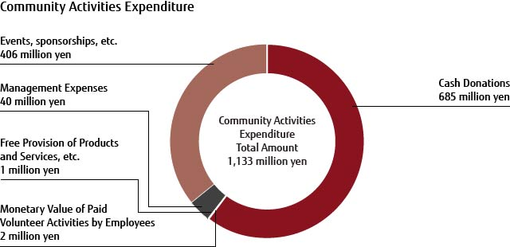
Fujitsu wants to encourage people to live as independently as possible and make the world accessible. Fujitsu carry out community engagement activities through its website, social media platforms and in-person meetings. Online and offline both presences are required for business organizations out there (Jones, Felps and Bigley, 2007). The company aims to provide its products and services with effect by integrating human values into all aspects of their business. This can be seen through their charitable contributions. In this process, they also facilitate interactions between community. members on different levels in order to create a strong sense of belonging in the communities that they serve; this is done by creating an identity for them as Fujitsu people and towards enhancing the connection among community members. The company has set out a number of key community success factors, which includes providing access and support for people with disabilities, improving diversity within the company and increasing female representation at senior level.
Figure 1: Community activities by Fujitsu (Fujitsu, 2022)
3. Service users of Fujitsu and their requirements
Fujitsu is the UK's leading IT service provider, with more than 4,000 employees in 110 offices across the UK (Fujitsu UK, 2022). Fujitsu service users in the UK work in a wide range of industries including finance, energy, healthcare and education. More service users include businesses and business units from various national, regional and local government departments, commercial organizations and private sector organizations. They use these products in buildings and vehicles such as servers and laptops, state-of-the-art information storage systems and digital cameras. Most of the customers are internal departments such as those within financial services or retail firms. Their customers are also some blue-chip companies such as Zurich Insurance Company, Zurich Transport UK and Zurich New Zealand Limited.
They require Fujitsu's technology solutions, business accelerators and expertise in producing end-to-end solutions that enable them to grow their business sustainably. They are using Fujitsu’s IT services and products to deliver solutions for their needs. As a service user, they expect an approach from Fujitsu that is responsive, flexible and innovative to meet their business requirements in the most cost-efficient manner possible. Fujitsu’s primary goal is to continually improve their service standards for all service users.
4. Importance of the community engagement role in Fujitsu’s business
The community engagement role plays an important role, especially in the large businesses (Carroll and Shabana, 2010). For Fujitsu, it helps to ensure that they work with their customers and suppliers to develop future-ready technologies that enable new opportunities and make a positive impact on society. The company focuses on technology, product and service innovation, supporting professional communities and people-to-people connections to foster a better future for all through their efforts lead by their customers, employees and partners. As a leading manufacturer in the world of IT and services, Fujitsu creates new opportunities for its clients. To aid this progress, Fujitsu strongly believe that having a well-defined process is vital to achieving this objective by creating a clear understanding of community requirements and expectations.
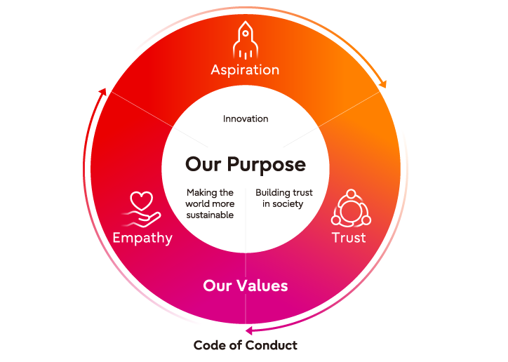
Figure 2: Fujitsu way of community engagement (Fujitsu, 2022)
5. Skills and knowledge needed for Fujitsu staffs to successfully carry out community engagement activities.
Fujitsu’s community engagement is widely known for its high-quality approach, engaging with the local community to understand their needs. Their community interactions are designed to connect and grow relationships with their key stakeholders, by fostering a connection between the Fujitsu team and their community partners. They help them develop and provide relevant services that benefit their communities.
To successfully carry out such engagement activities, a strong understanding of the needs, culture and issues of residents/communities is an essential element for a successful community engagement approach (Bhattacharya and Sen, 2004). A profound level of local knowledge about the area is also required to target the correct community and engage it effectively. The skills required are: - communication skills to collect and use information, which facilitates community engagement activities, a good understanding of the business benefits of working with customers and the community, listening ability and empathy, technical knowledge including data analysis skills and project management experience, business acumen and creativity (Carroll and Shabana, 2010). The knowledge required to carry out community engagement activities is to identify the needs and/or identified needs of the community; as well as to understand how particular needs have been solved by previous projects (community leaders and residents). The ability to build trust with local communities and an appreciation of cultural diversity also needed.
6. Acquisition of the identified skills
It is important to ensure that all staffs of Fujitsu acquire the skills for community engagement and contribute in a meaningful way. Community engagement efforts may be about making a difference in the lives of individuals and communities, becoming more aware of environmental issues, or providing support for those who are disadvantaged (Howard, 2015). The Fujitsu staffs should start by considering how they can identify their own personal passions and skills, as well as those of their colleagues. The Staffs of Fujitsu can acquire the skills for community engagement by practicing and enhancing their ability to influence, motivate and interact with people around them. This will help improve communication between staff and community, encouraging mutual understanding. Staffs need to gain knowledge about the community they are serving in order to understand individual and societal needs (Budiani, 2020). For instance, they must learn what is important for the community. They should use this knowledge to foster better quality interactions between themselves and their customers or clients.
Community engagement is a key focus for Fujitsu, and many of their staff have been trained in community outreach. This internal training will help them to better understand the needs and concerns of the communities Fujitsu works with. Community engagement initiatives can be implemented with multi-lingual staff and partners, who are used as a resource to develop new ideas or solve problems by bringing their experience and expertise to the table (Akland, 2011). Fujitsu also wants to identify the potential causes of community disconnections, so that their staffs can provide solutions where possible.
The results of a survey conducted by Fujitsu UK in 2015 shows that more than half (52%) of Fujitsu’s workforce in the UK receive training on a regular basis, which is significantly higher than the UK average (32%). One-third (34%) of employees have attended training over the past 12 months, an increase from 26% in 2014/15 (Fujitsu UK, 2022). In addition to this, around 20% of employees have attended formal education with their company over the same time period (Fujitsu, 2022).
Conclusion
Fujitsu is a world leader in IT and telecom solutions. The company takes pride in delivering professional service and technology that keep businesses competitive in a fast-moving environment, while at the same time ensuring that people and the environment are protected. This is reflected in Fujitsu’s business Code of Conduct which aims to foster an ethical and responsible working culture within the company. The code also promotes positive relationships with customers, employees, suppliers and other stakeholders by acting in accordance with their values: integrity, respect for others, respect for diversity. A thorough review of Fujitsu UK and its community engagement has been undertaken in this report. Some areas have been identified yet for improvement including locating the key stakeholders in our target market; understanding the potential of customers and employees; supporting the development of our impact on society both through direct value creation as well as supporting a sustainable society. The key lessons that Fujitsu has learned from its community engagement projects are: building relationships with customers, through both in-store and e-commerce initiatives, is a key differentiator of their service; offering specialist advice is a great way to build up goodwill; a specialized team makes it easy for any business to show expertise and knowledge about the brand in question: this means that brands help people understand why their services are relevant to them; being helpful at all times is key; as part of community strategy a company needs to work with other brands within its own market which enables all to leverage each other’s strengths rather than compete.
References
Akland, G., 2011. Community Engagement: A Model Partnership. Journal of Community Engagement and Scholarship
Bhattacharya, C. and Sen, S., 2004. Doing Better at Doing Good: When, Why, and How Consumers Respond to Corporate Social Initiatives. California Management Review
Budiani, I., 2020. Enhancing the community engagement of UK Companies through the implementation of the Social Life Cycle Assessment (SLCA). Journal of Community Engagement
Carroll, A. and Shabana, K., 2010. The Business Case for Corporate Social Responsibility: A Review of Concepts, Research and Practice. International Journal of Management Reviews
Du, S., Bhattacharya, C. and Sen, S., 2007. Reaping relational rewards from corporate social responsibility: The role of competitive positioning. International Journal of Research in Marketing
Elsbach, K., 2003. ORGANIZATIONAL PERCEPTION MANAGEMENT. Research in Organizational Behavior
Fujitsu UK. 2022. Fujitsu UK. [online] Available at: <https://www.fujitsu.com/uk/> [Accessed 28 June 2022].
Fujitsu.com., 2022. [online] Available at: <https://www.fujitsu.com/uk/imagesgig5/Community_Plan_2019_Final.pdf>
Fujitsu.com., 2022. Community Involvement & Development: Fujitsu UK. [online] Available at: <https://www.fujitsu.com/uk/about/local/corporate-responsibility/responsible-business-report/social-action/>
Howard, M., 2015. Fujitsu tech turns biometric data into a cryptographic key. Biometric Technology Today
Jones, T., Felps, W. and Bigley, G., 2007. Ethical Theory and Stakeholder-Related Decisions: The Role of Stakeholder Culture. Academy of Management Review
Markets.financialcontent.com., 2022. [online] Available at: <https://markets.financialcontent.com/publicradio/article/jcnnewswire-2022-6-15-fujitsu-commits-to-the-uks-science-and-technology-superpower-potential> [Accessed 28 June 2022].
Perks, K., Farache, F., Shukla, P. and Berry, A., 2013. Communicating responsibility-practicing irresponsibility in CSR advertisements. Journal of Business Research

