A study to Explore the Word Length Effect
Introduction
Memory can be defined as ‘the ability to retain information or a representation of past experience, based on the mental processes of learning or encoding, retention across some interval of time, and retrieval or reactivation of the memory’ (APA, 2022). Memory is essential to everyday life and is the essence of what makes an individual unique, using past experiences to operate in the present and future, not just memorising information, it is in fact the process of acquiring, storing and then retaining information to be used later, however, this process is not entirely full proof, and memories can become distorted or even forgotten (Glenberg, 1997).
There are several memory theories, one being the working memory model, Baddeley and Hitch, (1974) proposing three components to the working memory model: visuospatial sketchpad, central executive and the phonological loop (Baddeley, 2001). Baddeley and Hitch (1974) describe the phonological loop as the component of working memory model dealing with auditory information, separated into two different stores: phonological store; temporarily holding verbal information, and articulatory loop; enables short strings of words to be remembered by repeatedly rehearsing.
Baddeley et al. (1975) suggested that within the short-term memory, should two word lists be displayed, one of short words the other longer words with more syllables, an individual would recall a higher number from the short list compared to the long list, known as the word-length effect. This can be explained as short words can be articulated more quickly, meaning that before they decay, more short words can be silently articulated (Baddeley et al., 2002).
Further experiments into the word-length effect have been carried out using similar methods to Baddeley et al. (1975). One such experiment by Ellis and Hennelly (1980) conducted a bilingual version of the original study. This experiment was part of an intelligence test, the outcome showing poorer results for the Welsh children compared to children in America of the same age, although when looked at more closely, Welsh digits took longer to articulate than their English counterparts, demonstrating a bilingual word-length effect rather than intellectual differences as the cause (Ellis and Hennelly, 1980).
Neath and Nairne (1995), however, suggested that memory is worse when a word takes longer to pronounce, regardless of the length of the word, even with the same number of syllables and number of phonemes and thus arguing that word-length effects cannot adequately justify the inclusion of time-based decay components within the theories of memory.
There is evidence from various sources supporting this study, one deriving from experiments by Britton et al. (1982). Britton et al. (1982) studied what demand text processing had on a learner’s cognitive capacity, firstly exhibiting a version of text with simplified vocabulary and structure, although maintaining meaning of the original text, results suggesting that, despite no significant difference in correct answers given, it could be concluded that less cognitive capacity was required to process this text compared to standard versions. Secondly, Britton et al. (1982) ascertained that the reduction in requirement of cognitive capacity in experiment one was essentially due to syntactic factors, this is when more common vocabulary and more simple syntax had been used within the text. Finally, Britton et al. (1982) suggested that less cognitive capacity was required when reading a more complex piece of text including key words and phrases, thus assisting the reader as a cue or signal towards important connections within the text, in comparison to text that displayed no signals within it, allowing the assumption that with said signals omitted from the text the reader would have to assume their own connections and increasing capacity.
Further research into the importance of cognitive capacity was completed by Niaz and Logie (1993) who looked specifically at science students and the need for correct processing capacity for successful study outcomes. Niaz and Logie (1993) saw a need to organise the terminology within the science education literature, although within this research there was still no agreement on what would be appropriate. Niaz and Logie (1993) looked at two models regarding information processing, mental capacity developed by Pascual-Leone and colleagues and working memory developed by Baddeley and colleagues, concluding that, despite neither having directly looked at science education, elements of the working memory could prove beneficial in assisting with processing capacity within science education.
This study was a partial replication of Baddeley et al. (1975) and was conducted for educational purposes and to highlight the implications on a student’s work, should they become overloaded with study.
The aim of this study was to see if the word length effect is correct, and does exist, influencing memory recall.

Hypothesis
Participants will recall significantly more short words than long words.

Method
Design
A within-subjects design was used. There was one independent variable with two conditions: the length of the word recalled, long or short. There was one dependant variable: how many words were recalled. Participants took part in both conditions of the experiment.
Participants
A convenience sample of 26 participants completed both conditions of this study: 26 female and 0 male. Ages ranged from 18 to 49 years (M = 29.42 years, SD = 3.79 years). Participants were all undergraduate students from West Wales who took part in the study. All participants were naïve to the purpose of the experiment.
Materials
- Computer
- Whiteboard/screen
- Pen
- Paper
Stimuli used: two word lists, fifteen long words (see appendix 1), and fifteen short words (see appendix 1) chosen by chief researcher.
Long words included: forgiveness and proximity.
Short words included: mood and snore.
Words were white in the middle of the screen on a blue background.
Font used was Arial and size 72.
The words were held on the screen for one second and then the next word was shown after another second.

Procedure
(See appendix 2).
Results
The following results present the findings for the study word-length effect.
Chart 1
Median scores for the long and short words recall.
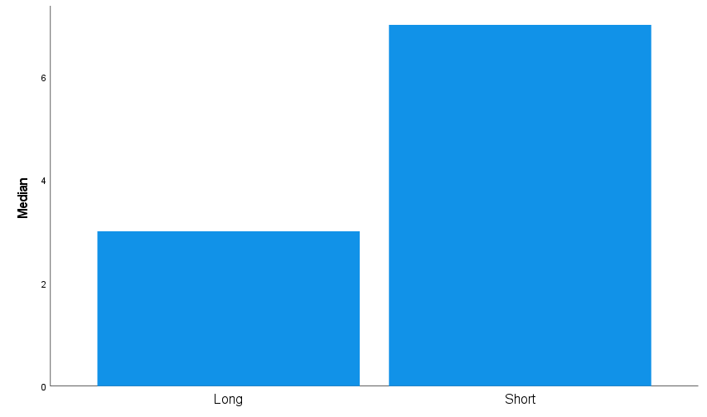
The chart above shows the median score for long and short words. The median was higher for the shorter words.
To examine if the median for both conditions are significantly different to the probability of .05, the nonparametric Wilcoxon statistical test was carried out.
A Wilcoxon signed-rank test showed a significant difference between the long and short words condition (Z = -4.136, p = .001). Median recall scores for short words were significantly better than for long words (7.00 and 3.00, respectively).
The results indicate that the hypothesis, participants will recall significantly more short words than long words, was supported and provides support for the word-length effect.
Reference List
American Psychological Society. (2022). APA Dictionary of Psychology: memory. Dictionary.apa.org. https://dictionary.apa.org/memory
Baddeley, A. (2001). Is Working Memory Still Working. European Psychologist, Vol. 7, No. 2, June 2002, pp. 85–97 DOI: 10.1027//1016-9040.7.2.85
Baddeley, A. D., Thomson, N., & Buchanan, M. (1975). Word length and the structure of short-term memory. Journal of verbal learning and verbal behavior, 14(6), 575-589.
Baddeley, A., Chincotta, D., Stafford, L., & Turk, D. (2002). Is the word length effect in STM entirely attributable to output delay? Evidence from serial recognition. The Quarterly Journal of Experimental Psychology Section A, 55(2), 353-369.
Britton, B. K., Glynn, S. M., Meyer, B. J., & Penland, M. J. (1982). Effects of text structure on use of cognitive capacity during reading. Journal of Educational Psychology, 74(1), 51.
Ellis, N. C., & Hennelly, R. A. (1980). A bilingual word‐length effect: Implications for intelligence testing and the relative ease of mental calculation in Welsh and English. British Journal of Psychology, 71(1), 43-51.
Glenberg, A. M. (1997). What memory is for. Behavioural and brain sciences, 20(1), 1-19.
Neath, I., & Nairne, J. S. (1995). Word-length effects in immediate memory: Overwriting trace decay theory. Psychonomic Bulletin & Review, 2(4), 429-441.
Niaz, M., & Logie, R. H. (1993). Working memory, mental capacity and science education: towards an understanding of the ‘working memory overload hypothesis’. Oxford Review of Education, 19(4), 511-525.

Appendices
Appendix 1:

Appendix 2:
Appendix 3:

Appendix 4:

Appendix 5:
Raw Data:
Long – Condition One | Short – Condition Two
3 | 5
4 | 6
4 | 7
2 | 3
3 | 9
3 | 7
4 | 7
4 | 9
2 | 7
3 | 6
6 | 8
7 | 9
3 | 7
5 | 7
4 | 7
5 | 4
3 | 8
3 | 3
6 | 8
3 | 4
4 | 7
4 | 3
2 | 3
1 | 3
2 | 2
3 | 7

Appendix 6:
Median and SD for long and short words.

Wilcoxon Signed Ranks Test


