Presenting data: descriptive statistics
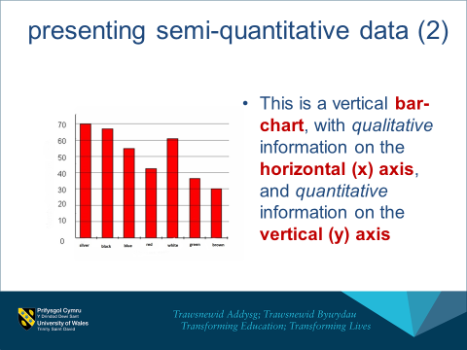
Measures of central tendency (ie. ‘middle’ values):
Mean: sum of all values divided by frequency
Mode: most common value
Median: value at the 50% frequency point
Measures of dispersion (spread)
Range: difference between the largest and smallest values
(also variance, and Standard deviation)



