

Assessment 1 – Reading Task Template
PART 1: Upload your photo of your A3 in-class notes here:
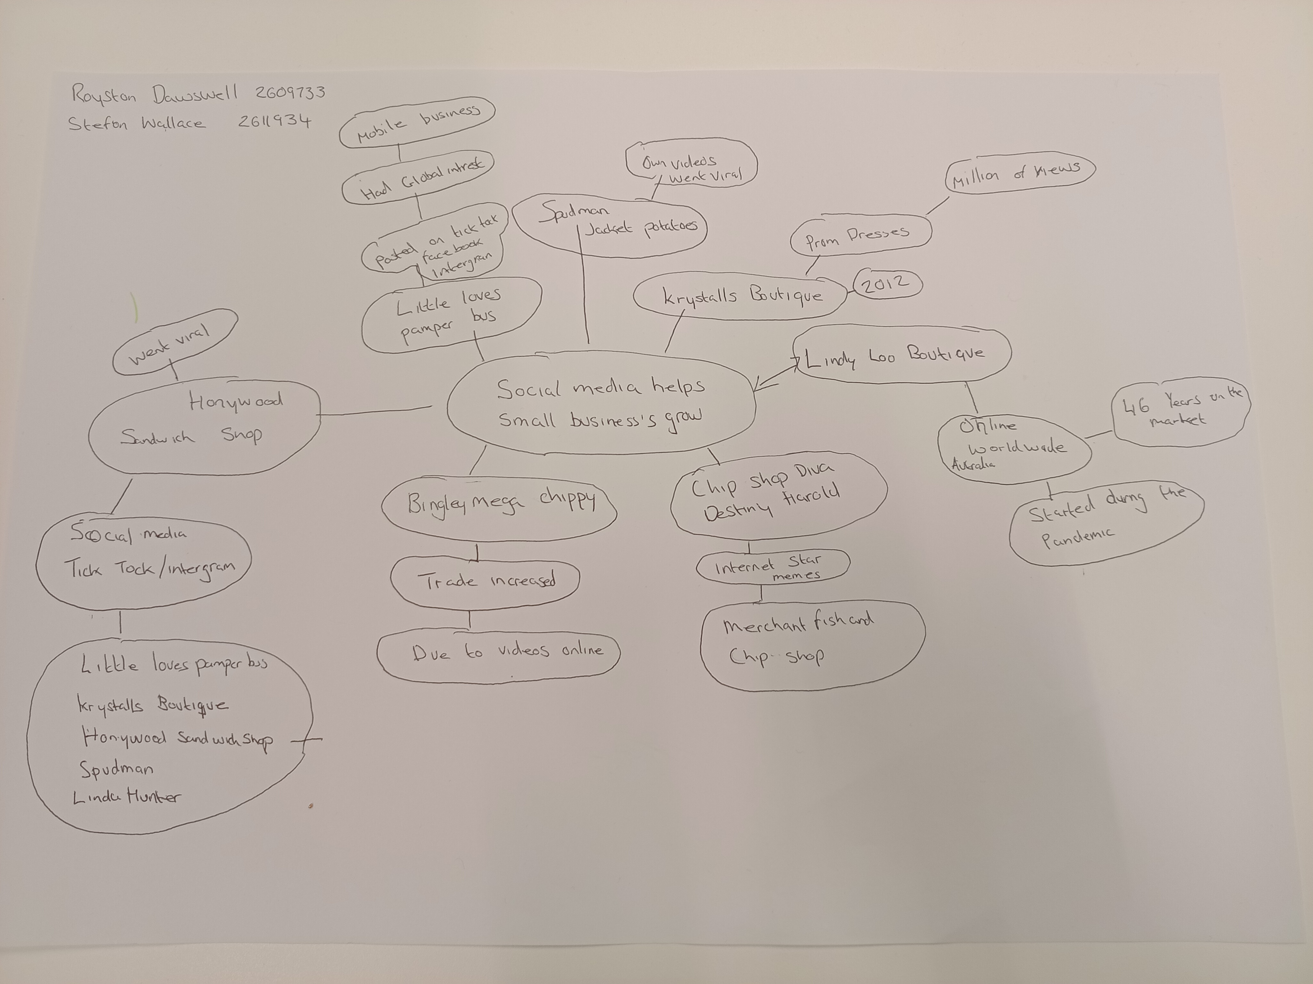

PART 2:
- Answer every question below in 1-3 full sentences.
- Use your own words. Do not use generative AI to answer these questions.
- Include a specific detail from the text when asked.
REMINDER
- The main idea is the overall message of the whole text.
- A key point helps to explain the main idea.
- A specific detail or example from the text shows that the key point is true.

- What is the main idea of the whole text?

The whole text about the central theme of the primary idea of the subject is analysing different small business’ social media methods that owners apply.

- What is one key point that supports the main idea, and which specific example from the text shows this?

Social media helps small businesses grow to a bigger scale; for instance, Linda hunter owns Lindy Loo’s boutique an online clothing shop as claimed by the government business academy, over two hundred million businesses globally are making use of Instagram to reach purchasers
Linda Hunter has transferred her business fully online and ships outfits throughout the UK and Australia.

- What is a different key point that supports the main idea, and which specific example from the text shows this?

The business uses the social media likes of TikTok, Instagram and videos online to grow the number of buyers.

- Which part of the text do you think is most important, and why?
Social media is a massive asset to starting a business because it brings brand awareness, and it could reach potential customers worldwide.

Reflection:
- What did you find difficult in this task (including in-class components), and why was it difficult?

What I find difficult in the classroom is the mind map; I rarely use it what difficult at first to understand how to use it.

- What helped you with this difficulty, and how did it help you?
What helped me with this difficulty, was revising the homework independently, and I understand it’s a lot more effective for me than in the classroom. I was able to take my time and have a much better understanding of the work I am set to do.

