Jacob Evans (2311160)
2311160@student.uwtsd.ac.uk
22/03/2024
Network and Cybersecurity Essentials
ACCA4024
Assignment

Table of Contents
Introduction 2
Part 1) 2
A) 2
B) 3
C) 4
i) 4
ii) 5
Part 2 – 6
A) 6
B) 7
i) 7
ii) 8
Conclusion 9
References 10

Introduction

This assignment is to showcase the importance of Network and Cyber Security, and how we can mitigate attacks and threats on a network. This report will answer the importance of the NIST Cybersecurity Framework, how useful tools such as Nmap and Wireshark are and how to mitigate malware and phishing attacks. The report will then contain a self-created network showcasing the steps implemented to make the network secure with high availability.

Part 1)

A)
The NIST stands for the National Institute of Standards and Technology, which is an agency founded in 1901. It is now part of the U.S. Department of Commerce. The framework was created to aid businesses in understanding, managing, and reducing cybersecurity risk. The framework gives a business a “framework” of the best practices that can be used to maintain secure networks and data [1]. This framework, as stated in the background information for this assignment, offers insight into recognising weaknesses, establishing protective measure, and safeguarding personal information and digital infrastructure against potential risks. The steps used in this framework provides important information to any specialist in the field of cyber security.

There are 5 important steps in the framework-
- Identify – example of this would be make a list of all equipment, devices, software, and data used in the business. This is to establish where the potential weaknesses/risks are when safeguarding any data. This stage allows us as the user to identify the weaknesses that an inside or outside attacker may use to gain access to the data. The “Reconnaissance” and “Weaponization” stages in the “cyber kill chain” would also identify this list to decide where to attack and which tools would be necessary.

- Protect – this would come under the administration and security. This area is to implement the necessary safeguards as well as organise information, enabling cybersecurity risk management decisions, addressing threats, and learning from past activities and threat attempts. The business would need to control who can log onto a network and device, update the security of the network and devices regularly, and train the users of these devices which avoids the risk and weakness. This again would make the “Reconnaissance” and “Weaponisation” stages harder for any attackers, as there are less weaknesses.

- Detect – this area would be to monitor the network and all devices. This area is useful to avoid the “Reconnaissance” and “Weaponisation” stages as if a cybersecurity user recognises unusual activities (unauthorised devices, outside source login attempts), then they may be able to defend/contain the breach of data before the “Delivery” stage is completed. Detection can also aid in case that the delivery stage was completed, as the detection may help understand by who, where and how the data was breached.

- Respond – this is the area before and after the “Delivery” stage in the cyber attack kill chain. If a breach was detected, then the user may be able to contain the breach before the “delivery” stage can be completed. If there is a breach, then a business should have a response ready by notifying all users (customers, employees) of the data breach, and to notify authorities. The business would then need to respond to this data breach by updating policies and procedures based on how the data was breached.

- Recover – this is the aftermath of a “successful delivery” stage. This would be the policies and procedures used to repair and restore any equipment/network faults/breaches to avoid any further instances.

The NIST framework is incredibly vital in maintaining secure data and infrastructure, especially in today’s society. As more and more data becomes digital and available on networks, there are more instances of cyberattacks.

B)

Nmap (Network Mapper) is first described as a “free and open source utility for network discovery and security auditing” [2]. Nmap allows the user to determine what hosts are available on a network and what services those hosts are offering, what operating systems each host is using, open and closed ports, firewalls, filters, and potential vulnerabilities.
Nmap was used to scan large networks quickly and accurately, which is incredibly useful for attackers/hackers during the “Reconnaissance” stage, as Nmap can provide information about the network topology and configuration, as well as provide a large amount of information about the hosts and devices. Nmap can use advanced function such as “banner grabbing”, which is “connecting to remote applications and observing the output” [3]. It is a technique used to “grab” information, and the results can then be used in the “Reconnaissance” stage as the attacker can reveal information on the compromised network. “Banner grabbing” can also be used by administration to detect how vulnerable their network is.
Nmap is considered “noisy”, as it generates a lot of traffic which can be detected (via the framework), and then blocked by prevention systems. Nmap also has a steep learning curve for beginners [4].

Wireshark (previously known as Ethereal) is a packet analyser. This can “intercept and log encrypted traffic passing over the ethernet port” [5]. This information intercepted is captured as a packet and can be decoded to capture large amounts of information about the “target”. Wireshark is used to “measure” the packet information [6]. This cannot be detected by an “intrusion detection system”, which would be ideal for the “Reconnaissance” stage as in gathers information efficiently without alarm.

C)

i)
WannaCry is a malware known as “ransomware”, where an attacker will block/encrypt data and demand a monetary ransom be paid. This data will not be accessible until the ransom is paid, to which the attacker will then allow users access to the data again.

WannaCry uses “EternalBlue”, “which enables attackers to use zero-day vulnerability to gain access to systems and data” [7]. WannaCry uses a worm malware which spreads quickly, by exploiting the vulnerability found in Microsoft’s public internet port 445. It appears on a computer as a “dropper”, which delivers and installs the malware.

There is a case study for WannaCry where an attacker encrypted data from the NHS in England on the 12th of May 2017, and then threatened to release the data. According to the case study, Microsoft were made aware of this potential attack 12 months in advanced and advised the organisation to install a security patch. Due to not installing this security patch, 200,000 PCs were infected as a result [8].

As stated in the case study, we can see that the best mitigation for the WannaCry attack would be to make sure the security and OS is updated correctly. Businesses are also advised to follow the NIST Framework to have a strategy against ransomware by prioritising the prevention, detection and recovery area of the framework [10]. WannaCry malware is usually sent through harmful emails, so organisations and businesses should invest in blocking spam or outside source emails, whether by training staff correctly or measures within the operating system.

TeleRAT uses the “Telegram Bot API” to communicate with the C&C (command and control) server to extract data. The TeleRAT first installs two files onto the device, with the first file containing device information, and then the second file containing a Telegram channel with a list of commands. The code can then inform the attackers and the malware then runs in the background. It will then receive commands to extract data (contacts, location, download files, images) [9]. The TeleRAT is known as an “Android OS Trojan”, which is a program that looks like a legitimate program but is disguised as this malware.

There are several ways to mitigate/avoid TeleRAT malware, with the most common ways being to avoid third-party applications, not allow application side-loading on devices, ensure that the application is legitimate and office and to check the application permissions before allowing access [10].

ii)
“Phishing” is described to be when attackers/hackers “send scam emails or messages that contain links to malicious websites, which can contain malware, to sabotage systems” [11]. The two examples stated in the question are “Whaling” and “Pharming”.

“Whaling” is the term used for when attackers send these scam emails to people “higher up” in the business, such as executives (more lucrative targets). These emails tend to contain information about the business/organisation to disguise the fact that the attack is an outside source. The email will usually be crafted “with a solid understanding of business language”, while conveying a sense of urgency [12]. This is all in the attempt to trick the recipient into clicking the links.

This can cause the loss of data, financial loss and damage to the business’/organisation’s reputation, as clicking one of the links causes a breach where the attacker can encrypt or extract the data. Whaling has even evolved to different forms of communication, such as text messages, phone calls, and even the messages “seemingly” coming from co-workers, friends, or family.

Businesses are encouraged to train employees in identifying a possible whaling threat, so the threat is prevented, but due to the evolution, businesses should be made aware that a whaling attempt could always happen, and therefore things should be put in place to mitigate the effects. Some of these can include regularly conducting phishing simulations, increased whaling and phishing security training, install anti-phishing software and implement multi-factor authentication [13].

“Pharming” is described as “phishing without the lure”, or “redirecting users to accessing fake websites to divulge personal information” [14]. This means that there is no specific target and the means of gaining information does not include a suspicious email. Pharming is the advanced form of creating a fake website to steal users’ information. The attacker will create a fake website which tricks the DNS server and directs the user to the fake website. The website may have a login or a store which will allow the user to input financial or login credentials, which the attackers can then use to steal more information.

Pharming can be a lot harder to spot, but there are several signs, such as website interaction and style (colours could be different, website looks incomplete and works badly, grammatical errors), web browser may warn the user that the URL is suspicious, as well as the URL showing as “http” rather than “https” [15].

Part 2 –

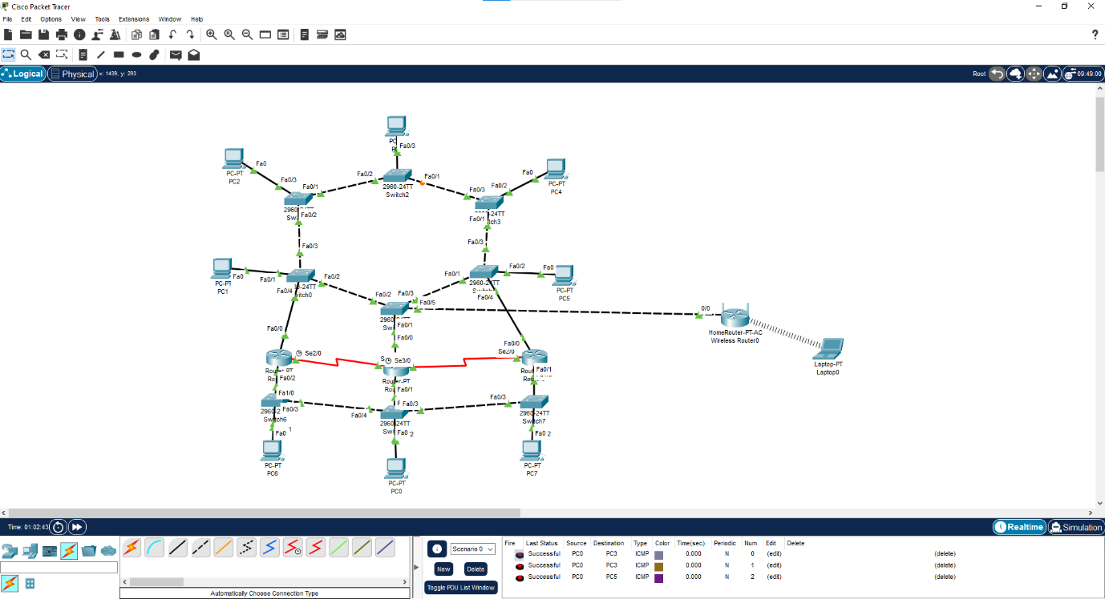
A)
The network created follows the Mesh Topology method. By following this, it creates less single points of failure, as data has multiple paths to follow, allowing for high availability. This is known as redundancy, which then also provides a reliable crossover, as data is not lost. The Mesh design implemented allows for high-speed communication, reliability, and the addition of new devices without interference/issues.
As there are multiple routers, it provides an additional gateway to the “core”. When sending data from PC0, PC6 or PC7, there are multiple routers and switches connected to one-another. This allows the data to “hop” from the most direct path in case of any of the routers or switches having issues, which is known as the “first-hop redundancy”.
The other design implemented was the hierarchy, which creates multiple levels for the network. As we can see, the topology has three layers, such as the core, the distribution layer, and the access layer.

B)
The first proposed software technology would be the use of “firewalls”. Firewalls are described as a network security device that monitors the incoming and outgoing network traffic, and then decides whether to allow or block the traffic. It makes the decision based on the security rules defined and set by the administration and/or the IT team within the business [16]. This is the first line of security and creates a wall between the business and outside sources, such as internet access. This can also be hardware technology.

The next software proposed would be antivirus and antimalware systems, examples such as McAfee and Norton. This is used to detect and remove any malicious software. This software can run a scan when downloading files from the internet and can notify the user when accessing a malicious website. This software often provides a quick or full scan of the device to search for any malicious software and can also provide the service of removing any unnecessary files to clear up space on the device. Extremely useful to avoid any cyberattacks as it keeps users safe [17].

A proposed hardware technology would be the use of “smart cards”. These cards are usually provided to employees, which contain important information such as usernames, passwords, and act as identification for the employee/user. These cards use a “RFID” (Radio Frequency Identification) which emits a radio wave, which is then received by a RFID tag [18]. The RFID tag can be configured as a device within the network or PC, which allows for quick login as well as automated identification to the network. These can be expensive to implement into a business but allow for another measure of security. Attackers would need to physically steal or copy the RFID signal, which could repel cyberattacks.

i)
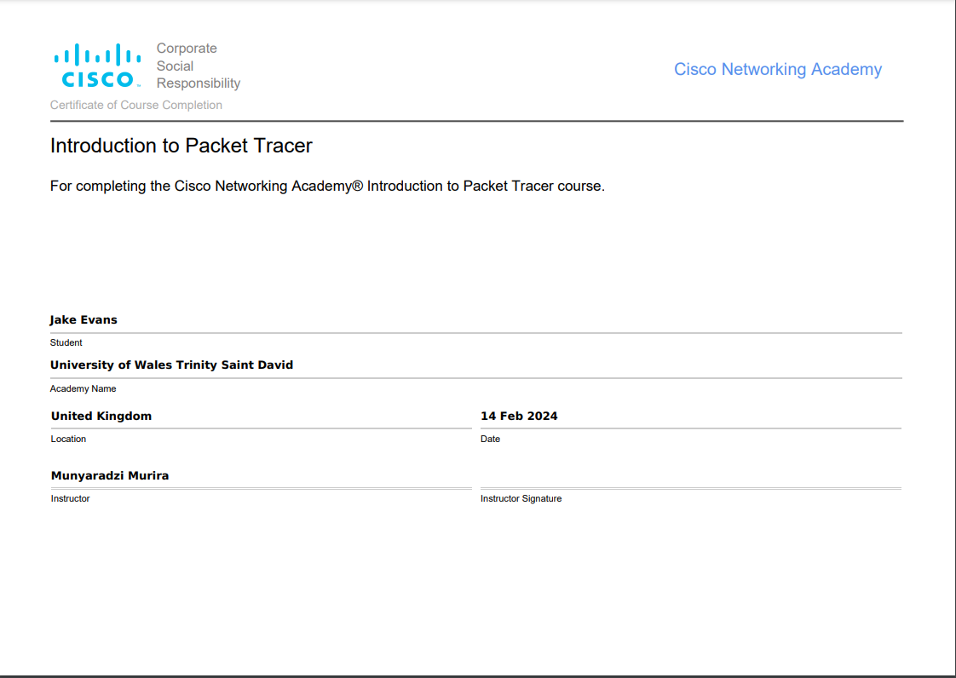
https://www.credly.com/badges/c19d1d11-56c9-41c5-81f3-569bb7a91654/public_url

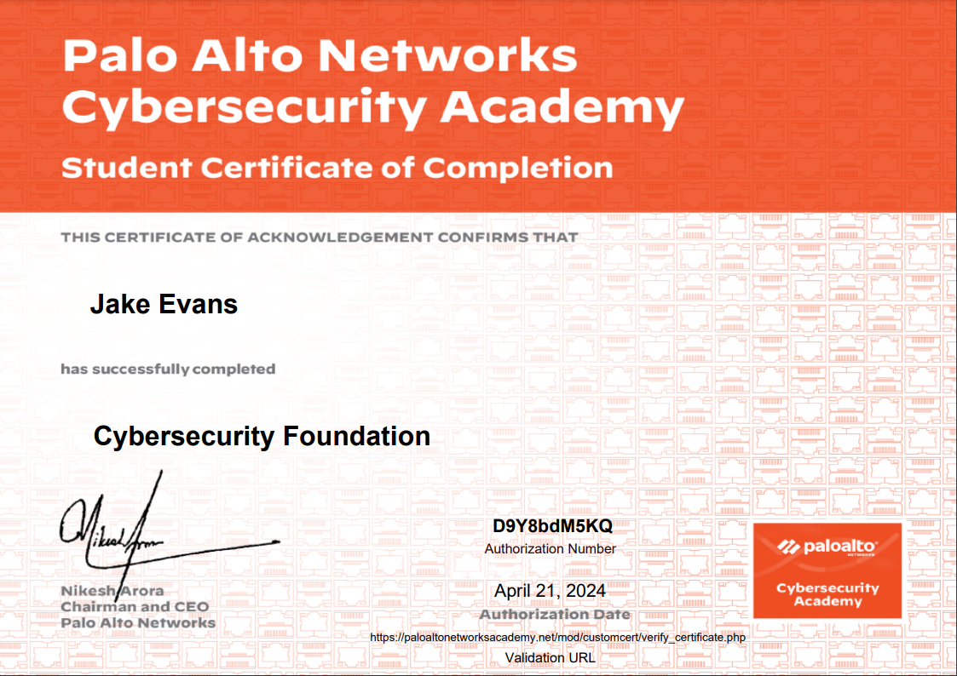
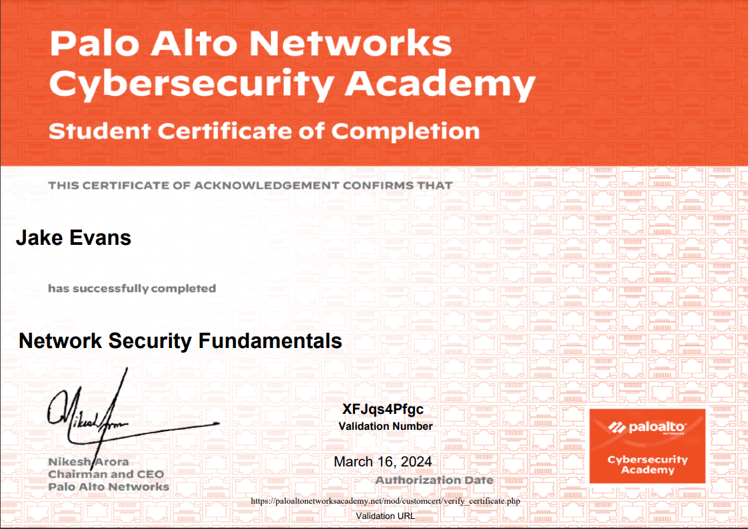
ii)

Conclusion

After studying Network and Cybersecurity, we can see how important these fundamentals are. We are currently in the digital age, where advancements of computer software and hardware are evolving, the need for security is also evolving. As more and more data is digitalised, the need for data security is important to avoid “black hat attackers” and “script kiddies” who can have a negative effect on businesses and organisations. This in turn causes an effect on the service and users (us).

This course has supplied the necessary fundamentals of Network and Cybersecurity and has allowed us as students to experience and research the different ways data can be extracted from a network. Through this experience and research, our understanding has improved and broadened our view of the ever-growing branch of cybersecurity.

References
[1]NIST(July 10, 2009): About NIST. Available: NIST | NIST - National Institute of Standards and Technology
[2] Nmap: The network mapper - free security scanner. Nmap: The network mapper - free security scanner. Available: https://nmap.org/.
[3] 1 Tabu S. Kondo, 2 Leonard J. Mselle. 1 Tabu S. Kondo, 2 Leonard J. Mselle. Penetration testing with banner grabbers and packet sniffers. Penetration testing with banner grabbers and packet sniffers. ; ; 55(4), pp. 321. pp. 321. 2014. Available: https://citeseerx.ist.psu.edu/document?repid=rep1&type=pdf&doi=c420cc25991bd61affb7670688afaf4ec91d3dcc.
[4]LinkedIn: Anonymous(20 February 2024). What are the advantages and disadvantages of using Nmap for network mapping and enumeration?: How to Use Nmap for Network Mapping and Enumeration - LinkedIn
[5] Anonymous (23 February). Wireshark - capture data - Zenitel Wiki. Available: https://wiki.zenitel.com/wiki/Wireshark_-_capture_data.
[6] Anonymous (). Wireshark - Chapter 1. Introduction. Available: https://www.wireshark.org/docs/wsug_html_chunked/ChapterIntroduction.html#ChIntroWhatIs.
[7] A. S.G Gillis. (July). What is WannaCry Ransomware? | Definition from TechTarget. Available: https://www.techtarget.com/searchsecurity/definition/WannaCry-ransomware.
[8] Anonymous (April). NHS England » NHS England business continuity management toolkit case study: WannaCry attack. Available: https://www.england.nhs.uk/long-read/case-study-wannacry-attack/.
[9]Proofpoint.com, Ryan Kalember(13 May 2017): Worldwide WannaCry Ransomware Attack Hits 99+ Countries ... - Proofpoint
[10] R. N. Wilhoit Kyle. R. N. Wilhoit Kyle. TeleRAT: Another android trojan leveraging telegram’s bot API to target iranian users. Available: https://unit42.paloaltonetworks.com/unit42-telerat-another-android-trojan-leveraging-telegrams-bot-api-to-target-iranian-users/.
[13] Sabrina Pagnotta. (August). What is a Whaling Attack and How to Prevent It. Available: https://www.bitsight.com/blog/what-is-whaling-attack-prevent-it.
[14] C. C. Editor. (). Pharming - Glossary | CSRC. Available: https://csrc.nist.gov/glossary/term/pharming.
[15] Dan Rafter. (August). What is a pharming attack? An overview + prevention tips. Available: https://us.norton.com/blog/online-scams/pharming-attack
[16] Anonymous (). What Is a Firewall?. Available: https://www.cisco.com/c/en_uk/products/security/firewalls/what-is-a-firewall.html.
[17] C. f. D. a. R. Health. (Thu, 01/05/ - 11:29). Radio Frequency Identification (RFID). Available: https://www.fda.gov/radiation-emitting-products/electromagnetic-compatibility-emc/radio-frequency-identification-rfid.
[18] Anonymous (). McAfee Antivirus Software 2023 Anti-Virus Free Download. Available: https://www.mcafee.com/en-gb/antivirus.html.

