Network Operating Systems and Services

Worksheet 4: Routing and packet filtering within core TCP/IP services and critical failover/redundancy practices.

Author: Kallum Gordon
Prepared for: Nitheesh Kaliyamurthy & Lee Cobley

1st May 2021

Table of Contents
Network Operating Systems and Services 1
1.0 Worksheet 4 Task 1: Utilising ARP and Routing Tables 3
2.0 Task 2: Deploy Core Services (FTP Server) 4
3.0 Task 3: Installing and configuring the Routing and Remote Access Service. 12
4.0 Task 4: IP Packet Filtering 16
5.0 Task 5: Failover Clustering for high availability systems/services. 20
6.0 Task 6: Observational Tasks. 21
References 22

Worksheet 4 Task 1: Utilising ARP and Routing Tables
Address resolution protocol which connects an IP that constantly changes to a fixed physical MAC address in a LAN. The mapping procedure is critical due to the fact that an IP and MAC address can have differing lengths and so it is essential to translate one to the other so the systems can recognise each other.
To do this, on server 1 the command prompt is launched and ‘ARP -A’ is typed. This provides important information, but for now it doesn’t display much.
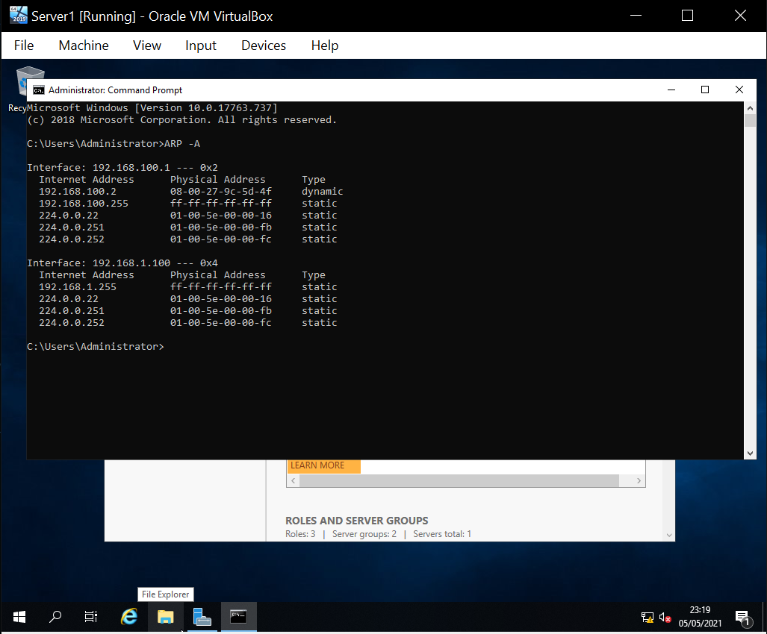

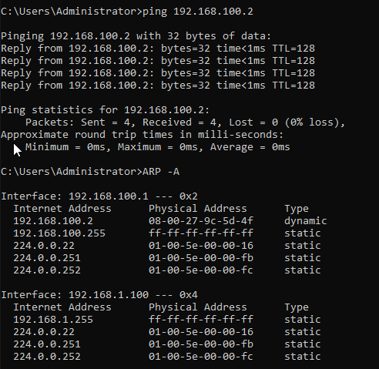
Client 1 is then pinged and ‘ARP -A’ is searched again.

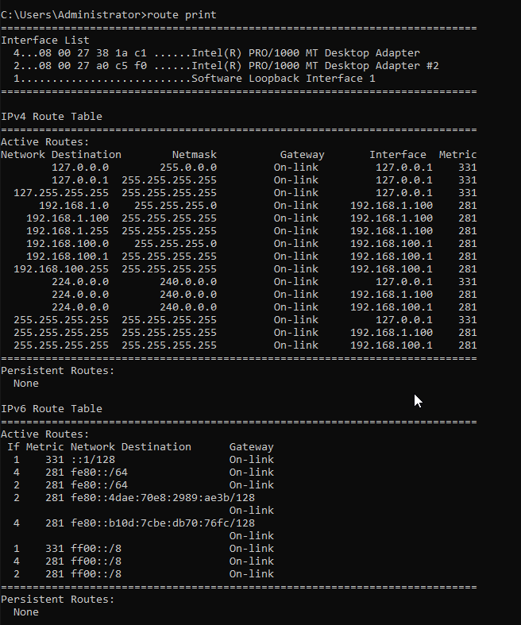
‘route print’ is then typed in the command prompt, the information provided is below:

2.0 Task 2: Deploy Core Services (FTP Server)
A File Transfer Protocol (FTP) will now be deployed to allow the transfer of files from a server to a client. On Server 2, Server Manager is launched, then ‘Add Roles and Features’, then ‘Role based or Feature based installation’ is selected. For the destination server, it is ensured that the right server is being used.
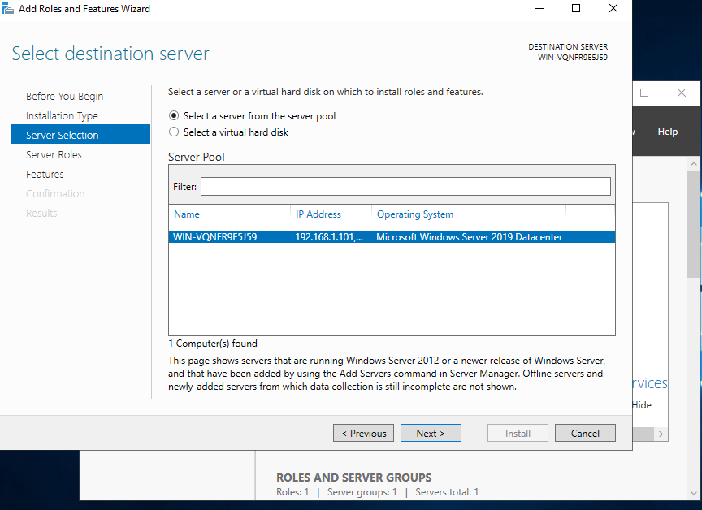

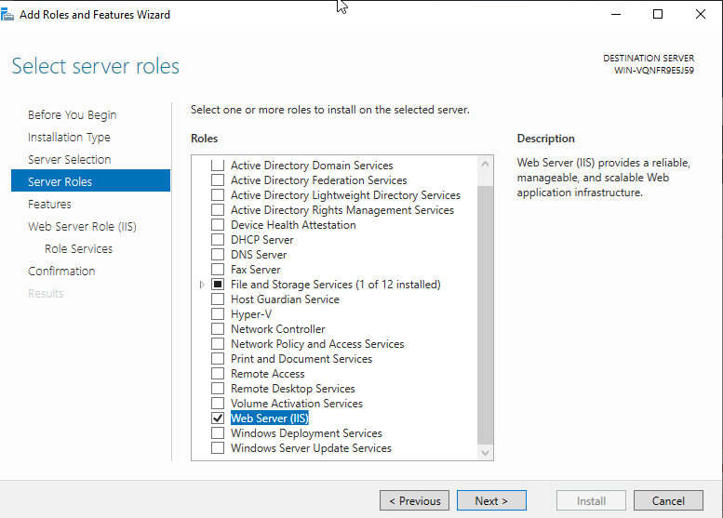
For the roles, ‘Web Server (IIS)’ is selected.

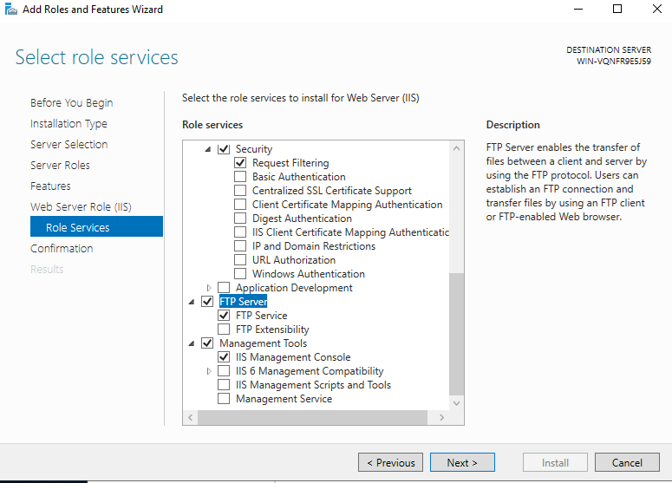
Both FTP Server, and FTP Service are enabled, and they are installed.

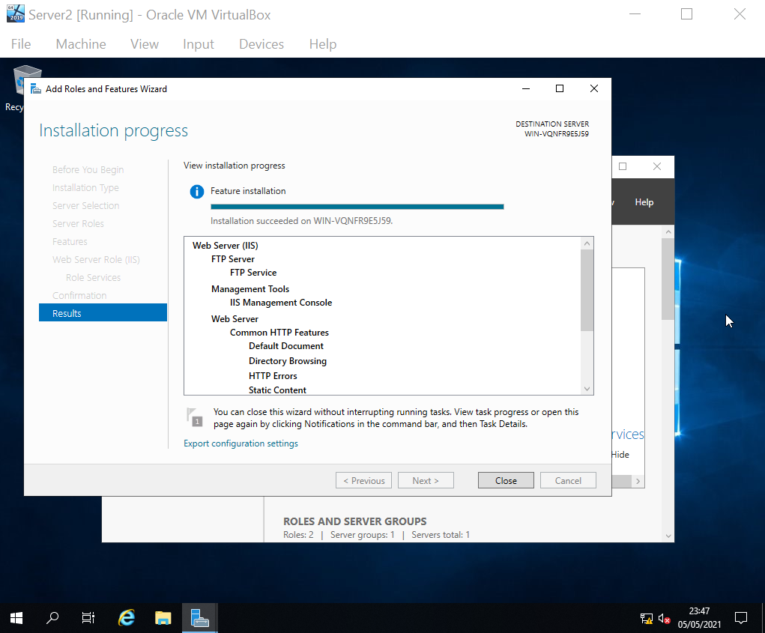

Once installed, server manager is opened again, tools is selected, then computer management. ‘local Users and Groups’ is expanded, and a new user is created.
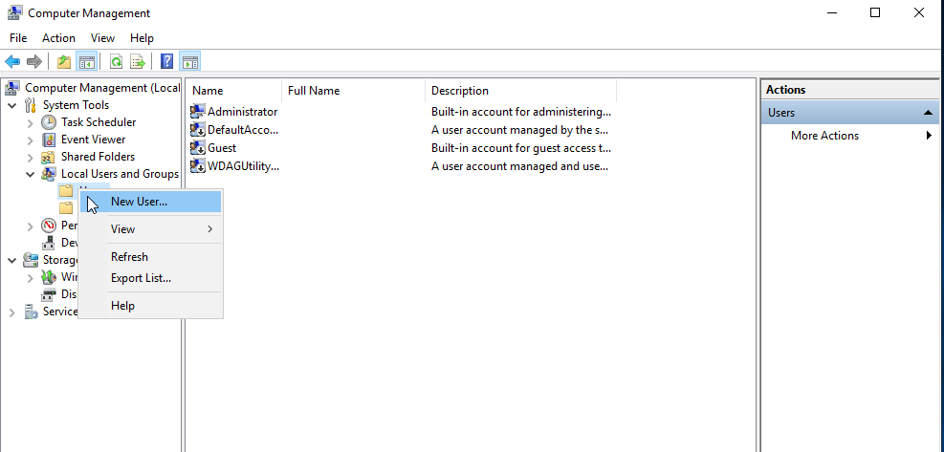

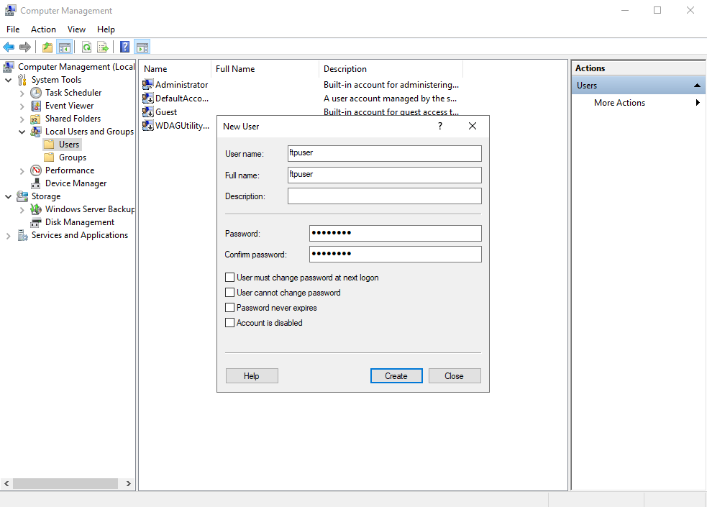
The name is set to ‘ftpuser’ and the password is set to ‘P@ssw0rd’.

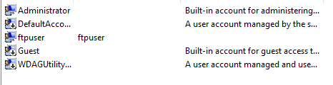

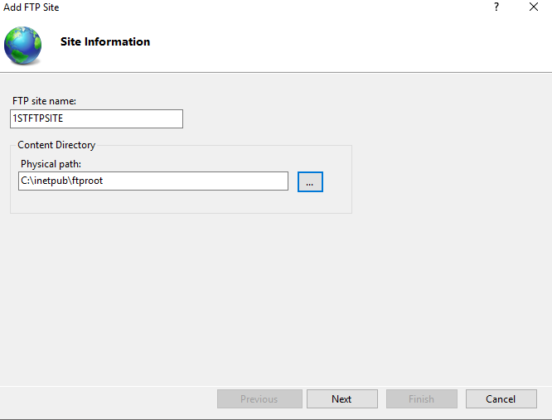
Tools are navigated to, then the IIS Manager. ‘Sites’ is right clicked, and ‘Add FTP Site’ is selected. ‘1STFTPSITE’ is entered in the Site name box. For the path, a folder and subfolder are selected on the root drive.

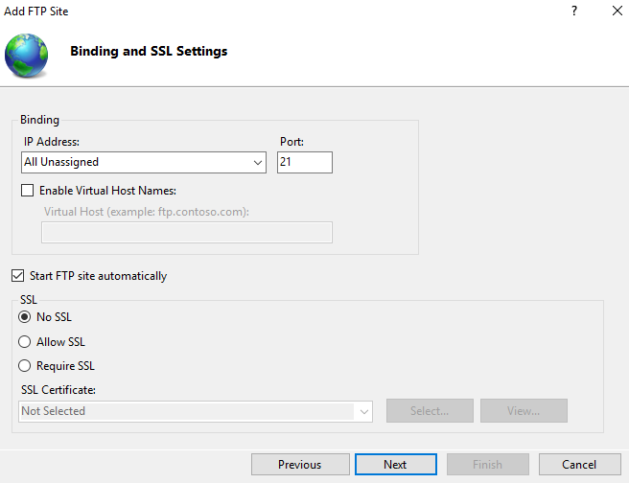
No SSL is selected in the following options. The port number is 21.

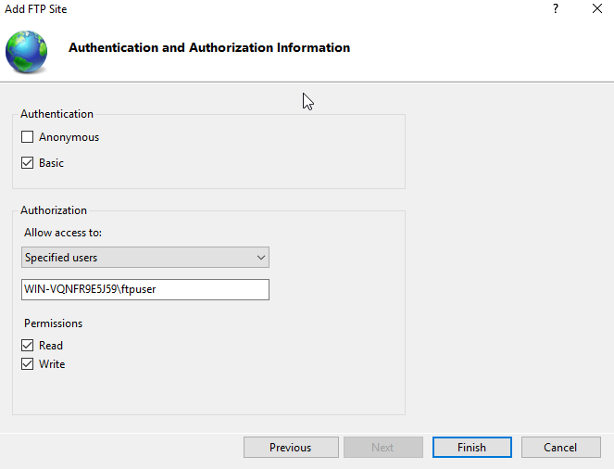
‘Basic Authentication’ is selected and for ‘Allow access to:’, specific users was selected. The name of the server, then the user account name are entered. Read/Write are also checked to allow the user permission to read and write to files.

Banners are then set up as a way to welcome users. To do this, ISS manager is opened again, sites is expanded and the ftp site created earlier is double clicked.
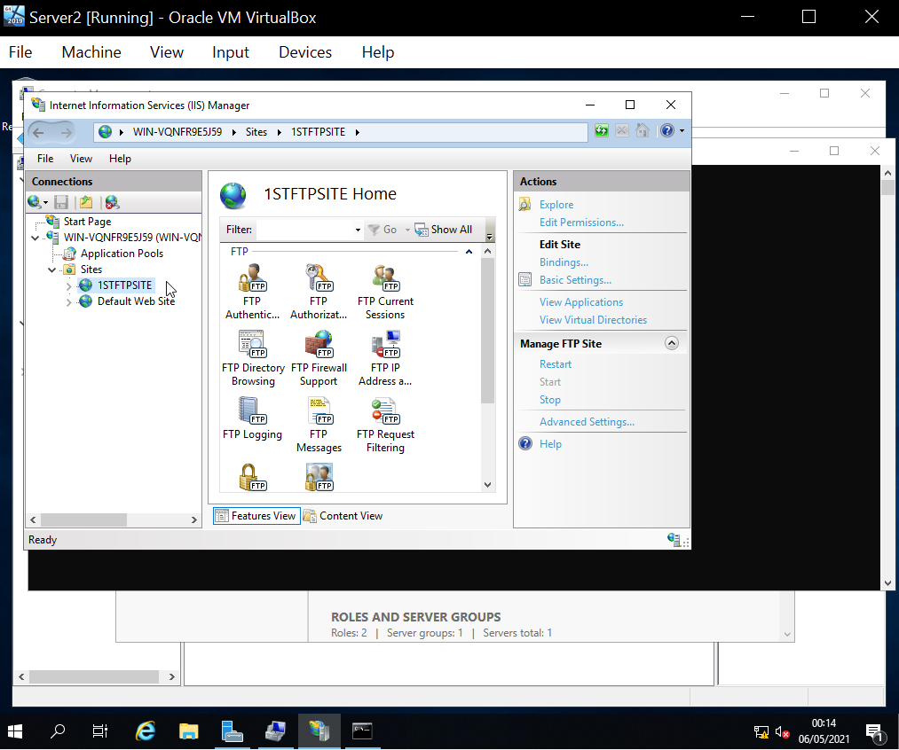

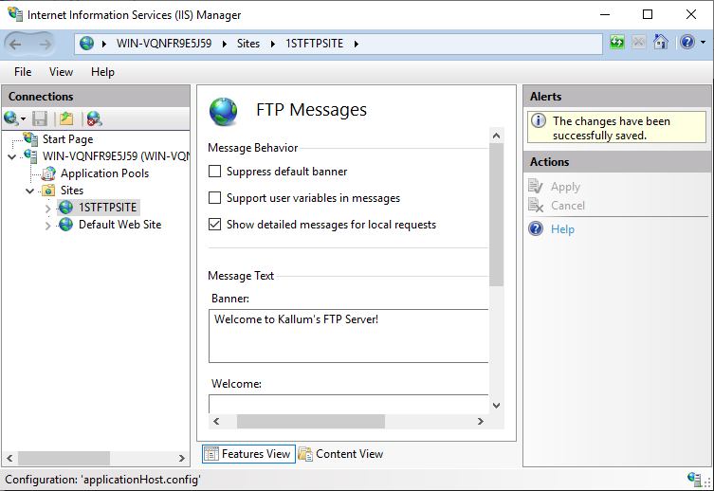
‘FTP messages’ is selected, and text is entered in the Banner field.

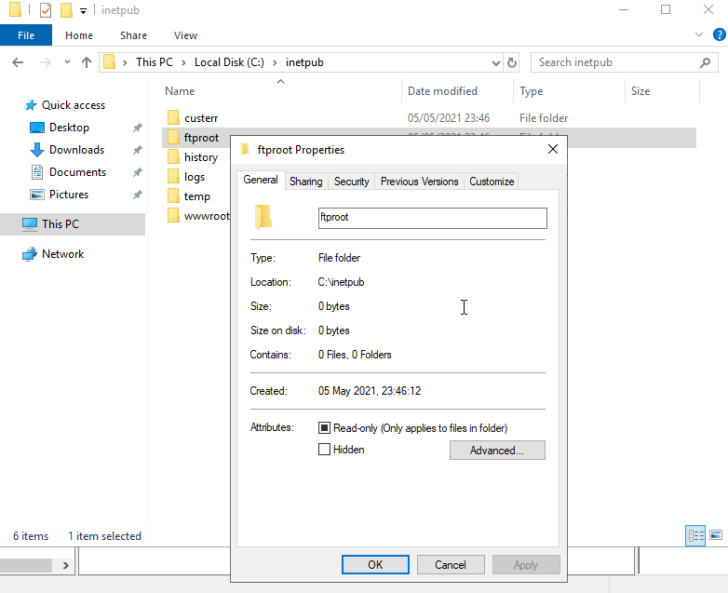
An additional permission is checked. C:\Inetpub is navigated to and ftproot is right clicked and properties is selected.

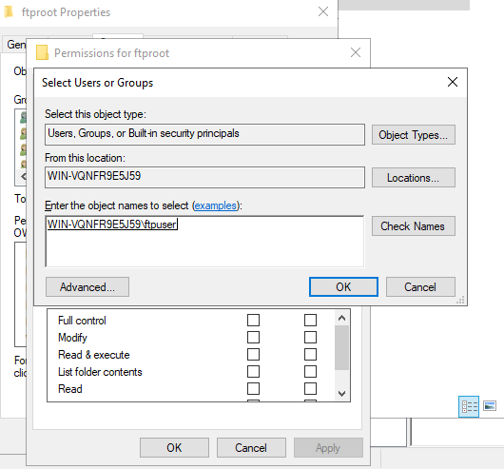
The recently created user account is added.

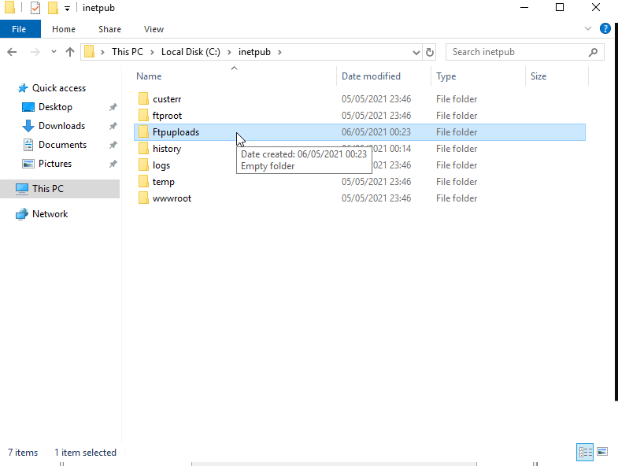
Within the ‘ftproot’ folder, a new folder is created named ‘Ftpuploads’.

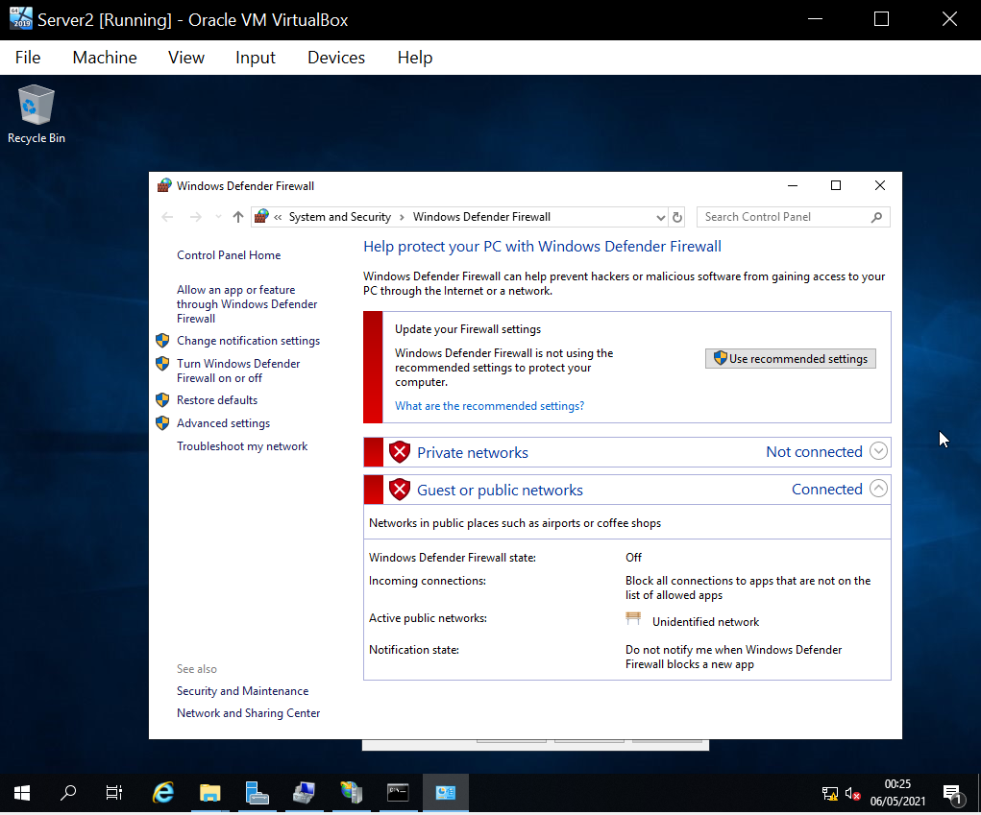
Once it is ensured that Server 2 has no Firewalls running, Client 2 is opened.

Client 2 is logged into as an administrator, and a folder is created in the C:\ root named ‘FTPFiles’. Within this folder, a text file is created named ‘ftpfile2upload.txt’.
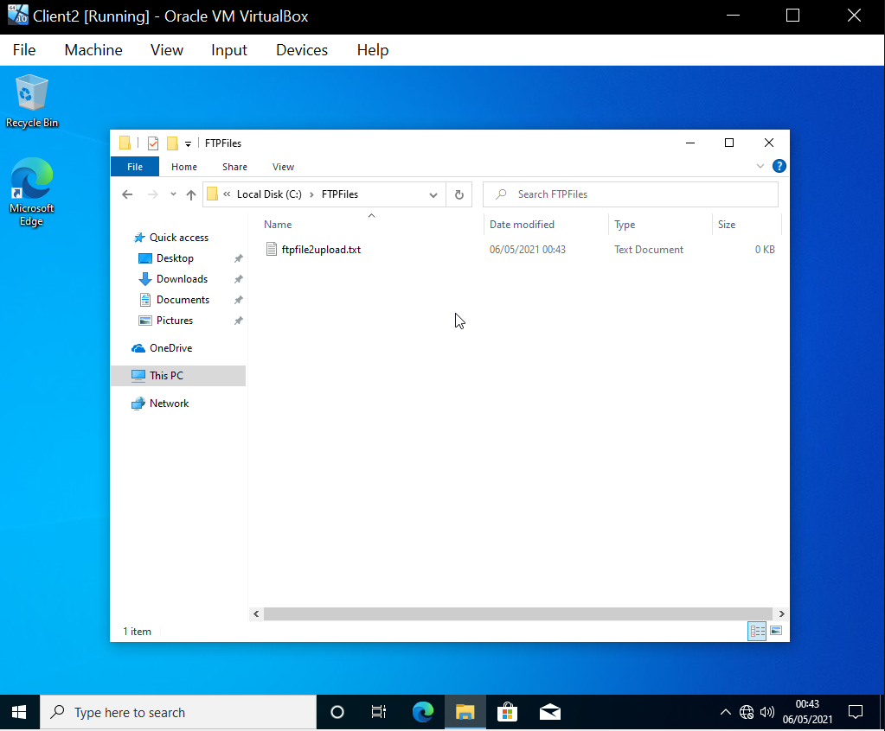

The ftpservice is then connected to by opening command prompt and typing ‘ftp 192.168.101.1’. It was successfully and the banner is also displayed.
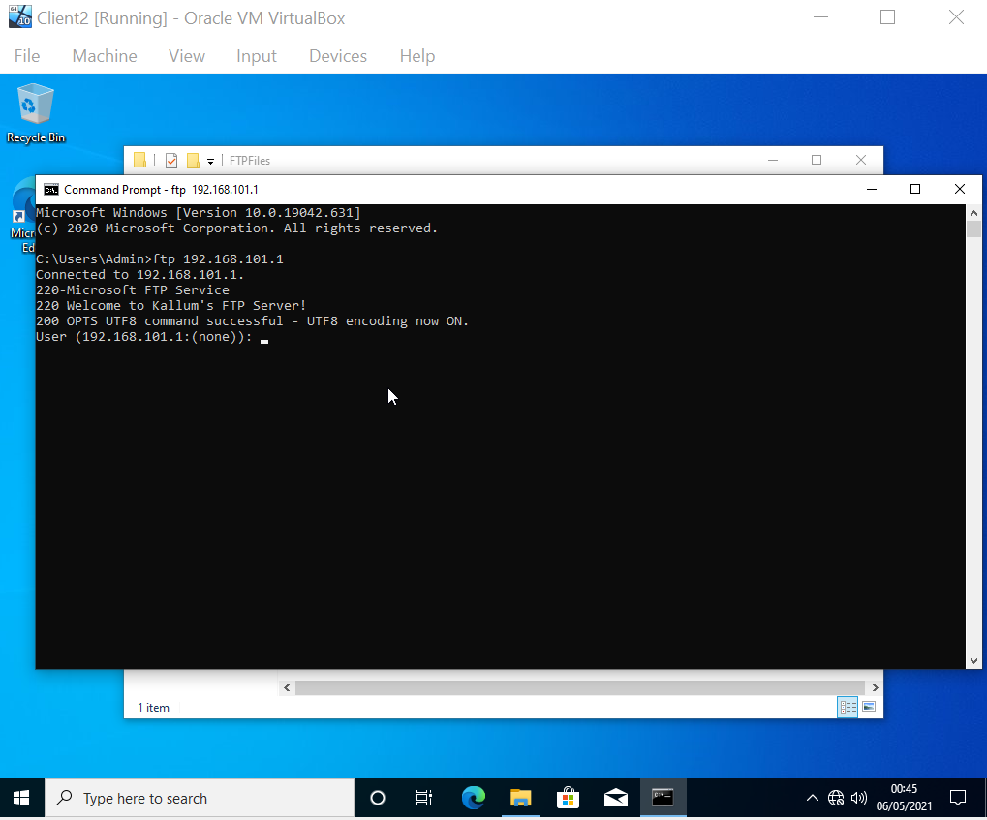

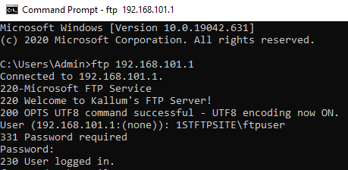
Once connected to the FTP, ‘Lcd C:\FPTFiles’ is typed to change the client directory. A password is prompted, and was entered.

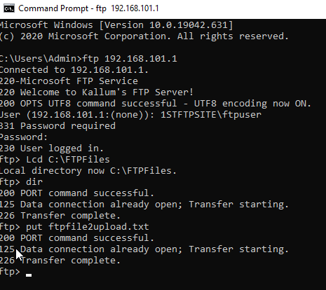
‘dir’ is entered, then ‘put ftpfile2upload.txt’.
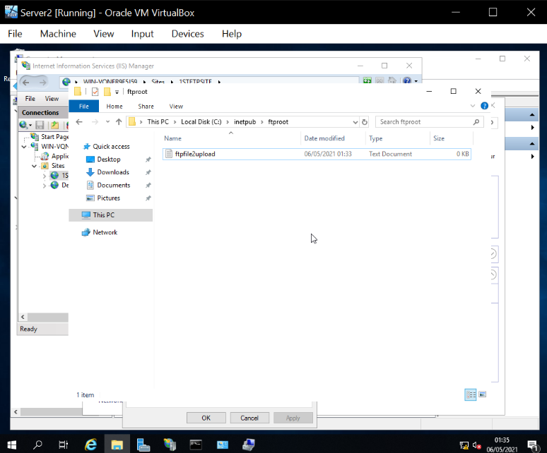

3.0 Task 3: Installing and configuring the Routing and Remote Access Service.
A WAN will now be assembled. To start, on Server 1, ‘Server Manager’ is opened, then ‘Add roles and features’. Remote Access is enabled.
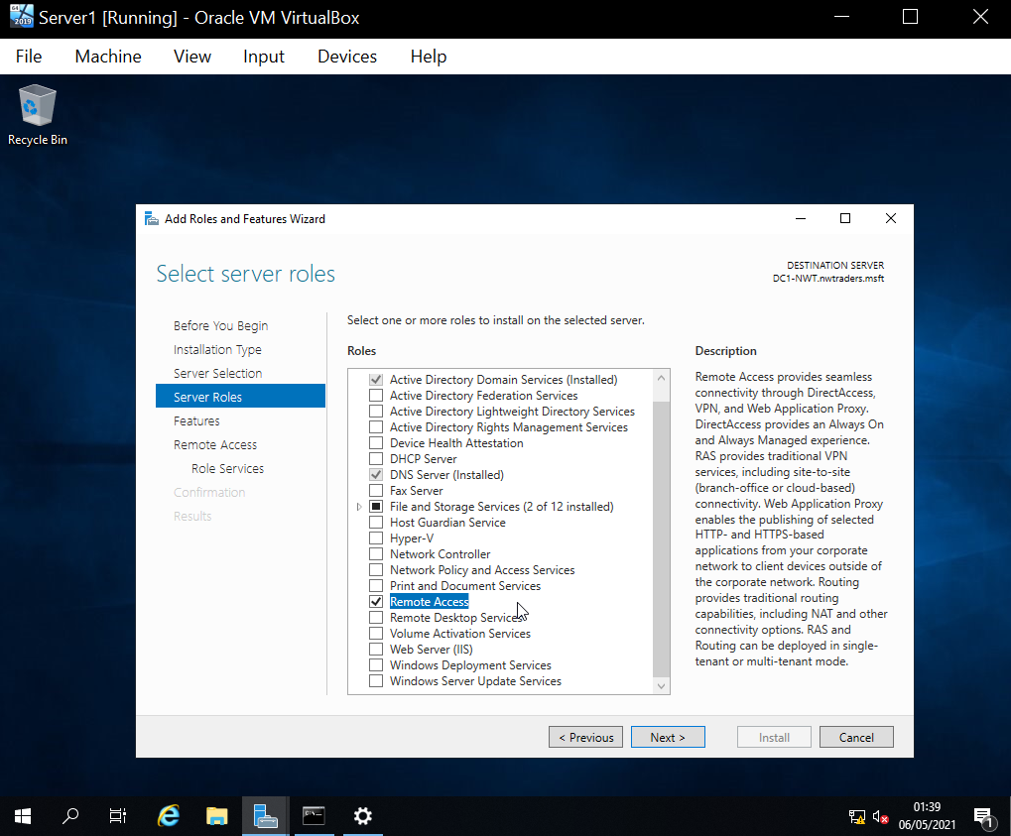

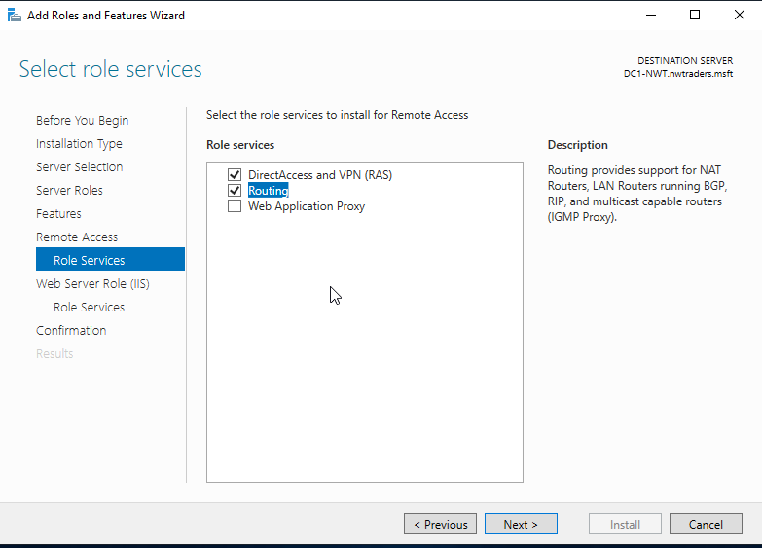
In ‘Role services’, DirectAccess and VPN, and Routing services are enabled.

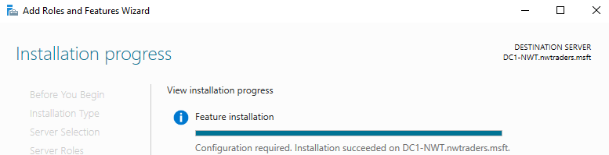
They are then installed.

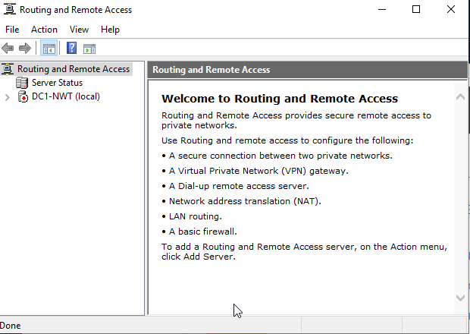
‘Deploy VPN only’ is selected and the ‘Routing and Remote Access Window’ is opened.

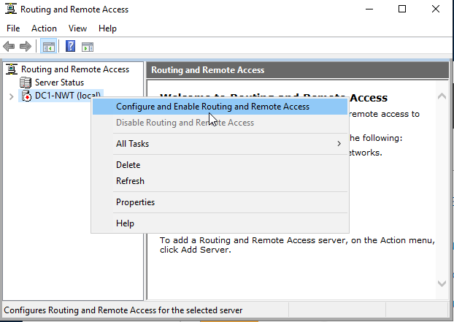
DC1-NWT is right clicked and enabled.

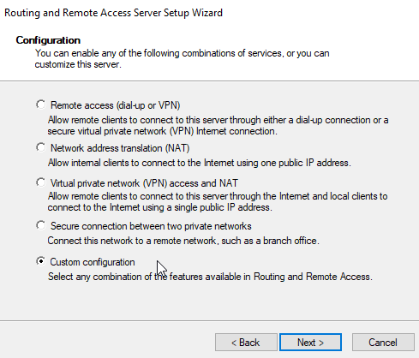
‘Custom Configuration’ is selected.

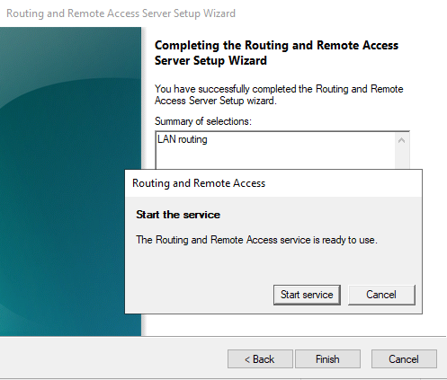
Then ‘LAN Routing’ then ‘Start service’.

The service has started and now routing protocols must be enabled so new networks can be detected. The server icon is clicked, ‘General’ is right clicked, then ‘New Routing Protocol’ is selected.
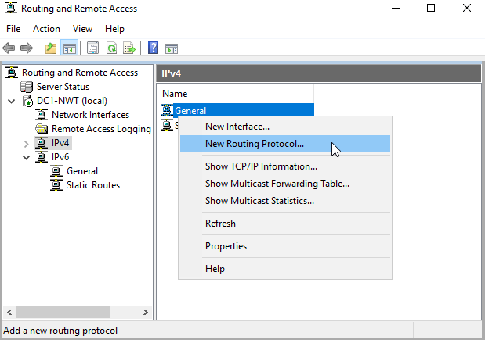

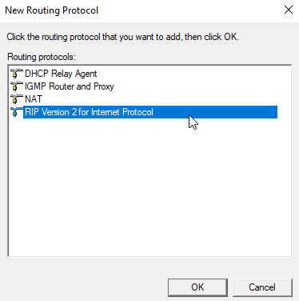
‘RIP Version 2’ is selected.

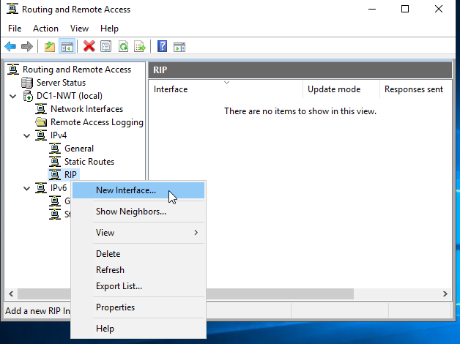
‘RIP’ is right clicked, and ‘New Interface’ is selected.

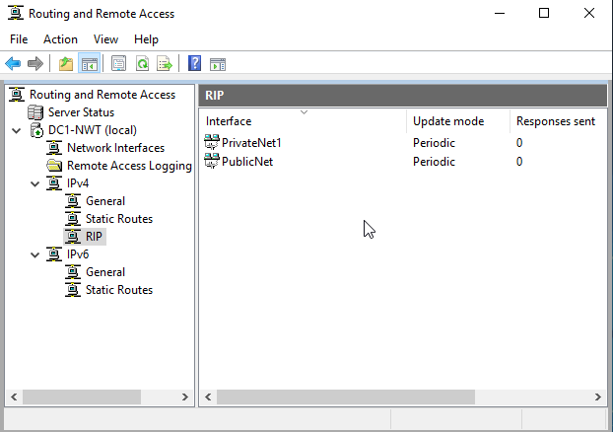
Both interfaces are added.

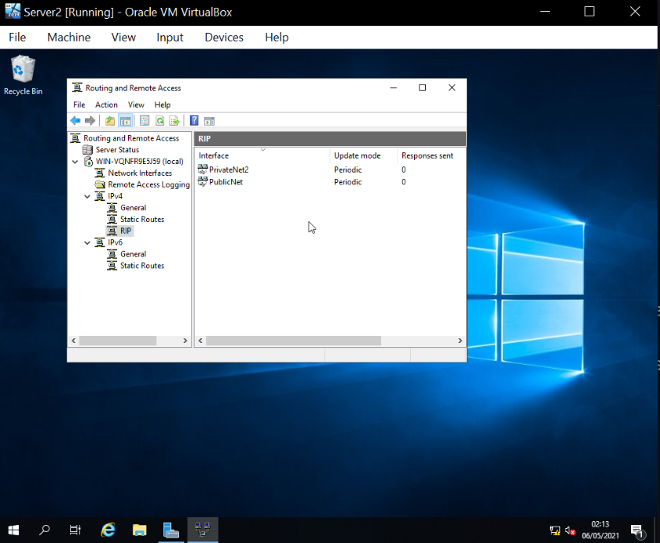
On server 2, the process is repeated.

Now WAN connectivity will be tested. Over on server 1, Server 2 is pinged using its PublicNet IP.
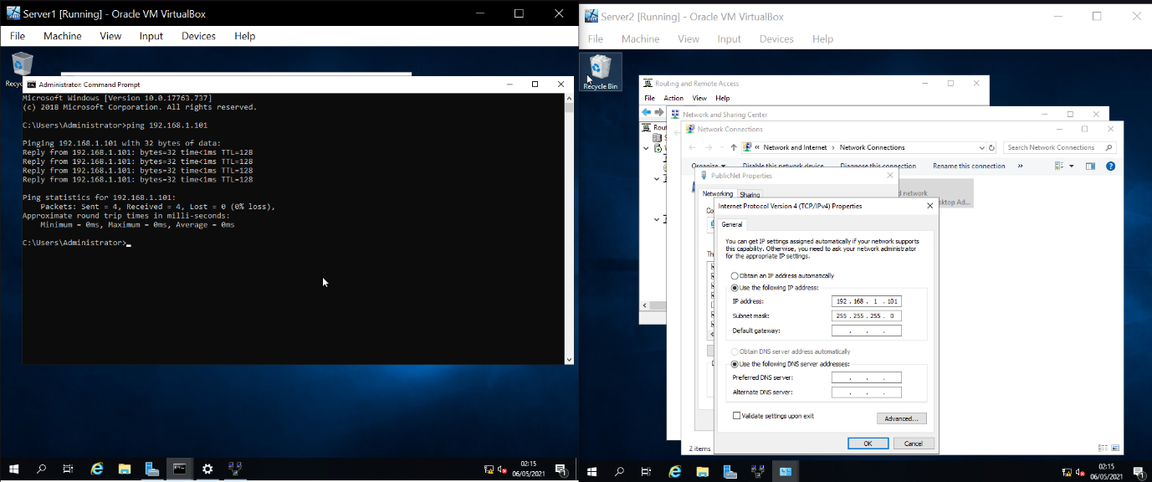

Client 2 is then pinged using its PrivateNet2 IP. The requests timed out and no packets were received.

3 a)
By using a Wide Area Network with routers and routing protocols set up in a specific way to allow networks to establish connections with one another.

4.0 Task 4: IP Packet Filtering
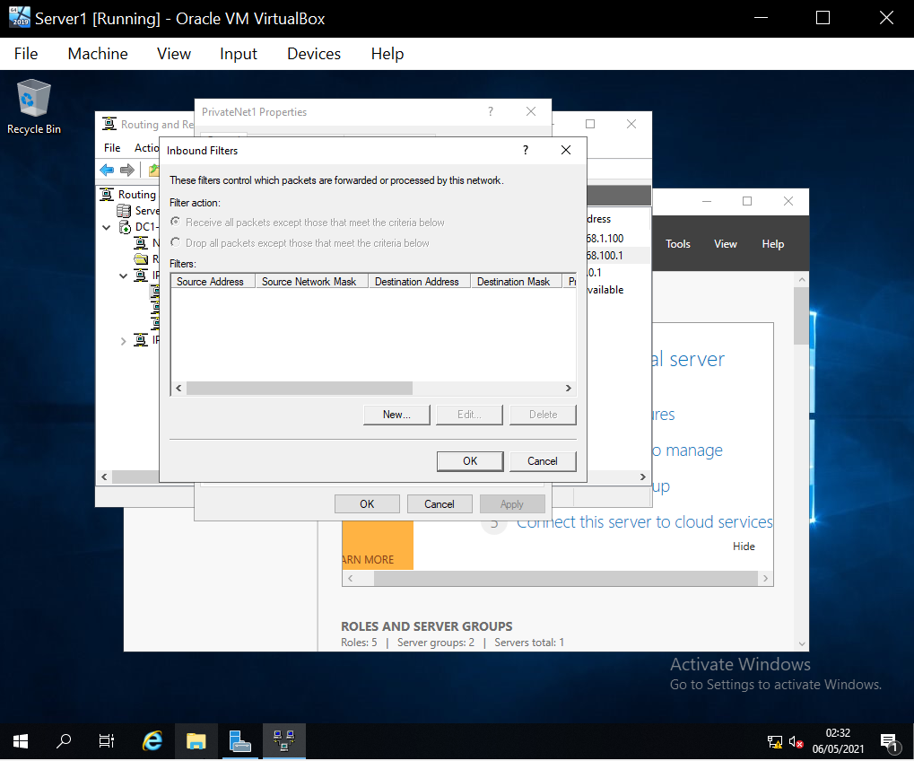
Filter 1 is created by going to ‘Server Manager’, ‘Tools’, then ‘Routing and Remote Access’. The properties of PrivateNet1 are accessed and ‘Inbound Filter’ is selected.

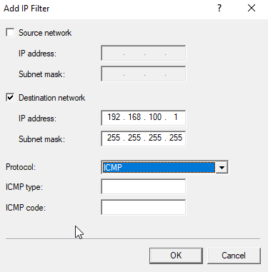
The IP Address and Subnet Mask are set and ICMP is set as the protocol.

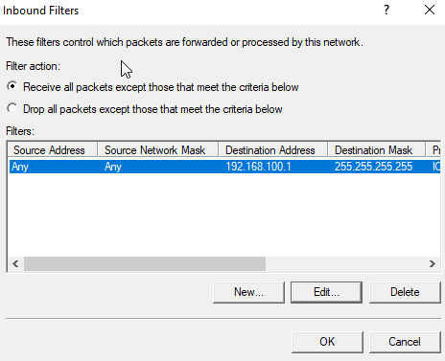

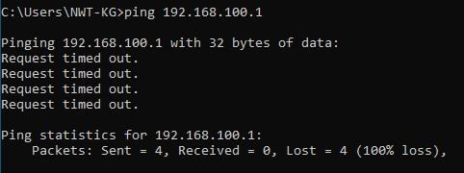
On Client 1 the filter is tested by attempting to ping ‘192.168.100.1’. There is no reply.

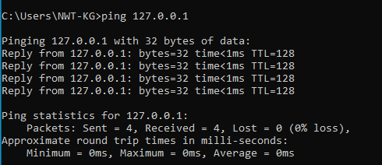
Server 1’s DNS was then pinged, and it received a reply.

Filter 2: On Server 1 ‘IP Routing’ is opened, then ‘General’. The properties of ‘PublicNet’ are accessed. Then ‘Outbound Filter’ is selected.
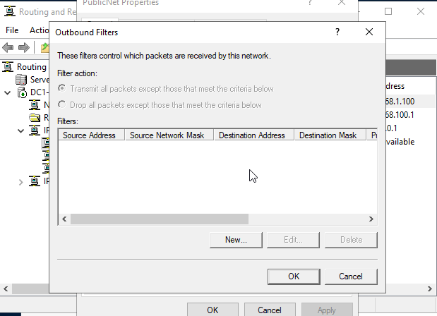

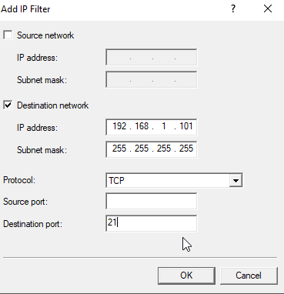
A new outbound filter is created with the IP address, subnet mask, Protocol, and Destination Port set as follows:

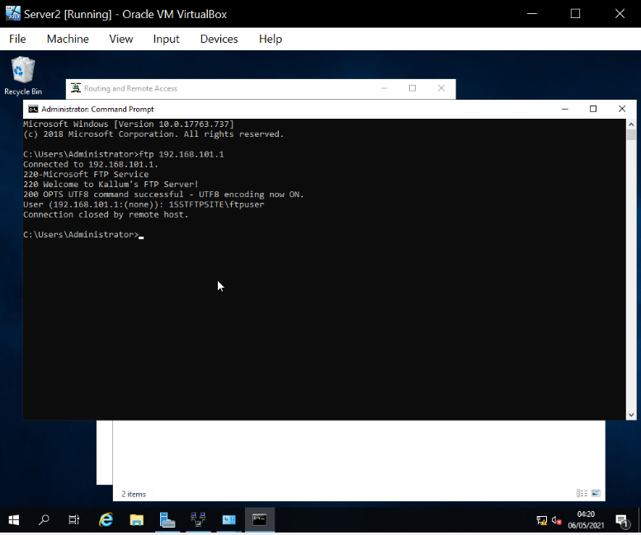
The filter was then tested by attempting to access the ftp service on server 2. It could still access the FTP so another filter was created changing the destination port to 20. This would still allow the FTP to connect. As a final attempt, an inbound filter was created identical to the outbound filters. This worked and the connection was closed by remote host.

Figure 3: A rule is constructed to restrict FTP access to everyone bar client 1. This was done by creating an inbound filter, entering 192.168.100.1, and selecting ‘Drop all packets except those that meet the criteria below’. This blocks every IP except the one entered.
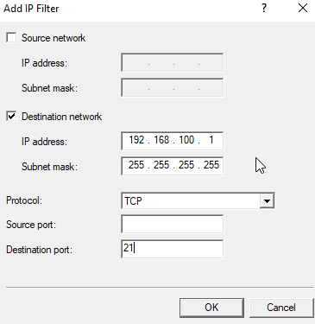

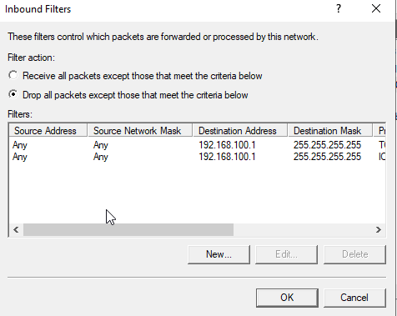

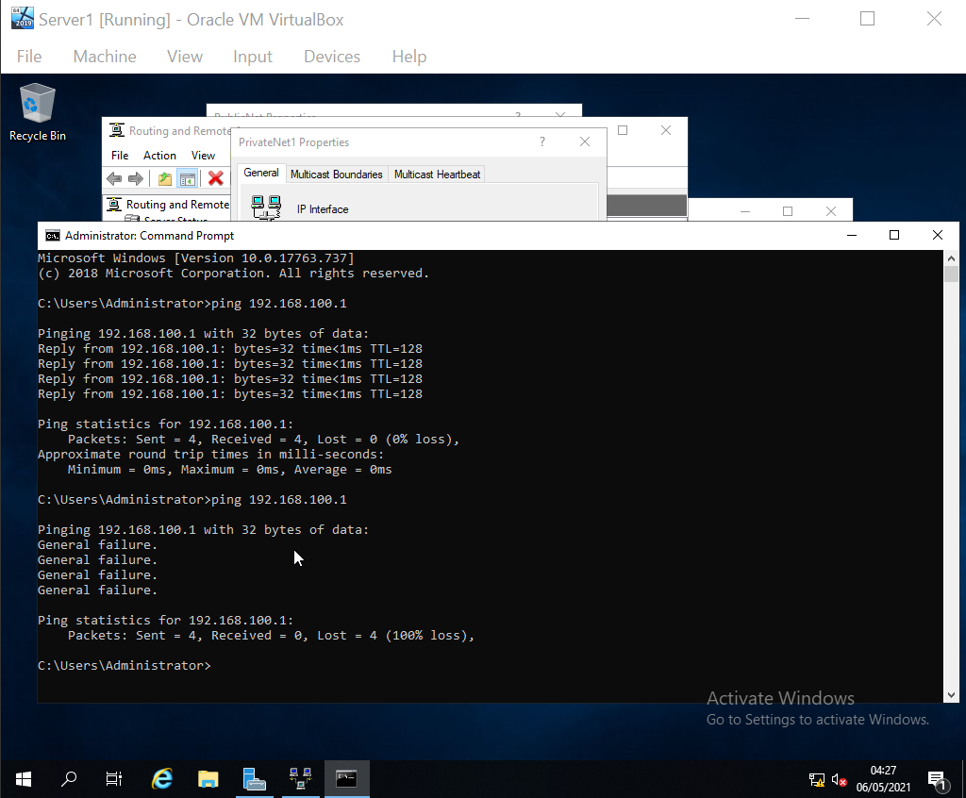
Client 1 was pinged by Server 1, which resulted in a failure.

5.0 Task 5: Failover Clustering for high availability systems/services.
A failover cluster has multiple physical servers which are as identical as possible which are called nodes, these nodes are all attached to form of a shared disk storage. They also have the capability of hosting a certain workload such as a highly available file share or virtual machines. The goal of this is that if a server or number of them go down, there will be at-least one available to offer the content the node that went down offers. Clustering abstracts the service and presents a virtual IP and DNS to users and applications. Therefore, if a node goes down for maintenance or another reason, the user will be directed to another node which still has access to the data the user was trying to access. [1] [2]
A failover clusters general layout, as a simple example, would be two nodes that go to a switch which is directed to a server. Within Server 1 in the ‘Add Roles and Features Wizard’, within the ‘Features’ section, ‘Failover Clustering’ is checked.
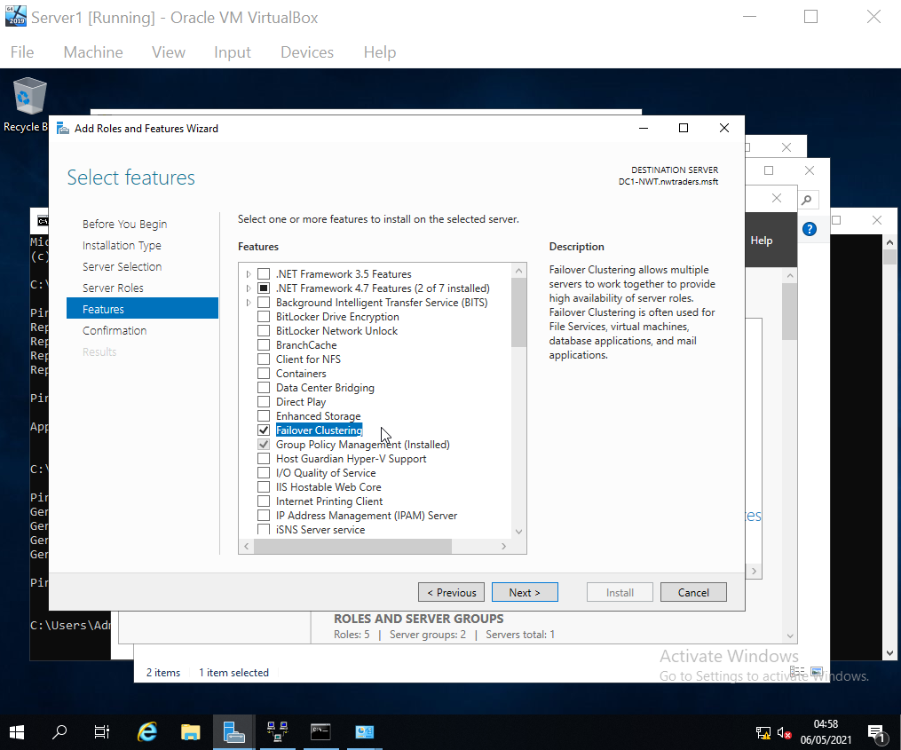

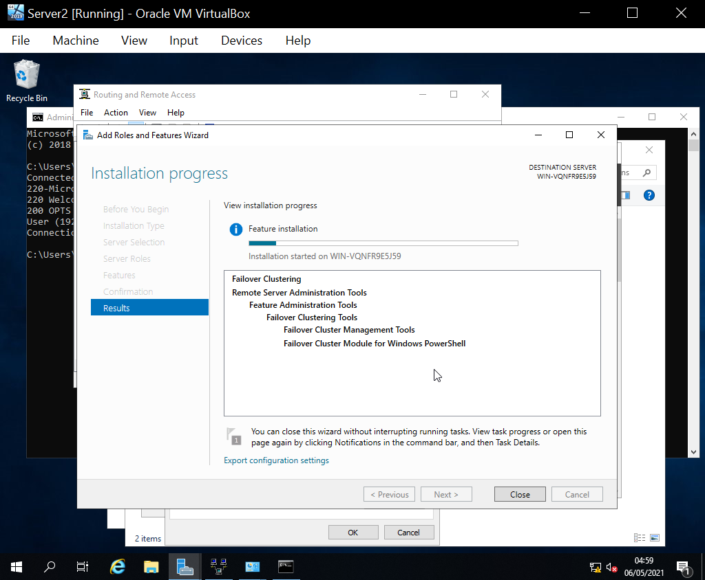
The same feature is installed on Server 2. Making Server 1 and Server 2 the nodes.

6.0 Task 6: Observational Tasks.
6 a)
- Introduction
This business employs a Network Policy to ensure users and the company are safeguarded from security threats. Documented in this booklet are rules that must be established to accomplish this goal.
- Scope
General users: The public that will access the server to access information.
Employees: Those that are using their own devices or provided devices for use when working or on break.
All electronic devices that are connected to the company network.
- Rules
  - When using the network, employees may not access the control panel.
  - When using the network, employees may not access the command prompt.
  - Under no circumstances should employees insert removable media into provided systems.
  - Employees should not install software onto provided systems, everything necessary will already be installed.
  - On company systems, only work-related activities are permitted.
  - Personal devices such as mobile phones are permitted to access the company network while on break, but access to restricted material is not permitted.

Policy author: Kallum Gordon
Current status of Policy: Final [3]

References

[1] | J. e. al., “Failover Clustering in Windows Server and Azure Stack HCI,” Microsoft, 30th April 2021. [Online]. Available: https://docs.microsoft.com/en-us/windows-server/failover-clustering/failover-clustering-overview. [Accessed 6th May 2021].
[2] | C. Nuggets, “What is Failover Clustering in Windows Server 2012?,” 2nd March 2013. [Online]. Available: https://www.youtube.com/watch?v=mtJj7bsbYTU. [Accessed 6th May 2021].
[3] | J. Cale, “Information Technology and Systems: Acceptable Use Policy V2.4,” UWTSD, 6th June 2017. [Online]. Available: https://uwtsd.ac.uk/media/uwtsd-website/content-assets/documents/strategies-policies/its-acceptable-use-policy-29.07.19.pdf. [Accessed 6th May 2021].

