Assignment Title: Effective Teamwork and Communication
MODULE CODE: BMSW4002

Module Lecturer :Timothy Hopkins

Student Name :Catalina Luca

Student ID: 1916220

Executive summary
The preparation of the present report has been on the basis of the different communication models and concepts. The definition of communication, its importance in the workplace, barriers, and the effects of these in a communication process has been described. The case study of Maria and Pedro, given in the class has been used here and at last a hypothetical organizational communication scenario has also been developed. The use of the models like Schramm Model, Berlo Model and Shannon & Weaver Model has been used to describe the issues with communication in Pedro and Billy’s case. Other things, such as different communications, kinetics, proxemics and the tools supporting communication are described. At last, a conclusive statement has also been drawn.

Table of Contents
1.0 Introduction 4
2.0 Models of communication 4
2.1 Shannon and Weaver 4
2.2 Schramm 5
2.3 Berlo 7
3.0 Communication Skills 8
3.1 Verbal 8
3.2 Non-verbal 9
3.3 Listening – Active Listening – Empathetic Listening 9
4.0 Conclusion 11
References 12
Appendices 14
Appendix 1: Standard communication model 14
Appendix 3: Hypothetical case study scenario 19

1.0 Introduction
This report is going to discuss multiple aspects of communication and its importance in personal as well as in professional life. Communication can be considered as a very simple or complex act of conveying information and message from one person or place to another. It always has been a vital component behind the success of any organisation. Companies utilise the skills of communication to establish a good relationship with their employees, consumers and other shareholders. In any workplace, communication is very much important to boost productivity and overall performance. However, multiple aspects like low attention or lack of interest can be considered as serious barriers of communication, which can destroy the real meaning of a message. This report also will display the effects of the barriers by utilizing a case study of "Maria and Pedro”. Apart from that, a hypothetical scenario also will be drawn for decoding and analysing the communication’s aspects more deeply.

2.0 Models of communication

2.1 Shannon and Weaver
The communications models are ubiquitous and still do not clearly outline the essence of the intercultural process. This model will help to understand cognition from the inner circle involving the sender. This is seen through the model developed by “Shannon and Weaver” in 1948. The model moved from mathematics and cybernetics into normal communication. The model has five essential elements: information source, transmitter, channel, the receiver of information, and the goal (Soter, 2016). The case of "Maria" and "Pedro" identifies the former as the source from whom the process of information flow begins. While the latter in the form of "Pedro" acts as the receiver of information. In this case, the encoder is the mobile device that connects both the sender and receiver through the conversation. Similarly, the mobile device also acts as the decoder as it can bring about clarity in message transmission. However, in the case study, it is keenly observed that there existed a misunderstanding between both the sender and receiver. This might have been caused by externally created noise from the environment, or random error in the transmission of a message. As communication was taking place through a mobile device, there is always a chance of noise intervening between information exchanges. This depends on the circumstances through which both sender and receiver might be going through at the time of communication. This can be seen in the form of moving in heavy traffic or experiencing temporary network issues (Soter, 2016). That was different from face-to-face communication that took place between "Maria" and "Pedro", while they were inside the house. The message was understood by "Pedro" with clarity. Hence both the sender and receiver should have found a less-noisier place to communicate through a mobile device. This would have brought about clarity in the message. The sender or the receiver should have asked for feedback from each other in arriving at a clearer message like "Chicken" instead of "Kitchen". This would have reduced the confusion between "Maria" and "Pedro".

2.2 Schramm
According to the communication model of Shannon and weaver, the main role within a communication has been of the sender and receiver. “Schramm Model” (1954) has been developed through the earlier model, but it has considered the "encoding and decoding" of the message and the feedback of the receiver against the message. According to the model of Schramm, communication is a cyclical process where the communicating parties are both sender and receiver. Here, the model has explained some factors which can affect the decoding of the message by the receiver. Schramm strongly believed that the communication and decoding of a message are affected by the culture, knowledge and experience of the communicators. A communication and information flow is never completed until the message is clearly understood. Here, feedback is very necessary from the sender to clearly decipher the message. When feedback is received from the receiver by the sender, the message is considered to be complete. (Schramm's Model of Communication, 2020)
If the communication process of Pedro and Maria is seen, it can be seen that the encoder and decoder of the message have been mobile while the sender and the receiver are Maria and Pedro. The misconfusion has been there for Pedro in listening to the message. According to the model of Shannon & weaver, 1948, the confusion has been created due to the secondary role of the receiver. The main role here has been of Maria to send the message; the response of Pedro is not so important.
In this case, the confusion has been the creation of outside noise and improper communication medium. Here Schramm Model (1954) is very necessary as it considered the role of the receiver to be equally important. The feedback from the receiver is also necessary. Therefore, the receiver must have to interpret the message and give feedback to the sender without which the process is incomplete. Here, Schramm Model is useful as the message is to be encoded and decoded by the communicating parties. Therefore, a message through mobile could have been a better communication medium as Pedro’s workplace is noisy. (OSGOOD- SCHRAMM MODEL OF COMMUNICATION, 2020)

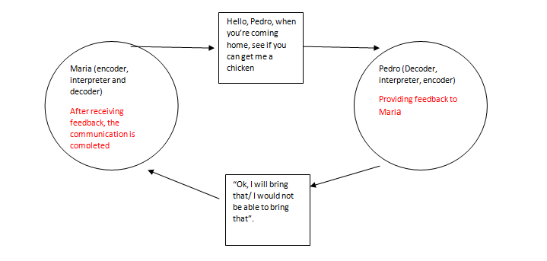
Figure 1: Application of Schramm Model in Pedro and Maria’s communication
(Source: Self-created)

2.3 Berlo
The model suggested by “Berlo” in 1960 included four elements like message, sender, channel, and receiver. As soon as the message is transferred by the sender, which in this case was "Maria". The subject matter is carried forward through “hearing” or the channel by "Pedro". The interpretation of the message relies on him to derive a proper meaning. In the case study, both "Maria" and "Pedro" are not in direct contact with each other, that makes the communication process asynchronous (Umeozor, 2020). This reduces the scope of feedback between the two and further suggests in implementing better channels that are seen later on in the case. Where "Pedro" confirms his confusion in hearing "Chicken" as "Kitchen" through direct contact. That makes communication more synchronous with a better chance of feedback. A higher context of communication has been used by the sender and receiver through mobile conversation. However, with a lower context of communication, the message is clearer and better to understand. This can also point to a socially distant relationship between "Maria" and "Pedro" that results in more mobile transmission than direct communication. [Referred to Appendix 2]
In the present scenario, it can be seen that Billy was not on common grounds with Sheringham. Therefore, it was not the fault of Billy in understanding the communication issues. Here Schramm Model (1954) would be the best to describe the issue. As stated earlier, Schramm believed that the education, social and cultural factors of the receiver also play a role in deciphering the message. Therefore, Billy would have to be of the same background so that he is able to understand the technical terms in order to understand in the same way with Sheringham. As there was no common ground, Billy failed to understand Sheringham's needs. Therefore, the Schramm model can identify the importance of encoding. He should have said, "can you call the technical expert?" [Referred to Appendix 3]
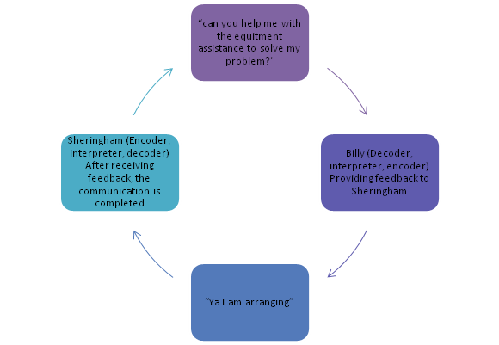
Figure 2: Application of Schramm Model in the present case
(Source: Self-created)

3.0 Communication Skills

3.1 Verbal
The case of "Maria and Pedro" is a basic example of technical communication error which often causes professional communication to break down. The own case scenario presented in the context of Billy and Sheringham is an identical case which again stems from the auditory communication failure on a technical level. However, had there been a face to face communication, I can assume both the parties, meaning Maria and Pedro as well as Billy and Sheringham (De Stefani and De Marco, 2019). Here what strike the most is the choice of words and the use of proper vocabulary. “Shannon and Weaver” model clearly illustrates the function of noise which has plagued digital or radio communication since the beginning of the technology. This recurring problem was solved by various military organisations through the use of NATO alphabets which concentrate alphabets and their pronunciations as per the need of the armed forces. These factors are taken as essential skills in the US armed forces training. Verbal communication skills are to be supplemented by non-verbal gestures and the tonality of the language. But as far the subject is concerned with communicating with authenticity and accuracy the use of formal emails, memos and other online tools is well advised to mitigate any substantial risk (Fandrejewska and Wasilik, 2018).

3.2 Non-verbal
The primary change in these situations is not just of context but also the mood, motif and intent which is communicated not by words but with body language and gestures. De Stefani and De Marco (2019) in their work had described the importance of gestures and non-verbal cues which drives the modern professional spheres and mediums. Emotional communication was another layer of this study which has been detailed further under the active or empathetic listening section. Furthermore, this is a given fact that telephonic or over the net conversations cannot deliver these essential ques for body language and underlying mood of the speakers (Khan et al. 2017). The Maria and Pedro case was essentially a miscommunication which might have been caused by the indistinct network noises mentioned by Schramm. However, the case study of Bill and Sheringham has been essential to establishing the organisational point of view amidst the miscommunication. A formal mail or a straight video conference might have solved this issue in the beginning. There are many such cases where the lack of essential communication details has imparted wrong information on the other side (Raba, 2017). The social mirror mechanism has been explored as a possible source of this form of a communication error. Acknowledging these possibilities and taking active steps to stop it is some of the most effective mediums which help in professional and organisational excellence. [Referred to Appendix 3]

3.3 Listening – Active Listening – Empathetic Listening
S.O.L.E.R.
The importance of active, assertive or empathetic listening is an essential skill at the end of the decoder. If the communication is happening in a manual or in a high-context environment, then the function of the receiver is as important as the sender. The activity of the listener decides the chemistry and the flow of the conversation (Raba, 2017). With the organisation endeavouring to make their administration more and more employee-oriented, the importance of equal participation is becoming more apparent.
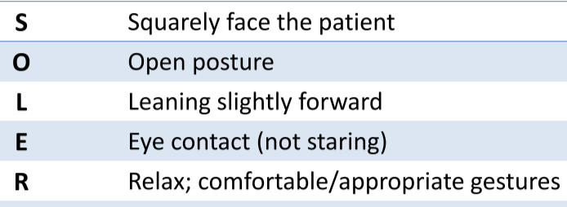
Figure 3: S.O.L.E.R. model of communication
(Source: https://d1yboe6750e2cu.cloudfront.net/i/9f2d249420c06acc9015b022e1ed7c6368646274)
This model is equally transferable in various digital communication mediums as assertiveness and confirmation can also be presented via telephonic conversions. Both Pedro and Sheringham could have been a bit more engaging as in both the cases, the one-sidedness of the conversions cannot be overlooked (Khan et al. 2017).
Proxemics/ Kinesics (proximity)
Proxemics can be described as the process of using space and distance to communicate within the organisation. Proxemics, described by Hall, is effective informal communication where a degree of formality is maintained. In the case of Billy and Sheringham, the proxemics was not present, which would enable Billy to understand his language. According to Hall, the proxemics is present within the people distancing one and one-half to four feet. Therefore, proxemics is not possible (Fandrejewska and Wasilik, 2018).
Kinesics can be described as the understanding of facial expression, gesture and other non-verbal behaviour. As the technical terms of Sheringham were not clear to him, it would be better to use informal language, and the "level of formality" should below. (- Proxemics, kinesics, and artifacts — Moniviestin, 2020)
Personal awareness – K.E.Y.S.
A requirement of personal awareness mainly transcends through the physical, relational, and emotional elements experienced by a person. If body language is read properly, it can often signal through cues and mannerisms, when something is not in order while encoding and decoding a message. Both “Maria” and “Teddy Sheringham” should have been more aware of their delivery mediums (Civico, 2020). At the same time, relational semblance comes from the ability to communicate through habits between spouses, partners, friends, and other members. In a similar way, the emotional characteristic transmits personal experiences to the receiver in the form of anger, happiness, or sadness (Civico, 2020). These three areas of personal awareness are normally taken up in many professional capacities around the world. That requires the full attention of "Pedro" and "Billy" who should have expressed their personal feelings of confusion.

4.0 Conclusion
From analysing the case study of “Maria and Pedro” the impact of “communication barriers” can be identified. From analysing the models of communication, a lack of systematic representation between the telephonic interaction of Pedro and Maria could be identified. It has led to the fact that bad communication can occur at any point. However, it is important for both the parties to be attentive during the interaction. The hypothetical scenario of Billy and Sheringham has described the impact of barriers in communication by highlighting a lack of understanding between them.

References
Journals
De Stefani, E. and De Marco, D., 2019. Language, Gesture, and Emotional Communication: An Embodied View of Social Interaction. Frontiers in Psychology, 10. DOI: 10.3389/fpsyg.2019.02063
Khan, A., Khan, S., Zia-Ul-Islam, S. and Khan, M., 2017. Communication Skills of a Teacher and Its Role in the Development of the Students' Academic Success. Journal of Education and Practice, 8(1), pp.18-21. DOI: https://doi.org/10.1590/S0080-623420160000300005
Raba, A.A.A., 2017. The influence of think-pair-share (TPS) on improving students’ oral communication skills in EFL classrooms. Creative Education, 8(1), pp.12-23. DOI: http://dx.doi.org/10.4236/ce.2017.81002
Fandrejewska, A. and Wasilik, K., 2018. Cultural differences and barriers in communication and functioning of an international organisation. Handel Wewnętrzny, 1 (3), pp.203-215. DOI: 10.5772/45816
Soter, M., 2016. Theoretical Modelling of Intercultural Communication Process. Journal of Advocacy, Research and Education, [online] (2), pp.87-92. Available at: <http://www.kadint.net/journals_n/1473284978.pdf> [Accessed 17 July 2020].
Umeozor, S., 2020. Information Retrieval: A Communication Process in the 21st Century Library. International Journal of Knowledge Content Development & Technology, [online] 10(2), pp.7-18. Available at: <http://www.ijkcdt.net/xml/22689/22689.pdf> [Accessed 17 July 2020].

Websites
Managementstudyguide.com. 2020. Schramm's Model Of Communication. [online] Available at: <https://www.managementstudyguide.com/schramm-model-of-communication.htm> [Accessed 17 July 2020].
Communication Theory. 2020. OSGOOD- SCHRAMM MODEL OF COMMUNICATION. [online] Available at: <https://www.communicationtheory.org/osgood-schramm-model-of-communication/> [Accessed 17 July 2020].
Moniviestin.jyu.fi. 2020. - Proxemics, Kinesics, And Artifacts — Moniviestin. [online] Available at: <https://moniviestin.jyu.fi/ohjelmat/hum/viesti/en/ics/26> [Accessed 17 July 2020].
Civico, A., 2020. How Self-Awareness Leads To Effective Communication. [online] Psychology Today. Available at: <https://www.psychologytoday.com/us/blog/turning-point/201404/how-self-awareness-leads-effective-communication> [Accessed 17 July 2020].

Appendices

Appendix 1: Standard communication model
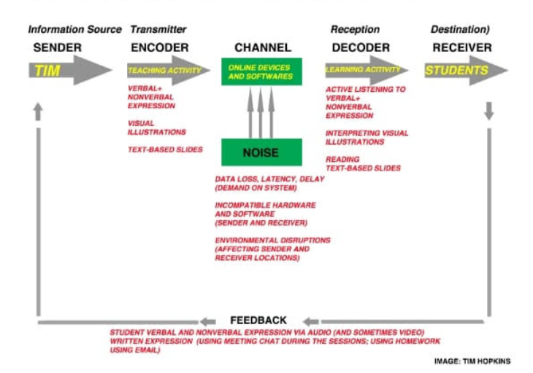

Appendix 2: Class exercises and written case study
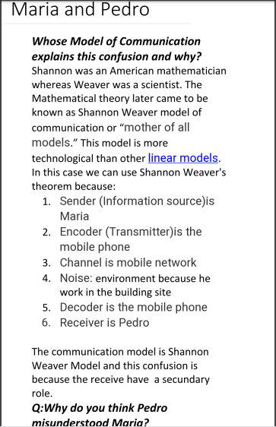
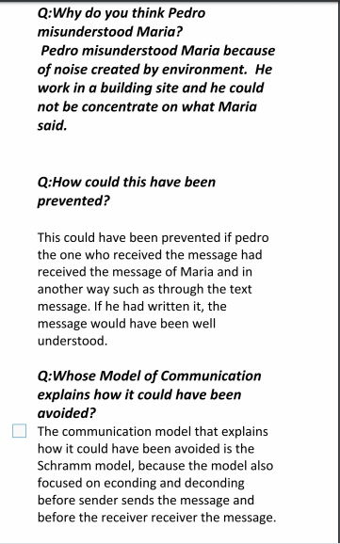
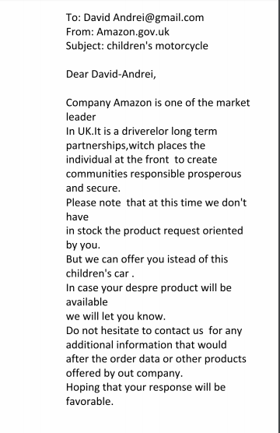


Appendix 3: Hypothetical case study scenario
Billy is an employee within a reputed organization AM Technocart where he has been working as an office assistant. He performed the general activities within the office which were not related to the office activities such as developing website, client portfolio profiles and other software related work jobs. Therefore, there was nothing common between the executives and the employees. He was also not familiar with the terms.
An executive of that company is Teddy Sheringham who performed the software jobs.
One day Mr. Sheringham came to the office and was working. Suddenly, the website of the organization was crashed and expert help was immediately needed. Therefore, it was necessary for him to look for the technicians.
He called Billy and said, “can you help me with the equitment assistance to solve my problem?’
Billy at first tried to understand what actually Sheringham needed.
“Don’t you understand”, Sherigham said, “can you please arrange for the equipment assistance to solve my problem?”
Billy took it for the equipments, and tools, “Ya I am arranging”, and went back to bring the same.
When Billy brought the tools and equipments, Sheringham was disgusted. He said, “What have you bought? I wanted you to call the technical expert assistance”
Billy said, “But you told me equipment assistance. You have not told me to call the expert.”

(Source: Self created)

