EFFECTIVE TEAM WORK AND COMMUNICATION

Teletha Duberry
Student I.D - 1917189
Effective Team work and Communication
Assignment: Term 1
Lecturer: Molly Jack
TABLE OF CONTENTS

- Introduction
  - Introducing Purpose of the Essay 3
1.2 Appendix A – The Evolution of Communication 3
- 7 C’s of Communication 4
  - 7 C’s of Communication Explained 4
  - Appendix B – Diagram of the 7 C’s in Communication Defined 4
- Communication in the Workplace 5
  - Effective Communication in the Workplace 5
  - Background of my Most Recent Employment 5
  - Various Types of Communication 5
- Models of Communication 6
  - The Shannon Weaver Model Explained 6
  - Appendix C – Diagram of the Shannon Weaver Communication Model 6
  - Shannon Weaver Model in the Workplace 6
- The Berlo’s Model 6
  - The Berlo’s Model Explained 6
  - Appendix D – Diagram of The Berlo’s Communication Model 7
  - Berlo’s Model in the Workplace 8
- The Schramms Model 8
  - The Schramms Model Explained 8
  - Appendix E – Diagram of the Schramms Communication Model 8
  - Schramms Model in the Workplace 8
- Conclusion 9
- Bibliography 10
- Appendices (A-E) 11 - 15

INTRODUCTION

The word Communication derived from the Latin words “Communicare,” “Communis” or “Communico,” which means to convey messages, share information, or make common our knowledge and our thoughts. It took thousands of years for communication to develop to what it is today, making it very convenient for us to communicate with each other.

In this essay I will be identifying the various types of communication and their effectiveness in the workplace. I will also look into a few communication model theories, giving a brief account on how effective they have been over the past years and how they are used in the place of employment.

Appendix A

7 C’S OF COMMUNCIATION

According to David Lumley: ‘We communicate with people every day, both at work and in our personal life. We communicate using a number of different methods – face to face, telephone, email, instant messenger. letter, reports, meetings, presentations and more.’

‘In order to ensure you get the right result when you communicate you need to ensure that your communication is effective and clear and this is where the 7 Cs of Communication can help.

The 7 Cs is a checklist for ensuring your emails, meetings, calls, reports, presentations and other methods you use to communicate are clear and ensures the recipient gets the message’ (Lumley, 2020).

- Clear
- Concise
- Concrete
- Correct
- Coherent
- Complete
- Courteous

Appendix B

COMMUNICATION IN THE WORKPLACE

Effective communication is essential in the workplace, below I have a listed a few reasons why:

- Allows building of relationships in the workplace
- Effective Team working in all areas of the business
- Customer Satisfaction
- Productivity and success in tasks and growth of the business
- Respect and Values
- Allows employers and employees to create and initiate ideas that they can share

Background of My Most Recent Employment

In my most recent employment as an Operations Administrator for a security solutions company, it was my responsibility to liaise with clients via email and telephone, and to care for security staff via telephone - problem solving, conveying messages and giving instructions. This was not a one manned task on a normal day, which meant employees had to work as a team to achieve effective and efficient communication.

Effective communication in the workplace needed to consist of the 7 C’s in communication in order to improve understanding and clarity amongst employees and clients.

Various Types of Communication

Non - Verbal – Gestures, body language, eye contact, facial expressions and sign language
Verbal – Using speech to express and share information, along with body language, facial expressions and hand gestures.
- Intrapersonal – The ability to have conversations with yourself, this could be for self-encouragement and speaking things into existence.
- Interpersonal – The ability to communicate with others face to face, which can be via verbal or non- verbal communication e.g. interviews, meetings, presentations.
- Small groups – When a small group of individuals share the same interest or have the same purpose in an organisation or social circle, this can be formal or informal.
- Public – When individuals congregate to deliver information to an audience, to motivate, to persuade or to entertain e.g. conferences, seminars, hosting events.
Oral - Consists of conveying information or messages face to face or via telephone e.g. presentations, important meetings and informal debates.
Written – Communicating via letters, emails, fax, reports etc.

MODELS OF COMMUNICATION

In 1948 The Shannon-Weaver’s model was first advanced to evolve Technical communication.

(Blahaut, Hajek 1963) said ‘Shannon had the presight to overlay the subject of communication with a distinct partitioning into sources, source encoders, channel encoders, channels, and associated channel and source decoders. Although his formulization seems quite obvious in our time, it was not so obvious back then.’

Sender (Information Source)– This person creates a message and chooses a channel to send the message.
Encoder (Transmitter) – This person uses a machine to transform the Sender’s message into signals whilst taking into thought, any possible ‘noise’ that could interfere.
Channel – This is the medium used to send the message.
Decoder (Reception) – This is where the signals are transformed into a message for the receiver to comprehend.
Receiver (Destination) – This is the person or destination that receives the message from sender and responds by giving feedback, based on what they were able to comprehend from the message received. (Effective communication is only achieved when received in the way it was intended.)

Appendix C

Shannon Weaver Model in the Workplace

When having to get in contact with security guards and customers on behalf of our clients, it was often via telephone. There would always be noise in the office due to telephones ringing and others speaking, even sometimes on loudspeaker. As well as noise customers and security guards’ end as they were often in public or a busy environment. This sometimes caused messages being conveyed to be unclear, poor reception if mobile phones were being used on receiver end and sometimes language barriers making it difficult for us to understand each other. However, the Shannon Weaver Model probably wouldn’t be required in an environment where emotional elements of communication are used verbally and non-verbally.

Example: In a hospital, staff mainly communicate amongst each other face to face where hand gestures, facial expressions and body language are taken into account. The phonetic alphabet would not be required in this environment as clarity is demonstrated more by lip reading, voice projection, and sometimes sign language depending on the partially impaired, the noise and distractions surrounding those communicating.

The Berlo’s Model

(Shalini.P 2020) shared information that ‘In 1960, David Berlo expanded Shannon and Weaver’s 1949 linear model of communication and created the Source-Message-Channel-Receiver (SMCR) Model of Communication. How does the source or the sender transfer his information to the receiver? The speech must be coupled with lots of hand movements, gestures, postures, facial expressions, body movements to capture the attention of the listeners and make the speech impressive.’

Appendix C

Source (Sender) – This is the person who sends the message to the receiver.
- Communication Skill – Communication skills determines how effective the sender’s message is conveyed. Only when the receiver has successfully comprehended this message will communication be effective.
- Attitudes – The sender and receiver in communication could have a change in effect on how messages are sent and received, based on their attitude towards each other, their current mood and the dynamics of the environment they are in.
- Knowledge – The sender and receiver’s knowledge in the message content could have an effect on how messages are sent and received. If the sender has strong knowledge in the message they are sending, this message will be sent clearly and correctly. If the receiver does not have strong knowledge in the same content, it’s possible that the message may not be received in the way it was intended.
- Social System – This is based on a group of individuals in an environment, who are interrelated and independent in having an effect on a joint result. The generation of the message can variate depending on religion, beliefs, rules, laws etc.
- Culture – Cultural backgrounds could have an effect on how messages are sent and received. A person from one culture could be easily offended by something that is NOT offensive in another culture. It is essential that this is taken into consideration in the workplace.
Message – The object of the message between the sender and receiver can be in various forms of communication e.g. speech, audio, video, text messaging.
- Content - This is the substance of the message from start to finish.
- Elements – The non – verbal factors that assist the content are the elements of the message e.g. language, signs, gestures.
- Treatment – The way in which the message is transmitted to the receiver, which therefore determines the effect of the feedback from the receiver to sender.
- Structure – They way in which the message has been structured, affects how effective the message is.
- Code – The form a message is sent, e.g. audio, text message, video.
Channel – To achieve effectiveness in standard communication, the five senses of a human beings are used as a channel to achieve this. Other communication such as, the internet, telephone, video etc. may also be used in Mass Communication.
- Hearing – The message is received through hearing.
- Seeing – Non-verbal messages are received and perceived through seeing.
- Touching – Touching to gesticulate non-verbal communication.
- Smelling – Smelling allows us to collect information.
- Tasting – Provides information for us to send in message form.
Receiver – This person receives the message from sender, provided all other factors in this model are in sync to achieve effective communication. If the receiver hasn’t got great listening skills or other factors similar to the sender as mentioned in the ‘Source,’ the message may not be received the way it was intended.
- Communication Skill
- Attitudes
- Knowledge
- Social Systems
- Culture

Berlo’s Model in The Workplace

This model would be effective in my workplace when communicating with other employees. We often used the factors of this model to share relevant information on our clients, so that we were able to take over each other’s calls if for any reason we were out of office.
In meetings, we collected information from our manager by listening and seeing to understand. In training sessions also, we learnt new procedures by touching and walking through new systems together.
In an environment with employees from various backgrounds, we all had to respect each other’s religions, beliefs, rules, laws etc. For example: When it came to Ramadan, those who celebrated this special season still came into work, under the condition that they had to ‘fast’ for a certain number of hours. Taking this into consideration, when it came to our break times and lunch times, where we would usually eat in the offices, we chose to support and eat outside of the office.

Schramm’s Model
According to (Janse.B 2010) ‘In 1954, The Schramm Communication Model is a cyclical communication model containing all basic principles of communication. The Schramm Communication Model offers a classic approach to and explanation of communication. It can be used to determine how communication between two people works when they’re exchanging information, ideas, or attitudes.’
Appendix D

Source (Encoder) – The sender is responsible for ensuring the message is sent clearly to the recipient.
Message – The message can consist of verbal or non-verbal content sent from the encoder to the decoder.
Recipient (Decoder) – The recipient receives the message from sender effectively depending on the similarity in common factors e.g. knowledge of content in message, communication skill, attitude.

Schramm’s Model in the Workplace

Non – Verbal/ Written Communication - Emails
- To provide clients with relevant information on behalf of their security guards on shift, such as emergency’s, incidents, absences etc.
- Update client data
- Informing assigned contractors on security alerts
- Sending Alarm Reports
- Communicating with employees at all levels of the organisation

Verbal/Interpersonal/Oral Communication (Formal) – Telephone and face to face
- Communicating with security guards on shift – booking them on and off shifts, logging incidents and emergency’s, checking-in every so often to ensure they are safe on job
- Contacting security guards and agencies to find cover for empty shifts
- Dealing with potential clients – other companies interested in using us as their sub-contractor and would like further information
Communication amongst employees at all levels of the organisation to update, inform and support. On occasions this can include' Interpersonal Communication’ such as meetings, training on SPO’s for new clients or existing Clients etc.
CONCLUSION

Now that I have identified the various types of communication and how they are used in the workplace, I can now fully comprehend the many dynamics in the communication field. After going in to more depth in the way which we communicate, looking at the three different Models of communication, this has made me take into account the effectiveness and non-effectiveness of these theories when in different environments. Overall I have highlighted the similarities between them, and now I have a better understanding as to why they have been useful in the world of communication over the years.
Bibliography

Janse, B. (2020). Schramm Communication Model, A Communication Theory | Toolshero. [online] toolshero. Available at: <https://www.toolshero.com/communication-skills/schramm-communication-model/> [Accessed 13 April 2020].
Keefe, M. (2009). Evolution Of Communication – The Denver Post. [online] Denverpost.com. Available at: <https://www.denverpost.com/2009/03/26/evolution-of-communication/> [Accessed 26 April 2020].
Lumley, D. (2014). The 7 Cs Of Communication - Revolution Learning And Development Ltd. [online] Revolution Learning and Development Ltd. Available at: <https://www.revolutionlearning.co.uk/7-cs-communication/> [Accessed 13 April 2020].

Richard E. Blahut, Bruce Hajek – Foreword (1949) A Mathematical Theory of Communication Claude E. Shannon and Warren Weaver 1963 Edition [E-Book]

Shalini, P. (2020). BERLO's MODEL OF COMMUNICATION. [online] prezi.com. Available at: <https://prezi.com/n-a0shzoqtqi/berlos-model-of-communication> [Accessed 13 April 2020].

Appendices

Appendix 1

The Evolution of Communication

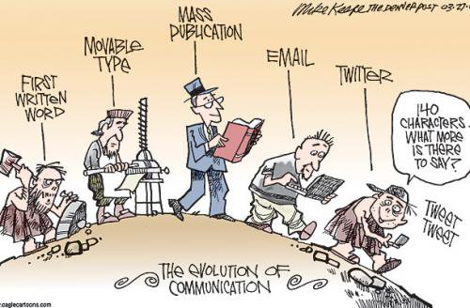
Artwork showing how communication has evolved over centuries.
Image: Mike Keefe: www.denverpost.com/2009/03/26/evolution-of-communication
Appendix 2

Diagram of the 7 C’s in Communication Defined

This is a table I created, defining the 7 c’s of communication.

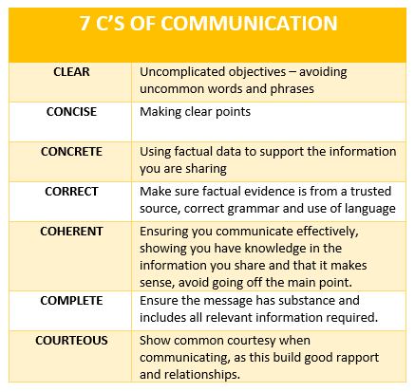

Appendix 3

Diagram of The Shannon Weaver Model

This is a diagram of the Shannon Weaver Model created by myself, showing what happens when we send and receive message, taking into account the ‘noise’ effect when using various channels to communicate in general and in the work place.

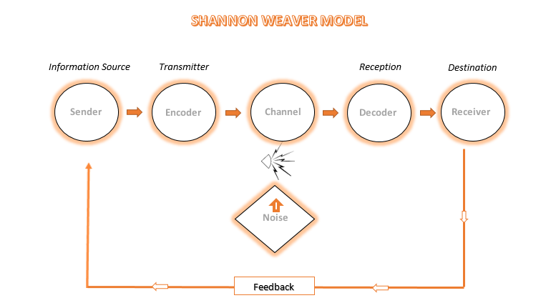

Appendix 4

Diagram of The Berlo’s Model

This is a diagram created by myself, showing the formation of ‘Berlo’s model’ inlcuding the various elements taken into consideration to ensure communication is effective in the workplace.
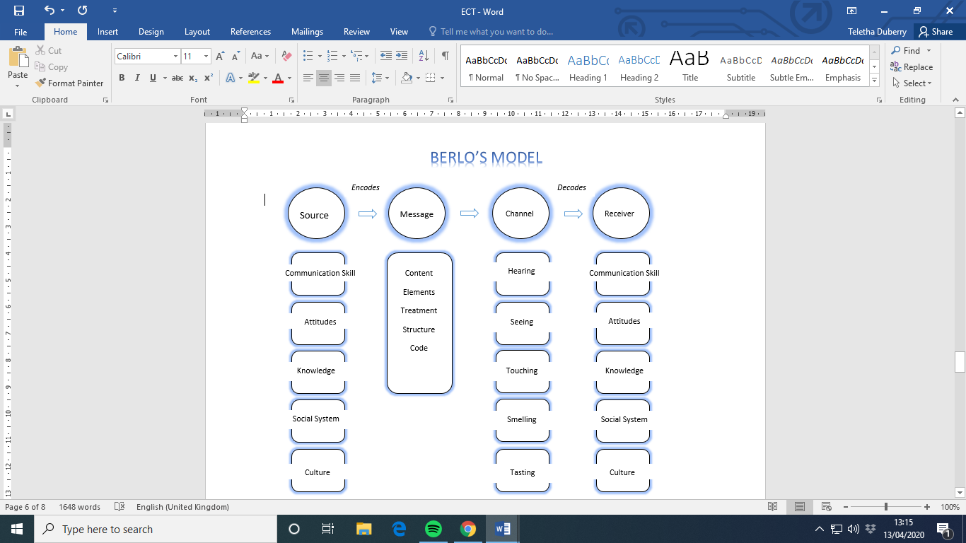

Appendix 5

Diagram of The Schramm’s Model

This is a diagram of the ‘Schramm’s Model’ created by me, demonstrating how communication between sender and receiver is deemed effective based on interpretation and knowledge of the message in transit on both ends.


