UWTSD

Effective Teamwork and Communication
CONTENT
Write a report of 2000 words demonstrating your understanding of the models of communication and the communication skills discussed in class and refer to any case studies done to show how these helped your understanding. Give examples of poor communication in your own or your friend’s workplace and suggest how it could be improved by using your findings from published literature (i.e. refer to theory).
Dayami dos Santos
2022551
Lloyd Beharry
BMSW4002

- Introduction ………………………………………………………………………….2
- The Models of Communication ……………………………………………………3
- Communication Skills ………………………………………………………………7
- Refer to case studies………………………………………………………………7
- Example of poor communication in the workplace …………………………… 7
- Suggestions for improvements by using theory (from published literature) …7
- Conclusion………………………………………………………………………….8
- References…………………………………………………………………………9

INTRODUCTION
It is essential to have an in-depth understanding of communication, the concept of communication is defined as the sending and receiving of messages to create shared meaning. The report bellow review insights of my understanding from three different selected authors about the Models of Communication, the influence of Shannon weaver model of communication, also known as the mother of all models, towards the Schramm and Berlo model of communication. It also outlines some of the most important communication skills that I learned while studying this module, where I refer to the case study ‘A Day with the Chief’’, explaining my point of view referring to the context. Furthermore, I gave a few examples of poor communication in my workplace, finally I gave a few suggestions on how to improve poor communication, based on my understanding on the subject.

The Models of Communication

For many years, humans have been trying to master the skill of communication in the most effective way possible. It is said that communication skills can take a lifetime to master, and the person that masters it, is yet to be confirmed. The urge to transfer information from one place to the other, has made us, over the time develop our communication skills to help in various aspects of life, from professional life to social gatherings and everything in between.
To this day, experts from diverse areas have dedicated their life and time trying to find ways to make communication easier, clear and more effective for everyone.
In 1948, the Americans Claude Shannon, mathematician and Warren Weaver, scientist, wrote an article about ‘A Mathematical Theory of Communication’ to the Bell System Technical Journal where years later the article starter to be known as the Shannon Weaver model of communication or the ‘Mother of all Models’.
The model of communication by Shannon and Weaver contends that human communication can be broken down into six different concepts:
- Sender (information source).
- Encoder (transmitter)
- Channel.
- Decoder (receiver).
- Receiver (destination).
- Noise (physical disturbance).
This is a linear model of communication that provides a framework for analysing how messages are sent and received. The model explains how messages can be lost, distorted and misinterpreted in the process between sending and receiving it because of noise, we can see it happening in the case study ‘Maria and Pedro’. The model provides an understanding of how information is transferred and how messages are sent and received but does not account well for the face-to-face and explanatory dynamics.
To this point, if I send a text message to my friend saying, ‘Let’s go for dinner today’, looking at the Shannon and Weaver model of communication we can say that communication occurred, but realistically it is not enough. I believe that the model luck context, that the sender takes for granted crucial information when writing a message and because this is a linear model which does not include feedback, how can the receiver in this case my friend, know the time or the place we are going to meet for dinner?
Although communication itself may have occurred, I believe that adding the feedback and the context would help avoiding miss understanding and modelling the required elements for an effective communication and make the model more suitable for human interaction.

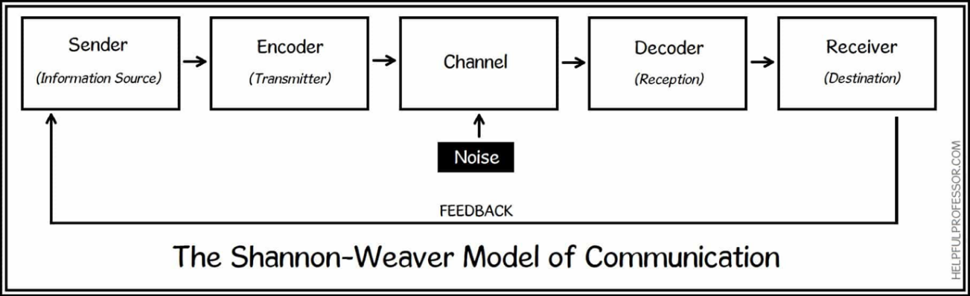
The Shannon- Weaver Model of Communication

‘My investigation shows that a later version of the theory by Norbert Weiner added a seventh concept to the model, Feedback which changed the model from linear to cyclical model.’
Shannon Weaver Model of Communication is mainly called the mother of all models, because right after they shared their thoughts about communication, it inspired other experts to do the same. In 1954 Wilber Schramm a well-known communication theorist, developed a circular communication Model, known as the Schramm’s Model of Communication, which has its roots from the Shannon Weaver model itself.
The Schramm’s Model views communication as a process that takes place between a sender (transmitter) and a receiver: there will also be a message and a channel through which the message can be transmitted Schramm, 1954.
Schramm defends that information is of no use, until it is carefully put into words and transported to others, he also defends that by encoding we are converting our thoughts into content which will initiate the process of communication, furthermore, the recipient or receiver has the responsibility to understand the message send by the speaker. Once the second part (receiver) can decode, understand the message sent by the sender and answer back, providing feedback communication is complete.
According to the Schramm’s model, coding and decoding are the two essential processes of an effective communication, emphasizing that communication is incomplete unless and until the sender receives a feedback from the recipient and that is where the big difference between the Shannon Weaver model of communication and Schramm’s model of communication is.
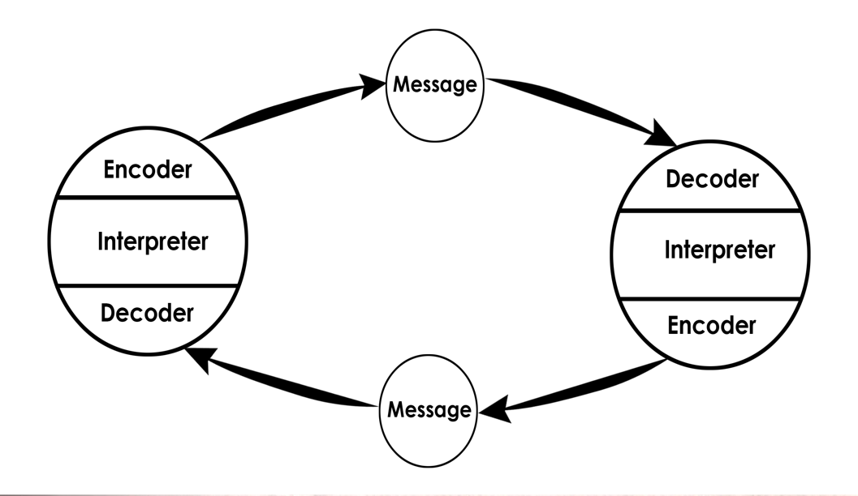

Schramm model of Communication, 1954

In the case study ‘Maria and Pedro’ if Pedro texted Maria back saying that he could not hear her properly because of the external noise and clarify with Maria what she meant the misunderstanding could be avoided, or in the case with my friend, using the Schramm model of communication, she could have texted me back right after receiving my message asking for more details, such as place and time.
During his research, Schramm also emphasised that the cultural background, knowledge and experience of an individual plays an important role when it comes to communication, Individuals from different cultures, religion or background tend to interpret message in different ways. For this reason, to this point it can be said that when a sender sends on the message to the receiver, the receiver must elucidate it in the preferred form the sender wants and send back the feedback or respond in the most suitable way. Any communication where the sender does not get the feedback, the communication is not complete and thus ineffective (Schramm, 1954).
For a long time, scholars were satisfied with Schramm interactive model and its approach to how human communication works, but they still felt as is something was missing, the need of a system that could explain the process of communication on its simplest form was evident. However, the model assumed that encoding and decoding does not require external assistance, and that’s a big limitation because how can I read a text message without having a phone?
I believe that Schramm model of communication was very efficient and its approach to emphasize the importance of having feedback, after sending a message it’s what made the model different, realistic and easy to relate up to modern days. This interactive model considers diverse concepts, that makes communication efficient.
Whilst Schramm studies focused explicitly on communication as a process between an encoder and a decoder, in 1964 David Berlo, expanded on this interactive and the linear model of communication by Shannon and Weaver, into a transactional model and created the SMCR Model of Communication, or Berlo’s Sender-Message-Channel-Receiver (SMCR).
Berlo’s SMCR Model of Communication represents communication in its simplest form, describing different parts that form the process of communication, but just like Shannon and Weaver model it was also a linear model that did not included feedback. In this model different factors that could cause interference or noise, are applicable for both sender and receiver and they could be External just like in the first linear model by Shannon and Weaver, where interference could be caused by background noise or internal, that can be caused by differences between the sender and listener in communication skills, such as listening, speaking, reading and language differences, attitude, and Knowledge. We can see these differences apply in the case study ‘The Professor and the Village people’, where the village people were largely uneducated so the possibilities of, they understand the language the professor used while shouting for help, was very low or inexistent.
I work for a multi-ethnic company, so every time a have meetings with my team we try and use language that every employee can understand so that they can perform in the best way possible.

Communication Skills
There are many different skills that exist to make communication easier, naming:
- Verbal communication (spoken and written, choice of words, tone, and pitch),
- Non-Verbal (Body language, facial expressions, physical appearance, eye contact),
- Active Listening - paying attention and not doing other things like reading your phone, filing your nails, assuming what the other person is going to say or completing their sentences.
- Empathetic listening – listening and trying to put yourself in the speaker’s shoes.

By having an overall look at the case study, ‘A Day with the Chief’, I believe that Mark should have acted different, we can observe that he did not evaluated the situation in the most appropriate way, by having the first verbal contact with the CEO made him notice that Mrs. Brown was the opposite of what they described her, he got too comfortable and did not keep a professional approach to the situation, by changing his body language( nonverbal communication), not paying attention on what the CEO asked( active listening) and answering something out of context (empathetic listening), and the fact of him not keeping his body language, listening to what she said and asked, in my opinion is what made her change her attitude towards Mark.
Beginning with an overview and historical perspective, the discussion covered general issues, including the communication skills above mentioned,it mainly reveals the significant impact of nonverbal behaviour on communication; yet this body of knowledge is incomplete and often complex. (Owen Hargie 2019).
Owen Hargie argues, 2019 nonverbal behaviour, as a communication skill, is mean- ingful only if the context of behaviour is taken into account. Incomplete or narrow perspectives regarding others’ or one’s own behaviour may lead to misinterpretation of actions observed or performed and that what we have happening with Mark, is also the case that careful and reliable applications of nonverbal behaviour can enrich and enlighten one’s understanding and control of communication in a variety of situations, roles, and cultural settings.
Resulting as an improvements of communication.

Conclusion
In conclusion, communication is of greatest importance to keep society functioning in harmony, as human we still have a lot to learn, but I am sure that with time and effort we will eventually be able to master the art of communication. The more we communicate the less we suffer and the better we feel about ourselves; this report has made me understand that to build a meaningful relationship with future employers, family, friends and others it is important to known and use the communication skills in the best and most effective way possible.

1917 words

REFERENCES
Model of communication, available at:
https://ecampusontario.pressbooks.pub/evolutionhumancommunication/chapter/chapter-1/ accessed on the 14th of August 2021 https://helpfulprofessor.com/communication-models/ accessed on the 14th of August 2021
All of the case studies above mentioned are available at:
Moodle.uwsts.ac.uk
Hargie, O. (2019). The Handbook of Communication Skills. 4th edition, London: Routledge
Hargie, O. (2017). Skilled interpersonal Communication: research, theory, and practice. 6th edition, London: Routledge

