

BMMB7003
Impact of the Gender Wage Gap on the Motivation of Female Employees in Developing Countries: Case of India

Student ID: 2227263
Student Name: Namrata Garthe
Module code: BMMB7003
Supervisor’s Name: Sarah Peasley

Declaration:
This work has not previously been accepted in substance for any degree and is not being concurrently submitted in candidature for any degree.
Signed: Namrata Garthe
Date: 6/12/2024

STATEMENT 1
This work is the result of my own investigation, except where otherwise stated. Other sources are acknowledged by footnotes giving explicit references. A bibliography is appended.
Signed: Namrata Garthe
Date: 6/12/2024
STATEMENT 2
I hereby give consent for my work, if accepted, to be available for photocopying and for inter-library loan, and for the title and summary to be made available to outside organisations.
Signed: Namrata Garthe
Date: 6/12/2024

Acknowledgement
On behalf of all the people who supported me when I was conducting this research, I would want to take this opportunity to thank them. I would like to thank my supervisor Sarah Peasley most sincerely for the support she gave me while working on this paper and for the advice and recommendations she offered to enhance this paper’s quality. I would also like to express my gratitude to the respondents who agreed to participate in the survey and provided important information for the study. Also, I would like to express my appreciation to family and friends for their encouragement during the research of this work and therefore, I appreciate having them.

Abstract
Purpose: The major purpose of this study is to analyse the influence of the gender-based wage gap on the motivation of female employees in developing countries by analysing the case of India.
Methodology: This research was conducted by using the support of the primary data collection method in which the data was collected from 100 female employees in India by surveying them. The data was analysed by using SPSS software and descriptive statistical data analysis method to examine the numerical data and observe the correlation between variables to test the hypothesis.
Findings: Findings indicate that wage disparities for identical roles undermine female employees’ morale, productivity, and commitment and ultimately create a barrier to career progression and skill development. Data analysis highlights that a significant proportion of female employees experience unethical wage practices which leads to decrease in job satisfaction among them. Government policies, such as maternity benefits and equal wage regulations, have been enacted to address this issue; however, their limited implementation in organisational practices extends gender wage disparities. The R-square value of 0.543 from the data analysis confirms a moderate correlation between gender-based wage inequities and female employee demotivation, rejecting the null hypothesis that the gender wage gap has no impact on motivation. Thus, it is effective for firms in developing countries to implement the policies developed by the government to reduce the gender wage gap and increase the motivation of female employees.
Recommendations: Promotion of pay transparency, employee resource group and mentorship program. Regular pay audits can be effective for firms in developing countries to reduce the gap in the gaps among genders of employees.
Keywords: Female Employees, Motivation, Developing Countries, Wage Gap, Genders, Morale, and Confidence
Table of Contents
Abstract 4
Chapter 1: Introduction 7
1.1 Background of the study 7
1.2 Aim, Research Objectives and Research Questions 10
1.3 Hypothesis 11
1.4 Problem Statement 11
1.5 Research Rationale 11
1.6 Research Significance 12
1.7 Research Structure 13
Chapter 2: Literature Review 15
2.1 Introduction 15
2.2 Theoretical Underpinnings 15
2.2.1 Understanding the Gender Wage Gap Across Industries 15
2.2.2 The gender wage gap and its influence on female employee motivation 17
2.2.3 The psychological impact of the gender wage gap on female employees 18
2.3 The Range of the Gender Wage Gap in Various Industries within India. 18
2.4 Influence of Gender Pay Gap on Female Workers' Motivation at Workplaces in India 19
2.5 Factors influencing wage disparity and its effect on career progression for women. 21
2.6 Efficiency of Policies and initiatives aimed at minimising the gender pay gap thus, refining female employee motivation. 22
2.7 Recommendations to Boost Motivation and Job Satisfaction among Female Employees, Concerning Wage Inequality 23
2.8 Conceptual Framework 24
2.9 Research Gap 25
2.10 Summary 26
Chapter 3: Research Methodology 27
3.1 Introduction 27
3.2 Research Design 27
3.3 Research Philosophy 29
3.4 Research Approach 29
3.5 Research Method and Strategy 30
3.6 Population and sampling method 31
3.7 Data Collection Method 31
3.8 Data Analysis Method 32
3.9 Reliability and Validity 33
3.10 Ethical Consideration 34
3.11 Limitations 34
3.12 Chapter Summary 34
Chapter 4: Data Analysis 35
4.1 Introduction 35
4.2 Interpretation and Analysis of Findings 35
Chapter 5: Discussion, Conclusion, and Recommendations 53
5.1 Introduction 53
5.2 Discussion 53
5.3 Conclusion 55
5.4 Recommendations 57
5.5 Recommendations for future research 58
5.6 Limitations 58
References 59
Appendices 67

Chapter 1: Introduction

1.1 Background of the study
In the current business landscape, Employee motivation is a crucial aspect as it represents the energy levels, enthusiasm and commitment of employees towards their job roles. Motivation within an organisation is important as it drives its employees towards achieving the goals and objectives of a firm and its employees in a collaborative manner. It also plays a significant role in increasing the productivity and growth patterns of an organisation (Van Tuin, et al., 2020). It is also aligned with the disciplinary aspects of a firm as both aspects either motivation or discipline have a major aim of driving a firm towards success in its market (Chanana, 2021). Hence, it is necessary for a company to comprehend with motivational factors that impact its growth rate and performance positively.
Among the distinct aspects of a firm that mediates the motivational factors in a company, the workplace environment plays a major role. Along with the workplace environment, motivation within a company also depends on the communication and the degree of flexibility offered by a firm to its employees (Kalogiannidis, 2021). A firm with significant communication tactics being followed in its workplace has a tendency to gain a competitive advantage in its segment or market. Along with this, motivation in a company is also defined as the willingness of an employee to bring out his/her maximum potential to help a company achieve its goals and objectives (Chanana, 2021). The flow of a company towards its competing position and brand image also depends on how much its employees are motivated (Khuong and Linh, 2020). The flexible working operations being provided by a company affect the work-life balance of an employee working in the organisation which in turn also fosters a positive impact on the growth and competing position of a firm (Tumi, et al., 2022). Along with the above-mentioned aspects, there are also other factors such as socialisation and company culture which affect employee motivation accordingly. Socialisation can be stated as the comfort which has been provided by a firm to its employees either in terms of communication or feedback.
Apart from the above-presented data, the key aspect related to employee motivation is the wide difference between female and male employees of a company. The gender gap within the corporate work culture has been found to have increased significantly which has resulted in a false impact on female motivation within a company. There are various firms which practice this particular unethical characteristic of providing low wages to females such as Nykaa which provides females with 27% lower wages when compared to males (Raj, 2024). Along with this, Tata Consultancy Services (TCS) has also been found to perform the unethical practice of not providing enough job roles and wages to its female employees resulting in poor feedback and 17% lower chances of females getting higher roles and large salary packages (TCS, 2024). Hence based on the above presented data it can be stated that the wage gap and issues related to salary packages are the major demotivating factor that impacts the mental health of an employee negatively.
The wage gap and unethical practices related to female work have been performed at a tremendously higher rate. The practice of not providing wages to female employees despite their appropriate efforts in a company has been found to be performed on a regular basis (Chanana, 2021). In different industries ranging from retail to even the construction segment, females are not provided with equal salary packages to males despite their same working position. Alongside this, distinctive job roles have also been provided to females due to the unethical ideology of leaders of a firm. Considering the Indian market, it can be stated that females are provided with lower wages when compared to males in almost every sector and employment level. The average salary package of an Indian female is found to be 33% lower than that of males which can be referred to as only 4,014 INR per month (Van Tuin, et al., 2020). Moreover, considering the hourly pay provided by a firm to its employees, it has been analysed that in 2023, males earned significantly larger hourly pay when compared to males irrespective of their job role or working occupation. Males were earning 24% larger salary on an hourly basis when compared to females. This further poses a negative impact on female employee' motivation to indulge in different segments and even work outside their comfort zone in an organisation (Putra, et al., 2020).
The insignificant consideration by a firm towards maintaining its wages and salary increment for employees impacts its employee motivation and consideration towards the growth rate and performance of the respective company (Alam, et al., 2020). The wages and salary of employees vary based on the industry in which they pursue that work or the country in which they are residing. Hence, based on the above-discussed aspects, it can be stated that motivation has an integral role in the overall growth and performance of a company and its employees in its niche or market (Uka and Prendi, 2021). The table below represents the monthly salary of employees working in India.
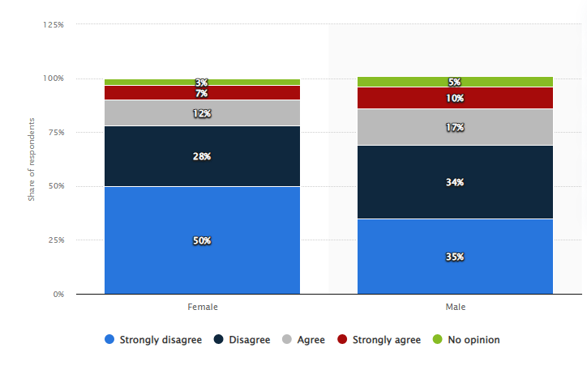
Figure 1: Opinion on men out-earning women in India 2020 by gender
(Source: Statista, 2023)
Based on the image, it can be stated that a survey occurred in 2020 in which Indian people were asked about gender wage gaps which provided the following results. Many respondents in India disagreed with the notion that men should be paid more than women for the same job, with approximately three-quarters of both female and male respondents sharing this view. Specifically, 50% of female respondents and 35% of male respondents took a strong stance against the gender pay gap for identical roles which is a major issue in India. (Statista, 2024). The survey occurred in 2020 in which Indian people were asked about gender wage gaps which provided following results. Alongside this, the wage similarities and differences between different or opposite genders also have a significant impact on work intention and the employee turnover rate of a company. This can be regarded as the primary reason behind the presence of male staff in big MNCs rather than female staff (Chahar, 2020).
Hence, it can be stated that gender-based pay is a global issue and has impacted the work culture and growth of different industries in negative terms. The false thinking of employees or leaders within a firm towards female and male wage dissimilarities not only impacts the work ethics of female employees but also demotivates them to work appropriately in the firm (Chanan, 2021). Considering India, senior women employees earn between 85 and 100 INR per day for a similar position, whereas their male counterparts in the same role earn between 150 and 200 INR per day (George, 2023). This in turn reveals the increasing gapes in wages among males and females in the Indian market. A detailed description of the female and male wage dissimilarities and problems that are addressed in this study is presented in the below-presented sub-section of the study.

1.2 Aim, Research Objectives and Research Questions
Aim
The primary aim of the study is to analyse the impact of the gender wage gap on the motivation of female employees in developing countries by comprehensively analysing the case of India.
Objectives
- To examine the extent of the gender wage gap in various industries within India.
- To analyse the impact of the gender wage gap on female employee motivation in Indian workplaces.
- To identify factors influencing wage disparity and its effect on career progression for women.
- To assess the effectiveness of policies and initiatives aimed at reducing the wage gap and improving female employee motivation.
- To provide recommendations to enhance motivation and job satisfaction among female employees in the context of wage inequality.
Research Questions
Primary research question
- What is the impact of the gender wage gap on the motivation of female employees in different developing countries such as India?
Secondary research question
- What are the factors that influence the wage disparity and have a significant impact on career progression for women?
- What is the effectiveness of the policies and initiatives which have a major aim of reducing the wage gap and improving female employee motivation?
- How can motivation and job satisfaction among female employees be enhanced in the context of wage inequality?

1.3 Hypothesis
H0- The gender wage gap does not have a significant impact on female employee motivation in developing countries like India.
H1- The gender wage gap has a significant impact on female employee motivation to work in developing countries like India.

1.4 Problem Statement
The wage provided to an employee has a prompt impact on his/her intention to work continuously and progressively in an organisation. However, the key issue linked with wage delivery in the Indian marketplace is gender stratification as the key ideology of the Indian leaders and higher managerial authorities of Indian firms (Singh and Pattanaik, 2020). This particular ideology of Indian firms is strictly linked to biases based on gender and judging an individual based on their gender (sexism) has impacted the overall task segregation system of various firms in the Indian marketplace. This particular act performed by Indian firms in the context of wage disparities among females and males poses a negative impact on the work intention of females. This unethical and gender stratification ideology of job owners in India has also been a major cause of the declining participation rate of female employees within an India-based company (Kesar, et al., 2021).
Women are more likely to be involved in undertaking activities such as more frequent breaks and absence from the job due to the mismanagement and unethical treatment of wage delivery being encountered by them. This particular aspect linked with the female and male wage dissimilarities has not been presented on a broader scale in previous studies (Mehrotra and Parida, 2021). Hence, this particular study has been performed to provide significant and broad information on this particular context.

1.5 Research Rationale
The increasing cases of unequal wages being provided by Indian firm owners and higher authorities have been hurting the work intention of females. This is also associated with the poor HRM propensities of the companies and poses a significant influence over women's engagement in daily tasks or decision-making in Indian firms (Pal, 2021). The dedication that females have to offer to a firm has also declined drastically due to this unethical practice performed with the females. There have been vast differences between the annual, monthly and even hourly salary packages of females when compared to males in the Indian marketplace (Llop-Gironés, et al., 2021).
The insignificant consideration laid by the Indian firms in ensuring successive development of ethical workplaces and equal wages to be provided to Indian females has also impacted the overall ideology and thinking of females to be inclined towards the particular firm’s success. Hence, based on the severity of the issues and their impact identified, there must be elimination of wage gaps that are performed by Indian firms (Singh and Pattanaik, 2020). Therefore, this particular research has been performed in order to gain comprehensive insights on the wage disparities among males and females of the Indian marketplace along with the delivery of significant recommendations to counter such issues and negative changes.

1.6 Research Significance
The current study has been done in a systematic order through the formation of appropriate objectives that are pivotal in addressing its primary research question. The research encompasses the delivery of vital information related to the current wage gap aspects that are being performed in the Indian marketplace along with the thorough examination of its severity and occurrence probability (Singh and Pattanaik, 2020). This in turn could enlighten the Indian firms regarding the brutality of this particular issue in the entire industry. Moreover, the data provided in this study related to the impact of gender wage differences of female and male employees also makes this particular research significantly beneficial for Indian firms and female employees as a whole. The factors identified in this study which pose a significant impact on wage disparities and career progressions of female employees also justify its significance.
Furthermore, the effectiveness of policies and procedures that have a significant aim of reducing wage differences in order to improve female work motivation and dedication is also presented in this study. This also justifies its significance in enlightening Indian firms and even female employees regarding the discussed policies and procedures. Lastly, the delivery of informative recommendations in this study for female employee motivation and job satisfaction in relation to wage disparities can also assist Indian firms in implementing new strategic options in their working operations.

1.7 Research Structure
The entire study has been done systematically by dividing it into subsequent sections followed by sub-sections. The research has been divided into chapters whose brief description has been presented in the below presented table.
Chapters | Brief information
Introduction | This particular chapter of the study focuses on identifying the major issues followed by their impacts on the study’s stakeholders. It also encompasses the delivery of vital information on the objectives and benefits that could be posed by the research outcomes on its stakeholders.
Literature Review | This section of the research deals with providing important information related to the study’s research variables by analysing previous studies and the findings of already published research materials. The gap that has been addressed in this study has also been presented in this section of the research.
Research Methodology | The particular section of the study provides information on the research methods and techniques that are been used in the current study. Data related to the justification of the used research methods and its distinct attributes has also been presented in this study section.
Data Analysis | The analysis of the gathered information has been done by the effective implementation of selected data analysis method.
Discussion, Conclusion and Recommendations | It delves in performing a critical analysis of the study findings and the findings of the literature review. Concluding remarks of the study has also been provided in this section along with delivery of significant recommendations for the study’s stakeholders.

Chapter 2: Literature Review

2.1 Introduction
The gender wage gap is defined as the gap in the average wage of both genders. This impacts the economic independence of the female worker, her career progression, and her overall welfare (Chanana, 2021). A literature review provides an outline to understand the amount of available information regarding the research area. A wide variety of articles, PDFs, and journals have been reviewed to gather a basic understanding of the research. This chapter presents an analytical critique of the various views of the authors derived from authentic and reliable sources.

2.2 Theoretical Underpinnings

2.2.1 Understanding the Gender Wage Gap Across Industries
According to, Petrongolo and Ronchi, (2020), the gender wage gap is a persistent issue in most sectors of developing economies and reflects broader societal and economic challenges. It is defined as the difference in average earnings between male and female employees, usually associated with many complex factors related to occupational segregation, limited access to education and training, and the underestimation of the value of work traditionally done by women (Bonaparte, et al., 2024). Some industries are more wage-gap-intensive, especially if they involve highly specialised skills or traditionally male-dominated professions. The gap is generally larger in sectors such as technology, manufacturing, and finance than in healthcare and education, where females hold higher levels of representation (Jung and Lim, 2020). Nevertheless, even in reasonably balanced gender representation in some industries, unequal pay continues to be a problem - often for reasons of inequitable career advancement and biased performance reviews.
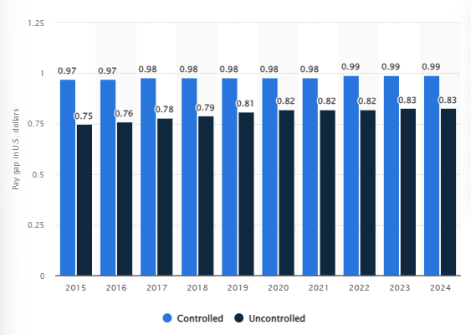
Figure 2: Wage gap on a global basis 2015-2024
(Source: Statista, 2024)
The above image provides a significant idea on the wage gap between males and females in the global marketplace (Statista, 2024). Moreover, Rouen, (2020), stated that occupational segregation is one of the major causes of wage inequality that has been found; jobs are dominated by males or females. High-paying jobs often have male dominant workers, and females dominate lower-paid jobs. And, within the same occupational roles, women are also restrained in negotiations regarding salaries and are more likely to be employed in part-time or temporary positions, all of which expand the income gap even more. In addition, Baker, et al., (2023), said, that relates to the "glass ceiling" phenomenon, where there is a restraint in female career advancement in an organisation and reinforces pay differences at higher organisational levels where men are more likely to hold well-paid top positions.
On the other hand, Adams-Prassl, et al., (2022), said that the wage gap has direct implications for women workers; it usually impacts the motivation and job satisfaction of women. When the pay structure is perceived to be unequal, especially in the context of gender, rather than performance, this reduces the morale and readiness to stay within specific industries or organisations. This demotivation not only has impacts on career advancement but also affects productivity and retention rates in industries. Moreover, low wages and limited career opportunities for advancement indicate women have less financial security and bargaining power within the workplace (Biasi and Sarsons, 2022).
In conclusion, the policy solution must therefore link pay equity with issues such as equality and transparency to determine more avenues to achieve equal opportunities. These methods help bridge the gap while improving pay equity and allowing change in the form of education. The gap can eventually be bridged by industries which, to increase gender inclusivity in jobs, create the motivation to attract and retain great workers who will be pillars for thriving businesses.

2.2.2 The gender wage gap and its influence on female employee motivation
As argued by Blau, et al., (2024), the current issue of gender wage inequality persists to be a serious problem within most developing economies. This issue has far-reaching implications, causing deep influences on the motivation and performance of female employees. This inequality of pay not only raises the matter of financial fairness but also causes more impacts on job satisfaction, engagement, and even women's career progression. Similarly, Agrawal, (2021) argued that when women are paid lower compensation than their male counterparts to do the same work, an impression of being undervalued and frustration is created. Inequity leads to de-motivation as women will perceive their efforts as less valued or rewarded even though qualifications or performance exist. Long-term consequences include reduced commitment, higher levels of intent to leave, and decreased productivity - all of which impact organizational success (Bilan, et al., 2020).
On the other side, Busch, (2020) said that the gap in wages also presents significant barriers to career growth for women, which creates an impact on their role in leadership and professional skills development. While pay differences persist, they usually present a deeper structural bias within the organization that restricts women's participation in top-paying, influential positions. This upward mobility makes women not be maximally engaged in their work because they may feel that their effort will not be rewarded at par with their male counterparts. In support, Manzoor, et al., (2021) opined that such experiences lead to what is often called the "glass ceiling effect," where women encounter invisible but real barriers to progression despite qualifications and efforts. These unreceived aspirations further intensify the decline in the self-confidence and drive of individuals, as well as their purpose in their jobs.

2.2.3 The psychological impact of the gender wage gap on female employees
The author, Cortés and Pan, (2023), pointed out that prolonged exposure to wage inequality lowers morale and job satisfaction, impacting both psychological well-being and perceptions of fairness in the workplace. Employees who feel they are treated unfairly are less likely to put in discretionary effort and may become disengaged. This reduced engagement affects not only their performance but also the overall morale of the organisation. In support of this opinion, Begeny, et al., (2020), conclude that the elimination of the gender wage gap is an essential issue in financial equality and in the development of a committed, diverse, and effective workforce. Organisations that actively work to eliminate the gap through transparent pay structures, mentorship, and equal growth opportunities benefit from a committed, high-performance workforce. Closing the wage gap fosters a work culture that values women, motivates them, and encourages their contribution toward the accomplishment of organisational goals (Weisshaar and Cabello-Hutt, 2020).
Simultaneously, the authors Kuhl, et al., (2021), reviewed that female employees who are paid lesser wages as compared to male co-workers for the same work confront economic insecurity, leading towards a range of negative outcomes, which may include health, stress, depression and anxiety. Whereas, per the human capital theory, the gender pay gap is associated with gender differences in human capital investment, thereby, resulting in wage differences (Gaddis and Klasen, 2019). Similarly, the research conducted by Blau and Kahn, (2020), illustrated that the gender pay gap can be explained by the differences in human capital such as in education and on-the-job training performance. However, it has been highlighted that the explanatory power of formal education has reduced in recent decades (Wiemers and Buchholz, 2019). While, authors Lindsey and Nguyen, (2022), in their study noted that the perceptions of the gender pay gap can cause stress and further may affect self-esteem, psychological well-being and workplace relationships. Along with this, some other factors that may contribute to the gender pay gap involve labour market discrimination and the cultural devaluing of professions linked with women and femininity (Rodriguez and Burns, 2021).

2.3 The Range of the Gender Wage Gap in Various Industries within India.
Per the insights of the study by Cotter and Hermsen, (2020), it has been examined that the gender wage gap varies from industry to industry, while having the largest gap in the consumer industry. In relation to consumer services, this industry has a larger gender gap in India, with women making up nearly 32.7% of the workforce in the overall sector. However, as per the report presented by UN Women, (2024), the gender pay gap worldwide stands at 20%, that is female employees earn 80% of the total pay of men, even after working the same. Besides, this gap is even higher, grounded on discrimination based on colour, migrant women, women with a disability and women with children. Hence, mitigating the gender wage gap is vital, in order to reduce global gender inequality and attain sustainable development (Reed and Morrow, 2019). On the other hand, the research held by Grimshaw and Rubery, (2021), emphasised the global historical factors that have led towards the emergence of the gender pay gap. The historical and structural inequality and unequal empowerment between men and women have been the major causes of the perception of the gender pay gap.
According to the perceptions of Sharma and Kumar, (2021), in India, the gender pay gap is associated with a wide range of factors which differ across industries, occupations and regions. In relation to the agriculture sector, women earn about half of what men earn, varying from state to state. For instance, as of 2020-21, in Kerala, women in agriculture earned about 500 Rupees a day, while men earned about 750 rupees per day. Also, Tamil Nadu has recorded the highest gender pay gap in the agriculture sector, that is, 112% (Rao and Reddy, 2020; Ghosh, 2021). Contradictorily, from the viewpoints of Chakraborty and Gupta, (2019), it has been demonstrated that in the manufacturing and construction industry, women are more likely to earn almost 50% less than men, even when performing the same task. Also, it has been found that the inadequacy of Indian legislation while addressing this issue has been the root cause of the inability to overcome it (Sen and Patnaik, 2020).
Whereas, in the opinion of Iyer and Sundaram, (2022), in India, the service sector is the one with the least gender wage gap among male and female employees. In terms of this sector, women earn 25% less than men, which is the minimal gender pay gap in a country like India. In addition to this, by offering more flexible working options to female employees, advocating for paid leave for both parents and passing laws that develop transparency, concerning how men and women are paid, the Indian government can effectively address the gender wage gap (Nair and Verma, 2021). Conversely, as noted by Basu, (2023), women in the education sector of India, earn less than men at every educational level. For instance, female workers with professional qualifications earn 44.25% less than male co-workers (Desai, 2021).

2.4 Influence of Gender Pay Gap on Female Workers' Motivation at Workplaces in India
According to the impressions of Bhattacharya and Sen, (2021), it has been estimated that at present, women are being compelled to focus on domestic chores rather than getting education, training and employment. This burden and restriction on their roles and responsibilities decrease job prospects and economic security leading to the constant status of inequality. However, as per the empirical studies conducted by the authors, Patel and Singh, (2019), this paper has highlighted that the gender pay gap has considerable implications for female employees’ motivation levels within the Indian context to be addressed. It has been further revealed that the matter of the Gender pay gap in India is related to female employees being paid less than male employees for the same job. This has not only negative effects on the financial position of women employees but also on work motivation in the organisational context.
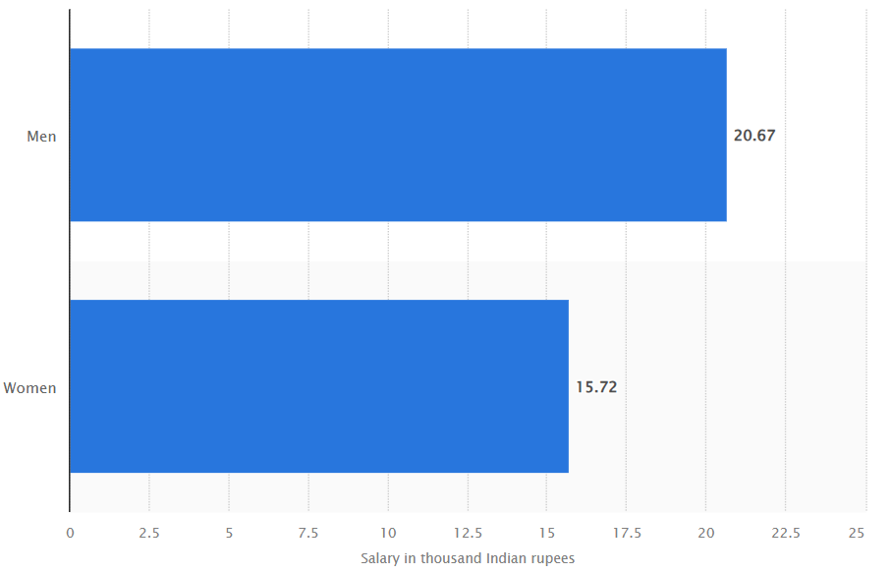
Figure 3: Average monthly salary of salaried class in India in 2023, by gender
(Source: Rathore, 2024)
The above image describes the differences in the Indian wage delivery system, where men are offered approximately 5% higher salaries than women (Rathore, 2024). On the contrary, according to Reddy and Mehta, (2022) when employees particularly females feel that they are paid less than male employees and sense the quality of being overqualified and demotivated, leading to decreased job satisfaction. The sense of injustice that halts the gender pay gap can also have following negative impact on the morale and propagation of the organisational commitment of females, including their enthusiasm to work at their best and promote the organisation. Similarly, in the work conducted by Gupta and Verma, (2020), it was captured that the gender pay gap can lock women in a loop of poor career mobility in organisations in India. Also, when the contributions made by women are not adequately rewarded or valued, they may be discouraged from putting in the write-up for a promotion or for assuming extra responsibilities.
Expanding to this viewpoint, from the perspectives of Das and Chakrabarti, (2021), it has been recognised that in all the discourses related to the gender pay gap and its prospective for female workers in India, it can be seen that there are a number of gender-based employment wage issues. The gender pay gap is not just a sign of unfair pay, but also highlights underlying biases and on-going gender imbalances within organisations. This structural inequality affects individual employees and has wider impacts on businesses, society, and organizational culture. Simultaneously, Sharma and Kapoor, (2019), in their study illustrated that the gender pay gap can act as a barrier to gender diversity and inclusion efforts, limiting the representation of women in leadership roles and decision-making positions.

2.5 Factors influencing wage disparity and its effect on career progression for women.
Based on the findings of Chen and Hassan, (2022), it can be stated that skill differences are a major factor which impacts wage changes and fluctuations among female and male employees within an Indian company. The skill levels and the physical capabilities of females and males vary significantly which in turn poses a significant variation in their salary packages. The cultural boundaries for women are often more restricted compared to those of men, which consequently limits the availability of certain job opportunities for women in Indian companies (Kabeer, 2021). In a similar context, the findings of Agrawal, (2021), emphasizes that the gender wage gap in India is influenced by various factors. In rural areas, education significantly contributes to the wage disparity, while in urban areas; occupational profiles play a more prominent role.
On the other hand, Radhakrishnan, (2020), depicts the negative impact of sexism ideology and unethical propensities on the work motivation of females and also illustrates it as a significant factor which impacts the career progression of females in a company. Whether being an Indian firm or a global firm, adherence to a sexist ideology or practising the core aspects of sexist ideology lengthens the wage disparities among male and female employees of a company. However, the findings of Mukherjee, (2022), stated the fact that leadership has a crucial role in deciding the job roles and wage packages of male and female employees in a company. Irrespective of the industry or the country, leadership has a significant impact on the work intention and work culture of a firm. The changes made by a leader with insignificant thinking towards males and females impact the salary packages of females and males. This in turn impacts the intention of females to be involved with a firm’s key decisions and growth. Hence, through a comprehensive understanding and analysis of this particular finding, it can be stated that leadership do possess a significant impact on the career progression of female staff in a company.
Based on the above findings, it can be stated that skill differences, distinctive physical capabilities, leadership and sexist mentality are major factors that impact the career progression of female employees and wage disparities in an organisation.

2.6 Efficiency of Policies and initiatives aimed at minimising the gender pay gap thus, refining female employee motivation.
In the opinion of the authors Sharma and Patel, (2020), there are several initiatives undertaken by the government, in order to reduce or mitigate the issue of the gender pay gap. The legislation of the country may enact laws which guarantee equal pay for work of equal value, ensuring the involvement of female operators by encouraging them to work. Furthermore, it is also necessary to launch relevant efforts to reduce the effects of the above-mentioned systematic problems which contribute to maintaining wage disparities and limiting women’s promotion at work. Through understanding these policy outcomes, researchers hope to give information on how gender pay gap policies have continued to enhance a favourable work environment for female employees (Kumar and Singh, 2021). Opposing this, in the research conducted by Nair and Gupta, (2019), it has been underscored that the achievement of policies and initiatives aimed to reduce gender wage differences and increase the motivation of female employees primarily depends upon several factors. These important aspects are the awareness of the known measures, the degree of organisations’ commitment to equality of genders, the presence of responsibility for following up the speed of changes, and the correlation of these activities with combating structural factors influencing the wage gap and motivation issues of women in the labour market (Raj and Bose, 2022).
Whereas, in the context of India, Chaudhary and Sen, (2020), reviewed several policies and initiatives that have been introduced to address the gender wage gap and enhance female employee motivation in the workforce. One notable policy is the Equal Remuneration Act, which mandates equal pay for equal work and prohibits discrimination based on gender in salary. This legislation aims to ensure that female employees receive fair and equitable compensation for their work, thereby contributing to reducing wage disparities between genders. Conversely, author Kumar, (2019), highlighted the Maternity Benefit Act provides female employees with maternity leave and benefits, promoting work-life balance and supporting women's participation in the workforce. By offering maternity benefits, this policy helps to retain female talent in the workforce and encourages their continued engagement and motivation in their careers. On the other hand, Mehta and Desai, (2021), elaborated on initiatives such as the Sexual Harassment of Women in Workplace, including prevention, prohibition and redressal acts aimed to create safe and inclusive work environments for women. In addition to this, by addressing issues of harassment and discrimination, this legislation helps to foster a workplace culture that values and respects female employees, thereby enhancing their motivation and overall well-being at work.
In brief, from the above analysis of viewpoints of various authors, it has been acknowledged that by implementing and enforcing these policies and initiatives, India aims at achieving the following goals in the policies and measures these policies and initiatives are being implemented and enforced: To reduce the gender wage gap, to ensure gender equality at the place of work, and increase the female Employee Motivation within Different Industries and Sectors. These efforts have been largely directed towards a greater focus on a progressive, diverse, empowering workplace for women in the Indian workforce.

2.7 Recommendations to Boost Motivation and Job Satisfaction among Female Employees, Concerning Wage Inequality
According to the perspectives of Nair and Sharma, (2021), it has been stated that companies can emphasise improving the problem of wage disparities, resulting in increased job satisfaction and motivation among female workers by promoting merit over gender. This elaborates on the promotion of the employees, grounded on their merits irrespective of their gender. Moreover, it has been analysed that being transparent about compensation, including salary structures and pay decisions can build trust among employees. Whereas, in the study by (Kumar and Singh, 2020), it has been described that standardising salary scales can help organisations offer job satisfaction with the firm and motivate female employees to perform the assigned tasks effectively. This further includes fair pay, career advancements, reduced stress and employee productivity. The study also identified that salary is one of the prime reasons, employees leave their jobs, thus this approach can help companies to increase employee satisfaction and curate productive results.
On the other hand, as noted by Verma and Gupta, (2019), it has been discussed that firms can augment female employees' motivation towards their job role within the workplace by providing a secure environment and eliminating gender discrimination. Gender discrimination can limit the job opportunities of women for promotion and leadership positions. Also, this can put psychological pressure on the employees, leading towards diminishing self-esteem, emotional instability and job satisfaction. While, the authors Mehta and Rao, (2022), emphasised addressing unconscious bias in the workplace can help reduce wage inequality and encourage female employees. The study also revealed that unconscious biases can hinder career advancements and professional growth, contributing to the gender pay gap. Besides, it may not create an inclusive environment which makes it difficult to be objective when evaluating employees. However, addressing these biases can foster a more equitable workplace, enhancing employee fulfilment of the female staff in the workplace.
In the beliefs presented by scholars Joshi and Chatterjee (2021), the study emphasises the importance of the recognition and rewards system for increasing job satisfaction and support for responsibilities. Being recognised for personal and professional success and for the team's success is especially motivating and keeps the women ‘in place’ due to reinforced feelings of value to the firms, ultimately leading towards mitigating wage inequality. Furthermore, other leadership practices include the promotion of gender equality within organisations and the maintenance of women leaders’ voices in decision-making processes. However, according to the study conducted by Iyer and Singh (2023), it has been analysed that the establishment of an inclusive leadership style is for the benefit of females in the workplace and to remove disparities in the characterisation of the wage gap. Managers who guarantee trust and cooperation also can help improve morale and create feelings of inclusion which also helps females and helps them engage more in their jobs.

2.8 Conceptual Framework

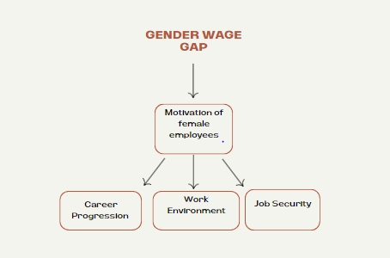
Figure 2: Conceptual Framework
(Source: By Author)
The graphical representation of the above conceptual framework depicts how the Gender Wage Gap affects the motivation of females in India. The diagram above shows the correlation of the gender wage gap, being an independent variable with the female employee motivation as the dependent variable. On the basis above mentioned conceptual framework, following hypothesis are developed:
H0- The gender wage gap does not have a significant impact on female employee motivation in developing countries like India.
H1- The gender wage gap has a significant impact on female employee motivation to work in developing countries like India.

2.9 Research Gap
In the existing literature, authors such as Basu, (2023), Bhattacharya and Sen, (2021), Desai, (2021), and many more have focused on various aspects including the impact of the gender pay gap within the workplace in India and their influence on motivation of female employees. Also, factors such as skills differences, sexism ideology and sexist ideology affect wage inequalities and career growth for women. Policies such as the Equal Remuneration Act have been effective in reducing the wage gap and improving motivation among female workers. However, the scholars in the previous studies failed to address the major threat to wage delivery in the Indian marketplace, that is gender stratification.

2.10 Summary
From the above analysis, it can be summarized that sources have shown that India has a gender wage gap in the workplace and its degree differs across the industrial segments with the consumer segment dealing with the gender pay gap as the female employees earn much less than their male colleagues. Lack of policy frameworks that consider women, supreme and past discrimination results in increasing this problem, especially in agricultural and manufacturing sectors where women are paid half of what man earns. The gap has a direct relation to the motivation of female workers as perceived discrepancies result in creating a sense of being overlooked and dissatisfied at the workplace, thus, not facing any promotions in the organisation. These formal policies such as the Equal Remuneration Act are meant to solve such issues, however, their success lies within the organisational commitment as well as, responsibility. The recommendations for improvement include promoting merit-based promotion, providing transparency in employees’ remunerations, tackling unconscious bias, and encouraging the leadership to improve the satisfaction and motivation of working women effectively.

Chapter 3: Research Methodology

3.1 Introduction
This particular chapter of the study focuses on providing significant information on the research methods and instruments that are been used in this research. Along with this, the justification of the used research methods and why other research instruments are not utilised has also been provided in this research. The ethical considerations that have been adhered to in the current study along with the vital information on the limitations posed by using the particular research method have been presented in this section of the research.

3.2 Research Design
A research design can be stated as the overall strategy that is used while performing a research project which assists in prompt execution of the initiation and ending of research. The selection of significant research methods for performing important steps such as data collection and analysis of collected data also depends on the research design (Abdulhakim, 2021). Hence, for this particular context, the implementation of a significant research framework is important. The current study has implemented Saunders’s research onion model for effectively segregating its underlying chapters and performing the entire study in a systematic order. The name itself represents the fact that the particular model resembles the shape of an onion which encompasses different layers. The layers provide a significant understanding of the different research methods and properties that are been used in the current study (Iovino and Tsitisianis, 2020). The philosophical aspects, approaches, methodological choices, data collection and analysis method are presented significantly in the current study through the effective implication of Saunders’s research onion model in the current study.

Figure 3: Saunders's research onion model
(Source: Saunders, et al., 2019)
The Saunders Research Onion signifies how to design research methodology effectively by evaluating the significance of different research methods. It consists of layers that guide through the entire process including the outermost layer as a philosophical approach to the innermost layer of data analysis. The above-presented image is a pictorial presentation of Saunders’s research onion model that has been used in the current study. The particular model is helpful in taking significant steps for undertaking prompt decisions to select significant research methods and tools in the current study. It also offers flexibility for clarifying the philosophical and methodological underpinnings of the selected research methods and instruments thereby justifying its utility in analysing the impact of wage differences among male and female employees over their motivation in the Indian market or firms. Alongside this, there are also various benefits posed by Saunders’s research onion model apart from the above-mentioned ones which also justifies its implementation in the current study. The key benefits are structured framework, holistic approach of selecting prompt research method, higher probability of significant research outcomes and effective organisation of the entire methodology (Bianchi, 2021).

3.3 Research Philosophy
The set of beliefs and ideologies that is concerned and prioritised while selecting a significant research method and instruments can be stated as research philosophy (Alharahsheh and Pius, 2020). It includes the philosophical aspects linked with distinct methods for data collection, gathering, analysis and its usage in the current study. The selection criteria based on which an appropriate research philosophy has been selected in a study is itself very complex as it depends on the internal propensities of the research variables of the study (Bianchi, 2021). The current research encompasses the assimilation and understanding of aspects such as wage differences and motivation factors that could only be analysed appropriately through empirical evidence. Hence, based on the above fact the implementation of positivist research philosophy has been done in the current study. The selection of this approach ensures the reliability and consistency of findings as it is not based on the subjective interpretation. With the implementation of this philosophy, it is possible to collect real evidence from the participants and analyse them thoroughly with the scientific methods.
Unlike the interpretivism research philosophy, positivism research philosophy focuses on understanding a research aspect through measurable and objective measurements rather than subjective understanding (Junjie and Yingxin, 2022). Contrarily, interpretivism is not taken into consideration because of its subjective nature as primary data from respondents cannot be generalised effectively. The objective nature of the positivism research philosophy signifies the utility and adherence of the quantitative research method in the current study. In a similar context to Saunders’s research onion model, there are a wide variety of benefits posed by implementing positivism research philosophy in this study which in turn justifies its utility in the present study.

3.4 Research Approach
Research approach can be stated as the overall planning and procedures implemented to perform significant tasks of a study. The vital stages such as data collection, analysis and interpretation of the gathered information in appropriate terms are carried out through the selection of a proper research approach (Okoli, 2023). Similarly, to the selection criteria of a research philosophy, the selection of a research approach is also significant and important for deriving the best possible outcomes of a study. The fact that addressing a research question is the most important step of research, the selection of a specific and appropriate research approach is important.
Based on the nature of the research problem and the other research propensities that are used in the current study such as positivism philosophy and quantitative research prospects, the implementation of a deductive research approach is done. Unlike the flow of an inductive research approach, the deductive research approach incorporates hypothesis testing to draw significant concluding remarks about the study based on the collected data and empirical information accumulated in the current study (Bianchi, 2021). However, the inductive approach is not considered in this research as it focuses on the development of new theories and principles based on specific observations which can limit the study findings. The critique analysis of the collected information being fostered by the utility of a deductive research approach in a study signifies its utility in analysing the impact of wage inequalities among males and females over their motivation to work in an Indian firm. In addition, the concerned approach integrates scientific methods which focus more on empirical measurements and observations. The explanation of concepts and variables associated with the distinct dimensions of the current study also justifies its utility in the current study. With regard to the current study, the deductive approach was helpful in testing the hypothesis concerning the impact of gender pay gaps among female employees.

3.5 Research Method and Strategy
In order to seamlessly complete a study, it is necessary to have a plan, and this is termed as research method. As per the findings of Sardana, et al., (2023), research methods are associated with the processes, techniques and strategies that are indulged in the research to analyse and collect the data to gain better understanding of the topic. There are various methods present in the research stance which are used as per the needs and demands of the study, it majorly involves quantitative and qualitative research methods (Erro-Garcés and Alfaro-Tanco, 2020). The quantitative methods are associated with the collection of numerical and statistical data while qualitative methods involve detailed and subjective data. For instance, as the study focuses on the impact of the gender wage gap on the motivation of female employees in India, the most relevant research method that has to be used is the quantitative research method. This is because this method assists in collecting, organising and evaluating numerical and objective data from human participants. The phenomenon prediction related to the research topic and the societal beliefs surrounding the variables is possible with the assistance of the quantitative research method (Bauer, et al., 2021). The major benefits due to which this method has been opted for rather than the other methods are its accuracy and reliability. The data is not used anywhere and is collected on a fresh basis from human participants. The causal relationship between the two variables of the study, that is wage difference and female employee motivation can be predicted easily and efficiently with the assistance of the quantitative research method. Conversely, the qualitative research method has been excluded, as data for this study is collected through questionnaires which generate objective data that can be numerically analysed and generalised providing a more quantitative approach to the research.
Further, along with the plan, there must be a guide that helps in the execution of the selected plan, and this is termed a research strategy (Islam and Aldaihani, 2022). For this particular study, the survey strategy has been implemented and the data has been collected from female employees of Indian companies. Their perspectives are attained and analysed further to obtain suitable findings for the research. In this regard, 20 close-ended questions were developed for the questionnaire based on the research objectives which were distributed among 100 female employees to gather their experiences and knowledge. The survey method has been incorporated because it allows immediate and simultaneous responses that can be easily integrated into statistical software.

3.6 Population and sampling method
In concern to the research propensities, the population is considered as the targeted audience which involves groups of people, individuals and events (Hossan, et al., 2023). On the other hand, it has been articulated by (Mweshi and Sakyi, 2020) that samples are considered as the specific group or individuals in a population that a researcher is interested in to extract knowledge about. The research is based on analysing the impact of gender pay gaps on female employees, thus 100 female employees were selected on a random basis to collect pertinent data from them. The random sampling method has been selected for this research as it allows for the collection of unbiased data while also providing equal opportunity to the population of being selected.

3.7 Data Collection Method
One of the most crucial steps in research is to collect the most relevant and reliable data in order to effectively obtain the desired outcomes (Alam, 2021). In concern with the research landscape, there are majorly two major methods that are considered for data gathering including primary and secondary data collection methods (Aithal and Aithal, 2020). The primary data collection method is associated with the collection of data directly from the source while the secondary method involves gathering the data from already published or existing sources. In correlation to the research method and strategy used, the primary data collection method has been opted for in this study. Primary data collection is a way of collecting data first-hand data for some particular purpose or research objectives. It entails gathering information which has not been gathered and studied before, this makes this type of information unique to the research. It also provides an opportunity to develop a clear vision of the kind of information that the researcher is in search of. These are surveys, interviews, observations, experiments, and focus groups. All the stated methods are beneficial in their way and the one is selected depending on the nature of the study, the kind of data needed and the target participants. For example, interviews can produce rich qualitative information, at the same time, surveys can generate quantitative data from a large number of people. Although primary data collection could be very time-consuming and expensive it is the most important strategy for collecting reliable, current, and relevant data. However, this approach is most relevant when the secondary sources of information are inadequate or not up to date.
The data was collected from female participants from different organisations. The primary data collection method has been recruited as it is suitable for collecting real time and personal experiences of the responses which are more reliable and accurate.
As the focus of the study is on female employee and the impact of wage fluctuations on their overall motivation, thus they are the best sample to be included in this study and enhance its accuracy. In this regard, 100 female employees were approached for this study and after getting their approval, a questionnaire of 20 close ended questions was circulated among them in order to attain their responses. The responses are then organised in a strategic format in order to effectively use them to obtain the desired outcomes. Further, this data collection method has been selected as it is more accurate and reliable than the secondary data collection method. The specificity of the data that has been obtained is high which adds to the accuracy and credibility of the study. The chances of biases and monitoring of any errors are comparatively easier than the other forms of data collection methods.

3.8 Data Analysis Method
Data analysis is a process of evaluating the findings by using logical and statistical techniques that can help in examining the data, finding the patterns and drawing better results for fulfilling the purpose of the study (Kumar, et al., 2022). In addition to this, various types of methods have been used to analyse the data descriptive statistical, content, and thematic data analysis method. The content and thematic data analysis method is mainly used for analysing theoretical data (Braun and Clarke, 2022). The use of the quantitative research method has been considered in this research. Thus, for supporting and analysing the quantitative data gathered from the human respondents in this research, the descriptive statistical data analysis method has been used for analysing the impact of the gender wage gap on the motivation of female employees in India.
The descriptive statistical data analysis method is used to describe the main characteristics of a dataset by developing numerical information in the form of graphs and charts (Cooksey and Cooksey, 2020). The effect of the gender wage gap in Indian companies on female employees is effectively analysed by taking the support of this method as it helps in evaluating the statistical data gathered from the female employees by using a survey questionnaire strategy. SPSS software was used in this study to conduct regression analysis, which allowed for the examination of relationships between dependent and independent variables. The regression analysis helped assess how changes in independent variables affected the dependent variable, testing the hypothesis. The results were presented through numerical data, such as tables and graphs, which visually demonstrated the strength and direction of the correlations (Chen and Pang, 2023). Overall, the use of descriptive statistical analysis, supported by SPSS, proved effective in examining real-time data to assess the impact of the gender wage gap on the motivation of female employees in Indian companies. This method facilitated a comprehensive analysis of the data by the identification of key trends and patterns. Additionally, it allowed for the evaluation of central tendencies including the mean, median, and mode which further enhanced the accuracy and depth of the analysis. Consequently, this approach provided valuable insights into the responses contributing to a more in depth understanding of the research topic.

3.9 Reliability and Validity
Reliability within the research landscape is associated with the quality of data and consistency of measures involved in the study (Sürücü and Maslakci, 2020). On the other hand, validity is linked with the accuracy of measures in the study. It emphasises the involvement of accurate measures, methods and data to make the study more consistent and trustworthy. It has been articulated by Adeyemi, (2024) that both concepts are vital for research to assess the quality of data and statistics. Therefore, the concerned research has taken optimum steps to avoid any kind of error. In this regard, suitable sample sizes and statistical tools were employed to analyse and collect the data. Along with this, data manipulation practices were avoided and real data was presented to draw a valid conclusion for the study.

3.10 Ethical Consideration
Concerning the academic research domains, ethics are considered as the set of rules and guidelines that needs to be followed to conduct the research in an authentic manner (Bos, 2020). For guiding the design as well as practices for conducting a dissertation, ethical considerations are considered as a set of principles. It helps to ensure that the study is conducted in a specific way that protects the human participant's anonymity and scientific integrity (Smith, et al., 2021). In this research, the ethical guidelines of the university have been followed which are aligned with the collection of data from the human respondents regarding the primary data collection method. The consent has been asked of the participants before collecting responses from them and they are treated with proper dignity and respect. There has been no involvement of personal questions in the questionnaire to ensure their anonymity. In this research, the data gathered from the female employees of India has been preserved in a password password-protected drive to ensure the safety and confidentiality of their information. The participation of the human respondents is voluntary as they have not been forced to give their views on this dissertation. Additionally, the assembled information in the statistical form has not been manipulated to ensure the authenticity and integrity of the study.

3.11 Limitations
In this research, quantitative data has been collected from human participants which can hinder the quality of data due to the lack of subjective experiences of the individuals. Along with this, the data was collected through online surveys which are less reliable because no direct contact was made with participants and there are chances of negligence while filling the questionnaires. The research findings are based on the objective data extracted from the few participants that can ultimately limit the research findings.

3.12 Chapter Summary
The chapter outlines the research methodology used in the study which involves the research design, philosophy, approach, and methods. The study adopts Saunders’s research onion model for a structured framework with a positivist philosophy ensuring objective, empirical analysis. A deductive approach is applied that focuses on hypothesis testing using quantitative methods. The research strategy involves a survey of 100 female employees in India, with data collected through questionnaires. Along with this, a descriptive statistical analysis which is supported by SPSS has been employed to examine the impact of the gender wage gap on motivation. Ethical considerations and limitations such as potential data biases are also addressed in this chapter.

Chapter 4: Data Analysis

4.1 Introduction
In this section, the information gathered from the human respondents is effectively analysed to formulate relevant results for the study. The numerical findings have been analysed in the form of graphs and charts related to the impact of the gender wage gap on the motivation of female employees in developing countries like India by using descriptive statistical data analysis methods. The regression test has also been done in this section for analysing the correlation between the variables of hypotheses and tests them properly to prove one of them correct for generating valuable outcomes for the study area.

4.2 Interpretation and Analysis of Findings
1. What is Your Age?
Chart | Table
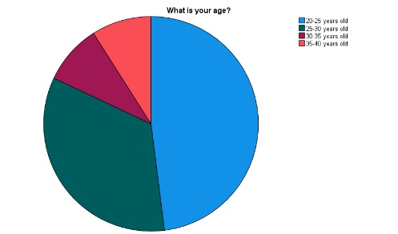 | 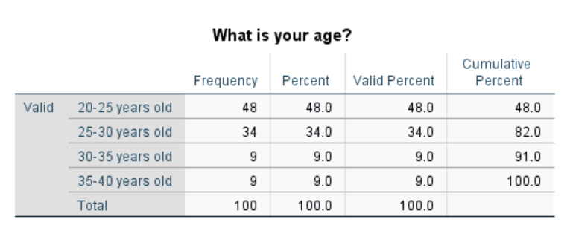
Figure 4: Table and Graph of collected responses
Interpretation and Analysis
The age table and graph show that most of the respondents belong to the 20-25 and 25-30 years of age, with a mean response of 1.79%, meaning there is a large concentration in those categories. In particular, 48% of women are of 20-25 years of age, while 34% are of 25-30 years of age, implying that most data received in this survey is attributed to young female employees. These findings are crucial for understanding how this age group perceives and rates service quality and thereby reshape the general feedback and analysis.
2. For how long have you been employed?
Graph | Table
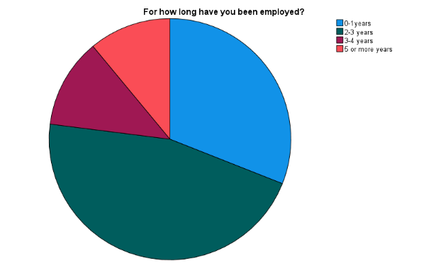 | 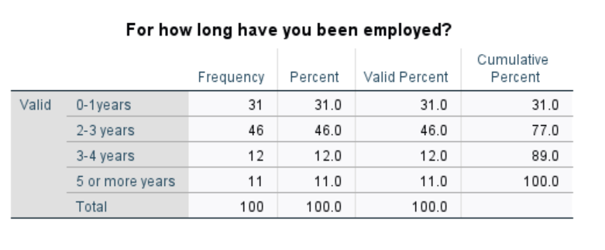
Figure 5: Table and Graph of collected responses
Interpretation and Analysis
From the above chart and table, it can be analysed that 46% of the female employees who shared their opinions have been employees for the last two to three years. The mode of overall responses provides the information related to the option that attained most of the responses which is 2. Along with this, 31% of the participants are employed from the last 0 to 1 year. Thus, the findings in this research have been gathered from female employees who have mainly worked for the last two to three years.
3. Do you agree with the fact that gender biases are present in various dimensions of industries?
Graph | Table
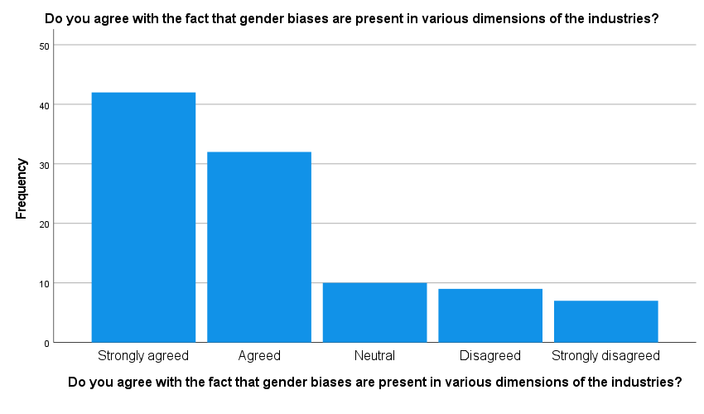 | 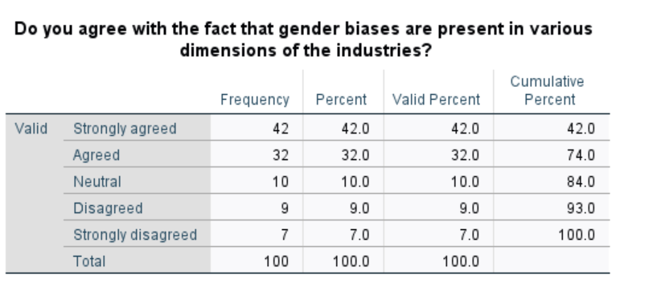
Figure 6: Table and Graph of collected Opinion
Interpretation and Analysis
42% and 32% of the respondents agree and strongly agree with the statement that gender bias is present in the various dimensions of the industries. It can be analysed from the above table that almost 70% of the female employees who share their reviews gave their opinion that gender biases are present in the numerous dimensions of the workplaces like equal pay and equal opportunities for career progression.
4. Do you believe that gender wage inequalities are present within workplaces?
Graph | Table
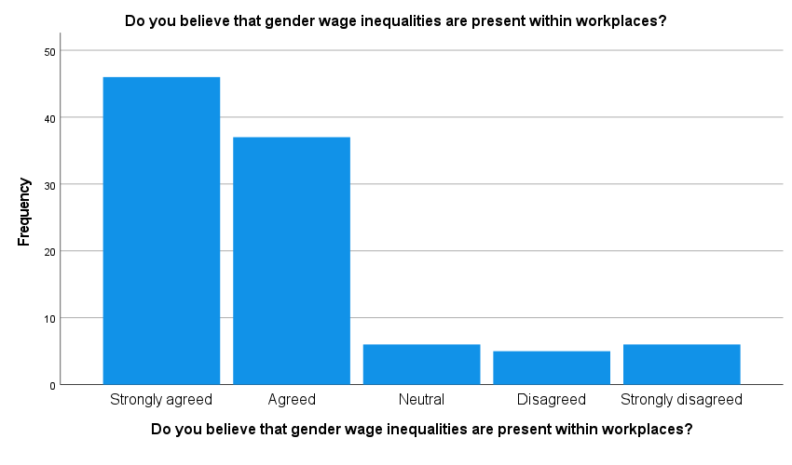 | 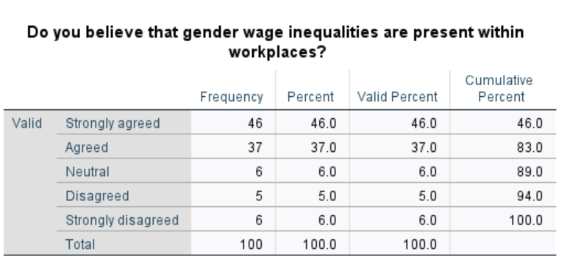
Figure 7: Table and Graph of collected Opinion

Interpretation and Analysis
46% and 37% of the participants gave their opinion on the side of strongly agree and agree on option as in their opinion gender wage inequalities are present in the workplaces. The mode is one of the overall responses which reflects the majority of the respondents gave their opinion on the side of the first option. In the opinion of major participants, the gender wage gap is present in the workplace as they get low pay in comparison to male ones for the same type of work.
5. Do you agree with the fact that males are being presented as dominant position holders in firms within developing countries?
Graph | Table
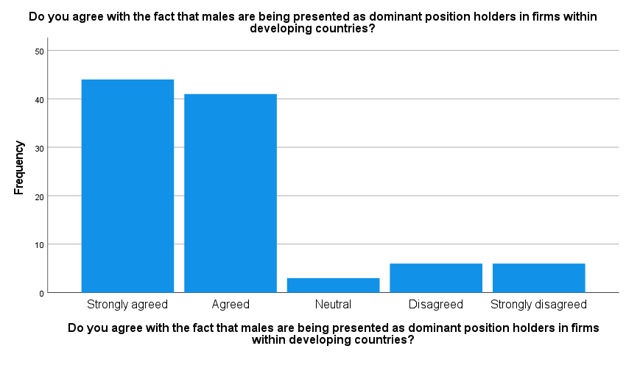 | 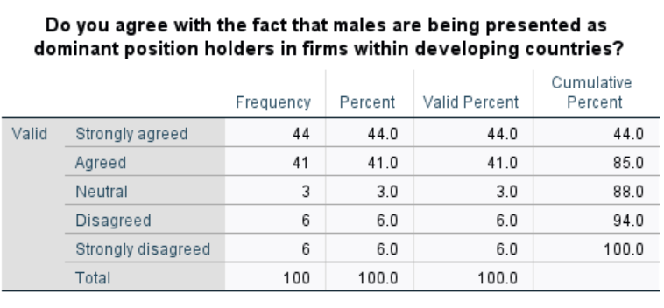
Figure 8: Responses' Table and Chart
Interpretation and Analysis
By observing the above graph, it can be analysed that 44% of the participants strongly agree with the statement that males are perceived as dominant position holders in firms in developing countries. 41% of the responses also agreed with the same statement as the mean of overall responses is 1.89that shows that the majority responses are attained on the side of first and second option. It can be determined that in developing countries like India male workers are more dominant in various industries which creates issues for women employees to get equal opportunities.
6. Do you agree that gender-based disparities are increasing within distinct industries of the developing markets?
Graph | Table
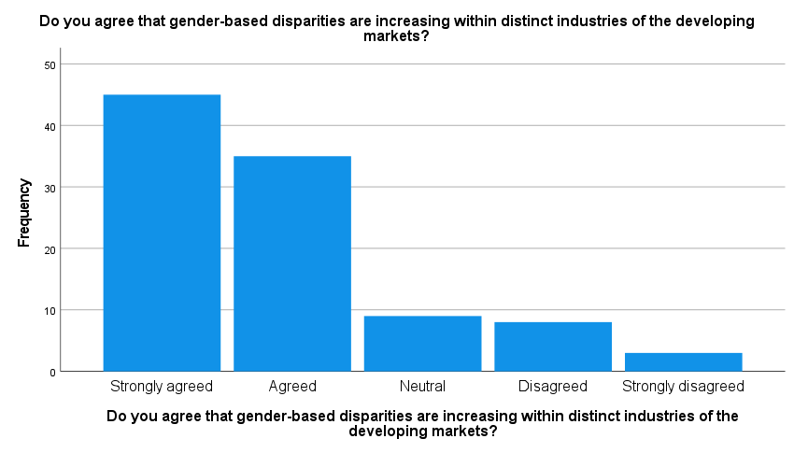 | 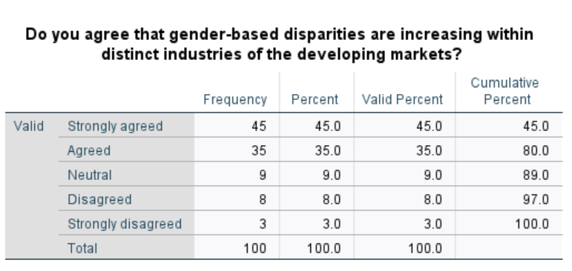
Figure 9: Responses' Table and Chart
Interpretation and Analysis
45% and 35% of the female employees who shared their reviews in this study presented their opinion on the side of strongly agree and agree on option respectively as they think that gender-based disparities are increasing in the distinct industries of developing markets. In their opinion, gender inequalities and discrimination are increasing for female workers in various industries day by day which also hampers their morale and confidence.
7. Have you been a victim of unethical wage delivery within your organisation?
Graph | Table
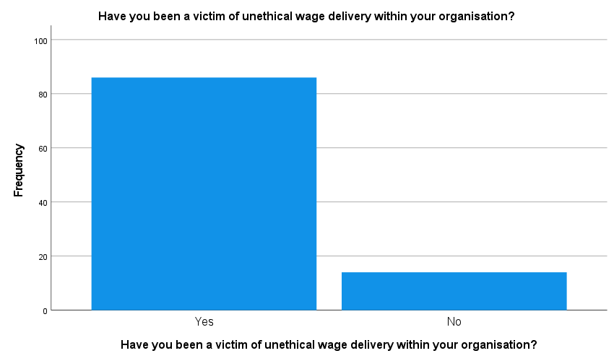 | 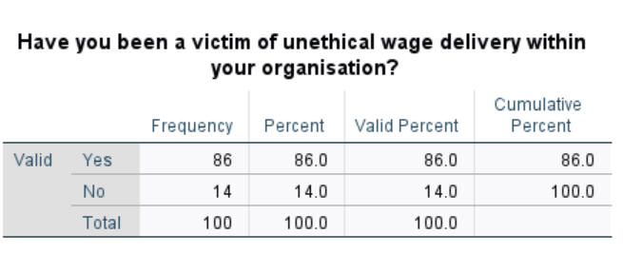
Figure 10: Responses' Table and Chart

Interpretation and Analysis
It can be observed from the above graph that 86% of the female employees who share their opinion in this research have been contracted and a victim of unethical wage delivery within their organisations. Mode is also 1 for this question which shows that major responses have been attained on the side of the first option. This shows that majority of the female employees face issues related to gender wage discrimination in their workplace and get a low salary for the same work in comparison to male colleagues.
8. Do you think that females are often demotivated due to increasing wage dissimilarities in firms?
Graph | Table
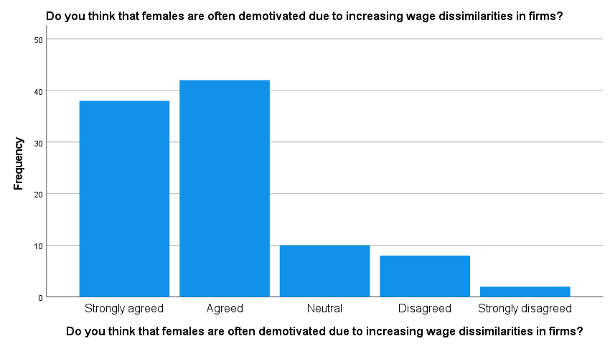 | 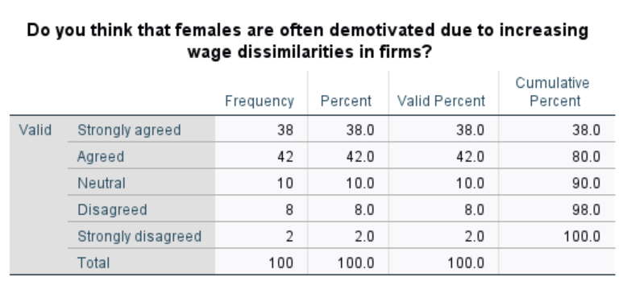
Figure 11: Responses' Table and Chart
Interpretation and Analysis
42% and 38% of the female employees who have provided their perception in this study agree and strongly agree respectively with the statement that women workers feel demotivated if they receive wage discrimination in the firms. In their opinion, if female employees receive low wages in comparison to males, they feel demotivated and lose their morale as well as commitment towards the organisation. It also negatively affects their productivity and confidence while working in a company that discriminates between male and female employees and provides low wages to them.
9. What according to you is a key contributor towards increasing wage disparities among males and females in the developing marketplaces?
Graph | Table
 | 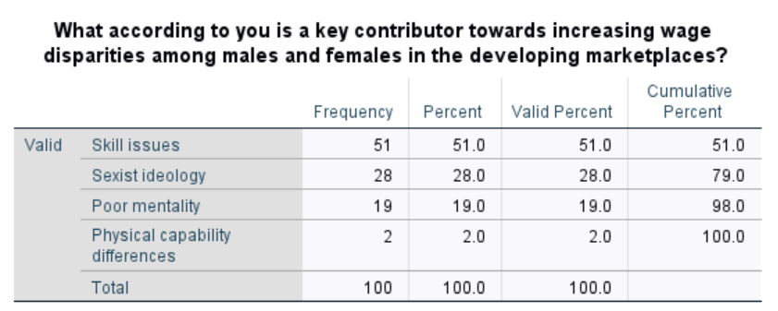
Figure 12: Responses' Table and Chart
Interpretation and Analysis
51% of respondents believe that “skill issues” is the key reason behind the growth in wage gaps between men and women. Further, 28% attributed it as a consequence of "Sexist ideology," 19% to "Poor mentality," and 2% to "Physical capability differences." The high percentage of votes towards skills issues could mean that women feel the gap due to some seen or felt differences in skills between them and males. Also, the association of the pay gap with sexist ideology indicates that cultural or leadership bias in the firms is an important explanation for this discriminatory practice. Such sources of bias are still potentially related to traditional forms of gender roles, which specify expectations in the workplace and lead to inequality. The lower percentage of votes towards poor mentality indicates that mental attitudes toward female employees may not be as significant a contributing factor as skills or ideological biases. This could be a development firms have felt in recent times with a broader perspective towards diversity.
10. Do you agree that the discriminated ideology of leaders within firms in developing countries impacts the motivation of female employees to work?
Graph | Table
 | 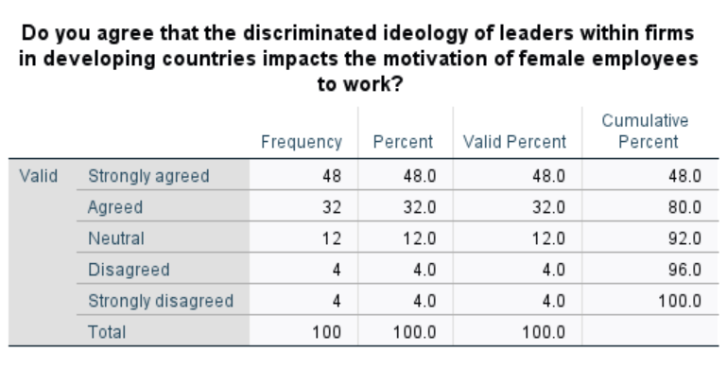
Figure 13: Responses' Table and Chart
Interpretation and Analysis
Of the total sample, a massive majority of the respondents 80% agreed or strongly agreed that discrimination in the ideology of leaders in firms affected the motivation of females to work while less than 8% disagreed or strongly disagreed with this narration. These statistics on discriminated leadership practices among organisations in developing countries indicated the influence on females' motivation at a significant negative level. This lowers the motivation and job satisfaction of working women if they feel less valued, degraded, or mistreated. Also, more women tend to quit organizations with a higher percentage. Organisations face this discriminatory practice by maintaining a diversified and just work environment to raise the productivity of women at workplaces.
11. Do you agree with the fact that the increasing gender-biased mentality of leaders results in poor job opportunities for females at higher positions in a company?
Graph | Table
 | 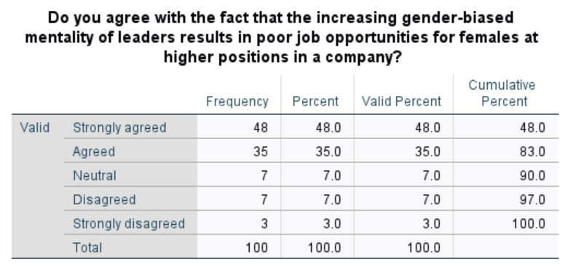
Figure 14: Responses' Table and Chart

Interpretation and Analysis
There is a great majority 83% who either agreed or strongly agreed that the more so gender-biased mentality of the leaders results in poor job opportunities for women in more upper levels of the company. Also, a small percentage (10%) showcased moderate or significant disagreeability towards this question. This shows that gender bias among leaders is a significant barrier to female career advancement. Leaders who have biased perceptions of the capabilities or potential of women to compete, may not promote them to good leadership and income positions. This situation could be a possible challenge for women to come up to leadership positions and high positions, hence keeping women in marginalised positions. The process of eliminating gender bias and ensuring diversity and inclusion in leadership is an important step for making the workplace more just and empowering women to contribute at their best.
12. Do you agree with the fact that the biased mentality in firms is due to the insignificant attitude of past leaders which has impacted female employee motivation?
Graph | Table
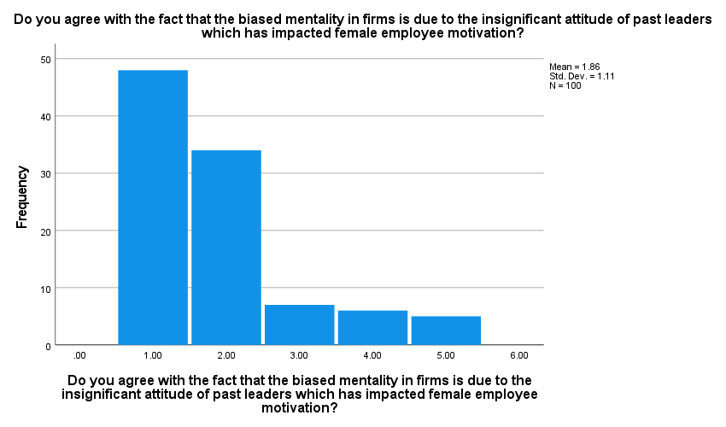 | 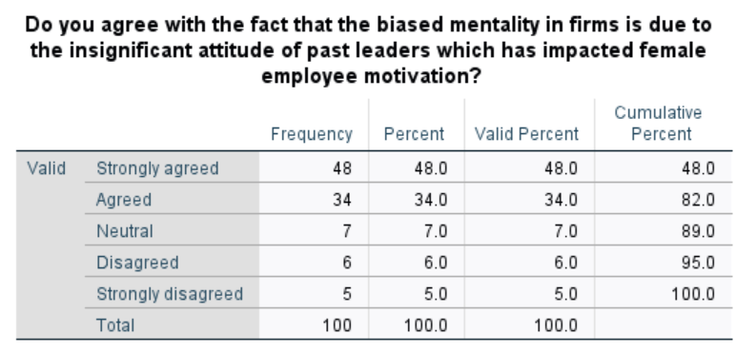
Figure 15: Responses' Table and Chart
Interpretation and Analysis
About 82% of respondents cumulatively agreed and strongly agreed with the view that a biased mindset within the organisation is the result of the negligible attitude of the past leaders who impacted female motivation. Further 7% of the respondents voted for neutrality in this regard and 11% disagreed or strongly disagreed. This could be understood as a fact that discriminatory attitudes of leaders have left an ever-present shadow in the present workplace culture. In this sense, unconscious bias, stereotypes, or discrimination may manifest which requires actions challenging the current perspective, promoting diversity, improving inclusion, and developing work environments where women in the workplace gain leverage. The same is implicative in the fact that organisations need to make concerted and proactive efforts to ensure that such a work environment becomes highly valued and respected.
13. Do you agree that a firm with the presence of a diverse workforce has a higher competitive position in the global workplace?
Graph | Table
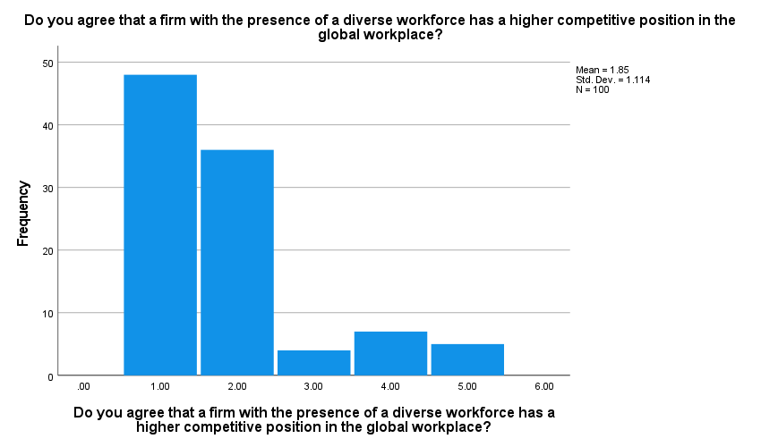 | 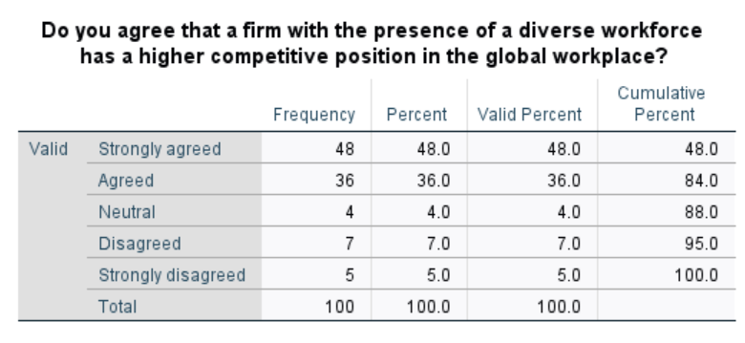
Figure 16: Responses' Table and Chart
Interpretation and Analysis
A total of 84% of respondents affirmed that the firm has a better competitive position in the global workplace because of having a diversified workforce while only 12% disagreed and strongly disagreed. This fact reinstates that respondents consider a lot of benefits that diversity and inclusion in the workplace bring along. The amalgamation of diverse views, skills, and experiences by the employees brings with it a lot of creativity and innovation as well as problem-solving skills. A diversified workforce can help a company bring in top talent, satisfy its customers, and even enhance its reputation among competitors. All these make for an improvement in their competitive position within the global marketplace.
14. Do you agree with the fact that policies for reducing wage gap concerns are a necessary implementation by firms within developing countries?
Graph | Table
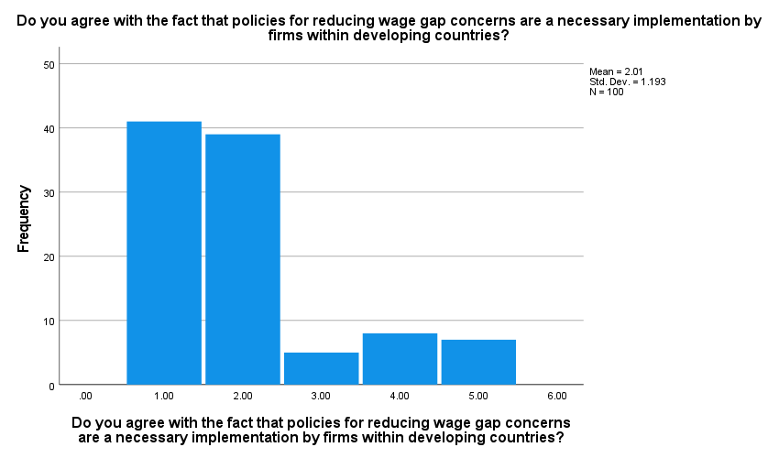 | 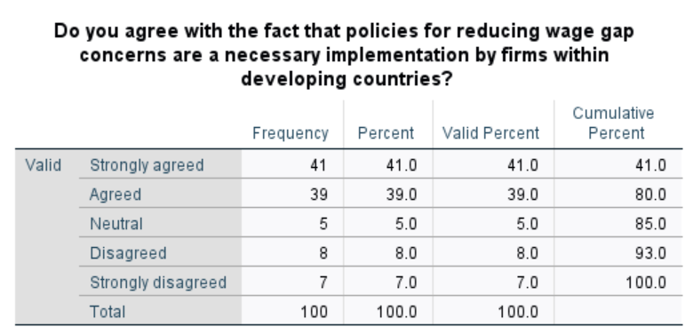
Figure 17: Responses' Table and Chart
Interpretation and Analysis
Out of the total count, 80% of the respondents, strongly agreed and agreed that policy innovations on wage gap issues are a necessary implementation by firms within developing countries. While a small percentage of respondents about 15% disagreed or strongly disagreed with the fact that reducing the gender wage gap is a necessary implementation. This data shows that the respondents strongly believe that firms in developing countries should actively implement policies to solve their wage gaps. However, this shows an increase in wage inequality awareness along with a need for greater fairness in the workplace. If this policy is implemented, firms can enhance morale, lower turnover rates, and enhance the reputation of any firm. Moreover, it can lead to a more equitable society along with fostering economic growth.
15. Do you think that transparency in working operations and decisions within a company can be an effective policy for reducing wage disparities among males and females?
Graph | Table
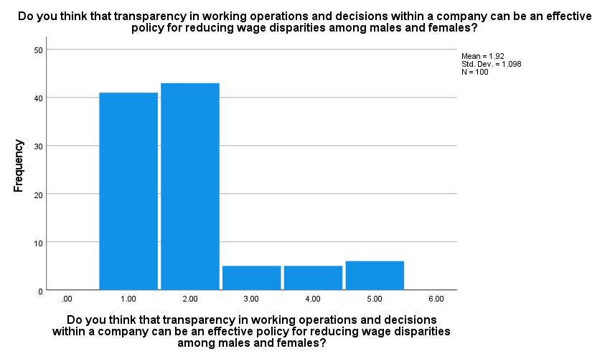 | 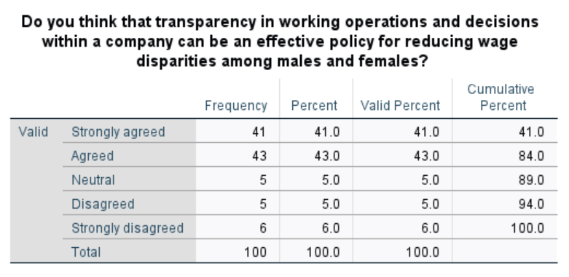
Figure 18: Responses' Table and Chart
Interpretation and Analysis
A huge number of respondents (84%) strongly agreed/agreed with the notion that transparency in working operations and decisions within a company can be a very sound policy to reduce wage disparities between males and females. Also, only 5% of respondents voted for neutral in this aspect and 11% of the respondents disagreed or strongly disagreed. These data indicate that the respondents strongly believe that transparency is the most fitting tool in terms of reducing wage disparity between subordinates and managers. If the information on salaries, promotion, and performance evaluation would be transparent to the company, then there are chances for an equal and just work setting. It will point out biasing possibilities and empower staff to ensure fair treatment.
16. Do you think that the government in developing countries must consider female wage dissimilarity as a major concern to reduce its increasing cases in firms?
Graph | Table
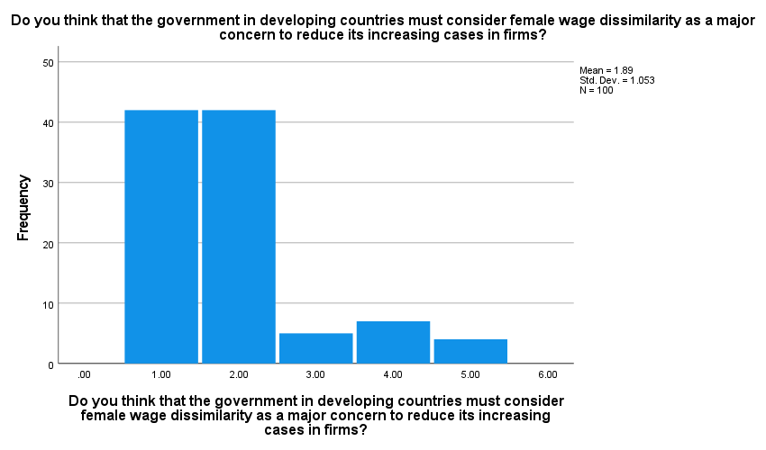 | 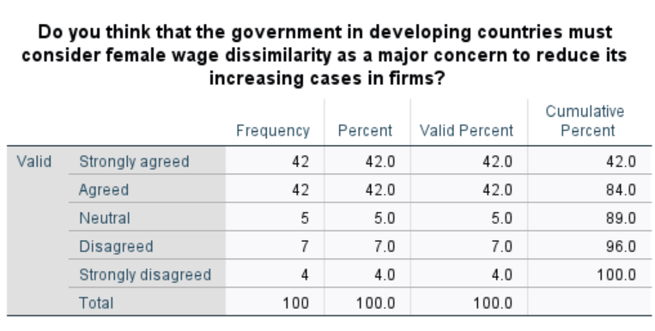
Figure 19: Responses' Table and Chart
Interpretation and Analysis
A vast majority of respondents (84%) either agreed or strongly agreed that the government in developing countries must consider female wage dissimilarity as a major concern to reduce its increasing cases in firms. Only a small percentage, 11%, disagreed or strongly disagreed with this interrogation. This data is suggestive of the view that respondents feel that governments of developing countries have an important role to play in tackling gender pay gaps. Through this understanding, governments can provide policies and regulations that would implement equal pay as well as equal opportunities for women. Such measures would include equal pay legislation, anti-discrimination laws, and other related instruments that economically empower women.
17. Do you believe that the education level of an employee and their experience must be considered as judgment criteria for providing a job role in a company?
Graph | Table
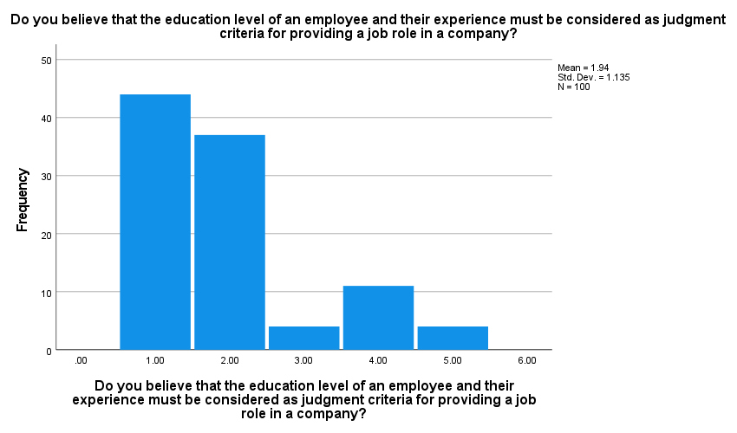 | 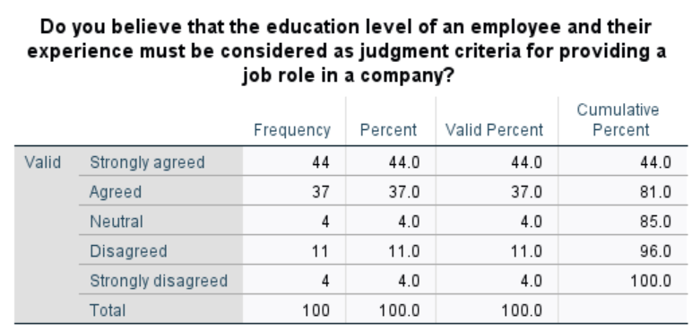
Figure 20: Responses' Table and Chart
Interpretation and Analysis
It was found that 81% of respondents either agreed or strongly agreed that the education level of an employee and experience must be considered as judgment criteria for providing a job role in a company and 15% disagreed or strongly disagreed. This indicates that respondents feel that education and experience are important factors regarding which they will assess a job. These are some of the common criteria used to determine whether a candidate possesses certain skills, potential, or qualifications for specific job roles in the eyes of an employer. Education and experience do work as good meters, however, they cannot be the sole determinants of choosing a person to hire. Skills, attitude, and even cultural fit must be given serious consideration so that the process is fair and does not discriminate.
18. What according to you can be significant for enhancing job satisfaction and motivation of female employees in firms?
Graph | Table
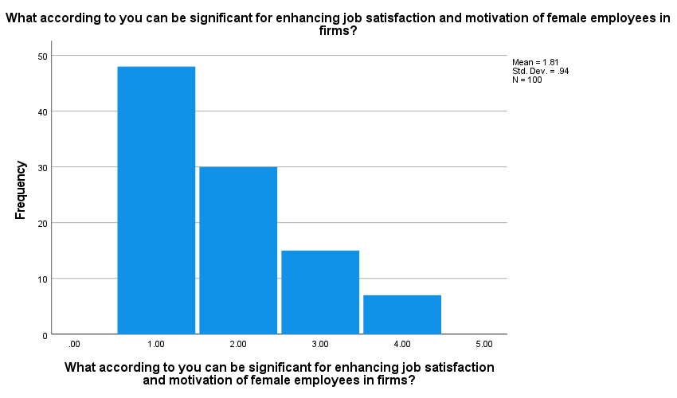 | 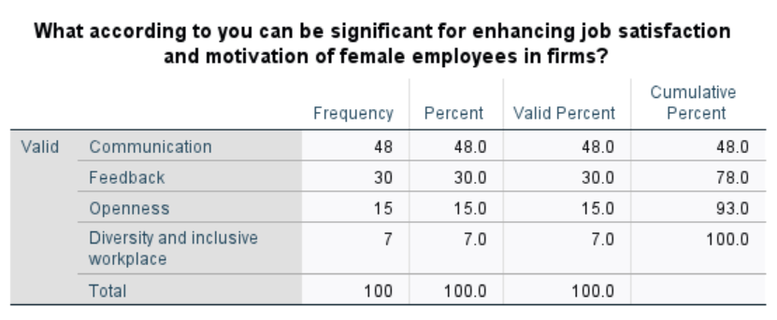
Figure 21: Responses' Table and Chart
Interpretation and Analysis
The category of "communication” as a contributor to increasing motivation for female employees received the highest votes from 48% of the respondents. While the categories of “feedback” received a total of 30% votes “openness" was selected by just 15% of the respondents, and "Diversity and Inclusive Workplace" by 7%. The percentage distribution of votes for this question showcases the significance of effective communication in building trust, understanding, and rapport among employees and management. This sense of belonging and recognition is an immediate driver of both job satisfaction and motivation. It can also be stated that the centre of personal and professional growth is formed through feedback mechanisms. Positive reinforcement is likely to create a high spirit of morale and motivation, while constructive feedback is for better performance. Additionally, ensuring an open and diverse working environment leads to incorporation and respect toward members, hence creating a workplace culture that might elevate job satisfaction and motivation among females in the workplace.
19. Do you agree with the fact that the presence of both male and female employees is fruitful for a firm's growth in its market?
Graph | Table
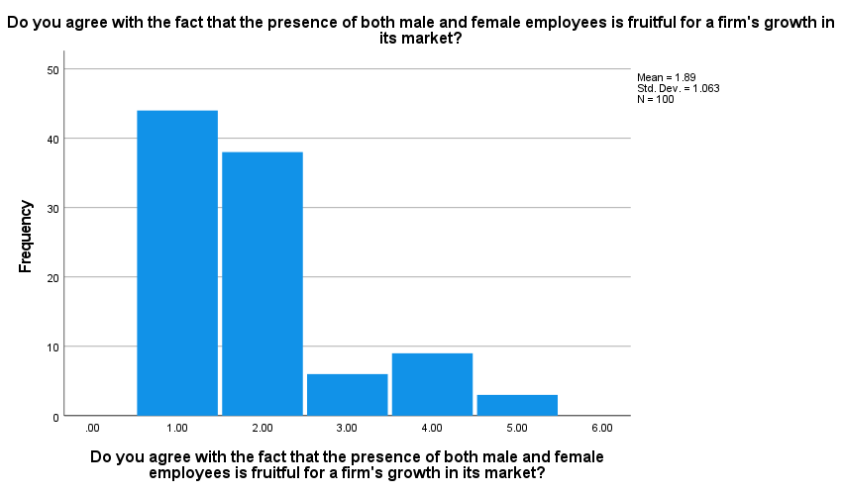 | 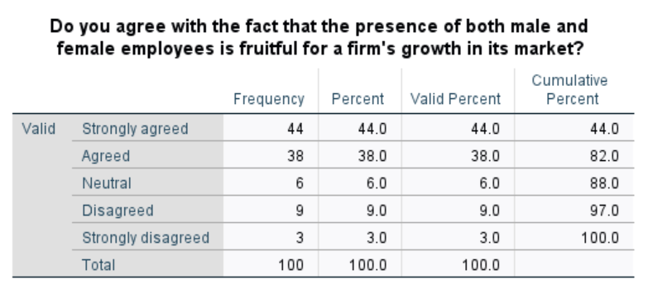
Figure 22: Responses' Table and Chart
Interpretation and Analysis:
A high cumulative percentage of the respondents (82%) either agreed or strongly agreed with the statement that the coexistence of the two genders at work is rewarding for the growth of the firm. While a total of 12% of respondents strongly disagreed or disagreed towards both males and females being fruitful for the growth of a firm in its market. This disagreeability could reflect personal experiences and the issues that prevail in such settings. Moreover, the high favourability towards a positive narration can be attributed to the existence of a blend of different perspectives, skills, and experiences among women and men which brings diversity of problem-solving capabilities within the firm. A diverse workforce might help an organisation attract and retain the best talent, improve customer satisfaction, and enhance its reputation.
20. Do you think that hiring diverse employees in a workplace can be an appropriate measure for improving female wage packages in firms?
Graph | Table
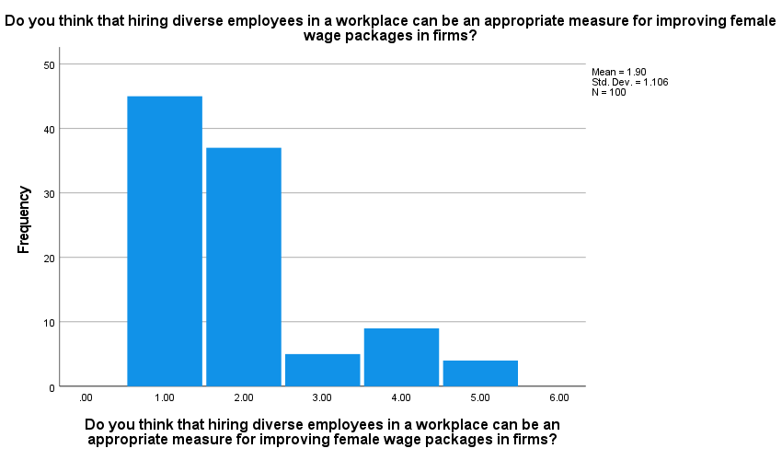 | 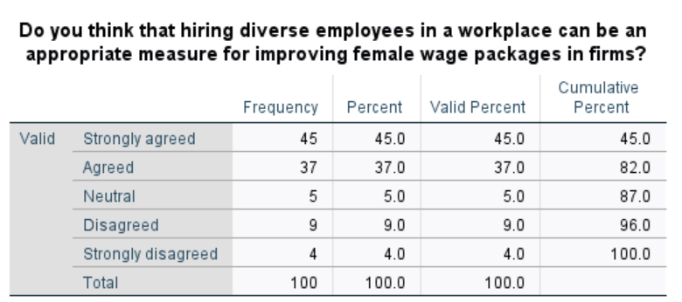
Figure 23: Responses' Table and Chart

Interpretation and Analysis
For the above question, a total of 82% of the respondents agreed or strongly agreed that hiring diverse employees within a workplace is an effective measure for improving the remuneration packages for females. Further, 5% of the respondents voted for neutrality towards this narration and a cumulative of 13% of respondents shared a negative orientation with either voting for disagreed or strongly disagreed. This is implicative towards an understanding that diversified workforces within organisations can lead to greater labour market competition for talent, which can raise wages for all workers-including women. Also, diversity can result in better decision-making, improved productivity, and higher financial performance, all of which eventually favour all employees through better wages and bonuses.

Regression Analysis
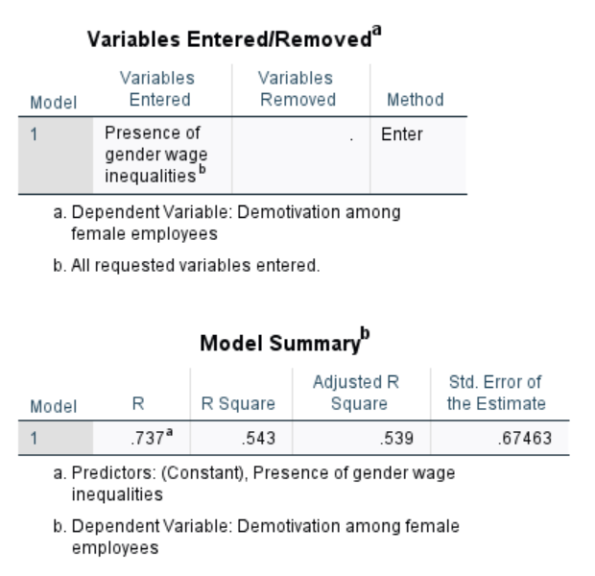
Figure 24: Regression Testing
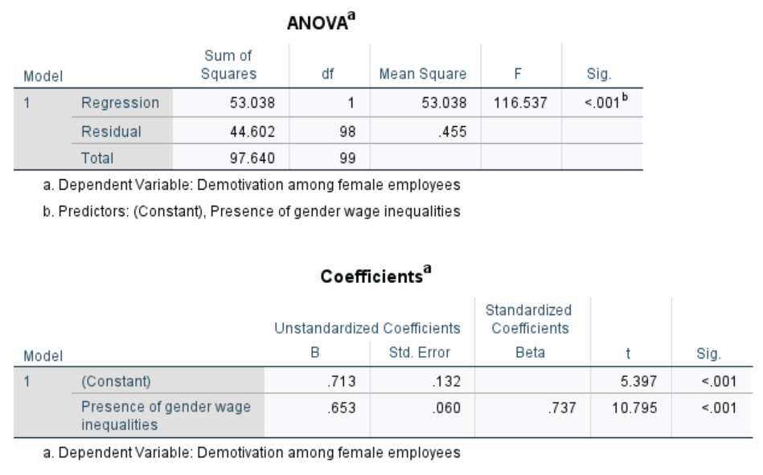
Figure 45: ANOVA Testing

Interpretation and Analysis:
The value of R or the correlation coefficient indicates the direction and strength of the linear relationship between two variables. For the above-presented regression, the R-value of 0.737 or 73% highlights that there is a high positive correlation between the existence of wage inequalities based on gender and demotivation among female employees. This shows that with a rise in gender wage inequality, the level of motivation is reduced among female employees. Further, the value of R-square or coefficient of determination determines the degree of variation in a dependent variable with the change in the other. The R-square value of 0.543 or 54.3% in the above analysis reflects a moderate variation in demotivation amongst female employees with the existence of gender wage inequalities. This would imply that gender wage disparities are one of the major motivating factors for employees.
Also, the Adjusted R-square value is 0.539, which considers the number of predictor variables in the model. Since the difference between R-square and Adjusted R-square is small, it means that the addition of any more variables would not drastically change the model. Instead, the dominance of the presence of gender wage inequalities as a predictor variable for female employee motivation is indicated. According to the ANOVA testing for these variables, the p-value is less than 0.001, which indicates that the regression model is statistically significant. This implies that female employee motivation is influenced by the existence of gender wage inequalities. Also, the value of the unstandardised coefficient for gender wage inequalities is 0.713 which states that with respect to a one-unit increase in gender wage inequalities demotivation amongst the female employees increases by 0.713 units. The t-value of 5.397 and p-value less than 0.001 assures that the said relationship is statistically significant. Hence, it could be concluded that gender wage inequalities do have an instantaneous negative impact on the motivation of female employees.
The arguments towards the above regression analysis are sufficient to reject the existence of H0 (The gender wage gap does not have a significant impact on female employee motivation in developing countries like India) and prove the alternative hypothesis “The gender wage gap has a significant impact on female employee motivation working in developing countries like India.” This presents strong evidence towards the fact that the gender wage gap does affect female employee motivation in developing countries. The R and R-square values demonstrate a significant role of the gender pay gap in the demotivation of the employees, further consolidated by the ANOVA testing for the relationship between the variables.

Chapter 5: Discussion, Conclusion, and Recommendations

5.1 Introduction
In this research, the results were discussed to compare and contrast the collected results from the human participants with previous study findings, which are identified in the literature review chapter. The conclusion has also been provided in this section which highlights the summary of key findings along with the main aim of this research by covering all objectives. The recommendations have also been provided in this report to improve the gender wage gap issues and enhance the motivation of female employees in developing countries to gain better results in the workplace. Along with this, the limitations and suggestions for future research are covered in this section of the study.

5.2 Discussion
It can be observed from the above evaluation that in various industries in developing firms like India has a tendency related to the gender wage gap in their workplace which negatively affects the motivation of female employees who are working in these nations. The wage dissimilarities in the workplace for the same work create issues in reducing the morale and confidence of the female employees which can hamper their productivity as well as commitment towards the organisation. The poor job opportunities for female employees in higher positions in the organisation in developing countries are increasing due to the gender-based mentality of the leaders. The findings of the literature review ga in the between gender provide the significant barriers to the career growth of women which creates a negative effect on their professional skill development (Busch, 2020).
From the above data interpretation and analysis, it can be analysed that the majority of female employees who share their opinions face issues related to unethical wage delivery in their organisations. This can negatively affect their motivation to work with commitment in the workplace in developing countries like India. In developing countries, the ideology related to male employees being superior and dominant in the workforce is increasing which generated the mentality among the leaders to provide the higher positions to their male employees in the firms. However, from the above literature review findings, it can be observed that female employees feel that they are getting low wages and less value in the firms in comparison to male ones which demotivates them from working in the company and decreases their job satisfaction (Reddy and Mehta, 2022).
It can also be analysed from the above findings that skills and sexiest ideology are the major issues which generated wage dissimilarities in female employees in comparison to male ones. The sexiest ideology and skills issues like leaders and managers judging female employees based on their physical strength can have a negative effect on the wage distribution among male and female employees. Similarly, it has also been analysed that leadership and the sexist ideology of leaders are major factors that can influence gender wage disparity in the workplace, and it negatively affects the career progression of women (Chen and Hassan, 2022).
It can also be analysed that skill differences and physical capabilities are key factors influencing wage disparities between male and female employees in Indian companies. Variations in physical abilities limit the job roles available to women, particularly in tasks requiring heavy manual labour. This contributes to significant differences in salary packages between genders. Sexism and unethical practices negatively impact female employees’ motivation and career progression, further exacerbating wage disparities. Such practices, whether in Indian or global firms, hinder equal opportunities for women. Similarly, the critical role of leadership in shaping job roles, work culture, and wage structures is also influencing the gender wage gaps in companies. Biased leadership decisions can demotivate female employees, reducing their morale, productivity, and organisational commitment. Addressing these issues requires equitable leadership practices and strategies to minimise gender-based wage gaps and promote an inclusive work environment (Agarwal, 2021).
By examining the above findings, it can be observed that policies made by the government to reduce the wage gap between genders are necessary for firms in developing countries to implement in their operational practices. This can be effective for the firms in following the rules and regulations that provide equal job, salary, and career progression opportunities for all employees in the firms including females and males as well. However, it can also be analysed from the above literature review that in developing countries like India, maternity benefits acts and other policies have been made by the government to reduce the gender wage gap (Kumar, 2019).
Hence from the above discussion, it can be determined that the Hypothesis Null (The gender wage gap does not have a significant impact on female employee motivation in developing countries like India) has been proved wrong and the alternative hypothesis (The gender wage gap has a significant impact on female employee motivation working in developing countries like India) has been proved correct. The findings of the literature review, data analysis and the R-square value is 0.543 which shows a moderate connection between the demotivation of female employees in their workplace due to the gender-based wage gap in developing countries like India.

5.3 Conclusion
Considering the first objective, it can be summarized that in the consumer industry, there is the largest gender pay gap in developing countries as it is focused on discrimination based on gender, colour, and women with children. In the construction and manufacturing industry, women are getting 50% less pay in comparison to male ones in developing countries which is an issue related to the gender pay gap in these industries. In the service sector like IT and others, there is also a gender pay gap in the workplace as females get 25% less than males for the same work. It can also be concluded from the responses gathered from human participants that gender-based disparities are increasing day by day in distinct industries within developing countries. Majority of the female employees have faced issues related to gender-based discrimination in their pay structure in the workplace in developing countries.
As per the evaluation of the second objective, it can be concluded that the gender wage gap is identified in the workplace of developing companies which has he direct effect on the motivation of female employees as they are getting a low pay structure for the same work in comparison to their male counterparts. The women employees are facing issues related to the invisible barrier in their progression while having good qualifications and efforts which is considered as a glass ceiling effect that has a negative and psychological effect on their motivation level. The gender wage can reduce the commitment of females towards the organisation which also negatively affects their morale and propagation. By observing the findings gathered through the use of the primary data collection method, it can also be summarised that almost 80% of the participants agree with the statement that gender-based wage gap and discrimination demotivates female workers and reduces their confidence as well as morale.
Evaluation of the third objective findings, it can be abridged that there are various factors that influence the wage differences in the genders and affect the career progress of women employees. The major issue is skills differences which impact the wage changes and fluctuation among both genders and women are judged based on their physical capabilities. This can help in addressing the question of the researhc properly “What are the factors that influence the wage disparity and have a significant impact on career progression for women?” Other factors like sexism ideology and leadership are also factors that increase the gender wage gap in the organisation and hinder the career progression of female employees in developing countries. As per the gathered findings from the participants, it can be concluded that skill issues and the sexiest ideology are major contributors towards increasing wage disparities among men and women employees in the workplace of developing countries. The sexiest ideology and skills issues in the workplace in developing countries create problems for female workers to get equal pay opportunities in their companies as managers and leaders consider female workers less compatible in comparison to male ones.
Along with this, by evaluating the fourth objective, it can be concluded that laws are enacted by the government to ensure equal pay in the workplace for equal work. The Equal Remuneration Act in India provides the information that it is mandatory for the organisation to give equal salaries to male and female employees for the same work. The initiatives related to sexual harassment, maternity benefits, involvement of prohibition and redressal acts are some of the policies that are taken by legislation to ensure equality in the workplace. The question of the study is properly addressed What is the effectiveness of the policies and initiatives which have a major aim of reducing the wage gap and improving female employee motivation? It can also be summarised from the findings gathered by surveying female employees that it is necessary for firms operating in developing countries to implement the policies and regulations made by the government related to reducing the wage gap. It can help in enhancing transparency between the operational practices and decision-making of companies to reduce the wage disparities among male and female workers. It is also concluded that wage disparities between male and female employees in Indian companies arise from skill and physical capability differences, limiting job opportunities for women. Sexism and biased leadership further hinder female career progression, affecting motivation and productivity. Equitable leadership and inclusive practices are essential to address these inequalities and promote workplace fairness.
As per the evaluation of the fifth objective, it can be summarised that promoting merit over genders, standardised salary scales, eliminating gender discrimination, addressing unconscious bias, recognition and rewards, as well as inclusive leadership style are effective recommendations. This can help in reducing the gender wage gap among male and female workers in developing countries and highlights as well as foster equality. The leaders who promote these factors in the workplace culture can boost morale and create a feeling of inclusion among female employees that increases their engagement within their workplace. As per the evaluation of the gathered findings, it can also be summarised that communication and feedback are effective for companies operating in developing countries to enhance the job satisfaction and motivation of female employees in the workplace. It can also help in reducing the wage gap as well by taking reviews and feedback constantly from the female workers. This is effective in addressing the question of the study properly “How can motivation and job satisfaction among female employees be enhanced in the context of wage inequality?

5.4 Recommendations
- Promote Pay transparency: The promotion of pay transparency in companies can help reduce the issues related to the gender wage gap in organisations in developing countries. This can help in solving the information of the compensation with employees that can promote fairness and equity in the workplace between both males as well as female employees. Collaboration between the employees can be encouraged and it also fosters fairness, trust, and connectivity between male and female workers by reducing any type of discrimination related to pay structure in the firms.
- Encourage employee resource groups and mentorship programs: Employee resource groups can be effective for sourcing mutual support as they act as a voice for employees which allow the managers and leaders of companies in developing countries to get feedback from their employees about the pay gap structure. It can be effective in providing equal pay opportunities and better workplace environment to the male and female employees in the organisation by establishing mentorship programs that create a network between people and share career advice. It also allows the leaders and management of the companies to stay ahead the providing equal opportunities to all workers related to work and pay status by ensuring a better workplace environment.
- Enhancing Motivation Through Career Advancement Opportunities: Enhancing motivation through career advancement opportunities can be effective for the firm in enhancing the motivation of female employees as it involves implementing a leadership training program for ensuring equitable access to promotions. Organisations can empower female employees by creating clear career pathways, providing skill-development resources, and fostering a supportive environment that encourages women to aspire to and achieve higher-paying leadership roles in the firms.
- Conduct Regular Pay Audits: Companies in developing countries can conduct regular pay audits which can help in promoting the pay of male as well as female workers to ensure that they receive equal salaries for equal work which is also effective in fostering positive workplace environment. This can also be effective for the firms in identifying the differences in the wages between the genders and using the data to make the decision about changing the pay structure in the company related to their male and female employees. With the help of regular pay, the mentality among managers and leaders about judging employees based on their gender can also be reduced if they regularly analyse the working quality of female workers.
- Encourage Salary negotiation: The firms who are operating in developing countries can also encourage the slavery negotiation process in their employees which can help in reducing the pay gap between genders by encouraging them to ask the fair compensation for their work and increase transparency about their pay structure. This can be enhanced by providing negotiation skills training by enhancing the workplace environment in which employees can develop the skills they need to negotiate for a fair wage policy in their workplace.

5.5 Recommendations for future research
This study mainly focuses on collecting real-time data from human participants by using a primary data collection process by conducting a survey with respondents and gathering numerical information. Therefore, in further studies, the research method can be changed to secondary ones for collecting a wide range of information from the previous studies to attain diversified knowledge about the topic area. Along with this, the primary method can be used for collecting theoretical data by conducting interviews with human respondents in further studies to attain real-time data in a qualitative manner. In a further study, the focus from the developing countries can be shifted to the global level for developing diversified knowledge within the areas of the subject.

5.6 Limitations
This research is limited in providing information related to the gender pay gap in developing countries only. It is also limited in analysing the information collected from the human respondents by conducting a survey with them which does not provide knowledge about the perception of different authors involved in previous studies related to the topic area. Time consumption is also a limitation in this research while collecting the data from the human respondents which has been properly handled by following the guidelines and timelines properly.

References
Abdelhakim, A.S. (2021) Adopted Research Designs by Tourism and Hospitality Postgraduates in The Light‎ of Research Onion. International Journal of Tourism and Hospitality Management, 4(2), pp.98-124.
Adams-Prassl, A., Boneva, T., Golin, M. and Rauh, C. (2022) Work that can be done from home: Evidence on variation within and across occupations and industries. Labour Economics, 74, p.102083.
Adeyemi, B.B. (2024) Reliability and Validity in Quantitative Research. In Applied Linguistics and Language Education Research Methods: Fundamentals and Innovations (pp. 86-102). IGI Global.
Agrawal, T. (2021) Gender segregation and wage differentials in India: the role of educational attainment and occupational choices. International Journal of Manpower, 42(1), pp.1-20.
Aithal, A. and Aithal, P.S. (2020) Development and validation of survey questionnaire & experimental data–a systematical review-based statistical approach. International Journal of Management, Technology, and Social Sciences (IJMTS), 5(2), pp.233-251.
Alam, M.K. (2021) A systematic qualitative case study: questions, data collection, NVivo analysis and saturation. Qualitative Research in Organizations and Management: An International Journal, 16(1), pp.1-31.
Alam, M.N., Hassan, M.M., Bowyer, D. and Reaz, M. (2020) The effects of wages and welfare facilities on employee productivity: Mediating role of employee work motivation. Australasian Accounting, Business and Finance Journal, 14(4), pp.38-60.
Alharahsheh, H.H. and Pius, A. (2020) A review of key paradigms: Positivism VS interpretivism. Global Academic Journal of Humanities and Social Sciences, 2(3), pp.39-43.
Baker, M., Halberstam, Y., Kroft, K., Mas, A. and Messacar, D. (2023) Pay transparency and the gender gap. American Economic Journal: Applied Economics, 15(2), pp.157-183.
Basu, A. (2023) Wage Disparities in India's Educational Sector: A Gendered Analysis. Education Economics, 31(2), pp. 159-174.
Bauer, G.R., Churchill, S.M., Mahendran, M., Walwyn, C., Lizotte, D. and Villa-Rueda, A.A. (2021) Intersectionality in quantitative research: A systematic review of its emergence and applications of theory and methods. SSM-population health, 14, p.100798.
Begeny, C.T., Ryan, M.K., Moss-Racusin, C.A. and Ravetz, G. (2020) In some professions, women have become well represented, yet gender bias persists—Perpetuated by those who think it is not happening. Science advances, 6(26), p.eaba7814.
Bhattacharya, A., and Sen, S. (2021) Gendered Roles in the Indian Household and Their Impact on Women’s Economic Stability. Gender, Work & Organization, 28(3), pp. 408-423.
Bianchi, L. (2021) Exploring ways of defining the relationship between research philosophy and research practice. Journal of Emergent Science, 20, pp.32-37.
Biasi, B. and Sarsons, H. (2022) Flexible wages, bargaining, and the gender gap. The Quarterly Journal of Economics, 137(1), pp.215-266.
Bilan, Y., Mishchuk, H., Samoliuk, N. and Mishchuk, V. (2020) Gender discrimination and its links with compensations and benefits practices in enterprises. Entrepreneurial Business and Economics Review, 8(3), pp.189-204.
Blau, F. D., and Kahn, L. M. (2020) Gender Differences in Education and Job Training Performance and Their Influence on Wage Gaps. Labour Economics, 63, pp. 101804.
Blau, F.D., Kahn, L.M., Boboshko, N. and Comey, M. (2024) The impact of selection into the labour force on the gender wage gap. Journal of Labor Economics, 42(4), pp.1093-1133.
Bonaparte, Y., Fabozzi, F.J., Koslowsky, D. and Parthasarathy, M. (2024) The gender wage gap and its effect on women’s entrepreneurship. Applied Economics, 56(38), pp.4563-4575.
Bos, J. (2020) Research ethics for students in the social sciences (p. 287). Springer Nature.
Braun, V. and Clarke, V. (2022) Conceptual and design thinking for thematic analysis. Qualitative psychology, 9(1), p.3.
Busch, F. (2020) Gender segregation, occupational sorting, and growth of wage disparities between women. Demography, 57(3), pp.1063-1088.
Chahar, B. (2020) Performance appraisal systems and their impact on employee performance: The moderating role of employee motivation. Information Resources Management Journal (IRMJ), 33(4), pp.17-32.
Chakraborty, S., and Gupta, A. (2019) Gender Pay Inequality in India’s Manufacturing and Construction Sectors. Asian Journal of Women's Studies, 25(1), pp. 109-125.
Chanana, N. (2021) The impact of COVID‐19 pandemic on employees' organizational commitment and job satisfaction in reference to gender differences. Journal of Public Affairs, 21(4), p.e2695.
Chaudhary, P., and Sen, A. (2020) Policy Initiatives to Address Gender Wage Disparities and Boost Female Workforce Motivation in India. Indian Journal of Industrial Relations, 56(2), pp. 245-261.
Chen, C. and Hassan, A. (2022) Management gender diversity, executives compensation and firm performance. International Journal of Accounting & Information Management, 30(1), pp.115-142.
Chen, J. and Pang, H. (2023) Analyzing Factors Influencing Student Achievement: A Financial and Agricultural Perspective Using SPSS Statistical Analysis Software. Journal of Commercial Biotechnology, 28(1), pp.304-316.
Cooksey, R.W. and Cooksey, R.W. (2020) Descriptive statistics for summarising data. Illustrating statistical procedures: Finding meaning in quantitative data, pp.61-139.
Cortés, P. and Pan, J. (2023) Children and the remaining gender gaps in the labor market. Journal of Economic Literature, 61(4), pp.1359-1409.
Cotter, D. A., and Hermsen, J. M. (2020) Industry-Specific Variations in the Gender Wage Gap: A Sectoral Analysis with a Focus on Consumer Services. Social Forces, 98(4), pp. 1497-1524.
Das, M., and Chakrabarti, R. (2021) Structural Inequities and the Gender Pay Gap: Implications for Indian Workplace Culture. Asian Journal of Social Science, 49(3), pp. 222-239.
Desai, P. (2021) Gender Pay Inequality in Professional Educational Roles in India. Journal of Educational Policy and Administration, 53(3), pp. 315-329.
Erro-Garcés, A. and Alfaro-Tanco, J.A. (2020) Action research as a meta-methodology in the management field. International Journal of Qualitative Methods, 19, p.1609406920917489.
Gaddis, I., and Klasen, S. (2019) Human Capital and Gender Pay Gaps: An Updated Perspective on Human Capital Theory. Economics of Education Review, 72, pp. 101-115.
George S (2023) Why is a woman's salary less than a man's? A gaze down the gap. [Online]. Available at: https://economictimes.indiatimes.com/jobs/hr-policies-trends/why-is-a-womans-salary-less-than-a-mans-a-gaze-down-the-gap/articleshow/99182414.cms?from=mdr. [Accessed on: 4-11-2024].
Ghosh, R. (2021) Gender-Based Wage Gaps in Rural Sectors: A Comparative Analysis. Journal of Development Studies, 57(4), pp. 680-695.
Grimshaw, D., and Rubery, J. (2021) Historical and Structural Drivers of the Gender Pay Gap: A Socioeconomic Perspective. Journal of Economic Inequality, 19(1), pp. 71-95.
Gupta, A., and Verma, P. (2020) The Cycle of Limited Advancement: Gender Pay Disparities and Career Progression in India. Journal of Human Resource Development, 44(2), pp. 137-155.
Hossan, D., Dato’Mansor, Z. and Jaharuddin, N.S. (2023) Research population and sampling in a quantitative study. International Journal of Business and Technopreneurship (IJBT), 13(3), pp.209-222.
Iovino, F. and Tsitsianis, N. (2020) The methodology of the research. In Changes in European energy markets (pp. 79-95). Emerald Publishing Limited.
Islam, M.A. and Aldaihani, F.M.F. (2022) Justification for adopting qualitative research method, research approaches, sampling strategy, sample size, interview method, saturation, and data analysis. Journal of International Business and Management, 5(1), pp.01-11.
Iyer, P., and Sundaram, S. (2022) Wage Inequality in India’s Service Sector: Analyzing the Gender Gap. South Asia Economic Journal, 23(1), pp. 92-110.
Iyer, S., and Singh, A. (2023) Inclusive Leadership and Gender Wage Equity: An Empirical Analysis of Indian Corporations. Leadership & Organization Development Journal, 44(2), pp. 164-179.
Joshi, A., and Chatterjee, S. (2021) The Role of Recognition and Reward Systems in Enhancing Job Satisfaction Among Female Employees in India. Journal of Organizational Behavior, 42(5), pp. 633-649.
Jung, J.H. and Lim, D.G. (2020) Industrial robots, employment growth, and labor cost: A simultaneous equation analysis. Technological Forecasting and Social Change, 159, p.120202.
Junjie, M. and Yingxin, M. (2022) The Discussions of Positivism and Interpretivism. Online Submission, 4(1), pp.10-14.
Kabeer, N. (2021) Gender equality, inclusive growth, and labour markets. In Women's Economic Empowerment (pp. 13-48). Routledge.
Kalogiannidis, S. (2021) Impact of employee motivation on organizational performance. A scoping review paper for public sector. The Strategic Journal of Business & Change Management, 8 (3), 984, 996(3).
Kesar, S., Abraham, R., Lahoti, R., Nath, P. and Basole, A. (2021) Pandemic, informality, and vulnerability: Impact of COVID-19 on livelihoods in India. Canadian Journal of Development Studies/Revue canadienne d'études du développement, 42(1-2), pp.145-164.
Khuong, M. and Linh, U. (2020) Influence of work-related stress on employee motivation, job satisfaction and employee loyalty in hospitality industry. Management Science Letters, 10(14), pp.3279-3290.
Kuhl, T., Poethke, U., and Weber, M. (2021) Wage Inequality and Psychological Health Among Female Workers: A Comprehensive Review. Journal of Workplace Health Management, 14(2), pp. 129–143.
Kumar, R. (2019) The Impact of Maternity Benefits on Women's Workforce Participation in India. Journal of Social Policy, 48(3), pp. 489-504.
Kumar, S., Dawson, K., Pollard, R. and Jeter, G. (2022) Analyzing theories, conceptual frameworks, and research methods in EdD dissertations. TechTrends, 66(4), pp.721-728.
Kumar, V., and Singh, A. (2020) Standardizing Salary Scales to Enhance Job Satisfaction: Implications for Gender Pay Equity. Indian Journal of Industrial Relations, 55(2), pp. 230-245.
Lindsey, L. L. M., and Nguyen, N. T. (2022) Psychological Impacts of Gender Pay Perceptions in the Workplace. Gender, Work & Organization, 29(4), pp. 845–862.
Llop-Gironés, A., Vračar, A., Llop-Gironés, G., Benach, J., Angeli-Silva, L., Jaimez, L., Thapa, P., Bhatta, R., Mahindrakar, S., Bontempo Scavo, S. and Nar Devi, S. (2021) Employment and working conditions of nurses: where and how health inequalities have increased during the COVID-19 pandemic?. Human Resources for Health, 19, pp.1-11.
Manzoor, F., Wei, L. and Asif, M. (2021) Intrinsic rewards and employee's performance with the mediating mechanism of employee's motivation. Frontiers in psychology, 12, p.563070.
Mehrotra, S. and Parida, J.K. (2021) Stalled structural change brings an employment crisis in India. The Indian Journal of Labour Economics, 64(2), pp.281-308.
Mehta, K., and Rao, P. (2022) Unconscious Bias and Gender Inequality: A Study on Indian Workplaces. Equality, Diversity and Inclusion: An International Journal, 41(4), pp. 470-487.
Mehta, N., and Desai, K. (2021) Ensuring Safe Work Environments: The Role of Sexual Harassment Laws in Enhancing Female Workforce Motivation in India. Gender, Work & Organization, 28(4), pp. 598-614.
Mukherjee, T. and Sen, S.S. (2022) Impact of CEO attributes on corporate reputation, financial performance, and corporate sustainable growth: evidence from India. Financial Innovation, 8(1), p.40.
Mweshi, G.K. and Sakyi, K. (2020) Application of sampling methods for the research design. Archives of Business Review–Vol, 8(11), pp.180-193.
Nair, L., and Joseph, T. (2020) The Role of Perceived Wage Inequity on Trust and Morale in Indian Workplaces. Journal of Business Ethics, 162(2), pp. 385-397.
Nair, M., and Verma, K. (2021) Policy Approaches to Reducing the Gender Wage Gap in India. Indian Journal of Human Development, 15(3), pp. 278-290.
Nair, S., and Sharma, P. (2021) Meritocracy and Gender Pay Disparities: A Study on Employee Motivation in Indian Corporations. Journal of Human Resource Management, 9(3), pp. 145-162.
Okoli, C. (2023) Inductive, abductive and deductive theorising. International Journal of Management Concepts and Philosophy, 16(3), pp.302-316.
Pal, B. (2021) Rising popularity in gig economy: A case study from India. International Journal of Religious and Cultural Studies, 3(2), pp.203-208.
Patel, V., and Singh, R. (2019) Gender Pay Gap and Employee Motivation: The Case of Indian Workplaces. Journal of Business and Management, 65(2), pp. 96-111.
Petrongolo, B. and Ronchi, M. (2020) Gender gaps and the structure of local labor markets. Labour Economics, 64, p.101819.
Putra, M.R., Yandi, A. and Maharani, A. (2020) Determination Of Employee Motivation And Performance: Working Environment, Organizational Culture, And Compensation (A Study of Human Resource Management Literature). Dinasti International Journal of Education Management And Social Science, 1(3), pp.419-436.
Radhakrishnan, S. (2020) Gender, the IT revolution and the making of a middle-class India. In Elite and everyman (pp. 193-219). Routledge India.
Raj, N. (2024). Nykaa’s female employees earn less than male counterparts, reveals report. [Online]. Available at: https://pune.news/business/nykaas-female-employees-earn-less-than-male-counterparts-reveals-report-225529/. [Accessed on: 4—12-2024].
Rao, M., and Reddy, V. (2020) Regional Variations in Gender Wage Inequality in Indian Agriculture. Indian Journal of Labour Economics, 63(2), pp. 215-230.
Rathore, M. (2024). Average Monthly Salary of Salaried Class in India 2023, by Gender. [Online]. Available at: https://www.statista.com/statistics/1452812/india-average-monthly-salary-of-salaried-class-by-gender/ [Accessed on: 4-11-2024]
Reddy, S., and Mehta, K. (2022) Impact of Gender Wage Disparities on Motivation and Job Satisfaction Among Indian Female Employees. Indian Journal of Industrial Relations, 57(1), pp. 34-51.
Reed, S. and Morrow, A. (2019) The Role of Gender Wage Gap Mitigation in Advancing Sustainable Development Goals. Journal of International Development, 31(6), pp. 743-756.
Rodriguez, J. K., and Burns, J. (2021) Gendered Occupations and the Cultural Devaluation of Women’s Work in Wage Inequality. Gender, Work & Organization, 28(5), pp. 1450–1465.
Rouen, E. (2020) Rethinking measurement of pay disparity and its relation to firm performance. The Accounting Review, 95(1), pp.343-378.
Sardana, N., Shekoohi, S., Cornett, E.M. and Kaye, A.D. (2023) Qualitative and quantitative research methods. In Substance use and addiction research (pp. 65-69). Academic Press.
Saunders, M., Lewis, P. and Thornhill, A. (2019) Research Methods for Business Students. 8th edition, FT Prentice Hall
Sen, R., and Patnaik, B. (2020) Legislative Gaps in Addressing the Gender Pay Gap in India. Journal of Social Policy, 49(2), pp. 267-285.
Sharma, A., and Kumar, R. (2021) Gender Pay Disparities Across Indian Industries: A Regional Perspective. Economic and Political Weekly, 56(3), pp. 45-53.
Sharma, R., and Kapoor, D. (2019) Gender Pay Gap and Its Effects on Diversity in Leadership: Insights from Indian Corporate Sector. Management and Labour Studies, 44(4), pp. 345-362.
Singh, P. and Pattanaik, F. (2020) Unfolding unpaid domestic work in India: women’s constraints, choices, and career. Palgrave Communications, 6(1), pp.1-13.
Smith, J., Blevins, B., Werse, N.R. and Talbert, S. (2021) Researcher positionality in the dissertation in practice. In Practice-based and practice-led research for dissertation development (pp. 43-63). IGI Global.
Statista (2024) 20 countries with the highest average monthly salaries of employees worldwide in 2022. [Online]. Available at: https://www.statista.com/statistics/1338750/average-monthly-salaries-countries-highest-worldwide/. [Accessed on: 4-11-2024].
Statista (2024) Gender Wage Pay worldwide in 2024. [Online]. Available at: https://www.statista.com/statistics/1212140/global-gender-pay-gap/#:~:text=By%20comparison%2C%20the%20uncontrolled%20gender,every%20dollar%20earned%20by%20men.. [Accessed on: 11-11-2024].
Sürücü, L. and Maslakci, A. (2020). Validity and reliability in quantitative research. Business & Management Studies: An International Journal, 8(3), pp.2694-2726.
TCS (2024) 2023 Tata Consultancy Services UK Gender Pay Gap Report. [Online]. Available at: https://www.tcs.com/who-we-are/worldwide/uk/tcs-uk-gender-pay-gap-report. [Accessed on: 5-12-2024].
Tumi, N.S., Hasan, A.N. and Khalid, J. (2022) Impact of compensation, job enrichment and enlargement, and training on employee motivation. Business Perspectives and Research, 10(1), pp.121-139.
Uka, A. and Prendi, A. (2021) Motivation as an indicator of performance and productivity from the perspective of employees. Management & Marketing, 16(3), pp.268-285.
van Tuin, L., Schaufeli, W.B., Van den Broeck, A. and van Rhenen, W. (2020) A corporate purpose as an antecedent to employee motivation and work engagement. Frontiers in Psychology, 11, p.572343.
Verma, R., and Gupta, N. (2019) The Impact of Gender Discrimination on Women's Job Motivation and Satisfaction: Insights from the Indian Context. Gender Studies International Forum, 73, pp. 28-35.
Weisshaar, K. and Cabello-Hutt, T. (2020) Labor force participation over the life course: The long-term effects of employment trajectories on wages and the gendered payoff to employment. Demography, 57(1), pp.33-60.
Wiemers, E., and Buchholz, S. (2019) Erosion of Education’s Effect on Wage Equality: The Changing Role of Education in Gender Pay Gaps. Sociology of Education, 92(1), pp. 76-95.

Appendices
Questionnaire
Q1 What is your age?
- 20-25 years old
- 25-30 years old
- 30-35 years old
- 35-40 years old
Q2 For how long have you been employed?
  - 0-1years
- 2-3 years
- 3-4 years
- 5 or more years
Q3 Do you agree with the fact that gender biases are present in various dimensions of the industries?
- Strongly agreed
- Agreed
- Neutral
- Disagreed
- Strongly disagreed
Q4 Do you believe that gender wage inequalities are present within workplaces?
- Strongly agreed
- Agreed
- Neutral
- Disagreed
- Strongly disagreed
Q5 Do you agree with the fact that males are being presented as dominant position holders in firms within developing countries?
- Strongly agreed
- Agreed
- Neutral
- Disagreed
- Strongly disagreed
Q6 Do you agree that gender-based disparities are increasing within distinct industries of the developing markets?
- Strongly agreed
- Agreed
- Neutral
- Disagreed
- Strongly disagreed
Q7 Have you been a victim of unethical wage delivery within your organisation?
- Yes
- No
Q8 Do you think that females are often demotivated due to increasing wage dissimilarities in firms?
- Strongly agreed
- Agreed
- Neutral
- Disagreed
- Strongly disagreed
Q9 What according to you is a key contributor towards increasing wage disparities among males and females in the developing marketplaces?
- Skill issues
- Sexist ideology
- Poor mentality
- Physical capability differences
Q10 Do you agree that the discriminated ideology of leaders within firms in developing countries impacts the motivation of female employees to work?
- Strongly agreed
- Agreed
- Neutral
- Disagreed
- Strongly disagreed
Q11 Do you agree with the fact that the increasing gender-biased mentality of leaders results in poor job opportunities for females at higher positions in a company?
- Strongly agreed
- Agreed
- Neutral
- Disagreed
- Strongly disagreed
Q12 Do you agree with the fact that the biased mentality in firms is due to the insignificant attitude of past leaders which has impacted female employee motivation?
- Strongly agreed
- Agreed
- Neutral
- Disagreed
- Strongly disagreed
Q13 Do you agree that a firm with the presence of a diverse workforce has a higher competitive position in the global workplace?
- Strongly agreed
- Agreed
- Neutral
- Disagreed
- Strongly disagreed
Q14 Do you agree with the fact that policies for reducing wage gap concerns are a necessary implementation by firms within developing countries?
- Strongly agreed
- Agreed
- Neutral
- Disagreed
- Strongly disagreed
Q15 Do you think that transparency in working operations and decisions within a company can be an effective policy for reducing wage disparities among males and females?
- Strongly agreed
- Agreed
- Neutral
- Disagreed
- Strongly disagreed
Q16 Do you think that the government in developing countries must consider female wage dissimilarity as a major concern to reduce its increasing cases in firms?
- Strongly agreed
- Agreed
- Neutral
- Disagreed
- Strongly disagreed
Q17 Do you believe that the education level of an employee and their experience must be considered as judgment criteria for providing a job role in a company?
- Strongly agreed
- Agreed
- Neutral
- Disagreed
- Strongly disagreed
Q18 What according to you can be significant for enhancing job satisfaction and motivation of female employees in firms?
- Communication
- Feedback
- Openness
- Diversity and inclusive workplace
Q19 Do you agree with the fact that the presence of both male and female employees is fruitful for a firm's growth in its market?
- Strongly agreed
- Agreed
- Neutral
- Disagreed
- Strongly disagreed
Q20 Do you think that hiring diverse employees in a workplace can be an appropriate measure for improving female wage packages in firms?
- Strongly agreed
- Agreed
- Neutral
- Disagreed
- Strongly disagreed

Questionnaire Link
https://forms.gle/GGYa19K6r5TMHef5A
Regression Histogram
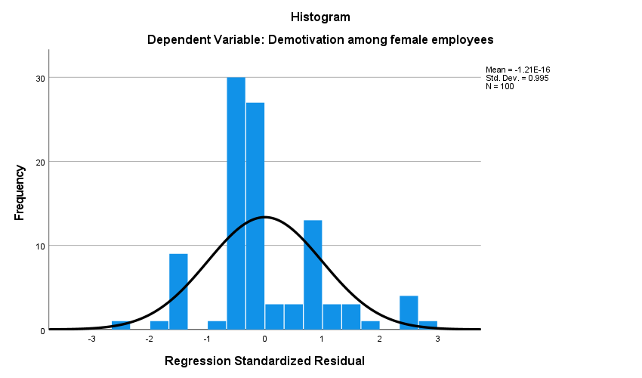

Statistical Calculations
Q1-Q2
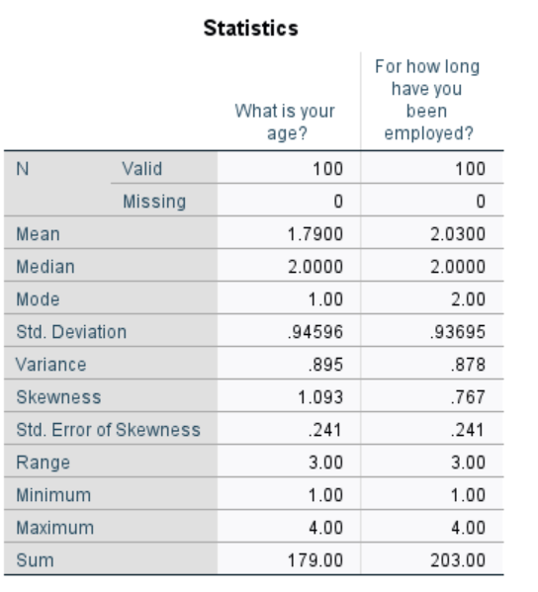
Q3-Q11
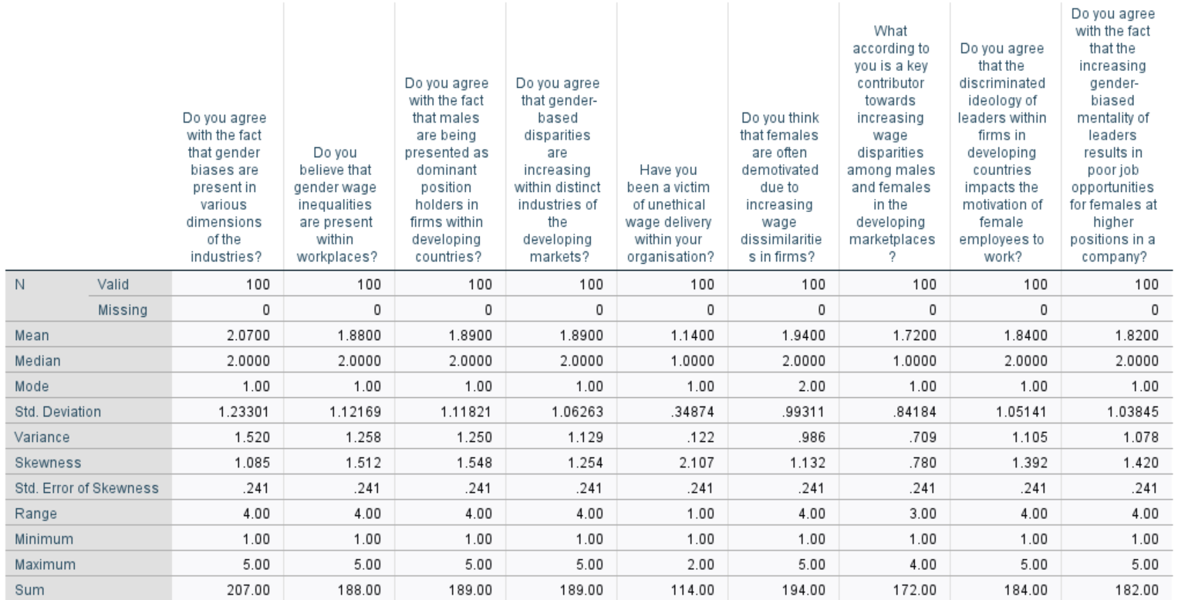
Q12-Q20


