

Student name: | Sufia B Chowdhury | Student ID number: | 2426191
Programme: | Master of Business Administration
Director of Studies/Supervisor: | Vasilios Tavlaridis and Dr Ejike R Udeogu
Module code: | LCMB7035
Research Title : | The Impact of Team Diversity on Project Performance: An Empirical Study of at Aldi UK

Table of Contents
Introduction 3
Research Aim, Objectives, & Questions 4
Aim 4
Objectives 4
Questions 4
Literature Review 5
Introduction to Team Diversity and Employee Performance 5
Theoretical Foundations and Key Concepts 5
Mediating Factors: Leadership, Trust, and Communication 6
Cultural Diversity and Employee Innovation 6
Managing Diversity Challenges 6
Diversity and Inclusion (D&I) Initiatives 7
Educational and Professional Applications 7
Identified Research Gaps 7
Summary 8
Methodology 9
Risk and Limitations 10
Timeframe 11
References 12

Introduction
Diversity in workforce is becoming an important issue that determines organisational success, engagement of employees and innovation. In contemporary workplaces, multicultural work teams include people with different cultural, educational, and professional backgrounds that make them more creative and decision-making; nevertheless, this aspect introduces some difficulties in the communication and union. In the UK retail industry, ALDI offers a strong example of the diversity of teams in relation to influencing the job performance of employees. Being a multinational company, ALDI can be seen as a large retailer, which operates in multicultural settings and therefore its workforce is perceived as a complex issue in terms of managing both inclusivity and productivity in dynamic service contexts. According to the previous studies, team diversity can positively affect performance in case of a strong leadership, trust, and an inclusive practice of human resource management (Ali et al., 2022). Nevertheless, diversity can become a source of interpersonal conflict and inefficiency in case of poor management (Liu et al., 2023). This paper thus examines the connection between various aspects of team diversity such as demographic, cognitive, and the functional and the employee job performance at ALDI UK. The research will employ secondary data gathered by company reports, industry analysis, and academic literature available to collect performance outcomes that are facilitated and detrimental by organisational mechanisms. The results will be of practical value towards enhancing diversity management practices in the UK retailing industry.

Research Aim, Objectives, & Questions

Aim
The aim of this study is to examine how different dimensions of team diversity influence employee job performance at ALDI UK, using secondary data sources to identify the organizational and leadership factors that shape this relationship.

Objectives
- To analyse the relationship between team diversity dimensions (demographic, cognitive, and functional) and employee job performance within ALDI UK.
- To identify the organizational and leadership factors—such as inclusive HRM practices, communication, and trust—that mediate or moderate the effect of team diversity on performance outcomes.
- To evaluate how ALDI’s diversity and inclusion (D&I) practices contribute to employee engagement, motivation, and productivity.
- To draw practical implications for improving diversity management strategies and workforce performance in the UK retail sector based on secondary data findings.

Questions
- What is the relationship between team diversity and employee job performance at ALDI UK?
- Which organizational and leadership factors influence how team diversity affects employee performance?
- How do ALDI’s diversity and inclusion initiatives contribute to employee engagement and productivity?
- What lessons can be drawn from ALDI’s experience to enhance workforce diversity management in the UK retail sector?

Literature Review

Introduction to Team Diversity and Employee Performance
The diversity within a team is very important in determining the level of organisational performance and employee performance in the modern-day workplaces. It includes demographic factors (gender, ethnicity, age), cognitive and functional factors (knowledge, skills, and professional backgrounds). It has been identified that diversity contributes to creativity and flexibility and can cause communication and conflict when not managed well (Patrício and Franco, 2022). These ambivalent results imply that diversity is a complicated yet critical subject of contemporary organisations particularly in people-oriented sectors like retail.
Diversity management in the multicultural workforce maintained in ALDI UK is important in preserving the quality of services as well as employee productivity. The purpose of examining the impacts of diversity on the job performance of the employees as opposed to project or organisational performance offers a good insight on the role of inclusive practices in motivation and general performance.

Conceptual Underpinnings and Major Ideas
The authors, Patrickrianco and Franco (2022) summarised 25 years of literature and found that the correlation between diversity and performance is contingent on mediator variables like leadership, communication, and organisational culture. This complexity is based on Social Identity Theory, which is subgroup formation and Information/Decision-Making Theory, which establishes a connection between various knowledge and better results. On the same note, in their meta-analysis of 615 articles, Wallrich et al. (2024) noted that the advantages of diversity are usually minimal and yet meaningful in cases where the workplace conditions are favorable. In the performance-oriented culture of ALDI, diversity can lead to collaboration when managed by an inclusive management approach but cause tension when it is not.

Intermediating Factors: Leadership, Trust, and Communication
Researchers have placed emphasis on leadership and trust as most important mediators in the transformation of diversity into improved performance. Mata et al. (2021) discovered that trust and absorptive capacity positively amplify the benefits of diversity by establishing the knowledge sharing and collaboration. Even though the research was conducted in the IT industry, the results can be applicable to retail teams where teamwork and communication are directly related to the efficiency of employees. Similarly, Ali et al. (2022) have shown that leadership skills and affirmative diversity ideals enhance motivation and inclusion, which positively assist employees with diverse backgrounds to deliver good performance. In the case of ALDI, inclusive leadership and open communication would hence open the potential of the diverse teams.

Diversity in Culture and Innovation among the employees
Cultural diversity has been found to enhance creativity, innovation which are two vital aspects of employee performance. As noted by Jones, Chace and Wright (2020), a diverse team will perform better than a homogeneous team in case there is an appropriate communication system. Yousef (2024) also concluded that the results of diversity are dependent on the mode of teamwork, which is either face-to-face or virtual. The conclusions apply to the ever-growing digital retail business of ALDI. Likewise, according to Stahl and Maznevski (2021), cultural diversity can be beneficial in terms of innovation only when there is a high-quality leadership and organisational support, the conditions that can be attributed to the well-structured but collaborative culture at ALDI.

Diversity Management Problems
Although it has benefits, diversity may result in interpersonal conflict and less cohesion. Liu, Zhu and Wang (2023) established that such challenges can be overcome by inclusive human resource management (HRM) and continuous learning practices. The misunderstandings linked to diversity in the fast-paced, customer-facing environment of ALDI can have a direct influence on the quality of service. Inclusive HRM practices, inclusive of bias-awareness training, fair promotions, and team-building initiatives would transform the possible conflict into an opportunity to work more collaboratively and have higher levels of job satisfaction.

Diversity and Inclusion (D&I) Programs
Diversity management requires system-wide dedication and not a mere intervention by the HR. As Okatta, Ajayi and Olawale (2024) noted, accountability of leadership makes the differences in D&I initiatives to be successful as they can enhance morale and engagement, which can be effectively predicted as key factors of job performance by employees. The nature of the operations and leadership culture at ALDI places it in a good position to inculcate the principles of diversity within its management systems to facilitate the inclusivity and performance excellence.

Professional and Educational Uses
Urionabarrenetxea, Fernandez-Sainz and Garcie Merino (2021) have designed a model that connects diversity and teamwork in education setting and proved that diversity in thinking improves collaboration. Although they rely on the educational context, their model is applicable to professional contexts such as in the case of ALDI where diversity-driven training can drive learning, flexibility, and interpersonal performance.

Identified Research Gaps
Despite growing literature on team diversity, several gaps remain. First, much of the existing research focuses on project-based or IT industries (Mata et al., 2021; Patrício and Franco, 2022), limiting generalisability to customer-facing service sectors like retail. Second, few studies examine employee-level outcomes such as job satisfaction, motivation, and performance within diverse teams. Third, there is limited analysis of diversity practices in multinational retailers like ALDI that operate under standardised processes yet employ highly diverse workforces. Finally, previous meta-analyses (Wallrich et al., 2024) highlight the need for context-specific research identifying the organisational conditions under which diversity yields positive effects.
This proposal seeks to address these gaps by using secondary data—including ALDI UK’s workforce diversity statistics, HRM reports, and industry analyses—to examine how team diversity impacts employee job performance. Through this approach, the study aims to provide both theoretical insights and practical recommendations for managing diversity in retail environments.

Summary
The literature demonstrates that team diversity can positively influence employee job performance, but only under conditions of strong leadership, trust, and inclusive HRM systems. The evidence highlights both the promise and complexity of diversity management: when effectively harnessed, diversity enhances collaboration and innovation; when mismanaged, it creates conflict and inefficiency. For ALDI UK, these insights emphasise the importance of embedding inclusion into everyday practices, leadership behaviours, and team dynamics. By synthesising secondary data and established research, this study aims to clarify how diversity contributes to employee performance and organisational success in the UK retail sector.

Methodology
The project will use a quantitative and descriptive research design whereby secondary data would be analyzed to determine the relationship between team diversity and job performance of employees in ALDI UK. This is because secondary data is suitable in investigating existing organisational patterns and relationships without necessarily having direct contact with the employees thereby saving time and resources and adhering to ethical values.
Data Sources
The research will be based on the publicly available and credible secondary information of various sources, such as the annual reports, corporate social responsibility (CSR) and diversity statement of ALDI UK, government and industry reports (UK Office for National Statistics and Statista), and scholarly literature reviewed by peers. These are some of the sources that give an understanding of the composition of workforce, employee engagement, inclusion programs, and performance measures across the UK retail industry.
Data Analysis
Data will be analysed through the content and comparative analysis approach. The quantitative measurements of such variables as diversity ratios and employee satisfaction metrics will be analyzed and qualitative description of HR and diversity approach at ALDI will be applied. In the analysis, the correlations and trends of diversity practices and job performance outcomes of the employees will be identified.
Validity, Reliability and Ethical considerations
In order to guarantee the validity and reliability, the research will rely on data covering non-refuted and consistent reporting periods (20202024) and triangulate results between various sources. The ethical considerations will be upheld through the utilization of information that is publicly available and appropriate references to all the sources of secondary data.
This method offers a solid evidence-based insight on the impact of team diversity on employee job performance in the organisational setting of ALDI UK.

Risk and Limitations
The following paper recognizes a number of limitations related with the usage of secondary data. Since the study is based on the existing reports and the information available publicly, the accuracy and completeness of the data will depend on the quality and transparency of the published materials of ALDI UK and other external sources. The inability to measure the level of performance is limited by the fact that there is no direct access to internal employee data. Furthermore, secondary information might fail to reflect on newly introduced changes in organisations or informal changes, which may influence the timeliness of the results. Limited generalisability is also one of the risks of the study because the findings relying on ALDI UK might not necessarily apply to other retail organisations that have a different structure or diversity policy. To curb such risks, the data of several sources and years of reporting will be triangulated to be consistent and the results will be viewed in the contextual frame of the working and organisation environment of ALDI UK.

Timeframe
Gantt chart demonstrates the 12-week research proposal timetable on team diversity and job performance in the employee work in ALDI UK. It shows how the major tasks such as literature review, data identification, analysis, and report preparation occur in order of sequence. The deadline guarantees a smooth advancement in order to give a sufficient time in synthesizing, interpreting and final editing of the data before submission.
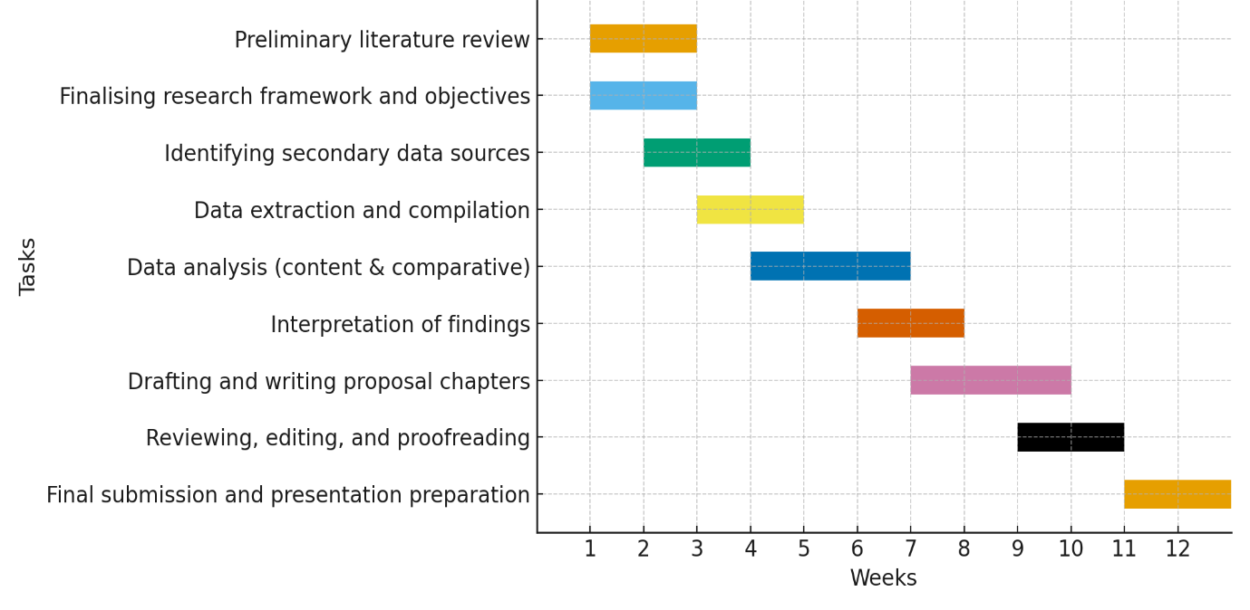

References
Ali, J., Khastoori, S., Sorooshian, S. and Campbell, N. (2022) ‘Diversity impact on organizational performance: Moderating and mediating role of diversity beliefs and leadership expertise’, PLOS ONE. Available at: https://doi.org/10.1371/journal.pone.0277083
Jones, G., Chace, B.C. and Wright, J. (2020) ‘Cultural diversity drives innovation: Empowering teams for success’, International Journal of Innovation Science, 12(3), pp. 323–340. Available at: https://doi.org/10.1108/IJIS-04-2020-0042
Liu, J., Zhu, Y. and Wang, H. (2023) ‘Managing the negative impact of workforce diversity: The important roles of inclusive HRM and employee learning-oriented behaviours’, Frontiers in Psychology, 14, 1190175. Available at: https://doi.org/10.3389/fpsyg.2023.1190175
Mata, M.N., Khan, F.H., Khan, K.I., Martins, J.M., Rita, J.X. and Dantas, R. (2021) ‘Team diversity and project performance: Role of trust and absorptive capacity in IT industry’, Academy of Strategic Management Journal, 20(2), pp. 1–20.
Okatta, C.G., Ajayi, F.A. and Olawale, O. (2024) ‘Enhancing organizational performance through diversity and inclusion initiatives: A meta-analysis’, Management Research. Available at: https://doi.org/10.1108/MR-02-2024-0123
Patrício, L. and Franco, M. (2022) ‘A systematic literature review about team diversity and team performance: Future lines of investigation’, Administrative Sciences, 12(1), 31. Available at: https://doi.org/10.3390/admsci12010031
Stahl, G.K. and Maznevski, M.L. (2021) ‘Unraveling the effects of cultural diversity in teams: A retrospective of research on multicultural work groups’, Journal of International Business Studies, 52(1), pp. 4–20. Available at: https://doi.org/10.1057/s41267-020-00389-5
Urionabarrenetxea, S., Fernández-Sainz, A. and García-Merino, J.D. (2021) ‘Team diversity and performance in management students: Towards an integrated model’, The International Journal of Management Education, 19(3), 100276. Available at: https://doi.org/10.1016/j.ijme.2021.100276
Wallrich, L., Opara, V., Wesołowska, M., Barnoth, D. and Yousefi, S. (2024) ‘The relationship between team diversity and team performance: Reconciling promise and reality through a comprehensive meta-analysis registered report’, Journal of Business and Psychology. Available at: https://doi.org/10.1007/s10869-024-09974-2
Yousef, K. (2024) ‘Exploring the impact of cultural diversity in global projects: A comparative analysis of virtual and face-to-face teamwork’, SAGE Open, 14(2). Available at: https://doi.org/10.1177/21582440241253754

