University Of Wales Trinity Saint David
Wales Institute of Science and Art


Kinetic Energy Recovery in a Vehicle
Alternative Propulsion Systems (ACHA5010)

Connor Smith
2101198
01/2023

Contents
1 Introduction 3
2 Characteristics of the Vehicle 4
2.1 Selection of vehicle and test procedure 4
2.2 Vehicle characteristics research 4
3 WLTP Analysis 6
4 Specification and Analysis of the KERS 9
4.1 Potential Solutions 9
4.1.1 Motor/Generator Solution 9
4.1.2 Mechanical Solution 9
4.2 Specification of a system 10
4.2.1 Braking type 10
4.2.2 KERS type 11
5 Evaluation 12
6 Conclusion 13
7 References 14

Figure 1 - Front area gridlines 5
Figure 2 – Highlighting the frontal area 5
Figure 3 – Counting the squares 5
Figure 4 - Velocity/time graph for the class 3a WLTP 6
Figure 5 - Tractive power for each second of the WLTP 6
Figure 6 - Cumulative tractive force 7
Figure 7 - Cumulative tractive energy/energy loss 7
Figure 8 - Points on the bike where a KERS can be fitted 11

Introduction
When fuels are burned in the internal combustion engine (ICE), it releases gases such as carbon monoxide and carbon dioxide. These directly affect both the environment and the quality of life of any person that faces prolonged exposure to them. As the world works towards a cleaner future, tolerance for these emissions has decreased enormously. An effective way to combat these emissions would be to implement a kinetic energy recovery system into ICE vehicles, which would temporarily reduce the need to burn fuel to generate the power needed for propulsion (Pérez et al, 2016).
When a vehicle is in motion, it has a store of kinetic energy. Under standard braking conditions, this energy is lost, as standard brakes apply frictional forces to convert the kinetic energy of the wheels into heat energy, rendering it useless. A kinetic energy recovery system aims to store some of the energy that would otherwise be lost. This can then be redelivered back into the powertrain when the vehicle requires it (Kumbhojkar et al, 2015). Restoring this energy back into the system means less energy is required from the engine to achieve the same output speed as if there were no KERS, and as such less fuel must be burned.

Characteristics of the Vehicle

Selection of vehicle
The Suzuki VanVan is a vehicle that solely uses an internal combustion engine to deliver power to the rear wheel. As such, although its fuel economy is good, it still releases emissions at the tailpipe. Installing a kinetic energy recovery system on the vehicle would reduce this and as such would make the vehicle cleaner to run. Additionally, it produces staggeringly low torque; having an additional source of power delivery active during its acceleration may increase the performance of the vehicle.

Vehicle characteristics research
To calculate the drag force, the density of air, the coefficient of drag and the frontal area of the motorcycle are all required. The frontal area of the motorcycle can be approximated taking a photo of the front end of the motorcycle and dividing it into squares. The number of squares that were over halfway filled by the motorcycle can then be counted (see figures 1, 2 and 3) The area of each square can be calculated by comparing the known area of a feature of the motorcycle and determining how many squares were in that area. For example, there were 23 squares that covered the indicator lens, which has a diameter of three inches.

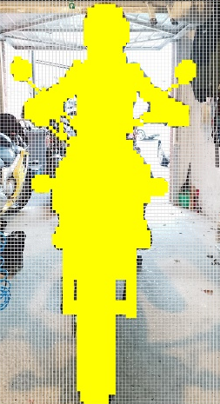
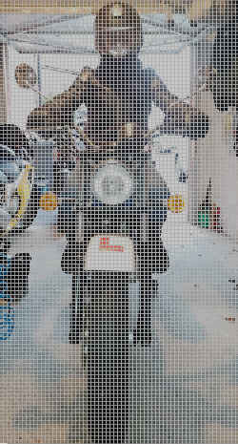

Figure 1 - Front area gridlines
Figure 2 – Highlighting the frontal area
Figure 3 – Counting the squares

Each square represents an area of 1.98 *10⁻⁴ m². Given that there were 2398 squares making up the frontal area of the bike, the frontal area can be determined to be 0.475m². This can be used in conjunction with the velocity (determined by the WLTP), the density of air, and the coefficient of drag to determine the drag force. The density of air varies with temperature; for the purposes of making the drag calculation as relevant as possible to the vehicle’s standard use, the daily mean temperature for the UK in 2022, 10.03°C (Seabrook, 2023), is used. The density of air at this temperature is 1.2474 kg/m³ (Evans, 2015), and the drag coefficient an aerodynamically poor motorcycle would be around 0.7 (Mifsud, 2020).
To determine the forces acting on the vehicle due to the rolling resistance, the mass is needed. Additionally, the rolling resistance coefficient is required. The Suzuki VanVan has a curb mass of 128kg (Suzuki Motor Corporation, 2015) and a rider mass of 71 kg, giving a total mass of 199 kg. In Cossalter’s 2006 book, “Motorcycle Dynamics”, it is stated that typical motorcycle rolling resistances are in the region of 0.02.

WLTP Analysis
The world-wide harmonized light duty test procedure (WLTP) is a drive cycle that is used to determine a vehicle’s emissions, replacing the new European driving cycle (NEDC). The WLTP was designed to simulate real-world vehicle operation better than the NEDC, which was criticised for being too flexible with its boundaries and not as representative of standard driving procedures (Tsiakmakis et al, 2017). As such, the WLTC can be used in combination with the vehicle’s characteristics to determine the magnitude of the forces acting on the vehicle during a standard drive cycle. This can then be used to determine how much kinetic energy can be stored via a KERS during braking.
WLTP Class 3 focuses on vehicles with a power to curb mass ratio above 34 N/kg, and is comprised of four sections: low speed, medium speed, high speed, and very high speed (Micari et al, 2022). The VanVan fits into this category despite producing stupidly low power due to its incredibly low mass. However, due to its low power it cannot fulfil the very high section of the test. Because of this, the extra high phase is replaced by a repetition of the low-speed phase. The velocity/time graph for this test is shown in Figure 4. The vehicle is braking whenever the speed is decreasing (e.g point A, B and C of figure 4); this is when a KERS would be converting the vehicle’s kinetic energy into its stored form. Figure 5 shows the tractive power of the vehicle for each second of the drive cycle.
C
B
A
Figure 4 - Velocity/time graph for the class 3a WLTP

Figure 5 - Tractive power for each second of the WLTP
Using a combination of this speed/time graph and the characteristics determined in section 2.2, the total kinetic energy of the vehicle and the amount of energy converted into heat by the brakes can be determined. Figure 5 shows the cumulative force that is required throughout the course of the WLTP, which can be used to determine the stored and lost during the vehicle’s operation. Figure 6 shows the power delivered by these forces.

Figure 6 - Cumulative tractive force

Figure 7 - Cumulative tractive energy/energy loss
Figure 7 shows that the total tractive energy of the vehicle during a standard cycle 674665.392J, 600483.903 of which were dissipated by the brakes. This highlights how a KERS would be beneficial to the operation of the motorcycle, as 600483.903 J is a huge amount of energy currently being wasted as heat. Having some of that energy be harvested would help the vehicle achieve much of its tractive energy when it next accelerates without injecting a great deal of fuel.
Point B on figure 4 represents the highest constant drop in velocity that occurs during the WLTP cycle. Ergo this would be the highest drop in kinetic energy during a standard drive cycle. During this time, the cumulative energy converted to heat by the brakes increases from 277904.261J to 297546.848J, indicating that 19642.587J was lost from the system. This is the maximum energy recoverable from a single braking operation if a KERS was 100% efficient and effective. This value can be used to determine how much energy the KERS could recover and store once the efficiency of the selected system is determined.

Specification and Analysis of the KERS

Potential Solutions

Motor/Generator Solution
Kinetic energy can be recovered during braking operation by using a motor/generator unit (MGU). The MGU is connected mechanically to the drivetrain. During braking operation, some of the kinetic energy of the vehicle is converted to electrical energy by the generator, slowing the vehicle small amounts (Pipitone et al, 2019). This electrical energy is usually either stored electrically in a capacitor or chemically in a battery. When the kinetic energy is needed in the system, the energy is then converted back from its stored form into electrical (unless it was stored as electrical). This electrical energy is then converted into kinetic energy by the motor and is delivered into the powertrain (Boretti, 2010).
This system can, however, be incredibly inefficient, as the energy is transferred into different forms multiple times, losing some energy in each transfer. This is an issue that a mechanical KERS overcomes, to an extent. (Matthews and Nishanth, 2013). Additionally, it requires a motor generator unit to be fitted somewhere along the drivetrain, as the vehicle does not currently have an electric propulsion component. On a motorcycle, with limited space, implementation of such a system may prove challenging.

Mechanical Solution
A mechanical KERS uses a rotating component (such as a flywheel), a clutch and a continuously variable transmission (CVT) to store kinetic energy (Kapoor and Parveen, 2013). A CVT is used instead of stepped transmission because the speed ratio between the vehicle and the flywheel is constantly changing. The CVT allows for a near infinite amount of gear ratios, which in turn provides a more seamless delivery of power from the flywheel without substantial losses (Matthews and Nishanth, 2013).
When under braking conditions, the clutch is engaged, connecting the drivetrain and the flywheel. This draws kinetic energy from the vehicle via the CVT, slowing it down whilst simultaneously storing some energy in the flywheel. Under such conditions, the CVT is at a gear ratio where the drive gear is larger than the flywheel gear, spinning the flywheel faster and increasing its kinetic energy store. Under acceleration conditions, the CVT’s gear ratio is changed in such a way that the flywheel side gear is larger than the driveline side gear, transferring the kinetic energy from the flywheel to the driveline (Panchbhai et al, 2020). This reduces the amount of rotational kinetic energy that the engine is required to produce, and thus reduces the fuel consumption.
Flywheels do, however, have their drawbacks. Due to the speeds at which they rotate, the forces acting on them can be enormous. If a mechanical failure occurs and the flywheel breaks, the debris will be flung outwards at a devastating speed. This could cause serious damage to the vehicle or critically injure the rider. This risk can be mitigated by selecting a material for the flywheel with high strength properties and shrouding it in protective casing to minimise the damage caused if it does burst.
Due to the vehicle in question being a motorcycle, the sizing and positioning of a flywheel must be taken into consideration too. As there is limited space to work with, the flywheel can’t be too large, as this will affect the geometry and therefore the handling of the motorcycle. In addition to this, rotational forces within the system will affect the handling characteristics of a motorcycle; this must be accounted for when designing a flywheel system for a motorcycle.

Specification of a system

Braking type
Kinetic energy recovery systems are always one of two types: series and parallel. Series brakes have integrated controls, beginning to introduce the friction brakes at only when the regenerative brakes can no longer cause the system to lose energy at a fast enough rate (Popiołek et al, 2019). This allows the kinetic energy recovered to be maximised but is difficult to implement due to the complex nature of the control system. Parallel braking systems activate the friction brakes and the regenerative brakes at the same time. This reduces the amount of energy recoverable but is much easier to implement as it requires fewer control systems to make it operate effectively. (Zhang et al, 2008).
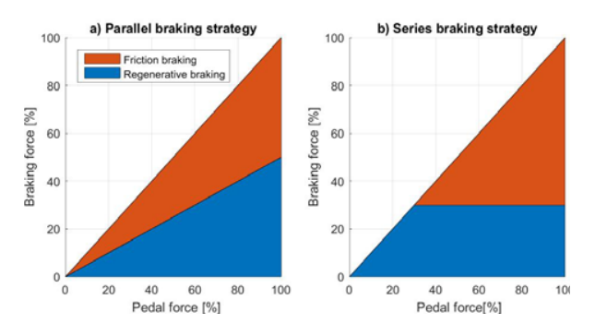
Figure 8 - Braking methods (Popiołek et al, 2019)
Due to the implementation issues surrounding the installation of a series KERS, a parallel KERS should be used on the VanVan. Installing a parallel KERS means that no additional brake by wire components would be required as the brakes on the VanVan are operated completely mechanically and no electronic brake controllers are currently installed on the bike. The implementation of a braking system where the brake force is determined predominantly by a control unit would prove challenging.

KERS type
The space available on the motorcycle is a limiting factor for what KERS can be used. The VanVan is quite small, with limited space for a KERS. It is also incredibly difficult to create more space for a system, and the bike has too little power to pull too much extra weight. Small components can be mounted to the sides of the motorcycle, but this could destabilise the bike if there is too much weight on one side. This means that the auxiliary system can only be fitted in either the space between the wheel and the engine, underneath the vehicle, or where the top box is currently mounted (see figure 8).
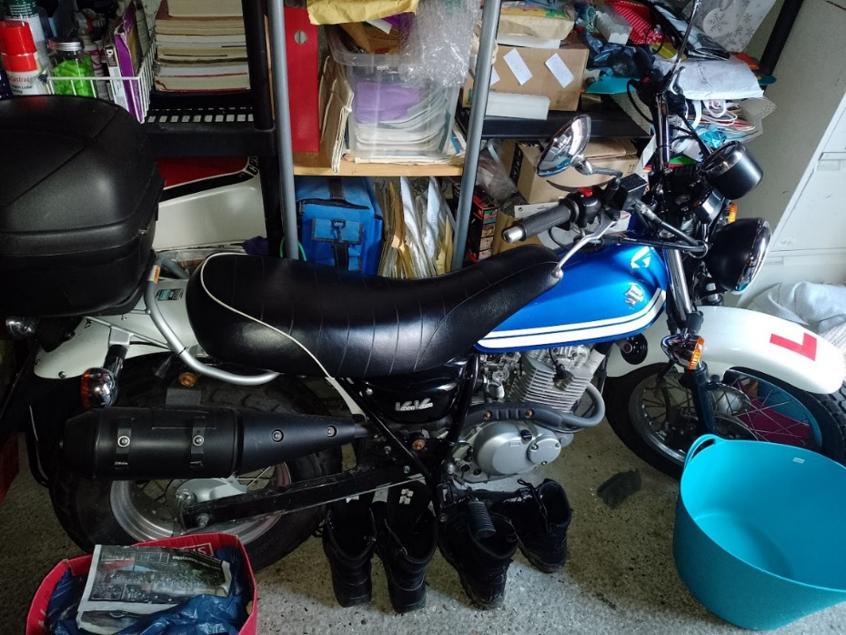
Point 1
Point 3
Point 2
Figure 9 - Points on the bike where a KERS can be fitted
Flywheel energy storage systems can be made to be flat but wide. This means that they can be made in such a way where they protrude less, which in turn means that they can be made to fit at any of the points highlighted by figure 8. Batteries and MGUs are notably heavy and can be quite large, and so would be less suitable as a KERS on this motorcycle than a flywheel. As mentioned in section 4.1, flywheels also tend to be more energy efficient than motors; installing a flywheel instead of a MGU and a battery will allow more of the kinetic energy to be recovered.

Potential Mounting Points
Because the KERS in question will feature a flywheel, the safety of the rider must be considered. If a flywheel fails, the fragments of it fly outwards at a high velocity. As such, it must be encased in a housing strong enough to prevent damage to the rider and the vehicle. However, it is possible for the casing to also fail. This means that point 1 of figure 8 is unsafe for KERS mounting; in the event of failure, the shrapnel will hit the rider in the back, causing serious injury or even death. Point 2 would also be an impractical place to mount a KERS, as the bike will tend to roll when the flywheel spins up. This force would be overcome by the gyroscopic forces on the motorcycle during motion. However, as the flywheel would at its highest speed when the motorcycle is motionless, the rolling force would be at its peak when there are no gyroscopic forces to counteract it. This means that the motorcycle would be actively trying to fall over after a high decrease in velocity.
Point 3 is the closest of the three points to the drive train; the flywheel can be connected underneath the bike, meaning it can be easily driven from output shaft of the gearbox by a belt driven CVT (a CVT where both gears act in the same plane, making them flusher to the surface of the bike) (Srivastava, & Hague, 2008). This means that it can be implemented over a smaller section of the bike, which would result in fewer mechanical losses and a less clunky design. However, despite this being the best place to mount the flywheel, the vehicle’s dynamics will be changed. As there is a rotating body acting as a gyroscope, the bike will resist leaning after braking has occurred. This could cause issues when braking before a corner, decreasing the bike’s handling.

Sizing the Components

Assumptions
As the KERS is working in tandem with the friction brakes, the assumption has been made that 50% of the braking force is applied by the KERS. The additional assumption has been made that 10% of the potentially recoverable energy would be lost due to friction in the gearing. Therefore, the flywheel would store a maximum of 7365.970J. This is highlighted by the below graph.
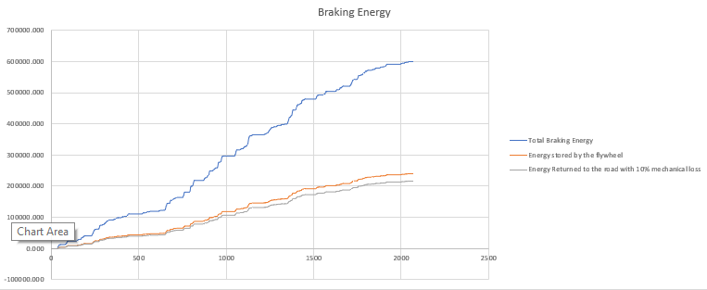
As the flywheel must fit underneath the engine, the radius of the disc must be 0.1m or below. Assuming the disc to be uniform, this leaves a radius of gyration (k) of 0.05m. If the maximum flywheel rotation speed is equal to the bike’s RPM limit, the maximum speed of the flywheel is 942.478rad/s.

Calculations
Steel is a material well- suited for the manufacture of a flywheel (Purohit and Ramachandran, 2015). Using $KE=\frac{1}{2}Iω^{2}$ with the above values, it can be determined that the moment of inertia for the flywheel should be 0.01658507724kgm³. Using $I=Mk^{2}$, the minimum mass of the flywheel can be determined as 6.634kg. Using the density of mild steel, 7850kg/m³, the mass and radius of the flywheel, it can be determined that the minimum thickness of the disc needs to be 2.4cm, with a radius of 10cm.

Conclusion
Installing a flywheel KERS on the Suzuki VanVan would increase the fuel efficiency of the vehicle, and so would make it more environmentally friendly. By installing the KERS as a flywheel on the underside of the bike working in parallel with the friction brakes, the flywheel could recover and redeliver a substantial amount of kinetic energy back to the road, reducing the need for petrol. However, the gyroscopic forces involved with this could make the motorcycle harder to corner after a long period of braking.

References
Boretti, A.A. (2010), “COUPLING OF A KERS POWERTRAIN AND A 4 LITRE GASOLINE ENGINE FOR IMPROVED FUEL ECONOMY IN A FULL SIZE CAR”, SAE International.
Cossalter, V. (2006), “Motorcycle Dynamics”, Second Edition, Section 2.3
Evans, P. [Online] (2015), “Properties of Air at atmospheric pressure”, The Engineering Mindset.com, https://theengineeringmindset.com/properties-of-air-at-atmospheric-pressure/, accessed 11/01/2022
Kapoor, R. & Parveen, C.M. (2013), “Comparative Study on Various KERS”, Proceedings of the World Congress on Engineering 2013 Vol III, pp.2-5
Kumbhojkar, N. & Mohite, K. & Kulkarni, A. & Patil, S. (2015“DESIGN AND IMPLEMENTATION OF KINETIC ENERGY RECOVERY SYSTEM (KERS) IN BICYCLE” International Journal of Mechanical Engineering and Technology (IJMET), ISSN 0976 – 6340, Volume 6, Issue 4, pp. 101-108
Matthews, T. & Nishanth, D. (2013), “FLYWHEEL BASED KINETIC ENERGY RECOVERY SYSTEMS (KERS) INTEGRATED IN VEHICLES”, / International Journal of Engineering Science and Technology (IJEST), Vol. 5 No.09, pp.1694-1699
Micari, S. & Foti, S. & Testa, A. & De Caro, S. & Sergi, F. & Andaloro, L. & Aloisio, D. & Leonardi, S.G. & Napoli, G. (2022), “Effect of WLTP CLASS 3B Driving Cycle on Lithium-Ion Battery for Electric Vehicles”, Energies 2022, 15, 6703, pp.4-5
Mifsud, N. (2020), “Going the Distance: Increasing Aerodynamic Efficiency In Electric Motorcycles With The Addition Of A Rear Fairing”, Robert D. Clark Honors College, pp. 1-4
Panchbhai, A.D. & Dhumane, S. & Dhalwar, G.P (2020), “Review on Kinetic Energy Recovery System for Bicycle”, International Journal of Scientific Research & Engineering Trends Volume 6, Issue 5, pp.2848-2852
Pérez, A. & Ramos, R. & Montero, G. & Coronado, M. & García, C. & Pérez, R. (2016) “Virtual Instrument for Emissions Measurement of Internal Combustion Engines” Hindawi Publishing Corporation, Journal of Analytical Methods in Chemistry, Volume 2016, Article ID 9459516, pp.1-2
Pipitone, E. & Vitale, G. & Lanzafame, R. & Brusca, S. & Mauro, S. & Beccari, S. (2019), “A Feasibility Analysis of an Electric KERS for Internal Combustion Engine Vehicles.”, Conference on Sustainable Mobility
Popiołek, K. & Detka, T. & Żebrowski, K. & Małek, K. (2019), “Analysis of Regenerative Braking Strategies”, PRZEGLĄD ELEKTROTECHNICZNY, ISSN 0033-2097, pp.117-122
Purohit, P. & Ramachandran, M. (2015), “Selection of Flywheel Material using Multicriteria Decision Making Fuzzy Topsis”, Indian Journal of Science and Technology, Vol 8(33), pp.2-4
Seabrook, V [Online] (2023), “UK average annual temperature in 2022 above 10C for first time, Met Office says”, Sky News, https://news.sky.com/story/uk-average-annual-temperature-was-10c-or-more-for-first-time-in-2022-met-office-says-12780281#:~:text=The%20UK%20has%20recorded%20an,of%209.88C%20in%202014., accessed 11/01/2023
Srivastava, N. & Hague, I. (2008), “A review on belt and chain continuously variable transmissions (CVT): Dynamics and control”, Mechanism and Machine Theory 44, pp.19-41
Suzuki Motor Corporation (2015), “RV125 Owner’s Manual”, Suzuki Motor Corporation, Specifications.
Tsiakmakis, S. & Fontaras, G. & Cubito, C. & Pavlovic, J. & Anagnostopoulos, K. & Ciuffo, B. (2017), “From NEDC to WLTP: effect on the type-approval CO2 emissions of light-duty vehicles”, JRC Science for Policy Report, European Commission, pp.5
Zhang, J. & Lu, X. & Xue, J. & Li, B. (2008), “Regenerative Braking System for Series Hybrid Electric City Bus” The World Electric Vehicle Journal, Vol 2, Issue 4, pp.128-134

