
Source: https://healthcareitskills.com/

MODULE CODE: LCBB5005
PROJECT MANAGEMENT
THE PROJECT
TUTOR’S NAME: DR. NANDISH PATEL
STUDENT NAME: ELENA HRISTOZOVA
STUDENT ID: 1811990

Table of Contents

1. Introduction 3
2. Goals and Objectives 3
3. Success Factors 4
4. Project Scope 4
5. Identifying the reason that constraints affect the project 5
6. The assumption made regarding the project 6
7. Project organization role responsibility and structure 7
8. Project control mechanism 8
9. Reporting Framework 8
10. Stakeholder Involvement and Analysis 9
11. Project planning and Milestone 10
15. Budget Assumption 12
16. Conclusion 12

1. Introduction
The management of a project is generally an application format or a process that helps in achieving or experiencing a proper knowledge method regarding a particular project objective which is based upon accordance with a grading parameter. Project management is a practice that helps an organisation to work efficiently for achieving certain objectives and reach the specific goals within a fixed period of time. The assessment using the provided integration about those factors of the project and the scope of the purpose of the project and identify the primary obstacle that will affect the project. In this project, there will be a discussion about a small single room healthcare office construction. The budget for the project is £ 50000. It will share the objective, success factors, and by the analysis of stakeholders and risk management, the method of successful project completion will be divided.

Business Case and Problem Statement
Oxleas NHS is a small healthcare sector that works in Suburban areas of UK. They always focus on the areas those are backward and do not get much advantage. They do customer survey and market analysis to find those kinds of remote areas. Recently, they found that in the village of Cottingham, there is not any proper healthcare unit for common people. Some of the local people where contacting Oxleas NHS to open a small branch there. As there was not any branch in Cottingham and around it then they will also get the foundation of expanding their organisation. It will help them to reach people of new area and those people will also get benefited. In this scenario, they have to construct unit of healthcare in that area. At this moment it their budget is only £ 50000, there have to start with a small unit. This study will discuss about the entire process of this project. The result of the plan is that better service can be provided to the customers. This will also ensure better customer experience. Better service can be provided. As well as, cost of service can also be reduced through opening branch customer can avail service easily.

2. Goals and Objectives
- To provide high quality of service by Oxleas NHS.
- To recognise the diverse nature and practicing of healthcare for encouraging health care service with primary medical care.
- To promote health care wellbeing and offering advice for prevention of various diseases.
- To involve professional physician for providing efficient care in remote location of Cottingham.

3. Success Factors
The success of a project usually depends upon the following aspect:
Planning: Planning is determined one of the crucial aspect for the success because advance planning will generally help in knowing about the issue or problem while conducting health care support in remote location and also knowing about various political risk organisation and risk that can be mitigated with developed governmental strategies (Kerzner, 2019).
Communication: Communication between the society, physician, employee will generally help in creating a better basement for conducting health care support. Relevant feedback will generally help in increasing the healthcare quality that should be provided for creating a better awareness.
Managing Stake Holders and Budget Planning: Stakeholder will generally provide basic identification about the project while conducting and provide written documentation about the budget that is required for contacting the project for providing healthcare support (Fleming, and Koppelman, 2016).

4. Project Scope
- Plan Scope Management: During this stage, it is generally necessary for the NHS determine about the project scope and also provide proper recorded and demonstrated data collected from market research which will be identified and validated about creating awareness about the health facility that will be provided by Oxleas NHS. It would also progress regarding the Requirement and gathering of imports from the stakeholders and later review for a successful project plan (Kerzner, 2017).
- Collect Requirement: According to the marketing research, it is seen that projects usually fail because of not meeting the goal and the main aspects generally like and trained employee, political factors, geographic location. For the better outcome of the project, it is generally required for Oxleas NHS to have a proper prediction over the cost and ensure the deliverable regarding the meet up of expectation from the stakeholder.
- Timelines: Timelines of a project will generally help in reaching the Milestone and provide identification about the conducting of healthcare branches for creating awareness about health information and provide efficient treatment with the help of physician. Proper budgeting and identifying about the location, political environment and working culture will generally help in completing the project with given period of time.

Project Limitation
While conducting a project for opening various subbranches in remote location it is it important to determine about the quality of healthcare services to be provided by Oxleas NHS (Meridith et al. 2017). It generally become hard for determining about the focus point and trying better for satisfying the physician for creating awareness and providing efficient service.

5. Identifying the reason that constraints affect the project
- Risk: Managing risk is an easily important task for the project manager because it helps in estimating the probability of risk that may provide a starting impact over the project. Various political risk, technical risk, social risk may get arise in the working environment while conducting project over healthcare support. The risks can be used limited with efficient governmental policy, legal aspect and determining about the rules and regulation that will safeguard the project.
- Quality: The priorities depend upon wellness and also forced to think beyond the contribution provided for improving the construction of healthcare by knowing about the time period and budget with the proper recorded documentation and the support for stakeholder with increase the awareness of NHS (Demirkesen and Ozorhon, 2017).
- Scope: Scope is one of the critical variables in the project on constructing healthcare which also impacts the schedule and cost. Moreover, a good manager with integrated different management design and value for the process and define the scope for providing healthcare awareness and treatment with directed physician.
- Cost: It is basically a best practice for preparing a budget a bit early, which includes a proper deadline about the construction cost and other costs of the project. Costing usually determined about the infrastructure, location, expert physician that will be required for providing healthcare support. It also determines about the expenses that are usually required for providing healthcare support generally like advance technology that will help in creating awareness about health in remote location like Cottingham. (Nicholas and Steyn, 2017).
Risk management and Registration Table
Risk | Risk Registration | Impact | Mitigation
Financial Risk | High | Increasing Cost  Increasing Interest over Loans | Proper planning and Budgeting
Operational Risk | Medium | Low qualified physician  Untrained employees  Weak organization Structure | Proper training.  Increasing communication skill.
Political Risk | Low | Compensation.  Breaches.  Failure of project. | Health and Social Care Act 2012.  PSA (voluntary registration for Health care NHS)

6. The assumption made regarding the project
The successful completion of a project depends on planning. Usually, project organisers want to complete the project successfully within the budget and time. These two are compulsory objectives for most of the projects. In these projects, projects the assumptions are,
- The budget of the project is £ 50000, and it will be completed within it. Even the maximum expense will not cross the budget.
- The project must be completed within six months, but it may take 10 or 15 days more to extend the rectification time.
- There may be issues regarding equipment and materials of the project, and it may put pressure on the budget.
- There may be specific issues with the workers, and the organisers are prepared for it.
- Some common risks anticipated and hence there will be chosen solutions for those.

7. Project organization role responsibility and structure
Project manager
The project manager has ownership for all tasks, and he and she quote that the project is being done by following all the conditions. As a manager of Oxleas NHS it is really important to build a proper relationship with the employees, professional physician providing health care support and stakeholders for providing advance idea about the project scope.
Business analyst
The business analyst has to study the current situation of a project and needs to identify if any changes are required to make regarding the geographical location, political nature, society and also determine the awareness required to create in between peoples of Cottingham about healthcare, which will result in increasing the scope of business.
Security team
Identify the possible risks and be prepared with appropriate solutions of various technical issues while providing healthcare support by Oxleas NHS. There may be operational issues during the construction, and the security team must keep them connected with all the departments.
Stakeholders
All the stakeholders have to be a part of the project, and they need to involve themselves directly with the plan for the benefit. There will be both primary and secondary stakeholders, and primary stakeholders have higher responsibilities towards successful completion of Healthcare NHS in suburban location of UK.

8. Project control mechanism
Planning is also referred to as a fundamental challenge of a manager regarding the execution of the healthcare support. It also involves various technologies defining the work task, identifying the budget required for developing the work and determining the time needed for completing the task. Proper construction planning that encompasses the cost orientation and schedule orientation will help in increasing the performance of the project for providing healthcare support to peoples of Cottingham, where the cost orientation will provide a direct indication to the manager about the expenses regarding direct and indirect cost. For improving the performance, it is usually important to align the goals and objective of Oxleas NHS. Determine and develop work breakdown structure for collaborating over the initial project in that location and monitoring and budgeting over the revenue required for conducting the project. (Shirley, 2017). The management technique will generally help in offering different way for adopting operational clinical financial improvement. Which also result in implementing a pragmatic approach for the health care setting and provide a vital technique for providing healthcare support with the help of professional physician for creating awareness. It is also seen that while providing health care support individual family generally depend upon the waterfall approach that determine about the true sequence of communication, behaviour, NHS healthcare system for people of Cottingham.

9. Reporting Framework
Effective Communication creates the foundation for any project. A transparent communication helps the members to be united, and the concerns related to budget all objectives get solved quickly. The following methods will help to improve communication standards in a project.
- Prioritisation
There must be a priority for Communication and appropriate strategy for healthcare support to people of Cottingham. It will help all the members to be concerned about contact, and it will remain their primary focus throughout the project. The prioritization generally focusses over the psychological needs and providing efficient support to the employee while conducting the project and providing efficient quality of health support for the employees and their family members.
- Avoid the wrong assumption.
The wrong assumption is one of the obstacles of project management, and it stops people from sharing views or information, which should be measured and monitored effectively by manager. All the stakeholders, organisers and members are required to avoid long as option ads may create a misconception among them (Oswald et al. 2018).
- Positive Vibe
If there is any negative news, then that should be affirmed among the stakeholders and project team members. Otherwise, it may discourage them, and the remaining work Oxleas NHS may get affected. Therefore, problems or any other drawbacks should be shared clearly with appropriate solutions.
- Communication channels
It may not be possible for the organisers to communicate directly with the stakeholders on a regular basis regarding the project. Hence, there must be some communication methods, like weekly emails or individual phone calls. It will keep the connection alive throughout the project (Kotera et al. 2020).
- Stay updated
All the information should be shared instantly with the stakeholders regarding the budgeting and expenditure while conduction project over healthcare support by Oxleas NHS. It is not like that there will be a specific time for sharing any information. Stakeholders and the members have the right to get regular information (Kotera et al. 2020).

10. Stakeholder Involvement and Analysis
Manager
Managers like the general manager and project manager are directly involved with the project. Their responsibilities are to share the objectives and accurate information related to budget and project steps to all other stakeholders. Managers will usually help in monitoring and controlling employees in the working environment and result in completing of the project in time.
Suppliers
It is a construction project, and there will be suppliers for different hardware of construction. They will be the provider of the original equipment for this project. They will generally result in increasing the supply of raw material and other basic needs that are usually required for conducting the project. Moreover, it will result in providing additional support, where the crisis of raw material will get solved by supplier.
Engineers
Engineers will make designs for the construction. It is essential to build health care in a way so that it can be able to meet the requirements. The innovations of the engineers will be used to make it possible. Engineer will help on determining the infrastructure where the business is going to operate and knowing about the site best for performing business.
Contractor
The contractor has the responsibility to complete the project successfully by availing all the facilities within the proposed budget. Contractor generally provides facility to the business organization and the managers for designing, holding, supplying, building community for effective running of the business.
Local community
Permission from local people will be taken for this healthcare, and in return, they will get benefited. They are secondary stakeholders in this case. It generally helps management for taking various actions regarding the action, influence and managing the site. They also help in building a better community in different geographical location.
Government
The government will not be directly involved with this project, and it is also a secondary stakeholder here. It is a small project and doesn't require much intervention from the government. According to The Health and Social Care Act 2010 and PSA will generally help Oxleas NHS for conducting healthcare support for people of Cottingham.

11. Project planning and Milestone
Activities | Date
Project planning and setting of objectives/goals | 01/07/2020
Budgeting and site acquiring | 16/07/2020
Appointment with consultant | 30/07/2020
Designing completion | 30/08/2020
Approvals and contractor handover | 16/09/2020
Project beginning to closure | 18/11/2020
Completion of rectification | 01/01/2021

12. Gantt Chart
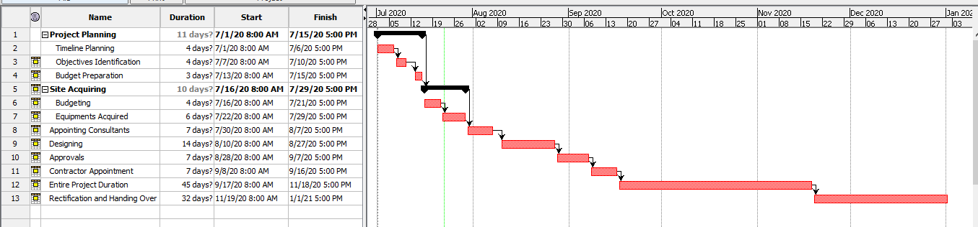
Figure: Gantt chart
(Source: Self-Created)
13. Network Diagram
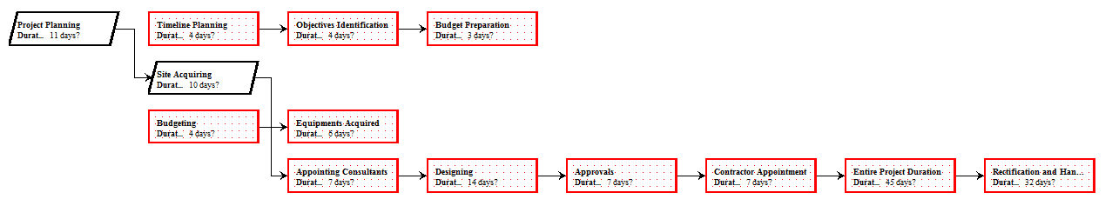
Figure: Network Diagram
(Source: Self-Created)
14. Work Break Down Structure:

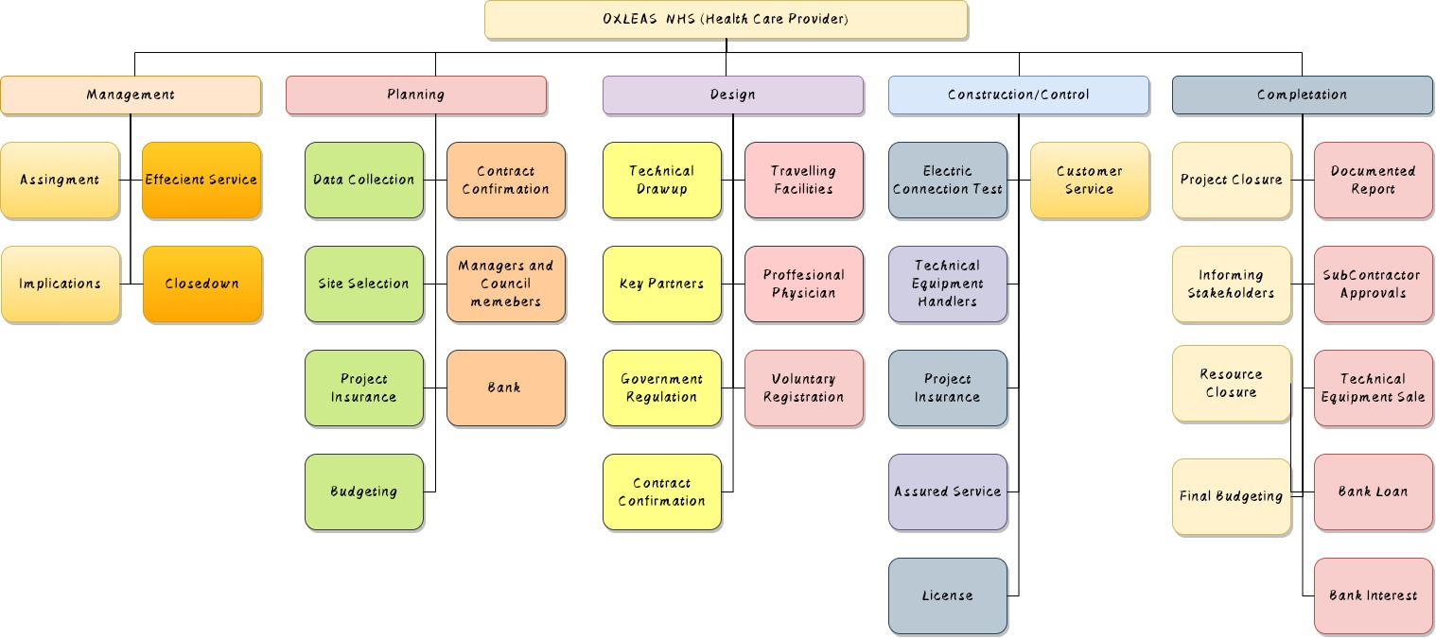
Figure: WBS
(Source: Self-created)

15. Budget Assumption

Activities | Amount (£)
Acquisition of Land | 4000
Planning | 500
Designing | 750
Approvals | 1000
Work in sites | 10000
Construction of building | 25500
Off-site cost | 2000
Cost of management | 2500
Overhead cost | 750
Permits cost | 500
Engineering cost | 2500
Total | 50000

16. Conclusion
It can be concluded that project management usually helps in defining the budgeting criteria that is required while conducting a proper project. It often provides an essential identification regarding the cost that is necessary for the project and the reason that can be mitigated while doing the project. Moreover, a proper essential plan is required, and work breakdown structure provides a necessary identification about the dividing up worker according to skill and job role. The assessment also includes adequate information about the project milestone that can be reached, and even the budget that is required for completing the project of healthcare construction.

Reference List

- Demirkesen, S. and Ozorhon, B., (2017). ‘Impact of integration management on construction project management performance’. International Journal of Project Management, 35(8), pp.1639-1654.
- Ebiloma, D. and Rimtip, M.N., (2019). ‘Factors Affecting the Success or Failure of Project Management Methodologies (PMM) Usage in the UK and Nigerian Construction Industry.’ International Journal of Innovation and Sustainability, 3, pp.17-28.
- Fleming, Q.W. and Koppelman, J.M., (2016). Earned value project management. Project Management Institute.
- Heagney, J., (2016). Fundamentals of project management. Amacom.
- Kerzner, H., (2017). Project management: a systems approach to planning, scheduling, and controlling. John Wiley & Sons.
- Kerzner, H., (2018). Project management best practices: Achieving global excellence. John Wiley & Sons.
- Kerzner, H., (2019). Using the project management maturity model: strategic planning for project management. John Wiley & Sons.
- Kotera, Y., Green, P. and Sheffield, D., (2020). ‘Work-life balance of UK construction workers: relationship with mental health.’ Construction Management and Economics, 38(3), pp.291-303.
- LARSON, E.W. and GRAY, C.F., (2018). Project management: the managerial process. McGraw-Hill.
- Meredith, J.R., Shafer, S.M. and Mantel Jr, S.J., (2017). Project Management: A Strategic Managerial Approach. John Wiley & Sons.
- Nicholas, J.M. and Steyn, H., (2017). Project management for engineering, business and technology. Taylor & Francis.
- Oswald, D., Sherratt, F., Smith, S.D. and Hallowell, M.R., (2018). ‘Exploring safety management challenges for multi-national construction workforces: a UK case study’. Construction management and economics, 36(5), pp.291-301.
- Radujković, M. and Sjekavica, M., (2017). ‘Project management success factors’, Procedia engineering, 196, pp.607-615.
- Shirley, D., (2020). Project management for healthcare. CRC

