Dina Priedulena
Student ID Number: 2233688
Food and Beverage Operations
BMIH4002
Jaliya de Silva
Trinity Hotel restaurant children's menu.

Hotel Trinity is a four-star city-center hotel, and a large part of the hotel's existing and potential visitors are families with children.
Key points characterizing the concept of the Trinity Hotel and restaurant:
- we provide a service level corresponding to a four-star hotel,
- we are family-friendly - we offer a children's playground, a kid's play corner in the restaurant, a healthy children's menu, as well as animator services,
- informal and cozy atmosphere in the restaurant, which would make the guests feel at home,
- high-quality fresh food ingredients with an emphasis on local and seasonal products,
- we appreciate loyalty - as a part of the Trinity Hotel chain, we offer a customer loyalty program that works in all establishments in the Trinity Hotel chain, as well as with our partners,
- we are proud of our locality - we provide guests with information about walking trails, attractions in the area, etc.,
- we know and respect local history and culture - the theme of local history and culture is used in the interior design of the hotel and restaurant.
Nowadays, eating is no longer just a physical process, but also an act of socialization. In today's society, compared to earlier times, families want to see kids as a part of this socialization. Most hospitality establishments offer special programs for families with children to attract more customers and retain existing customers who may have children in the future.
Children are a very sensitive and, one might say, capricious audience with specific desires and tastes.
It is worth remembering that a child's satisfaction with a meal is often the straightest way to the parents' hearts.
In today's highly competitive environment, it is important to follow the trend of healthy eating, and offering a healthy meal to children is really a big challenge.
The given restaurant is located in Burton upon Trent, Staffordshire, United Kingdom. Children's menus offered by the most-rated hotel restaurants according to TripAdvisor (tripadvisor.co.uk, 2023), similar to the criteria and located in Staffordshire, were researched. The target audience is well-situated families with kids who are interested in healthy and qualitative food and beverages.
The prices on the menu were determined based on the above research.
The following goals and standards were set in creating the menu:
- to interest children by serving healthy food in an attractive form and with humor,
- to provide seasonal, local, and fresh products on the kid's menu,
- to try to avoid unhealthy food ingredients but ensure that food and beverage taste good,
- to offer food and beverages for different tastes and children with different needs (vegetarian food, gluten, and lactose-free food),
- to follow and comply with the legal requirements and guidelines regarding food allergens.

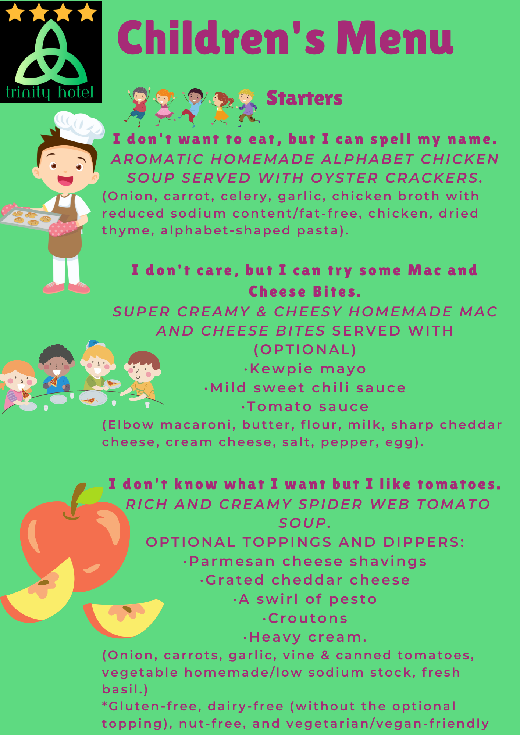
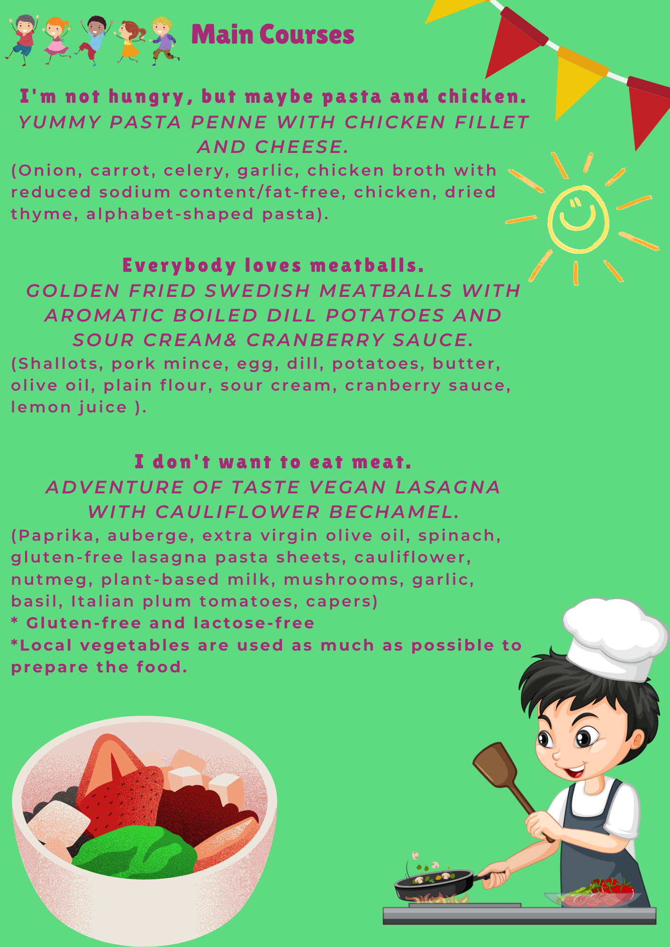
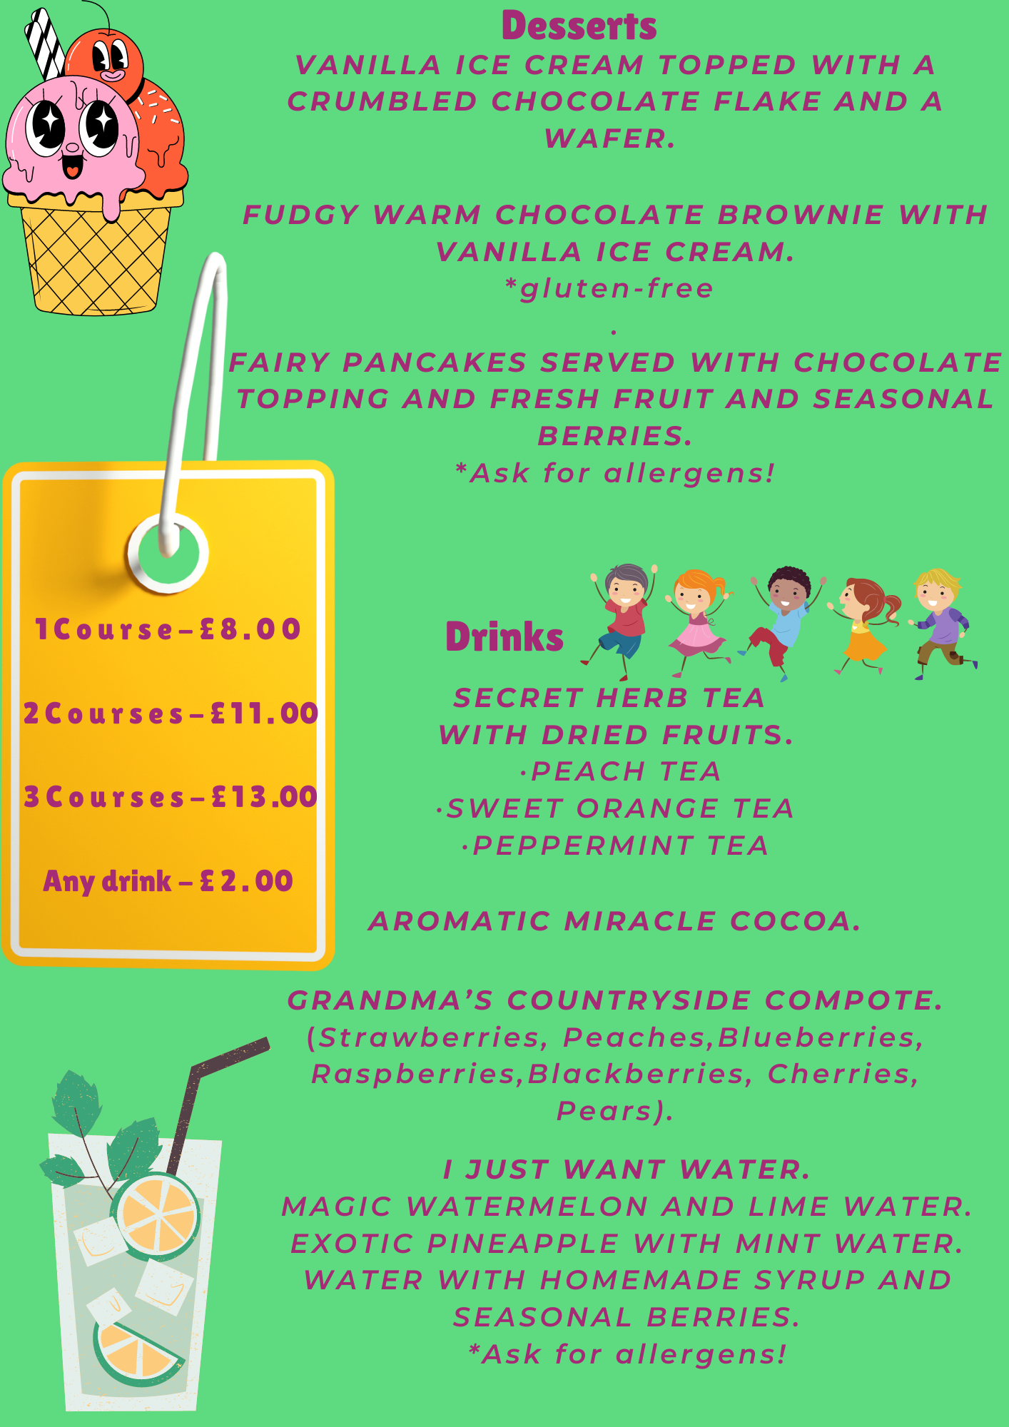
Reference List
Antun, J.M.& Gustafson, C. (2005). Menu analysis: design, merchandising, and pricing strategies used by successful restaurants and private clubs. Journal of Nutrition in Recipe & Menu Development, 3(3-4), 81–102. https://doi.org/10.1300/J071v03n03_07
Ayala, G, X., Castro, I. A., Pickrel, J. L., Williams, C. B., Lin, S.-F., Madanat, H., Jun, H.-J., & Zive, M. (2016). A restaurant-based intervention to promote sales of healthy children’s menu items: the Kids’ Choice Restaurant Program cluster randomized trial. BMC Public Health, 16(250), 250–250. https://doi.org/10.1186/s12889-016-2892-5
Bowen, J.T., & Morris, A. J. (1995). Menu design: can menus sell. International Journal of Contemporary Hospitality Management, 7(4), 4–9. https://doi.org/10.1108/09596119510091699
Camillo,A.A. (2021). Strategic international restaurant development: from concept to production. IGI Global.
How to develop a restaurant menu (typsy.com) (Accessed: 6th of June 2023)
How to Design a Perfect Menu (And Design Tips!) (webstaurantstore.com) (Accessed: 6th of June 2023)
The best kids menu in America contest: winners. (2004). Restaurant Hospitality, 88(7), 51–.
Words to Describe Food: 73 Adjectives for Food Descriptions (webstaurantstore.com) (Accessed: 6th of June 2023)
https://www.tripadvisor.co.uk/HotelsList-Staffordshire-Hotels-With-Restaurants-zfp7807207.html (Accessed: 6th of June 2023)
https://theupperhouse.com/wp-content/uploads/2023/03/Spring-Childrens-Menu-2023.pdf (Accessed: 6th of June 2023)
https://www.coachinginngroup.co.uk/wp-content/uploads/2023/04/Coaching-Inn-Group-kids-restaurant-menu-2023.pdf (Accessed: 6th of June 2023)
https://www.premierinn.com/content/dam/global/restaurants/Global/pi-band1.pdf (Accessed: 6th of June 2023)
https://www.food.gov.uk/business-guidance/allergen-guidance-for-food-businesses (Accessed: 6th of June 2023)

