Economics of Sustainability BMSP6007

Natalie Emma Male 1702161
Tutor: Anthony Burns

Report: Climate change agreements

Tutor: Anthony Burns

Table of Contents

Executive Summary 1
Chapter 2. Overview 3
2.1 Countries set their own targets with no enforcement. 4
2.2 Land use not a high enough priority 6
2.3 Technology development and transfer 7
Chapter 3. Is a global agreement still required ? 9
Chapter 4. Conclusion 10
Chapter 5. Recommendations 11
Chapter 6. References 12

Executive Summary

The aim of this report is to critically evaluate treaties, such as the Paris Agreement 2015. Climate change is a pressing issue and targets are not proving successful in reducing the effects that GHG has to the atmosphere, and the consequent warming effects. There are many issues, however three key areas of concern are identified and analysed, for their impact on delaying progress to the treaty’s target of a 1.5c reduction. They are as follows:
1. Countries set their own targets with no enforcement.
2. Land use is not a high enough priority.
3. Technology transfer.

Chapter 1. Introduction

The issue of managing climate change has been debated since the 1990’s. With governments mainly accepting the supporting scientific evidence. Although, the issue of who bares the most responsibility and what targets will be set has created division. The Montreal Protocol in 1987 did much to address the issue of substances such as CFC’s damaging the ozone, limiting their impact by 99%. The Montreal Protocol achieved a climate protection that was greater than the Kyoto Protocols first period of commitment (Velders et al, 2007).
The Paris agreement 2015 was a document developed at COP21, involving the collaboration of 196 parties, with the goal of heading towards sustainable development. The goal was to prevent warming of between 1.5c and 2c above the existing preindustrial levels (U.N, 2021). Governments are required to set nationally determined contributions of reduced emission promises, finding ways to adapt to the impact of climate change. Greenhouse gases (GHG) trap heat in the atmosphere. They include carbon dioxide, methane, nitrous oxide, and fluorinated gases. The effect of each gas on climate change depends on several factors including volume, length of time in the atmosphere and their impact on the planet. Though all gases range in their effect on climate change, gases containing a higher global warming potential (GWP) are significantly more warming. (EPA, 2021)
If climate change is not effectively addressed the impact could be catastrophic, including droughts and floods. Sea levels will rise, and heatwaves will cause devastation. The impact on homes, businesses and the global economy will be unimaginable. Figure 1 highlights the social and economic effect of climate change.
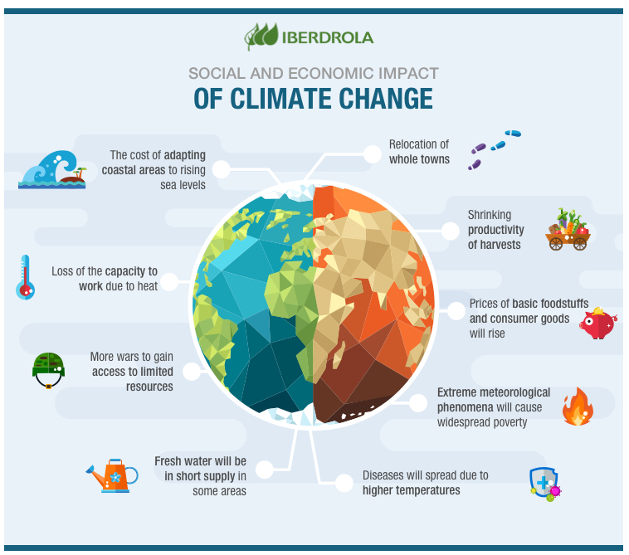
Fig 1. (Iberdrola, 2021)
Treaties such as the Paris agreement aim to stop this happening, though targets are not enforceable. Many issues have been exposed during negotiations that cannot be agreed on, thus holding back progress. Most experts believe the Paris Agreement will not be enough to prevent climate change.
This report will critically evaluate relevant treaties and aims to address three of the issues found within. Recommendations seek to offer an alternative perspective.

Chapter 2. Overview

Historically profit maximisation produced from stronger economic growth had no environmental objective. It is fair to say that the majority of problems with climate change developed for this very reason. The contributing factor of this rapid warming is human activity from the utilisation of fossil fuels, natural gas, coal, and oil. Factories began to move to developing countries in order to make operations cheaper, with a workforce who expected lower wages. This passes on the residual to another country, who are ill equipped to deal with it effectively. Nevertheless, developing countries have been able to grow their economies without the restraints encountered by the developed world. A fact that causes conflict between countries.
Figure 2 displays the Environmental Kuznets Curve; the model suggests that initially economic development leads to environmental degradation. At the turning point of economic growth society improves on its relationship with the environment and economic deterioration levels reduce. Suggesting economic growth benefits the environment. (Marsiglio et al, 2016) argues that “The negative relationship between income and pollution can only be a transitory phenomenon, and in the long run pollution will increase as income rises, generating overall an N-shaped pattern”. Economic growth does not always lead to a better-quality environment. Targeted policies are required to ensure this does not happen. (Pettinger, 2019)
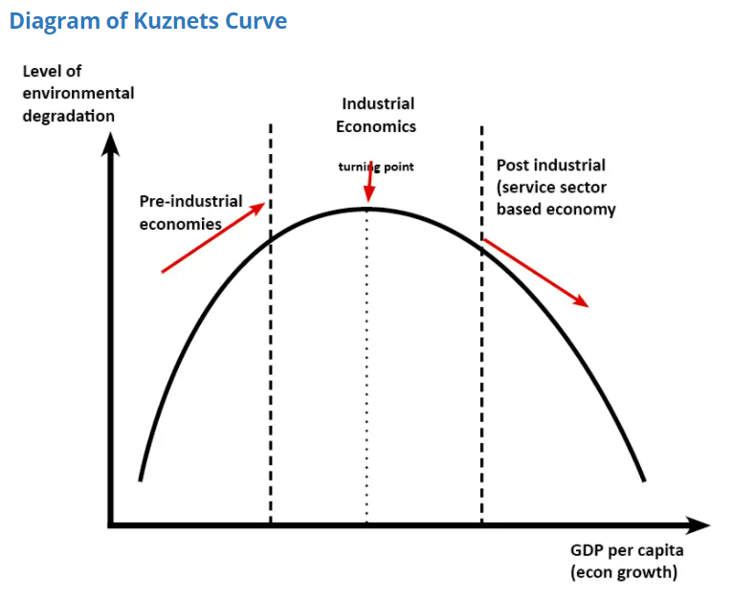 Fig 2. (Pettinger, 2019)

2.1 Countries set their own targets with no enforcement.

Figure 3 displays the top greenhouse gas emitters since 1950. Countries vary in their level of GHG emissions, with the United States emitting the highest level of all. The Paris Agreement was affected when President Donald Trump pulled out of the treaty in November 2020. Although the U.S signed the treaty they were never ratified and withdrew their signature. The impact meant that other countries had to compensate by raising emission costs. Additionally, developing countries felt the impact with the loss of climate aid, making it more difficult to adapt and implement climate change. (Zhang et al, 2017). The U.S has now re-entered the treaty. The issue of climate change has never been more pressing, yet countries can leave the treaty or decline joining. If meeting targets is a choice, then some of the largest emitters shoulder no accountability, or incentive to practice methods of pollution prevention.
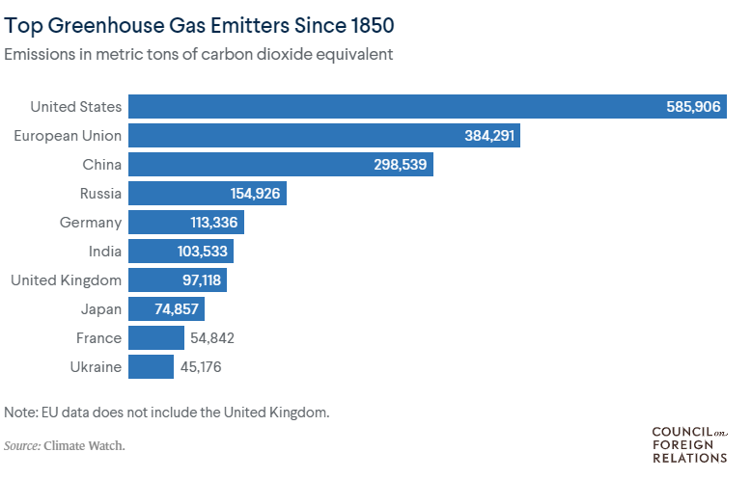
Fig 3. (Maizland , 2021)

One of the main issues with the Paris Agreement is that countries are responsible for setting their own targets, there are no enforceable mechanisms. The Global stocktake is a key element of the Paris Agreement. Countries determine their own climate targets, (NDC’s) nationally determined contributions. This leaves countries with the responsibility of determining their own contribution to climate change, and how they will reduce this risk. If they do not reach the set target, there is no penalty.
Countries undertake a review every five years to assess the collaborative progress towards the agreement’s goals. COP25 held in Madrid will not have the global stocktake on the agenda as it is not due until the end of 2023. Although, ensuring the process meets the objectives will require planning ahead. (Dagnet & Anderson, 2019). Scientists claim that countries commitments are neither ambitious enough, nor can be delivered in the time scale to prevent global temperature rise. Figure 4 shows the global temperature rise over preindustrial average, as countries are not meeting the Paris Agreement’s goal.
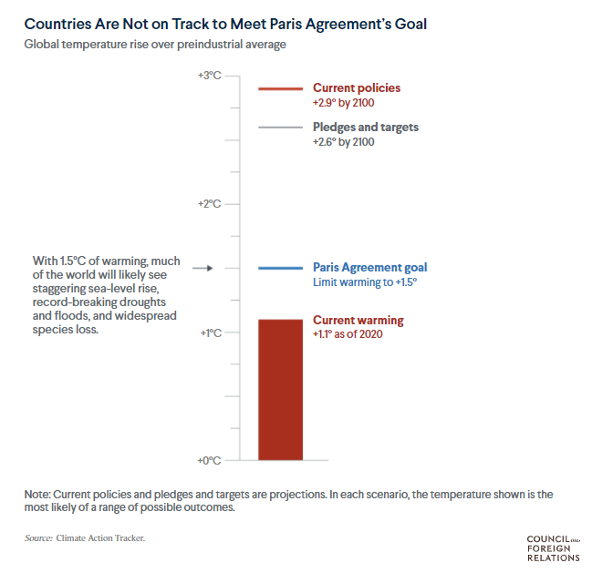
Fig.4 (Maizland , 2021)

By 2100 a rise of 2.9% could be the result of current policies according to Climate analytics and the New Climate institute. A rise of 2.6c could still be the result even if the government follows its pledges (Maizland , 2021). The Paris Agreement is voluntary based on morality and goodwill, therein lies the issue, climate change is an issue that requires a stricter and enforceable approach. Although this is unlikely when profit maximisation is still the driving force for many countries.

2.2 Land use not a high enough priority

Land use falls under the category of mitigation in the Paris Agreement, However, not enough consideration is given to the greenhouse gasses that deforestation and forest degradation (D&D) emits. Land use equates to one quarter of GHG emissions worldwide, though mainly in tropical developing countries. Carbon forest retention was an agenda in the UNFCC in 1992, Although in 1997 the Kyoto protocol did not recognise forests as a mitigation concern. The clean development mechanism did not have incentives at reduction on a national scale (Stavins & Stowe, 2016). Over time forests have declined due to agriculture, using the land cleared and gaining a higher economic return. The cost to the environment is difficult to measure leading to the rapid depletion of forestry. Agriculture is not specifically referenced in the Paris Agreement although forests are, one of the reasons is that reducing GHG emissions from agriculture creates concern in developing countries. Meaning this may diminish their responsibility to produce sufficient food. (Forests and Land Use in the Paris Agreement, 2015). Agriculture is the production of any method used to maintain human life, including fabrics, biofuels, and medicinal products. Globally the industry in 2020 is expected to grow to $9602.79 billion increasing to $10181.92 billion in 2021. Asia Pacific accounts for the largest region with 57% of the market. (Agriculture Global Market Report 2021: COVID-19 Impact And Recovery To 2030, 2020).
Vertical farming is a market that in 2020 was valued at $3.12 Billion. The vertical farming market addresses the lack of fertile land and increased urbanisation. The practice requires the production of food on vertically stacked layers, in a used warehouse for example. (Vertical Farming Market Size And Forecast, 2021). Figure 5 displays a method of vertical farming.
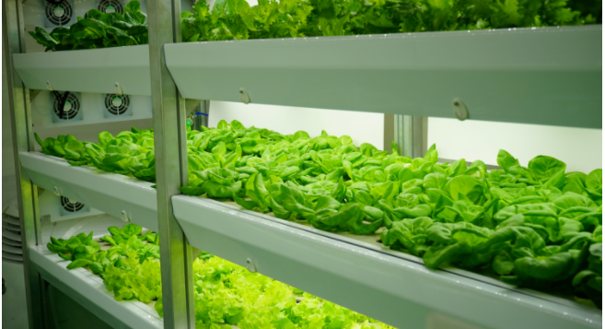
Fig 5. (Vertical Farming Market Size And Forecast, 2021)

Although, vertical farming was heralded as the answer to climate change and sustainability issues producing less waste, less water and reduced shipping. Critics suggest the carbon footprint is no different to other agricultural methods. A review of the literature suggests that growing lettuce in a VF may equate to the same carbon footprint as traditional farming (Greig, 2020). Furthermore, it is difficult to find any information regarding VF in the Paris Agreement, which brings the conclusion that this method may not have been considered statistically in emissions targets. Further research may assist new farming methods to produce lower emissions. Environmental literacy considers the issue of natural resource depletion and is referred to in Agenda 21. Progress will depend on technology implementation, which is already proving a continued issue in the developing world.

2.3 Technology development and transfer

Climate technologies can be defined as a technology that is implemented to address climate change. Renewable energies will help to reduce GHG’s and include hydropower, solar power, and wind energy. Transferring and developing technologies to other parties has been considered essential since 1992, under the United Nations Framework Convention on Climate Change (UNFCCC, 2021). Developing countries emissions are the most concerning and are increasing very quickly. In order for the developing world to lower its carbon footprint, the implementation of technology will be required. However, it is expected that the developed world will meet the cost. Article 9 of the Paris agreement states that “Developed country Parties shall provide financial resources to assist developing country Parties with respect to both mitigation and adaptation in continuation of their existing obligations under the Convention” (UNFCCC, 2015).
Developed countries will argue that they have their own obligations to their citizens and standard of living. Incomes must be raised, and pollution controlled, this takes a precedence over GHG emissions. Developing countries claim that economic sacrifice should only be required when the industrialised nations have made sacrifices first. As they have created the problem and are financially able to rectify it. (Frankel, 1999). Though, the Paris Agreement does not give any specific information on financial support. There is no defined amount that a developed country has to commit to, with no penalty issued if they do not meet this obligation. In 2009 developed countries pledged financial support of $100 billion from private and public sources. To what extent this promise was met became a contentious subject. Although by 2014 $62 billion had been committed, countries criticised the OECD report claim it was exaggerated and deeply flawed (Clemencon, 2016). One of the issues of the OECD report is that countries have their own methodology and little clarity of financial flows.
A further consideration is the lack of policy drivers, meaning many lower emission technologies exist globally and have remained unused. An estimate by the IEA states that existing technologies could account for a 70% reduction in order to halve global emission reduction by 2050 (Diringer, 2016). The percentage of technologies that have since been utilised is unknown. Design for the environment (DfE) should be a consideration in product design and development. Technology development and transfer policies must be accelerated in order to meet emission targets, with a clear commitment from the developed nations. The process is crucial to meet sustainable development goals 2030.

Chapter 3. Is a global agreement still required ?

The Montreal Protocol showed that global agreements could be effective, surpassing meeting the original objectives of the treaty. If targets are not being met under the Paris Agreement, there would be little chance of any development without implementing further global agreements. Although it is considered to be the first global effort to reduce climate change, caution should be sought when resting all climate goals on the Paris agreement alone. Climate change is an issue faced by everyone and the crisis should not be the burden of governments alone. This is an issue that the wealthiest citizens and corporations should be included. Since 1998 71% of global emissions are the responsibility of only 100 companies (Bhushan, 2020). The Paris Agreement may prove ineffective and from this a new strategy will need to be urgently sought. Perhaps there will be no choice but to make commitments that have once been optional into law. In order to agreements to be affective they must be achievable and potentially enforceable.
There are many international agreements, they are needed to tackle profit maximisation over environmental issues. Pollution has historically increased for economic growth as seen in the Kuznets Curve, without treaties this practice would continue unhindered without sustainable development or pollution prevention. (Dorr & Schmalenbach, 2011) state that “Treaties form the basis of most parts of modern international law. They serve to satisfy a fundamental need of States to regulate by consent issues of common concern, and thus to bring stability into their mutual relations”. Whilst the Paris Agreement is not enforceable it acts as a code of conduct. Countries are accountable for their contribution to climate change and defining methods to increase sustainable solutions and pollution prevention. Treaties are not perfect, there is always room for improvement and amendments, a structured plan that is not enforceable is better than no plan at all in, regard to addressing climate change.

Chapter 4. Conclusion

In 1992 when the UNFCCC was first developed the world was a very different place from today. Economies growth relied heavily on the consumption of fossil fuels, profit maximisation existed to be the only driving force and environmental effects were a secondary consequence. Treaties came into effect to mitigate the damage created; however, earlier intervention could have prevented the current crisis. The main problem with the Paris Agreement is that it is voluntary, based on goodwill and morality. Countries NDC’s are not ambitious enough and may not be delivered in the time frame required.
There is no penalty if the contributions are not met, and no penalties awarded which offers little incentive. This does little to reinforce the serious repercussions of what will happen if warming rises over 2’c of pre industrialised levels. Each country is looking out for its own interests committing to doing as little as possible in regard to mitigating, adapting, reporting, and financing climate action. Technology development and transfer is essential to meet the targets set by the Paris agreement yet pledges to developing countries are not being adequately met. Furthermore, technologies exist that could reduce climate change are not being utilised. Land use is not given enough consideration under the agreement, or the impact of the industries carbon footprint.
To conclude, the Paris Agreement is not on track to meet defined targets. Climate change is not just an issue for the sole responsibility of governments, with corporations and society needing to play their role to avoid a devastating impact to the environment and economy. Climate change is an issue that will affect every nation and its inhabitants and is the responsibility of all. Whilst the argument continues about who is responsible and who should pay, the clock is ticking and essentially it is humanity who will suffer the consequences of their actions.

Chapter 5. Recommendations

The following recommendations have been highlighted in regard to issues within the Paris Agreement:

1. The Paris Agreement has much to learn from the Montreal Protocol
2. Collaboration of countries in a free trade agreement
3. Corporations are responsible for global emissions not just governments, they should also be accountable and included in the Paris Agreement.
4. Abatements and incentives
5. A Carbon Tax
6. Land use given further consideration.
7. New treaties or amendments applying to specific emissions or sectors to compliment the Paris agreement.
8. Reduction of trade barriers

Chapter 6. References

Agriculture Global Market Report 2021: COVID-19 Impact And Recovery To 2030. (2020, December). Retrieved May 2021, from The Business Research Company: https://www.thebusinessresearchcompany.com/report-preview1.aspx?Rid=agriculture%20global%20market%20report%202020%2030%20covid%2019%20impact%20and%20recovery
Bhushan, C. (2020, December 11th). Paris agreement isn’t enough: Climate crisis is too important to be left to governments alone. Private sector too must pitch in. Retrieved May 2021, from Times of India: https://timesofindia.indiatimes.com/blogs/toi-edit-page/paris-agreement-isnt-enough-climate-crisis-is-too-important-to-be-left-to-governments-alone-private-sector-too-must-pitch-in/
Clemencon, R. (2016). The Two Sides of the Paris Climate Agreement: Dismal Failure or Historic Breakthrough? The Journal of Environment & Development . doi:https://doi.org/10.1177%2F1070496516631362
Dagnet, Y., & Anderson, J. (2019, November 2019). How Will the Paris Agreement's Global Stocktake Work? Retrieved May 2021, from World Resources Institute: https://www.wri.org/insights/how-will-paris-agreements-global-stocktake-work
Diringer, E. (2016). Technology Transfer in New Global Cimate Arrangement. PEW CENTER ON GLOBAL CLIMATE CHANGE, 1-9. Retrieved May 2021, from https://www.brookings.edu/wp-content/uploads/2016/07/09_climate_change_poverty_diringer.pdf
Dorr, O., & Schmalenbach, K. (2011). Introduction: On the Role of Treaties in the Development of International Law. Vienna Convention on the Law of Treaties, 1-6. Retrieved May 2021, from https://link.springer.com/chapter/10.1007/978-3-642-19291-3_1
EPA. (2021, April 14th). Overview of Greenhouse Gases. Retrieved May 2021, from United States Environmental Protection Agency: https://www.epa.gov/ghgemissions/overview-greenhouse-gases
(2015). Forests and Land Use in the Paris Agreement. Climate Focus . Retrieved May 2021, from https://www.climatefocus.com/sites/default/files/20151223%20Land%20Use%20and%20the%20Paris%20Agreement%20FIN.pdf
Frankel, J. A. (1999). Greenhouse Gas Emissions . Brookings . Retrieved May 2021, from https://www.brookings.edu/research/greenhouse-gas-emissions/
Greig, R. (2020, Feb 2nd). Apples to Apples: Are Vertical Farms Better for the Environment? Retrieved May 2020, from Robinson Greig: https://robinsongreig.medium.com/apples-to-apples-are-vertical-farms-better-for-the-environment-b80304ffa8cc
Iberdrola. (2021). How is climate changex affecting the economy and society ? Retrieved May 2021, from Iberdrola.com: https://www.iberdrola.com/environment/impacts-of-climate-change
Maizland , L. (2021, April 29th). Global Climate Agreements: Successes and Failures. Retrieved May 2021, from Council on Foreign Relations: https://www.cfr.org/backgrounder/paris-global-climate-change-agreements
Marsiglio, S. A. (2016). The environmental Kuznets curve and the structural change hypothesis. Environmental and resource economics,, 265-288. Retrieved May 2021
Pettinger, T. (2019, September 11th). Environmental Kuznets curve. Retrieved May 2021, from Economics help.org: https://www.economicshelp.org/blog/14337/environment/environmental-kuznets-curve/
Stavins, R. N., & Stowe, R. C. (2016). THE PARIS AGREEMENT AND BEYOND: INTERNATIONAL CLIMATE CHANGE POLICY POST-2020. Harvard Project on Climate Agreements. Retrieved May 2021, from http://belfercenter.ksg.harvard.edu/publication/26833
U.N. (2021). Nationally Determined Contributions (NDCs). Retrieved May 2021, from United Nations: https://unfccc.int/process-and-meetings/the-paris-agreement/nationally-determined-contributions-ndcs/nationally-determined-contributions-ndcs#:~:text=Nationally%20determined%20contributions%20(NDCs)%20are,the%20impacts%20of%20climate%20change.
UNFCCC. (2015). The Paris agreement. Retrieved May 2021, from United Nations: https://unfccc.int/sites/default/files/english_paris_agreement.pdf
UNFCCC. (2021). What is technology development and transfer? Retrieved May 2021, from UNFCCC: https://unfccc.int/topics/climate-technology/the-big-picture/what-is-technology-development-and-transfer
Velders, G. J. (2007). The importance of the Montreal Protocol in protecting climate. Proceedings of the National Academy of Sciences, 4814-4819. Retrieved May 2021, from https://www.pnas.org/content/pnas/104/12/4814.full.pdf
Vertical Farming Market Size And Forecast. (2021, March). Retrieved May 2021, from Verified Market Research: https://www.verifiedmarketresearch.com/product/global-vertical-farming-market-size-and-forecast-to-2025/
Zhang, H.-B., Cheng Dai, H., Xia-Lai, H., & Toa-Wang. (2017). https://www.sciencedirect.com/science/journal/16749278. Advances in Climate Change Research, 8(4), 220-225. Retrieved May 2021, from https://www.sciencedirect.com/science/journal/16749278

