RESEARCH METHODS

ASSESSMENT 1

NAME: DAVINA MOORHOUSE

STUDENT NO: P151813

DUE DATE: 5TH MARCH

CONTENTS PAGE
- Introduction
1.1 Research Rationale
1.2 Title of Research
1.3 Aims
1.4 Objectives
1. 5 Contextual Background

- Research Design
2.1 Methodology
2.2 Approach

- Research Strategy
3.1 Questionnaires
3.2 Interviews
3.3 Observations
3.4 Sampling
3.5 Pilot Study Results
3.6 Data Collection
3.7 Data Analysis
3.8 Validility/Reliability
3.9 Limitations/Recommendations

- Gantt Chart
- Appendices
- References

1. Introduction
1.1 Research Rationale
The purpose of this research is to identify and explore anti-social behaviour and to determine the effect it is having at festivals.

1.2 Title of Research
Anti-social behaviour at festivals (focusing on Radio 1’s Big Weekend)

1.3 Aim
To determine whether anti-social behaviour is a result of the festival or surrounding factors

1.4 Objectives
- To determine whether anti-social behaviour is a result due to its location
- To determine whether anti-social behaviour is a result due to the attitudes of attendees
- To determine whether anti-social behaviour is a result due to the genre of music
1.5 Contextual Background
Anti-social behaviour has always been present in some sort of way when large events like festivals are hosted. It is almost impossible for it not to linger, however it causes a trigger to find out why. In 2016, almost a third of people had personally witnessed ASB in their local area and the most common incidents are drink related, gangs loitering and loud music. Categories of ASB incidents reported by the police. They were; Nuisance (67.4%), Personal (26.3%) and Environmental (6.3%) according to Sentrysis.

‘Peterborough teenager tried to take loaded gun into Notting Hill Carnival’ A headline article published by the Evening Telegraph in 2017. This displays how ASB has the potential to cause increasingly damaging effects which could result in death.

‘Music festivals to get neighbourhood watch schemes to reduce crime’. A headline article published by The Guardian in 2010. This shows how this type of behaviour has been affecting large scale effects for several years and attracting the wrong type of publicity. Since then large names like Reading and V festival use teams of volunteers to help protect campers and offer advice.

‘Radio 1’s Big Weekend will be continuing as planned this weekend in Hull. After conducting a full review of the festival, in conjunction with the police and partners, various extra security measures have been put in place to ensure the safety of those attending’. A statement released by Hull Police 2017 after the recent terrorist attack at a gig in Manchester. This explains how anti-social behaviour can detract the public from the event itself, and focus on the danger expected.

2. Research Design

2.1 Methodology
Primary research involves ‘gathering new data that has not been collected before’. This would include surveys using questionnaires or interviews with groups of participants in a focus group (Bitesize 2014). The advantages of primary research are that it targets issues that are addressed, data interpretation is better and the data is more reliable and recent. The disadvantages can be that there is a high cost risk, it is time consuming, more resources are required and it can contain inaccurate feed-backs.
‘Quantitative data is measured using a numerical scale that reflects a quantity such as age, cost, percentage satisfaction with an experience’ (Klobas & Baggio 2011). This means this type of data focuses on numeric valuables.
The advantages of using this data how easily accessible it is. To collect this data, questionnaires are created providing answers with ‘yes/no’ and ‘on a scale of 1-5 how would you rate’. These straightforward answers are easily collected and can establish conclusions to be displayed with a bar graph or a pie chart. As this type of data is easily accessible, large samples are able to be collected. As a result of this, the conclusion is more accurate as it cancels out random answering.
The disadvantages of using this data is that it is restrictive. It does not allow a participant to give an extenuated answer or expand on what they have said. If a larger answer was allowed it would help determine in more specific areas. Data can be inaccurate also if the participant has rushed it, which is easily done due to the accessibility of it.

‘Qualitative data is to collect about activities, events, occurrences and behaviours and to seek an understanding of actions, problems and processes in their social context’ (Phillimore & Goodson 2004). This type of data is collected by methods such as interviews, open-ended questionnaires, diary accounts and participant observation to allow a clear understanding of sample space.
The advantages of using this data is the descriptive answers from participants involved. For example, interviews allows a detailed understanding from both parties which enables a more accurate result concerning the subject matter.
The disadvantages of using this data is the limited time consumption. It is impossible to draw samples from large-scale data sets due to the how little time is involved within, for example, a diary entry or interview. Therefore this descriptive information cannot be used as a fast quantitative survey. Another disadvantage would be if the participant was to give an alternative answer. It would confuse the analysis and make the date collected incorrect.

‘ A simple random sample brings equal probability to each unit of the population’ (Jha, 2008). This explains how sampling is vital. It enables the collected date more reliable because a selection of random people questioned which means no answer will be exactly the same.

2.2 Approach
Primary research will be conducted for the purpose of this report as not enough secondary research has been done within this particular field. No research found has targeted exactly what the researcher is trying to find out. This makes the report unique as it will uncover new information which can be used for further study.

Realism will be used for the purpose of this report as scientific methods alone cannot give a accurate verdict. Therefore several types of research methods will be used to triangulate results for a more reliable outcome.

Pilot studies are to be considered for this report as it will allow the researcher to ‘determine the adequacy of instructions to interviewers, or to respondents completing a self-administered questionnaire’ (Bryman 2016). Concerning theories, the micro approach will be used as it relates to a specific subject within the social world. The research purpose for this report will be descriptive, as a large understanding of contributing factors of anti-social behaviour is required.

Multi- methods will be used for the purpose of this research as the researcher will use both quantative and qualitative data however the outlook is only focused on qualitative. Both type of data will be analysed, from only one point-of-view.

An interpretivist approach will be used in order to gather consumer’s interpretations and understandings and to have an empathetic understanding. This is due to some of the sensitive questions which concerning anti-social behaviour. Qualitative data will be collected.

‘Reality is socially constructed, based on participants perceptions and needs to be understood rather than trying to generate facts’ (Saunders 2007). The phenomenology approach will be used to conduct this research as the topic requires more of an understanding of it than strict facts and figures. This links in with the inductive approach as it aiming to collect and analyse data to be able to develop theory. As this is a sensitive topic which has not be researched and examined enough, the overall outcome is to be able to add to the body of knowledge within this specific area.

3. Strategy

3.1 Questionnaires
For the purpose of this research a questionnaire will be created reaching a large sample of around 100 people, focusing on the target groups selected, collecting this data will not be time consuming. The questionnaire will include the following questions;
- Have you witnessed anti-social behaviour at festivals?
- Have you ever felt at risk whilst anti-social behaviour has arisen?
- Have you ever been involved in an act of anti-social behaviour?
- Do you think anti-social behaviour is an increasing problem at large events?

These questions will help indentify how anti-social behaviour is affecting festivals and the participants involved. The quantitative data collected will be displayed in charts and graphs and the answers will be ordered in numerical value for ‘how many’ each answer was selected. A pie chart or bar graph will display visually the results.

3.2 Interviews
Conducting interviews will give the researcher a deeper understanding into questions asked as they will not have a ‘yes/no’ or ‘tick box’ approach. This will be more time consuming for the researcher to collect the information and analyse as the answers could be extensive. Similar questions will be asked within the interviews, except in more depth which will enables the researcher to have a better understanding of the more basic questions asked in questionnaire. This qualitative information will be displayed using charts and graphs as it can be used for this type of information which holds multiple answers.
This qualitative information can be displayed in the form of graphs and charts produced from multiple answers. Answers which contain more detailed information will be summarised in text blocks as the details will need to be displayed.
Interviews will include the following questions:
- Does anti-social behaviour affect your festival experience?
- Do you think certain music genres can affect a participant’s attitude?

3.3 Observations
Observations will provide the researcher with factual information that is not an opinion. This is vital in order to confirm the research is validated. Observations will include the following:
- How many people from the ages of 18-25 attended a festival last year (2017)
- How many arrests were made from anti-social behaviour at large event (example: Notting Hill Carnival)
The quantitative results will be displayed in charts and graphs as they are in numerical form.

(see appendices for design of questionnaire and interview)

3.4 Sampling

Non probability sampling will be conducted for this research as individuals (age group 18-25) have been selected on the basis of higher levels on anti-social behaviour amongst young adults and larger attendees of festivals.
Judgement sampling will be used for questionnaires where the researcher will gain an insight to the effects of anti-social behaviour in young people. Researcher will access this by using social media tools (Facebook, Twitter) and displaying at local universities.
Quota sampling will be used for interviews where the researcher will gain an understanding of young adults opinions on anti-social behaviour (e.g. is it a problem/what can be done). Researcher will access this by targeting people on the street and at local universities.

3.5 Pilot Study Results
As there has been little to none research conducted on this particular topic, a pilot study must be conducted beforehand to ensure:
- Are the public willing to answer sensitive questions?
- Are people aware of anti-social behaviour?
- Do the public see it as a problem?

3.6 Data Collection/Survey Techniques
In order to collect the data required, young adults between the age of 18-25 will be targeted using observational research, conducting interviews and gaining research and information from the internet (in order to back up research and compare to similar case studies).

3.7 Data Analysis Techniques
In order to analyse the data required, a variety of techniques will be used. These will include statistical tests for the questionnaires. Manual tallies and SPSS will also be used. Interviews will be analysed by tying up transcripts of the interviewee responses.
Graphs and charts will be used to display results of questionnaires answered and to produce statistics.

3.8 Validity/Reliability
The methods for this research have been chosen in order to obtain the most validity/reliability. For example, the questionnaires will be posted on social media accounts. This is because the target audience (18-25 year olds) use social media more than any other target groups therefore attracting them in an environment where they feel comfortable and familiar. This will help to ensure the answers are honest and informative.

3.9 Limitations/Recommendations
A limitation for this research is the target audience. Because of the specific age group required due to the chosen topic, unless the majority are willing the research cannot be conducted.
Legal issues may contain the fact that anti-social behaviour is often related to drugs and alcohol which is a sensitive subject therefore the researcher must be careful to ensure to keep within guidelines concerning the law.
The risks could be attracting the attention of festivals mentioned in the research as depending on the answers could be seen as promoting bad publicity for their event. The researcher must ensure not to mention actual names of festivals, keep it general.
Another risk could be participants are not willing to share their opinion on this subject as they do not want to expose any of their own personal incidents/drug or alcohol use. To ensure participants feel comfortable, all date collected from them will be anonymous to avoid offense.

For future research, in order to gain more accurate results, research could be conducted at the actual event. This would help to indentify more recent cases of anti-social behaviour and the ability to analyse and back up how it is an ongoing problem.

- Gant Chart

- Task 1: Conduct secondary research concerning topic. Analyse information to use for own research.
- Task 2: Conduct a pilot study to understanding participants willingness to be involved in discussion of chosen topic
- Task 3: Analyse pilot study results and based on that, create questionnaire.
- Task 4: Post questionnaire on social media and around universities, analyse data
- Task 5: Based on results of questionnaire, conduct street interviews, analyse data
- Task 6: Compare data and present in a graph chart to display findings

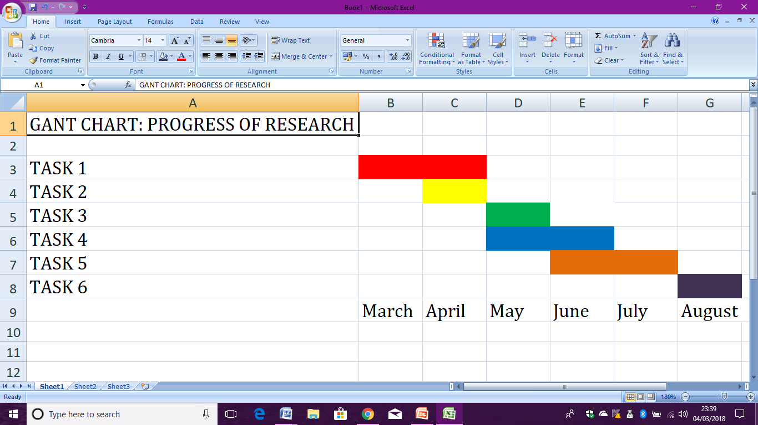

- Appendices

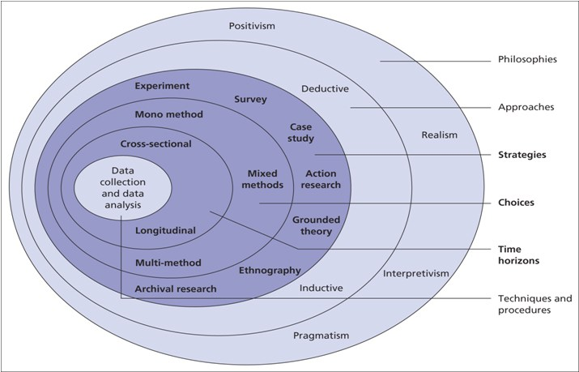
Used in order to identify what approach for this research.

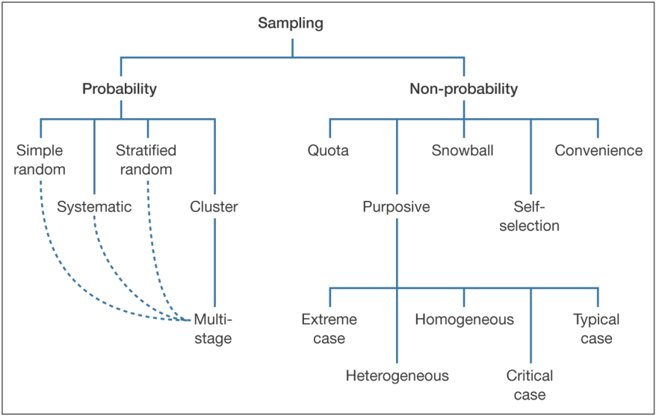

Used to identify which sampling methods are appropriate for this research.

Questionnaire: Anti-Social Behaviour

Have you ever witnessed anti-social behaviour at festivals? | YES/NO
Have you ever felt at risk whilst anti-social behaviour has arisen? | YES/NO
Have you ever been involved in an act of anti-social behaviour? | YES/NO
Do you think anti-social behaviour is an increasing problem at large events? | YES/NO
Can a specific location put you off going to an event? | YES/NO
Do you think drugs and alcohol increase risks of anti-social behaviour? | YES/NO
Do you think anti-social behaviour has increased in the last 5 years? | YES/NO
Have you ever seen anti-social behaviour as headline news? | YES/NO

Street Interview: Questions on Anti-Social Behaviour

- Does anti-social behaviour affect your festival experience?
- Do you think certain music genres can affect a participant’s attitude?
- Why do you think young adults are the cause of most anti-social behaviour incidents?
- What do you think could be done to lower the rate of anti-social behaviour?
- Have you ever felt in a vulnerable situation due to anti-social behaviour?
- Do you consider location before attending an event? Do you ever do research before going?
- What was the last act of anti-social behaviour you remember hearing/seeing/reading about?
- Do you think anti-social behaviour is an ongoing or increasing issue?
- Who would you say are the main components behind anti-social behaviour?
- Do you think drugs and alcohol encourage or instigate anti-social behaviour?

- References

- BBC News Official Website Last accessed: 02/03/2018. http://www.bbc.co.uk/newsbeat/article/22651154/radio-1s-big-weekend-police-confident-about-safety
- Research Methodology Jha, N. (2008) Chandigarh: Abhishek Publications. Last accessed 03/03/2018.
- Anti social behaviour statistics, Sentrysis. Last accessed: 02/03/2018 https://www.sentrysis.com/blog/2016/10/anti-social-behaviour-statistics/
- Peterborough Telegraph. Published as Evening Telepgraph. Accessed from university online library. Last accessed: 02/03/2017
- The Guardian Newspaper. Last accessed: 03/03/2018
https://www.theguardian.com/culture/2010/aug/15/music-festivals-neighbourhood-watch-schemes
- GCSE Bitesize. Last accessed: 02/03/2018
http://www.bbc.co.uk/schools/gcsebitesize/business/marketing/marketresearchrev3.shtml
- Research Onion: Derby. Last accessed: 03/03/2018 https://onion.derby.ac.uk/onion.pdf
- Qulitative Research in Tourism: Phillimore and Goodson. Last accessed: 02/03/2018
- Quantitative Methods in Tourism: Baggio and Jane Klobas. Last accessed: 02/03/2018
- Saunders, Lewis and Thornhill, Research Methods in Business, 4th Edition © Pearson Education Limited 2007. Last accessed: 02/03/2018

